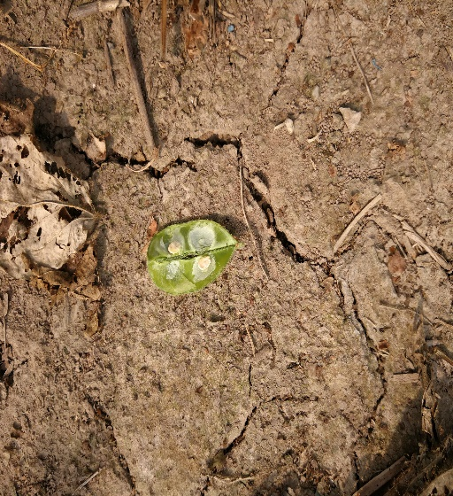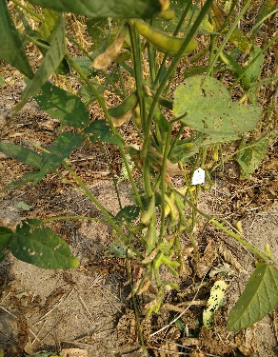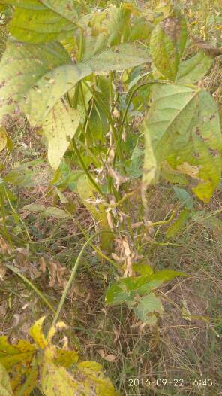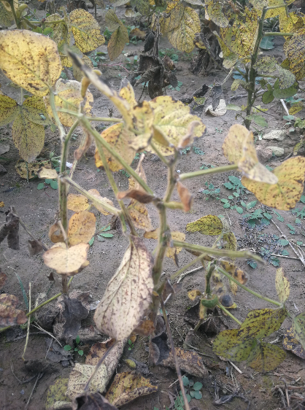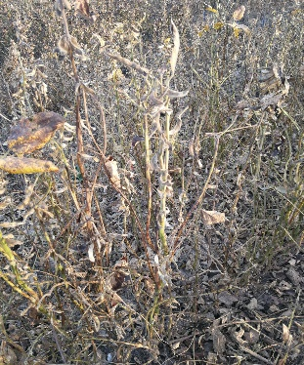
A
B
C
D
E
Fig. S1. The soybean stay-green syndrome (SGS) from 2016 to 2020 on the east campus of Liaocheng University. (A) SGS-afflicted plant in 2016, unknown line; (B) SGS-afflicted plant in 2017, Sui-Nong52; (C) Seeds in pod on the SGS-afflicted plant in 2017, Sui-Nong52; (D) SGS-afflicted plant in 2019, dwarf mutant 5053 (wild type Ji-Dou 17); (E) SGS-afflicted plant in 2020, Ji-Dou 17.

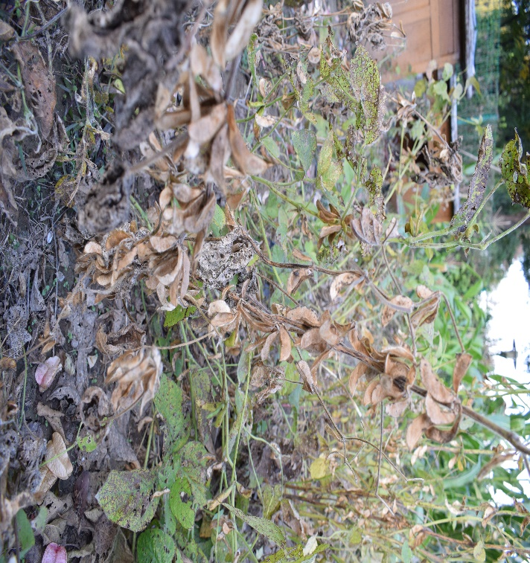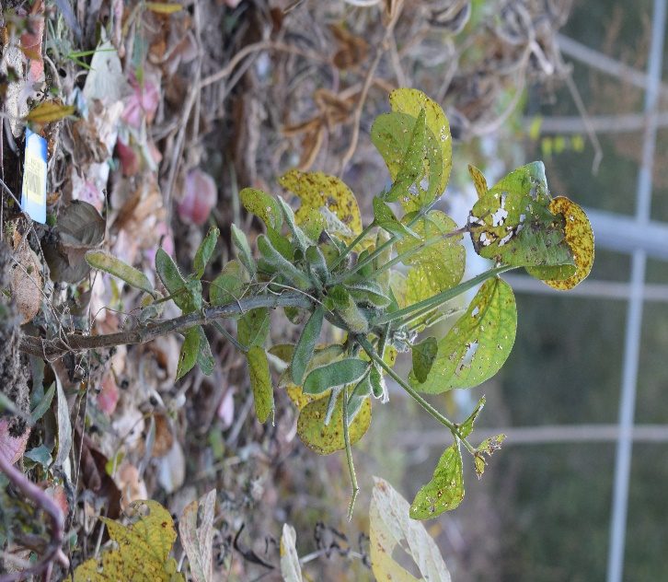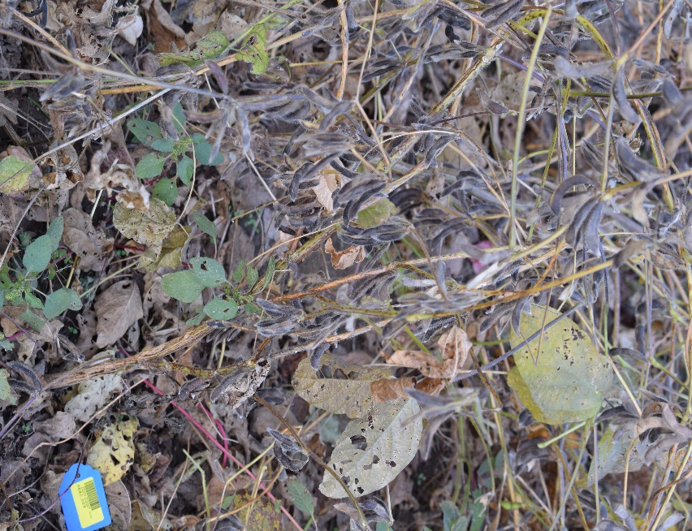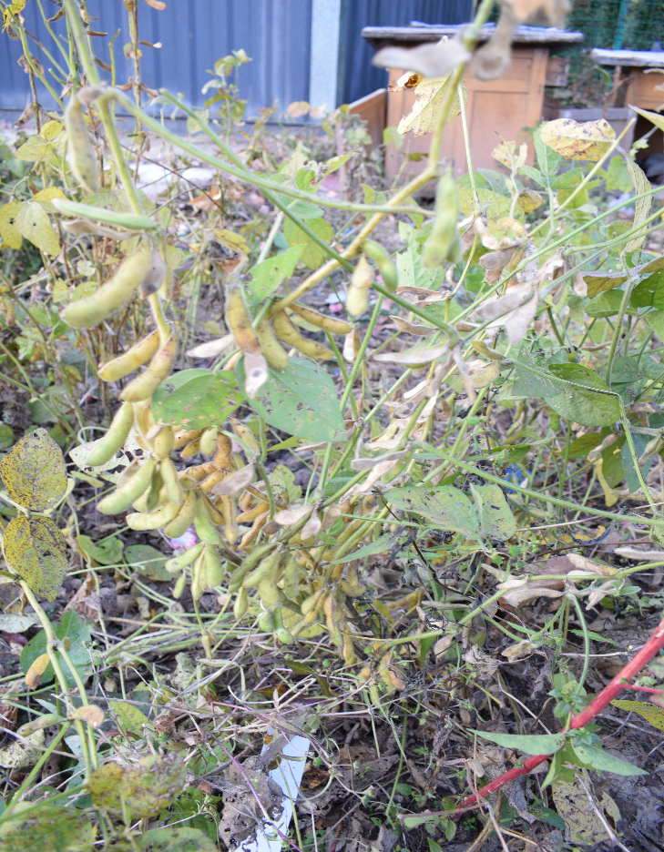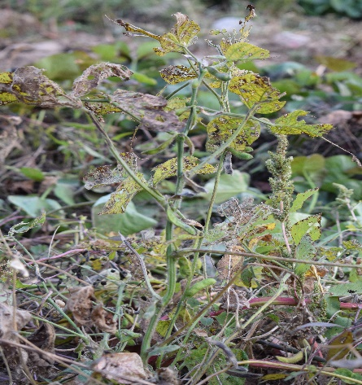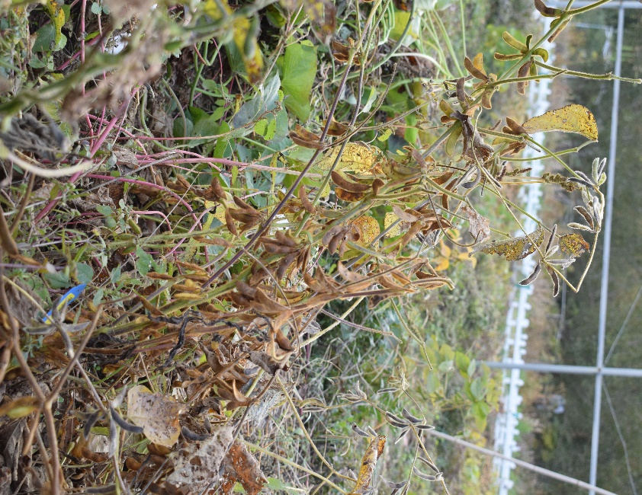
A
B
E
D
F
C

FiFig. S2. Field performance of some SGS resistant and SGS sensitive accessions in 2022. (A–C) SGS sensitive accessions, (D–F) SGS resistant accessions. (A) KeFeng 1, (B) ZhongHuang 35, (C) ERHUANYAN, (D) LaoBaiDou, (E) ZaoShuHeiDou, (F) ZheChengHongMianDou.

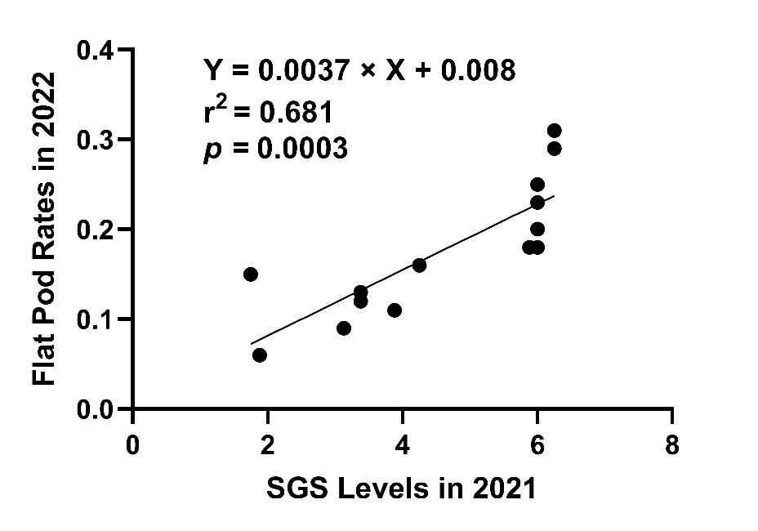
Fig. S3. The consistence between the SGS levels in 2021 and flat pod rates in 2022 for the fourteen germplasms. X was the SGS levels in 2021, Y was the flat pod rate in 2022, and r² was determination coefficient.

