Supplementary material

Figure S1. Correlation between the anxiety scores of the hospital anxiety and depression scale (anxiety, HADS_A) and area of pinprick hyperalgesia after topical application of 1% capsaicin, and between HADS_A and average pain intensity during topical application of capsaicin 1% applied on the masseter and forearm. (0-10) = 0-10 numeric rating scale.
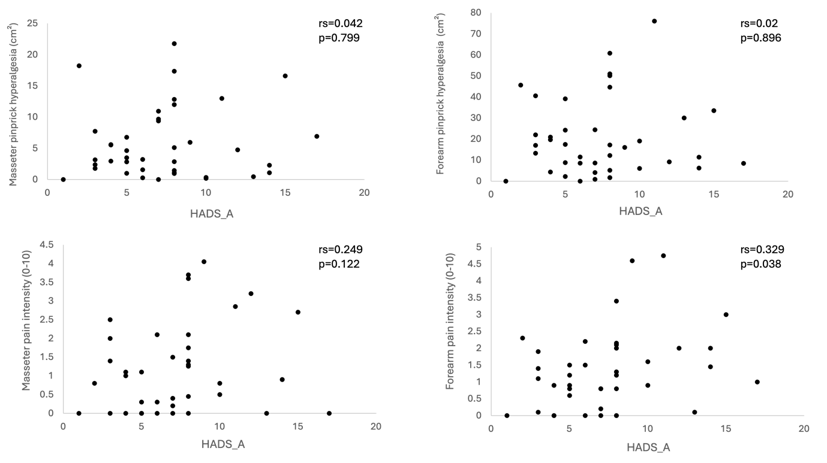

Figure S2. Correlation between the depression scores of the hospital depression scale (depression, HADS_D) and area of area of pinprick hyperalgesia after topical application of 1% capsaicin, and between HADS_D and average pain intensity during topical application of capsaicin 1% applied on the masseter and forearm. (0-10) = 0-10 numeric rating scale.
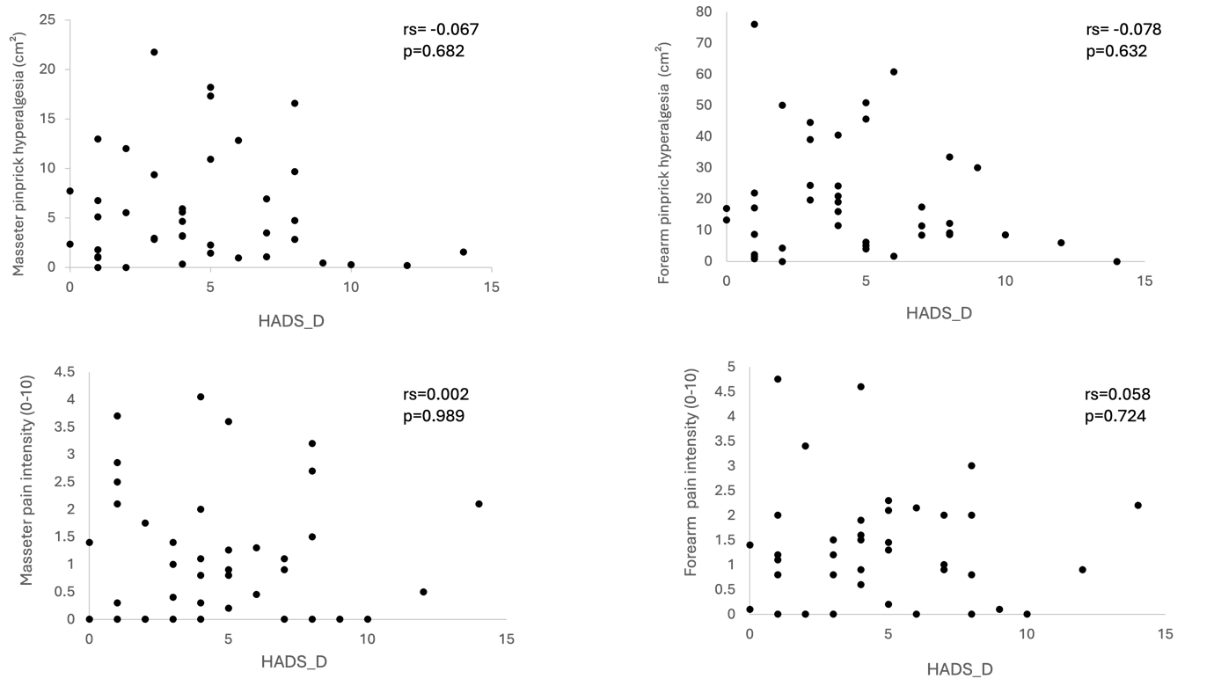

Figure S3. Correlation between Pittsburgh Sleep Quality Index (PSQI) and area of pinprick hyperalgesia after topical application of 1% capsaicin, and between PSQI and average pain intensity during topical application of capsaicin 1% applied on the masseter and forearm. (0-10) = 0-10 numeric rating scale.
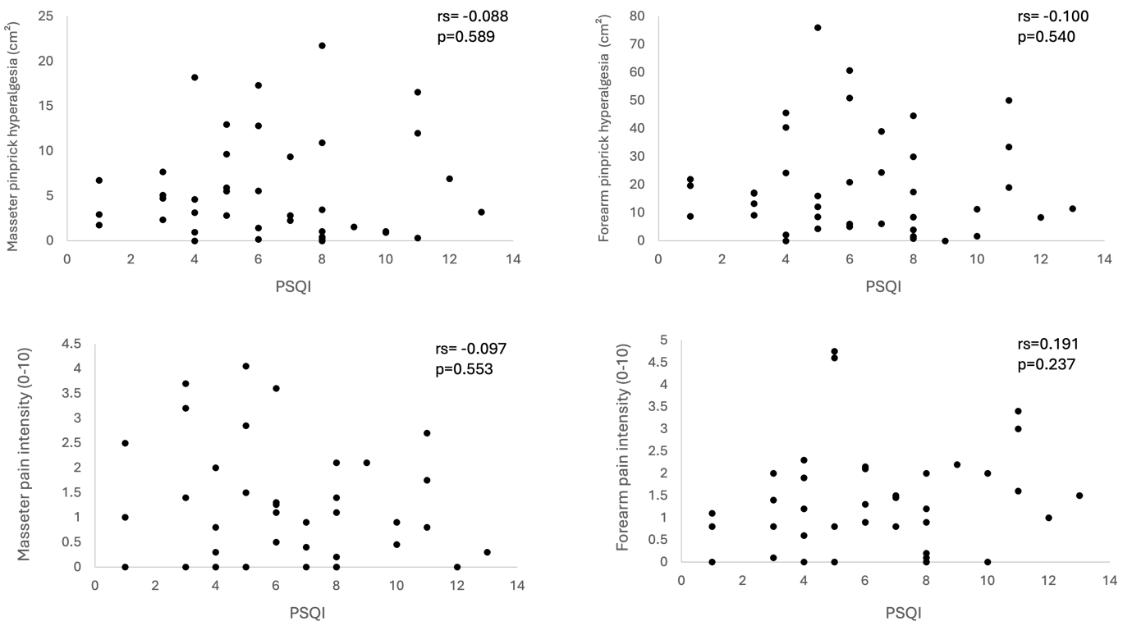

Figure S4. Correlation between Pain Catastrophizing Scale (PCS) and area of pinprick hyperalgesia after topical application of 1% capsaicin, and between PCS and average pain intensity during topical application of capsaicin 1% applied on the masseter and forearm. (0-10) = 0-10 numeric rating scale.
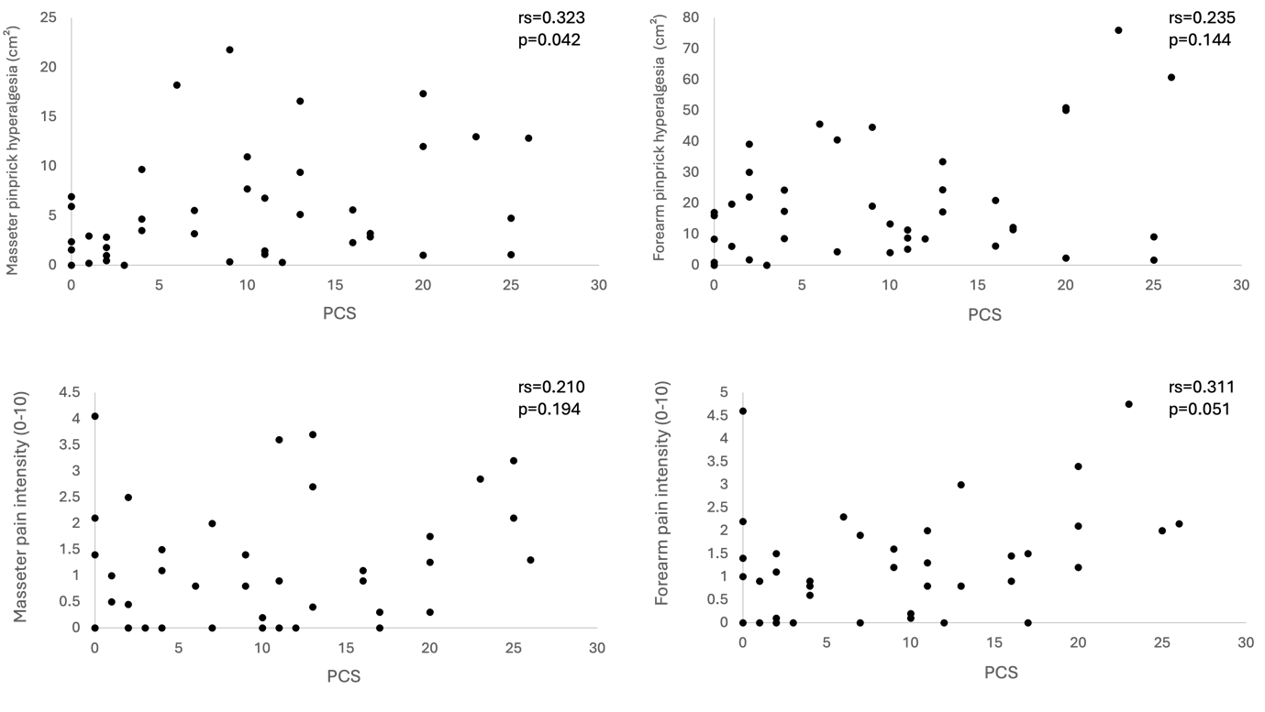

Figure S5. Correlation between Perceived Stress Scale (PSS) area of pinprick hyperalgesia after topical application of 1% capsaicin, and between PCS and average pain intensity during topical application of capsaicin 1% applied on the masseter and forearm. (0-10) = 0-10 numeric rating scale.
