GFS Online Supplement

Important Notes and Caveats

This online supplement to the Global Flourishing Study paper reporting demographic variation in inner peace has several important caveats to interpretation.
First, this study focused on childhood predictors of inner peace using a retrospective (recall) approach to obtain information about the respondents’ lives at age 12. Several the childhood characteristics such as relationship quality with parents, subjective financial status growing up, etc. are necessarily highly related. This led to multicollinearity issues so some effects may be unstable. Secondly, the low degree of variability of inner peace in some countries for some subgroups leads to the issues of complete separation in the modified Poisson regression model. The complete separation results in uninterpretable estimates for those effects as there were no observed differences between the exposure and the outcome in this sample. We have tried to note when this occurs in the meta-analyses. Third, in rare instances for childhood predictor analyses the confidence interval of the effect estimate can contradict the reported global p-value (e.g., for the single-category effects of relationship with mother). In such cases, the reported confidence interval is more robust with corrected degrees of freedom from the pooling across multiple imputations, whereas the global p-value is based on a Wald-type test and is less robust to uncertainty attributable to multiple imputation. Lastly, comparing results across countries should be done with caution due to possible measurement non-invariance and differences in translation.

Table S1a. Nationally representative descriptive statistics for Argentina
Characteristic | N = 6,724¹
Relationship with mother
Very good | 4,463 (66%)
Somewhat good | 1,436 (21%)
Somewhat bad | 299 (4.4%)
Very bad | 216 (3.2%)
Does not apply | 273 (4.1%)
(Missing) | 36 (0.5%)
Relationship with father
Very good | 3,612 (54%)
Somewhat good | 1,537 (23%)
Somewhat bad | 440 (6.5%)
Very bad | 401 (6.0%)
Does not apply | 694 (10%)
(Missing) | 39 (0.6%)
Parent marital status
Parents married | 4,110 (61%)
Divorced | 637 (9.5%)
Parents were never married | 1,368 (20%)
One or both parents had died | 199 (3.0%)
(Missing) | 410 (6.1%)
Subjective financial status of family growing up
Lived comfortably | 2,042 (30%)
Got by | 2,305 (34%)
Found it difficult | 1,789 (27%)
Found it very difficult | 569 (8.5%)
(Missing) | 19 (0.3%)
Abuse
Yes | 1,302 (19%)
No | 5,271 (78%)
(Missing) | 151 (2.2%)
Outsider growing up
Yes | 1,165 (17%)
No | 5,458 (81%)
(Missing) | 101 (1.5%)
Self-rated health growing up
Excellent | 2,402 (36%)
Very good | 1,819 (27%)
Good | 1,830 (27%)
Fair | 505 (7.5%)
Poor | 156 (2.3%)
(Missing) | 12 (0.2%)
Immigration status
Born in this country | 6,346 (94%)
Born in another country | 348 (5.2%)
(Missing) | 29 (0.4%)
Age 12 religious service attendance
At least 1/week | 2,601 (39%)
1-3/month | 1,204 (18%)
<1/month | 1,059 (16%)
Never | 1,808 (27%)
(Missing) | 53 (0.8%)
Year of birth
1998-2005; age 18-24 | 1,108 (16%)
1993-1998; age 25-29 | 719 (11%)
1983-1993; age 30-39 | 1,432 (21%)
1973-1983; age 40-49 | 1,254 (19%)
1963-1973; age 50-59 | 1,014 (15%)
1953-1963; age 60-69 | 730 (11%)
1943-1953; age 70-79 | 356 (5.3%)
1943 or earlier; age 80+ | 112 (1.7%)
(Missing) | 0 (0%)
Gender
Male | 3,143 (47%)
Female | 3,542 (53%)
Other | 21 (0.3%)
(Missing) | 18 (0.3%)
Religious affiliation
Christianity | 5,805 (86%)
Islam | 11 (0.2%)
Hinduism | 2 (<0.1%)
Buddhism | 3 (<0.1%)
Judaism | 51 (0.8%)
Sikhism | 5 (<0.1%)
Baha'i | 0 (0%)
Jainism | 0 (0%)
Shinto | 0 (0%)
Taoism | 1 (<0.1%)
Confucianism | 0 (0%)
Primal, Animist, or Folk religion | 17 (0.2%)
Spiritism | 0 (0%)
Umbanda, Candomble, and other African-derived religions | 0 (0%)
Chinese folk/traditional religion | 0 (0%)
Some other religion | 10 (0.2%)
No religion/Atheist/Agnostic | 697 (10%)
(Missing) | 122 (1.8%)
Race/Ethnicity
Asian | 43 (0.6%)
Black | 95 (1.4%)
Indigenous | 129 (1.9%)
Mestizo(a) | 1,801 (27%)
Mullato(a) | 75 (1.1%)
Other | 104 (1.5%)
White | 3,406 (51%)
(Missing) | 1,070 (16%)
¹n (%)

Table S1b. Childhood predictors regression for Argentina
Variable | Category | Risk-Ratio | RR 95% CI | Global p-value
Relationship with mother | (Ref: Very bad/somewhat bad) |  |  | 0.135
 | Very good/somewhat good | 1.08 | (0.97,1.20)
Relationship with father | (Ref: Very bad/somewhat bad) |  |  | 0.585
 | Very good/somewhat good | 1.02 | (0.95,1.10)
Parent marital status | (Ref: Parents married) |  |  | 0.052
 | Divorced | 0.99 | (0.90,1.08)
 | Parents were never married | 0.91 | (0.85,0.98)
 | One or both parents had died | 0.89 | (0.77,1.04)
Subjective financial status of family growing up | (Ref: Got by) |  |  | 0.013
 | Lived comfortably | 1.03 | (0.97,1.09)
 | Found it difficult | 0.94 | (0.88,1.00)
 | Found it very difficult | 1.05 | (0.96,1.16)
Abuse | (Ref: No) |  |  | 0.757
 | Yes | 0.99 | (0.93,1.06)
Outsider growing up | (Ref: No) |  |  | 0.329
 | Yes | 0.96 | (0.89,1.04)
Self-rated health growing up | (Ref: Good) |  |  | 0.034
 | Excellent | 0.99 | (0.93,1.05)
 | Very good | 1.01 | (0.94,1.07)
 | Fair | 1.12 | (1.02,1.22)
 | Poor | 0.89 | (0.72,1.09)
Immigration status | (Ref: Born in this country) |  |  | 0.944
 | Born in another country | 1.00 | (0.90,1.11)
Age 12 religious service attendance | (Ref: Never) |  |  | 0.550
 | At least 1/week | 1.02 | (0.96,1.09)
 | 1-3/month | 1.02 | (0.95,1.10)
 | < 1/month | 0.98 | (0.90,1.06)
Year of birth | (Ref: 1998-2005; current age: 18-24) |  |  | <.001
 | 1993-1998; age 25-29 | 0.91 | (0.82,1.01)
 | 1983-1993; age 30-39 | 1.01 | (0.93,1.10)
 | 1973-1983; age 40-49 | 1.01 | (0.93,1.10)
 | 1963-1973; age 50-59 | 1.12 | (1.03,1.22)
 | 1953-1963; age 60-69 | 1.14 | (1.03,1.25)
 | 1943-1953; age 70-79 | 1.18 | (1.05,1.32)
 | 1943 or earlier; age 80+ | 0.98 | (0.79,1.22)
Gender | (Ref: Male) |  |  | 0.078
 | Female | 0.98 | (0.94,1.03)
 | Other | 0.45 | (0.22,0.93)
Religious affiliation | (Ref: No religion/Atheist/Agnostic) |  |  | 0.724
 | Christianity | 1.00 | (0.91,1.10)
 | Collapsed affiliations with prevalence<3% | 0.91 | (0.70,1.17)
Race/ethnicity | (Ref: Plurality group) |  |  | 0.093
 | Non-plurality groups | 1.04 | (0.98,1.10)

Table S1c. Sensitivity to unmeasured confounding of childhood predictors in Argentina
Variable | Category | E-value for Estimate | E-value for 95% CI
Relationship with mother | (Ref: Very bad/somewhat bad)
 | Very good/somewhat good | 1.37 | 1.00
Relationship with father | (Ref: Very bad/somewhat bad)
 | Very good/somewhat good | 1.17 | 1.00
Parent marital status | (Ref: Parents married)
 | Divorced | 1.13 | 1.00
 | Parents were never married | 1.42 | 1.14
 | One or both parents had died | 1.49 | 1.00
Subjective financial status of family growing up | (Ref: Got by)
 | Lived comfortably | 1.22 | 1.00
 | Found it difficult | 1.33 | 1.04
 | Found it very difficult | 1.29 | 1.00
Abuse | (Ref: No)
 | Yes | 1.11 | 1.00
Outsider growing up | (Ref: No)
 | Yes | 1.24 | 1.00
Self-rated health growing up | (Ref: Good)
 | Excellent | 1.12 | 1.00
 | Very good | 1.08 | 1.00
 | Fair | 1.48 | 1.18
 | Poor | 1.50 | 1.00
Immigration status | (Ref: Born in this country)
 | Born in another country | 1.02 | 1.00
Age 12 religious service attendance | (Ref: Never)
 | At least 1/week | 1.18 | 1.00
 | 1-3/month | 1.18 | 1.00
 | < 1/month | 1.19 | 1.00
Year of birth | (Ref: 1998-2005; current age: 18-24)
 | 1993-1998; age 25-29 | 1.43 | 1.00
 | 1983-1993; age 30-39 | 1.13 | 1.00
 | 1973-1983; age 40-49 | 1.11 | 1.00
 | 1963-1973; age 50-59 | 1.49 | 1.21
 | 1953-1963; age 60-69 | 1.53 | 1.22
 | 1943-1953; age 70-79 | 1.63 | 1.28
 | 1943 or earlier; age 80+ | 1.16 | 1.00
Gender | (Ref: Male)
 | Female | 1.15 | 1.00
 | Other | 3.84 | 1.35
Religious affiliation | (Ref: No religion/Atheist/Agnostic)
 | Christianity | 1.04 | 1.00
 | Collapsed affiliations with prevalence<3% | 1.43 | 1.00
Race/ethnicity | (Ref: Plurality group)
 | Non-plurality groups | 1.25 | 1.00

Table S2a. Nationally representative descriptive statistics for Australia
Characteristic | N = 3,844¹
Relationship with mother
Very good | 2,554 (66%)
Somewhat good | 925 (24%)
Somewhat bad | 218 (5.7%)
Very bad | 107 (2.8%)
Does not apply | 32 (0.8%)
(Missing) | 7 (0.2%)
Relationship with father
Very good | 2,032 (53%)
Somewhat good | 1,144 (30%)
Somewhat bad | 315 (8.2%)
Very bad | 196 (5.1%)
Does not apply | 148 (3.9%)
(Missing) | 9 (0.2%)
Parent marital status
Parents married | 3,048 (79%)
Divorced | 462 (12%)
Parents were never married | 187 (4.9%)
One or both parents had died | 96 (2.5%)
(Missing) | 52 (1.4%)
Subjective financial status of family growing up
Lived comfortably | 1,756 (46%)
Got by | 1,496 (39%)
Found it difficult | 422 (11%)
Found it very difficult | 154 (4.0%)
(Missing) | 16 (0.4%)
Abuse
Yes | 995 (26%)
No | 2,790 (73%)
(Missing) | 59 (1.5%)
Outsider growing up
Yes | 756 (20%)
No | 3,062 (80%)
(Missing) | 26 (0.7%)
Self-rated health growing up
Excellent | 1,736 (45%)
Very good | 1,087 (28%)
Good | 603 (16%)
Fair | 308 (8.0%)
Poor | 106 (2.8%)
(Missing) | 4 (<0.1%)
Immigration status
Born in this country | 2,953 (77%)
Born in another country | 885 (23%)
(Missing) | 6 (0.2%)
Age 12 religious service attendance
At least 1/week | 1,362 (35%)
1-3/month | 486 (13%)
<1/month | 600 (16%)
Never | 1,307 (34%)
(Missing) | 90 (2.3%)
Year of birth
1998-2005; age 18-24 | 345 (9.0%)
1993-1998; age 25-29 | 282 (7.3%)
1983-1993; age 30-39 | 641 (17%)
1973-1983; age 40-49 | 618 (16%)
1963-1973; age 50-59 | 691 (18%)
1953-1963; age 60-69 | 589 (15%)
1943-1953; age 70-79 | 498 (13%)
1943 or earlier; age 80+ | 178 (4.6%)
(Missing) | 2 (<0.1%)
Gender
Male | 1,861 (48%)
Female | 1,941 (50%)
Other | 36 (0.9%)
(Missing) | 6 (0.2%)
Religious affiliation
Christianity | 2,678 (70%)
Islam | 48 (1.2%)
Hinduism | 39 (1.0%)
Buddhism | 16 (0.4%)
Judaism | 29 (0.8%)
Sikhism | 6 (0.2%)
Baha'i | 5 (0.1%)
Jainism | 0 (0%)
Shinto | 0 (0%)
Taoism | 1 (<0.1%)
Confucianism | 0 (0%)
Primal, Animist, or Folk religion | 4 (<0.1%)
Spiritism | 0 (0%)
Umbanda, Candomble, and other African-derived religions | 0 (0%)
Chinese folk/traditional religion | 0 (0%)
Some other religion | 8 (0.2%)
No religion/Atheist/Agnostic | 990 (26%)
(Missing) | 21 (0.5%)
Race/Ethnicity
Aboriginal | 53 (1.4%)
Australian | 1,946 (51%)
Australian British/European | 1,047 (27%)
Chinese | 75 (1.9%)
Indian | 58 (1.5%)
Japanese | 1 (<0.1%)
Malay | 11 (0.3%)
New Zealander | 91 (2.4%)
Other | 163 (4.2%)
Other European | 357 (9.3%)
Russian | 7 (0.2%)
Samoan | 4 (0.1%)
Sinhalese | 1 (<0.1%)
Spanish | 2 (<0.1%)
Sri Lankan Moor | 1 (<0.1%)
Sri Lankan Tamil | 7 (0.2%)
Vietnamese | 7 (0.2%)
(Missing) | 14 (0.4%)
¹n (%)

Table S2b. Childhood predictors regression for Australia
Variable | Category | Risk-Ratio | RR 95% CI | Global p-value
Relationship with mother | (Ref: Very bad/somewhat bad) |  |  | 0.489
 | Very good/somewhat good | 1.04 | (0.93,1.16)
Relationship with father | (Ref: Very bad/somewhat bad) |  |  | 0.722
 | Very good/somewhat good | 0.99 | (0.91,1.07)
Parent marital status | (Ref: Parents married) |  |  | 0.021
 | Divorced | 0.96 | (0.87,1.05)
 | Parents were never married | 1.15 | (1.01,1.31)
 | One or both parents had died | 1.13 | (0.99,1.29)
Subjective financial status of family growing up | (Ref: Got by) |  |  | 0.875
 | Lived comfortably | 0.99 | (0.94,1.03)
 | Found it difficult | 0.98 | (0.91,1.06)
 | Found it very difficult | 0.95 | (0.81,1.11)
Abuse | (Ref: No) |  |  | 0.001
 | Yes | 0.90 | (0.85,0.96)
Outsider growing up | (Ref: No) |  |  | <.001
 | Yes | 0.84 | (0.78,0.92)
Self-rated health growing up | (Ref: Good) |  |  | 0.002
 | Excellent | 1.09 | (1.02,1.17)
 | Very good | 1.03 | (0.96,1.11)
 | Fair | 0.96 | (0.84,1.09)
 | Poor | 0.88 | (0.72,1.07)
Immigration status | (Ref: Born in this country) |  |  | 0.048
 | Born in another country | 1.06 | (1.00,1.11)
Age 12 religious service attendance | (Ref: Never) |  |  | 0.070
 | At least 1/week | 1.07 | (1.01,1.14)
 | 1-3/month | 1.06 | (0.99,1.14)
 | < 1/month | 1.01 | (0.94,1.09)
Year of birth | (Ref: 1998-2005; current age: 18-24) |  |  | <.001
 | 1993-1998; age 25-29 | 0.93 | (0.79,1.10)
 | 1983-1993; age 30-39 | 1.05 | (0.93,1.19)
 | 1973-1983; age 40-49 | 1.08 | (0.95,1.22)
 | 1963-1973; age 50-59 | 1.12 | (1.00,1.27)
 | 1953-1963; age 60-69 | 1.22 | (1.09,1.38)
 | 1943-1953; age 70-79 | 1.30 | (1.15,1.46)
 | 1943 or earlier; age 80+ | 1.34 | (1.19,1.50)
Gender | (Ref: Male) |  |  | 0.382
 | Female | 1.03 | (0.98,1.07)
 | Other | 0.89 | (0.58,1.36)
Religious affiliation | (Ref: No religion/Atheist/Agnostic) |  |  | 0.182
 | Christianity | 0.94 | (0.88,1.00)
 | Collapsed affiliations with prevalence<3% | 0.97 | (0.86,1.10)
Race/ethnicity | (Ref: Plurality group) |  |  | 0.522
 | Non-plurality groups | 0.98 | (0.94,1.03)

Table S2c. Sensitivity to unmeasured confounding of childhood predictors in Australia
Variable | Category | E-value for Estimate | E-value for 95% CI
Relationship with mother | (Ref: Very bad/somewhat bad)
 | Very good/somewhat good | 1.24 | 1.00
Relationship with father | (Ref: Very bad/somewhat bad)
 | Very good/somewhat good | 1.14 | 1.00
Parent marital status | (Ref: Parents married)
 | Divorced | 1.26 | 1.00
 | Parents were never married | 1.57 | 1.12
 | One or both parents had died | 1.51 | 1.00
Subjective financial status of family growing up | (Ref: Got by)
 | Lived comfortably | 1.13 | 1.00
 | Found it difficult | 1.15 | 1.00
 | Found it very difficult | 1.28 | 1.00
Abuse | (Ref: No)
 | Yes | 1.45 | 1.24
Outsider growing up | (Ref: No)
 | Yes | 1.65 | 1.40
Self-rated health growing up | (Ref: Good)
 | Excellent | 1.41 | 1.17
 | Very good | 1.21 | 1.00
 | Fair | 1.27 | 1.00
 | Poor | 1.54 | 1.00
Immigration status | (Ref: Born in this country)
 | Born in another country | 1.30 | 1.01
Age 12 religious service attendance | (Ref: Never)
 | At least 1/week | 1.35 | 1.11
 | 1-3/month | 1.32 | 1.00
 | < 1/month | 1.12 | 1.00
Year of birth | (Ref: 1998-2005; current age: 18-24)
 | 1993-1998; age 25-29 | 1.36 | 1.00
 | 1983-1993; age 30-39 | 1.28 | 1.00
 | 1973-1983; age 40-49 | 1.37 | 1.00
 | 1963-1973; age 50-59 | 1.50 | 1.00
 | 1953-1963; age 60-69 | 1.75 | 1.40
 | 1943-1953; age 70-79 | 1.92 | 1.58
 | 1943 or earlier; age 80+ | 2.01 | 1.67
Gender | (Ref: Male)
 | Female | 1.20 | 1.00
 | Other | 1.51 | 1.00
Religious affiliation | (Ref: No religion/Atheist/Agnostic)
 | Christianity | 1.32 | 1.00
 | Collapsed affiliations with prevalence<3% | 1.20 | 1.00
Race/ethnicity | (Ref: Plurality group)
 | Non-plurality groups | 1.14 | 1.00

Table S3a. Nationally representative descriptive statistics for Brazil
Characteristic | N = 13,204¹
Relationship with mother
Very good | 8,369 (63%)
Somewhat good | 3,559 (27%)
Somewhat bad | 483 (3.7%)
Very bad | 214 (1.6%)
Does not apply | 507 (3.8%)
(Missing) | 73 (0.6%)
Relationship with father
Very good | 6,364 (48%)
Somewhat good | 3,654 (28%)
Somewhat bad | 1,035 (7.8%)
Very bad | 756 (5.7%)
Does not apply | 1,303 (9.9%)
(Missing) | 93 (0.7%)
Parent marital status
Parents married | 8,546 (65%)
Divorced | 1,384 (10%)
Parents were never married | 1,985 (15%)
One or both parents had died | 508 (3.8%)
(Missing) | 781 (5.9%)
Subjective financial status of family growing up
Lived comfortably | 4,998 (38%)
Got by | 4,616 (35%)
Found it difficult | 2,484 (19%)
Found it very difficult | 1,027 (7.8%)
(Missing) | 79 (0.6%)
Abuse
Yes | 2,606 (20%)
No | 10,147 (77%)
(Missing) | 451 (3.4%)
Outsider growing up
Yes | 1,659 (13%)
No | 11,234 (85%)
(Missing) | 311 (2.4%)
Self-rated health growing up
Excellent | 5,312 (40%)
Very good | 3,392 (26%)
Good | 2,873 (22%)
Fair | 1,368 (10%)
Poor | 228 (1.7%)
(Missing) | 30 (0.2%)
Immigration status
Born in this country | 12,688 (96%)
Born in another country | 153 (1.2%)
(Missing) | 363 (2.7%)
Age 12 religious service attendance
At least 1/week | 6,306 (48%)
1-3/month | 2,491 (19%)
<1/month | 2,629 (20%)
Never | 1,707 (13%)
(Missing) | 71 (0.5%)
Year of birth
1998-2005; age 18-24 | 1,986 (15%)
1993-1998; age 25-29 | 1,468 (11%)
1983-1993; age 30-39 | 2,908 (22%)
1973-1983; age 40-49 | 2,638 (20%)
1963-1973; age 50-59 | 2,131 (16%)
1953-1963; age 60-69 | 1,435 (11%)
1943-1953; age 70-79 | 510 (3.9%)
1943 or earlier; age 80+ | 126 (1.0%)
(Missing) | 0 (0%)
Gender
Male | 6,320 (48%)
Female | 6,820 (52%)
Other | 35 (0.3%)
(Missing) | 30 (0.2%)
Religious affiliation
Christianity | 11,403 (86%)
Islam | 15 (0.1%)
Hinduism | 1 (<0.1%)
Buddhism | 27 (0.2%)
Judaism | 40 (0.3%)
Sikhism | 0 (0%)
Baha'i | 1 (<0.1%)
Jainism | 4 (<0.1%)
Shinto | 4 (<0.1%)
Taoism | 1 (<0.1%)
Confucianism | 7 (<0.1%)
Primal, Animist, or Folk religion | 17 (0.1%)
Spiritism | 336 (2.5%)
Umbanda, Candomble, and other African-derived religions | 262 (2.0%)
Chinese folk/traditional religion | 0 (0%)
Some other religion | 87 (0.7%)
No religion/Atheist/Agnostic | 908 (6.9%)
(Missing) | 94 (0.7%)
Race/Ethnicity
Amarela | 238 (1.8%)
Branca | 5,169 (39%)
Indígena | 131 (1.0%)
Other | 61 (0.5%)
Parda | 5,125 (39%)
Preta | 1,615 (12%)
(Missing) | 865 (6.6%)
¹n (%)

Table S3b. Childhood predictors regression for Brazil
Variable | Category | Risk-Ratio | RR 95% CI | Global p-value
Relationship with mother | (Ref: Very bad/somewhat bad) |  |  | 0.607
 | Very good/somewhat good | 1.02 | (0.95,1.09)
Relationship with father | (Ref: Very bad/somewhat bad) |  |  | 0.001
 | Very good/somewhat good | 1.08 | (1.03,1.13)
Parent marital status | (Ref: Parents married) |  |  | 0.021
 | Divorced | 0.94 | (0.90,0.99)
 | Parents were never married | 0.95 | (0.90,0.99)
 | One or both parents had died | 0.93 | (0.86,1.02)
Subjective financial status of family growing up | (Ref: Got by) |  |  | 0.005
 | Lived comfortably | 1.03 | (1.00,1.07)
 | Found it difficult | 0.99 | (0.95,1.03)
 | Found it very difficult | 0.94 | (0.87,1.00)
Abuse | (Ref: No) |  |  | <.001
 | Yes | 0.91 | (0.87,0.94)
Outsider growing up | (Ref: No) |  |  | <.001
 | Yes | 0.83 | (0.78,0.88)
Self-rated health growing up | (Ref: Good) |  |  | <.001
 | Excellent | 1.14 | (1.09,1.18)
 | Very good | 1.07 | (1.02,1.12)
 | Fair | 0.93 | (0.87,1.00)
 | Poor | 0.99 | (0.86,1.13)
Immigration status | (Ref: Born in this country) |  |  | 0.451
 | Born in another country | 1.04 | (0.93,1.18)
Age 12 religious service attendance | (Ref: Never) |  |  | 0.002
 | At least 1/week | 1.09 | (1.04,1.15)
 | 1-3/month | 1.10 | (1.04,1.16)
 | < 1/month | 1.07 | (1.01,1.13)
Year of birth | (Ref: 1998-2005; current age: 18-24) |  |  | <.001
 | 1993-1998; age 25-29 | 1.05 | (0.98,1.11)
 | 1983-1993; age 30-39 | 1.14 | (1.09,1.20)
 | 1973-1983; age 40-49 | 1.24 | (1.18,1.31)
 | 1963-1973; age 50-59 | 1.29 | (1.23,1.37)
 | 1953-1963; age 60-69 | 1.35 | (1.27,1.43)
 | 1943-1953; age 70-79 | 1.29 | (1.17,1.42)
 | 1943 or earlier; age 80+ | 1.35 | (1.15,1.58)
Gender | (Ref: Male) |  |  | <.001
 | Female | 0.93 | (0.90,0.95)
 | Other | 0.59 | (0.36,0.98)
Religious affiliation | (Ref: No religion/Atheist/Agnostic) |  |  | 0.414
 | Christianity | 0.97 | (0.91,1.03)
 | Collapsed affiliations with prevalence<3% | 0.95 | (0.88,1.03)
Race/ethnicity | (Ref: Plurality group) |  |  | 0.598
 | Non-plurality groups | 1.01 | (0.98,1.04)

Table S3c. Sensitivity to unmeasured confounding of childhood predictors in Brazil
Variable | Category | E-value for Estimate | E-value for 95% CI
Relationship with mother | (Ref: Very bad/somewhat bad)
 | Very good/somewhat good | 1.15 | 1.00
Relationship with father | (Ref: Very bad/somewhat bad)
 | Very good/somewhat good | 1.37 | 1.20
Parent marital status | (Ref: Parents married)
 | Divorced | 1.31 | 1.08
 | Parents were never married | 1.30 | 1.08
 | One or both parents had died | 1.35 | 1.00
Subjective financial status of family growing up | (Ref: Got by)
 | Lived comfortably | 1.22 | 1.04
 | Found it difficult | 1.14 | 1.00
 | Found it very difficult | 1.34 | 1.00
Abuse | (Ref: No)
 | Yes | 1.45 | 1.31
Outsider growing up | (Ref: No)
 | Yes | 1.71 | 1.55
Self-rated health growing up | (Ref: Good)
 | Excellent | 1.53 | 1.41
 | Very good | 1.34 | 1.18
 | Fair | 1.36 | 1.07
 | Poor | 1.12 | 1.00
Immigration status | (Ref: Born in this country)
 | Born in another country | 1.26 | 1.00
Age 12 religious service attendance | (Ref: Never)
 | At least 1/week | 1.41 | 1.23
 | 1-3/month | 1.44 | 1.26
 | < 1/month | 1.33 | 1.09
Year of birth | (Ref: 1998-2005; current age: 18-24)
 | 1993-1998; age 25-29 | 1.27 | 1.00
 | 1983-1993; age 30-39 | 1.55 | 1.39
 | 1973-1983; age 40-49 | 1.79 | 1.64
 | 1963-1973; age 50-59 | 1.91 | 1.75
 | 1953-1963; age 60-69 | 2.04 | 1.86
 | 1943-1953; age 70-79 | 1.90 | 1.62
 | 1943 or earlier; age 80+ | 2.04 | 1.57
Gender | (Ref: Male)
 | Female | 1.38 | 1.28
 | Other | 2.78 | 1.16
Religious affiliation | (Ref: No religion/Atheist/Agnostic)
 | Christianity | 1.22 | 1.00
 | Collapsed affiliations with prevalence<3% | 1.29 | 1.00
Race/ethnicity | (Ref: Plurality group)
 | Non-plurality groups | 1.09 | 1.00

Table S4a. Nationally representative descriptive statistics for Egypt
Characteristic | N = 4,729¹
Relationship with mother
Very good | 4,110 (87%)
Somewhat good | 505 (11%)
Somewhat bad | 21 (0.4%)
Very bad | 10 (0.2%)
Does not apply | 83 (1.8%)
(Missing) | 0 (0%)
Relationship with father
Very good | 3,713 (79%)
Somewhat good | 683 (14%)
Somewhat bad | 56 (1.2%)
Very bad | 30 (0.6%)
Does not apply | 233 (4.9%)
(Missing) | 14 (0.3%)
Parent marital status
Parents married | 4,049 (86%)
Divorced | 131 (2.8%)
Parents were never married | 9 (0.2%)
One or both parents had died | 485 (10%)
(Missing) | 55 (1.2%)
Subjective financial status of family growing up
Lived comfortably | 1,251 (26%)
Got by | 2,352 (50%)
Found it difficult | 857 (18%)
Found it very difficult | 268 (5.7%)
(Missing) | 1 (<0.1%)
Abuse
Yes | 405 (8.6%)
No | 4,293 (91%)
(Missing) | 30 (0.6%)
Outsider growing up
Yes | 260 (5.5%)
No | 4,456 (94%)
(Missing) | 13 (0.3%)
Self-rated health growing up
Excellent | 2,687 (57%)
Very good | 1,174 (25%)
Good | 497 (11%)
Fair | 265 (5.6%)
Poor | 106 (2.2%)
(Missing) | 1 (<0.1%)
Immigration status
Born in this country | 4,713 (100%)
Born in another country | 16 (0.3%)
(Missing) | 1 (<0.1%)
Age 12 religious service attendance
At least 1/week | 2,307 (49%)
1-3/month | 570 (12%)
<1/month | 629 (13%)
Never | 1,165 (25%)
(Missing) | 57 (1.2%)
Year of birth
1998-2005; age 18-24 | 960 (20%)
1993-1998; age 25-29 | 607 (13%)
1983-1993; age 30-39 | 1,204 (25%)
1973-1983; age 40-49 | 897 (19%)
1963-1973; age 50-59 | 613 (13%)
1953-1963; age 60-69 | 387 (8.2%)
1943-1953; age 70-79 | 54 (1.1%)
1943 or earlier; age 80+ | 7 (0.2%)
(Missing) | 0 (0%)
Gender
Male | 2,394 (51%)
Female | 2,334 (49%)
Other | 0 (0%)
(Missing) | 0 (<0.1%)
Religious affiliation
Christianity | 123 (2.6%)
Islam | 4,602 (97%)
Hinduism | 0 (0%)
Buddhism | 0 (0%)
Judaism | 0 (0%)
Sikhism | 0 (0%)
Baha'i | 0 (0%)
Jainism | 1 (<0.1%)
Shinto | 0 (0%)
Taoism | 0 (<0.1%)
Confucianism | 0 (0%)
Primal, Animist, or Folk religion | 0 (0%)
Spiritism | 0 (0%)
Umbanda, Candomble, and other African-derived religions | 0 (0%)
Chinese folk/traditional religion | 0 (0%)
Some other religion | 0 (0%)
No religion/Atheist/Agnostic | 0 (0%)
(Missing) | 3 (<0.1%)
Race/Ethnicity
Arab | 4,585 (97%)
Bedouin Arab | 4 (<0.1%)
Greek | 1 (<0.1%)
Nubian | 27 (0.6%)
Turkish | 9 (0.2%)
(Missing) | 102 (2.2%)
¹n (%)

Table S4b. Childhood predictors regression for Egypt
Variable | Category | Risk-Ratio | RR 95% CI | Global p-value
Relationship with mother | (Ref: Very bad/somewhat bad) |  |  | 0.584
 | Very good/somewhat good | 0.98 | (0.89,1.08)
Relationship with father | (Ref: Very bad/somewhat bad) |  |  | 0.303
 | Very good/somewhat good | 0.96 | (0.87,1.04)
Parent marital status | (Ref: Parents married) |  |  | 0.034
 | Divorced | 1.02 | (0.93,1.12)
 | Parents were never married | 0.79 | (0.58,1.06)
 | One or both parents had died | 0.93 | (0.88,0.99)
Subjective financial status of family growing up | (Ref: Got by) |  |  | 0.048
 | Lived comfortably | 1.02 | (0.99,1.06)
 | Found it difficult | 0.97 | (0.93,1.01)
 | Found it very difficult | 0.96 | (0.89,1.03)
Abuse | (Ref: No) |  |  | 0.260
 | Yes | 0.97 | (0.91,1.03)
Outsider growing up | (Ref: No) |  |  | 0.326
 | Yes | 1.03 | (0.98,1.08)
Self-rated health growing up | (Ref: Good) |  |  | 0.504
 | Excellent | 0.98 | (0.94,1.03)
 | Very good | 0.97 | (0.92,1.02)
 | Fair | 0.95 | (0.88,1.02)
 | Poor | 0.94 | (0.84,1.05)
Immigration status | (Ref: Born in this country) |  |  | 0.579
 | Born in another country | 0.92 | (0.69,1.23)
Age 12 religious service attendance | (Ref: Never) |  |  | 0.373
 | At least 1/week | 1.03 | (0.99,1.07)
 | 1-3/month | 0.99 | (0.94,1.04)
 | < 1/month | 1.01 | (0.96,1.07)
Year of birth | (Ref: 1998-2005; current age: 18-24) |  |  | <.001
 | 1993-1998; age 25-29 | 1.02 | (0.97,1.08)
 | 1983-1993; age 30-39 | 1.06 | (1.01,1.10)
 | 1973-1983; age 40-49 | 1.05 | (1.00,1.10)
 | 1963-1973; age 50-59 | 1.08 | (1.03,1.14)
 | 1953-1963; age 60-69 | 1.10 | (1.04,1.17)
 | 1943-1953; age 70-79 | 1.07 | (0.90,1.28)
 | 1943 or earlier; age 80+ | 1.22 | (1.15,1.31)
Gender | (Ref: Male) |  |  | <.001
 | Female | 1.06 | (1.03,1.09)
Religious affiliation | (Ref: Islam) |  |  | 0.434
 | Collapsed affiliations with prevalence<3% | 1.03 | (0.95,1.12)
Race/ethnicity | (Ref: Plurality group) |  |  | 0.152
 | Non-plurality groups | 0.89 | (0.77,1.04)

Table S4c. Sensitivity to unmeasured confounding of childhood predictors in Egypt
Variable | Category | E-value for Estimate | E-value for 95% CI
Relationship with mother | (Ref: Very bad/somewhat bad)
 | Very good/somewhat good | 1.17 | 1.00
Relationship with father | (Ref: Very bad/somewhat bad)
 | Very good/somewhat good | 1.27 | 1.00
Parent marital status | (Ref: Parents married)
 | Divorced | 1.17 | 1.00
 | Parents were never married | 1.86 | 1.00
 | One or both parents had died | 1.36 | 1.12
Subjective financial status of family growing up | (Ref: Got by)
 | Lived comfortably | 1.18 | 1.00
 | Found it difficult | 1.20 | 1.00
 | Found it very difficult | 1.25 | 1.00
Abuse | (Ref: No)
 | Yes | 1.23 | 1.00
Outsider growing up | (Ref: No)
 | Yes | 1.19 | 1.00
Self-rated health growing up | (Ref: Good)
 | Excellent | 1.16 | 1.00
 | Very good | 1.22 | 1.00
 | Fair | 1.29 | 1.00
 | Poor | 1.33 | 1.00
Immigration status | (Ref: Born in this country)
 | Born in another country | 1.39 | 1.00
Age 12 religious service attendance | (Ref: Never)
 | At least 1/week | 1.20 | 1.00
 | 1-3/month | 1.12 | 1.00
 | < 1/month | 1.12 | 1.00
Year of birth | (Ref: 1998-2005; current age: 18-24)
 | 1993-1998; age 25-29 | 1.17 | 1.00
 | 1983-1993; age 30-39 | 1.30 | 1.13
 | 1973-1983; age 40-49 | 1.26 | 1.00
 | 1963-1973; age 50-59 | 1.38 | 1.20
 | 1953-1963; age 60-69 | 1.44 | 1.24
 | 1943-1953; age 70-79 | 1.35 | 1.00
 | 1943 or earlier; age 80+ | 1.75 | 1.56
Gender | (Ref: Male)
 | Female | 1.31 | 1.19
Religious affiliation | (Ref: Islam)
 | Collapsed affiliations with prevalence<3% | 1.21 | 1.00
Race/ethnicity | (Ref: Plurality group)
 | Non-plurality groups | 1.48 | 1.00

Table S5a. Nationally representative descriptive statistics for Germany
Characteristic | N = 9,506¹
Relationship with mother
Very good | 5,497 (58%)
Somewhat good | 3,031 (32%)
Somewhat bad | 496 (5.2%)
Very bad | 187 (2.0%)
Does not apply | 241 (2.5%)
(Missing) | 54 (0.6%)
Relationship with father
Very good | 4,652 (49%)
Somewhat good | 3,012 (32%)
Somewhat bad | 846 (8.9%)
Very bad | 385 (4.0%)
Does not apply | 538 (5.7%)
(Missing) | 73 (0.8%)
Parent marital status
Parents married | 7,620 (80%)
Divorced | 927 (9.8%)
Parents were never married | 578 (6.1%)
One or both parents had died | 245 (2.6%)
(Missing) | 136 (1.4%)
Subjective financial status of family growing up
Lived comfortably | 3,177 (33%)
Got by | 4,508 (47%)
Found it difficult | 1,481 (16%)
Found it very difficult | 314 (3.3%)
(Missing) | 26 (0.3%)
Abuse
Yes | 1,086 (11%)
No | 8,321 (88%)
(Missing) | 99 (1.0%)
Outsider growing up
Yes | 1,105 (12%)
No | 8,262 (87%)
(Missing) | 139 (1.5%)
Self-rated health growing up
Excellent | 2,633 (28%)
Very good | 3,518 (37%)
Good | 2,582 (27%)
Fair | 612 (6.4%)
Poor | 134 (1.4%)
(Missing) | 26 (0.3%)
Immigration status
Born in this country | 8,722 (92%)
Born in another country | 744 (7.8%)
(Missing) | 40 (0.4%)
Age 12 religious service attendance
At least 1/week | 1,943 (20%)
1-3/month | 1,899 (20%)
<1/month | 2,887 (30%)
Never | 2,749 (29%)
(Missing) | 27 (0.3%)
Year of birth
1998-2005; age 18-24 | 829 (8.7%)
1993-1998; age 25-29 | 774 (8.1%)
1983-1993; age 30-39 | 1,438 (15%)
1973-1983; age 40-49 | 1,494 (16%)
1963-1973; age 50-59 | 1,729 (18%)
1953-1963; age 60-69 | 1,915 (20%)
1943-1953; age 70-79 | 1,137 (12%)
1943 or earlier; age 80+ | 190 (2.0%)
(Missing) | 0 (0%)
Gender
Male | 4,641 (49%)
Female | 4,843 (51%)
Other | 11 (0.1%)
(Missing) | 11 (0.1%)
Religious affiliation
Christianity | 5,751 (61%)
Islam | 350 (3.7%)
Hinduism | 15 (0.2%)
Buddhism | 25 (0.3%)
Judaism | 18 (0.2%)
Sikhism | 5 (<0.1%)
Baha'i | 2 (<0.1%)
Jainism | 1 (<0.1%)
Shinto | 0 (0%)
Taoism | 0 (0%)
Confucianism | 4 (<0.1%)
Primal, Animist, or Folk religion | 19 (0.2%)
Spiritism | 0 (0%)
Umbanda, Candomble, and other African-derived religions | 0 (0%)
Chinese folk/traditional religion | 0 (0%)
Some other religion | 67 (0.7%)
No religion/Atheist/Agnostic | 3,163 (33%)
(Missing) | 85 (0.9%)
¹n (%)

Table S5b. Childhood predictors regression for Germany
Variable | Category | Risk-Ratio | RR 95% CI | Global p-value
Relationship with mother | (Ref: Very bad/somewhat bad) |  |  | <.001
 | Very good/somewhat good | 1.12 | (1.05,1.19)
Relationship with father | (Ref: Very bad/somewhat bad) |  |  | 0.884
 | Very good/somewhat good | 1.00 | (0.95,1.05)
Parent marital status | (Ref: Parents married) |  |  | 0.465
 | Divorced | 0.99 | (0.95,1.04)
 | Parents were never married | 0.95 | (0.89,1.02)
 | One or both parents had died | 1.02 | (0.94,1.11)
Subjective financial status of family growing up | (Ref: Got by) |  |  | 0.123
 | Lived comfortably | 1.03 | (1.00,1.06)
 | Found it difficult | 0.98 | (0.94,1.03)
 | Found it very difficult | 1.00 | (0.91,1.09)
Abuse | (Ref: No) |  |  | 0.108
 | Yes | 0.96 | (0.92,1.01)
Outsider growing up | (Ref: No) |  |  | <.001
 | Yes | 0.89 | (0.85,0.93)
Self-rated health growing up | (Ref: Good) |  |  | <.001
 | Excellent | 1.10 | (1.06,1.15)
 | Very good | 1.06 | (1.02,1.10)
 | Fair | 0.88 | (0.81,0.95)
 | Poor | 1.06 | (0.94,1.20)
Immigration status | (Ref: Born in this country) |  |  | 0.246
 | Born in another country | 1.03 | (0.98,1.09)
Age 12 religious service attendance | (Ref: Never) |  |  | 0.007
 | At least 1/week | 1.06 | (1.02,1.10)
 | 1-3/month | 1.06 | (1.02,1.10)
 | < 1/month | 1.05 | (1.02,1.09)
Year of birth | (Ref: 1998-2005; current age: 18-24) |  |  | <.001
 | 1993-1998; age 25-29 | 1.12 | (1.04,1.22)
 | 1983-1993; age 30-39 | 1.16 | (1.08,1.24)
 | 1973-1983; age 40-49 | 1.14 | (1.06,1.23)
 | 1963-1973; age 50-59 | 1.19 | (1.11,1.28)
 | 1953-1963; age 60-69 | 1.25 | (1.17,1.34)
 | 1943-1953; age 70-79 | 1.26 | (1.17,1.35)
 | 1943 or earlier; age 80+ | 1.35 | (1.23,1.47)
Gender | (Ref: Male) |  |  | 0.009
 | Female | 0.96 | (0.94,0.99)
 | Other | 0.65 | (0.26,1.62)
Religious affiliation | (Ref: No religion/Atheist/Agnostic) |  |  | 0.213
 | Islam | 0.92 | (0.83,1.01)
 | Christianity | 0.98 | (0.95,1.01)
 | Collapsed affiliations with prevalence<3% | 0.95 | (0.84,1.09)
Race/ethnicity | (Ref: Plurality group)

Table S5c. Sensitivity to unmeasured confounding of childhood predictors in Germany
Variable | Category | E-value for Estimate | E-value for 95% CI
Relationship with mother | (Ref: Very bad/somewhat bad)
 | Very good/somewhat good | 1.48 | 1.26
Relationship with father | (Ref: Very bad/somewhat bad)
 | Very good/somewhat good | 1.05 | 1.00
Parent marital status | (Ref: Parents married)
 | Divorced | 1.09 | 1.00
 | Parents were never married | 1.27 | 1.00
 | One or both parents had died | 1.17 | 1.00
Subjective financial status of family growing up | (Ref: Got by)
 | Lived comfortably | 1.21 | 1.03
 | Found it difficult | 1.16 | 1.00
 | Found it very difficult | 1.07 | 1.00
Abuse | (Ref: No)
 | Yes | 1.24 | 1.00
Outsider growing up | (Ref: No)
 | Yes | 1.51 | 1.37
Self-rated health growing up | (Ref: Good)
 | Excellent | 1.44 | 1.32
 | Very good | 1.31 | 1.18
 | Fair | 1.55 | 1.30
 | Poor | 1.32 | 1.00
Immigration status | (Ref: Born in this country)
 | Born in another country | 1.22 | 1.00
Age 12 religious service attendance | (Ref: Never)
 | At least 1/week | 1.31 | 1.16
 | 1-3/month | 1.31 | 1.16
 | < 1/month | 1.29 | 1.15
Year of birth | (Ref: 1998-2005; current age: 18-24)
 | 1993-1998; age 25-29 | 1.50 | 1.23
 | 1983-1993; age 30-39 | 1.58 | 1.36
 | 1973-1983; age 40-49 | 1.55 | 1.32
 | 1963-1973; age 50-59 | 1.66 | 1.45
 | 1953-1963; age 60-69 | 1.82 | 1.61
 | 1943-1953; age 70-79 | 1.83 | 1.61
 | 1943 or earlier; age 80+ | 2.03 | 1.77
Gender | (Ref: Male)
 | Female | 1.24 | 1.13
 | Other | 2.46 | 1.00
Religious affiliation | (Ref: No religion/Atheist/Agnostic)
 | Islam | 1.40 | 1.00
 | Christianity | 1.18 | 1.00
 | Collapsed affiliations with prevalence<3% | 1.27 | 1.00
Race/ethnicity | (Ref: Plurality group)

Table S6a. Nationally representative descriptive statistics for Hong Kong
Characteristic | N = 3,012¹
Relationship with mother
Very good | 1,077 (36%)
Somewhat good | 1,164 (39%)
Somewhat bad | 293 (9.7%)
Very bad | 49 (1.6%)
Does not apply | 426 (14%)
(Missing) | 3 (<0.1%)
Relationship with father
Very good | 868 (29%)
Somewhat good | 1,089 (36%)
Somewhat bad | 393 (13%)
Very bad | 102 (3.4%)
Does not apply | 557 (19%)
(Missing) | 3 (0.1%)
Parent marital status
Parents married | 2,752 (91%)
Divorced | 114 (3.8%)
Parents were never married | 40 (1.3%)
One or both parents had died | 50 (1.7%)
(Missing) | 56 (1.8%)
Subjective financial status of family growing up
Lived comfortably | 906 (30%)
Got by | 1,527 (51%)
Found it difficult | 473 (16%)
Found it very difficult | 84 (2.8%)
(Missing) | 22 (0.7%)
Abuse
Yes | 318 (11%)
No | 2,688 (89%)
(Missing) | 5 (0.2%)
Outsider growing up
Yes | 664 (22%)
No | 2,224 (74%)
(Missing) | 124 (4.1%)
Self-rated health growing up
Excellent | 545 (18%)
Very good | 1,073 (36%)
Good | 863 (29%)
Fair | 426 (14%)
Poor | 91 (3.0%)
(Missing) | 13 (0.4%)
Immigration status
Born in this country | 2,637 (88%)
Born in another country | 321 (11%)
(Missing) | 53 (1.8%)
Age 12 religious service attendance
At least 1/week | 432 (14%)
1-3/month | 528 (18%)
<1/month | 753 (25%)
Never | 1,295 (43%)
(Missing) | 4 (0.1%)
Year of birth
1998-2005; age 18-24 | 217 (7.2%)
1993-1998; age 25-29 | 198 (6.6%)
1983-1993; age 30-39 | 507 (17%)
1973-1983; age 40-49 | 580 (19%)
1963-1973; age 50-59 | 711 (24%)
1953-1963; age 60-69 | 620 (21%)
1943-1953; age 70-79 | 164 (5.5%)
1943 or earlier; age 80+ | 15 (0.5%)
(Missing) | 0 (0%)
Gender
Male | 1,390 (46%)
Female | 1,620 (54%)
Other | 2 (<0.1%)
(Missing) | 0 (0%)
Religious affiliation
Christianity | 715 (24%)
Islam | 86 (2.9%)
Hinduism | 27 (0.9%)
Buddhism | 323 (11%)
Judaism | 16 (0.5%)
Sikhism | 4 (0.1%)
Baha'i | 0 (0%)
Jainism | 1 (<0.1%)
Shinto | 18 (0.6%)
Taoism | 81 (2.7%)
Confucianism | 10 (0.3%)
Primal, Animist, or Folk religion | 15 (0.5%)
Spiritism | 0 (0%)
Umbanda, Candomble, and other African-derived religions | 0 (0%)
Chinese folk/traditional religion | 108 (3.6%)
Some other religion | 5 (0.2%)
No religion/Atheist/Agnostic | 1,601 (53%)
(Missing) | 1 (<0.1%)
Race/Ethnicity
Chinese (Cantonese) | 1,930 (64%)
Chinese (Chaoshan) | 201 (6.7%)
Chinese (Fujianese) | 117 (3.9%)
Chinese (Hakka) | 121 (4.0%)
Chinese (Other ethnicity) | 264 (8.8%)
Chinese (Shanghainese) | 89 (2.9%)
East Asian (Korean, Japanese) | 10 (0.3%)
Other | 4 (0.1%)
South Asian (Indian, Nepalese, Pakistani) | 17 (0.6%)
Southeast Asian (Filipino, Indonesian, Thailand) | 46 (1.5%)
Taiwanese | 14 (0.4%)
White | 15 (0.5%)
(Missing) | 184 (6.1%)
¹n (%)

Table S6b. Childhood predictors regression for Hong Kong
Variable | Category | Risk-Ratio | RR 95% CI | Global p-value
Relationship with mother | (Ref: Very bad/somewhat bad) |  |  | 0.019
 | Very good/somewhat good | 1.07 | (1.01,1.13)
Relationship with father | (Ref: Very bad/somewhat bad) |  |  | 0.522
 | Very good/somewhat good | 1.01 | (0.97,1.06)
Parent marital status | (Ref: Parents married) |  |  | 0.180
 | Divorced | 0.94 | (0.82,1.07)
 | Parents were never married | 1.04 | (0.90,1.21)
 | One or both parents had died | 0.79 | (0.63,1.00)
Subjective financial status of family growing up | (Ref: Got by) |  |  | 0.892
 | Lived comfortably | 1.01 | (0.98,1.05)
 | Found it difficult | 1.00 | (0.94,1.06)
 | Found it very difficult | 0.97 | (0.81,1.17)
Abuse | (Ref: No) |  |  | 0.033
 | Yes | 0.91 | (0.84,0.99)
Outsider growing up | (Ref: No) |  |  | 0.567
 | Yes | 0.99 | (0.94,1.04)
Self-rated health growing up | (Ref: Good) |  |  | <.001
 | Excellent | 1.03 | (0.97,1.10)
 | Very good | 1.04 | (1.00,1.08)
 | Fair | 0.85 | (0.79,0.91)
 | Poor | 0.73 | (0.57,0.92)
Immigration status | (Ref: Born in this country) |  |  | 0.111
 | Born in another country | 0.94 | (0.87,1.01)
Age 12 religious service attendance | (Ref: Never) |  |  | 0.068
 | At least 1/week | 1.08 | (1.02,1.16)
 | 1-3/month | 1.06 | (0.99,1.13)
 | < 1/month | 1.05 | (1.00,1.09)
Year of birth | (Ref: 1998-2005; current age: 18-24) |  |  | <.001
 | 1993-1998; age 25-29 | 1.01 | (0.93,1.09)
 | 1983-1993; age 30-39 | 0.98 | (0.92,1.04)
 | 1973-1983; age 40-49 | 1.02 | (0.96,1.08)
 | 1963-1973; age 50-59 | 1.07 | (1.01,1.13)
 | 1953-1963; age 60-69 | 1.12 | (1.05,1.19)
 | 1943-1953; age 70-79 | 1.15 | (1.04,1.27)
 | 1943 or earlier; age 80+ | 0.85 | (0.45,1.62)
Gender | (Ref: Male) |  |  | 0.107
 | Female | 1.01 | (0.98,1.04)
 | Other | 1.08 | (1.00,1.17)
Religious affiliation | (Ref: No religion/Atheist/Agnostic) |  |  | 0.590
 | Buddhism | 0.98 | (0.92,1.05)
 | Chinese folk/traditional religion | 0.97 | (0.90,1.04)
 | Christianity | 0.97 | (0.92,1.02)
 | Collapsed affiliations with prevalence<3% | 0.94 | (0.88,1.02)
Race/ethnicity | (Ref: Plurality group) |  |  | 0.642
 | Non-plurality groups | 1.00 | (0.96,1.04)

Table S6c. Sensitivity to unmeasured confounding of childhood predictors in Hong Kong
Variable | Category | E-value for Estimate | E-value for 95% CI
Relationship with mother | (Ref: Very bad/somewhat bad)
 | Very good/somewhat good | 1.33 | 1.11
Relationship with father | (Ref: Very bad/somewhat bad)
 | Very good/somewhat good | 1.14 | 1.00
Parent marital status | (Ref: Parents married)
 | Divorced | 1.34 | 1.00
 | Parents were never married | 1.25 | 1.00
 | One or both parents had died | 1.83 | 1.00
Subjective financial status of family growing up | (Ref: Got by)
 | Lived comfortably | 1.13 | 1.00
 | Found it difficult | 1.06 | 1.00
 | Found it very difficult | 1.19 | 1.00
Abuse | (Ref: No)
 | Yes | 1.42 | 1.09
Outsider growing up | (Ref: No)
 | Yes | 1.13 | 1.00
Self-rated health growing up | (Ref: Good)
 | Excellent | 1.22 | 1.00
 | Very good | 1.23 | 1.00
 | Fair | 1.63 | 1.41
 | Poor | 2.09 | 1.38
Immigration status | (Ref: Born in this country)
 | Born in another country | 1.32 | 1.00
Age 12 religious service attendance | (Ref: Never)
 | At least 1/week | 1.39 | 1.15
 | 1-3/month | 1.31 | 1.00
 | < 1/month | 1.26 | 1.05
Year of birth | (Ref: 1998-2005; current age: 18-24)
 | 1993-1998; age 25-29 | 1.11 | 1.00
 | 1983-1993; age 30-39 | 1.17 | 1.00
 | 1973-1983; age 40-49 | 1.16 | 1.00
 | 1963-1973; age 50-59 | 1.34 | 1.13
 | 1953-1963; age 60-69 | 1.48 | 1.28
 | 1943-1953; age 70-79 | 1.56 | 1.25
 | 1943 or earlier; age 80+ | 1.62 | 1.00
Gender | (Ref: Male)
 | Female | 1.08 | 1.00
 | Other | 1.37 | 1.00
Religious affiliation | (Ref: No religion/Atheist/Agnostic)
 | Buddhism | 1.14 | 1.00
 | Chinese folk/traditional religion | 1.21 | 1.00
 | Christianity | 1.20 | 1.00
 | Collapsed affiliations with prevalence<3% | 1.31 | 1.00
Race/ethnicity | (Ref: Plurality group)
 | Non-plurality groups | 1.03 | 1.00

Table S7a. Nationally representative descriptive statistics for India
Characteristic | N = 12,765¹
Relationship with mother
Very good | 11,465 (90%)
Somewhat good | 788 (6.2%)
Somewhat bad | 88 (0.7%)
Very bad | 73 (0.6%)
Does not apply | 269 (2.1%)
(Missing) | 82 (0.6%)
Relationship with father
Very good | 10,923 (86%)
Somewhat good | 995 (7.8%)
Somewhat bad | 126 (1.0%)
Very bad | 100 (0.8%)
Does not apply | 481 (3.8%)
(Missing) | 141 (1.1%)
Parent marital status
Parents married | 5,578 (44%)
Divorced | 236 (1.8%)
Parents were never married | 1,055 (8.3%)
One or both parents had died | 940 (7.4%)
(Missing) | 4,956 (39%)
Subjective financial status of family growing up
Lived comfortably | 4,946 (39%)
Got by | 3,010 (24%)
Found it difficult | 2,703 (21%)
Found it very difficult | 2,035 (16%)
(Missing) | 70 (0.5%)
Abuse
Yes | 1,468 (11%)
No | 10,526 (82%)
(Missing) | 771 (6.0%)
Outsider growing up
Yes | 1,926 (15%)
No | 10,780 (84%)
(Missing) | 59 (0.5%)
Self-rated health growing up
Excellent | 2,182 (17%)
Very good | 3,882 (30%)
Good | 4,028 (32%)
Fair | 2,202 (17%)
Poor | 424 (3.3%)
(Missing) | 47 (0.4%)
Immigration status
Born in this country | 12,629 (99%)
Born in another country | 110 (0.9%)
(Missing) | 26 (0.2%)
Age 12 religious service attendance
At least 1/week | 5,288 (41%)
1-3/month | 2,959 (23%)
<1/month | 2,719 (21%)
Never | 1,478 (12%)
(Missing) | 321 (2.5%)
Year of birth
1998-2005; age 18-24 | 2,543 (20%)
1993-1998; age 25-29 | 1,640 (13%)
1983-1993; age 30-39 | 3,109 (24%)
1973-1983; age 40-49 | 2,275 (18%)
1963-1973; age 50-59 | 1,574 (12%)
1953-1963; age 60-69 | 1,188 (9.3%)
1943-1953; age 70-79 | 370 (2.9%)
1943 or earlier; age 80+ | 67 (0.5%)
(Missing) | 0 (0%)
Gender
Male | 6,473 (51%)
Female | 6,292 (49%)
Other | 0 (0%)
(Missing) | 0 (0%)
Religious affiliation
Christianity | 254 (2.0%)
Islam | 1,550 (12%)
Hinduism | 10,417 (82%)
Buddhism | 180 (1.4%)
Judaism | 0 (0%)
Sikhism | 126 (1.0%)
Baha'i | 0 (0%)
Jainism | 9 (<0.1%)
Shinto | 4 (<0.1%)
Taoism | 0 (0%)
Confucianism | 0 (0%)
Primal, Animist, or Folk religion | 27 (0.2%)
Spiritism | 0 (0%)
Umbanda, Candomble, and other African-derived religions | 0 (0%)
Chinese folk/traditional religion | 0 (0%)
Some other religion | 59 (0.5%)
No religion/Atheist/Agnostic | 7 (<0.1%)
(Missing) | 131 (1.0%)
Race/Ethnicity
General | 3,538 (28%)
Other backward caste | 4,177 (33%)
Schedule caste | 3,599 (28%)
Schedule tribe | 1,185 (9.3%)
(Missing) | 267 (2.1%)
¹n (%)

Table S7b. Childhood predictors regression for India
Variable | Category | Risk-Ratio | RR 95% CI | Global p-value
Relationship with mother | (Ref: Very bad/somewhat bad) |  |  | 0.054
 | Very good/somewhat good | 0.89 | (0.79,1.00)
Relationship with father | (Ref: Very bad/somewhat bad) |  |  | 0.603
 | Very good/somewhat good | 0.97 | (0.87,1.09)
Parent marital status | (Ref: Parents married) |  |  | 0.008
 | Divorced | 0.95 | (0.85,1.07)
 | Parents were never married | 1.08 | (1.02,1.15)
 | One or both parents had died | 1.01 | (0.95,1.07)
Subjective financial status of family growing up | (Ref: Got by) |  |  | 0.516
 | Lived comfortably | 1.00 | (0.95,1.04)
 | Found it difficult | 1.01 | (0.95,1.06)
 | Found it very difficult | 1.04 | (0.98,1.10)
Abuse | (Ref: No) |  |  | 0.004
 | Yes | 0.93 | (0.88,0.98)
Outsider growing up | (Ref: No) |  |  | <.001
 | Yes | 0.90 | (0.86,0.96)
Self-rated health growing up | (Ref: Good) |  |  | <.001
 | Excellent | 1.05 | (0.99,1.11)
 | Very good | 0.97 | (0.93,1.02)
 | Fair | 0.87 | (0.82,0.92)
 | Poor | 0.93 | (0.84,1.03)
Immigration status | (Ref: Born in this country) |  |  | 0.354
 | Born in another country | 0.92 | (0.76,1.10)
Age 12 religious service attendance | (Ref: Never) |  |  | 0.097
 | At least 1/week | 1.06 | (1.00,1.13)
 | 1-3/month | 1.01 | (0.95,1.08)
 | < 1/month | 1.03 | (0.96,1.11)
Year of birth | (Ref: 1998-2005; current age: 18-24) |  |  | <.001
 | 1993-1998; age 25-29 | 0.96 | (0.90,1.02)
 | 1983-1993; age 30-39 | 0.99 | (0.94,1.04)
 | 1973-1983; age 40-49 | 1.01 | (0.96,1.07)
 | 1963-1973; age 50-59 | 1.09 | (1.02,1.16)
 | 1953-1963; age 60-69 | 1.12 | (1.04,1.20)
 | 1943-1953; age 70-79 | 1.05 | (0.95,1.17)
 | 1943 or earlier; age 80+ | 1.34 | (1.14,1.58)
Gender | (Ref: Male) |  |  | 0.671
 | Female | 1.01 | (0.97,1.04)
Religious affiliation | (Ref: Hinduism) |  |  | 0.008
 | Islam | 0.92 | (0.86,0.99)
 | Collapsed affiliations with prevalence<3% | 1.06 | (1.00,1.14)
Race/ethnicity | (Ref: Plurality group) |  |  | 0.080
 | Non-plurality groups | 1.04 | (1.00,1.08)

Table S7c. Sensitivity to unmeasured confounding of childhood predictors in India
Variable | Category | E-value for Estimate | E-value for 95% CI
Relationship with mother | (Ref: Very bad/somewhat bad)
 | Very good/somewhat good | 1.49 | 1.00
Relationship with father | (Ref: Very bad/somewhat bad)
 | Very good/somewhat good | 1.20 | 1.00
Parent marital status | (Ref: Parents married)
 | Divorced | 1.28 | 1.00
 | Parents were never married | 1.38 | 1.16
 | One or both parents had died | 1.09 | 1.00
Subjective financial status of family growing up | (Ref: Got by)
 | Lived comfortably | 1.05 | 1.00
 | Found it difficult | 1.09 | 1.00
 | Found it very difficult | 1.23 | 1.00
Abuse | (Ref: No)
 | Yes | 1.37 | 1.17
Outsider growing up | (Ref: No)
 | Yes | 1.45 | 1.27
Self-rated health growing up | (Ref: Good)
 | Excellent | 1.27 | 1.00
 | Very good | 1.20 | 1.00
 | Fair | 1.57 | 1.39
 | Poor | 1.36 | 1.00
Immigration status | (Ref: Born in this country)
 | Born in another country | 1.41 | 1.00
Age 12 religious service attendance | (Ref: Never)
 | At least 1/week | 1.32 | 1.00
 | 1-3/month | 1.13 | 1.00
 | < 1/month | 1.20 | 1.00
Year of birth | (Ref: 1998-2005; current age: 18-24)
 | 1993-1998; age 25-29 | 1.27 | 1.00
 | 1983-1993; age 30-39 | 1.11 | 1.00
 | 1973-1983; age 40-49 | 1.13 | 1.00
 | 1963-1973; age 50-59 | 1.39 | 1.15
 | 1953-1963; age 60-69 | 1.48 | 1.25
 | 1943-1953; age 70-79 | 1.28 | 1.00
 | 1943 or earlier; age 80+ | 2.02 | 1.54
Gender | (Ref: Male)
 | Female | 1.09 | 1.00
Religious affiliation | (Ref: Hinduism)
 | Islam | 1.38 | 1.13
 | Collapsed affiliations with prevalence<3% | 1.33 | 1.00
Race/ethnicity | (Ref: Plurality group)
 | Non-plurality groups | 1.23 | 1.00

Table S8a. Nationally representative descriptive statistics for Indonesia
Characteristic | N = 6,992¹
Relationship with mother
Very good | 6,238 (89%)
Somewhat good | 583 (8.3%)
Somewhat bad | 50 (0.7%)
Very bad | 26 (0.4%)
Does not apply | 68 (1.0%)
(Missing) | 27 (0.4%)
Relationship with father
Very good | 6,067 (87%)
Somewhat good | 628 (9.0%)
Somewhat bad | 68 (1.0%)
Very bad | 52 (0.7%)
Does not apply | 115 (1.6%)
(Missing) | 61 (0.9%)
Parent marital status
Parents married | 5,557 (79%)
Divorced | 448 (6.4%)
Parents were never married | 47 (0.7%)
One or both parents had died | 735 (11%)
(Missing) | 205 (2.9%)
Subjective financial status of family growing up
Lived comfortably | 3,408 (49%)
Got by | 2,955 (42%)
Found it difficult | 439 (6.3%)
Found it very difficult | 181 (2.6%)
(Missing) | 9 (0.1%)
Abuse
Yes | 486 (6.9%)
No | 6,427 (92%)
(Missing) | 79 (1.1%)
Outsider growing up
Yes | 343 (4.9%)
No | 6,639 (95%)
(Missing) | 10 (0.1%)
Self-rated health growing up
Excellent | 1,246 (18%)
Very good | 1,968 (28%)
Good | 2,490 (36%)
Fair | 1,233 (18%)
Poor | 55 (0.8%)
(Missing) | 1 (<0.1%)
Immigration status
Born in this country | 6,958 (100%)
Born in another country | 34 (0.5%)
(Missing) | 0 (0%)
Age 12 religious service attendance
At least 1/week | 5,363 (77%)
1-3/month | 973 (14%)
<1/month | 329 (4.7%)
Never | 275 (3.9%)
(Missing) | 51 (0.7%)
Year of birth
1998-2005; age 18-24 | 1,216 (17%)
1993-1998; age 25-29 | 849 (12%)
1983-1993; age 30-39 | 1,591 (23%)
1973-1983; age 40-49 | 1,576 (23%)
1963-1973; age 50-59 | 1,169 (17%)
1953-1963; age 60-69 | 490 (7.0%)
1943-1953; age 70-79 | 83 (1.2%)
1943 or earlier; age 80+ | 17 (0.2%)
(Missing) | 0 (0%)
Gender
Male | 3,461 (50%)
Female | 3,513 (50%)
Other | 7 (<0.1%)
(Missing) | 11 (0.2%)
Religious affiliation
Christianity | 528 (7.6%)
Islam | 6,373 (91%)
Hinduism | 75 (1.1%)
Buddhism | 5 (<0.1%)
Judaism | 0 (0%)
Sikhism | 0 (0%)
Baha'i | 0 (0%)
Jainism | 1 (<0.1%)
Shinto | 0 (0%)
Taoism | 0 (<0.1%)
Confucianism | 1 (<0.1%)
Primal, Animist, or Folk religion | 1 (<0.1%)
Spiritism | 0 (0%)
Umbanda, Candomble, and other African-derived religions | 0 (0%)
Chinese folk/traditional religion | 0 (0%)
Some other religion | 0 (0%)
No religion/Atheist/Agnostic | 2 (<0.1%)
(Missing) | 8 (0.1%)
Race/Ethnicity
Bali | 69 (1.0%)
Banjar/Melayu Banjar | 320 (4.6%)
Batak | 165 (2.4%)
Betawi | 251 (3.6%)
Bugis | 243 (3.5%)
Jawa | 2,846 (41%)
Madura | 262 (3.7%)
Makasar | 91 (1.3%)
Minangkabau | 273 (3.9%)
Other | 1,262 (18%)
Sunda/Parahyangan | 1,172 (17%)
(Missing) | 38 (0.5%)
¹n (%)

Table S8b. Childhood predictors regression for Indonesia
Variable | Category | Risk-Ratio | RR 95% CI | Global p-value
Relationship with mother | (Ref: Very bad/somewhat bad) |  |  | 0.059
 | Very good/somewhat good | 1.26 | (0.99,1.60)
Relationship with father | (Ref: Very bad/somewhat bad) |  |  | 0.381
 | Very good/somewhat good | 0.94 | (0.83,1.08)
Parent marital status | (Ref: Parents married) |  |  | <.001
 | Divorced | 0.90 | (0.82,0.98)
 | Parents were never married | 1.11 | (0.91,1.36)
 | One or both parents had died | 0.87 | (0.81,0.95)
Subjective financial status of family growing up | (Ref: Got by) |  |  | <.001
 | Lived comfortably | 1.08 | (1.03,1.12)
 | Found it difficult | 0.96 | (0.87,1.06)
 | Found it very difficult | 0.88 | (0.74,1.05)
Abuse | (Ref: No) |  |  | 0.144
 | Yes | 0.94 | (0.87,1.02)
Outsider growing up | (Ref: No) |  |  | 0.447
 | Yes | 0.96 | (0.86,1.07)
Self-rated health growing up | (Ref: Good) |  |  | 0.305
 | Excellent | 1.02 | (0.97,1.08)
 | Very good | 0.99 | (0.94,1.04)
 | Fair | 0.97 | (0.92,1.03)
 | Poor | 0.76 | (0.53,1.08)
Immigration status | (Ref: Born in this country) |  |  | 0.954
 | Born in another country | 0.99 | (0.79,1.25)
Age 12 religious service attendance | (Ref: Never) |  |  | 0.862
 | At least 1/week | 0.99 | (0.90,1.10)
 | 1-3/month | 0.97 | (0.86,1.09)
 | < 1/month | 0.98 | (0.87,1.11)
Year of birth | (Ref: 1998-2005; current age: 18-24) |  |  | <.001
 | 1993-1998; age 25-29 | 0.98 | (0.91,1.05)
 | 1983-1993; age 30-39 | 1.08 | (1.02,1.14)
 | 1973-1983; age 40-49 | 1.09 | (1.03,1.15)
 | 1963-1973; age 50-59 | 1.11 | (1.04,1.18)
 | 1953-1963; age 60-69 | 1.08 | (0.98,1.19)
 | 1943-1953; age 70-79 | 0.77 | (0.59,1.01)
 | 1943 or earlier; age 80+ | 0.99 | (0.51,1.94)
Gender | (Ref: Male) |  |  | 0.392
 | Female | 0.99 | (0.96,1.03)
 | Other | 0.40 | (0.10,1.61)
Religious affiliation | (Ref: Islam) |  |  | 0.505
 | Christianity | 1.05 | (0.97,1.13)
 | Collapsed affiliations with prevalence<3% | 1.00 | (0.82,1.21)
Race/ethnicity | (Ref: Plurality group) |  |  | 0.117
 | Non-plurality groups | 0.96 | (0.92,1.01)

Table S8c. Sensitivity to unmeasured confounding of childhood predictors in Indonesia
Variable | Category | E-value for Estimate | E-value for 95% CI
Relationship with mother | (Ref: Very bad/somewhat bad)
 | Very good/somewhat good | 1.83 | 1.00
Relationship with father | (Ref: Very bad/somewhat bad)
 | Very good/somewhat good | 1.31 | 1.00
Parent marital status | (Ref: Parents married)
 | Divorced | 1.47 | 1.16
 | Parents were never married | 1.47 | 1.00
 | One or both parents had died | 1.55 | 1.30
Subjective financial status of family growing up | (Ref: Got by)
 | Lived comfortably | 1.37 | 1.22
 | Found it difficult | 1.25 | 1.00
 | Found it very difficult | 1.52 | 1.00
Abuse | (Ref: No)
 | Yes | 1.32 | 1.00
Outsider growing up | (Ref: No)
 | Yes | 1.25 | 1.00
Self-rated health growing up | (Ref: Good)
 | Excellent | 1.18 | 1.00
 | Very good | 1.11 | 1.00
 | Fair | 1.20 | 1.00
 | Poor | 1.96 | 1.00
Immigration status | (Ref: Born in this country)
 | Born in another country | 1.08 | 1.00
Age 12 religious service attendance | (Ref: Never)
 | At least 1/week | 1.10 | 1.00
 | 1-3/month | 1.22 | 1.00
 | < 1/month | 1.15 | 1.00
Year of birth | (Ref: 1998-2005; current age: 18-24)
 | 1993-1998; age 25-29 | 1.16 | 1.00
 | 1983-1993; age 30-39 | 1.37 | 1.18
 | 1973-1983; age 40-49 | 1.40 | 1.21
 | 1963-1973; age 50-59 | 1.46 | 1.25
 | 1953-1963; age 60-69 | 1.37 | 1.00
 | 1943-1953; age 70-79 | 1.91 | 1.00
 | 1943 or earlier; age 80+ | 1.10 | 1.00
Gender | (Ref: Male)
 | Female | 1.09 | 1.00
 | Other | 4.45 | 1.00
Religious affiliation | (Ref: Islam)
 | Christianity | 1.27 | 1.00
 | Collapsed affiliations with prevalence<3% | 1.07 | 1.00
Race/ethnicity | (Ref: Plurality group)
 | Non-plurality groups | 1.23 | 1.00

Table S9a. Nationally representative descriptive statistics for Israel
Characteristic | N = 3,669¹
Relationship with mother
Very good | 2,686 (73%)
Somewhat good | 793 (22%)
Somewhat bad | 110 (3.0%)
Very bad | 18 (0.5%)
Does not apply | 45 (1.2%)
(Missing) | 17 (0.5%)
Relationship with father
Very good | 2,290 (62%)
Somewhat good | 912 (25%)
Somewhat bad | 234 (6.4%)
Very bad | 37 (1.0%)
Does not apply | 171 (4.7%)
(Missing) | 25 (0.7%)
Parent marital status
Parents married | 3,172 (86%)
Divorced | 284 (7.8%)
Parents were never married | 36 (1.0%)
One or both parents had died | 130 (3.5%)
(Missing) | 47 (1.3%)
Subjective financial status of family growing up
Lived comfortably | 923 (25%)
Got by | 1,822 (50%)
Found it difficult | 667 (18%)
Found it very difficult | 239 (6.5%)
(Missing) | 17 (0.5%)
Abuse
Yes | 0 (0%)
No | 0 (0%)
(Missing) | 3,669 (100%)
Outsider growing up
Yes | 371 (10%)
No | 3,228 (88%)
(Missing) | 70 (1.9%)
Self-rated health growing up
Excellent | 1,785 (49%)
Very good | 1,284 (35%)
Good | 480 (13%)
Fair | 105 (2.9%)
Poor | 6 (0.2%)
(Missing) | 8 (0.2%)
Immigration status
Born in this country | 2,796 (76%)
Born in another country | 868 (24%)
(Missing) | 5 (0.1%)
Age 12 religious service attendance
At least 1/week | 867 (24%)
1-3/month | 435 (12%)
<1/month | 810 (22%)
Never | 1,539 (42%)
(Missing) | 17 (0.5%)
Year of birth
1998-2005; age 18-24 | 553 (15%)
1993-1998; age 25-29 | 407 (11%)
1983-1993; age 30-39 | 666 (18%)
1973-1983; age 40-49 | 616 (17%)
1963-1973; age 50-59 | 542 (15%)
1953-1963; age 60-69 | 469 (13%)
1943-1953; age 70-79 | 336 (9.2%)
1943 or earlier; age 80+ | 79 (2.2%)
(Missing) | 0 (0%)
Gender
Male | 1,791 (49%)
Female | 1,872 (51%)
Other | 0 (<0.1%)
(Missing) | 6 (0.2%)
Religious affiliation
Christianity | 60 (1.6%)
Islam | 647 (18%)
Hinduism | 0 (0%)
Buddhism | 0 (0%)
Judaism | 2,873 (78%)
Sikhism | 1 (<0.1%)
Baha'i | 1 (<0.1%)
Jainism | 0 (0%)
Shinto | 0 (0%)
Taoism | 0 (0%)
Confucianism | 0 (0%)
Primal, Animist, or Folk religion | 3 (<0.1%)
Spiritism | 0 (0%)
Umbanda, Candomble, and other African-derived religions | 0 (0%)
Chinese folk/traditional religion | 0 (0%)
Some other religion | 5 (0.1%)
No religion/Atheist/Agnostic | 69 (1.9%)
(Missing) | 10 (0.3%)
Race/Ethnicity
Arab | 674 (18%)
Jewish | 2,926 (80%)
Other | 39 (1.1%)
(Missing) | 30 (0.8%)
¹n (%)

Table S9b. Childhood predictors regression for Israel
Variable | Category | Risk-Ratio | RR 95% CI | Global p-value
Relationship with mother | (Ref: Very bad/somewhat bad) |  |  | 0.917
 | Very good/somewhat good | 1.00 | (0.91,1.09)
Relationship with father | (Ref: Very bad/somewhat bad) |  |  | 0.092
 | Very good/somewhat good | 1.07 | (0.99,1.15)
Parent marital status | (Ref: Parents married) |  |  | 0.050
 | Divorced | 0.92 | (0.85,1.00)
 | Parents were never married | 0.82 | (0.67,0.99)
 | One or both parents had died | 0.91 | (0.82,1.01)
Subjective financial status of family growing up | (Ref: Got by) |  |  | 0.252
 | Lived comfortably | 1.02 | (0.98,1.05)
 | Found it difficult | 1.03 | (0.99,1.07)
 | Found it very difficult | 0.98 | (0.90,1.08)
Abuse | (Ref: No)
Outsider growing up | (Ref: No) |  |  | 0.004
 | Yes | 0.89 | (0.83,0.96)
Self-rated health growing up | (Ref: Good) |  |  | 0.448
 | Excellent | 0.98 | (0.93,1.04)
 | Very good | 0.96 | (0.91,1.02)
 | Fair | 0.89 | (0.75,1.04)
 | Poor | 1.02 | (0.74,1.42)
Immigration status | (Ref: Born in this country) |  |  | 0.023
 | Born in another country | 0.93 | (0.88,0.99)
Age 12 religious service attendance | (Ref: Never) |  |  | 0.011
 | At least 1/week | 1.05 | (1.00,1.10)
 | 1-3/month | 1.04 | (0.98,1.11)
 | < 1/month | 1.07 | (1.03,1.11)
Year of birth | (Ref: 1998-2005; current age: 18-24) |  |  | 0.565
 | 1993-1998; age 25-29 | 1.02 | (0.96,1.07)
 | 1983-1993; age 30-39 | 1.02 | (0.98,1.06)
 | 1973-1983; age 40-49 | 1.01 | (0.95,1.08)
 | 1963-1973; age 50-59 | 0.98 | (0.92,1.04)
 | 1953-1963; age 60-69 | 1.03 | (0.98,1.09)
 | 1943-1953; age 70-79 | 0.99 | (0.92,1.06)
 | 1943 or earlier; age 80+ | 1.04 | (0.93,1.16)
Gender | (Ref: Male) |  |  | <.001
 | Female | 0.99 | (0.96,1.02)
 | Other | 1.25 | (1.11,1.40)
Religious affiliation | (Ref: Judaism) |  |  | 0.088
 | Islam | 0.95 | (0.80,1.12)
 | Collapsed affiliations with prevalence<3% | 1.07 | (0.95,1.20)
Race/ethnicity | (Ref: Plurality group) |  |  | 0.193
 | Non-plurality groups | 0.91 | (0.78,1.07)

Table S9c. Sensitivity to unmeasured confounding of childhood predictors in Israel
Variable | Category | E-value for Estimate | E-value for 95% CI
Relationship with mother | (Ref: Very bad/somewhat bad)
 | Very good/somewhat good | 1.03 | 1.00
Relationship with father | (Ref: Very bad/somewhat bad)
 | Very good/somewhat good | 1.34 | 1.00
Parent marital status | (Ref: Parents married)
 | Divorced | 1.38 | 1.02
 | Parents were never married | 1.75 | 1.11
 | One or both parents had died | 1.43 | 1.00
Subjective financial status of family growing up | (Ref: Got by)
 | Lived comfortably | 1.15 | 1.00
 | Found it difficult | 1.22 | 1.00
 | Found it very difficult | 1.15 | 1.00
Abuse | (Ref: No)
Outsider growing up | (Ref: No)
 | Yes | 1.49 | 1.24
Self-rated health growing up | (Ref: Good)
 | Excellent | 1.15 | 1.00
 | Very good | 1.24 | 1.00
 | Fair | 1.51 | 1.00
 | Poor | 1.16 | 1.00
Immigration status | (Ref: Born in this country)
 | Born in another country | 1.35 | 1.11
Age 12 religious service attendance | (Ref: Never)
 | At least 1/week | 1.27 | 1.03
 | 1-3/month | 1.26 | 1.00
 | < 1/month | 1.33 | 1.19
Year of birth | (Ref: 1998-2005; current age: 18-24)
 | 1993-1998; age 25-29 | 1.15 | 1.00
 | 1983-1993; age 30-39 | 1.15 | 1.00
 | 1973-1983; age 40-49 | 1.11 | 1.00
 | 1963-1973; age 50-59 | 1.17 | 1.00
 | 1953-1963; age 60-69 | 1.22 | 1.00
 | 1943-1953; age 70-79 | 1.13 | 1.00
 | 1943 or earlier; age 80+ | 1.25 | 1.00
Gender | (Ref: Male)
 | Female | 1.12 | 1.00
 | Other | 1.81 | 1.46
Religious affiliation | (Ref: Judaism)
 | Islam | 1.29 | 1.00
 | Collapsed affiliations with prevalence<3% | 1.34 | 1.00
Race/ethnicity | (Ref: Plurality group)
 | Non-plurality groups | 1.43 | 1.00

Table S10a. Nationally representative descriptive statistics for Japan
Characteristic | N = 20,543¹
Relationship with mother
Very good | 5,630 (27%)
Somewhat good | 9,461 (46%)
Somewhat bad | 2,750 (13%)
Very bad | 799 (3.9%)
Does not apply | 1,838 (8.9%)
(Missing) | 66 (0.3%)
Relationship with father
Very good | 4,156 (20%)
Somewhat good | 9,081 (44%)
Somewhat bad | 3,446 (17%)
Very bad | 1,223 (6.0%)
Does not apply | 2,580 (13%)
(Missing) | 57 (0.3%)
Parent marital status
Parents married | 17,713 (86%)
Divorced | 1,127 (5.5%)
Parents were never married | 591 (2.9%)
One or both parents had died | 754 (3.7%)
(Missing) | 359 (1.7%)
Subjective financial status of family growing up
Lived comfortably | 8,320 (41%)
Got by | 8,799 (43%)
Found it difficult | 2,398 (12%)
Found it very difficult | 973 (4.7%)
(Missing) | 52 (0.3%)
Abuse
Yes | 1,482 (7.2%)
No | 18,964 (92%)
(Missing) | 96 (0.5%)
Outsider growing up
Yes | 1,963 (9.6%)
No | 17,136 (83%)
(Missing) | 1,444 (7.0%)
Self-rated health growing up
Excellent | 2,711 (13%)
Very good | 7,106 (35%)
Good | 6,689 (33%)
Fair | 3,199 (16%)
Poor | 758 (3.7%)
(Missing) | 80 (0.4%)
Immigration status
Born in this country | 19,548 (95%)
Born in another country | 158 (0.8%)
(Missing) | 837 (4.1%)
Age 12 religious service attendance
At least 1/week | 398 (1.9%)
1-3/month | 883 (4.3%)
<1/month | 5,023 (24%)
Never | 14,117 (69%)
(Missing) | 123 (0.6%)
Year of birth
1998-2005; age 18-24 | 1,589 (7.7%)
1993-1998; age 25-29 | 806 (3.9%)
1983-1993; age 30-39 | 2,851 (14%)
1973-1983; age 40-49 | 3,363 (16%)
1963-1973; age 50-59 | 3,770 (18%)
1953-1963; age 60-69 | 4,118 (20%)
1943-1953; age 70-79 | 3,554 (17%)
1943 or earlier; age 80+ | 493 (2.4%)
(Missing) | 0 (0%)
Gender
Male | 9,847 (48%)
Female | 10,602 (52%)
Other | 28 (0.1%)
(Missing) | 66 (0.3%)
Religious affiliation
Christianity | 343 (1.7%)
Islam | 7 (<0.1%)
Hinduism | 4 (<0.1%)
Buddhism | 6,536 (32%)
Judaism | 0 (0%)
Sikhism | 0 (0%)
Baha'i | 7 (<0.1%)
Jainism | 1 (<0.1%)
Shinto | 382 (1.9%)
Taoism | 14 (<0.1%)
Confucianism | 25 (0.1%)
Primal, Animist, or Folk religion | 13 (<0.1%)
Spiritism | 0 (0%)
Umbanda, Candomble, and other African-derived religions | 0 (0%)
Chinese folk/traditional religion | 0 (0%)
Some other religion | 46 (0.2%)
No religion/Atheist/Agnostic | 12,950 (63%)
(Missing) | 215 (1.0%)
¹n (%)

Table S10b. Childhood predictors regression for Japan
Variable | Category | Risk-Ratio | RR 95% CI | Global p-value
Relationship with mother | (Ref: Very bad/somewhat bad) |  |  | <.001
 | Very good/somewhat good | 1.15 | (1.10,1.19)
Relationship with father | (Ref: Very bad/somewhat bad) |  |  | <.001
 | Very good/somewhat good | 1.13 | (1.10,1.17)
Parent marital status | (Ref: Parents married) |  |  | 0.021
 | Divorced | 1.09 | (1.03,1.15)
 | Parents were never married | 0.97 | (0.90,1.04)
 | One or both parents had died | 1.03 | (0.96,1.10)
Subjective financial status of family growing up | (Ref: Got by) |  |  | <.001
 | Lived comfortably | 1.08 | (1.05,1.10)
 | Found it difficult | 0.91 | (0.87,0.95)
 | Found it very difficult | 0.86 | (0.79,0.93)
Abuse | (Ref: No) |  |  | 0.268
 | Yes | 0.97 | (0.92,1.03)
Outsider growing up | (Ref: No) |  |  | <.001
 | Yes | 0.87 | (0.82,0.92)
Self-rated health growing up | (Ref: Good) |  |  | <.001
 | Excellent | 1.20 | (1.17,1.24)
 | Very good | 1.12 | (1.09,1.15)
 | Fair | 0.86 | (0.82,0.90)
 | Poor | 0.75 | (0.68,0.83)
Immigration status | (Ref: Born in this country) |  |  | 0.524
 | Born in another country | 0.96 | (0.83,1.11)
Age 12 religious service attendance | (Ref: Never) |  |  | <.001
 | At least 1/week | 1.09 | (1.02,1.16)
 | 1-3/month | 1.15 | (1.10,1.21)
 | < 1/month | 1.04 | (1.01,1.06)
Year of birth | (Ref: 1998-2005; current age: 18-24) |  |  | <.001
 | 1993-1998; age 25-29 | 1.04 | (0.97,1.11)
 | 1983-1993; age 30-39 | 1.00 | (0.94,1.05)
 | 1973-1983; age 40-49 | 0.96 | (0.91,1.01)
 | 1963-1973; age 50-59 | 1.03 | (0.98,1.09)
 | 1953-1963; age 60-69 | 1.13 | (1.08,1.19)
 | 1943-1953; age 70-79 | 1.25 | (1.19,1.31)
 | 1943 or earlier; age 80+ | 1.28 | (1.20,1.37)
Gender | (Ref: Male) |  |  | <.001
 | Female | 1.09 | (1.07,1.12)
 | Other | 0.98 | (0.64,1.50)
Religious affiliation | (Ref: No religion/Atheist/Agnostic) |  |  | <.001
 | Buddhism | 1.04 | (1.02,1.07)
 | Collapsed affiliations with prevalence<3% | 1.05 | (1.00,1.10)
Race/ethnicity | (Ref: Plurality group)

Table S10c. Sensitivity to unmeasured confounding of childhood predictors in Japan
Variable | Category | E-value for Estimate | E-value for 95% CI
Relationship with mother | (Ref: Very bad/somewhat bad)
 | Very good/somewhat good | 1.56 | 1.43
Relationship with father | (Ref: Very bad/somewhat bad)
 | Very good/somewhat good | 1.52 | 1.42
Parent marital status | (Ref: Parents married)
 | Divorced | 1.40 | 1.19
 | Parents were never married | 1.22 | 1.00
 | One or both parents had died | 1.19 | 1.00
Subjective financial status of family growing up | (Ref: Got by)
 | Lived comfortably | 1.36 | 1.28
 | Found it difficult | 1.42 | 1.28
 | Found it very difficult | 1.61 | 1.37
Abuse | (Ref: No)
 | Yes | 1.21 | 1.00
Outsider growing up | (Ref: No)
 | Yes | 1.57 | 1.39
Self-rated health growing up | (Ref: Good)
 | Excellent | 1.70 | 1.61
 | Very good | 1.49 | 1.41
 | Fair | 1.61 | 1.48
 | Poor | 2.00 | 1.71
Immigration status | (Ref: Born in this country)
 | Born in another country | 1.25 | 1.00
Age 12 religious service attendance | (Ref: Never)
 | At least 1/week | 1.40 | 1.18
 | 1-3/month | 1.57 | 1.43
 | < 1/month | 1.23 | 1.11
Year of birth | (Ref: 1998-2005; current age: 18-24)
 | 1993-1998; age 25-29 | 1.23 | 1.00
 | 1983-1993; age 30-39 | 1.06 | 1.00
 | 1973-1983; age 40-49 | 1.25 | 1.00
 | 1963-1973; age 50-59 | 1.21 | 1.00
 | 1953-1963; age 60-69 | 1.52 | 1.38
 | 1943-1953; age 70-79 | 1.81 | 1.67
 | 1943 or earlier; age 80+ | 1.88 | 1.68
Gender | (Ref: Male)
 | Female | 1.41 | 1.35
 | Other | 1.16 | 1.00
Religious affiliation | (Ref: No religion/Atheist/Agnostic)
 | Buddhism | 1.25 | 1.16
 | Collapsed affiliations with prevalence<3% | 1.28 | 1.00
Race/ethnicity | (Ref: Plurality group)

Table S11a. Nationally representative descriptive statistics for Kenya
Characteristic | N = 11,389¹
Relationship with mother
Very good | 9,418 (83%)
Somewhat good | 1,435 (13%)
Somewhat bad | 130 (1.1%)
Very bad | 100 (0.9%)
Does not apply | 240 (2.1%)
(Missing) | 66 (0.6%)
Relationship with father
Very good | 7,958 (70%)
Somewhat good | 1,896 (17%)
Somewhat bad | 216 (1.9%)
Very bad | 220 (1.9%)
Does not apply | 967 (8.5%)
(Missing) | 132 (1.2%)
Parent marital status
Parents married | 9,238 (81%)
Divorced | 697 (6.1%)
Parents were never married | 681 (6.0%)
One or both parents had died | 471 (4.1%)
(Missing) | 301 (2.6%)
Subjective financial status of family growing up
Lived comfortably | 3,026 (27%)
Got by | 3,279 (29%)
Found it difficult | 4,071 (36%)
Found it very difficult | 994 (8.7%)
(Missing) | 19 (0.2%)
Abuse
Yes | 1,300 (11%)
No | 10,039 (88%)
(Missing) | 49 (0.4%)
Outsider growing up
Yes | 1,223 (11%)
No | 10,114 (89%)
(Missing) | 52 (0.5%)
Self-rated health growing up
Excellent | 4,449 (39%)
Very good | 2,598 (23%)
Good | 2,582 (23%)
Fair | 1,384 (12%)
Poor | 349 (3.1%)
(Missing) | 26 (0.2%)
Immigration status
Born in this country | 11,270 (99%)
Born in another country | 117 (1.0%)
(Missing) | 2 (<0.1%)
Age 12 religious service attendance
At least 1/week | 9,189 (81%)
1-3/month | 1,687 (15%)
<1/month | 236 (2.1%)
Never | 198 (1.7%)
(Missing) | 79 (0.7%)
Year of birth
1998-2005; age 18-24 | 2,868 (25%)
1993-1998; age 25-29 | 2,035 (18%)
1983-1993; age 30-39 | 2,564 (23%)
1973-1983; age 40-49 | 1,708 (15%)
1963-1973; age 50-59 | 1,072 (9.4%)
1953-1963; age 60-69 | 710 (6.2%)
1943-1953; age 70-79 | 360 (3.2%)
1943 or earlier; age 80+ | 67 (0.6%)
(Missing) | 5 (<0.1%)
Gender
Male | 5,567 (49%)
Female | 5,813 (51%)
Other | 2 (<0.1%)
(Missing) | 7 (<0.1%)
Religious affiliation
Christianity | 10,369 (91%)
Islam | 916 (8.0%)
Hinduism | 0 (0%)
Buddhism | 5 (<0.1%)
Judaism | 6 (<0.1%)
Sikhism | 0 (<0.1%)
Baha'i | 3 (<0.1%)
Jainism | 1 (<0.1%)
Shinto | 0 (0%)
Taoism | 0 (0%)
Confucianism | 0 (0%)
Primal, Animist, or Folk religion | 13 (0.1%)
Spiritism | 0 (0%)
Umbanda, Candomble, and other African-derived religions | 0 (0%)
Chinese folk/traditional religion | 0 (0%)
Some other religion | 0 (<0.1%)
No religion/Atheist/Agnostic | 67 (0.6%)
(Missing) | 9 (<0.1%)
Race/Ethnicity
Embu | 197 (1.7%)
Kalenjin | 1,377 (12%)
Kamba | 1,299 (11%)
Kenyan Somali/Somali | 396 (3.5%)
Kikuyu | 2,119 (19%)
Kisii | 789 (6.9%)
Luhya | 1,943 (17%)
Luo | 1,120 (9.8%)
Maasai | 237 (2.1%)
Meru | 630 (5.5%)
Miji Kenda tribes | 708 (6.2%)
Other | 548 (4.8%)
(Missing) | 27 (0.2%)
¹n (%)

Table S11b. Childhood predictors regression for Kenya
Variable | Category | Risk-Ratio | RR 95% CI | Global p-value
Relationship with mother | (Ref: Very bad/somewhat bad) |  |  | 0.695
 | Very good/somewhat good | 1.02 | (0.89,1.17)
Relationship with father | (Ref: Very bad/somewhat bad) |  |  | 0.839
 | Very good/somewhat good | 1.01 | (0.92,1.10)
Parent marital status | (Ref: Parents married) |  |  | 0.079
 | Divorced | 0.93 | (0.85,1.01)
 | Parents were never married | 1.00 | (0.92,1.09)
 | One or both parents had died | 0.89 | (0.80,1.01)
Subjective financial status of family growing up | (Ref: Got by) |  |  | <.001
 | Lived comfortably | 1.09 | (1.04,1.14)
 | Found it difficult | 0.95 | (0.91,1.00)
 | Found it very difficult | 1.00 | (0.93,1.08)
Abuse | (Ref: No) |  |  | 0.015
 | Yes | 0.92 | (0.86,0.98)
Outsider growing up | (Ref: No) |  |  | 0.123
 | Yes | 0.95 | (0.89,1.01)
Self-rated health growing up | (Ref: Good) |  |  | 0.144
 | Excellent | 1.04 | (0.99,1.09)
 | Very good | 1.02 | (0.96,1.08)
 | Fair | 0.96 | (0.89,1.02)
 | Poor | 1.03 | (0.90,1.17)
Immigration status | (Ref: Born in this country) |  |  | 0.536
 | Born in another country | 0.95 | (0.79,1.13)
Age 12 religious service attendance | (Ref: Never) |  |  | 0.146
 | At least 1/week | 1.06 | (0.89,1.25)
 | 1-3/month | 0.99 | (0.84,1.18)
 | < 1/month | 1.03 | (0.83,1.27)
Year of birth | (Ref: 1998-2005; current age: 18-24) |  |  | <.001
 | 1993-1998; age 25-29 | 0.98 | (0.93,1.02)
 | 1983-1993; age 30-39 | 0.95 | (0.90,0.99)
 | 1973-1983; age 40-49 | 0.85 | (0.80,0.91)
 | 1963-1973; age 50-59 | 0.90 | (0.83,0.97)
 | 1953-1963; age 60-69 | 0.96 | (0.88,1.06)
 | 1943-1953; age 70-79 | 0.94 | (0.81,1.08)
 | 1943 or earlier; age 80+ | 0.89 | (0.65,1.22)
Gender | (Ref: Male) |  |  | <.001
 | Female | 0.90 | (0.87,0.93)
 | Other | 0.00 | (0.00,0.00)
Religious affiliation | (Ref: Christianity) |  |  | 0.893
 | Islam | 0.98 | (0.90,1.07)
 | Collapsed affiliations with prevalence<3% | 0.97 | (0.77,1.23)
Race/ethnicity | (Ref: Plurality group) |  |  | 0.444
 | Non-plurality groups | 0.98 | (0.93,1.03)

Table S11c. Sensitivity to unmeasured confounding of childhood predictors in Kenya
Variable | Category | E-value for Estimate | E-value for 95% CI
Relationship with mother | (Ref: Very bad/somewhat bad)
 | Very good/somewhat good | 1.18 | 1.00
Relationship with father | (Ref: Very bad/somewhat bad)
 | Very good/somewhat good | 1.09 | 1.00
Parent marital status | (Ref: Parents married)
 | Divorced | 1.37 | 1.00
 | Parents were never married | 1.05 | 1.00
 | One or both parents had died | 1.48 | 1.00
Subjective financial status of family growing up | (Ref: Got by)
 | Lived comfortably | 1.40 | 1.23
 | Found it difficult | 1.28 | 1.00
 | Found it very difficult | 1.05 | 1.00
Abuse | (Ref: No)
 | Yes | 1.39 | 1.14
Outsider growing up | (Ref: No)
 | Yes | 1.29 | 1.00
Self-rated health growing up | (Ref: Good)
 | Excellent | 1.24 | 1.00
 | Very good | 1.15 | 1.00
 | Fair | 1.27 | 1.00
 | Poor | 1.19 | 1.00
Immigration status | (Ref: Born in this country)
 | Born in another country | 1.31 | 1.00
Age 12 religious service attendance | (Ref: Never)
 | At least 1/week | 1.30 | 1.00
 | 1-3/month | 1.08 | 1.00
 | < 1/month | 1.20 | 1.00
Year of birth | (Ref: 1998-2005; current age: 18-24)
 | 1993-1998; age 25-29 | 1.18 | 1.00
 | 1983-1993; age 30-39 | 1.30 | 1.12
 | 1973-1983; age 40-49 | 1.62 | 1.42
 | 1963-1973; age 50-59 | 1.46 | 1.19
 | 1953-1963; age 60-69 | 1.24 | 1.00
 | 1943-1953; age 70-79 | 1.34 | 1.00
 | 1943 or earlier; age 80+ | 1.49 | 1.00
Gender | (Ref: Male)
 | Female | 1.46 | 1.35
 | Other | 262246.43 | 54078.22
Religious affiliation | (Ref: Christianity)
 | Islam | 1.15 | 1.00
 | Collapsed affiliations with prevalence<3% | 1.20 | 1.00
Race/ethnicity | (Ref: Plurality group)
 | Non-plurality groups | 1.16 | 1.00

Table S12a. Nationally representative descriptive statistics for Mexico
Characteristic | N = 5,776¹
Relationship with mother
Very good | 3,912 (68%)
Somewhat good | 1,340 (23%)
Somewhat bad | 177 (3.1%)
Very bad | 90 (1.6%)
Does not apply | 177 (3.1%)
(Missing) | 80 (1.4%)
Relationship with father
Very good | 3,089 (53%)
Somewhat good | 1,556 (27%)
Somewhat bad | 335 (5.8%)
Very bad | 267 (4.6%)
Does not apply | 470 (8.1%)
(Missing) | 60 (1.0%)
Parent marital status
Parents married | 3,999 (69%)
Divorced | 341 (5.9%)
Parents were never married | 827 (14%)
One or both parents had died | 176 (3.0%)
(Missing) | 432 (7.5%)
Subjective financial status of family growing up
Lived comfortably | 1,775 (31%)
Got by | 1,872 (32%)
Found it difficult | 1,712 (30%)
Found it very difficult | 369 (6.4%)
(Missing) | 48 (0.8%)
Abuse
Yes | 905 (16%)
No | 4,604 (80%)
(Missing) | 267 (4.6%)
Outsider growing up
Yes | 772 (13%)
No | 4,897 (85%)
(Missing) | 107 (1.9%)
Self-rated health growing up
Excellent | 1,860 (32%)
Very good | 1,350 (23%)
Good | 1,677 (29%)
Fair | 743 (13%)
Poor | 133 (2.3%)
(Missing) | 14 (0.2%)
Immigration status
Born in this country | 5,517 (96%)
Born in another country | 108 (1.9%)
(Missing) | 151 (2.6%)
Age 12 religious service attendance
At least 1/week | 2,514 (44%)
1-3/month | 1,162 (20%)
<1/month | 1,087 (19%)
Never | 944 (16%)
(Missing) | 69 (1.2%)
Year of birth
1998-2005; age 18-24 | 986 (17%)
1993-1998; age 25-29 | 623 (11%)
1983-1993; age 30-39 | 1,312 (23%)
1973-1983; age 40-49 | 1,027 (18%)
1963-1973; age 50-59 | 873 (15%)
1953-1963; age 60-69 | 611 (11%)
1943-1953; age 70-79 | 277 (4.8%)
1943 or earlier; age 80+ | 68 (1.2%)
(Missing) | 0 (0%)
Gender
Male | 2,755 (48%)
Female | 2,997 (52%)
Other | 3 (<0.1%)
(Missing) | 21 (0.4%)
Religious affiliation
Christianity | 5,337 (92%)
Islam | 6 (<0.1%)
Hinduism | 1 (<0.1%)
Buddhism | 1 (<0.1%)
Judaism | 8 (0.1%)
Sikhism | 4 (<0.1%)
Baha'i | 1 (<0.1%)
Jainism | 0 (0%)
Shinto | 2 (<0.1%)
Taoism | 5 (<0.1%)
Confucianism | 0 (0%)
Primal, Animist, or Folk religion | 2 (<0.1%)
Spiritism | 0 (0%)
Umbanda, Candomble, and other African-derived religions | 0 (0%)
Chinese folk/traditional religion | 0 (0%)
Some other religion | 7 (0.1%)
No religion/Atheist/Agnostic | 328 (5.7%)
(Missing) | 74 (1.3%)
Race/Ethnicity
Black | 108 (1.9%)
Indigenous | 594 (10%)
Mestizo | 2,762 (48%)
Mulatto | 63 (1.1%)
Other | 339 (5.9%)
White | 1,116 (19%)
(Missing) | 794 (14%)
¹n (%)

Table S12b. Childhood predictors regression for Mexico
Variable | Category | Risk-Ratio | RR 95% CI | Global p-value
Relationship with mother | (Ref: Very bad/somewhat bad) |  |  | 0.723
 | Very good/somewhat good | 1.02 | (0.92,1.13)
Relationship with father | (Ref: Very bad/somewhat bad) |  |  | 0.060
 | Very good/somewhat good | 1.08 | (1.00,1.16)
Parent marital status | (Ref: Parents married) |  |  | 0.079
 | Divorced | 0.99 | (0.90,1.09)
 | Parents were never married | 1.01 | (0.95,1.09)
 | One or both parents had died | 1.16 | (1.02,1.32)
Subjective financial status of family growing up | (Ref: Got by) |  |  | <.001
 | Lived comfortably | 1.10 | (1.04,1.16)
 | Found it difficult | 0.97 | (0.91,1.03)
 | Found it very difficult | 1.03 | (0.94,1.14)
Abuse | (Ref: No) |  |  | 0.849
 | Yes | 1.01 | (0.95,1.07)
Outsider growing up | (Ref: No) |  |  | 0.634
 | Yes | 1.02 | (0.95,1.09)
Self-rated health growing up | (Ref: Good) |  |  | 0.007
 | Excellent | 0.95 | (0.90,1.01)
 | Very good | 0.97 | (0.91,1.04)
 | Fair | 1.09 | (1.01,1.17)
 | Poor | 0.91 | (0.75,1.10)
Immigration status | (Ref: Born in this country) |  |  | 0.178
 | Born in another country | 1.11 | (0.95,1.29)
Age 12 religious service attendance | (Ref: Never) |  |  | 0.018
 | At least 1/week | 1.05 | (0.98,1.13)
 | 1-3/month | 1.09 | (1.01,1.18)
 | < 1/month | 0.98 | (0.91,1.06)
Year of birth | (Ref: 1998-2005; current age: 18-24) |  |  | <.001
 | 1993-1998; age 25-29 | 1.02 | (0.93,1.11)
 | 1983-1993; age 30-39 | 1.04 | (0.97,1.12)
 | 1973-1983; age 40-49 | 1.08 | (1.00,1.17)
 | 1963-1973; age 50-59 | 1.10 | (1.01,1.20)
 | 1953-1963; age 60-69 | 1.22 | (1.12,1.33)
 | 1943-1953; age 70-79 | 1.23 | (1.09,1.38)
 | 1943 or earlier; age 80+ | 1.28 | (1.06,1.54)
Gender | (Ref: Male) |  |  | 0.010
 | Female | 0.95 | (0.91,0.99)
 | Other | 1.32 | (0.89,1.96)
Religious affiliation | (Ref: No religion/Atheist/Agnostic) |  |  | 0.938
 | Christianity | 1.00 | (0.91,1.10)
 | Collapsed affiliations with prevalence<3% | 1.03 | (0.78,1.35)
Race/ethnicity | (Ref: Plurality group) |  |  | 0.023
 | Non-plurality groups | 0.95 | (0.90,1.00)

Table S12c. Sensitivity to unmeasured confounding of childhood predictors in Mexico
Variable | Category | E-value for Estimate | E-value for 95% CI
Relationship with mother | (Ref: Very bad/somewhat bad)
 | Very good/somewhat good | 1.15 | 1.00
Relationship with father | (Ref: Very bad/somewhat bad)
 | Very good/somewhat good | 1.36 | 1.00
Parent marital status | (Ref: Parents married)
 | Divorced | 1.11 | 1.00
 | Parents were never married | 1.13 | 1.00
 | One or both parents had died | 1.60 | 1.17
Subjective financial status of family growing up | (Ref: Got by)
 | Lived comfortably | 1.44 | 1.26
 | Found it difficult | 1.22 | 1.00
 | Found it very difficult | 1.21 | 1.00
Abuse | (Ref: No)
 | Yes | 1.08 | 1.00
Outsider growing up | (Ref: No)
 | Yes | 1.15 | 1.00
Self-rated health growing up | (Ref: Good)
 | Excellent | 1.28 | 1.00
 | Very good | 1.20 | 1.00
 | Fair | 1.39 | 1.12
 | Poor | 1.43 | 1.00
Immigration status | (Ref: Born in this country)
 | Born in another country | 1.45 | 1.00
Age 12 religious service attendance | (Ref: Never)
 | At least 1/week | 1.28 | 1.00
 | 1-3/month | 1.41 | 1.13
 | < 1/month | 1.15 | 1.00
Year of birth | (Ref: 1998-2005; current age: 18-24)
 | 1993-1998; age 25-29 | 1.14 | 1.00
 | 1983-1993; age 30-39 | 1.25 | 1.00
 | 1973-1983; age 40-49 | 1.37 | 1.00
 | 1963-1973; age 50-59 | 1.43 | 1.12
 | 1953-1963; age 60-69 | 1.73 | 1.48
 | 1943-1953; age 70-79 | 1.76 | 1.41
 | 1943 or earlier; age 80+ | 1.88 | 1.31
Gender | (Ref: Male)
 | Female | 1.29 | 1.08
 | Other | 1.97 | 1.00
Religious affiliation | (Ref: No religion/Atheist/Agnostic)
 | Christianity | 1.05 | 1.00
 | Collapsed affiliations with prevalence<3% | 1.19 | 1.00
Race/ethnicity | (Ref: Plurality group)
 | Non-plurality groups | 1.30 | 1.04

Table S13a. Nationally representative descriptive statistics for Nigeria
Characteristic | N = 6,827¹
Relationship with mother
Very good | 5,986 (88%)
Somewhat good | 648 (9.5%)
Somewhat bad | 62 (0.9%)
Very bad | 18 (0.3%)
Does not apply | 104 (1.5%)
(Missing) | 9 (0.1%)
Relationship with father
Very good | 5,578 (82%)
Somewhat good | 924 (14%)
Somewhat bad | 76 (1.1%)
Very bad | 43 (0.6%)
Does not apply | 177 (2.6%)
(Missing) | 29 (0.4%)
Parent marital status
Parents married | 5,568 (82%)
Divorced | 307 (4.5%)
Parents were never married | 335 (4.9%)
One or both parents had died | 462 (6.8%)
(Missing) | 154 (2.3%)
Subjective financial status of family growing up
Lived comfortably | 2,192 (32%)
Got by | 2,381 (35%)
Found it difficult | 1,661 (24%)
Found it very difficult | 563 (8.3%)
(Missing) | 29 (0.4%)
Abuse
Yes | 880 (13%)
No | 5,851 (86%)
(Missing) | 96 (1.4%)
Outsider growing up
Yes | 669 (9.8%)
No | 6,059 (89%)
(Missing) | 99 (1.5%)
Self-rated health growing up
Excellent | 2,644 (39%)
Very good | 2,613 (38%)
Good | 1,152 (17%)
Fair | 306 (4.5%)
Poor | 98 (1.4%)
(Missing) | 14 (0.2%)
Immigration status
Born in this country | 6,779 (99%)
Born in another country | 47 (0.7%)
(Missing) | 1 (<0.1%)
Age 12 religious service attendance
At least 1/week | 5,907 (87%)
1-3/month | 600 (8.8%)
<1/month | 136 (2.0%)
Never | 138 (2.0%)
(Missing) | 45 (0.7%)
Year of birth
1998-2005; age 18-24 | 1,533 (22%)
1993-1998; age 25-29 | 1,193 (17%)
1983-1993; age 30-39 | 1,943 (28%)
1973-1983; age 40-49 | 1,059 (16%)
1963-1973; age 50-59 | 619 (9.1%)
1953-1963; age 60-69 | 296 (4.3%)
1943-1953; age 70-79 | 133 (2.0%)
1943 or earlier; age 80+ | 50 (0.7%)
(Missing) | 0 (0%)
Gender
Male | 3,371 (49%)
Female | 3,456 (51%)
Other | 0 (<0.1%)
(Missing) | 0 (0%)
Religious affiliation
Christianity | 3,463 (51%)
Islam | 3,314 (49%)
Hinduism | 0 (0%)
Buddhism | 0 (<0.1%)
Judaism | 0 (0%)
Sikhism | 0 (0%)
Baha'i | 0 (0%)
Jainism | 0 (0%)
Shinto | 0 (0%)
Taoism | 0 (0%)
Confucianism | 0 (<0.1%)
Primal, Animist, or Folk religion | 17 (0.3%)
Spiritism | 0 (0%)
Umbanda, Candomble, and other African-derived religions | 0 (0%)
Chinese folk/traditional religion | 0 (0%)
Some other religion | 0 (0%)
No religion/Atheist/Agnostic | 19 (0.3%)
(Missing) | 14 (0.2%)
Race/Ethnicity
Edo | 116 (1.7%)
Efik | 48 (0.7%)
Fulani | 266 (3.9%)
Hausa | 2,342 (34%)
Ibibio | 180 (2.6%)
Idoma | 61 (0.9%)
Igala | 77 (1.1%)
Igbo (Ibo) | 1,111 (16%)
Ijaw | 110 (1.6%)
Kanuri | 31 (0.5%)
Other | 1,014 (15%)
Tiv | 198 (2.9%)
Urhobo | 38 (0.6%)
Yoruba | 1,230 (18%)
(Missing) | 4 (<0.1%)
¹n (%)

Table S13b. Childhood predictors regression for Nigeria
Variable | Category | Risk-Ratio | RR 95% CI | Global p-value
Relationship with mother | (Ref: Very bad/somewhat bad) |  |  | 0.683
 | Very good/somewhat good | 0.98 | (0.86,1.12)
Relationship with father | (Ref: Very bad/somewhat bad) |  |  | 0.196
 | Very good/somewhat good | 0.93 | (0.82,1.05)
Parent marital status | (Ref: Parents married) |  |  | <.001
 | Divorced | 0.81 | (0.72,0.91)
 | Parents were never married | 0.84 | (0.76,0.93)
 | One or both parents had died | 0.81 | (0.72,0.90)
Subjective financial status of family growing up | (Ref: Got by) |  |  | 0.293
 | Lived comfortably | 1.01 | (0.97,1.06)
 | Found it difficult | 0.98 | (0.93,1.03)
 | Found it very difficult | 0.93 | (0.84,1.02)
Abuse | (Ref: No) |  |  | 0.629
 | Yes | 0.99 | (0.94,1.04)
Outsider growing up | (Ref: No) |  |  | 0.245
 | Yes | 0.96 | (0.89,1.03)
Self-rated health growing up | (Ref: Good) |  |  | 0.008
 | Excellent | 1.01 | (0.96,1.08)
 | Very good | 1.04 | (0.98,1.10)
 | Fair | 1.03 | (0.92,1.15)
 | Poor | 1.19 | (1.08,1.31)
Immigration status | (Ref: Born in this country) |  |  | 0.020
 | Born in another country | 1.15 | (1.02,1.29)
Age 12 religious service attendance | (Ref: Never) |  |  | 0.181
 | At least 1/week | 0.92 | (0.79,1.07)
 | 1-3/month | 0.96 | (0.83,1.12)
 | < 1/month | 0.84 | (0.67,1.05)
Year of birth | (Ref: 1998-2005; current age: 18-24) |  |  | 0.636
 | 1993-1998; age 25-29 | 1.03 | (0.98,1.08)
 | 1983-1993; age 30-39 | 1.02 | (0.97,1.06)
 | 1973-1983; age 40-49 | 0.99 | (0.94,1.05)
 | 1963-1973; age 50-59 | 0.97 | (0.89,1.07)
 | 1953-1963; age 60-69 | 0.94 | (0.83,1.05)
 | 1943-1953; age 70-79 | 1.08 | (0.92,1.26)
 | 1943 or earlier; age 80+ | 1.01 | (0.85,1.20)
Gender | (Ref: Male) |  |  | <.001
 | Female | 0.99 | (0.96,1.03)
 | Other | 1.20 | (1.12,1.27)
Religious affiliation | (Ref: Christianity) |  |  | 0.389
 | Islam | 0.97 | (0.92,1.03)
 | Collapsed affiliations with prevalence<3% | 1.07 | (0.91,1.27)
Race/ethnicity | (Ref: Plurality group) |  |  | 0.535
 | Non-plurality groups | 0.98 | (0.93,1.05)

Table S13c. Sensitivity to unmeasured confounding of childhood predictors in Nigeria
Variable | Category | E-value for Estimate | E-value for 95% CI
Relationship with mother | (Ref: Very bad/somewhat bad)
 | Very good/somewhat good | 1.15 | 1.00
Relationship with father | (Ref: Very bad/somewhat bad)
 | Very good/somewhat good | 1.36 | 1.00
Parent marital status | (Ref: Parents married)
 | Divorced | 1.78 | 1.42
 | Parents were never married | 1.65 | 1.34
 | One or both parents had died | 1.78 | 1.46
Subjective financial status of family growing up | (Ref: Got by)
 | Lived comfortably | 1.12 | 1.00
 | Found it difficult | 1.17 | 1.00
 | Found it very difficult | 1.36 | 1.00
Abuse | (Ref: No)
 | Yes | 1.12 | 1.00
Outsider growing up | (Ref: No)
 | Yes | 1.26 | 1.00
Self-rated health growing up | (Ref: Good)
 | Excellent | 1.14 | 1.00
 | Very good | 1.25 | 1.00
 | Fair | 1.21 | 1.00
 | Poor | 1.67 | 1.38
Immigration status | (Ref: Born in this country)
 | Born in another country | 1.55 | 1.16
Age 12 religious service attendance | (Ref: Never)
 | At least 1/week | 1.39 | 1.00
 | 1-3/month | 1.23 | 1.00
 | < 1/month | 1.66 | 1.00
Year of birth | (Ref: 1998-2005; current age: 18-24)
 | 1993-1998; age 25-29 | 1.21 | 1.00
 | 1983-1993; age 30-39 | 1.14 | 1.00
 | 1973-1983; age 40-49 | 1.08 | 1.00
 | 1963-1973; age 50-59 | 1.19 | 1.00
 | 1953-1963; age 60-69 | 1.34 | 1.00
 | 1943-1953; age 70-79 | 1.37 | 1.00
 | 1943 or earlier; age 80+ | 1.08 | 1.00
Gender | (Ref: Male)
 | Female | 1.08 | 1.00
 | Other | 1.68 | 1.50
Religious affiliation | (Ref: Christianity)
 | Islam | 1.21 | 1.00
 | Collapsed affiliations with prevalence<3% | 1.36 | 1.00
Race/ethnicity | (Ref: Plurality group)
 | Non-plurality groups | 1.14 | 1.00

Table S14a. Nationally representative descriptive statistics for Philippines
Characteristic | N = 5,292¹
Relationship with mother
Very good | 3,333 (63%)
Somewhat good | 1,703 (32%)
Somewhat bad | 124 (2.3%)
Very bad | 39 (0.7%)
Does not apply | 59 (1.1%)
(Missing) | 35 (0.7%)
Relationship with father
Very good | 3,443 (65%)
Somewhat good | 1,429 (27%)
Somewhat bad | 159 (3.0%)
Very bad | 58 (1.1%)
Does not apply | 108 (2.0%)
(Missing) | 95 (1.8%)
Parent marital status
Parents married | 4,575 (86%)
Divorced | 64 (1.2%)
Parents were never married | 517 (9.8%)
One or both parents had died | 51 (1.0%)
(Missing) | 85 (1.6%)
Subjective financial status of family growing up
Lived comfortably | 937 (18%)
Got by | 3,006 (57%)
Found it difficult | 1,055 (20%)
Found it very difficult | 291 (5.5%)
(Missing) | 3 (<0.1%)
Abuse
Yes | 420 (7.9%)
No | 4,837 (91%)
(Missing) | 35 (0.7%)
Outsider growing up
Yes | 395 (7.5%)
No | 4,884 (92%)
(Missing) | 13 (0.2%)
Self-rated health growing up
Excellent | 1,041 (20%)
Very good | 559 (11%)
Good | 2,174 (41%)
Fair | 1,246 (24%)
Poor | 272 (5.1%)
(Missing) | 0 (<0.1%)
Immigration status
Born in this country | 5,284 (100%)
Born in another country | 8 (0.1%)
(Missing) | 0 (0%)
Age 12 religious service attendance
At least 1/week | 2,453 (46%)
1-3/month | 1,699 (32%)
<1/month | 892 (17%)
Never | 201 (3.8%)
(Missing) | 47 (0.9%)
Year of birth
1998-2005; age 18-24 | 1,073 (20%)
1993-1998; age 25-29 | 695 (13%)
1983-1993; age 30-39 | 1,160 (22%)
1973-1983; age 40-49 | 972 (18%)
1963-1973; age 50-59 | 732 (14%)
1953-1963; age 60-69 | 495 (9.4%)
1943-1953; age 70-79 | 143 (2.7%)
1943 or earlier; age 80+ | 23 (0.4%)
(Missing) | 0 (0%)
Gender
Male | 2,625 (50%)
Female | 2,643 (50%)
Other | 13 (0.2%)
(Missing) | 11 (0.2%)
Religious affiliation
Christianity | 4,968 (94%)
Islam | 276 (5.2%)
Hinduism | 0 (0%)
Buddhism | 1 (<0.1%)
Judaism | 0 (0%)
Sikhism | 4 (<0.1%)
Baha'i | 1 (<0.1%)
Jainism | 0 (0%)
Shinto | 0 (0%)
Taoism | 0 (0%)
Confucianism | 0 (0%)
Primal, Animist, or Folk religion | 14 (0.3%)
Spiritism | 0 (0%)
Umbanda, Candomble, and other African-derived religions | 0 (0%)
Chinese folk/traditional religion | 0 (0%)
Some other religion | 9 (0.2%)
No religion/Atheist/Agnostic | 9 (0.2%)
(Missing) | 11 (0.2%)
Race/Ethnicity
Aeta | 1 (<0.1%)
Badjao | 2 (<0.1%)
Bicolano/Bikolano | 300 (5.7%)
Cebuano | 656 (12%)
Chinese-Filipino | 3 (<0.1%)
Igorot | 42 (0.8%)
Ilocano/Ilokano | 429 (8.1%)
Ilonggo/Hiligaynon | 428 (8.1%)
Kapampangan | 107 (2.0%)
Maguindanaoan | 84 (1.6%)
Mangyan | 2 (<0.1%)
Maranao | 39 (0.7%)
Masbateno | 54 (1.0%)
Other | 244 (4.6%)
Pangasinense | 107 (2.0%)
Tagalog | 1,691 (32%)
Tausug | 94 (1.8%)
Visayan/Bisaya | 739 (14%)
Waray | 216 (4.1%)
Zamboangueno | 51 (1.0%)
(Missing) | 3 (<0.1%)
¹n (%)

Table S14b. Childhood predictors regression for Philippines
Variable | Category | Risk-Ratio | RR 95% CI | Global p-value
Relationship with mother | (Ref: Very bad/somewhat bad) |  |  | 0.092
 | Very good/somewhat good | 1.18 | (0.97,1.44)
Relationship with father | (Ref: Very bad/somewhat bad) |  |  | 0.142
 | Very good/somewhat good | 1.12 | (0.96,1.32)
Parent marital status | (Ref: Parents married) |  |  | 0.106
 | Divorced | 1.27 | (1.01,1.59)
 | Parents were never married | 0.97 | (0.87,1.09)
 | One or both parents had died | 1.16 | (0.91,1.48)
Subjective financial status of family growing up | (Ref: Got by) |  |  | 0.091
 | Lived comfortably | 1.11 | (1.02,1.20)
 | Found it difficult | 1.04 | (0.95,1.13)
 | Found it very difficult | 0.99 | (0.85,1.14)
Abuse | (Ref: No) |  |  | 0.510
 | Yes | 0.95 | (0.83,1.10)
Outsider growing up | (Ref: No) |  |  | 0.789
 | Yes | 1.02 | (0.89,1.16)
Self-rated health growing up | (Ref: Good) |  |  | 0.002
 | Excellent | 1.17 | (1.08,1.27)
 | Very good | 1.09 | (0.98,1.21)
 | Fair | 0.96 | (0.87,1.05)
 | Poor | 1.01 | (0.86,1.18)
Immigration status | (Ref: Born in this country) |  |  | 0.987
 | Born in another country | 1.01 | (0.48,2.10)
Age 12 religious service attendance | (Ref: Never) |  |  | 0.160
 | At least 1/week | 1.09 | (0.89,1.34)
 | 1-3/month | 1.02 | (0.83,1.25)
 | < 1/month | 1.00 | (0.81,1.24)
Year of birth | (Ref: 1998-2005; current age: 18-24) |  |  | 0.008
 | 1993-1998; age 25-29 | 1.01 | (0.90,1.13)
 | 1983-1993; age 30-39 | 0.90 | (0.82,0.99)
 | 1973-1983; age 40-49 | 0.88 | (0.80,0.97)
 | 1963-1973; age 50-59 | 0.86 | (0.76,0.96)
 | 1953-1963; age 60-69 | 0.82 | (0.70,0.95)
 | 1943-1953; age 70-79 | 0.87 | (0.70,1.08)
 | 1943 or earlier; age 80+ | 1.24 | (0.92,1.66)
Gender | (Ref: Male) |  |  | 0.225
 | Female | 0.95 | (0.89,1.01)
 | Other | 0.96 | (0.58,1.60)
Religious affiliation | (Ref: Christianity) |  |  | 0.347
 | Islam | 1.03 | (0.86,1.24)
 | Collapsed affiliations with prevalence<3% | 0.65 | (0.36,1.18)
Race/ethnicity | (Ref: Plurality group) |  |  | <.001
 | Non-plurality groups | 0.89 | (0.83,0.96)

Table S14c. Sensitivity to unmeasured confounding of childhood predictors in Philippines
Variable | Category | E-value for Estimate | E-value for 95% CI
Relationship with mother | (Ref: Very bad/somewhat bad)
 | Very good/somewhat good | 1.65 | 1.00
Relationship with father | (Ref: Very bad/somewhat bad)
 | Very good/somewhat good | 1.50 | 1.00
Parent marital status | (Ref: Parents married)
 | Divorced | 1.85 | 1.10
 | Parents were never married | 1.21 | 1.00
 | One or both parents had died | 1.59 | 1.00
Subjective financial status of family growing up | (Ref: Got by)
 | Lived comfortably | 1.45 | 1.17
 | Found it difficult | 1.23 | 1.00
 | Found it very difficult | 1.12 | 1.00
Abuse | (Ref: No)
 | Yes | 1.27 | 1.00
Outsider growing up | (Ref: No)
 | Yes | 1.15 | 1.00
Self-rated health growing up | (Ref: Good)
 | Excellent | 1.62 | 1.36
 | Very good | 1.40 | 1.00
 | Fair | 1.25 | 1.00
 | Poor | 1.11 | 1.00
Immigration status | (Ref: Born in this country)
 | Born in another country | 1.08 | 1.00
Age 12 religious service attendance | (Ref: Never)
 | At least 1/week | 1.41 | 1.00
 | 1-3/month | 1.16 | 1.00
 | < 1/month | 1.03 | 1.00
Year of birth | (Ref: 1998-2005; current age: 18-24)
 | 1993-1998; age 25-29 | 1.08 | 1.00
 | 1983-1993; age 30-39 | 1.47 | 1.13
 | 1973-1983; age 40-49 | 1.52 | 1.19
 | 1963-1973; age 50-59 | 1.61 | 1.25
 | 1953-1963; age 60-69 | 1.74 | 1.27
 | 1943-1953; age 70-79 | 1.55 | 1.00
 | 1943 or earlier; age 80+ | 1.78 | 1.00
Gender | (Ref: Male)
 | Female | 1.29 | 1.00
 | Other | 1.24 | 1.00
Religious affiliation | (Ref: Christianity)
 | Islam | 1.22 | 1.00
 | Collapsed affiliations with prevalence<3% | 2.46 | 1.00
Race/ethnicity | (Ref: Plurality group)
 | Non-plurality groups | 1.49 | 1.26

Table S15a. Nationally representative descriptive statistics for Poland
Characteristic | N = 10,389¹
Relationship with mother
Very good | 4,879 (47%)
Somewhat good | 4,973 (48%)
Somewhat bad | 285 (2.7%)
Very bad | 58 (0.6%)
Does not apply | 80 (0.8%)
(Missing) | 112 (1.1%)
Relationship with father
Very good | 4,231 (41%)
Somewhat good | 4,984 (48%)
Somewhat bad | 516 (5.0%)
Very bad | 78 (0.7%)
Does not apply | 407 (3.9%)
(Missing) | 173 (1.7%)
Parent marital status
Parents married | 8,972 (86%)
Divorced | 587 (5.7%)
Parents were never married | 193 (1.9%)
One or both parents had died | 313 (3.0%)
(Missing) | 324 (3.1%)
Subjective financial status of family growing up
Lived comfortably | 1,384 (13%)
Got by | 6,257 (60%)
Found it difficult | 2,133 (21%)
Found it very difficult | 509 (4.9%)
(Missing) | 106 (1.0%)
Abuse
Yes | 325 (3.1%)
No | 10,009 (96%)
(Missing) | 55 (0.5%)
Outsider growing up
Yes | 490 (4.7%)
No | 9,615 (93%)
(Missing) | 284 (2.7%)
Self-rated health growing up
Excellent | 2,676 (26%)
Very good | 5,371 (52%)
Good | 1,779 (17%)
Fair | 406 (3.9%)
Poor | 123 (1.2%)
(Missing) | 34 (0.3%)
Immigration status
Born in this country | 10,258 (99%)
Born in another country | 108 (1.0%)
(Missing) | 23 (0.2%)
Age 12 religious service attendance
At least 1/week | 4,751 (46%)
1-3/month | 2,689 (26%)
<1/month | 2,161 (21%)
Never | 354 (3.4%)
(Missing) | 434 (4.2%)
Year of birth
1998-2005; age 18-24 | 955 (9.2%)
1993-1998; age 25-29 | 761 (7.3%)
1983-1993; age 30-39 | 2,159 (21%)
1973-1983; age 40-49 | 1,956 (19%)
1963-1973; age 50-59 | 1,670 (16%)
1953-1963; age 60-69 | 1,909 (18%)
1943-1953; age 70-79 | 833 (8.0%)
1943 or earlier; age 80+ | 145 (1.4%)
(Missing) | 1 (<0.1%)
Gender
Male | 4,974 (48%)
Female | 5,387 (52%)
Other | 3 (<0.1%)
(Missing) | 26 (0.2%)
Religious affiliation
Christianity | 9,861 (95%)
Islam | 3 (<0.1%)
Hinduism | 0 (0%)
Buddhism | 2 (<0.1%)
Judaism | 0 (0%)
Sikhism | 1 (<0.1%)
Baha'i | 0 (0%)
Jainism | 0 (0%)
Shinto | 0 (0%)
Taoism | 0 (0%)
Confucianism | 0 (0%)
Primal, Animist, or Folk religion | 5 (<0.1%)
Spiritism | 0 (0%)
Umbanda, Candomble, and other African-derived religions | 0 (0%)
Chinese folk/traditional religion | 0 (0%)
Some other religion | 0 (0%)
No religion/Atheist/Agnostic | 482 (4.6%)
(Missing) | 35 (0.3%)
Race/Ethnicity
Belarussian | 2 (<0.1%)
German | 4 (<0.1%)
Kashubians | 3 (<0.1%)
Other | 4 (<0.1%)
Polish | 10,309 (99%)
Silesia | 14 (0.1%)
Ukrainian | 38 (0.4%)
(Missing) | 14 (0.1%)
¹n (%)

Table S15b. Childhood predictors regression for Poland
Variable | Category | Risk-Ratio | RR 95% CI | Global p-value
Relationship with mother | (Ref: Very bad/somewhat bad) |  |  | 0.024
 | Very good/somewhat good | 1.21 | (1.02,1.42)
Relationship with father | (Ref: Very bad/somewhat bad) |  |  | 0.007
 | Very good/somewhat good | 1.15 | (1.04,1.28)
Parent marital status | (Ref: Parents married) |  |  | 0.021
 | Divorced | 0.88 | (0.80,0.97)
 | Parents were never married | 0.92 | (0.79,1.08)
 | One or both parents had died | 0.91 | (0.80,1.04)
Subjective financial status of family growing up | (Ref: Got by) |  |  | 0.050
 | Lived comfortably | 0.95 | (0.91,1.00)
 | Found it difficult | 0.98 | (0.94,1.02)
 | Found it very difficult | 0.87 | (0.76,1.00)
Abuse | (Ref: No) |  |  | <.001
 | Yes | 0.79 | (0.69,0.91)
Outsider growing up | (Ref: No) |  |  | 0.450
 | Yes | 1.03 | (0.95,1.12)
Self-rated health growing up | (Ref: Good) |  |  | 0.002
 | Excellent | 1.05 | (1.00,1.11)
 | Very good | 1.00 | (0.96,1.05)
 | Fair | 0.88 | (0.77,1.00)
 | Poor | 1.03 | (0.81,1.32)
Immigration status | (Ref: Born in this country) |  |  | 0.489
 | Born in another country | 1.06 | (0.89,1.27)
Age 12 religious service attendance | (Ref: Never) |  |  | <.001
 | At least 1/week | 1.31 | (1.16,1.49)
 | 1-3/month | 1.26 | (1.11,1.42)
 | < 1/month | 1.09 | (0.96,1.22)
Year of birth | (Ref: 1998-2005; current age: 18-24) |  |  | 0.040
 | 1993-1998; age 25-29 | 0.95 | (0.89,1.01)
 | 1983-1993; age 30-39 | 0.93 | (0.88,0.98)
 | 1973-1983; age 40-49 | 0.90 | (0.84,0.96)
 | 1963-1973; age 50-59 | 0.92 | (0.86,0.98)
 | 1953-1963; age 60-69 | 0.94 | (0.88,1.00)
 | 1943-1953; age 70-79 | 0.96 | (0.88,1.04)
 | 1943 or earlier; age 80+ | 0.77 | (0.60,1.00)
Gender | (Ref: Male) |  |  | 0.388
 | Female | 0.98 | (0.95,1.01)
 | Other | 0.58 | (0.15,2.20)
Religious affiliation | (Ref: No religion/Atheist/Agnostic) |  |  | <.001
 | Christianity | 0.84 | (0.78,0.91)
 | Collapsed affiliations with prevalence<3% | 0.78 | (0.56,1.10)
Race/ethnicity | (Ref: Plurality group) |  |  | 0.205
 | Non-plurality groups | 0.82 | (0.61,1.11)

Table S15c. Sensitivity to unmeasured confounding of childhood predictors in Poland
Variable | Category | E-value for Estimate | E-value for 95% CI
Relationship with mother | (Ref: Very bad/somewhat bad)
 | Very good/somewhat good | 1.71 | 1.18
Relationship with father | (Ref: Very bad/somewhat bad)
 | Very good/somewhat good | 1.57 | 1.24
Parent marital status | (Ref: Parents married)
 | Divorced | 1.54 | 1.22
 | Parents were never married | 1.38 | 1.00
 | One or both parents had died | 1.43 | 1.00
Subjective financial status of family growing up | (Ref: Got by)
 | Lived comfortably | 1.28 | 1.00
 | Found it difficult | 1.15 | 1.00
 | Found it very difficult | 1.56 | 1.06
Abuse | (Ref: No)
 | Yes | 1.83 | 1.42
Outsider growing up | (Ref: No)
 | Yes | 1.20 | 1.00
Self-rated health growing up | (Ref: Good)
 | Excellent | 1.29 | 1.00
 | Very good | 1.03 | 1.00
 | Fair | 1.55 | 1.07
 | Poor | 1.21 | 1.00
Immigration status | (Ref: Born in this country)
 | Born in another country | 1.32 | 1.00
Age 12 religious service attendance | (Ref: Never)
 | At least 1/week | 1.95 | 1.58
 | 1-3/month | 1.82 | 1.45
 | < 1/month | 1.39 | 1.00
Year of birth | (Ref: 1998-2005; current age: 18-24)
 | 1993-1998; age 25-29 | 1.29 | 1.00
 | 1983-1993; age 30-39 | 1.36 | 1.16
 | 1973-1983; age 40-49 | 1.47 | 1.26
 | 1963-1973; age 50-59 | 1.40 | 1.16
 | 1953-1963; age 60-69 | 1.32 | 1.00
 | 1943-1953; age 70-79 | 1.27 | 1.00
 | 1943 or earlier; age 80+ | 1.92 | 1.06
Gender | (Ref: Male)
 | Female | 1.15 | 1.00
 | Other | 2.85 | 1.00
Religious affiliation | (Ref: No religion/Atheist/Agnostic)
 | Christianity | 1.67 | 1.44
 | Collapsed affiliations with prevalence<3% | 1.87 | 1.00
Race/ethnicity | (Ref: Plurality group)
 | Non-plurality groups | 1.73 | 1.00

Table S16a. Nationally representative descriptive statistics for South Africa
Characteristic | N = 2,651¹
Relationship with mother
Very good | 2,186 (82%)
Somewhat good | 263 (9.9%)
Somewhat bad | 51 (1.9%)
Very bad | 39 (1.5%)
Does not apply | 90 (3.4%)
(Missing) | 21 (0.8%)
Relationship with father
Very good | 1,656 (62%)
Somewhat good | 333 (13%)
Somewhat bad | 86 (3.3%)
Very bad | 159 (6.0%)
Does not apply | 331 (12%)
(Missing) | 85 (3.2%)
Parent marital status
Parents married | 1,321 (50%)
Divorced | 131 (5.0%)
Parents were never married | 904 (34%)
One or both parents had died | 140 (5.3%)
(Missing) | 155 (5.8%)
Subjective financial status of family growing up
Lived comfortably | 1,050 (40%)
Got by | 875 (33%)
Found it difficult | 432 (16%)
Found it very difficult | 289 (11%)
(Missing) | 5 (0.2%)
Abuse
Yes | 450 (17%)
No | 2,149 (81%)
(Missing) | 52 (2.0%)
Outsider growing up
Yes | 434 (16%)
No | 2,211 (83%)
(Missing) | 6 (0.2%)
Self-rated health growing up
Excellent | 1,225 (46%)
Very good | 590 (22%)
Good | 370 (14%)
Fair | 266 (10%)
Poor | 183 (6.9%)
(Missing) | 17 (0.6%)
Immigration status
Born in this country | 2,511 (95%)
Born in another country | 139 (5.2%)
(Missing) | 1 (<0.1%)
Age 12 religious service attendance
At least 1/week | 1,681 (63%)
1-3/month | 552 (21%)
<1/month | 175 (6.6%)
Never | 217 (8.2%)
(Missing) | 26 (1.0%)
Year of birth
1998-2005; age 18-24 | 461 (17%)
1993-1998; age 25-29 | 364 (14%)
1983-1993; age 30-39 | 655 (25%)
1973-1983; age 40-49 | 522 (20%)
1963-1973; age 50-59 | 309 (12%)
1953-1963; age 60-69 | 195 (7.4%)
1943-1953; age 70-79 | 120 (4.5%)
1943 or earlier; age 80+ | 17 (0.6%)
(Missing) | 9 (0.3%)
Gender
Male | 1,288 (49%)
Female | 1,356 (51%)
Other | 2 (<0.1%)
(Missing) | 4 (0.2%)
Religious affiliation
Christianity | 2,323 (88%)
Islam | 52 (2.0%)
Hinduism | 2 (<0.1%)
Buddhism | 11 (0.4%)
Judaism | 0 (0%)
Sikhism | 0 (0%)
Baha'i | 0 (0%)
Jainism | 0 (0%)
Shinto | 2 (<0.1%)
Taoism | 1 (<0.1%)
Confucianism | 0 (0%)
Primal, Animist, or Folk religion | 117 (4.4%)
Spiritism | 0 (0%)
Umbanda, Candomble, and other African-derived religions | 0 (0%)
Chinese folk/traditional religion | 0 (0%)
Some other religion | 7 (0.3%)
No religion/Atheist/Agnostic | 107 (4.1%)
(Missing) | 27 (1.0%)
Race/Ethnicity
Asian/Indian | 6 (0.2%)
Black | 2,381 (90%)
Colored | 252 (9.5%)
Other | 1 (<0.1%)
White | 8 (0.3%)
(Missing) | 3 (0.1%)
¹n (%)

Table S16b. Childhood predictors regression for South Africa
Variable | Category | Risk-Ratio | RR 95% CI | Global p-value
Relationship with mother | (Ref: Very bad/somewhat bad) |  |  | 0.066
 | Very good/somewhat good | 1.16 | (0.99,1.36)
Relationship with father | (Ref: Very bad/somewhat bad) |  |  | 0.424
 | Very good/somewhat good | 0.97 | (0.90,1.05)
Parent marital status | (Ref: Parents married) |  |  | 0.010
 | Divorced | 0.95 | (0.84,1.07)
 | Parents were never married | 1.00 | (0.95,1.06)
 | One or both parents had died | 0.74 | (0.61,0.90)
Subjective financial status of family growing up | (Ref: Got by) |  |  | 0.634
 | Lived comfortably | 1.01 | (0.95,1.06)
 | Found it difficult | 1.03 | (0.95,1.10)
 | Found it very difficult | 0.96 | (0.86,1.06)
Abuse | (Ref: No) |  |  | 0.268
 | Yes | 0.96 | (0.89,1.03)
Outsider growing up | (Ref: No) |  |  | 0.364
 | Yes | 0.96 | (0.89,1.04)
Self-rated health growing up | (Ref: Good) |  |  | 0.131
 | Excellent | 0.99 | (0.93,1.06)
 | Very good | 1.03 | (0.95,1.12)
 | Fair | 0.94 | (0.84,1.04)
 | Poor | 0.90 | (0.78,1.04)
Immigration status | (Ref: Born in this country) |  |  | 0.679
 | Born in another country | 0.97 | (0.84,1.12)
Age 12 religious service attendance | (Ref: Never) |  |  | 0.432
 | At least 1/week | 0.97 | (0.87,1.09)
 | 1-3/month | 0.93 | (0.82,1.05)
 | < 1/month | 0.94 | (0.80,1.10)
Year of birth | (Ref: 1998-2005; current age: 18-24) |  |  | <.001
 | 1993-1998; age 25-29 | 1.03 | (0.96,1.11)
 | 1983-1993; age 30-39 | 1.00 | (0.93,1.08)
 | 1973-1983; age 40-49 | 1.00 | (0.92,1.08)
 | 1963-1973; age 50-59 | 1.00 | (0.90,1.10)
 | 1953-1963; age 60-69 | 0.90 | (0.76,1.07)
 | 1943-1953; age 70-79 | 1.10 | (0.95,1.27)
 | 1943 or earlier; age 80+ | 1.19 | (1.10,1.29)
Gender | (Ref: Male) |  |  | 0.010
 | Female | 0.99 | (0.94,1.04)
 | Other | 1.22 | (1.07,1.40)
Religious affiliation | (Ref: No religion/Atheist/Agnostic) |  |  | 0.015
 | Primal, Animist, or Folk religion | 0.96 | (0.77,1.20)
 | Christianity | 1.09 | (0.92,1.28)
 | Collapsed affiliations with prevalence<3% | 1.21 | (1.02,1.44)
Race/ethnicity | (Ref: Plurality group) |  |  | 0.084
 | Non-plurality groups | 0.90 | (0.81,1.01)

Table S16c. Sensitivity to unmeasured confounding of childhood predictors in South Africa
Variable | Category | E-value for Estimate | E-value for 95% CI
Relationship with mother | (Ref: Very bad/somewhat bad)
 | Very good/somewhat good | 1.59 | 1.00
Relationship with father | (Ref: Very bad/somewhat bad)
 | Very good/somewhat good | 1.21 | 1.00
Parent marital status | (Ref: Parents married)
 | Divorced | 1.29 | 1.00
 | Parents were never married | 1.06 | 1.00
 | One or both parents had died | 2.03 | 1.46
Subjective financial status of family growing up | (Ref: Got by)
 | Lived comfortably | 1.08 | 1.00
 | Found it difficult | 1.19 | 1.00
 | Found it very difficult | 1.27 | 1.00
Abuse | (Ref: No)
 | Yes | 1.25 | 1.00
Outsider growing up | (Ref: No)
 | Yes | 1.23 | 1.00
Self-rated health growing up | (Ref: Good)
 | Excellent | 1.09 | 1.00
 | Very good | 1.22 | 1.00
 | Fair | 1.33 | 1.00
 | Poor | 1.47 | 1.00
Immigration status | (Ref: Born in this country)
 | Born in another country | 1.21 | 1.00
Age 12 religious service attendance | (Ref: Never)
 | At least 1/week | 1.21 | 1.00
 | 1-3/month | 1.36 | 1.00
 | < 1/month | 1.32 | 1.00
Year of birth | (Ref: 1998-2005; current age: 18-24)
 | 1993-1998; age 25-29 | 1.22 | 1.00
 | 1983-1993; age 30-39 | 1.05 | 1.00
 | 1973-1983; age 40-49 | 1.06 | 1.00
 | 1963-1973; age 50-59 | 1.06 | 1.00
 | 1953-1963; age 60-69 | 1.46 | 1.00
 | 1943-1953; age 70-79 | 1.42 | 1.00
 | 1943 or earlier; age 80+ | 1.66 | 1.42
Gender | (Ref: Male)
 | Female | 1.13 | 1.00
 | Other | 1.74 | 1.34
Religious affiliation | (Ref: No religion/Atheist/Agnostic)
 | Primal, Animist, or Folk religion | 1.25 | 1.00
 | Christianity | 1.39 | 1.00
 | Collapsed affiliations with prevalence<3% | 1.72 | 1.14
Race/ethnicity | (Ref: Plurality group)
 | Non-plurality groups | 1.45 | 1.00

Table S17a. Nationally representative descriptive statistics for Spain
Characteristic | N = 6,290¹
Relationship with mother
Very good | 4,557 (72%)
Somewhat good | 1,258 (20%)
Somewhat bad | 248 (3.9%)
Very bad | 92 (1.5%)
Does not apply | 107 (1.7%)
(Missing) | 28 (0.4%)
Relationship with father
Very good | 4,131 (66%)
Somewhat good | 1,397 (22%)
Somewhat bad | 309 (4.9%)
Very bad | 178 (2.8%)
Does not apply | 243 (3.9%)
(Missing) | 33 (0.5%)
Parent marital status
Parents married | 5,285 (84%)
Divorced | 378 (6.0%)
Parents were never married | 312 (5.0%)
One or both parents had died | 126 (2.0%)
(Missing) | 188 (3.0%)
Subjective financial status of family growing up
Lived comfortably | 2,041 (32%)
Got by | 2,956 (47%)
Found it difficult | 1,154 (18%)
Found it very difficult | 110 (1.7%)
(Missing) | 29 (0.5%)
Abuse
Yes | 659 (10%)
No | 5,510 (88%)
(Missing) | 122 (1.9%)
Outsider growing up
Yes | 579 (9.2%)
No | 5,637 (90%)
(Missing) | 75 (1.2%)
Self-rated health growing up
Excellent | 2,450 (39%)
Very good | 2,286 (36%)
Good | 1,235 (20%)
Fair | 164 (2.6%)
Poor | 135 (2.1%)
(Missing) | 20 (0.3%)
Immigration status
Born in this country | 5,479 (87%)
Born in another country | 788 (13%)
(Missing) | 23 (0.4%)
Age 12 religious service attendance
At least 1/week | 2,391 (38%)
1-3/month | 1,132 (18%)
<1/month | 1,287 (20%)
Never | 1,445 (23%)
(Missing) | 36 (0.6%)
Year of birth
1998-2005; age 18-24 | 594 (9.4%)
1993-1998; age 25-29 | 450 (7.2%)
1983-1993; age 30-39 | 1,111 (18%)
1973-1983; age 40-49 | 1,396 (22%)
1963-1973; age 50-59 | 1,252 (20%)
1953-1963; age 60-69 | 977 (16%)
1943-1953; age 70-79 | 467 (7.4%)
1943 or earlier; age 80+ | 43 (0.7%)
(Missing) | 0 (0%)
Gender
Male | 3,142 (50%)
Female | 3,119 (50%)
Other | 6 (0.1%)
(Missing) | 22 (0.4%)
Religious affiliation
Christianity | 5,119 (81%)
Islam | 132 (2.1%)
Hinduism | 5 (<0.1%)
Buddhism | 8 (0.1%)
Judaism | 5 (<0.1%)
Sikhism | 2 (<0.1%)
Baha'i | 0 (0%)
Jainism | 0 (0%)
Shinto | 0 (0%)
Taoism | 0 (0%)
Confucianism | 1 (<0.1%)
Primal, Animist, or Folk religion | 4 (<0.1%)
Spiritism | 0 (0%)
Umbanda, Candomble, and other African-derived religions | 0 (0%)
Chinese folk/traditional religion | 0 (0%)
Some other religion | 13 (0.2%)
No religion/Atheist/Agnostic | 972 (15%)
(Missing) | 29 (0.5%)
¹n (%)

Table S17b. Childhood predictors regression for Spain
Variable | Category | Risk-Ratio | RR 95% CI | Global p-value
Relationship with mother | (Ref: Very bad/somewhat bad) |  |  | 0.856
 | Very good/somewhat good | 0.99 | (0.88,1.13)
Relationship with father | (Ref: Very bad/somewhat bad) |  |  | 0.316
 | Very good/somewhat good | 0.95 | (0.86,1.05)
Parent marital status | (Ref: Parents married) |  |  | 0.201
 | Divorced | 0.99 | (0.88,1.11)
 | Parents were never married | 0.87 | (0.75,1.00)
 | One or both parents had died | 0.94 | (0.76,1.17)
Subjective financial status of family growing up | (Ref: Got by) |  |  | 0.156
 | Lived comfortably | 1.06 | (0.99,1.14)
 | Found it difficult | 0.99 | (0.91,1.08)
 | Found it very difficult | 1.14 | (0.94,1.38)
Abuse | (Ref: No) |  |  | 0.654
 | Yes | 0.98 | (0.89,1.07)
Outsider growing up | (Ref: No) |  |  | 0.159
 | Yes | 1.06 | (0.97,1.16)
Self-rated health growing up | (Ref: Good) |  |  | 0.876
 | Excellent | 0.98 | (0.90,1.07)
 | Very good | 0.97 | (0.89,1.05)
 | Fair | 0.96 | (0.79,1.18)
 | Poor | 1.06 | (0.86,1.31)
Immigration status | (Ref: Born in this country) |  |  | 0.153
 | Born in another country | 0.94 | (0.86,1.02)
Age 12 religious service attendance | (Ref: Never) |  |  | 0.010
 | At least 1/week | 1.06 | (0.97,1.15)
 | 1-3/month | 1.13 | (1.03,1.24)
 | < 1/month | 0.99 | (0.90,1.09)
Year of birth | (Ref: 1998-2005; current age: 18-24) |  |  | 0.086
 | 1993-1998; age 25-29 | 0.95 | (0.82,1.09)
 | 1983-1993; age 30-39 | 1.06 | (0.95,1.19)
 | 1973-1983; age 40-49 | 0.99 | (0.89,1.10)
 | 1963-1973; age 50-59 | 1.02 | (0.91,1.15)
 | 1953-1963; age 60-69 | 1.09 | (0.95,1.24)
 | 1943-1953; age 70-79 | 1.17 | (0.99,1.38)
 | 1943 or earlier; age 80+ | 1.30 | (0.93,1.80)
Gender | (Ref: Male) |  |  | 0.094
 | Female | 0.94 | (0.89,1.00)
 | Other | 0.68 | (0.30,1.57)
Religious affiliation | (Ref: No religion/Atheist/Agnostic) |  |  | <.001
 | Christianity | 1.01 | (0.93,1.11)
 | Collapsed affiliations with prevalence<3% | 1.31 | (1.13,1.52)
Race/ethnicity | (Ref: Plurality group)

Table S17c. Sensitivity to unmeasured confounding of childhood predictors in Spain
Variable | Category | E-value for Estimate | E-value for 95% CI
Relationship with mother | (Ref: Very bad/somewhat bad)
 | Very good/somewhat good | 1.08 | 1.00
Relationship with father | (Ref: Very bad/somewhat bad)
 | Very good/somewhat good | 1.29 | 1.00
Parent marital status | (Ref: Parents married)
 | Divorced | 1.12 | 1.00
 | Parents were never married | 1.58 | 1.00
 | One or both parents had died | 1.32 | 1.00
Subjective financial status of family growing up | (Ref: Got by)
 | Lived comfortably | 1.32 | 1.00
 | Found it difficult | 1.10 | 1.00
 | Found it very difficult | 1.53 | 1.00
Abuse | (Ref: No)
 | Yes | 1.17 | 1.00
Outsider growing up | (Ref: No)
 | Yes | 1.32 | 1.00
Self-rated health growing up | (Ref: Good)
 | Excellent | 1.17 | 1.00
 | Very good | 1.22 | 1.00
 | Fair | 1.23 | 1.00
 | Poor | 1.32 | 1.00
Immigration status | (Ref: Born in this country)
 | Born in another country | 1.32 | 1.00
Age 12 religious service attendance | (Ref: Never)
 | At least 1/week | 1.31 | 1.00
 | 1-3/month | 1.52 | 1.22
 | < 1/month | 1.11 | 1.00
Year of birth | (Ref: 1998-2005; current age: 18-24)
 | 1993-1998; age 25-29 | 1.29 | 1.00
 | 1983-1993; age 30-39 | 1.33 | 1.00
 | 1973-1983; age 40-49 | 1.12 | 1.00
 | 1963-1973; age 50-59 | 1.17 | 1.00
 | 1953-1963; age 60-69 | 1.39 | 1.00
 | 1943-1953; age 70-79 | 1.61 | 1.00
 | 1943 or earlier; age 80+ | 1.92 | 1.00
Gender | (Ref: Male)
 | Female | 1.32 | 1.01
 | Other | 2.30 | 1.00
Religious affiliation | (Ref: No religion/Atheist/Agnostic)
 | Christianity | 1.12 | 1.00
 | Collapsed affiliations with prevalence<3% | 1.95 | 1.50
Race/ethnicity | (Ref: Plurality group)

Table S18a. Nationally representative descriptive statistics for Sweden
Characteristic | N = 15,068¹
Relationship with mother
Very good | 8,743 (58%)
Somewhat good | 4,513 (30%)
Somewhat bad | 1,194 (7.9%)
Very bad | 371 (2.5%)
Does not apply | 216 (1.4%)
(Missing) | 30 (0.2%)
Relationship with father
Very good | 7,134 (47%)
Somewhat good | 4,885 (32%)
Somewhat bad | 1,588 (11%)
Very bad | 725 (4.8%)
Does not apply | 720 (4.8%)
(Missing) | 16 (0.1%)
Parent marital status
Parents married | 10,887 (72%)
Divorced | 1,927 (13%)
Parents were never married | 1,747 (12%)
One or both parents had died | 362 (2.4%)
(Missing) | 145 (1.0%)
Subjective financial status of family growing up
Lived comfortably | 5,951 (39%)
Got by | 7,717 (51%)
Found it difficult | 1,238 (8.2%)
Found it very difficult | 140 (0.9%)
(Missing) | 22 (0.1%)
Abuse
Yes | 2,288 (15%)
No | 12,735 (85%)
(Missing) | 45 (0.3%)
Outsider growing up
Yes | 1,867 (12%)
No | 13,034 (86%)
(Missing) | 168 (1.1%)
Self-rated health growing up
Excellent | 5,733 (38%)
Very good | 5,124 (34%)
Good | 2,669 (18%)
Fair | 1,108 (7.4%)
Poor | 397 (2.6%)
(Missing) | 38 (0.2%)
Immigration status
Born in this country | 13,922 (92%)
Born in another country | 1,052 (7.0%)
(Missing) | 94 (0.6%)
Age 12 religious service attendance
At least 1/week | 955 (6.3%)
1-3/month | 1,362 (9.0%)
<1/month | 6,224 (41%)
Never | 6,472 (43%)
(Missing) | 54 (0.4%)
Year of birth
1998-2005; age 18-24 | 1,515 (10%)
1993-1998; age 25-29 | 1,399 (9.3%)
1983-1993; age 30-39 | 2,398 (16%)
1973-1983; age 40-49 | 2,221 (15%)
1963-1973; age 50-59 | 2,493 (17%)
1953-1963; age 60-69 | 2,168 (14%)
1943-1953; age 70-79 | 2,253 (15%)
1943 or earlier; age 80+ | 621 (4.1%)
(Missing) | 0 (0%)
Gender
Male | 7,536 (50%)
Female | 7,493 (50%)
Other | 27 (0.2%)
(Missing) | 12 (<0.1%)
Religious affiliation
Christianity | 10,617 (70%)
Islam | 462 (3.1%)
Hinduism | 16 (0.1%)
Buddhism | 41 (0.3%)
Judaism | 51 (0.3%)
Sikhism | 9 (<0.1%)
Baha'i | 3 (<0.1%)
Jainism | 0 (0%)
Shinto | 1 (<0.1%)
Taoism | 0 (0%)
Confucianism | 4 (<0.1%)
Primal, Animist, or Folk religion | 31 (0.2%)
Spiritism | 0 (0%)
Umbanda, Candomble, and other African-derived religions | 0 (0%)
Chinese folk/traditional religion | 0 (0%)
Some other religion | 69 (0.5%)
No religion/Atheist/Agnostic | 3,738 (25%)
(Missing) | 26 (0.2%)
¹n (%)

Table S18b. Childhood predictors regression for Sweden
Variable | Category | Risk-Ratio | RR 95% CI | Global p-value
Relationship with mother | (Ref: Very bad/somewhat bad) |  |  | 0.555
 | Very good/somewhat good | 1.01 | (0.97,1.05)
Relationship with father | (Ref: Very bad/somewhat bad) |  |  | 0.213
 | Very good/somewhat good | 1.02 | (0.99,1.06)
Parent marital status | (Ref: Parents married) |  |  | 0.025
 | Divorced | 1.01 | (0.98,1.05)
 | Parents were never married | 0.96 | (0.92,0.99)
 | One or both parents had died | 1.04 | (0.98,1.10)
Subjective financial status of family growing up | (Ref: Got by) |  |  | <.001
 | Lived comfortably | 1.04 | (1.02,1.05)
 | Found it difficult | 0.95 | (0.91,0.99)
 | Found it very difficult | 0.89 | (0.76,1.04)
Abuse | (Ref: No) |  |  | <.001
 | Yes | 0.93 | (0.90,0.97)
Outsider growing up | (Ref: No) |  |  | <.001
 | Yes | 0.89 | (0.86,0.93)
Self-rated health growing up | (Ref: Good) |  |  | <.001
 | Excellent | 1.19 | (1.16,1.23)
 | Very good | 1.15 | (1.11,1.18)
 | Fair | 0.92 | (0.86,0.97)
 | Poor | 0.80 | (0.71,0.90)
Immigration status | (Ref: Born in this country) |  |  | 0.789
 | Born in another country | 0.99 | (0.95,1.04)
Age 12 religious service attendance | (Ref: Never) |  |  | <.001
 | At least 1/week | 1.08 | (1.04,1.12)
 | 1-3/month | 1.01 | (0.98,1.04)
 | < 1/month | 1.03 | (1.01,1.05)
Year of birth | (Ref: 1998-2005; current age: 18-24) |  |  | <.001
 | 1993-1998; age 25-29 | 1.07 | (1.01,1.12)
 | 1983-1993; age 30-39 | 1.11 | (1.06,1.16)
 | 1973-1983; age 40-49 | 1.12 | (1.07,1.17)
 | 1963-1973; age 50-59 | 1.19 | (1.14,1.24)
 | 1953-1963; age 60-69 | 1.25 | (1.20,1.31)
 | 1943-1953; age 70-79 | 1.27 | (1.22,1.33)
 | 1943 or earlier; age 80+ | 1.27 | (1.21,1.34)
Gender | (Ref: Male) |  |  | 0.004
 | Female | 0.97 | (0.96,0.99)
 | Other | 0.83 | (0.55,1.25)
Religious affiliation | (Ref: No religion/Atheist/Agnostic) |  |  | 0.090
 | Islam | 1.04 | (0.96,1.13)
 | Christianity | 1.03 | (1.01,1.06)
 | Collapsed affiliations with prevalence<3% | 0.99 | (0.89,1.11)
Race/ethnicity | (Ref: Plurality group)

Table S18c. Sensitivity to unmeasured confounding of childhood predictors in Sweden
Variable | Category | E-value for Estimate | E-value for 95% CI
Relationship with mother | (Ref: Very bad/somewhat bad)
 | Very good/somewhat good | 1.12 | 1.00
Relationship with father | (Ref: Very bad/somewhat bad)
 | Very good/somewhat good | 1.17 | 1.00
Parent marital status | (Ref: Parents married)
 | Divorced | 1.12 | 1.00
 | Parents were never married | 1.27 | 1.09
 | One or both parents had died | 1.23 | 1.00
Subjective financial status of family growing up | (Ref: Got by)
 | Lived comfortably | 1.23 | 1.15
 | Found it difficult | 1.28 | 1.08
 | Found it very difficult | 1.50 | 1.00
Abuse | (Ref: No)
 | Yes | 1.35 | 1.23
Outsider growing up | (Ref: No)
 | Yes | 1.48 | 1.35
Self-rated health growing up | (Ref: Good)
 | Excellent | 1.68 | 1.58
 | Very good | 1.56 | 1.46
 | Fair | 1.40 | 1.19
 | Poor | 1.82 | 1.48
Immigration status | (Ref: Born in this country)
 | Born in another country | 1.08 | 1.00
Age 12 religious service attendance | (Ref: Never)
 | At least 1/week | 1.36 | 1.24
 | 1-3/month | 1.10 | 1.00
 | < 1/month | 1.20 | 1.11
Year of birth | (Ref: 1998-2005; current age: 18-24)
 | 1993-1998; age 25-29 | 1.33 | 1.12
 | 1983-1993; age 30-39 | 1.45 | 1.31
 | 1973-1983; age 40-49 | 1.49 | 1.35
 | 1963-1973; age 50-59 | 1.66 | 1.53
 | 1953-1963; age 60-69 | 1.81 | 1.69
 | 1943-1953; age 70-79 | 1.86 | 1.73
 | 1943 or earlier; age 80+ | 1.87 | 1.72
Gender | (Ref: Male)
 | Female | 1.20 | 1.11
 | Other | 1.70 | 1.00
Religious affiliation | (Ref: No religion/Atheist/Agnostic)
 | Islam | 1.26 | 1.00
 | Christianity | 1.21 | 1.08
 | Collapsed affiliations with prevalence<3% | 1.10 | 1.00
Race/ethnicity | (Ref: Plurality group)

Table S19a. Nationally representative descriptive statistics for Tanzania
Characteristic | N = 9,075¹
Relationship with mother
Very good | 7,739 (85%)
Somewhat good | 796 (8.8%)
Somewhat bad | 84 (0.9%)
Very bad | 84 (0.9%)
Does not apply | 303 (3.3%)
(Missing) | 70 (0.8%)
Relationship with father
Very good | 6,831 (75%)
Somewhat good | 1,101 (12%)
Somewhat bad | 203 (2.2%)
Very bad | 247 (2.7%)
Does not apply | 550 (6.1%)
(Missing) | 142 (1.6%)
Parent marital status
Parents married | 6,929 (76%)
Divorced | 678 (7.5%)
Parents were never married | 751 (8.3%)
One or both parents had died | 313 (3.4%)
(Missing) | 404 (4.4%)
Subjective financial status of family growing up
Lived comfortably | 2,611 (29%)
Got by | 2,909 (32%)
Found it difficult | 2,679 (30%)
Found it very difficult | 814 (9.0%)
(Missing) | 61 (0.7%)
Abuse
Yes | 716 (7.9%)
No | 8,328 (92%)
(Missing) | 32 (0.3%)
Outsider growing up
Yes | 734 (8.1%)
No | 8,320 (92%)
(Missing) | 22 (0.2%)
Self-rated health growing up
Excellent | 2,406 (27%)
Very good | 2,036 (22%)
Good | 2,946 (32%)
Fair | 1,177 (13%)
Poor | 456 (5.0%)
(Missing) | 54 (0.6%)
Immigration status
Born in this country | 9,048 (100%)
Born in another country | 25 (0.3%)
(Missing) | 1 (<0.1%)
Age 12 religious service attendance
At least 1/week | 5,580 (61%)
1-3/month | 2,383 (26%)
<1/month | 333 (3.7%)
Never | 595 (6.6%)
(Missing) | 184 (2.0%)
Year of birth
1998-2005; age 18-24 | 2,284 (25%)
1993-1998; age 25-29 | 1,349 (15%)
1983-1993; age 30-39 | 2,060 (23%)
1973-1983; age 40-49 | 1,503 (17%)
1963-1973; age 50-59 | 912 (10%)
1953-1963; age 60-69 | 575 (6.3%)
1943-1953; age 70-79 | 297 (3.3%)
1943 or earlier; age 80+ | 93 (1.0%)
(Missing) | 2 (<0.1%)
Gender
Male | 4,299 (47%)
Female | 4,776 (53%)
Other | 0 (0%)
(Missing) | 0 (0%)
Religious affiliation
Christianity | 5,651 (62%)
Islam | 3,060 (34%)
Hinduism | 0 (0%)
Buddhism | 0 (0%)
Judaism | 0 (0%)
Sikhism | 0 (0%)
Baha'i | 1 (<0.1%)
Jainism | 0 (0%)
Shinto | 0 (0%)
Taoism | 0 (0%)
Confucianism | 0 (0%)
Primal, Animist, or Folk religion | 11 (0.1%)
Spiritism | 0 (0%)
Umbanda, Candomble, and other African-derived religions | 0 (0%)
Chinese folk/traditional religion | 0 (0%)
Some other religion | 0 (0%)
No religion/Atheist/Agnostic | 345 (3.8%)
(Missing) | 7 (<0.1%)
Race/Ethnicity
African | 9,060 (100%)
Arab | 11 (0.1%)
Indian | 3 (<0.1%)
(Missing) | 2 (<0.1%)
¹n (%)

Table S19b. Childhood predictors regression for Tanzania
Variable | Category | Risk-Ratio | RR 95% CI | Global p-value
Relationship with mother | (Ref: Very bad/somewhat bad) |  |  | 0.204
 | Very good/somewhat good | 1.09 | (0.95,1.25)
Relationship with father | (Ref: Very bad/somewhat bad) |  |  | 0.340
 | Very good/somewhat good | 1.05 | (0.95,1.15)
Parent marital status | (Ref: Parents married) |  |  | <.001
 | Divorced | 0.91 | (0.85,0.99)
 | Parents were never married | 0.83 | (0.75,0.91)
 | One or both parents had died | 0.82 | (0.70,0.96)
Subjective financial status of family growing up | (Ref: Got by) |  |  | <.001
 | Lived comfortably | 1.02 | (0.97,1.07)
 | Found it difficult | 0.92 | (0.87,0.97)
 | Found it very difficult | 0.87 | (0.80,0.95)
Abuse | (Ref: No) |  |  | 0.026
 | Yes | 0.90 | (0.82,0.99)
Outsider growing up | (Ref: No) |  |  | 0.195
 | Yes | 0.93 | (0.84,1.04)
Self-rated health growing up | (Ref: Good) |  |  | 0.004
 | Excellent | 1.11 | (1.05,1.17)
 | Very good | 1.10 | (1.04,1.17)
 | Fair | 1.08 | (1.01,1.16)
 | Poor | 0.98 | (0.86,1.11)
Immigration status | (Ref: Born in this country) |  |  | 0.316
 | Born in another country | 1.19 | (0.85,1.65)
Age 12 religious service attendance | (Ref: Never) |  |  | 0.061
 | At least 1/week | 1.02 | (0.91,1.16)
 | 1-3/month | 0.97 | (0.85,1.10)
 | < 1/month | 1.08 | (0.93,1.25)
Year of birth | (Ref: 1998-2005; current age: 18-24) |  |  | 0.043
 | 1993-1998; age 25-29 | 0.98 | (0.91,1.05)
 | 1983-1993; age 30-39 | 0.96 | (0.91,1.03)
 | 1973-1983; age 40-49 | 0.96 | (0.90,1.03)
 | 1963-1973; age 50-59 | 0.95 | (0.88,1.04)
 | 1953-1963; age 60-69 | 0.93 | (0.84,1.03)
 | 1943-1953; age 70-79 | 1.16 | (1.04,1.29)
 | 1943 or earlier; age 80+ | 0.91 | (0.70,1.18)
Gender | (Ref: Male) |  |  | 0.001
 | Female | 0.94 | (0.90,0.98)
Religious affiliation | (Ref: No religion/Atheist/Agnostic) |  |  | 0.826
 | Islam | 0.97 | (0.82,1.14)
 | Christianity | 0.95 | (0.81,1.12)
 | Collapsed affiliations with prevalence<3% | 0.85 | (0.47,1.55)
Race/ethnicity | (Ref: Plurality group) |  |  | 0.166
 | Non-plurality groups | 0.57 | (0.26,1.26)

Table S19c. Sensitivity to unmeasured confounding of childhood predictors in Tanzania
Variable | Category | E-value for Estimate | E-value for 95% CI
Relationship with mother | (Ref: Very bad/somewhat bad)
 | Very good/somewhat good | 1.40 | 1.00
Relationship with father | (Ref: Very bad/somewhat bad)
 | Very good/somewhat good | 1.27 | 1.00
Parent marital status | (Ref: Parents married)
 | Divorced | 1.41 | 1.12
 | Parents were never married | 1.71 | 1.44
 | One or both parents had died | 1.73 | 1.25
Subjective financial status of family growing up | (Ref: Got by)
 | Lived comfortably | 1.15 | 1.00
 | Found it difficult | 1.40 | 1.22
 | Found it very difficult | 1.56 | 1.29
Abuse | (Ref: No)
 | Yes | 1.46 | 1.13
Outsider growing up | (Ref: No)
 | Yes | 1.34 | 1.00
Self-rated health growing up | (Ref: Good)
 | Excellent | 1.46 | 1.27
 | Very good | 1.43 | 1.24
 | Fair | 1.38 | 1.09
 | Poor | 1.18 | 1.00
Immigration status | (Ref: Born in this country)
 | Born in another country | 1.65 | 1.00
Age 12 religious service attendance | (Ref: Never)
 | At least 1/week | 1.18 | 1.00
 | 1-3/month | 1.22 | 1.00
 | < 1/month | 1.37 | 1.00
Year of birth | (Ref: 1998-2005; current age: 18-24)
 | 1993-1998; age 25-29 | 1.18 | 1.00
 | 1983-1993; age 30-39 | 1.24 | 1.00
 | 1973-1983; age 40-49 | 1.25 | 1.00
 | 1963-1973; age 50-59 | 1.27 | 1.00
 | 1953-1963; age 60-69 | 1.34 | 1.00
 | 1943-1953; age 70-79 | 1.59 | 1.25
 | 1943 or earlier; age 80+ | 1.43 | 1.00
Gender | (Ref: Male)
 | Female | 1.33 | 1.19
Religious affiliation | (Ref: No religion/Atheist/Agnostic)
 | Islam | 1.21 | 1.00
 | Christianity | 1.27 | 1.00
 | Collapsed affiliations with prevalence<3% | 1.62 | 1.00
Race/ethnicity | (Ref: Plurality group)
 | Non-plurality groups | 2.89 | 1.00

Table S20a. Nationally representative descriptive statistics for Türkiye
Characteristic | N = 1,473¹
Relationship with mother
Very good | 970 (66%)
Somewhat good | 401 (27%)
Somewhat bad | 48 (3.2%)
Very bad | 26 (1.8%)
Does not apply | 21 (1.4%)
(Missing) | 7 (0.5%)
Relationship with father
Very good | 795 (54%)
Somewhat good | 425 (29%)
Somewhat bad | 73 (5.0%)
Very bad | 95 (6.5%)
Does not apply | 60 (4.1%)
(Missing) | 25 (1.7%)
Parent marital status
Parents married | 1,325 (90%)
Divorced | 57 (3.9%)
Parents were never married | 7 (0.5%)
One or both parents had died | 61 (4.1%)
(Missing) | 23 (1.5%)
Subjective financial status of family growing up
Lived comfortably | 498 (34%)
Got by | 647 (44%)
Found it difficult | 218 (15%)
Found it very difficult | 108 (7.3%)
(Missing) | 2 (0.1%)
Abuse
Yes | 158 (11%)
No | 1,290 (88%)
(Missing) | 25 (1.7%)
Outsider growing up
Yes | 157 (11%)
No | 1,306 (89%)
(Missing) | 9 (0.6%)
Self-rated health growing up
Excellent | 377 (26%)
Very good | 410 (28%)
Good | 419 (28%)
Fair | 220 (15%)
Poor | 47 (3.2%)
(Missing) | 0 (<0.1%)
Immigration status
Born in this country | 1,415 (96%)
Born in another country | 58 (4.0%)
(Missing) | 0 (0%)
Age 12 religious service attendance
At least 1/week | 609 (41%)
1-3/month | 238 (16%)
<1/month | 225 (15%)
Never | 383 (26%)
(Missing) | 18 (1.2%)
Year of birth
1998-2005; age 18-24 | 222 (15%)
1993-1998; age 25-29 | 152 (10%)
1983-1993; age 30-39 | 315 (21%)
1973-1983; age 40-49 | 312 (21%)
1963-1973; age 50-59 | 225 (15%)
1953-1963; age 60-69 | 164 (11%)
1943-1953; age 70-79 | 65 (4.4%)
1943 or earlier; age 80+ | 18 (1.2%)
(Missing) | 0 (0%)
Gender
Male | 754 (51%)
Female | 719 (49%)
Other | 0 (0%)
(Missing) | 0 (0%)
Religious affiliation
Christianity | 1 (<0.1%)
Islam | 1,439 (98%)
Hinduism | 0 (0%)
Buddhism | 0 (0%)
Judaism | 1 (<0.1%)
Sikhism | 0 (0%)
Baha'i | 0 (0%)
Jainism | 0 (0%)
Shinto | 0 (0%)
Taoism | 0 (0%)
Confucianism | 0 (0%)
Primal, Animist, or Folk religion | 0 (0%)
Spiritism | 0 (0%)
Umbanda, Candomble, and other African-derived religions | 0 (0%)
Chinese folk/traditional religion | 0 (0%)
Some other religion | 0 (0%)
No religion/Atheist/Agnostic | 13 (0.9%)
(Missing) | 19 (1.3%)
Race/Ethnicity
Albanian | 8 (0.5%)
Arab | 51 (3.5%)
Armenian | 1 (<0.1%)
Azeri | 9 (0.6%)
Bosnian | 5 (0.3%)
Circassian | 19 (1.3%)
Georgian | 4 (0.3%)
Greek | 1 (<0.1%)
Kurdish/Zaza | 252 (17%)
Laz | 25 (1.7%)
Other | 58 (3.9%)
Turkish | 1,030 (70%)
Uyghur | 1 (<0.1%)
(Missing) | 9 (0.6%)
¹n (%)

Table S20b. Childhood predictors regression for Türkiye
Variable | Category | Risk-Ratio | RR 95% CI | Global p-value
Relationship with mother | (Ref: Very bad/somewhat bad) |  |  | 0.407
 | Very good/somewhat good | 1.16 | (0.82,1.63)
Relationship with father | (Ref: Very bad/somewhat bad) |  |  | 0.199
 | Very good/somewhat good | 1.16 | (0.92,1.45)
Parent marital status | (Ref: Parents married) |  |  | 0.193
 | Divorced | 1.36 | (1.03,1.80)
 | Parents were never married | 1.03 | (0.53,2.00)
 | One or both parents had died | 0.97 | (0.66,1.43)
Subjective financial status of family growing up | (Ref: Got by) |  |  | 0.014
 | Lived comfortably | 1.18 | (1.03,1.34)
 | Found it difficult | 1.02 | (0.84,1.23)
 | Found it very difficult | 0.76 | (0.55,1.07)
Abuse | (Ref: No) |  |  | 0.232
 | Yes | 0.88 | (0.71,1.09)
Outsider growing up | (Ref: No) |  |  | 0.515
 | Yes | 1.07 | (0.87,1.33)
Self-rated health growing up | (Ref: Good) |  |  | <.001
 | Excellent | 1.32 | (1.12,1.57)
 | Very good | 1.12 | (0.94,1.33)
 | Fair | 0.96 | (0.76,1.21)
 | Poor | 0.37 | (0.18,0.77)
Immigration status | (Ref: Born in this country) |  |  | 0.247
 | Born in another country | 1.18 | (0.89,1.57)
Age 12 religious service attendance | (Ref: Never) |  |  | 0.006
 | At least 1/week | 1.33 | (1.12,1.57)
 | 1-3/month | 1.32 | (1.08,1.61)
 | < 1/month | 1.17 | (0.94,1.46)
Year of birth | (Ref: 1998-2005; current age: 18-24) |  |  | <.001
 | 1993-1998; age 25-29 | 1.10 | (0.86,1.41)
 | 1983-1993; age 30-39 | 1.37 | (1.13,1.66)
 | 1973-1983; age 40-49 | 1.32 | (1.08,1.63)
 | 1963-1973; age 50-59 | 1.63 | (1.32,2.01)
 | 1953-1963; age 60-69 | 1.20 | (0.89,1.62)
 | 1943-1953; age 70-79 | 1.25 | (0.84,1.88)
 | 1943 or earlier; age 80+ | 1.14 | (0.44,2.96)
Gender | (Ref: Male) |  |  | 0.059
 | Female | 1.13 | (1.00,1.27)
Religious affiliation | (Ref: Islam) |  |  | 0.856
 | Collapsed affiliations with prevalence<3% | 1.03 | (0.69,1.52)
Race/ethnicity | (Ref: Plurality group) |  |  | 0.213
 | Non-plurality groups | 0.91 | (0.78,1.06)

Table S20c. Sensitivity to unmeasured confounding of childhood predictors in Türkiye
Variable | Category | E-value for Estimate | E-value for 95% CI
Relationship with mother | (Ref: Very bad/somewhat bad)
 | Very good/somewhat good | 1.58 | 1.00
Relationship with father | (Ref: Very bad/somewhat bad)
 | Very good/somewhat good | 1.58 | 1.00
Parent marital status | (Ref: Parents married)
 | Divorced | 2.06 | 1.19
 | Parents were never married | 1.20 | 1.00
 | One or both parents had died | 1.21 | 1.00
Subjective financial status of family growing up | (Ref: Got by)
 | Lived comfortably | 1.63 | 1.22
 | Found it difficult | 1.15 | 1.00
 | Found it very difficult | 1.94 | 1.00
Abuse | (Ref: No)
 | Yes | 1.53 | 1.00
Outsider growing up | (Ref: No)
 | Yes | 1.35 | 1.00
Self-rated health growing up | (Ref: Good)
 | Excellent | 1.97 | 1.47
 | Very good | 1.48 | 1.00
 | Fair | 1.25 | 1.00
 | Poor | 4.82 | 1.92
Immigration status | (Ref: Born in this country)
 | Born in another country | 1.64 | 1.00
Age 12 religious service attendance | (Ref: Never)
 | At least 1/week | 1.98 | 1.49
 | 1-3/month | 1.98 | 1.39
 | < 1/month | 1.62 | 1.00
Year of birth | (Ref: 1998-2005; current age: 18-24)
 | 1993-1998; age 25-29 | 1.43 | 1.00
 | 1983-1993; age 30-39 | 2.09 | 1.52
 | 1973-1983; age 40-49 | 1.98 | 1.37
 | 1963-1973; age 50-59 | 2.65 | 1.98
 | 1953-1963; age 60-69 | 1.68 | 1.00
 | 1943-1953; age 70-79 | 1.82 | 1.00
 | 1943 or earlier; age 80+ | 1.55 | 1.00
Gender | (Ref: Male)
 | Female | 1.50 | 1.00
Religious affiliation | (Ref: Islam)
 | Collapsed affiliations with prevalence<3% | 1.19 | 1.00
Race/ethnicity | (Ref: Plurality group)
 | Non-plurality groups | 1.43 | 1.00

Table S21a. Nationally representative descriptive statistics for United Kingdom
Characteristic | N = 5,368¹
Relationship with mother
Very good | 3,435 (64%)
Somewhat good | 1,338 (25%)
Somewhat bad | 325 (6.1%)
Very bad | 150 (2.8%)
Does not apply | 92 (1.7%)
(Missing) | 27 (0.5%)
Relationship with father
Very good | 2,907 (54%)
Somewhat good | 1,383 (26%)
Somewhat bad | 407 (7.6%)
Very bad | 321 (6.0%)
Does not apply | 321 (6.0%)
(Missing) | 29 (0.5%)
Parent marital status
Parents married | 4,343 (81%)
Divorced | 481 (9.0%)
Parents were never married | 315 (5.9%)
One or both parents had died | 154 (2.9%)
(Missing) | 75 (1.4%)
Subjective financial status of family growing up
Lived comfortably | 2,552 (48%)
Got by | 1,933 (36%)
Found it difficult | 632 (12%)
Found it very difficult | 230 (4.3%)
(Missing) | 22 (0.4%)
Abuse
Yes | 864 (16%)
No | 4,455 (83%)
(Missing) | 49 (0.9%)
Outsider growing up
Yes | 1,017 (19%)
No | 4,308 (80%)
(Missing) | 43 (0.8%)
Self-rated health growing up
Excellent | 2,154 (40%)
Very good | 1,736 (32%)
Good | 995 (19%)
Fair | 332 (6.2%)
Poor | 130 (2.4%)
(Missing) | 20 (0.4%)
Immigration status
Born in this country | 4,659 (87%)
Born in another country | 682 (13%)
(Missing) | 27 (0.5%)
Age 12 religious service attendance
At least 1/week | 1,732 (32%)
1-3/month | 733 (14%)
<1/month | 903 (17%)
Never | 1,972 (37%)
(Missing) | 28 (0.5%)
Year of birth
1998-2005; age 18-24 | 490 (9.1%)
1993-1998; age 25-29 | 391 (7.3%)
1983-1993; age 30-39 | 946 (18%)
1973-1983; age 40-49 | 827 (15%)
1963-1973; age 50-59 | 949 (18%)
1953-1963; age 60-69 | 889 (17%)
1943-1953; age 70-79 | 711 (13%)
1943 or earlier; age 80+ | 163 (3.0%)
(Missing) | 1 (<0.1%)
Gender
Male | 2,557 (48%)
Female | 2,789 (52%)
Other | 14 (0.3%)
(Missing) | 9 (0.2%)
Religious affiliation
Christianity | 3,461 (64%)
Islam | 230 (4.3%)
Hinduism | 88 (1.6%)
Buddhism | 15 (0.3%)
Judaism | 59 (1.1%)
Sikhism | 30 (0.6%)
Baha'i | 5 (<0.1%)
Jainism | 0 (<0.1%)
Shinto | 0 (0%)
Taoism | 2 (<0.1%)
Confucianism | 3 (<0.1%)
Primal, Animist, or Folk religion | 22 (0.4%)
Spiritism | 0 (0%)
Umbanda, Candomble, and other African-derived religions | 0 (0%)
Chinese folk/traditional religion | 0 (0%)
Some other religion | 24 (0.5%)
No religion/Atheist/Agnostic | 1,409 (26%)
(Missing) | 21 (0.4%)
Race/Ethnicity
Asian | 426 (7.9%)
Black | 152 (2.8%)
Other | 96 (1.8%)
White | 4,647 (87%)
(Missing) | 47 (0.9%)
¹n (%)

Table S21b. Childhood predictors regression for United Kingdom
Variable | Category | Risk-Ratio | RR 95% CI | Global p-value
Relationship with mother | (Ref: Very bad/somewhat bad) |  |  | <.001
 | Very good/somewhat good | 1.20 | (1.08,1.33)
Relationship with father | (Ref: Very bad/somewhat bad) |  |  | 0.012
 | Very good/somewhat good | 1.11 | (1.02,1.20)
Parent marital status | (Ref: Parents married) |  |  | 0.098
 | Divorced | 0.97 | (0.88,1.07)
 | Parents were never married | 0.83 | (0.72,0.96)
 | One or both parents had died | 0.98 | (0.85,1.13)
Subjective financial status of family growing up | (Ref: Got by) |  |  | 0.191
 | Lived comfortably | 1.02 | (0.97,1.07)
 | Found it difficult | 0.96 | (0.89,1.05)
 | Found it very difficult | 0.86 | (0.73,1.02)
Abuse | (Ref: No) |  |  | 0.005
 | Yes | 0.90 | (0.83,0.97)
Outsider growing up | (Ref: No) |  |  | 0.060
 | Yes | 0.93 | (0.87,1.00)
Self-rated health growing up | (Ref: Good) |  |  | <.001
 | Excellent | 1.14 | (1.06,1.23)
 | Very good | 1.11 | (1.03,1.20)
 | Fair | 0.84 | (0.73,0.98)
 | Poor | 0.87 | (0.69,1.10)
Immigration status | (Ref: Born in this country) |  |  | 0.375
 | Born in another country | 1.03 | (0.96,1.11)
Age 12 religious service attendance | (Ref: Never) |  |  | 0.137
 | At least 1/week | 1.07 | (1.01,1.14)
 | 1-3/month | 1.08 | (1.00,1.16)
 | < 1/month | 1.06 | (0.99,1.14)
Year of birth | (Ref: 1998-2005; current age: 18-24) |  |  | <.001
 | 1993-1998; age 25-29 | 1.18 | (1.04,1.33)
 | 1983-1993; age 30-39 | 1.05 | (0.94,1.18)
 | 1973-1983; age 40-49 | 1.07 | (0.96,1.21)
 | 1963-1973; age 50-59 | 1.09 | (0.97,1.22)
 | 1953-1963; age 60-69 | 1.12 | (1.00,1.27)
 | 1943-1953; age 70-79 | 1.25 | (1.11,1.40)
 | 1943 or earlier; age 80+ | 1.37 | (1.20,1.56)
Gender | (Ref: Male) |  |  | <.001
 | Female | 0.92 | (0.88,0.96)
 | Other | 0.44 | (0.15,1.26)
Religious affiliation | (Ref: No religion/Atheist/Agnostic) |  |  | 0.259
 | Islam | 1.06 | (0.94,1.21)
 | Christianity | 1.06 | (0.99,1.13)
 | Collapsed affiliations with prevalence<3% | 1.10 | (0.99,1.23)
Race/ethnicity | (Ref: Plurality group) |  |  | 0.082
 | Non-plurality groups | 1.07 | (0.99,1.17)

Table S21c. Sensitivity to unmeasured confounding of childhood predictors in United Kingdom
Variable | Category | E-value for Estimate | E-value for 95% CI
Relationship with mother | (Ref: Very bad/somewhat bad)
 | Very good/somewhat good | 1.69 | 1.37
Relationship with father | (Ref: Very bad/somewhat bad)
 | Very good/somewhat good | 1.45 | 1.17
Parent marital status | (Ref: Parents married)
 | Divorced | 1.19 | 1.00
 | Parents were never married | 1.70 | 1.24
 | One or both parents had died | 1.16 | 1.00
Subjective financial status of family growing up | (Ref: Got by)
 | Lived comfortably | 1.14 | 1.00
 | Found it difficult | 1.23 | 1.00
 | Found it very difficult | 1.59 | 1.00
Abuse | (Ref: No)
 | Yes | 1.47 | 1.22
Outsider growing up | (Ref: No)
 | Yes | 1.34 | 1.00
Self-rated health growing up | (Ref: Good)
 | Excellent | 1.55 | 1.33
 | Very good | 1.47 | 1.22
 | Fair | 1.65 | 1.15
 | Poor | 1.57 | 1.00
Immigration status | (Ref: Born in this country)
 | Born in another country | 1.21 | 1.00
Age 12 religious service attendance | (Ref: Never)
 | At least 1/week | 1.35 | 1.08
 | 1-3/month | 1.37 | 1.00
 | < 1/month | 1.31 | 1.00
Year of birth | (Ref: 1998-2005; current age: 18-24)
 | 1993-1998; age 25-29 | 1.63 | 1.25
 | 1983-1993; age 30-39 | 1.29 | 1.00
 | 1973-1983; age 40-49 | 1.36 | 1.00
 | 1963-1973; age 50-59 | 1.39 | 1.00
 | 1953-1963; age 60-69 | 1.50 | 1.00
 | 1943-1953; age 70-79 | 1.81 | 1.47
 | 1943 or earlier; age 80+ | 2.07 | 1.68
Gender | (Ref: Male)
 | Female | 1.41 | 1.25
 | Other | 3.99 | 1.00
Religious affiliation | (Ref: No religion/Atheist/Agnostic)
 | Islam | 1.33 | 1.00
 | Christianity | 1.30 | 1.00
 | Collapsed affiliations with prevalence<3% | 1.44 | 1.00
Race/ethnicity | (Ref: Plurality group)
 | Non-plurality groups | 1.36 | 1.00

Table S22a. Nationally representative descriptive statistics for United States
Characteristic | N = 38,312¹
Relationship with mother
Very good | 20,590 (54%)
Somewhat good | 11,525 (30%)
Somewhat bad | 3,523 (9.2%)
Very bad | 1,874 (4.9%)
Does not apply | 694 (1.8%)
(Missing) | 106 (0.3%)
Relationship with father
Very good | 15,313 (40%)
Somewhat good | 12,665 (33%)
Somewhat bad | 4,879 (13%)
Very bad | 2,604 (6.8%)
Does not apply | 2,811 (7.3%)
(Missing) | 38 (0.1%)
Parent marital status
Parents married | 27,415 (72%)
Divorced | 6,325 (17%)
Parents were never married | 3,048 (8.0%)
One or both parents had died | 1,024 (2.7%)
(Missing) | 500 (1.3%)
Subjective financial status of family growing up
Lived comfortably | 15,116 (39%)
Got by | 15,682 (41%)
Found it difficult | 5,152 (13%)
Found it very difficult | 2,342 (6.1%)
(Missing) | 19 (<0.1%)
Abuse
Yes | 10,026 (26%)
No | 28,045 (73%)
(Missing) | 242 (0.6%)
Outsider growing up
Yes | 10,185 (27%)
No | 27,714 (72%)
(Missing) | 413 (1.1%)
Self-rated health growing up
Excellent | 16,866 (44%)
Very good | 12,108 (32%)
Good | 6,444 (17%)
Fair | 2,303 (6.0%)
Poor | 520 (1.4%)
(Missing) | 71 (0.2%)
Immigration status
Born in this country | 34,865 (91%)
Born in another country | 3,020 (7.9%)
(Missing) | 427 (1.1%)
Age 12 religious service attendance
At least 1/week | 18,609 (49%)
1-3/month | 6,644 (17%)
<1/month | 5,829 (15%)
Never | 7,085 (18%)
(Missing) | 145 (0.4%)
Year of birth
1998-2005; age 18-24 | 2,682 (7.0%)
1993-1998; age 25-29 | 3,540 (9.2%)
1983-1993; age 30-39 | 7,284 (19%)
1973-1983; age 40-49 | 5,649 (15%)
1963-1973; age 50-59 | 6,745 (18%)
1953-1963; age 60-69 | 6,832 (18%)
1943-1953; age 70-79 | 4,054 (11%)
1943 or earlier; age 80+ | 1,525 (4.0%)
(Missing) | 0 (0%)
Gender
Male | 18,222 (48%)
Female | 19,562 (51%)
Other | 392 (1.0%)
(Missing) | 136 (0.4%)
Religious affiliation
Christianity | 30,444 (79%)
Islam | 220 (0.6%)
Hinduism | 203 (0.5%)
Buddhism | 172 (0.4%)
Judaism | 787 (2.1%)
Sikhism | 47 (0.1%)
Baha'i | 4 (<0.1%)
Jainism | 18 (<0.1%)
Shinto | 6 (<0.1%)
Taoism | 17 (<0.1%)
Confucianism | 8 (<0.1%)
Primal, Animist, or Folk religion | 67 (0.2%)
Spiritism | 0 (0%)
Umbanda, Candomble, and other African-derived religions | 0 (0%)
Chinese folk/traditional religion | 0 (0%)
Some other religion | 359 (0.9%)
No religion/Atheist/Agnostic | 5,845 (15%)
(Missing) | 115 (0.3%)
Race/Ethnicity
Asian | 2,466 (6.4%)
Black | 4,501 (12%)
Hispanic | 6,724 (18%)
Other | 997 (2.6%)
White | 23,605 (62%)
(Missing) | 20 (<0.1%)
¹n (%)

Table S22b. Childhood predictors regression for United States
Variable | Category | Risk-Ratio | RR 95% CI | Global p-value
Relationship with mother | (Ref: Very bad/somewhat bad) |  |  | 0.034
 | Very good/somewhat good | 1.06 | (1.00,1.13)
Relationship with father | (Ref: Very bad/somewhat bad) |  |  | 0.026
 | Very good/somewhat good | 1.05 | (1.01,1.10)
Parent marital status | (Ref: Parents married) |  |  | 0.522
 | Divorced | 0.98 | (0.94,1.03)
 | Parents were never married | 0.93 | (0.85,1.03)
 | One or both parents had died | 0.98 | (0.89,1.07)
Subjective financial status of family growing up | (Ref: Got by) |  |  | 0.006
 | Lived comfortably | 1.04 | (1.02,1.07)
 | Found it difficult | 1.05 | (1.00,1.09)
 | Found it very difficult | 0.99 | (0.91,1.07)
Abuse | (Ref: No) |  |  | <.001
 | Yes | 0.93 | (0.89,0.96)
Outsider growing up | (Ref: No) |  |  | <.001
 | Yes | 0.84 | (0.80,0.88)
Self-rated health growing up | (Ref: Good) |  |  | <.001
 | Excellent | 1.16 | (1.10,1.21)
 | Very good | 1.10 | (1.04,1.16)
 | Fair | 0.89 | (0.79,1.01)
 | Poor | 0.97 | (0.78,1.21)
Immigration status | (Ref: Born in this country) |  |  | 0.138
 | Born in another country | 1.04 | (0.99,1.10)
Age 12 religious service attendance | (Ref: Never) |  |  | 0.073
 | At least 1/week | 1.05 | (1.00,1.10)
 | 1-3/month | 1.05 | (1.00,1.11)
 | < 1/month | 1.01 | (0.95,1.07)
Year of birth | (Ref: 1998-2005; current age: 18-24) |  |  | <.001
 | 1993-1998; age 25-29 | 0.99 | (0.86,1.14)
 | 1983-1993; age 30-39 | 1.12 | (0.99,1.26)
 | 1973-1983; age 40-49 | 1.20 | (1.07,1.35)
 | 1963-1973; age 50-59 | 1.28 | (1.14,1.44)
 | 1953-1963; age 60-69 | 1.33 | (1.19,1.49)
 | 1943-1953; age 70-79 | 1.37 | (1.22,1.53)
 | 1943 or earlier; age 80+ | 1.37 | (1.22,1.54)
Gender | (Ref: Male) |  |  | 0.545
 | Female | 0.99 | (0.97,1.02)
 | Other | 0.89 | (0.68,1.15)
Religious affiliation | (Ref: No religion/Atheist/Agnostic) |  |  | 0.136
 | Christianity | 1.00 | (0.94,1.06)
 | Collapsed affiliations with prevalence<3% | 0.94 | (0.86,1.02)
Race/ethnicity | (Ref: Plurality group) |  |  | 0.178
 | Non-plurality groups | 1.02 | (0.99,1.05)

Table S22c. Sensitivity to unmeasured confounding of childhood predictors in United States
Variable | Category | E-value for Estimate | E-value for 95% CI
Relationship with mother | (Ref: Very bad/somewhat bad)
 | Very good/somewhat good | 1.33 | 1.07
Relationship with father | (Ref: Very bad/somewhat bad)
 | Very good/somewhat good | 1.29 | 1.08
Parent marital status | (Ref: Parents married)
 | Divorced | 1.16 | 1.00
 | Parents were never married | 1.34 | 1.00
 | One or both parents had died | 1.18 | 1.00
Subjective financial status of family growing up | (Ref: Got by)
 | Lived comfortably | 1.26 | 1.15
 | Found it difficult | 1.26 | 1.00
 | Found it very difficult | 1.12 | 1.00
Abuse | (Ref: No)
 | Yes | 1.37 | 1.24
Outsider growing up | (Ref: No)
 | Yes | 1.66 | 1.52
Self-rated health growing up | (Ref: Good)
 | Excellent | 1.58 | 1.43
 | Very good | 1.43 | 1.26
 | Fair | 1.49 | 1.00
 | Poor | 1.20 | 1.00
Immigration status | (Ref: Born in this country)
 | Born in another country | 1.24 | 1.00
Age 12 religious service attendance | (Ref: Never)
 | At least 1/week | 1.27 | 1.00
 | 1-3/month | 1.29 | 1.00
 | < 1/month | 1.10 | 1.00
Year of birth | (Ref: 1998-2005; current age: 18-24)
 | 1993-1998; age 25-29 | 1.11 | 1.00
 | 1983-1993; age 30-39 | 1.48 | 1.00
 | 1973-1983; age 40-49 | 1.70 | 1.34
 | 1963-1973; age 50-59 | 1.88 | 1.55
 | 1953-1963; age 60-69 | 1.99 | 1.66
 | 1943-1953; age 70-79 | 2.08 | 1.74
 | 1943 or earlier; age 80+ | 2.08 | 1.73
Gender | (Ref: Male)
 | Female | 1.10 | 1.00
 | Other | 1.51 | 1.00
Religious affiliation | (Ref: No religion/Atheist/Agnostic)
 | Christianity | 1.02 | 1.00
 | Collapsed affiliations with prevalence<3% | 1.34 | 1.00
Race/ethnicity | (Ref: Plurality group)
 | Non-plurality groups | 1.17 | 1.00

Table S23.
Population weighted meta-analysis of regression results and sensitivity of results to unmeasured confounding
Variable | Category | RR | 95% CI | E-value for Estimate | E-value for 95% CI
Relationship with mother | (Ref: Very bad/somewhat bad)
 | Very good/somewhat good | 1.01 | (0.96,1.07) | 1.11 | 1.00
Relationship with father | (Ref: Very bad/somewhat bad)
 | Very good/somewhat good | 1.01 | (0.96,1.06) | 1.11 | 1.00
Parent marital status | (Ref: Parents married)
 | Divorced | 0.97 | (0.92,1.02) | 1.21 | 1.00
 | Single, never married | 1.00 | (0.97,1.04) | 1.06 | 1.00
 | One or both parents had died | 0.97 | (0.94,1.00) | 1.20 | 1.00
Subjective financial status of family growing up | (Ref: Got by)
 | Lived comfortably | 1.03 | (1.01,1.05) | 1.21 | 1.12
 | Found it difficult | 0.99 | (0.97,1.02) | 1.09 | 1.00
 | Found it very difficult | 0.98 | (0.95,1.01) | 1.18 | 1.00
Abuse | (Ref: No)
 | Yes | 0.93 | (0.91,0.96) | 1.35 | 1.26
Outsider growing up | (Ref: No)
 | Yes | 0.92 | (0.89,0.94) | 1.40 | 1.32
Self-rated health growing up | (Ref: Good)
 | Excellent | 1.07 | (1.05,1.10) | 1.36 | 1.27
 | Very good | 1.02 | (1.00,1.04) | 1.16 | 1.00
 | Fair | 0.91 | (0.89,0.94) | 1.42 | 1.32
 | Poor | 0.91 | (0.86,0.97) | 1.43 | 1.23
Immigration status | (Ref: Born in this country)
 | Born in another country | 0.98 | (0.91,1.07) | 1.14 | 1.00
Age 12 religious service attendance | (Ref: Never)
 | At least 1/week | 1.06 | (1.03,1.09) | 1.30 | 1.19
 | 1-3/month | 1.04 | (1.01,1.07) | 1.24 | 1.09
 | < 1/month | 1.02 | (0.98,1.05) | 1.15 | 1.00
Year of birth | (Ref: 1998-2005; age 18-24)
 | 1993-1998; age 25-29 | 0.99 | (0.96,1.02) | 1.09 | 1.00
 | 1983-1993; age 30-39 | 1.04 | (1.01,1.07) | 1.23 | 1.11
 | 1973-1983; age 40-49 | 1.05 | (1.03,1.08) | 1.30 | 1.19
 | 1963-1973; age 50-59 | 1.11 | (1.08,1.15) | 1.46 | 1.37
 | 1953-1963; age 60-69 | 1.13 | (1.09,1.17) | 1.51 | 1.41
 | 1943-1953; age 70-79 | 1.10 | (1.04,1.16) | 1.43 | 1.26
 | 1943 or earlier; age 80+ | 1.25 | (1.14,1.37) | 1.81 | 1.54
Gender | (Ref: Male)
 | Female | 0.99 | (0.98,1.01) | 1.08 | 1.00
 | Other | 0.60 | (0.47,0.76) | 2.74 | 1.96

Table 24a. Post-hoc sensitivity analysis of meta-analyzed childhood predictors of inner peace to alternative dichotomization point (always vs often/rarely/never)
 |  |  |  | Estimated Proportion of Effects by Threshold
Variable | Category | RR | 95% CI | < 0.90 | > 1.10 | I^2 | Global p-value
Relationship with mother | (Ref: Very/somewhat bad) |  |  |  |  |  | 0.232
 | Very /somewhat good | 1.04 | (0.97,1.11) | 0.05 | 0.18 | 27.5
Relationship with father | (Ref: Very/somewhat bad) |  |  |  |  |  | <.001**
 | Very/somewhat good | 1.11 | (1.03,1.19) | 0.00 | 0.50 | 56.2
Parent marital status | (Ref: Parents married) |  |  |  |  |  | 0.004*
 | Divorced | 0.93 | (0.87,1.00) | 0.32 | 0.05 | 47.6
 | Single, never married | 1.01 | (0.94,1.08) | 0.18 | 0.18 | 50.9
 | One or both parents had died | 0.96 | (0.88,1.03) | 0.27 | 0.09 | 40.8
Subjective financial status of family growing up | (Ref: Got by) |  |  |  |  |  | <.001**
 | Lived comfortably | 1.17 | (1.09,1.25) | 0.05 | 0.59 | 84.9
 | Found it difficult | 0.97 | (0.92,1.02) | 0.23 | 0.09 | 52.9
 | Found it very difficult | 1.08 | (0.99,1.18) | 0.05 | 0.36 | 59.0
Abuse | (Ref: No) |  |  |  |  |  | <.001**
 | Yes | 0.87 | (0.81,0.93) | 0.62 | 0.00 | 69.0
Outsider growing up | (Ref: No) |  |  |  |  |  | 0.002**
 | Yes | 0.95 | (0.87,1.03) | 0.41 | 0.18 | 79.5
Self-rated health growing up | (Ref: Good) |  |  |  |  |  | <.001**
 | Excellent | 1.46 | (1.25,1.70) | 0.00 | 0.73 | 95.3
 | Very good | 1.12 | (1.04,1.21) | 0.00 | 0.45 | 78.7
 | Fair | 0.96 | (0.89,1.04) | 0.23 | 0.09 | 62.6
 | Poor | 1.11 | (0.97,1.26) | 0.18 | 0.55 | 59.3
Immigration status | (Ref: Born in this country) |  |  |  |  |  | 0.182
 | Born in another country | 1.02 | (0.95,1.11) | 0.05 | 0.23 | 22.0
Age 12 religious service attendance | (Ref: Never) |  |  |  |  |  | <.001**
 | At least 1/week | 1.12 | (1.04,1.21) | 0.00 | 0.45 | 66.2
 | 1-3/month | 0.97 | (0.91,1.03) | 0.14 | 0.05 | 38.8
 | < 1/month | 0.90 | (0.84,0.96) | 0.55 | 0.05 | 58.2
Year of birth | (Ref: 1998-2005; age 18-24) |  |  |  |  |  | <.001**
 | 1993-1998; age 25-29 | 1.02 | (0.96,1.08) | 0.05 | 0.14 | 40.7
 | 1983-1993; age 30-39 | 1.10 | (0.98,1.23) | 0.18 | 0.45 | 89.5
 | 1973-1983; age 40-49 | 1.16 | (1.02,1.33) | 0.09 | 0.59 | 90.7
 | 1963-1973; age 50-59 | 1.27 | (1.10,1.47) | 0.09 | 0.73 | 91.1
 | 1953-1963; age 60-69 | 1.41 | (1.20,1.65) | 0.05 | 0.77 | 89.9
 | 1943-1953; age 70-79 | 1.60 | (1.34,1.92) | 0.09 | 0.77 | 86.8
 | 1943 or earlier; age 80+ | 1.06 | (0.31,3.65) | 0.09 | 0.82 | 99.5
Gender | (Ref: Male) |  |  |  |  |  | <.001**
 | Female | 0.88 | (0.82,0.95) | 0.45 | 0.09 | 91.6
 | Other | 0.00 | (0.00,0.08) | 0.61 | 0.28 | 99.5
Table 24b. Post-hoc sensitivity analysis of meta-analyzed childhood predictors of inner peace to alternative dichotomization point (always/often/rarely vs never)
 |  |  |  | Estimated Proportion of Effects by Threshold
Variable | Category | RR | 95% CI | < 0.90 | > 1.10 | I^2 | Global p-value
Relationship with mother | (Ref: Very bad/somewhat bad) |  |  |  |  |  | <.001**
 | Very good/somewhat good | 1.00 | (1.00,1.01) | 0.00 | 0.00 | 48.1
Relationship with father | (Ref: Very bad/somewhat bad) |  |  |  |  |  | 0.015*
 | Very good/somewhat good | 1.00 | (1.00,1.01) | 0.00 | 0.00 | <0.1ǂ
Parent marital status | (Ref: Parents married) |  |  |  |  |  | 0.006*
 | Divorced | 1.00 | (0.99,1.01) | 0.00 | 0.00 | 59.7
 | Single, never married | 1.00 | (0.99,1.01) | 0.00 | 0.00 | 74.5
 | One or both parents had died | 1.00 | (0.98,1.01) | 0.00 | 0.00 | 73.3
Subjective financial status of family growing up | (Ref: Got by) |  |  |  |  |  | <.001**
 | Lived comfortably | 1.00 | (0.99,1.00) | 0.00 | 0.00 | 69.1
 | Found it difficult | 1.00 | (0.99,1.00) | 0.00 | 0.00 | 62.0
 | Found it very difficult | 0.98 | (0.97,1.00) | 0.00 | 0.00 | 63.6
Abuse | (Ref: No) |  |  |  |  |  | 0.010*
 | Yes | 0.99 | (0.99,1.00) | 0.00 | 0.00 | 76.3
Outsider growing up | (Ref: No) |  |  |  |  |  | <.001**
 | Yes | 0.99 | (0.98,0.99) | 0.00 | 0.00 | 44.8
Self-rated health growing up | (Ref: Good) |  |  |  |  |  | <.001**
 | Excellent | 1.00 | (1.00,1.01) | 0.00 | 0.00 | 61.6
 | Very good | 1.00 | (1.00,1.01) | 0.00 | 0.00 | 60.1
 | Fair | 1.00 | (0.99,1.01) | 0.00 | 0.00 | 68.1
 | Poor | 0.98 | (0.96,1.00) | 0.05 | 0.00 | 82.6
Immigration status | (Ref: Born in this country) |  |  |  |  |  | 0.001**
 | Born in another country | 1.01 | (1.00,1.02) | 0.00 | 0.00 | 60.4
Age 12 religious service attendance | (Ref: Never) |  |  |  |  |  | <.001**
 | At least 1/week | 1.01 | (1.00,1.02) | 0.00 | 0.00 | 59.6
 | 1-3/month | 1.01 | (1.00,1.02) | 0.00 | 0.00 | 76.5
 | < 1/month | 1.01 | (1.01,1.02) | 0.00 | 0.00 | 69.1
Year of birth | (Ref: 1998-2005; age 18-24) |  |  |  |  |  | <.001**
 | 1993-1998; age 25-29 | 1.00 | (1.00,1.01) | 0.00 | 0.00 | 37.7
 | 1983-1993; age 30-39 | 1.00 | (0.99,1.01) | 0.00 | 0.00 | 83.3
 | 1973-1983; age 40-49 | 1.00 | (0.98,1.01) | 0.00 | 0.00 | 86.3
 | 1963-1973; age 50-59 | 1.00 | (0.98,1.01) | 0.00 | 0.00 | 91.5
 | 1953-1963; age 60-69 | 1.00 | (0.99,1.01) | 0.00 | 0.00 | 85.7
 | 1943-1953; age 70-79 | 0.99 | (0.97,1.01) | 0.05 | 0.00 | 89.2
 | 1943 or earlier; age 80+ | 1.02 | (1.00,1.04) | 0.00 | 0.00 | 75.7
Gender | (Ref: Male) |  |  |  |  |  | <.001**
 | Female | 1.00 | (1.00,1.01) | 0.00 | 0.00 | 84.4
 | Other | 1.04 | (1.02,1.06) | 0.00 | 0.00 | 76.1

Figure S1. Forest plot for ‘Relationship with mother’ – ‘Very good / somewhat good’ effect

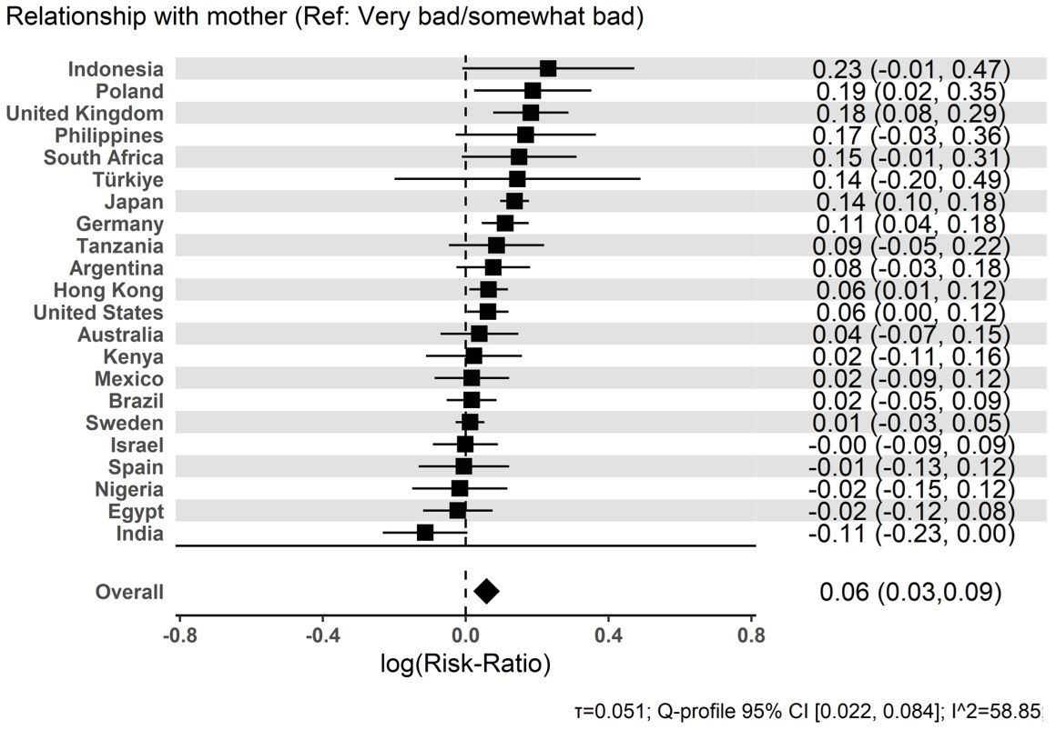

Figure S2. Forest plot for ‘Relationship with father’ – ‘Very good / somewhat good’ effect

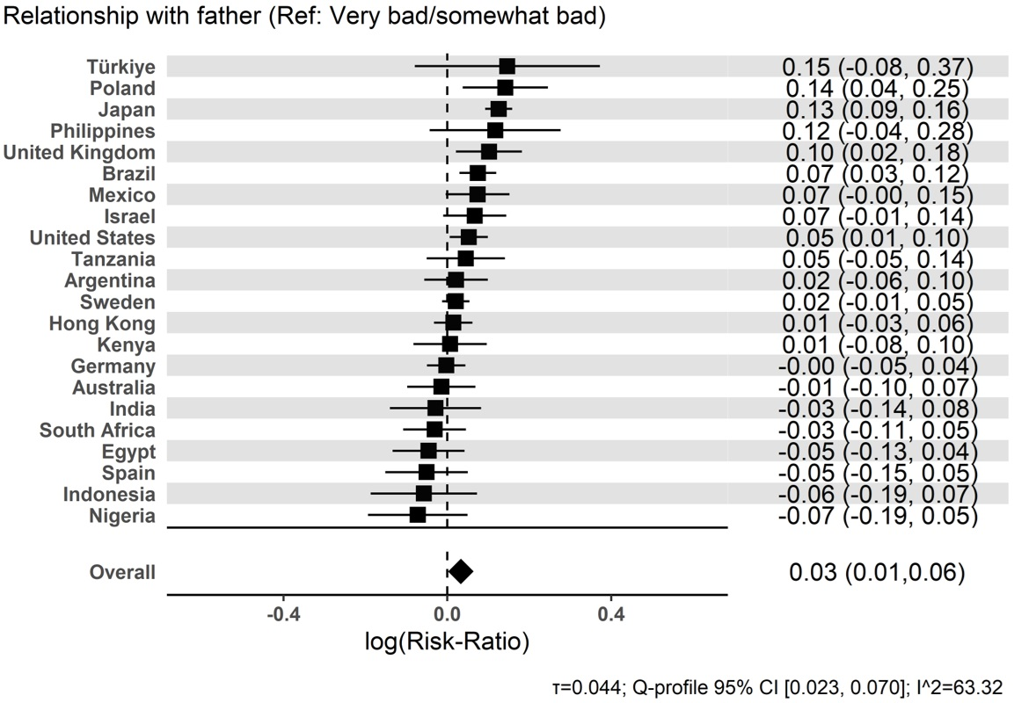

Figure S3. Forest plot for ‘Parent marital status’ – ‘Divorced’ effect

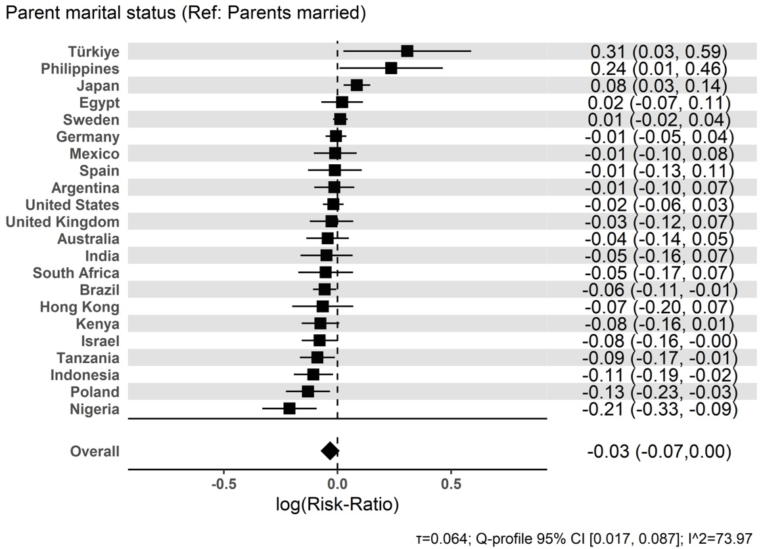

Figure S4. Forest plot for ‘Parent marital status’ – ‘Single, never married’ effect

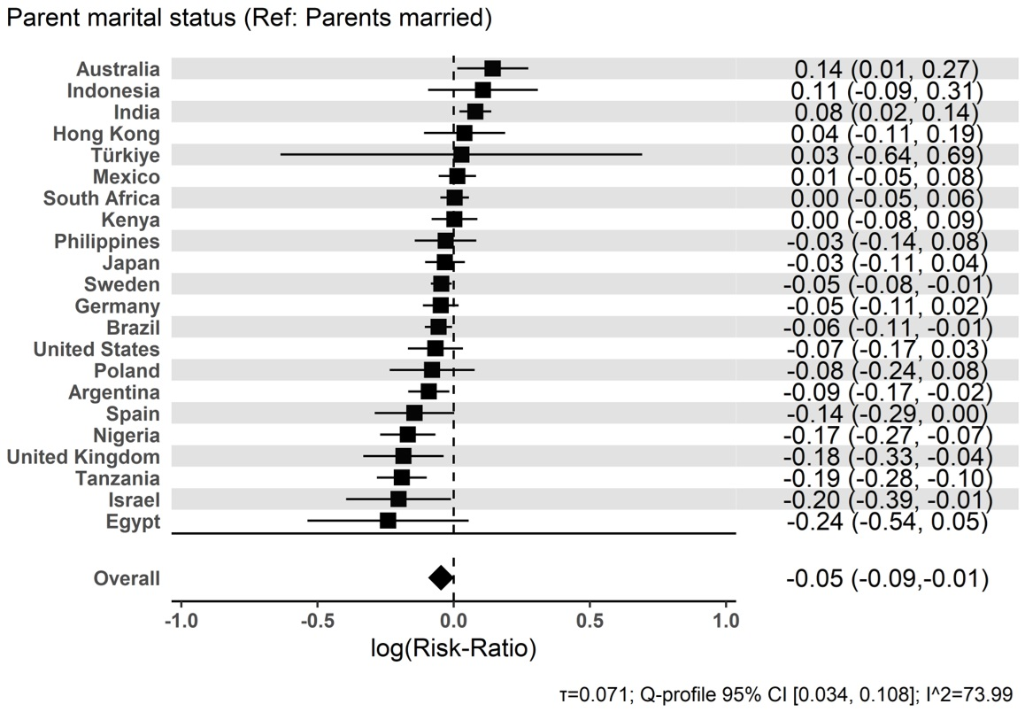

Figure S5. Forest plot for ‘Parent marital status’ – ‘One or more parents had died’ effect

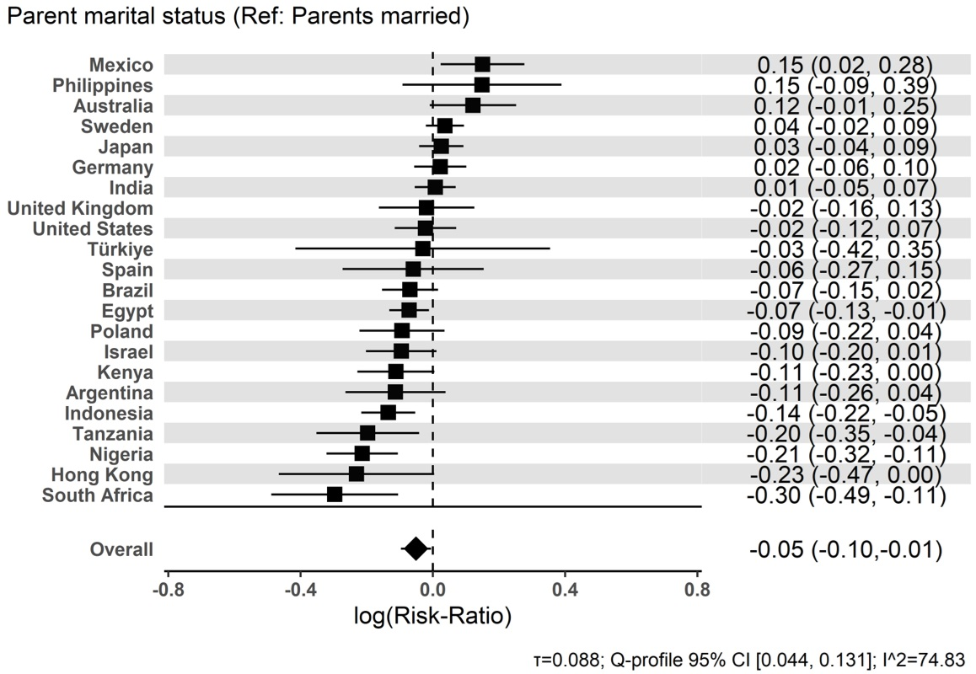

Figure S6. Forest plot for ‘Subjective financial status of family growing up’ – ‘Lived comfortably’ effect

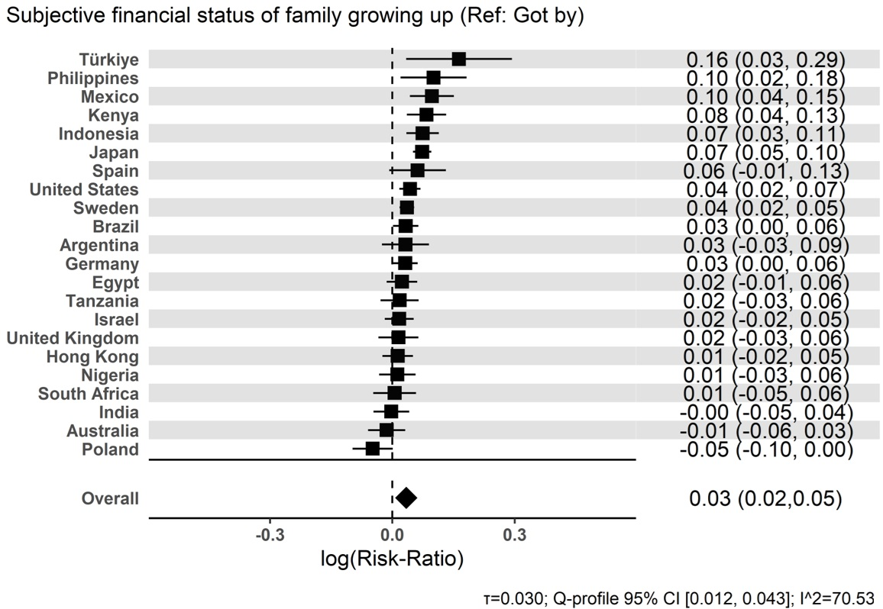

Figure S7. Forest plot for ‘Subjective financial status of family growing up’ – ‘Found it difficult’ effect

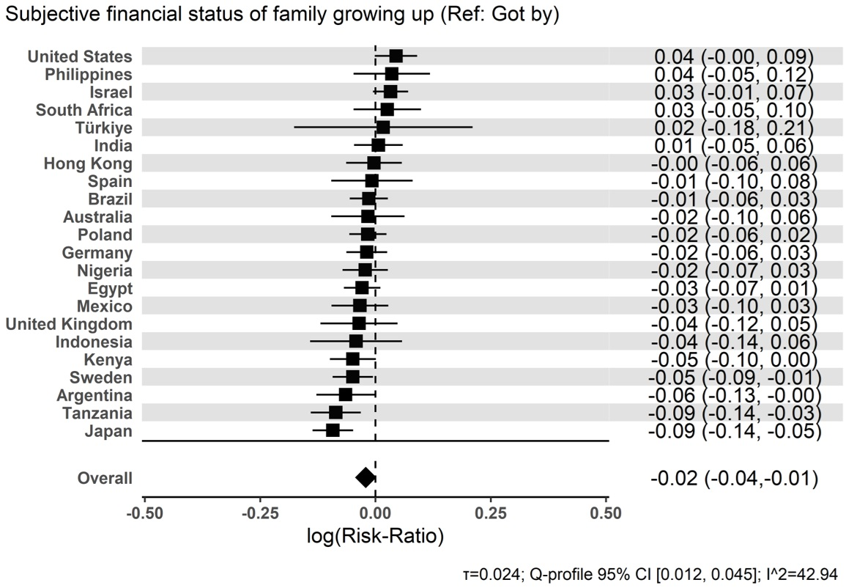

Figure S8. Forest plot for ‘Subjective financial status of family growing up’ – ‘Found it very difficult’ effect

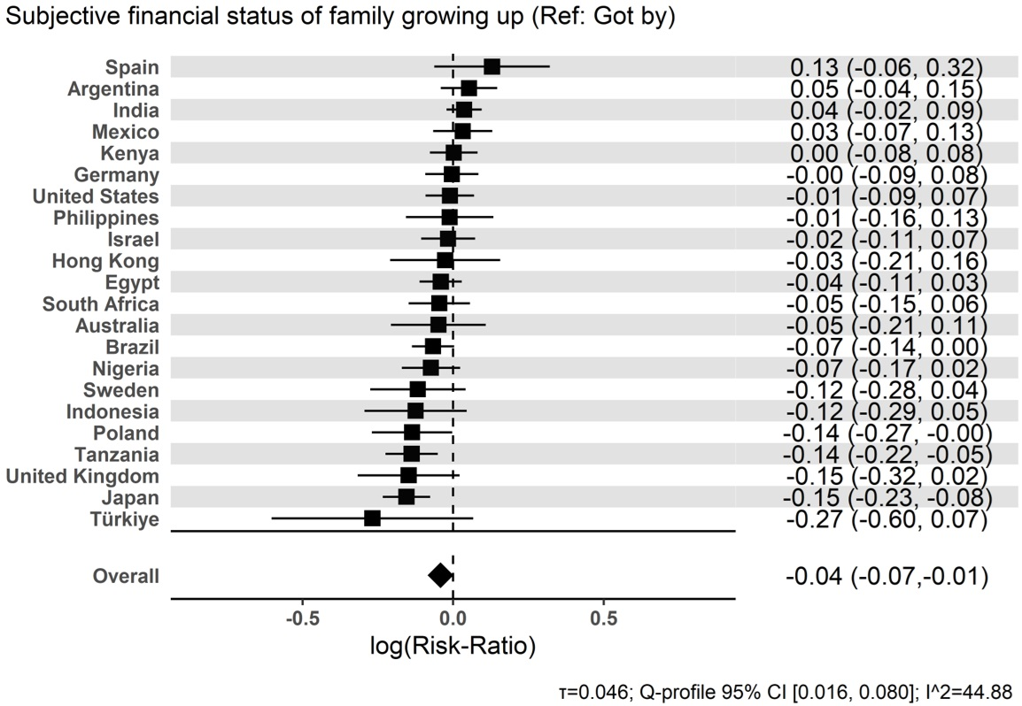

Figure S9. Forest plot for ‘Abuse’ – ‘Yes’ effect

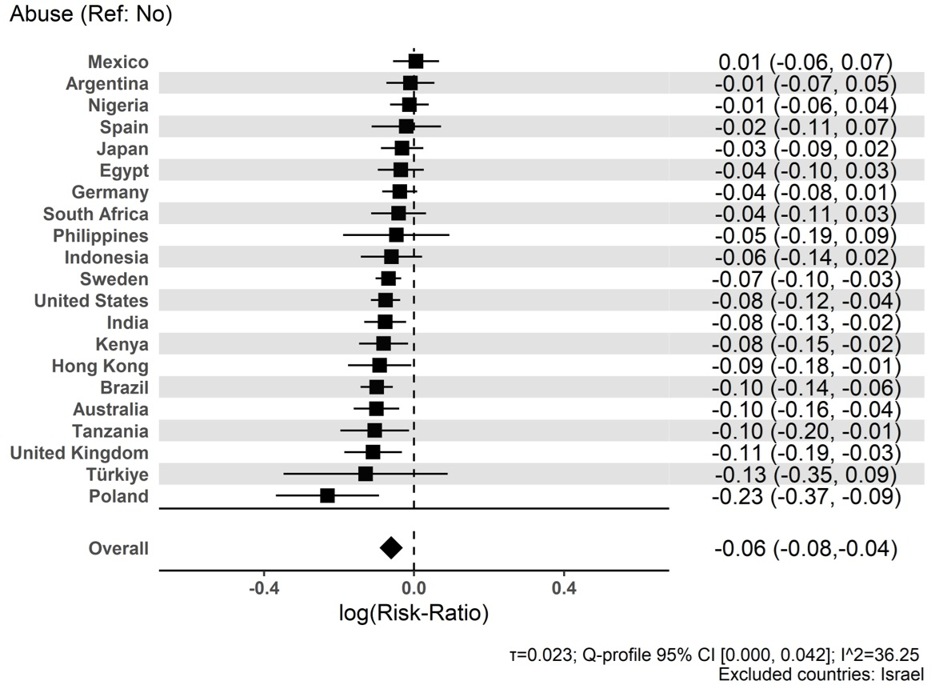

Figure S10. Forest plot for ‘Outsider growing up’ – ‘Yes’ effect

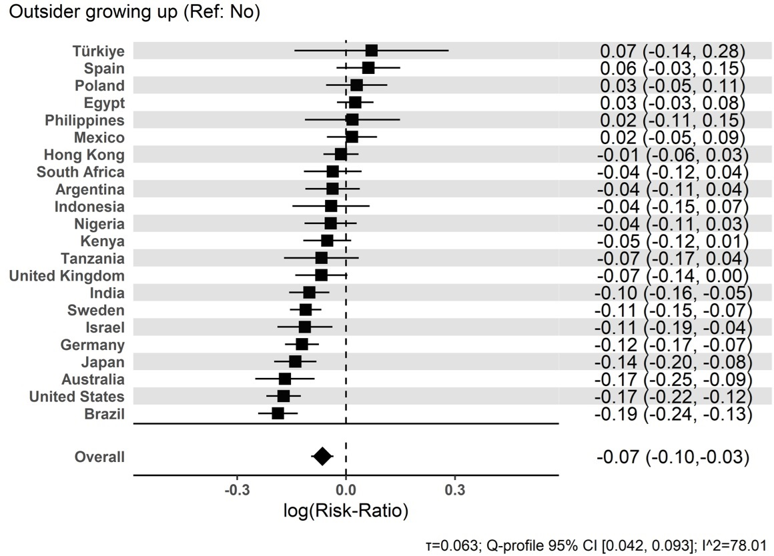

Figure S11. Forest plot for ‘Self-rated health growing up’ – ‘Excellent’ effect

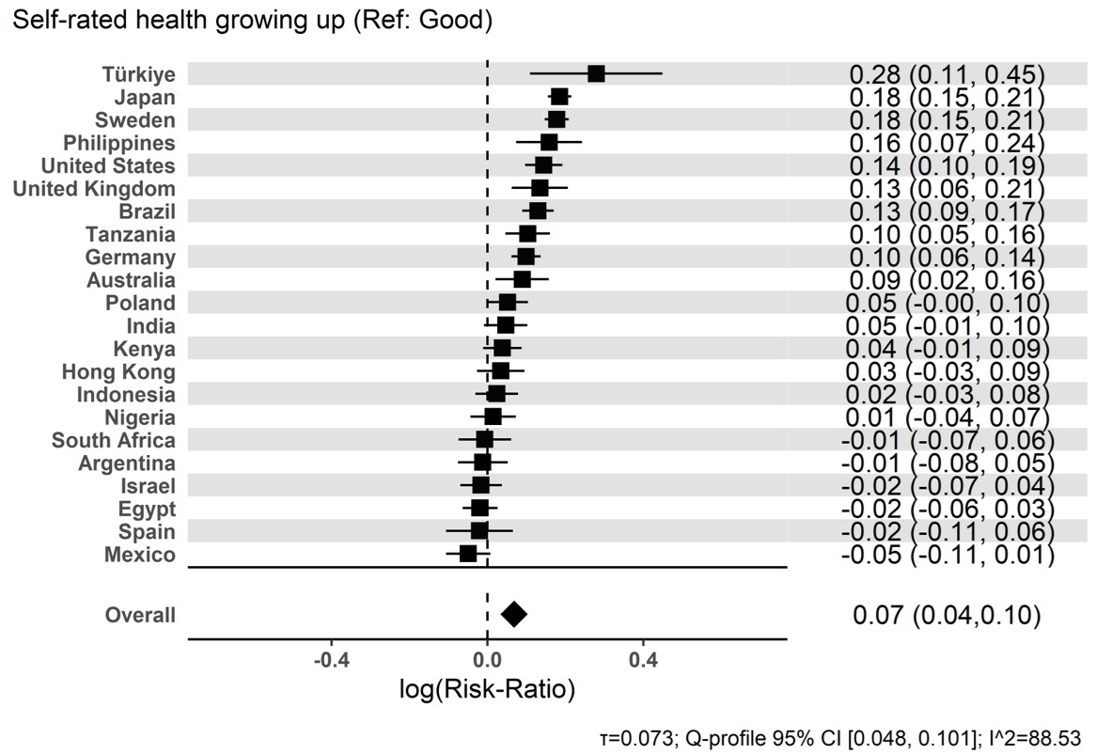

Figure S12. Forest plot for ‘Self-rated health growing up’ – ‘Excellent’ effect

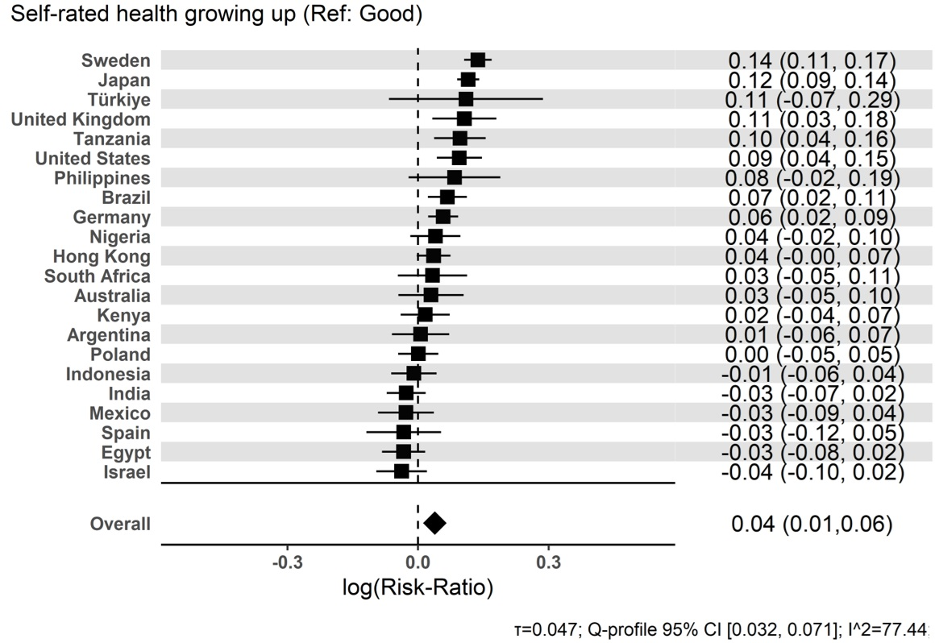

Figure S13. Forest plot for ‘Self-rated health growing up’ – ‘Good’ effect

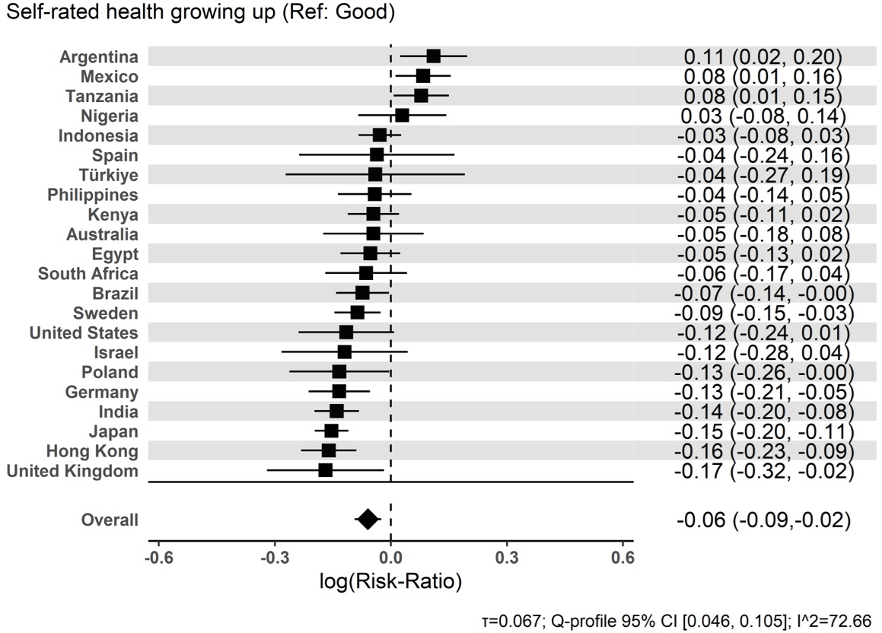

Figure S14. Forest plot for ‘Self-rated health growing up’ – ‘Poor’ effect

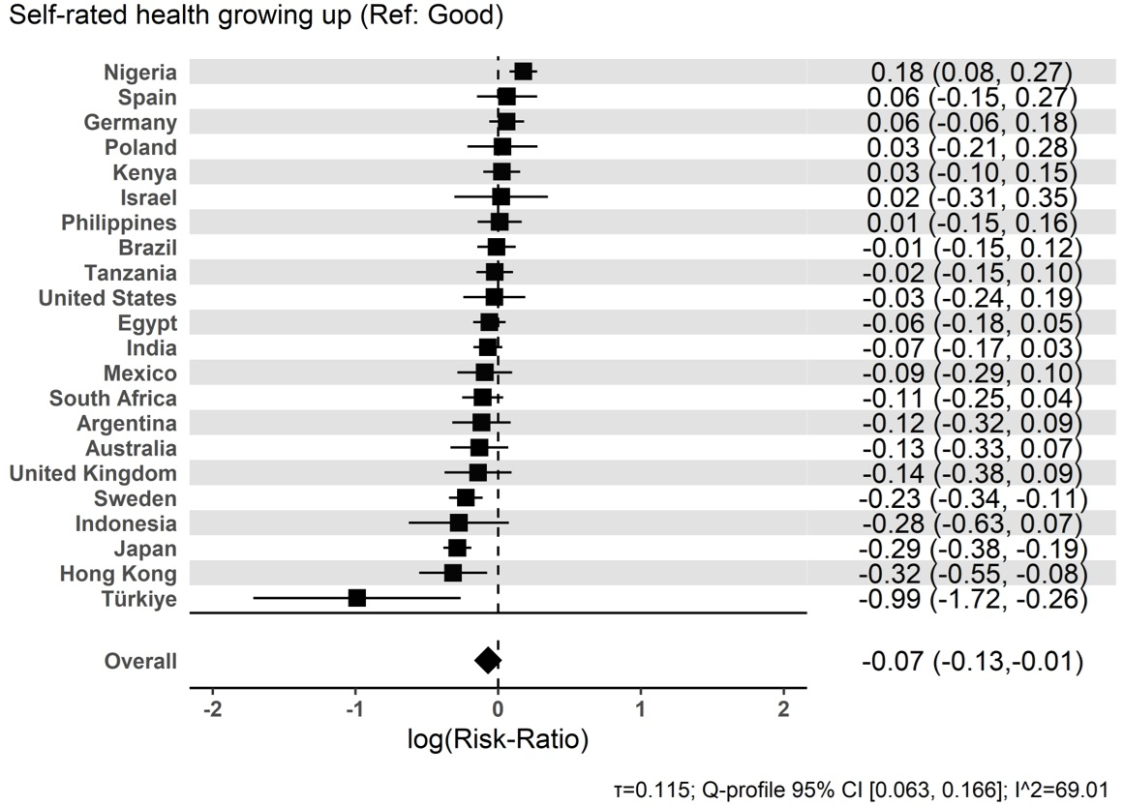

Figure S15. Forest plot for ‘Immigration status’ – ‘Born in another country’ effect

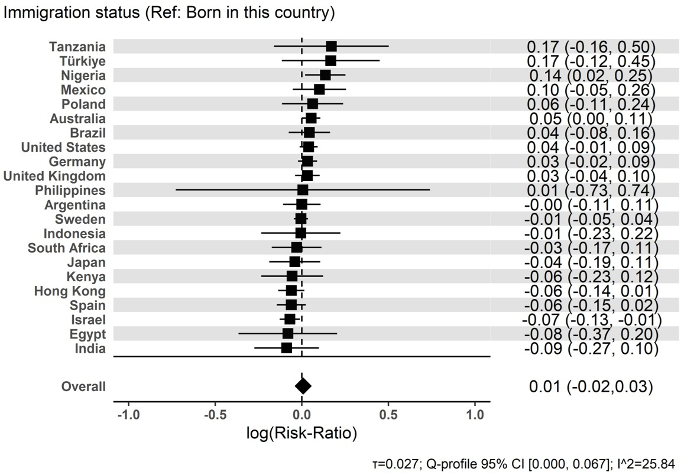

Figure S16. Forest plot for ‘Age 12 religious service attendance’ – ‘At least 1/week’ effect

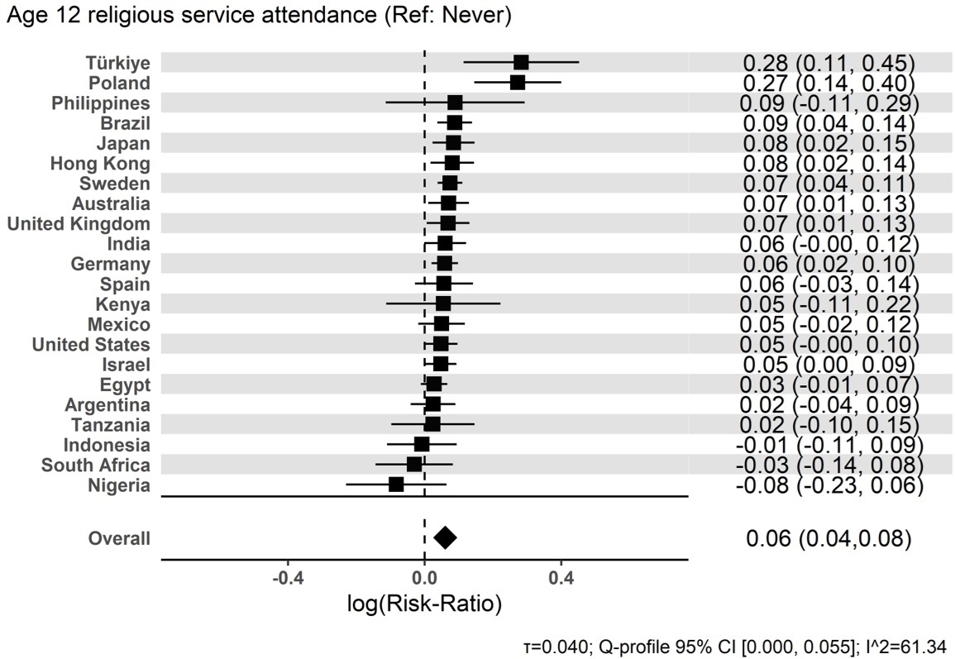

Figure S17. Forest plot for ‘Age 12 religious service attendance’ – ‘1-3/month’ effect

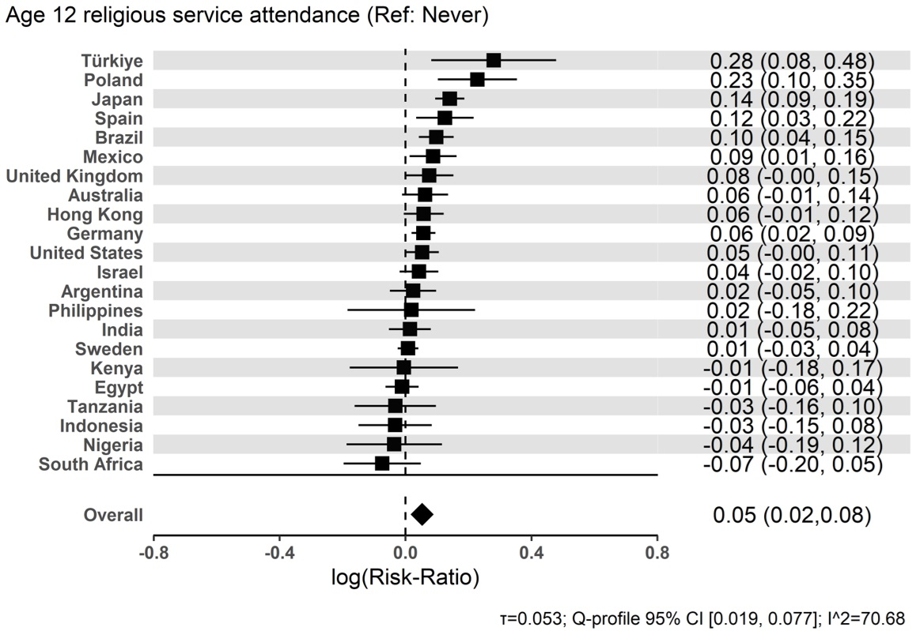

Figure S18. Forest plot for ‘Age 12 religious service attendance’ – ‘< 1/month’ effect

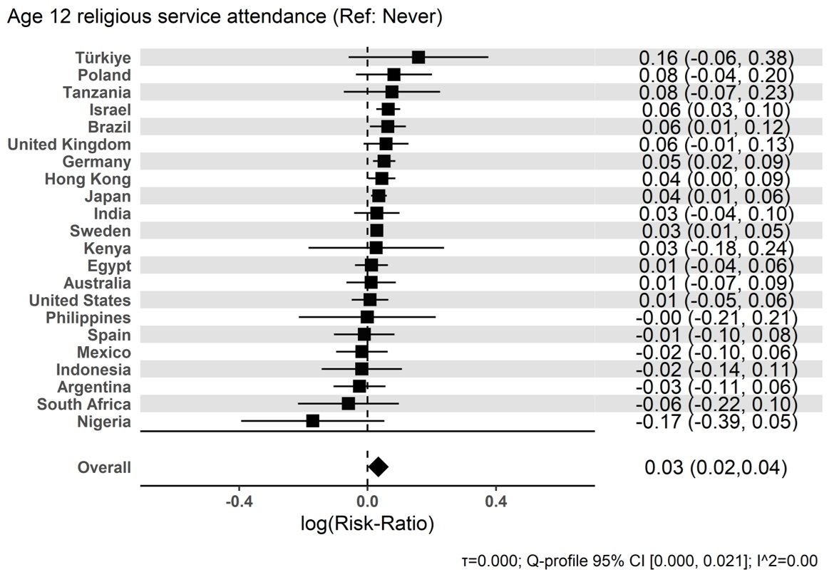

Figure S19. Forest plot for ‘Year of birth’ – ‘1993-1998; age 25-29’ effect

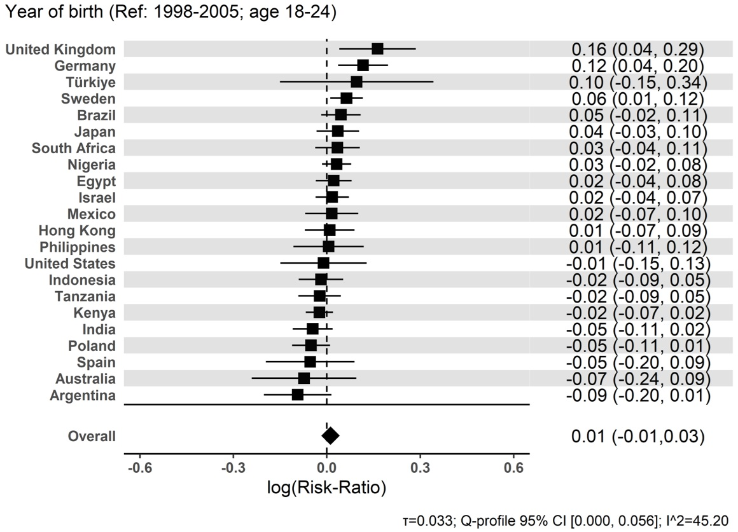

Figure S20. Forest plot for ‘Year of birth’ – ‘1983-1993; age 30-39’ effect

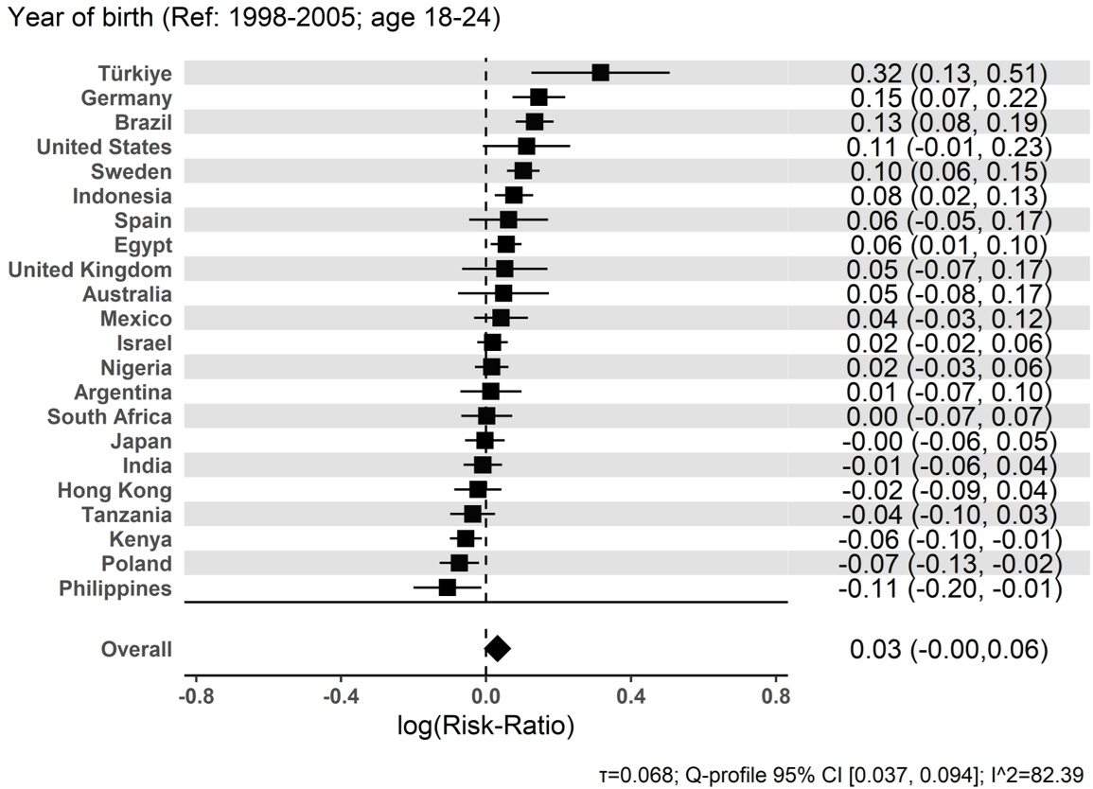

Figure S21. Forest plot for ‘Year of birth’ – ‘1973-1983; age 40-49’ effect

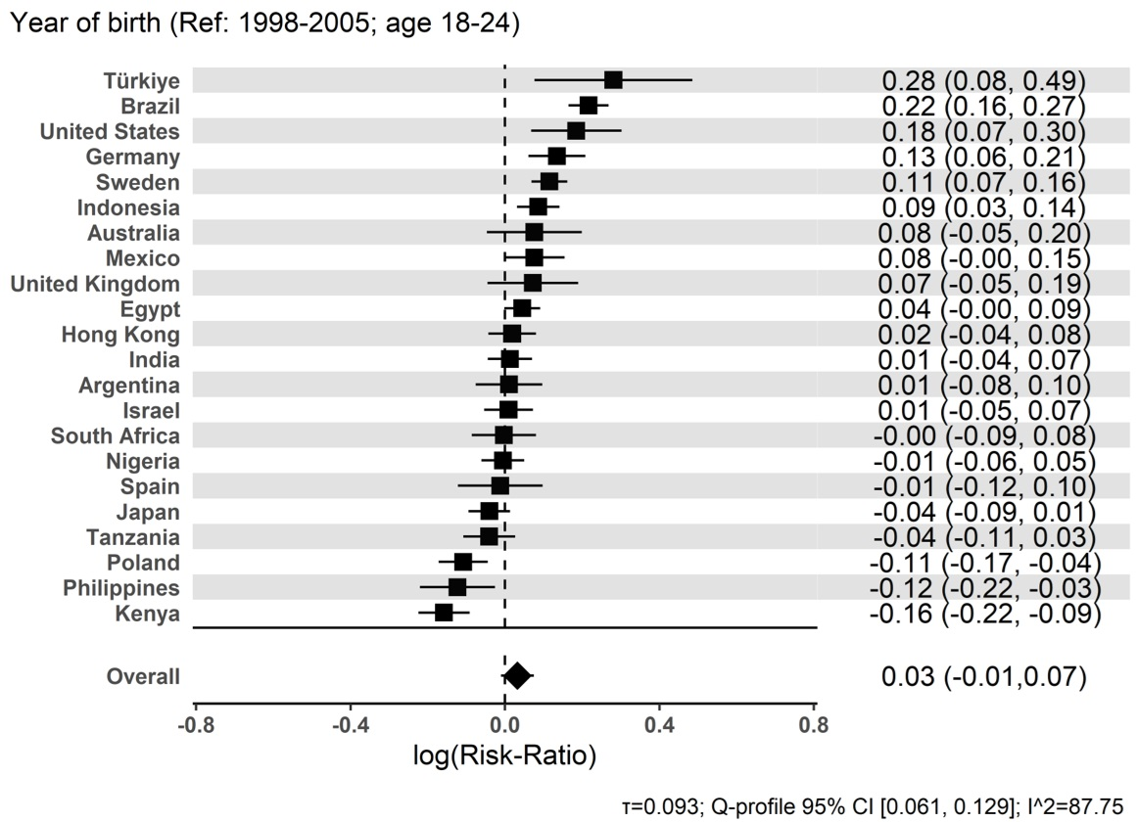

Figure S22. Forest plot for ‘Year of birth’ – ‘1963-1973; age 50-59’ effect

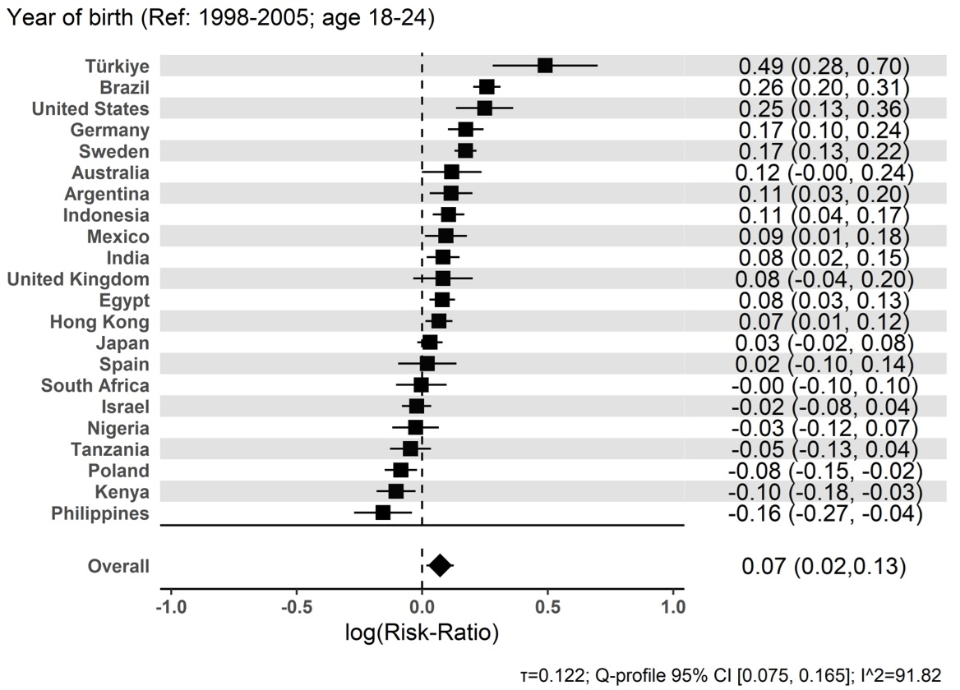

Figure S23. Forest plot for ‘Year of birth’ – ‘1963-1973; age 60-69’ effect

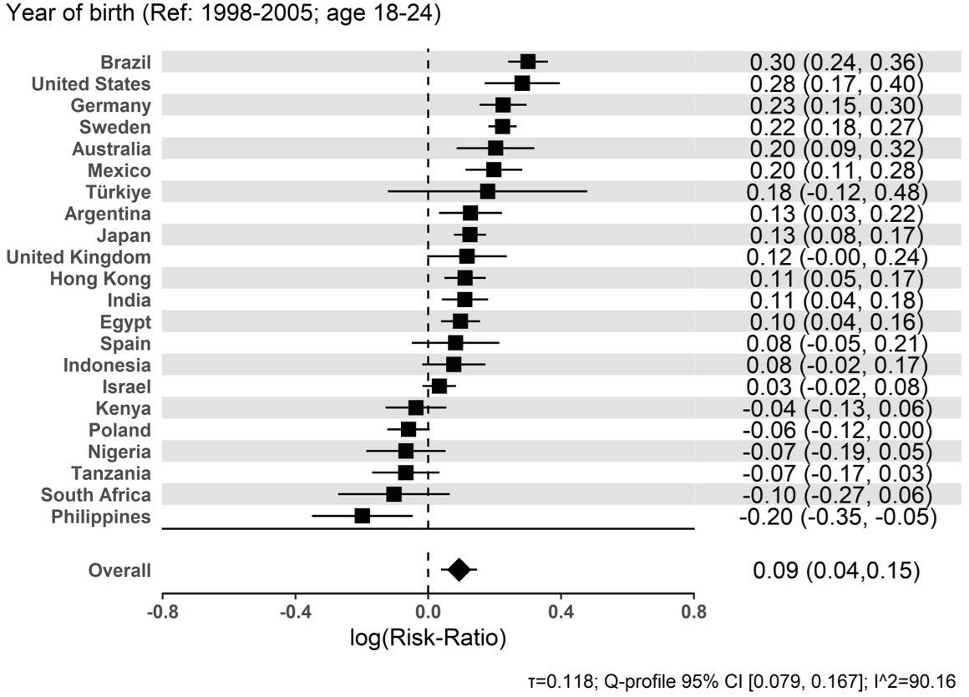

Figure S24. Forest plot for ‘Year of birth’ – ‘1943-1953; age 70-79’ effect

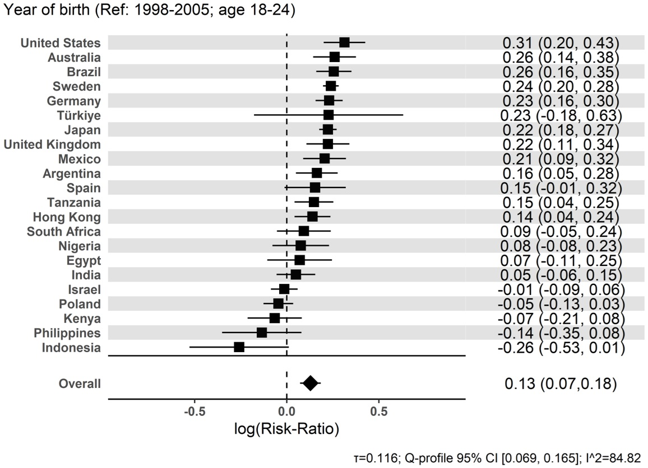

Figure S25. Forest plot for ‘Year of birth’ – ‘1943 or earlier; 80+’ effect

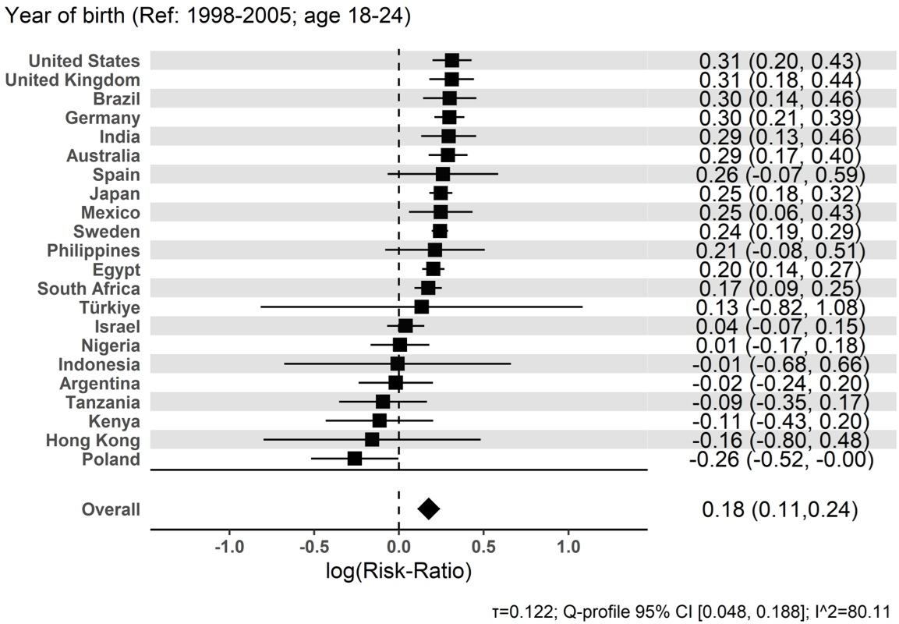

Figure S26. Forest plot for ‘Gender’ – ‘Female’ effect

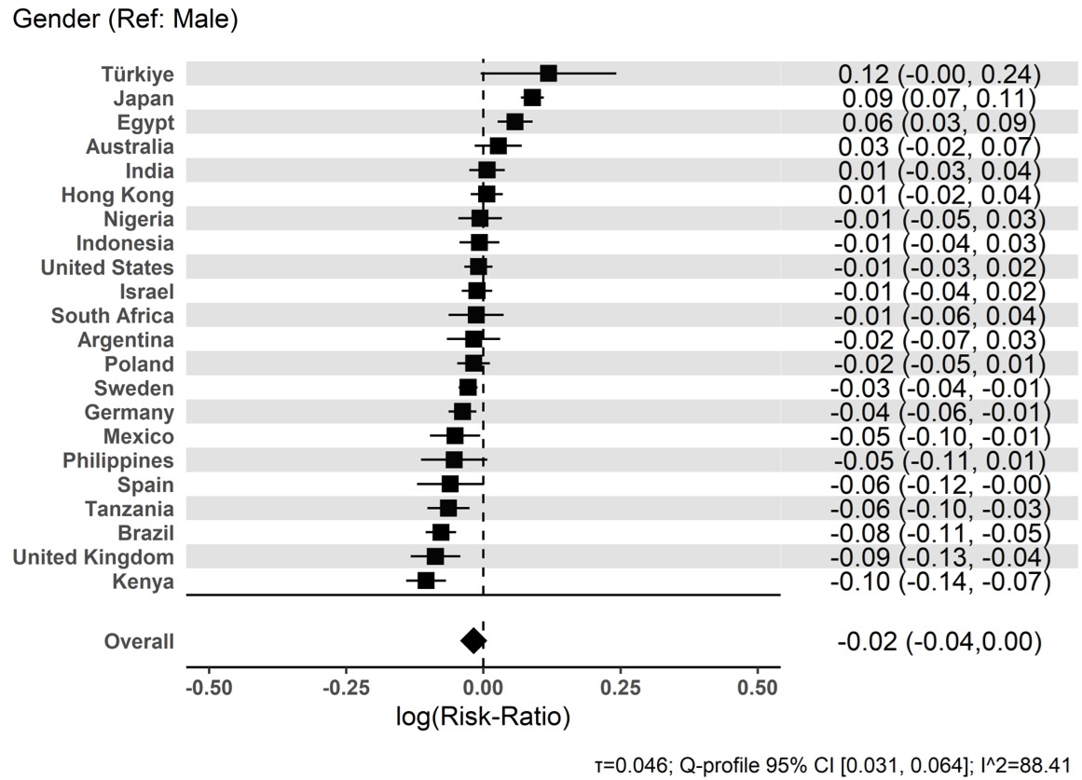

Figure S27. Forest plot for ‘Gender’ – ‘Other’ effect

