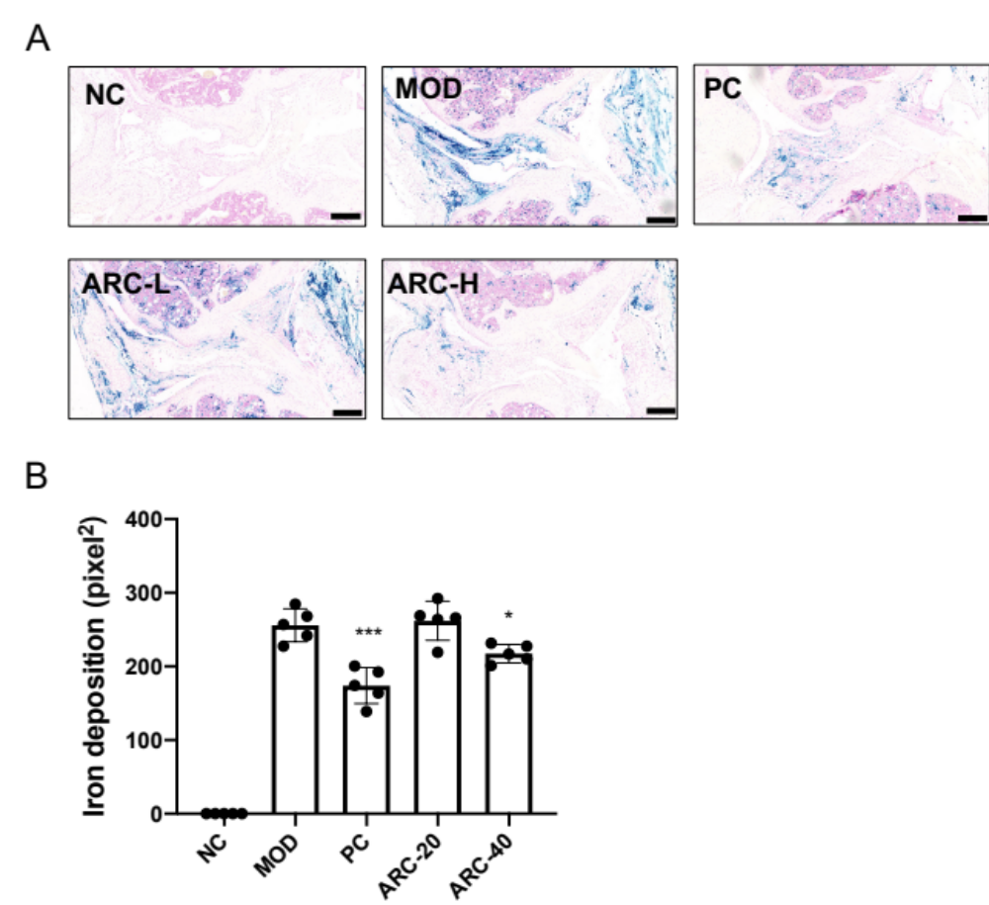
Supplementary Fig. 1. ARC declined iron deposition in the knee joint. (Data were presented as mean ± SD. n = 3 per group. Significant differences between the MOD and other groups were shown as * (p-value < 0.05), and *** (p-value < 0.001))

Supplementary Fig. 2. SBP thickness of femur and tibia. (Data were presented as mean ± SD. n = 3 per group. Significant differences between the MOD and other groups were shown as * (p-value < 0.05))

Original blots

AKT

p-AKT

BAX

BCL2

GPX4

HO-1

MMP13

NRF2

SOX9

xCT

β-ACTIN

