Supplementary Information

Self-Propelling, Protein-Bound Magnetic Nanobots for Efficient In Vitro Drug Delivery in Triple Negative Breast Cancer Cells
Neha Naikwadi¹, Milan Paul², Swati Biswas²*, Sohan Chitlange¹, Ravindra Wavhale¹*
¹Department of Pharmaceutical Chemistry, Dr. D. Y. Patil Institute of Pharmaceutical Sciences and Research, Pimpri, Pune, India.
²Nanomedicine Research Laboratory, Department of Pharmacy, Birla Institute of Technology & Science-Pilani, Hyderabad Campus, Medchal, Hyderabad 500078, Telangana, India
* Corresponding author’s email:
ravindra.wavhale@dypvp.edu.in
swati.biswas@hyderabad.bits-pilani.ac.in

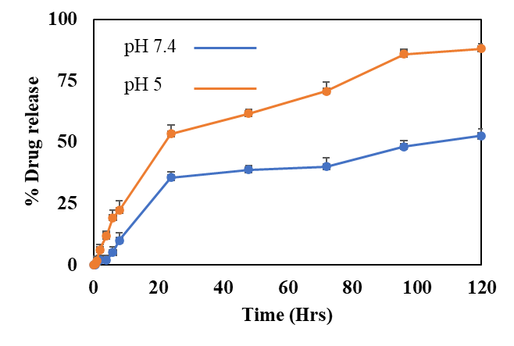

Figure S1 pH-dependent controlled release of DOX under two different pH conditions: one representing the physiological pH (7.4) and the other representing the lysosomal pH (~5).

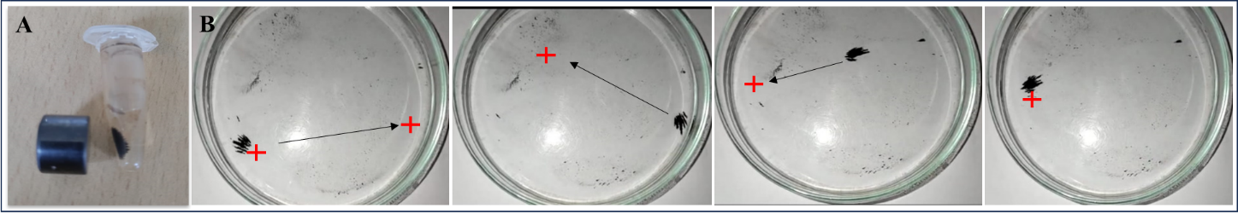
Figure S2. A. Fe-GSH-Protein-Dox nanobots are drawn from the solution to the sidewall of the tube when exposed to a magnetic field due to the presence of Fe₃O₄. B. Fe-GSH-Protein-Dox nanobots exhibited successful localization at a designated point where the magnetic field was strongest

Sample code | IC₅₀ value 24 h (µg/mL) | IC₅₀ value 48 h (µg/mL)
Fe | 62.35 | 56.32
Fe-GSH | 38.60 | 34.32
Fe-GSH-Protein | 33.20 | 27.24
Fe-GSH-Protein-Dox (A) | 6.30 | 4.2
Fe-GSH-Protein-Dox (C) | 8.52 | 6.23
Dox | 9.63 | 7.90

Sample code | IC₅₀ value 24 h (µg/mL) | IC₅₀ value 48 h (µg/mL)
Fe | 65.60 | 60.10
Fe-GSH | 43.20 | 35.70
Fe-GSH-Protein | 39.35 | 30.24
Fe-GSH-Protein-Dox (A) | 7.63 | 5.20
Fe-GSH-Protein-Dox (C) | 9.10 | 8.32
Dox | 10.20 | 8.32

Table S1: IC₅₀ value of MDA-MB-231 and 4T1 cell lines at 24 h and 48 h.

Video S1: Propulsion of Fe-GSH-Protein-Dox nanobots in PBS with 4% H₂O₂.

Video S2: Propulsion of Fe-GSH-Protein-Dox nanobots in Serum with 4% H₂O_{2.}

Video S3: Propulsion of Fe-GSH-Protein-Dox nanobots under magnetic field.

