Supplemental Material

Prediction of Ischemic Stroke in Patients With H-type Hypertension Based on Biomarker
Ke Chen, Jianxun He, Lan Fu, Xiaohua Song, Ning Cao, Hui Yuan

TRIPOD Checklist
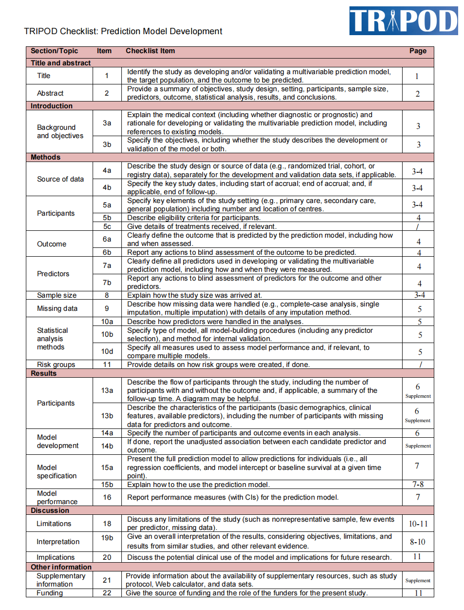

Supplementary Table 1. Baseline clinical and biochemical characteristics of the training set and validation set
Variable | Training set  (n=2340) | Internal validation set  (n=965) | P value
Age, years, median (IQR) | 56 (42-67) | 55 (42-66) | 0.371
Male, % | 1652 (70.6%) | 701 (72.6%) | 0.238
BMI, median (IQR) | 26.26 (24.00-28.76) | 26.30 (24.12-29.03) | 0.424
SBP, mmHg, median (IQR) | 142 (130-155) | 141 (130-155) | 0.918
DBP, mmHg, median (IQR) | 86 (78-96) | 85 (77-96) | 0.153
Smoke, % | 1069 (45.7%) | 465 (48.2%) | 0.190
Drink, % | 957 (40.9%) | 459 (47.6%) | <0.001
Diabetes mellitus, % | 700 (29.9%) | 304 (31.5%) | 0.367
Hyperlipidemia, % | 1908 (81.5%) | 797 (82.6%) | 0.476
Coronary heart disease, % | 503 (21.5%) | 187 (19.4%) | 0.173
Atrial fibrillation, % | 109 (4.7%) | 66 (6.8%) | 0.011
Antihypertensive drugs, % | 1572 (67.2%) | 634 (65.7%) | 0.412
Antiplatelet drugs, % | 149 (6.4%) | 60 (6.2%) | 0.872
Family history of cerebral infarction, % | 141 (6.0%) | 60 (6.2%) | 0.834
hs-CRP, mg/L, median (IQR) | 1.35 (0.68-3.20) | 1.28 (0.62-3.34) | 0.161
Na, mmol/L, median (IQR) | 140.6 (139.0-142.0) | 140.5 (139.1-141.9) | 0.607
K, mmol/L, median (IQR) | 4.04 (3.80-4.26) | 4.06 (3.83-4.28) | 0.127
Mg, mmol/L, median (IQR) | 0.90 (0.85-0.95) | 0.90 (0.86-0.96) | 0.272
TBil, μmol/L, median (IQR) | 13.00 (10.08-16.83) | 13.25 (10.20-17.19) | 0.130
DBil, μmol/L, median (IQR) | 4.18 (3.01-5.54) | 4.19 (2.97-5.74) | 0.664
Urinary protein, % |  |  | 0.040
- | 1957 (83.6%) | 780 (80.8%)
+ | 275 (11.8%) | 147 (15.2%)
++ | 76 (3.2%) | 29 (3.0%)
+++ | 32 (1.4%) | 9 (0.9%)
Hcy, μmol/L, % |  |  | 0.322
< 15 | 1455 (62.2%) | 574 (59.5%)
15-30 | 702 (30.0%) | 314 (32.5%)
>30 | 183 (7.8%) | 77 (8.0%)
Carotid artery stenosis, % | 178 (7.6%) | 84 (8.7%) | 0.288
Outcome |  |  | 0.251
Non-stroke | 1353 (57.8%) | 537 (55.6%)
Stroke | 987 (42.2%) | 428 (44.4%)
IQR, interquartile range; BMI, body mass index; SBP, systolic blood pressure; DBP, diastolic blood pressure; hs-CRP, hypersensitive C-reactive protein; Na, sodium; K, potassium; Mg, magnesium; TBil, total bilirubin; DBil, direct bilirubin; Hcy, homocysteine.

Supplementary Table 2. Univariate logistic regression analyses of factors potentially associated with ischemic stroke in the training set
Variable | OR (95%CI) | P value
Age | 1.102 (1.093-1.111) | <0.001
Female | 0.933 (0.779-1.118) | 0.452
BMI | 0.921 (0.901-0.941) | <0.001
SBP (mmHg) | 1.011 (1.007-1.016) | <0.001
DBP (mmHg) | 0.969 (0.963-0.975) | <0.001
Smoke | 1.169 (0.991-1.378) | 0.063
Drink | 0.886 (0.750-1.047) | 0.156
Diabetes mellitus | 3.124 (2.600-3.753) | <0.001
Hyperlipidemia | 6.546 (4.865-8.807) | <0.001
Coronary heart disease | 2.049 (1.678-2.502) | <0.001
Atrial fibrillation | 14.973 (7.771-28.849) | <0.001
Antihypertensive drugs | 0.706 (0.593-0.840) | <0.001
Antiplatelet drugs | 0.975 (0.697-1.366) | 0.884
Family history of ischemic stroke | 1.221 (0.868-1.718) | 0.252
hs-CRP (mg/L) | 1.108 (1.086-1.130) | <0.001
Na (mmol/L) | 1.051 (1.018-1.085) | 0.002
K (mmol/L) | 0.181 (0.140-0.234) | <0.001
Mg (mmol/L) | 0.004 (0.001-0.013) | <0.001
TBil (μmol/L) | 1.002 (0.991-1.014) | 0.702
DBil (μmol/L) | 1.071 (1.031-1.113) | <0.001
Urinary protein
+ | 6.718 (4.957-9.106) | <0.001
++ | 3.259 (2.019-5.260) | <0.001
+++ | 3.428 (1.643-7.152) | 0.001
Hcy (μmol/L)
15-30 | 0.907 (0.664-1.239) | 0.539
>30 | 1.330 (0.957-1.848) | 0.090
Carotid artery stenosis | 1.216 (0.895-1.652) | 0.212
BMI, body mass index; SBP, systolic blood pressure; DBP, diastolic blood pressure; hs-CRP, hypersensitive C-reactive protein; Na, sodium; K, potassium; Mg, magnesium; TBil, total bilirubin; DBil, direct bilirubin; Hcy, homocysteine.

Supplementary Table 3. Predict performances of four models on the external validation set
 | AUC (95%CI) | Sensitivity | Specificity | Accuracy | PPV | NPV
Logistic model | 0.872 (0.805-0.939)ª | 0.952 | 0.656 | 0.777 | 0.656 | 0.952
SVM model | 0.881 (0.817-0.945)ª | 0.976 | 0.656 | 0.786 | 0.661 | 0.976
Random forest model | 0.812 (0.728-0.895)^{b} | 0.929 | 0.623 | 0.748 | 0.629 | 0.927
XGBoost model | 0.857 (0.787-0.927)^{ab} | 0.929 | 0.672 | 0.777 | 0.661 | 0.923
ª: There was no significant difference in AUC among the logistic model, SVM model and XGBoost model by Delong test; ^{b}: There was no significant difference in AUC between the random forest model and XGBoost model. AUC: area under curve; CI: confidence interval; PPV: positive predictive value; NPV: negative predictive value; SVM: support vector machine.

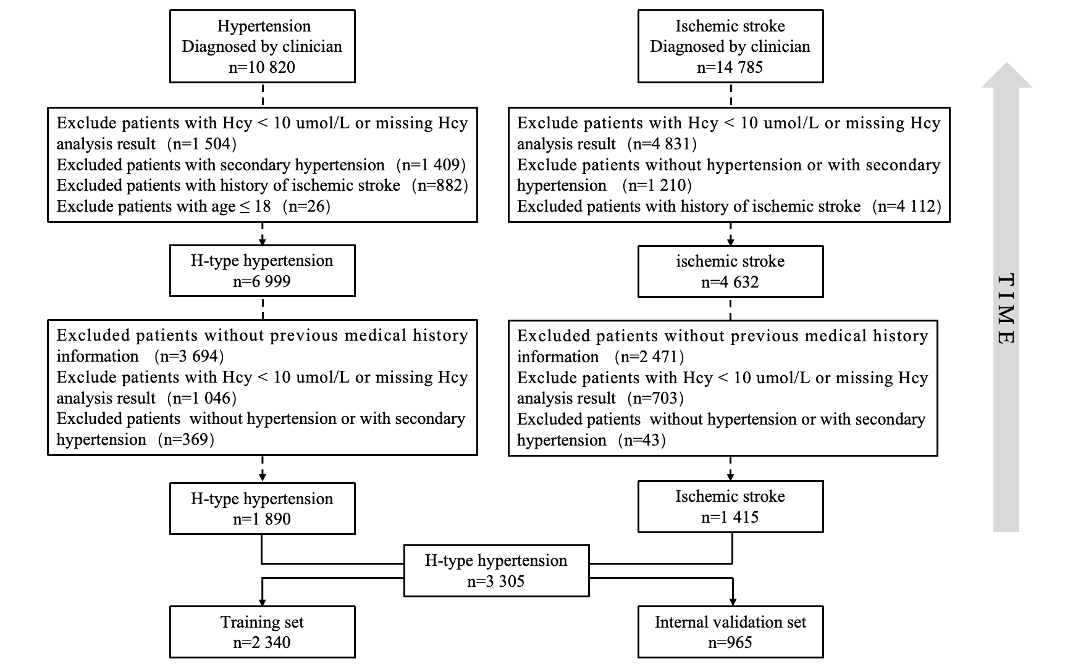
Supplementary Figure 1. Consort diagram of development cohort.

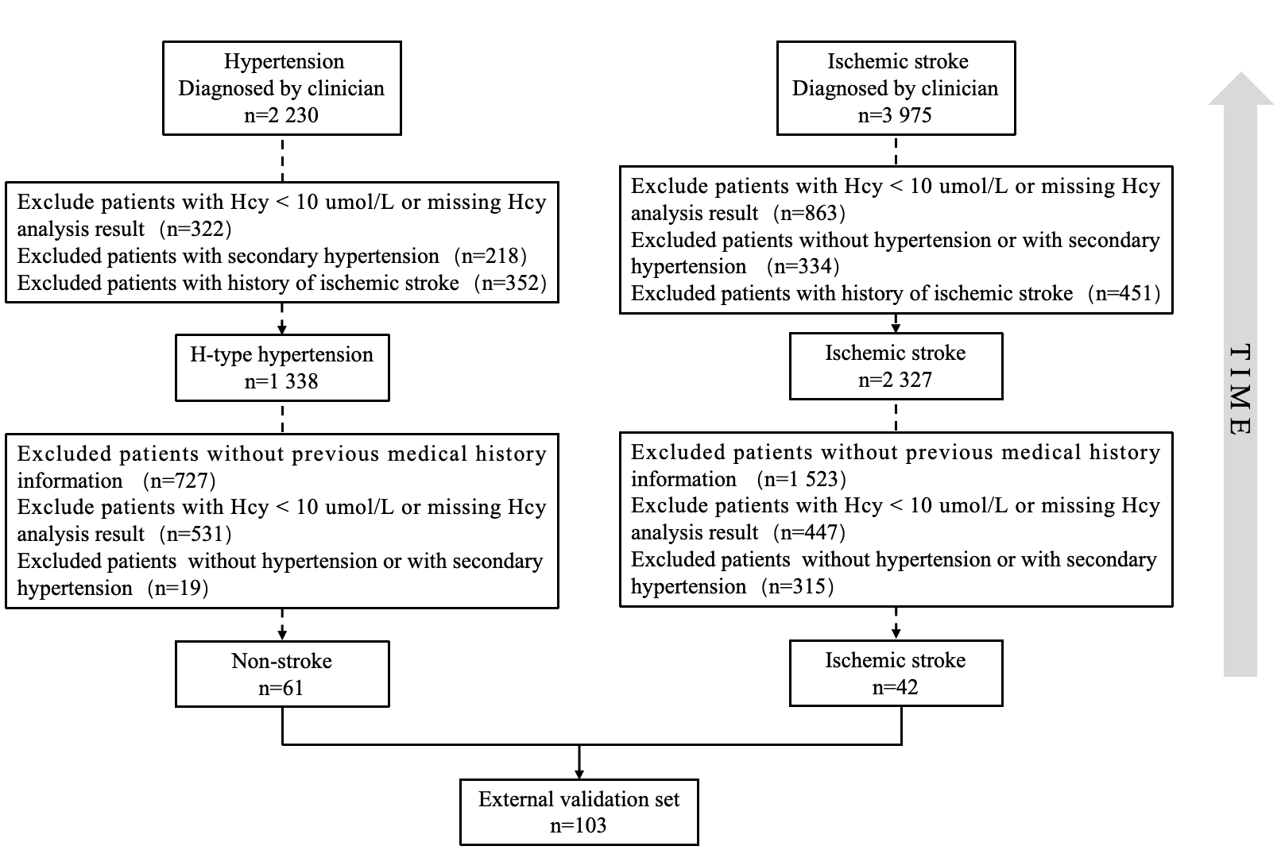
Supplementary Figure 2. Consort diagram of external validation cohort.

Supplementary Figure 3. Variable importance. Importance of each variable in the logistic model.

Supplementary Figure 4. Receiver operating characteristic (ROC) curves of the logistic model in external validation cohort.

Supplementary Figure 5. Calibration for the logistic model in external validation cohort.

Supplementary Figure 6. Decision-curve analysis of the logistic model in external validation cohort.

