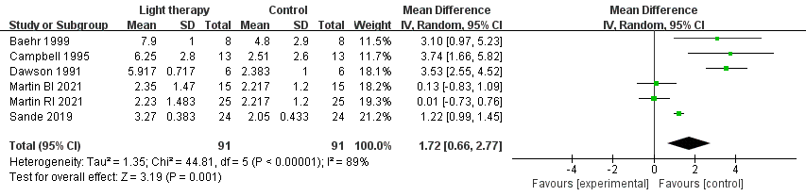
Figure S1. Forest plot: Rhythm phase shift, light therapy (LT) group vs. control group.

Table S1. Search strategy
Search Number | Search Details | Results
Cochrane | (((shift work sleep disorder) OR (Sleep Wake Schedule Disorders) OR (Circadian Rhythm Sleep Disorders) OR (Sleep-Wake Cycle Disorder) OR (Delayed Sleep Phase Syndrome) OR (Advanced Sleep Phase Syndrome))) AND (((Phototherapy or Photoradiation Therapy) OR (Therapies, Photoradiation) OR (Light Therapy) OR (Therapies, Light) OR (Blue Light Therapy) OR (Light Therapy, Blue) OR (Therapy, Blue Light) OR (Blue-light Therapy) OR (Red Light Phototherapy) OR (Light Phototherapy, Red))) in Title Abstract Keyword.  Then define terms. | 288
PubMed | (("Phototherapy"[Mesh]) OR (((((((((((((((((Photoradiation Therapy) OR (Light Therapy)) OR (Blue Light Therapy)) OR (Red Light Phototherapy)) OR (Phototherapies)) OR (Photoradiation Therapies)) OR (Therapies, Photoradiation)) OR (Therapy, Photoradiation)) OR (Light Therapies)) OR (Therapies, Light)) OR (Therapy, Light)) OR (Light Therapies, Blue)) OR (Blue-light Therapy)) OR (Light Phototherapies, Red)) OR (Phototherapies, Red Light)) OR (bright light)) OR (lighting))) AND (("Sleep Disorders, Circadian Rhythm"[Mesh]) OR (((((((((((((shift work sleep disorder) OR (Sleep Wake Schedule Disorders)) OR (Sleep-Wake Cycle Disorder)) OR (Delayed Sleep Phase Syndrome)) OR (Advanced Sleep Phase Syndrome)) OR (Circadian Rhythm Sleep Disorders)) OR (Disturbed Nyctohemeral Rhythm)) OR (Nyctohemeral Rhythm, Disturbed)) OR (Sleep Disorder, Shift-Work)) OR (Non-24 Hour Sleep-Wake Disorder)) OR (Nonorganic Sleep Wake Cycle Disorders)) OR (Sleep-Wake Disorder, Non-24 Hour)) OR (shift worker))) Filters: Full text  Then define terms. | 2569
Web of science | (TS=((phototherapy OR Phototherapies OR (light therapy) OR (light therapies)))) AND TS=((Sleep Wake Schedule Disorders) OR (shift work sleep disorder) OR (Sleep-Wake Cycle Disorder) OR (Delayed Sleep Phase Syndrome) OR (Advanced Sleep Phase Syndrome))  Then define terms. | 1732
Scopus | TITLE-ABS-KEY ( ( ( sleep AND disorder ) OR ( shift AND work ) OR ( shift AND work AND sleep AND disorder ) OR ( sleep AND wake AND schedule AND disorders ) OR ( circadian AND rhythm AND sleep AND disorders ) OR ( sleep-wake AND cycle AND disorder ) OR ( delayed AND sleep AND phase AND syndrome ) OR ( advanced AND sleep AND phase AND syndrome ) ) AND ( ( phototherapy ) OR ( photoradiation AND therapy ) OR ( therapies AND photoradiation ) OR ( light AND therapy ) OR ( therapies AND light ) OR ( blue AND light AND therapy ) OR ( light AND therapy AND blue ) OR ( therapy AND blue AND light ) OR ( blue-light AND therapy ) OR ( red AND light AND phototherapy ) OR ( light AND phototherapy AND red ) ) ).  Then define terms | 1366
Embase | ((shift work sleep disorder or Sleep Wake Schedule Disorders or Circadian Rhythm Sleep Disorders or Sleep-Wake Cycle Disorder or Delayed Sleep Phase Syndrome or Advanced Sleep Phase Syndrome).af.) AND ((Phototherapy or Photoradiation Therapy or Therapies, Photoradiation or Light Therapy or Therapies, Light or Blue Light Therapy or Light Therapy, Blue or Therapy, Blue Light or Blue-light Therapy or Red Light Phototherapy or Light Phototherapy, Red).af.).  Then define terms | 39

Table S2. Subgroup analysis of light therapy on rhythm phase shift.
 | Rhythm phase shift
Subgroup | k | MD (95%CI) | P(Z) | I²
Illuminance (lx)
< 900 | 2 | 0.06 (-0.53, -0.65) | 0.85 | 0%
> 900 | 4 | 2.78 (1.12, 4.43) | 0.001 | 89%
Duration of treatment (h/day)
< 4 | 3 | 3.50 (2.68, 4.32) | <0.00001 | 0%
> 4 | 3 | 0.52 (-0.40, 1.45) | 0.27 | 85%
Total time (h)
< 15 | 2 | 3.46 (2.56, 4.35) | <0.00001 | 0%
> 15 | 4 | 0.94 (-0.04, 1.93) | 0.06 | 84%

