Supplementary Material

Association between behavioral and sociodemographic factors and high subjective health among adolescents: A nationwide representative study in South Korea

Running Title: Subjective health among South Korean adolescents

Jaehyun Kong^{1,2†}, Seohyun Hong^{1,2†}, Seunghwan Lee^{1†}, Seokjun Kim^{1,2}, Soeun Kim^{1,3}, Jiyeon Oh^{1,2}, Wonwoo Jang^{1,2}, Hanseul Cho^{1,2}, Sooji Lee^{1,2}, Jiseung Kang^{4,5}, Yejun Son^{1,3}, Lee Smith⁶, Selin Woo^{1,2*}, Dong Keon Yon^{1,2,3,7*}

† These authors contributed equally to this work as the first authors.
* These authors contributed equally to this work.

Corresponding authors:
Selin Woo, PhD
Center for Digital Health, Medical Science Research Institute, Kyung Hee University College of Medicine, 23 Kyungheedae–ro, Dongdaemun–gu, Seoul 02453, South Korea
Email: dntpfls@naver.com

Dong Keon Yon, MD, PhD, FACAAI, FAAAAI
Department of Pediatrics, Kyung Hee University College of Medicine, 23 Kyungheedae–ro, Dongdaemun–gu, Seoul 02447, South Korea
Tel: +82–2–6935–2476
Fax: +82–504–478–0201
Email: yonkkang@gmail.com

Contents of supplementary appendix
Supplementary Material | Supplementary Material
Supplementary Table 1 | Detailed questionnaires and specific categorizations for behavioral factors
Supplementary Table 2 | Weighted prevalence of high subjective health among South Korean adolescents, 2006-2023
Supplementary Figure 1 | Trend of high subjective health among South Korean adolescents by grade before and during the COVID-19 pandemic, 2006-2023
Supplementary Figure 2 | Trend of high subjective health among South Korean adolescents by breakfast consumption before and during the COVID-19 pandemic, 2006-2023
Supplementary Figure 3 | Trend of high subjective health among South Korean adolescents by fruit intake before and during the COVID-19 pandemic, 2006-2023
Supplementary Figure 4 | Trend of high subjective health among South Korean adolescents by physical activity before and during the COVID-19 pandemic, 2006-2023
Supplementary Figure 5 | Trend of high subjective health among South Korean adolescents by sedentary behavior on weekdays before and during the COVID-19 pandemic, 2006-2023
Supplementary Figure 6 | Trend of high subjective health among South Korean adolescents by sedentary behavior on weekends before and during the COVID-19 pandemic, 2006-2023
Supplementary Figure 7 | Trend of high subjective health among South Korean adolescents by perceived sleep sufficiency before and during the COVID-19 pandemic, 2006-2023
Supplementary Figure 8 | Trend of high subjective health among South Korean adolescents by frequency of brushing teeth before and during the COVID-19 pandemic, 2006-2023
Supplementary Figure 9 | Trend of high subjective health among South Korean adolescents by alcohol consumption before and during the COVID-19 pandemic, 2006-2023
Supplementary Figure 10 | Trend of high subjective health among South Korean adolescents by current smoking status before and during the COVID-19 pandemic, 2006-2023
Supplementary Figure 11 | Trend of high subjective health among South Korean adolescents by academic achievement before and during the COVID-19 pandemic, 2006-2023
Supplementary Figure 12 | Trend of high subjective health among South Korean adolescents by household income before and during the COVID-19 pandemic, 2006-2023
Supplementary Figure 13 | Trend of high subjective health among South Korean adolescents by BMI before and during the COVID-19 pandemic, 2006-2023
Supplementary Figure 14 | Trend of high subjective health among South Korean adolescents by stress levels before and during the COVID-19 pandemic, 2006-2023

Supplementary Table 1. Detailed Questionnaires and Specific Categorizations for Behavioral Factors
Grade
Middle school | Grades 7-9
High school | Grades 10-12
Breakfast Consumption
How many days did you have breakfast in the past week?
*If you only had milk or juice for your meal, it is considered 'did not eat'.
*If you had substitutes like bread, porridge, or cereal, it is considered as having had a meal.
Rarely | 0-2 days
Often | 3-5 days
Usually | 6-7 days
Fruit Intake
How often did you eat fruits in the past week?
*Fruit juice is excluded.
Insufficient | Not everyday
Sufficient | Everyday
Physical Activity
How many days in the past week did you engage in vigorous physical activity for more than 20 minutes, to the extent that you were out of breath or sweating?
*Vigorous physical activity includes jogging, soccer, basketball, jump rope, taekwondo, hiking, fast cycling, fast swimming, carrying heavy objects, etc.
Insufficient | 0-2 days
Moderate | 3-4 days
Sufficient | 5-7 days
Sedentary Behavior on Weekdays
During the past week, how many hours per day did you usually spend sitting during leisure time on weekdays, such as watching TV, playing games, or using the internet?
*Excludes time spent watching TV or using a computer during school hours.
Rarely | Average 0 to 2 hours of sedentary behavior per day on weekdays
Often | Average 2 to 4 hours of sedentary behavior per day on weekdays
Usually | More than average 4 hours of sedentary behavior per day on weekdays
Sedentary Behavior on Weekends
During the past week, how many hours per day did you usually spend sitting during leisure time on weekends, such as watching TV, playing games, or using the internet?
Rarely | Average 0 to 2 hours of sedentary behavior per day on weekdays
Often | Average 2 to 4 hours of sedentary behavior per day on weekdays
Usually | More than average 4 hours of sedentary behavior per day on weekdays
Perceived sleep sufficiency
Do you believe the amount of sleep you have had over the past week is sufficient for fatigue recovery?
Sufficient | Very sufficient or sufficient
Moderate | Moderate
Insufficient | Insufficient or completely insufficient

Supplementary Table 2. Weighted prevalence (95% CI) of high subjective health among South Korean adolescents, 2006-2023
variable | 2006 | 2007 | 2008 | 2009 | 2010 | 2011 | 2012 | 2013 | 2014 | 2015 | 2016 | 2017 | 2018 | 2019 | 2020 | 2021 | 2022 | 2023
Total | 61.46 (60.98-61.93) | 63.03 (62.59-63.46) | 63.55 (63.13-63.98) | 65.05 (64.63-65.48) | 64.00 (63.57-64.43) | 66.06 (65.69-66.44) | 67.95 (67.58-68.32) | 69.49 (69.12-69.86) | 70.96 (70.60-71.32) | 72.67 (72.30-73.04) | 71.77 (71.40-72.15) | 71.82 (71.44-72.20) | 71.64 (71.25-72.04) | 69.98 (69.57-70.39) | 69.63 (69.21-70.05) | 64.67 (64.23-65.11) | 63.13 (62.68-63.59) | 64.37 (63.92-64.81)
Sex
Male | 64.18 (63.54-64.83) | 65.24 (64.66-65.83) | 66.44 (65.86-67.01) | 69.18 (68.61-69.74) | 69.07 (68.49-69.64) | 71.71 (71.20-72.21) | 73.63 (73.14-74.12) | 74.61 (74.11-75.10) | 75.54 (75.05-76.02) | 76.79 (76.31-77.28) | 76.64 (76.15-77.13) | 76.59 (76.08-77.09) | 76.60 (76.08-77.13) | 76.12 (75.58-76.65) | 74.26 (73.70-74.81) | 69.68 (69.09-70.27) | 68.17 (67.55-68.79) | 69.50 (68.89-70.10)
Female | 58.31 (57.61-59.01) | 60.51 (59.87-61.16) | 60.30 (59.68-60.93) | 60.41 (59.78-61.04) | 58.34 (57.69-58.98) | 59.78 (59.23-60.33) | 61.69 (61.13-62.24) | 63.87 (63.33-64.42) | 65.97 (65.44-66.51) | 68.18 (67.62-68.73) | 66.47 (65.90-67.03) | 66.64 (66.07-67.21) | 66.25 (65.66-66.84) | 63.34 (62.72-63.96) | 64.65 (64.02-65.28) | 59.32 (58.67-59.96) | 57.77 (57.11-58.44) | 58.92 (58.26-59.57)
Grade
Middle school (Grades 7-9) | 64.45 (63.83-65.07) | 65.44 (64.85-66.02) | 65.66 (65.08-66.24) | 67.55 (66.98-68.13) | 66.19 (65.59-66.79) | 68.23 (67.71-68.75) | 71.23 (70.72-71.74) | 73.61 (73.11-74.12) | 74.98 (74.50-75.47) | 77.01 (76.52-77.50) | 76.54 (76.03-77.04) | 76.45 (75.93-76.97) | 76.53 (76.00-77.06) | 73.78 (73.22-74.34) | 71.65 (71.08-72.22) | 66.66 (66.07-67.25) | 66.03 (65.41-66.64) | 67.26 (66.66-67.86)
High school (Grades 10-12) | 57.83 (57.10-58.57) | 60.32 (59.67-60.97) | 61.30 (60.69-61.92) | 62.50 (61.89-63.12) | 61.80 (61.17-62.42) | 63.94 (63.39-64.48) | 64.80 (64.26-65.34) | 65.56 (65.03-66.10) | 67.21 (66.68-67.74) | 68.82 (68.28-69.36) | 67.81 (67.27-68.35) | 67.99 (67.44-68.55) | 67.40 (66.82-67.98) | 66.49 (65.89-67.09) | 67.64 (67.03-68.26) | 62.61 (61.95-63.26) | 60.04 (59.37-60.72) | 61.37 (60.71-62.03)
Breakfast Consumption
Rarely (0-2 days per week) | 58.21 (57.24-59.18) | 59.44 (58.59-60.29) | 59.23 (58.37-60.09) | 60.70 (59.86-61.54) | 58.66 (57.78-59.55) | 62.26 (61.47-63.04) | 63.81 (63.04-64.59) | 65.69 (64.95-66.43) | 67.31 (66.61-68.01) | 68.25 (67.53-68.98) | 67.79 (67.05-68.53) | 68.27 (67.56-68.98) | 68.01 (67.30-68.72) | 66.53 (65.82-67.24) | 66.01 (65.30-66.72) | 60.76 (60.03-61.49) | 59.11 (58.37-59.85) | 61.07 (60.36-61.78)
Often (3-5 days per week) | 60.53 (59.43-61.63) | 61.28 (60.30-62.26) | 61.61 (60.62-62.61) | 62.75 (61.76-63.74) | 61.89 (60.88-62.91) | 63.24 (62.43-64.05) | 64.69 (63.90-65.47) | 65.55 (64.77-66.33) | 67.51 (66.76-68.27) | 70.65 (69.88-71.43) | 69.21 (68.44-69.99) | 69.46 (68.65-70.26) | 69.24 (68.43-70.05) | 67.68 (66.84-68.52) | 68.55 (67.73-69.38) | 63.07 (62.22-63.92) | 62.25 (61.36-63.13) | 63.28 (62.40-64.17)
Usually (6-7 days per week) | 63.27 (62.65-63.90) | 65.55 (64.96-66.14) | 66.21 (65.66-66.77) | 68.02 (67.47-68.58) | 67.16 (66.60-67.73) | 68.99 (68.49-69.50) | 71.37 (70.87-71.87) | 73.42 (72.91-73.92) | 74.92 (74.43-75.42) | 76.22 (75.71-76.72) | 75.50 (74.98-76.03) | 75.61 (75.06-76.16) | 76.01 (75.43-76.59) | 74.62 (74.00-75.25) | 74.17 (73.50-74.84) | 70.11 (69.40-70.82) | 68.48 (67.72-69.24) | 69.23 (68.48-69.98)
Fruit Intake
Insufficient (not everyday) | 57.49 (56.70-58.27) | 58.34 (57.62-59.05) | 59.47 (58.73-60.22) | 63.24 (62.71-63.77) | 62.06 (61.53-62.59) | 64.40 (63.94-64.85) | 66.13 (65.68-66.57) | 67.76 (67.31-68.21) | 68.80 (68.35-69.25) | 70.64 (70.18-71.11) | 69.56 (69.08-70.03) | 69.55 (69.07-70.03) | 69.28 (68.79-69.77) | 67.61 (67.10-68.12) | 67.91 (67.41-68.42) | 62.64 (62.12-63.17) | 61.01 (60.47-61.55) | 62.36 (61.83-62.88)
Sufficient (everday) | 63.69 (63.10-64.29) | 65.91 (65.37-66.46) | 65.59 (65.08-66.11) | 68.31 (67.62-69.00) | 68.02 (67.28-68.76) | 69.78 (69.12-70.44) | 72.41 (71.75-73.08) | 73.48 (72.83-74.13) | 75.26 (74.68-75.85) | 76.63 (76.03-77.23) | 75.93 (75.33-76.54) | 76.32 (75.69-76.95) | 76.62 (75.96-77.27) | 75.15 (74.46-75.84) | 73.86 (73.10-74.61) | 69.81 (69.01-70.60) | 68.57 (67.74-69.41) | 69.96 (69.13-70.80)
Physical Activity
Insufficient (0-2 days per week) | 56.94 (56.36-57.53) | 59.03 (58.51-59.56) | 59.23 (58.70-59.75) | 60.81 (60.29-61.33) | 58.86 (58.31-59.40) | 60.98 (60.50-61.46) | 63.08 (62.60-63.55) | 64.67 (64.19-65.15) | 66.05 (65.58-66.52) | 67.47 (66.98-67.97) | 66.33 (65.82-66.83) | 66.62 (66.11-67.13) | 66.26 (65.73-66.78) | 64.74 (64.22-65.26) | 65.63 (65.12-66.14) | 59.87 (59.33-60.41) | 57.56 (56.96-58.15) | 57.79 (57.19-58.39)
Moderate (3-4 days per week) | 67.77 (66.72-68.81) | 69.99 (69.02-70.97) | 70.33 (69.42-71.24) | 72.27 (71.38-73.17) | 72.05 (71.15-72.95) | 73.29 (72.51-74.06) | 75.06 (74.30-75.82) | 75.66 (74.93-76.40) | 77.21 (76.51-77.92) | 78.86 (78.14-79.57) | 78.43 (77.71-79.15) | 78.39 (77.64-79.14) | 78.75 (77.99-79.51) | 78.85 (78.00-79.71) | 77.52 (76.54-78.50) | 73.01 (72.04-73.98) | 68.89 (67.93-69.85) | 70.69 (69.81-71.56)
Sufficient (5-7 days per week) | 75.70 (74.53-76.86) | 76.09 (74.95-77.22) | 76.74 (75.69-77.79) | 77.47 (76.41-78.54) | 78.27 (77.22-79.32) | 79.99 (79.10-80.88) | 81.70 (80.85-82.56) | 82.13 (81.30-82.96) | 82.38 (81.59-83.17) | 84.48 (83.73-85.23) | 84.21 (83.43-84.98) | 83.49 (82.70-84.28) | 83.01 (82.17-83.85) | 84.15 (83.27-85.03) | 83.39 (82.44-84.34) | 79.88 (78.86-80.89) | 77.23 (76.25-78.20) | 77.75 (76.84-78.67)
Sedentary Behavior on Weekdays
Rarely (0-2 hours per day) | 63.62 (62.94-64.31) | 65.23 (64.63-65.82) | 65.98 (65.40-66.57) | 67.39 (66.82-67.95) | 66.57 (65.99-67.15) | 69.18 (68.64-69.73) | 70.89 (70.40-71.39) | 71.63 (71.04-72.22) | 73.28 (72.72-73.84) | 74.17 (73.58-74.75) | 73.61 (73.02-74.20) | 73.64 (73.01-74.27) | 73.79 (73.04-74.53) | 71.66 (70.92-72.40) | 70.54 (69.53-71.55) | 66.64 (65.67-67.61) | 64.93 (64.03-65.83) | 65.72 (64.73-66.70)
Often (2-4 hours per day) | 60.87 (60.07-61.67) | 62.46 (61.71-63.21) | 62.75 (62.01-63.48) | 64.16 (63.41-64.91) | 63.03 (62.27-63.78) | 66.07 (65.46-66.68) | 66.77 (66.12-67.41) | 69.21 (68.62-69.79) | 70.76 (70.19-71.34) | 72.84 (72.26-73.42) | 71.75 (71.15-72.35) | 72.17 (71.58-72.77) | 72.32 (71.71-72.93) | 70.40 (69.77-71.02) | 71.09 (70.43-71.75) | 65.86 (65.20-66.53) | 64.86 (64.18-65.54) | 65.64 (64.97-66.31)
Usually (>= 4 hours per day) | 56.15 (55.00-57.31) | 55.68 (54.47-56.89) | 57.04 (55.91-58.18) | 57.99 (56.79-59.18) | 56.13 (54.88-57.39) | 57.75 (56.78-58.71) | 59.84 (58.78-60.90) | 66.07 (65.19-66.94) | 66.51 (65.64-67.38) | 69.22 (68.33-70.11) | 67.79 (66.86-68.72) | 67.68 (66.77-68.59) | 68.28 (67.49-69.07) | 67.02 (66.15-67.89) | 67.73 (67.06-68.40) | 62.15 (61.40-62.90) | 59.18 (58.32-60.04) | 62.12 (61.35-62.89)
Sedentary Behavior on Weekends
Rarely (0-2 hours per day) | 64.40 (63.61-65.20) | 66.03 (65.22-66.84) | 67.54 (66.76-68.32) | 68.47 (67.73-69.21) | 67.81 (67.05-68.57) | 70.30 (69.59-71.01) | 71.98 (71.32-72.63) | 72.22 (71.30-73.14) | 73.27 (72.39-74.15) | 75.26 (74.37-76.16) | 73.33 (72.40-74.26) | 73.35 (72.40-74.31) | 73.79 (72.69-74.90) | 70.21 (69.10-71.31) | 68.30 (66.95-69.66) | 63.59 (62.22-64.96) | 62.91 (61.68-64.14) | 64.18 (62.73-65.62)
Often (2-4 hours per day) | 62.18 (61.41-62.96) | 65.02 (64.35-65.70) | 65.40 (64.74-66.05) | 66.00 (65.35-66.66) | 65.32 (64.66-65.98) | 68.02 (67.46-68.58) | 69.62 (69.06-70.18) | 72.90 (72.25-73.54) | 73.84 (73.22-74.46) | 75.46 (74.83-76.09) | 74.57 (73.93-75.22) | 75.05 (74.38-75.72) | 74.97 (74.26-75.68) | 73.00 (72.25-73.74) | 71.90 (71.05-72.74) | 68.03 (67.18-68.88) | 66.43 (65.57-67.29) | 66.80 (65.92-67.67)
Usually (>= 4 hours per day) | 56.19 (55.27-57.11) | 57.68 (56.88-58.47) | 57.50 (56.72-58.27) | 59.81 (58.99-60.63) | 57.42 (56.55-58.29) | 59.58 (58.87-60.29) | 60.99 (60.25-61.73) | 66.81 (66.29-67.34) | 68.57 (68.05-69.09) | 70.26 (69.72-70.79) | 69.58 (69.04-70.13) | 69.50 (68.95-70.05) | 69.59 (69.06-70.13) | 68.45 (67.88-69.01) | 68.97 (68.44-69.50) | 63.49 (62.93-64.05) | 61.77 (61.16-62.37) | 63.60 (63.03-64.16)
Perceived sleep sufficiency
Sufficient | 70.39 (69.53-71.26) | 71.71 (70.92-72.50) | 72.71 (71.94-73.48) | 75.09 (74.34-75.84) | 74.17 (73.43-74.92) | 75.91 (75.29-76.52) | 78.62 (78.01-79.23) | 80.95 (80.32-81.57) | 81.75 (81.15-82.34) | 83.47 (82.89-84.05) | 83.08 (82.47-83.69) | 83.60 (82.98-84.23) | 84.41 (83.76-85.07) | 82.48 (81.75-83.22) | 80.50 (79.84-81.16) | 77.98 (77.18-78.77) | 75.50 (74.63-76.37) | 77.29 (76.52-78.05)
Moderate | 61.65 (60.83-62.47) | 64.08 (63.34-64.82) | 65.15 (64.43-65.88) | 66.48 (65.76-67.20) | 64.42 (63.67-65.17) | 66.36 (65.71-67.00) | 68.84 (68.20-69.48) | 71.65 (71.01-72.30) | 72.51 (71.88-73.14) | 73.77 (73.14-74.39) | 74.05 (73.40-74.71) | 73.74 (73.08-74.40) | 74.30 (73.63-74.97) | 74.43 (73.74-75.11) | 70.62 (69.91-71.34) | 67.38 (66.63-68.13) | 66.05 (65.26-66.85) | 66.54 (65.78-67.30)
Insufficient | 55.48 (54.70-56.26) | 56.59 (55.88-57.30) | 56.44 (55.75-57.13) | 57.40 (56.71-58.09) | 56.50 (55.77-57.22) | 57.71 (57.06-58.36) | 59.28 (58.65-59.91) | 60.93 (60.33-61.53) | 62.86 (62.27-63.45) | 63.89 (63.25-64.53) | 63.19 (62.57-63.81) | 63.43 (62.80-64.06) | 62.87 (62.23-63.52) | 61.14 (60.49-61.78) | 59.56 (58.81-60.31) | 55.89 (55.20-56.57) | 55.10 (54.41-55.80) | 54.22 (53.49-54.96)
Frequency of Brushing Teeth
Usually | 61.51 (60.71-62.31) | 63.61 (62.86-64.37) | 64.27 (63.57-64.97) | 65.01 (64.34-65.68) | 64.26 (63.59-64.93) | 65.88 (65.30-66.46) | 66.99 (66.40-67.58) | 68.33 (67.73-68.94) | 70.05 (69.47-70.63) | 71.96 (71.37-72.55) | 71.35 (70.75-71.95) | 71.16 (70.54-71.78) | 71.13 (70.50-71.75) | 69.26 (68.60-69.93) | 70.65 (69.93-71.37) | 64.56 (63.64-65.48) | 63.81 (62.75-64.87) | 64.44 (63.59-65.30)
Rarely | 61.35 (60.76-61.94) | 62.76 (62.23-63.29) | 63.18 (62.65-63.71) | 65.08 (64.54-65.62) | 63.82 (63.25-64.39) | 66.19 (65.70-66.69) | 68.56 (68.08-69.04) | 70.16 (69.70-70.63) | 71.54 (71.08-72.00) | 73.13 (72.66-73.60) | 72.04 (71.56-72.53) | 72.23 (71.75-72.72) | 71.98 (71.47-72.49) | 70.43 (69.90-70.95) | 69.14 (68.62-69.66) | 64.70 (64.20-65.20) | 62.98 (62.48-63.49) | 64.34 (63.82-64.86)
Alcohol Consumption
No | 61.39 (60.83-61.94) | 62.99 (62.48-63.50) | 63.62 (63.14-64.11) | 65.48 (65.01-65.95) | 64.35 (63.86-64.83) | 66.33 (65.91-66.75) | 68.46 (68.05-68.87) | 70.05 (69.65-70.46) | 71.51 (71.12-71.90) | 73.12 (72.72-73.52) | 72.33 (71.93-72.73) | 72.44 (72.03-72.86) | 72.38 (71.96-72.81) | 70.45 (70.01-70.90) | 69.93 (69.49-70.38) | 64.96 (64.49-65.42) | 63.48 (62.99-63.96) | 64.81 (64.34-65.28)
Yes | 61.44 (60.53-62.35) | 63.11 (62.28-63.95) | 63.34 (62.48-64.20) | 63.46 (62.52-64.40) | 62.71 (61.75-63.66) | 65.03 (64.18-65.87) | 65.87 (65.00-66.74) | 66.58 (65.64-67.52) | 68.26 (67.33-69.19) | 70.40 (69.46-71.35) | 68.61 (67.58-69.65) | 68.58 (67.56-69.59) | 67.98 (66.95-69.00) | 67.29 (66.18-68.39) | 67.08 (65.77-68.40) | 62.30 (60.92-63.68) | 60.85 (59.55-62.15) | 60.79 (59.41-62.16)
Current Smoking Status
No | 61.54 (61.04-62.05) | 63.13 (62.66-63.59) | 63.75 (63.30-64.20) | 65.54 (65.09-65.99) | 64.29 (63.83-64.76) | 66.40 (66.00-66.80) | 68.23 (67.84-68.62) | 69.73 (69.34-70.11) | 71.32 (70.95-71.70) | 72.88 (72.50-73.27) | 71.96 (71.57-72.35) | 72.05 (71.66-72.45) | 71.90 (71.50-72.31) | 70.16 (69.73-70.58) | 69.80 (69.37-70.23) | 64.75 (64.31-65.20) | 63.38 (62.92-63.85) | 64.65 (64.20-65.10)
Yes | 60.41 (58.98-61.83) | 62.38 (61.15-63.60) | 62.20 (60.98-63.42) | 61.74 (60.51-62.98) | 61.87 (60.60-63.13) | 63.62 (62.49-64.74) | 65.80 (64.66-66.94) | 67.29 (66.09-68.50) | 67.42 (66.16-68.68) | 70.10 (68.72-71.49) | 68.98 (67.41-70.56) | 68.44 (66.83-70.06) | 67.98 (66.32-69.64) | 67.48 (65.82-69.14) | 66.07 (64.00-68.13) | 62.88 (60.74-65.02) | 57.79 (55.50-60.08) | 57.96 (55.71-60.22)
Academic Achievement
High | 62.86 (62.12-63.60) | 65.82 (65.12-66.52) | 66.49 (65.78-67.19) | 68.26 (67.57-68.96) | 68.30 (67.60-69.00) | 70.54 (69.93-71.15) | 73.03 (72.43-73.63) | 74.13 (73.53-74.73) | 75.69 (75.14-76.25) | 76.67 (76.10-77.23) | 76.32 (75.75-76.89) | 76.54 (75.96-77.11) | 76.11 (75.51-76.71) | 74.52 (73.89-75.16) | 73.82 (73.16-74.49) | 69.89 (69.20-70.58) | 68.15 (67.44-68.86) | 68.51 (67.81-69.22)
Middle | 62.47 (61.58-63.36) | 64.13 (63.29-64.97) | 65.03 (64.23-65.83) | 67.12 (66.32-67.92) | 65.07 (64.24-65.90) | 67.10 (66.38-67.81) | 68.84 (68.13-69.55) | 70.79 (70.10-71.48) | 71.26 (70.58-71.93) | 73.67 (72.98-74.36) | 72.25 (71.54-72.95) | 72.25 (71.53-72.96) | 72.55 (71.82-73.27) | 70.19 (69.44-70.94) | 70.50 (69.73-71.26) | 65.08 (64.29-65.87) | 63.73 (62.90-64.56) | 65.65 (64.83-66.46)
Low | 58.83 (57.97-59.69) | 59.40 (58.67-60.14) | 59.83 (59.12-60.53) | 60.66 (59.95-61.36) | 59.17 (58.44-59.90) | 61.15 (60.52-61.78) | 62.80 (62.18-63.42) | 64.21 (63.58-64.84) | 65.72 (65.09-66.36) | 67.48 (66.82-68.14) | 66.16 (65.47-66.85) | 65.69 (64.97-66.41) | 65.37 (64.63-66.11) | 64.34 (63.57-65.11) | 64.16 (63.40-64.92) | 58.19 (57.38-58.99) | 56.31 (55.47-57.15) | 58.36 (57.55-59.16)
Household Income
High | 69.93 (69.13-70.74) | 71.01 (70.24-71.78) | 71.21 (70.47-71.96) | 72.52 (71.76-73.27) | 72.39 (71.65-73.12) | 73.50 (72.86-74.14) | 76.23 (75.61-76.84) | 77.35 (76.76-77.95) | 78.98 (78.42-79.54) | 79.68 (79.13-80.24) | 79.25 (78.69-79.80) | 78.37 (77.81-78.92) | 78.34 (77.77-78.91) | 77.06 (76.46-77.66) | 76.13 (75.50-76.76) | 71.95 (71.29-72.60) | 69.76 (69.09-70.43) | 70.50 (69.85-71.15)
Middle | 59.92 (59.22-60.62) | 62.19 (61.56-62.83) | 63.60 (62.99-64.21) | 64.87 (64.26-65.49) | 63.49 (62.85-64.13) | 65.32 (64.77-65.87) | 67.29 (66.74-67.84) | 68.38 (67.83-68.92) | 69.75 (69.22-70.27) | 71.27 (70.73-71.82) | 70.06 (69.51-70.62) | 69.85 (69.27-70.43) | 69.53 (68.94-70.13) | 67.41 (66.80-68.02) | 67.33 (66.71-67.95) | 61.40 (60.76-62.03) | 59.82 (59.14-60.50) | 61.64 (60.97-62.31)
Low | 52.47 (51.40-53.54) | 55.04 (54.12-55.95) | 54.15 (53.25-55.04) | 56.78 (55.91-57.66) | 54.34 (53.42-55.26) | 57.45 (56.62-58.28) | 58.09 (57.26-58.92) | 59.54 (58.66-60.41) | 59.32 (58.40-60.25) | 61.41 (60.43-62.39) | 59.13 (58.08-60.18) | 59.41 (58.29-60.53) | 58.25 (57.05-59.44) | 57.35 (56.10-58.60) | 57.75 (56.49-59.00) | 52.58 (51.20-53.95) | 50.58 (49.16-52.01) | 52.04 (50.71-53.37)
BMIª
Underweight | 56.14 (55.22-57.06) | 57.58 (56.70-58.45) | 58.89 (58.04-59.73) | 62.09 (61.26-62.93) | 61.18 (60.32-62.04) | 64.38 (63.62-65.14) | 66.81 (66.06-67.56) | 69.39 (68.64-70.15) | 70.75 (70.02-71.48) | 71.98 (71.21-72.76) | 71.93 (71.13-72.73) | 70.97 (70.12-71.81) | 72.37 (71.51-73.23) | 69.79 (68.89-70.69) | 66.94 (65.99-67.88) | 62.34 (61.37-63.31) | 60.94 (59.98-61.90) | 62.56 (61.61-63.50)
Normal | 63.80 (63.14-64.46) | 65.81 (65.22-66.40) | 66.52 (65.95-67.10) | 67.50 (66.93-68.07) | 66.69 (66.10-67.27) | 68.52 (68.01-69.02) | 70.11 (69.61-70.61) | 71.34 (70.84-71.84) | 72.83 (72.34-73.32) | 74.94 (74.45-75.44) | 74.07 (73.56-74.58) | 74.51 (73.99-75.04) | 73.87 (73.33-74.42) | 72.74 (72.17-73.32) | 72.80 (72.20-73.39) | 68.37 (67.74-69.00) | 67.57 (66.92-68.23) | 68.67 (68.04-69.30)
Overweight | 65.32 (63.92-66.73) | 66.71 (65.40-68.02) | 66.74 (65.43-68.05) | 65.74 (64.39-67.09) | 65.33 (63.97-66.68) | 65.58 (64.40-66.77) | 67.86 (66.72-69.01) | 69.48 (68.35-70.61) | 71.61 (70.52-72.70) | 73.45 (72.38-74.52) | 72.36 (71.28-73.45) | 72.55 (71.45-73.65) | 72.38 (71.26-73.50) | 70.11 (68.93-71.28) | 72.51 (71.40-73.63) | 67.88 (66.68-69.08) | 65.23 (63.93-66.53) | 66.01 (64.74-67.28)
Obese | 59.77 (58.14-61.40) | 60.12 (58.59-61.65) | 59.39 (57.87-60.91) | 61.77 (60.23-63.32) | 58.00 (56.42-59.57) | 61.09 (59.74-62.44) | 62.13 (60.81-63.45) | 63.53 (62.27-64.79) | 64.87 (63.64-66.10) | 66.38 (65.18-67.59) | 64.84 (63.70-65.97) | 65.42 (64.31-66.53) | 65.44 (64.33-66.55) | 63.98 (62.86-65.09) | 64.10 (63.02-65.19) | 58.06 (56.97-59.14) | 54.55 (53.38-55.72) | 55.78 (54.61-56.94)
Stress Levels
Low | 78.11 (74.92-81.29) | 80.62 (78.00-83.23) | 82.92 (80.58-85.26) | 85.09 (83.08-87.09) | 85.22 (83.15-87.28) | 85.94 (84.05-87.84) | 89.59 (88.05-91.12) | 89.01 (87.53-90.49) | 90.02 (88.74-91.30) | 91.02 (89.82-92.21) | 90.86 (89.60-92.12) | 91.13 (89.92-92.34) | 89.38 (87.84-90.93) | 91.36 (90.08-92.63) | 89.76 (88.29-91.22) | 87.03 (85.31-88.75) | 83.85 (81.79-85.91) | 85.36 (83.38-87.34)
Moderate | 68.05 (67.43-68.67) | 70.39 (69.82-70.95) | 70.29 (69.74-70.83) | 73.02 (72.49-73.55) | 71.79 (71.24-72.34) | 73.35 (72.88-73.82) | 75.32 (74.86-75.78) | 76.94 (76.49-77.40) | 77.46 (77.03-77.89) | 79.15 (78.72-79.58) | 78.63 (78.19-79.08) | 79.26 (78.81-79.72) | 80.21 (79.74-80.68) | 77.99 (77.50-78.49) | 76.12 (75.63-76.61) | 72.43 (71.89-72.97) | 71.40 (70.83-71.98) | 72.08 (71.54-72.61)
High | 53.28 (52.55-54.01) | 54.14 (53.48-54.81) | 54.36 (53.69-55.03) | 53.95 (53.27-54.62) | 53.31 (52.62-53.99) | 55.35 (54.75-55.96) | 56.83 (56.22-57.44) | 58.08 (57.47-58.70) | 58.69 (58.05-59.33) | 59.61 (58.92-60.29) | 59.11 (58.43-59.78) | 57.98 (57.29-58.67) | 58.24 (57.56-58.92) | 56.65 (55.94-57.35) | 55.69 (54.91-56.47) | 51.21 (50.47-51.95) | 50.53 (49.79-51.27) | 50.39 (49.63-51.15)
Abbreviations: BMI, body mass index; CI, confidence interval
ª According to the Asian–Pacific guidelines, the BMI is divided into four groups: underweight (<18.5 kg/m²), normal (18.5–22.9 kg/m²), overweight (23.0–24.9 kg/m²), and obese (≥25.0 kg/m²).

Supplementary Figure 1. Trend of high subjective health among South Korean adolescents by grade before and during the COVID-19 pandemic, 2006-2023
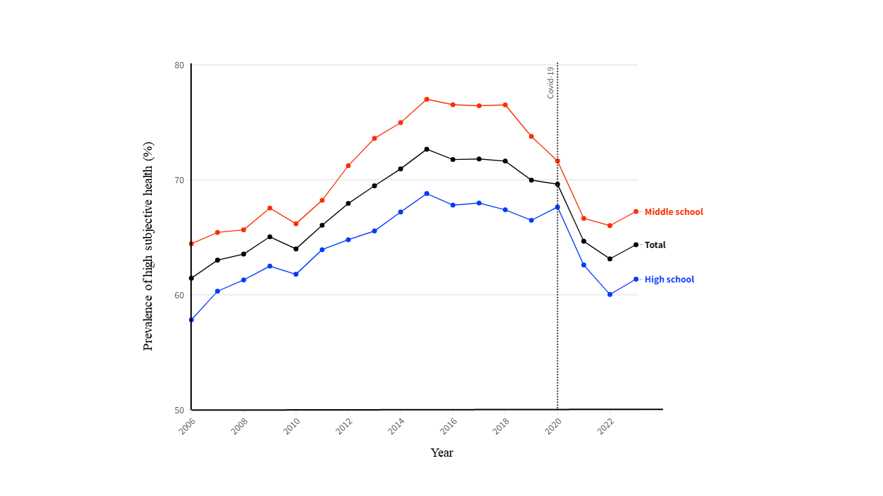

Supplementary Figure 2. Trend of high subjective health among South Korean adolescents by breakfast consumption before and during the COVID-19 pandemic, 2006-2023
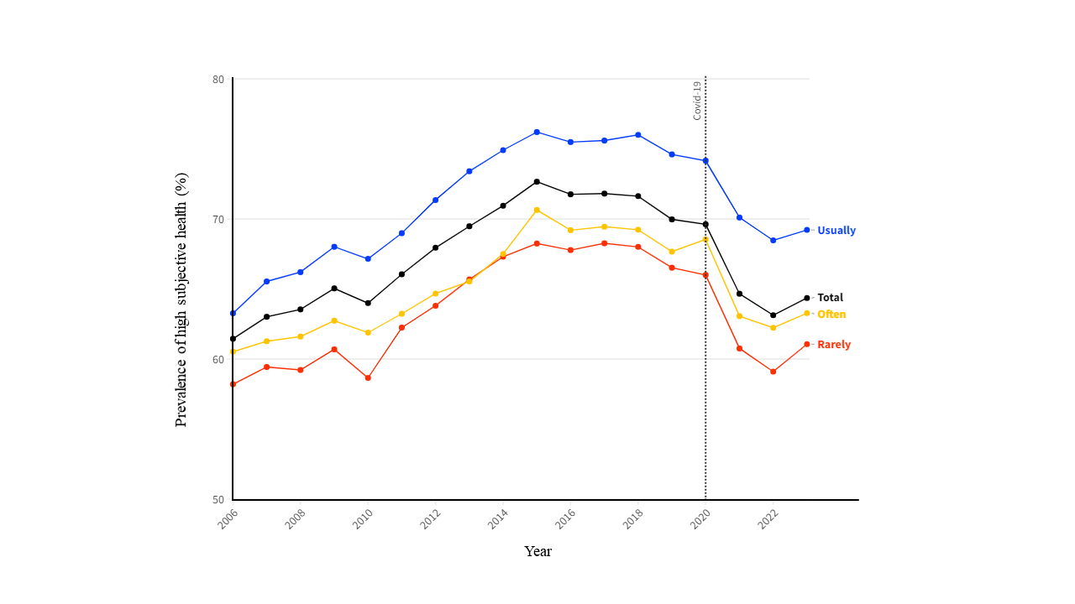

Supplementary Figure 3. Trend of high subjective health among South Korean adolescents by fruit intake before and during the COVID-19 pandemic, 2006-2023
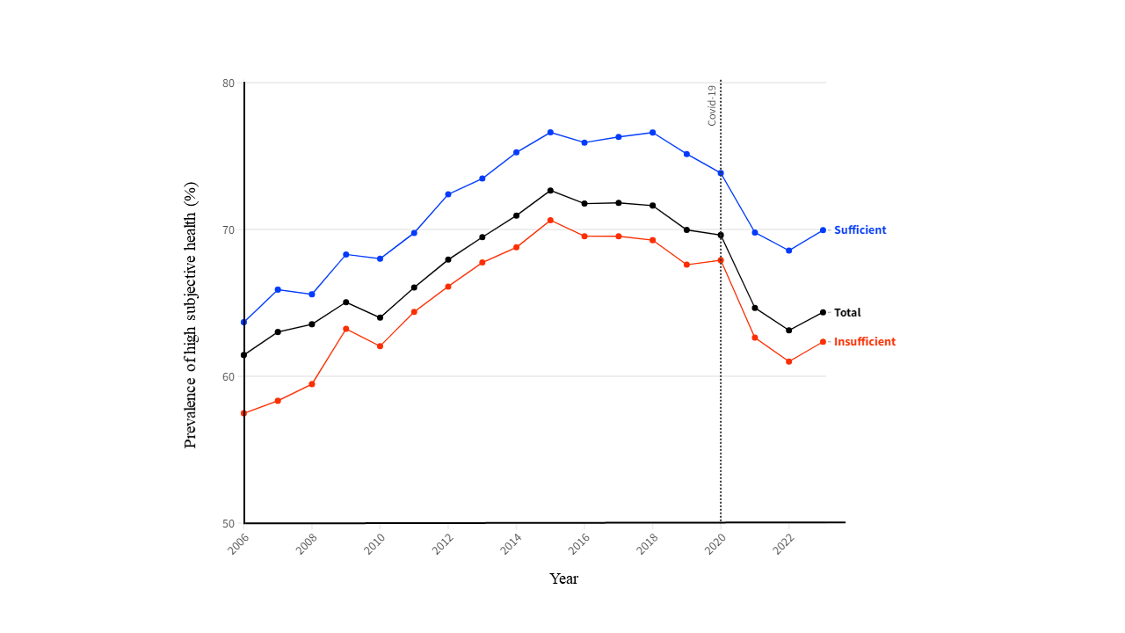

Supplementary Figure 4. Trend of high subjective health among South Korean adolescents by physical activity before and during the COVID-19 pandemic, 2006-2023
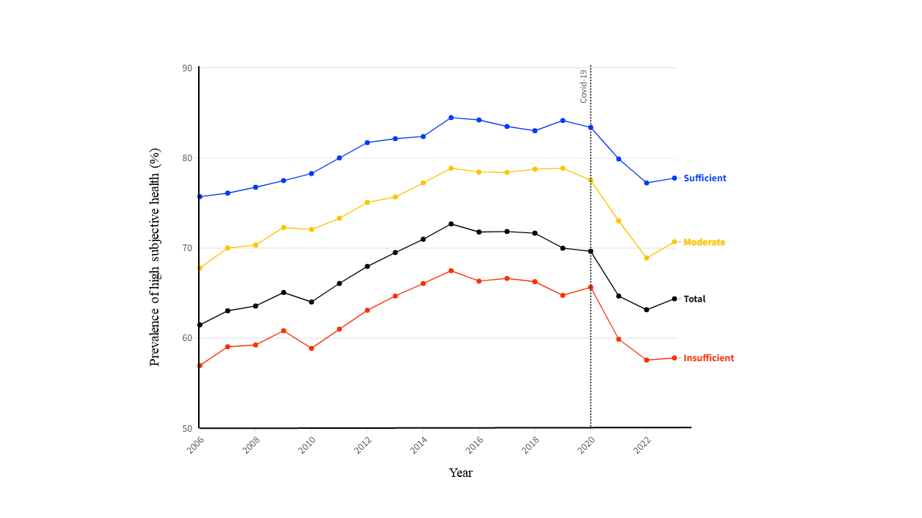

Supplementary Figure 5. Trend of high subjective health among South Korean adolescents by sedentary behavior on weekdays before and during the COVID-19 pandemic, 2006-2023
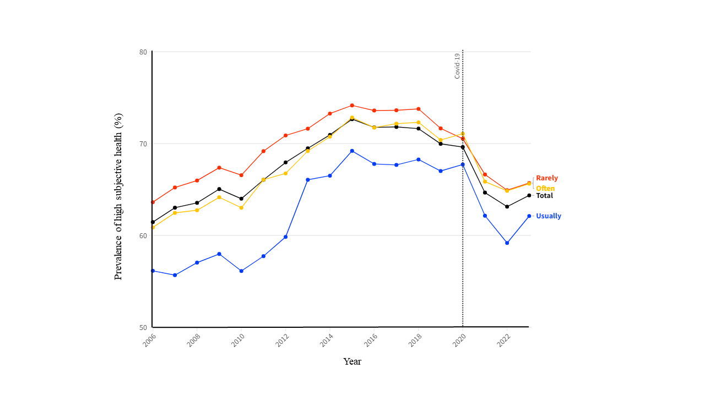

Supplementary Figure 6. Trend of high subjective health among South Korean adolescents by sedentary behavior on weekends before and during the COVID-19 pandemic, 2006-2023
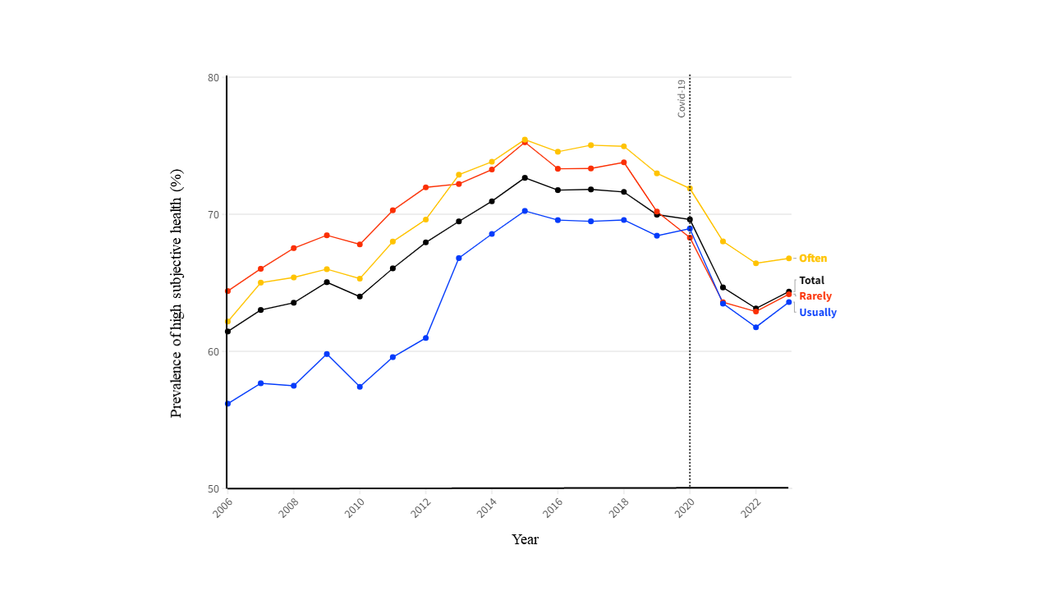

Supplementary Figure 7. Trend of high subjective health among South Korean adolescents by perceived sleep sufficiency before and during the COVID-19 pandemic, 2006-2023
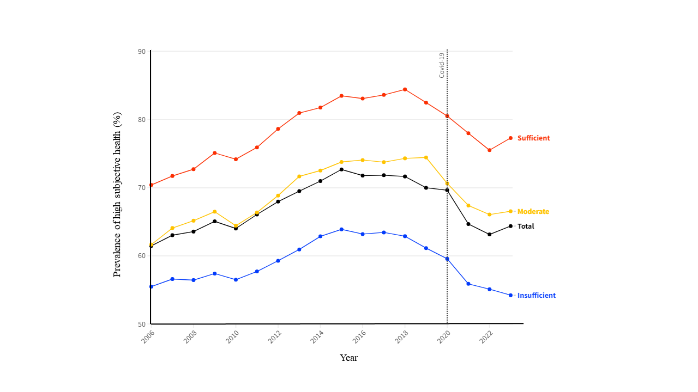

Supplementary Figure 8. Trend of high subjective health among South Korean adolescents by frequency of brushing teeth before and during the COVID-19 pandemic, 2006-2023
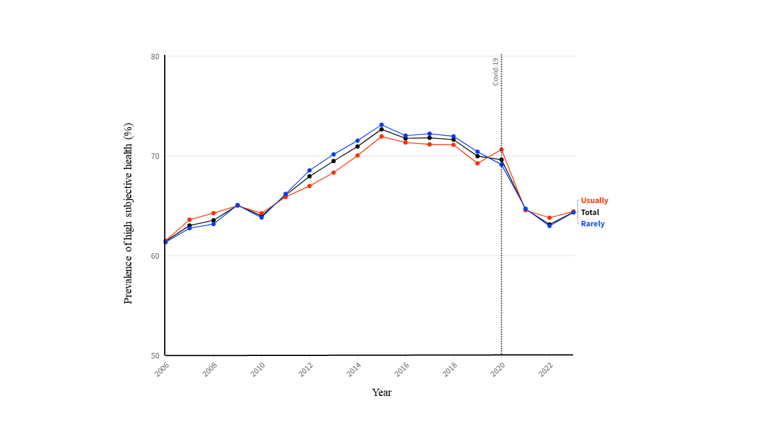

Supplementary Figure 9. Trend of high subjective health among South Korean adolescents by frequency of alcohol consumption before and during the COVID-19 pandemic, 2006-2023
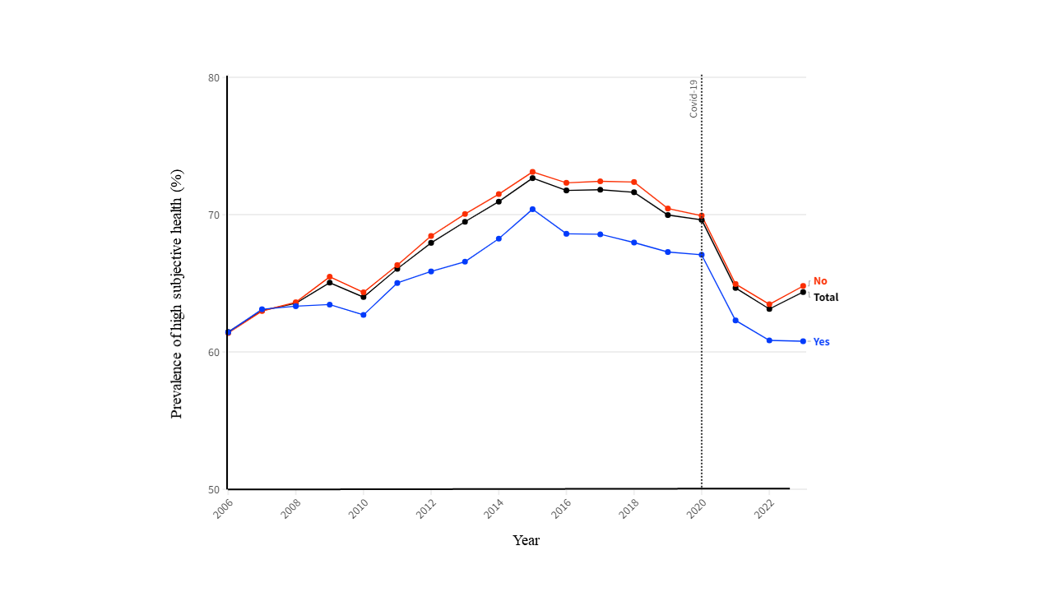

Supplementary Figure 10. Trend of high subjective health among South Korean adolescents by current smoking status before and during the COVID-19 pandemic, 2006-2023
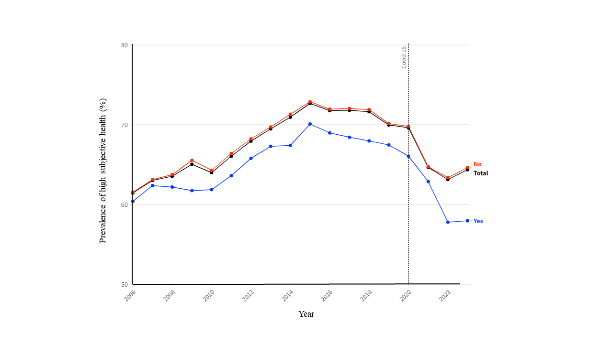

Supplementary Figure 11. Trend of high subjective health among South Korean adolescents by academic achievement before and during the COVID-19 pandemic, 2006-2023
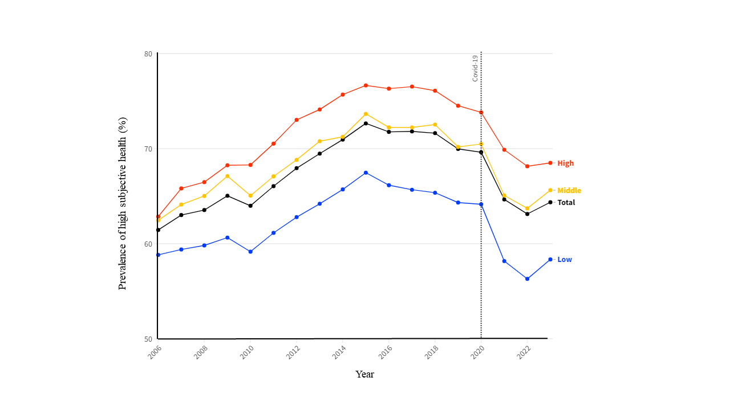

Supplementary Figure 12. Trend of high subjective health among South Korean adolescents by household income before and during the COVID-19 pandemic, 2006-2023
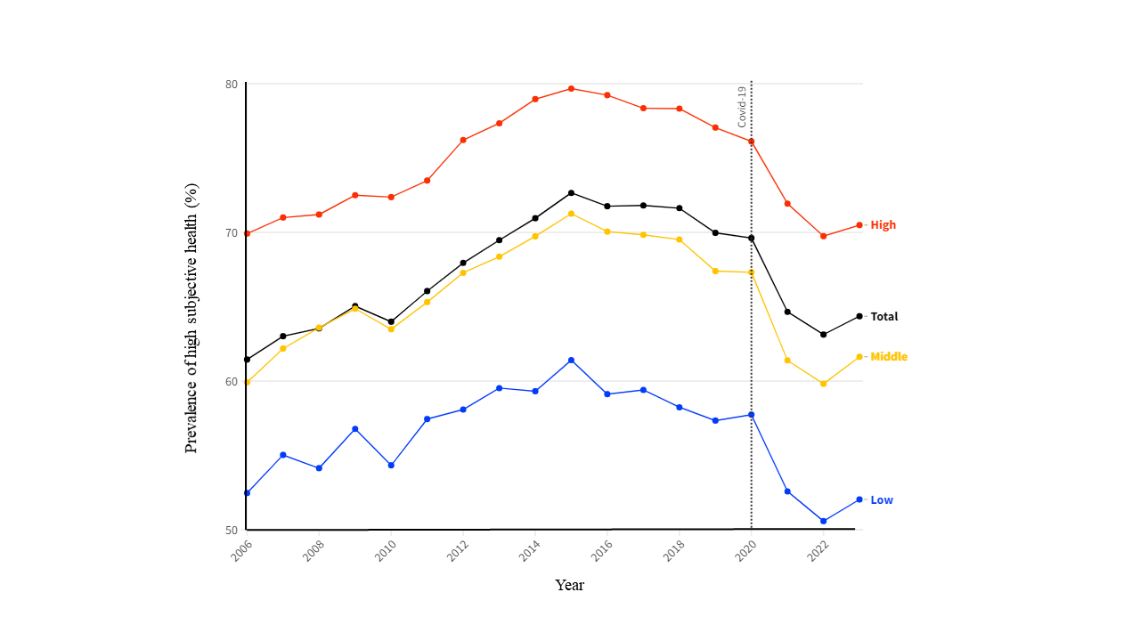

Supplementary Figure 13. Trend of high subjective health among South Korean adolescents by body mass index before and during the COVID-19 pandemic, 2006-2023
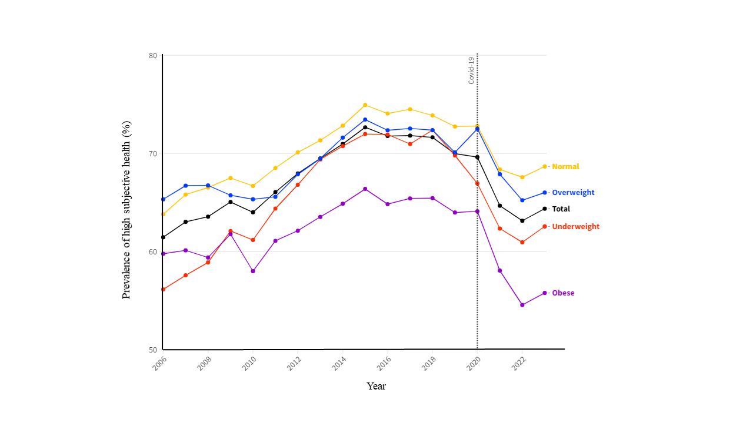

Supplementary Figure 14. Trend of high subjective health among South Korean adolescents by stress levels before and during the COVID-19 pandemic, 2006-2023
