Supplementary File
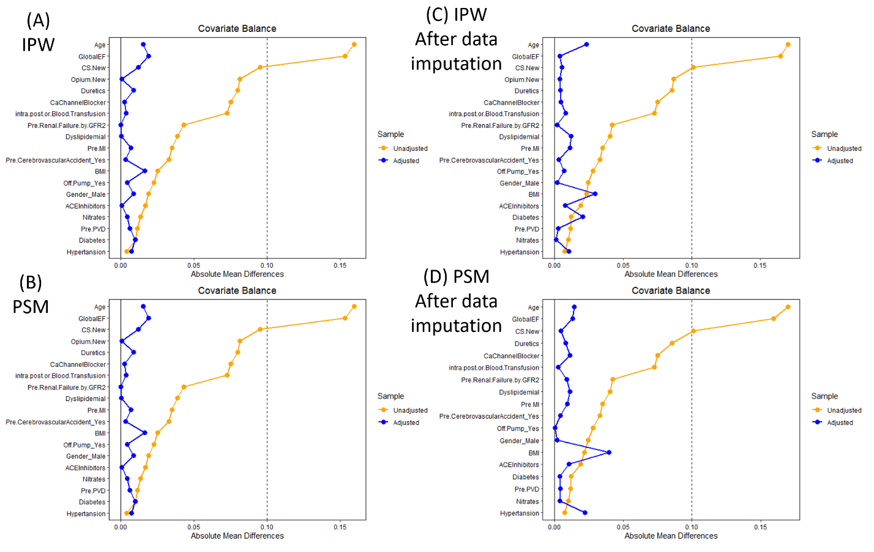Supplementary Figure 1. Standardized mean differences (SMD) for baseline characteristics before (yellow line) and after (blue line) inverse probability weighting (IPW) and propensity score matching (PSM) as shown in (A) and (B) respectively. (C) and (D) demonstrate the SMDs in IPW and PSM analysis after data imputation.

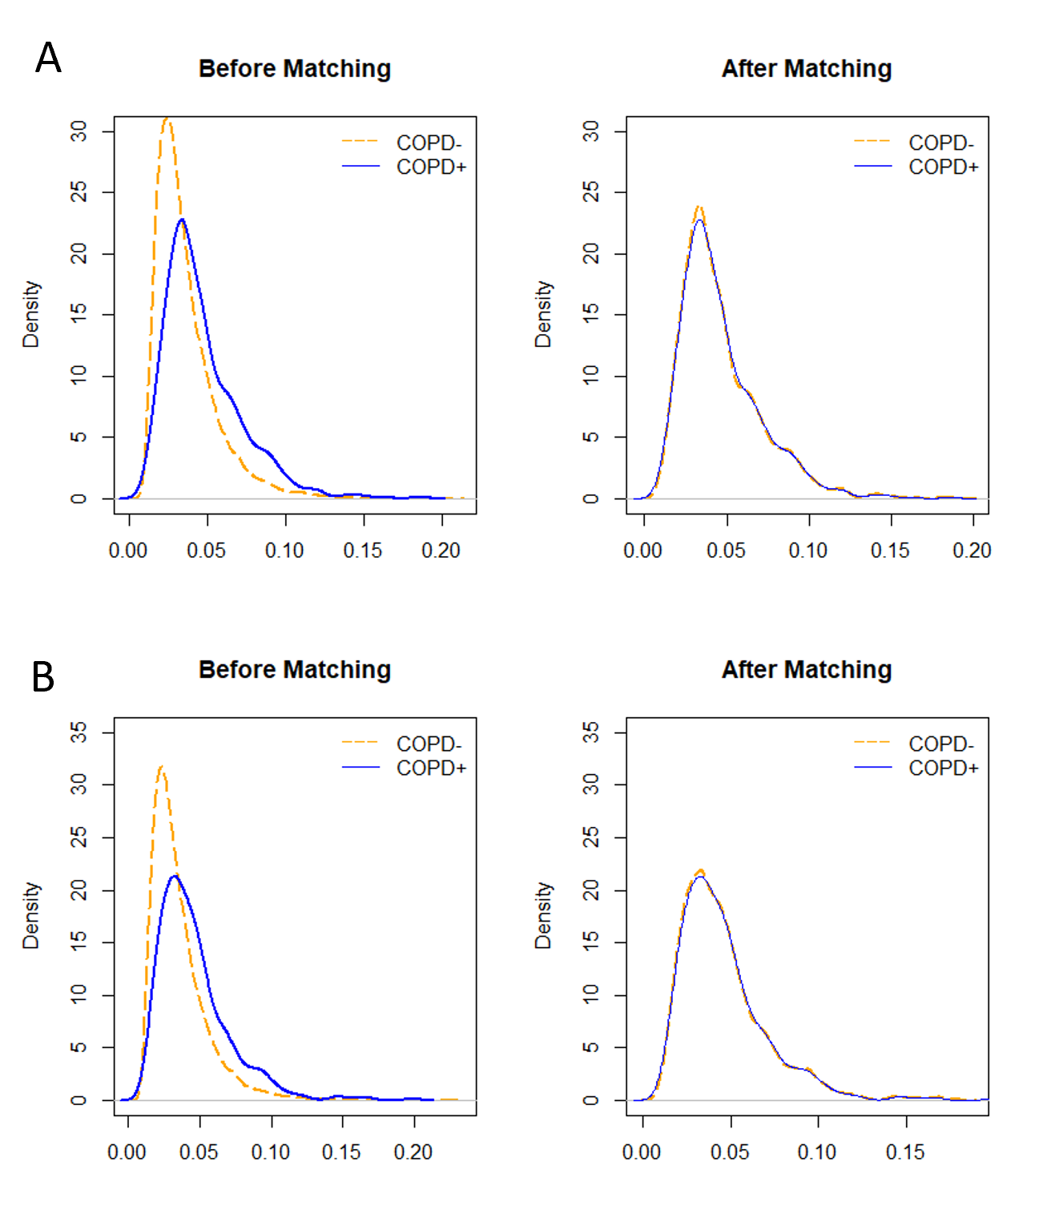Supplementary Figure 2. Coverage plots demonstrating the distribution balance of characteristics in patients with COPD (solid blue line) and non-COPD (dashed yellow line) after propensity score matching. The y-axis represents the density of the study population, and the x-axis represents the propensity scores. (A) and (B) show coverage plots before and after data imputation for sensitivity analysis respectively.

