Supplementary Table 1. Viruses reported in Paris yunnanensis

Number | virus | family | genus | reference
1 | Paris mosaic necrosis virus | Potyvidae | Potyvirus | 14
2 | Paris virus 1 | Potyvidae | Potyvirus | 11
3 | chilli veinal mottle virus | Potyvidae | Potyvirus | 17
4 | Paris potyvirus 3 | Potyvidae | Potyvirus | 7
5 | Paris potyvirus 4 | Potyvidae | Potyvirus | 7
6 | turnip mosaic virus | Potyvidae | Potyvirus | 13
7 | Paris virus 2 | Virgaviridae | Tobamovirus | 8
8 | pepper mild mottle virus | Virgaviridae | Tobamovirus | 16
9 | Paris nepovirus 1 | Secoviridae | Nepovirus | 7
10 | Lychnis mottle virus | Secoviridae | Stralarivirus | 7
11 | Paris polyphylla virus X | Alphaflexiviridae | Potexvirus | 12
12 | Hippeastrum chlorotic ringspot virus | Tospoviridae | Orthotospovirus | 7
13 | Paris mitovirus 1 | Mitoviridae | Duamitoviruses | 9
14 | Paris alphapartitivirus 1 | Partitiviridae | Alphapartitivirus | 15
15 | Yunnan Paris negative-stranded virus | Phenuiviridae | Coguvirus | 10
16 | Paris polyphylla chlorotic mottle virus | Betaflexiviridae | Capillovirus | 18

Supplementary Table 2 Viral contigs obtained from high-throughput sequencing

Contig number | Length (bp) | Average coverage | Reference virus | Accession number | nt/aa identity  (%) | Toxonomy
Contig_26 | 9672 | 9,635.31 | Paris mosaic necrosis virus | NC_043532 | 85/92 | Potyvirus
Contig_29 | 9617 | 2,510.65 | Paris mosaic necrosis virus | NC_043532 | 82/93 | Potyvirus
Contig_48 | 8951 | 1,056.82 | Paris mosaic necrosis virus | NC_043532 | 99/97 | Potyvirus
Contig_148 | 9671 | 359.13 | Paris virus 1 | NC_055600 | 79/87 | Potyvirus
Contig_58 | 8685 | 440.59 | Paris virus 1 | NC_055600 | 80/90 | Potyvirus
Contig_43 | 6369 | 3,852.49 | Paris polyphylla chlorotic mottle virus | MW822017 | 83/96 | betaflexivirus
Contig_44 | 6231 | 2,581.30 | Paris polyphylla chlorotic mottle virus | MW822017 | 82/91 | betaflexivirus
Contig_235 | 4079 | 277.75 | Paris polyphylla chlorotic mottle virus | MW822017 | 80/93 | betaflexivirus
Contig_24974 | 9573 | 818.04 | Wisteria vein mosaic virus | NC_007216 | 71/68 | Potyvirus

Supplementary Table 3. Primers used for detection YLuD-Paris and amplification its complete genome sequence
Primer name | Primer sequence(5’-3’) | Size (nt) | Note
PpCMVF53 | TGAGCAAGCTATCAACAATCTGC | 1611
PpCMVR1664 | AACCGGAATGGCGTCAAGATTTGG | 1611
PpCMVF1439 | ACGTCCAGGTCTTGTACAGCCAC | 1531
PpCMVR2970 | AGTTGGAGCTTGTGCGGAGAATATC | 1531
PpCMVF2830 | AGCATACTTGACATCCCTTGCC | 1571
PpCMVR4401 | TTCAGCAGTGAAGCCGACGAG | 1571
PpCMVF4270 | ACCTTCCTTTTCAACACATTTGCC | 1690
PpCMVR5960 | TTGTTCGTTTTGAGGAATGTGCGGGC | 1690
PpCMVR155 | TGCTCAAGGGGATTACGGTATGTGAATGCC | ~250 | 5’ end primer
PpCMVR226 | TCTCCATGATGTGATCTGCCGTCTTACTC | ~250 | 5’ end primer
PpCMVF5881 | AACCGCCTGGGTTTGAACCATACACTGAATGTGAC | ~500 | 3’ end primer
Via18 | GACCACGCGTATCGATGTCGACTTTTTTTTTTTTTTTTV | ~500 | 3’ end primer
Via19 | GACCACGCGTATCGATGTCGAC | ~500 | 3’ end primer
PpCMVdF | TTGCCTTTCTAGCACTGATCCAC | 872 | Detection primer
PpCMVdR | TTGTCTTGAGGAATGTGCGGGC | 872 | Detection primer
Note: F: Forward primer; R: Reverse primer; V=A,C or G

Supplementary Table 4. Primers used for detection YST-Paris and YLoD-Paris as well as amplification their complete genome sequence
Primer name | Primer sequence(5’-3’) | Size (nt) | Note
PpCMVF78 | TTGATCCGGGCTTCCATTCCATTACC | 1597 | Both YST-Paris and YLOD-Paris
PpCMVR1575 | TCAAGATTCGGGTTCATGAAGTCAGG | 1597 | Both YST-Paris and YLOD-Paris
PpCMVF1481 | AAACCGCAGGCCCCTCTTGCTCACCC | 1543 | YST-Paris
PpCMVR3050 | AGTTGGAGCTTGTGCGGAGAATATC | 1543 | YST-Paris
PpCMVF2955 | TTTGACTTCCTGCTTGGAGG | 1750 | YST-Paris
PpCMVR4815 | TTGAATACCCCGGATTTGCG | 1750 | YST-Paris
PpCMVF4746 | ATATACTCAACTGCATACGACG | 1130 | YST-Paris
PpCMVR5876 | TTGTTCGTTTTGAGGAATGTGCGGGC | 1130 | YST-Paris
PpCMVF5709 | ATACAACTGCCCCCTATAACATTCAACCG | ~600 | Both YST-Paris and YLoD-Paris
PpCMVF1406 | AAACCTTGGGACGTCCAGGCC | 1595 | YLOD-Paris
PpCMVR3001 | AAGAAGGAAGTCAAAGCCAGCGG | 1595 | YLOD-Paris
PpCMVF2879 | AAACATCAACTTCTCCTTGGCGCC | 1601 | YLOD-Paris
PpCMVR4489 | TAGTGGTAATCAAGTTCCTCATCCG | 1601 | YLOD-Paris
PpCMVF4277 | TTCTTTGGGTCATCTGCGACC | 1518 | YLOD-Paris
PpCMVR5795 | TTGTCTTGAGGAATGTGCGGGC | 1518 | YLOD-Paris

Supplementary Table 5. Primers used for detection ParPV-5 an amplification its complete genome sequence
Primer name | Primer sequence(5’-3’) | Size (nt) | Note
ParPV-5F81 | AATTCATCCTCCACATTTCAGCAATCTCG | 1662
ParPV-5R1743 | ATACCCTTCTGCTGGTATCACTTCCTC | 1662
ParPV-5F1512 | ACACAAGATGAGTTAGCTAGAGCC | 1624
ParPV-5R3136 | TTACTGTTTTTCCAATTGAACGCC | 1624
ParPV-5F3015 | AAGAAAGTCTCAGAAAAGAGCGC | 1664
ParPV-5R4679 | TTCCAAGTCTCTGGATTCTCTCACCG | 1664
ParPV-5F4549 | TCAACTCACCCTCTCGCTCTGG | 1631
ParPV-5R6810 | TCAACTCACCCTCTCGCTCTGG | 1631
ParPV-5F6043 | ATCGTAATAGAATTGTGAGCAACCC | 1482
ParPV-5R7654 | TCATACCAACAGTCCATGGGC | 1482
ParPV-5F7506 | GGCTCGCTGAAAGCTGAACTGAGA | 1482
ParPV-5R8988 | TACCATCCATTATGACCCAGTTGCC | 1482
ParPV-5F8806 | ATCTACTTGAATACAAACCAGCCC | ~600 | 3’ end primer
ParPV-5R245 | TATCTGTTTGCACGTTGCTATCTCAGC | ~200 | 5’ end primer
ParPV-5R511 | TTGCAATTGCATCTTGTCAGCTTGAGCC | ~500 | 5’ end primer
ParPV-5dF | AACAGTGTGGGGAGCTTGCAGCC | 556 | Detection primer
ParPV-5dR | ATACCCTTCTGCTGGTATCACTTCCTC | 556 | Detection primer

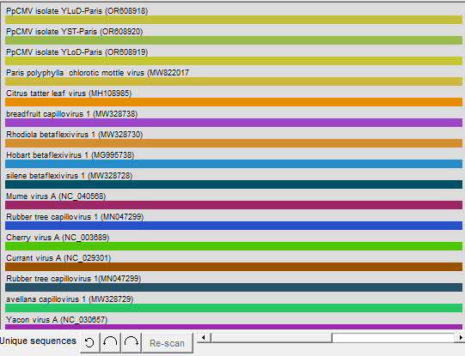

Fig. S1 Schematic diagram of the sequence recombination in the PpCMV and other capillovirus

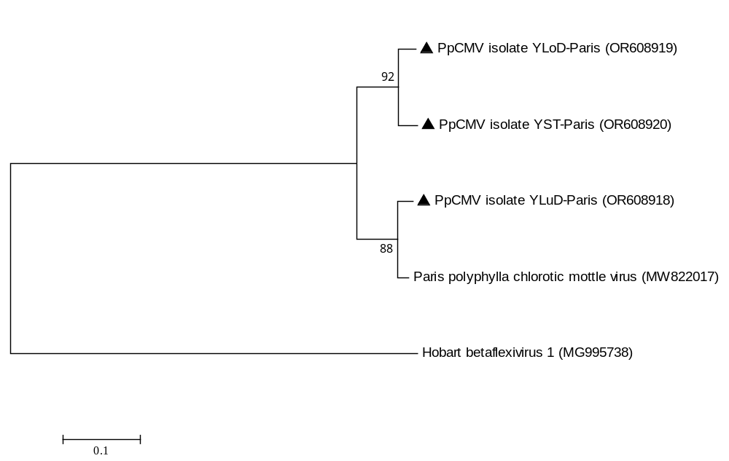
Fig. S2 Maximum-likelihood tree based on the deduced aa sequences of ORF2 of PpCMV

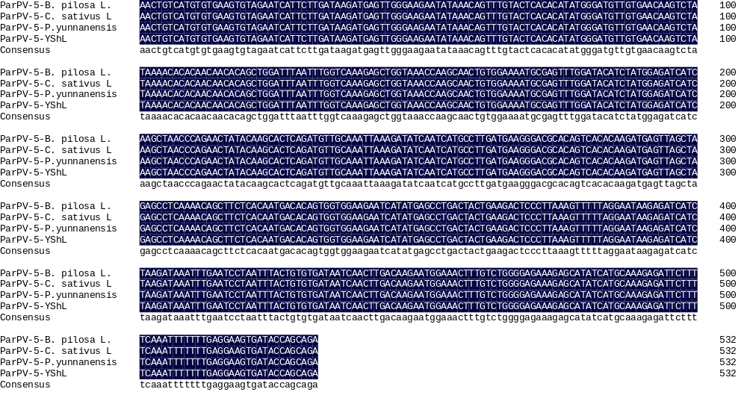
Fig. S3 Multiple comparison results of RT-PCR amplicon sequencing after ParPV5 inoculation

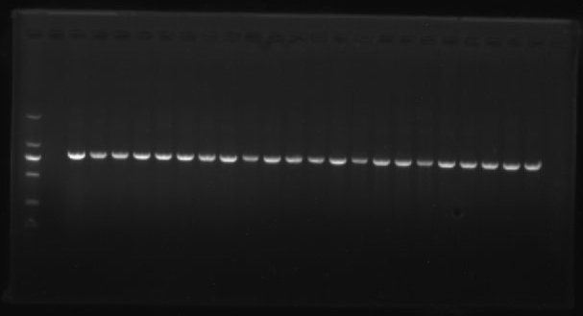
750bp
1000bp
M 1 2 3 4 5 6 7 8 9 10 11 12 13 14 15 16 17 18 19 20 21 22 23 24

Fig. S4 Detection of plasmids with correct inserts through PCR

pCB301-PpCMV-YluD pCB301
M - + 1 2 3 4 5 6 7 8 9 10 11 12 13
750bp
1000bp
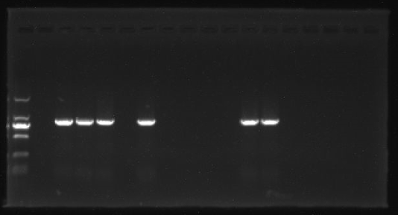
Fig. S5 RT-PCR detection of positive (+) and negative (− ) sense PpCMV-YLuD RNA in the inoculated leaves of P. yunnanensis

pCB301-PpCMV-YluD pCB301
750bp
1000bp
M - + 1 2 3 4 5 6 7 8 9 10 11 12 13
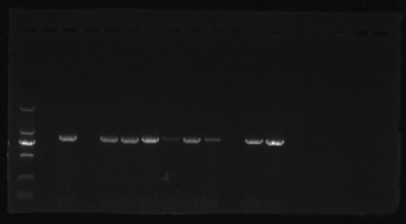
Fig. S6 RT-PCR detection of positive (+) and negative (− ) sense PpCMV-YLuD RNA in the inoculated leaves of N. benthamiana

pCB301-PpCMV-YluD pCB301
1000bp
750bp
M - + 1 2 3 4 5 6 7 8 9 10 11 12 13
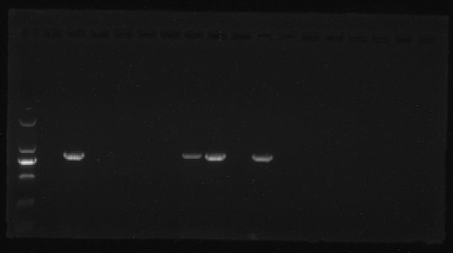
Fig.S7 RT-PCR detection of positive (+) and negative (− ) sense PpCMV-YLuD RNA in the inoculated leaves of N. tabacum var. Xanthi nc

pCB301-PpCMV-YluD pCB301
750bp
1000bp
M - + 1 2 3 4 5 6 7 8 9 10 11 12 13
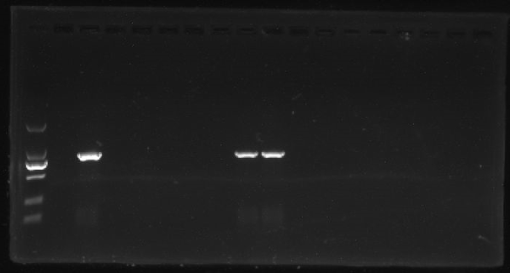
Fig.S8 RT-PCR detection of positive (+) and negative (− ) sense PpCMV-YLuD RNA in the inoculated leaves of Capsicum annuum

pCB301-PpCMV-YluD pCB301
1000bp
750bp
M - + 1 2 3 4 5 6 7 8 9 10 11 12 13
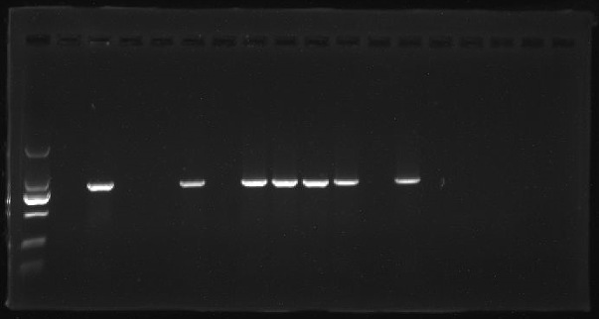
Fig. S9 RT-PCR detection of positive (+) and negative (− ) sense PpCMV-YLuD RNA in the inoculated leaves of C. moschata

pCB301 pCB301-ParPV-5-YShL
M 1 2 3 4 5 6 7 8 + -
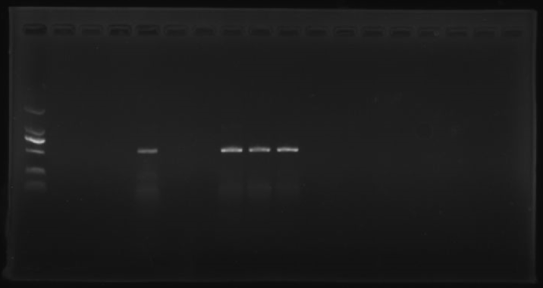
750bp
500bp

Fig. S10 RT-PCR detection of positive (+) and negative (− ) sense ParPV-5 in the inoculated leaves of Bidens pilosa L（i）.

pCB301 pCB301-ParPV-5-YShL
M 1 2 3 4 5 6 7 8 9 + -
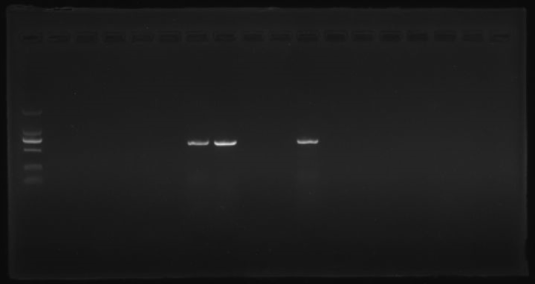
750bp
500bp

Fig. S11 RT-PCR detection of positive (+) and negative (− ) sense ParPV-5 in the inoculated leaves of N. benthamiana (ii).

pCB301 pCB301-ParPV-5-YShL
M 1 2 3 4 5 6 7 8 9 10 + -
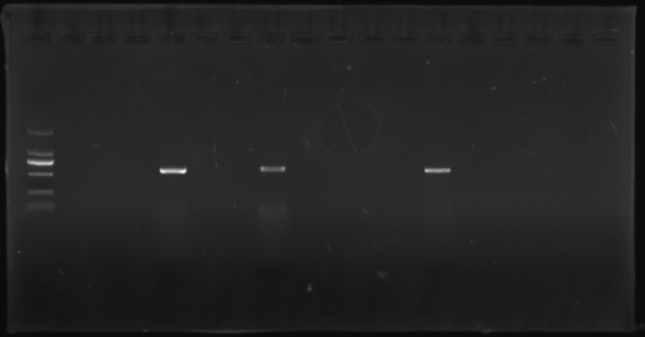
750bp
500bp
Fig. S12RT-PCR detection of positive (+) and negative (− ) sense ParPV-5 in the inoculated leaves of P. yunnanensis (iii).

pCB301 pCB301-ParPV-5-YShL
M 1 2 3 4 5 6 7 8 9 10 11 + -
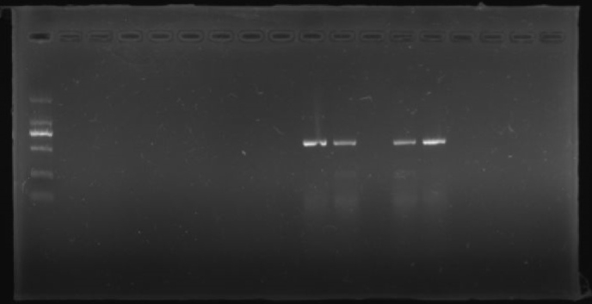
750bp
500bp
Fig. S11 RT-PCR detection of positive (+) and negative (− ) sense ParPV-5 in the inoculated leaves of C. sativus L. (iiii) .

The sequence uploaded to GenBank in the article.

LOCUS Seq1 9647 bp ss-RNA linear 27-SEP-2023
DEFINITION Paris potyvirus 5 isolate KMShL complete sequence.
ACCESSION Seq1
VERSION
KEYWORDS .
SOURCE Paris potyvirus 5
ORGANISM Paris potyvirus 5
Unclassified.
REFERENCE 1 (bases 1 to 9647)
AUTHORS Li,F., Lan,P.X., He,P. and Mu,A.Q.
TITLE Direct Submission
JOURNAL Submitted (24-SEP-2023) State Key Laboratory for Conservation and
Utilization of Bio-Resources in Yunnan, Yunnan Agricultural
University, 452 Fengyuan Rd, Kunming, Yunnan 650201, China
COMMENT Bankit Comment: ALT EMAIL:hepengfztx@163.com
Bankit Comment: TOTAL # OF SEQS:4

##Assembly-Data-START##
Sequencing Technology :: Sanger dideoxy sequencing
##Assembly-Data-END##
FEATURES Location/Qualifiers
source 1..9647
/organism="Paris potyvirus 5"
/mol_type="genomic RNA"
/isolate="KMShL"
/host="Paris polyphylla var. yunnanensis"
/country="China"
/collection_date="27-July-2021"
5'UTR 1..138
CDS 139..9408
/codon_start=1
/product="polyprotein"
/translation="MATIMIGSISVPIKSTAEIATCKQITRPVVIKAEHMAGPVANPK
VIQYQLNQFSKACINDYNKSLDVLTKFFNNDPHIVRRLKINTFSHVQRQKNGTCRLRH
VTEAQADKMQLQLVKMKEEHEAFMRGDYSDTVHIGQCKNAFEKKEGMSVGFKTPFFCR
TIKKNKSTKRERKSPHLSEIMDAVTLICSKNSTPIEFIGVGKQKPIRAQYINKHQSLI
PKIQLPHEVGKYFKVEVTRSDIQPILMQLCKFAKYRNINEMDICPGDSGFVFDGRSMI
TTQNTNLPFMVVRGRRSGQLVNALDKVDNMFDIQHYSQTPEQQFFNGWKKVFDQMVPH
TEIHDHTVDYQNEQCGELAAMICQTLFPVHKLSCVKCRIILDKMSWEEYKQFVLTHMG
CCEQVYKTHNNTAGFNLVKELVNQATVENASLDTSMEIIKLTQNYTSTQMLQIKDINH
ALMKGRTVTQDELARASKQLLTMTQWWKNHMSLTTEDSLKVFRNKRSSKINLNPNLLC
DNQLDKNGNFVWGERAYHAKRFFSNFFEEVIPAEGYGKYVIRKHPNGQRELAIGSLIV
PLDFDKARVTLQGKSITREPLTKACVSRHEGNFIYQCCCVTHDDGKPVYSEFRSPTKR
HLVVGATGDPKYIDLPTNETERMFIAKEGYCYLNIFLAMLVNVSEGEAKDFTKMVRDN
IVPRLGTWPAMIDVATAAHQLASFHPDTRNAELPRILVDHATQTMHVIDSFGSLTVGY
HVLKAGTVNDLIRFASNDLEGELKHYRVGGDISQRIRCEKALISSIFKPKRMIQILEN
DPYILLMGLVSPSVLIHMFRMRHLEKGVELWIHKNQNVAKIFLILDQLTRKVVVSELL
NDQMQIITETAGHIREILTMCPAAMHSYKPAMDLLSLYIEKQATNAQLHDNGFYDIND
NLYIALEKTYVSKLQQEWRGLNLLEKSSATWHLKKFSQHTERFLTKKVSEGKSAPLRG
FVSVCFMNAKTHLSNSRDMFYQKFDTVWRSIVRKTVNIALGVLYKCYSDIIYLVNVCI
IFSLLVQMTSTLRGIISTVRQEKAFIQKCKRSEAETTVYHLYEVFAQQSKEQPVFDEF
VQFVKKIRPDLMSTVDYMFSDTEEVTAQGKTALQLQFEKIIAFMALITMIIDGERSDA
LFKILSKLKTVFSTVGEDVRLQSLDEIENVEDDKKLTIDFDLNTSSEPSSTSFDVRFE
DWWNRQLQQNRVVPHYRSIGEFMEFTRETAAKVANQLVTSSQKEFLVRGAVGSGKSTG
LPHHLSKRGKVLLLEPTRPLAENVATQLGKDPFYHTVTLRMRGLSRFGSSNITVMTSG
YAFHYYVNNPQQLADFDFIIIDECHVLDSSTIAFNCALKEFEFPGKLIKVSATPPGRE
CEFTTQHPVKLKVEEQLSFQNFVQAQGSGSNADMIQHGHNLLVYVASYNEVDQLSKLL
VEKNFKVTKVDGRTMQMGNMEISTTGTEAKPHFIVATNIIENGVTLDVDCVIDFGLKV
SXTLDIDCRCVRYSKKSVTYGERIQRLGRVGRFKPGFALRIGHTEKGIEEVPDFIATE
AAFLSFAYSLPVTTQSVTTSFMARCTVKQAKSALNFELTPFFTIHFIKYDGSMHPAIH
GHLKAFKLRESEMVLNKLAIPHQYTSQWISGKEYERMGIHIQCDPTTKIPFHVHGIPD
KLFEVLWSCVCKHKSDAGFGRITSASAAKISYTLSTDPNAVPRTLAIIDHLIGEEMMK
KSHFDTIGSAVTGGSFSLAGIANSIRSRYMRDYTQHNINILQQAKAQLMEFDCTKVDL
NNLHNFETLGVLHTVCLQSKTDVIKYLELKGKWDGSKFLNDIILAILALIGGGWMMWE
YFIKTMNEPVQTQGKKRMLQKLKFRDARDRKVGREVYADDYTMEHTFGEAYTKKGKQK
GNTSTKGMGKKTRNFIHMYGVEPENYSMIRFVDPLTGHTMDESTRVDIRLVQDEFGEI
RRKMIEEDELDRNRIVSNPGIQAYFLGRGTEDALKIDLTPHVPTALCRNTNAISGFPE
REGELRQIGMPVPIPRSQVPKQKEVVEVESKSVYKGLRDYNSIATMVCQLVNSSDGHT
ESIFGLGYGSYVITNGHLFRRNNGQLTIKAWHGEFVIHNTTQIKIHFIEGKDAIIIRM
PKDFPPFIKRNIFRAPQHEEKVCMVGTNFQDKSMRSTVSESSVIYPENKGSFWMHWIS
TKEGDCGLPLVSVNDGMIVGFHGLTSNVSDKNFFVPFIDNFEDKYLKVAETLNWDSHW
LWQPDKISWGSLTLVADQPGKEFKVSKLVRDLFDTEVSTQSSTNAWVLEAAVGNLTAC
GQADSALVTKHVVKGKCPFFAQYLASNNEAEKFFKPLLGAYQPSRLNKEAFKKDFFKY
NKPVVINEVDFESFEKAIVGVKCMLNEFDFQECAFITDADSIYESLNLKAAVGAQYVG
KKKDYFEGMDQFEKERLLYKSCERLFYGQKGIWNGSLKAELRPIEKVQNNKTRTFTAA
PIDTLLGAKVCVDDFNNQFYSLNLTCPWTVGMTKFYGGWDRLMRSLPDGWLYCHADGS
QFDSSLTPLLLNSVLDVRQFLMEDWWVGHEMLQNLYAEIVFTPILAPDGTIFKKFRGN
NSGQPSTVVDNTLMVVIAMYYACIKQQWTYDDIQNRLVFFANGDDVILSVQHCDEGLL
DTLSTSFQELGLIYNFNERTNNREELWFMSHRAIEIDGIYIPKLEPERIVSILEWDRS
KELMHRTEAICAAMIEAWGYDDLLKEIRKFYLWLLQKDEFKELAALGKAPYISEIALK
KLYTNRDSEMDEIRMYLQAFHDIVETSDEEFVSLQSETRAPEVVDAGEERRRKDREND
RRNQLSPSSTNQPPPSNTQPPPAQDRDVGNSTSGSVVPRLKKITKKINLPMVNGQIIL
SLDHLLEYKPAQTDLFNTRATKSQFNAWYNAVKNEYELDDSQMQVIMNGFMVWCIDNG
TSPDINGNWVIMDGTKQVEYPLKPMVENAKPTLRQIMHHFSDVAEAYIEMRNSEELYM
PRYGLLRNLRDRSLARYAFDFYEVTAKTSDRAREAVAQMKAAALTNVSSKLFGLDGNV
STNVENTERHTARDVNQNMHTLLGMSPPQ"
mat_peptide 139..1074
/product="P1"
mat_peptide 1075..2445
/product="HC-Pro"
mat_peptide 2446..3486
/product="P3"
mat_peptide 3487..3642
/product="6K1"
mat_peptide 3643..5544
/product="CI"
mat_peptide 5545..5703
/product="6K2"
mat_peptide 5704..6273
/product="NIa-VPg"
mat_peptide 6274..7002
/product="NIa-Pro"
mat_peptide 7003..8553
/product="NIb"
mat_peptide 8554..9408
/product="CP"
3'UTR 9409..9631
BASE COUNT 3285 a 1681 c 2089 g 2591 t 1 others
ORIGIN
1 acatgggcag acaatacaac aaacgactca agacactcaa atccacttac atactttcga
61 atcccagagc ttattaaatc aaattcatcc tccacatttc agcaatctcg ttatcatctc
121 acattctcaa tttgtacaat ggcaacgatc atgattggat caatttctgt accaatcaaa
181 agcactgctg agatagcaac gtgcaaacag ataactagac ctgtagttat caaagctgaa
241 catatggcag gacctgttgc caatcctaaa gtgattcaat atcaattgaa tcaatttagc
301 aaagcatgta taaatgatta caataagagt ttggatgttc tgaccaaatt cttcaataat
361 gatccacaca ttgtgcgtag acttaagatc aatacattta gtcacgtaca aagacagaag
421 aatggaacat gcagactgag gcatgtcact gaggctcaag ctgacaagat gcaattgcaa
481 cttgtcaaaa tgaaagagga acatgaagcc tttatgagag gcgattattc tgacacagtt
541 cacattgggc aatgcaaaaa tgcctttgaa aagaaagaag gtatgagtgt tggttttaaa
601 acccctttct tctgtagaac aatcaagaag aacaaatcca ctaagagaga gaggaagagc
661 ccacaccttt ctgaaattat ggatgcagtt acattaattt gtagcaaaaa ctcaacacca
721 attgagttta ttggggtggg gaagcagaag ccaatcagag ctcaatatat taataaacat
781 cagagcttaa ttccaaagat tcaactccct catgaagtgg gaaaatactt caaggttgaa
841 gtgacaaggt ctgatatcca accaattctg atgcagcttt gtaaatttgc aaagtataga
901 aatatcaatg aaatggatat atgtcctggt gatagtggat ttgtgtttga tgggcggtct
961 atgatcacaa cacaaaacac taatctccca ttcatggtag ttagaggaag aagatctgga
1021 caattagtga atgcattgga taaagttgat aacatgtttg atattcaaca ttattcacaa
1081 acaccagagc aacaattctt caatggatgg aagaaagtct ttgaccaaat ggtgccacac
1141 acagaaattc atgatcatac agtagattat cagaatgaac agtgtgggga gcttgcagcc
1201 atgatctgcc aaacactatt tccagtgcac aaactgtcat gtgtgaagtg tagaatcatt
1261 cttgataaga tgagttggga agaatataaa cagtttgtac tcacacatat gggatgttgt
1321 gaacaagtct ataaaacaca caacaacaca gctggattta atttggtcaa agagctggta
1381 aaccaagcaa ctgtggaaaa tgcgagtttg gatacatcta tggagatcat caagctaacc
1441 cagaactata caagcactca gatgttgcaa attaaagata tcaatcatgc cttgatgaag
1501 ggacgcacag tcacacaaga tgagttagct agagcctcaa aacagcttct cacaatgaca
1561 cagtggtgga agaatcatat gagcctgact actgaagact cccttaaagt ttttaggaat
1621 aagagatcat ctaagataaa tttgaatcct aatttactgt gtgataatca acttgacaag
1681 aatggaaact ttgtctgggg agaaagagca tatcatgcaa agagattctt ttcaaatttt
1741 tttgaggaag tgataccagc agaagggtat gggaaatacg tcattcggaa gcatccaaat
1801 gggcagaggg aattagctat tggctcactg atagtaccat tggattttga caaagcacga
1861 gtaacattac aaggcaagag catcactaga gagccactca caaaagcttg tgtttcgcgc
1921 catgaaggga atttcatata ccaatgttgc tgtgttacgc atgatgatgg caagcctgtt
1981 tactctgagt ttcgtagccc cacaaagcga cacttggtag ttggtgcaac tggggatccc
2041 aaatacattg atcttccaac aaatgaaaca gaaaggatgt tcatagcaaa ggagggttat
2101 tgttatttga atatcttcct tgccatgctt gtaaatgtga gtgaagggga agcaaaggat
2161 tttaccaaaa tggtacgtga caatatagta ccacgacttg gaacttggcc ggcaatgata
2221 gatgtagcaa cagctgctca ccaattagcc agtttccatc cagatacaag aaatgcagaa
2281 ctgccaagaa tcttagttga tcatgctaca cagaccatgc atgttataga ctcatttggt
2341 tctttaacag ttggttatca tgtactaaaa gctggcacag tcaatgattt gatcagattt
2401 gcatcaaatg atcttgaagg agagttaaag cattatagag ttggtggtga catctcacaa
2461 cgaataagat gtgaaaaagc attgatctca agtatattca aaccaaagag aatgattcag
2521 atacttgaga atgacccata cattttgttg atgggtcttg tatcaccatc agttctaatt
2581 catatgttca gaatgaggca tctcgaaaaa ggagttgaat tatggataca caagaatcaa
2641 aatgtagcaa aaatattctt aattcttgat caactcacga gaaaagtggt tgttagtgaa
2701 ctcctaaatg accaaatgca gatcatcaca gagacagcag gtcatattag agagattctt
2761 actatgtgtc cagcagcgat gcactcatac aagccagcaa tggatctcct ctcattatac
2821 attgaaaaac aagccacaaa tgcacaactc catgacaatg ggttttatga cataaatgac
2881 aatttgtaca ttgcactgga aaaaacctat gtgtcaaagt tacaacagga atggcgcggc
2941 ttaaacttgt tggaaaaatc ttctgcaaca tggcacttga aaaagttttc acaacatacg
3001 gaaagatttt tgacaaagaa agtctcagaa ggaaagagcg cacctttaag aggatttgtg
3061 agtgtgtgct tcatgaatgc caaaacacac ctgtcaaaca gtcgagatat gttttatcag
3121 aaatttgaca cagtatggcg ttcaattgta agaaaaacag taaatatagc tctaggagtt
3181 ttgtataaat gttacagtga tattatatat ttagtcaatg tttgtatcat attttcatta
3241 ttagttcaaa tgaccagtac tttacgaggg ataatttcaa ctgttagaca ggaaaaagcc
3301 ttcatacaaa aatgtaaaag aagtgaggct gaaaccacag tgtatcattt gtatgaagta
3361 tttgcacaac agagcaaaga acagccagtg tttgatgagt ttgtgcaatt cgtcaagaaa
3421 ataagacccg atcttatgtc tacagttgac tacatgttct cagacacaga agaagtgaca
3481 gcccaaggga aaacagcatt gcagcttcaa tttgagaaga taatcgcttt tatggctttg
3541 atcacaatga tcattgatgg tgaaaggagt gatgctctgt tcaaaatatt gtcaaaattg
3601 aaaactgtat ttagtacagt aggtgaggat gttcggcttc agagtttgga tgaaattgag
3661 aatgtggaag atgacaagaa gcttacaatc gactttgatt tgaatacatc aagcgagcca
3721 tcttcaacaa gttttgatgt gaggtttgaa gactggtgga ataggcagct tcaacagaac
3781 agagtggttc cgcactacag aagcataggt gaattcatgg aatttacgcg tgaaacagca
3841 gcaaaagttg cgaatcaact tgtcacttct agtcagaaag agttccttgt gaggggcgct
3901 gtgggttctg gcaagtcaac aggactgcca catcatttgt ctaagagagg caaagtgtta
3961 cttctggaac caacaagacc tttagcagag aatgtggcta ctcaacttgg taaggatcct
4021 ttttaccaca cagtgacatt gcgtatgaga ggtcttagcc gatttggttc gagtaacata
4081 acagtcatga caagcgggta tgctttccac tactatgtga acaatccaca acagttggcc
4141 gactttgact tcattatcat tgatgaatgt catgttttag atagttcaac aatagcgttc
4201 aactgtgctt taaaagagtt tgaatttcct ggaaagttga taaaagtctc agctactcca
4261 ccaggtagag aatgtgagtt cacaactcag cacccagtta aattgaaggt tgaggagcag
4321 ttatcatttc aaaattttgt gcaagcacaa ggatcaggct caaatgcaga tatgattcaa
4381 catgggcata acttgctagt gtatgttgct agttacaatg aggttgatca attgtcaaaa
4441 ttattggtgg agaagaattt caaagtgact aaagttgatg gtaggacaat gcaaatgggc
4501 aacatggaaa ttagcacaac tggaacagag gcaaaaccac atttcattgt agccaccaac
4561 ataattgaaa atggggttac tttggatgtt gattgtgtta ttgattttgg actgaaagtt
4621 tcarcaacac ttgacattga ttgtagatgt gtgcgttaca gtaagaaatc agtaacatac
4681 ggtgagagaa tccagagact tggaagagtt ggacgcttta aaccaggatt cgccctacga
4741 atagggcaca ctgagaaagg gattgaagaa gtaccagatt tcatagccac tgaggcagca
4801 ttcttgtcct ttgcttacag tctaccagtc acaacacaga gtgtcacaac tagttttatg
4861 gcacgctgta cagttaagca agcaaaaagt gctctcaatt ttgaattaac accattcttc
4921 actatacatt tcatcaaata cgatggaagt atgcacccag caattcatgg gcatctgaag
4981 gcttttaagc tcagagaatc agagatggtg ttgaacaagc ttgcaatccc acatcaatac
5041 acaagtcagt ggatatcagg taaggagtac gaaagaatgg gaattcacat tcaatgtgat
5101 cccaccacaa aaataccatt ccatgttcat ggtatacctg ataagctctt tgaagtacta
5161 tggtcatgtg tttgcaaaca caagtcagat gcaggttttg ggagaattac aagtgcaagt
5221 gcagctaaga ttagctatac acttagcaca gatccaaatg cagttcctag aacactagct
5281 atcattgatc atctgattgg agaagaaatg atgaagaaga gccattttga cactattggc
5341 tcagctgtta caggtggatc attctcattg gcgggaattg caaacagcat taggagtaga
5401 tatatgcgtg attatacaca gcataatata aatattttgc aacaggccaa agcccagtta
5461 atggagtttg attgtacaaa agtagactta aataatctac ataattttga aactttaggt
5521 gttttacaca cagtatgttt acagagcaaa actgatgtaa ttaaatatct agaattgaaa
5581 ggtaagtggg atggatcgaa gtttctgaat gatataatct tagcaatttt agcattaatt
5641 ggcggtggtt ggatgatgtg ggagtatttc atcaaaacga tgaatgaacc agtgcagaca
5701 caaggtaaga aaagaatgct tcaaaaactc aaattcagag atgctcgtga ccgaaaagtc
5761 ggtagagagg tgtatgctga tgactacaca atggaacaca ctttcggaga agcatataca
5821 aagaaaggga agcagaaagg aaacaccagt actaagggta tgggaaagaa gaccagaaac
5881 ttcatacaca tgtatggagt ggagccagaa aattacagta tgattaggtt cgttgatcct
5941 cttactggac atacaatgga tgaaagtaca cgagtggaca ttagacttgt gcaagacgag
6001 tttggtgaaa ttcgtaggaa aatgattgaa gaggatgaac ttgatcgtaa tagaattgtg
6061 agcaaccctg gaattcaagc atatttcctt gggaggggaa cagaagatgc tctgaaaatt
6121 gacttaacac cacatgttcc aacagctcta tgtcgcaata ctaatgcgat atcaggattt
6181 ccagagcgag agggtgagtt gagacaaata ggcatgccag tgccaatccc aagatcacaa
6241 gttccgaagc aaaaagaagt ggttgaagtt gagagcaaat cagtttacaa gggtttaaga
6301 gattacaact ccatcgccac aatggtatgt caattagtca attcctccga tggccataca
6361 gaatcaatct ttggacttgg ctatgggtca tatgtaatca caaatggaca cttattcaga
6421 agaaacaatg ggcaattgac tatcaaggca tggcatggtg agtttgtaat tcacaataca
6481 acacaaatca aaatccattt cattgaaggt aaggatgcca ttataatcag aatgcccaaa
6541 gattttccac cattcatcaa gaggaatatt tttagggctc cacagcatga ggaaaaagtt
6601 tgcatggttg gaacaaattt tcaagataag agcatgagat ctactgtatc tgaatcatct
6661 gtgatatacc ctgaaaacaa aggttctttt tggatgcact ggatttcaac aaaggaagga
6721 gattgtggat taccacttgt ttcagtcaat gatggaatga ttgttggttt tcatggctta
6781 acatcaaatg tctcagacaa gaacttcttt gtccctttca tcgataattt tgaagacaag
6841 tatctcaaag tagctgagac attaaactgg gacagccatt ggttgtggca gccagacaaa
6901 atttcatggg gctccctcac attagttgca gatcaacctg gcaaagaatt caaagtctca
6961 aagttggttc gcgatctatt tgacacagaa gtgagcacac aaagtagtac aaatgcatgg
7021 gttttggaag cagccgtggg aaatctcact gcatgtgggc aagcagatag tgccttggtc
7081 acaaagcatg ttgtaaaagg aaaatgtcca ttctttgcgc aatatctggc cagcaacaat
7141 gaagcagaga agttcttcaa gcctcttctt ggtgcatatc aaccaagcag actcaacaaa
7201 gaagctttca agaaggattt ctttaagtac aataagccag tggtgataaa tgaagtcgat
7261 tttgaatcct ttgaaaaagc aattgttgga gtgaagtgca tgctcaatga gtttgacttt
7321 caagagtgcg cttttattac agatgcagat tcaatatatg aatctttaaa cttgaaggca
7381 gcagttgggg cgcaatatgt tggaaagaaa aaggattact ttgaggggat ggatcaattt
7441 gagaaggagc gtcttctgta caagagttgt gagcgtttgt tctatggtca aaaaggaatt
7501 tggaatggct cgctgaaagc tgaactgaga ccaatagaaa aggtgcaaaa taacaaaaca
7561 agaacattta cagcagcacc tattgatact ttgttggggg caaaagtttg tgtggacgat
7621 ttcaataacc agttctacag tcttaaccta acatgcccat ggactgttgg tatgacaaaa
7681 ttctatggag gatgggatag actaatgaga agtttacctg atgggtggtt gtattgtcat
7741 gcagatggat cacaatttga cagttcgcta acaccattgt tactcaattc agtgcttgat
7801 gtgcgtcaat ttttaatgga agattggtgg gttggacatg aaatgttaca aaatctgtac
7861 gcagaaatag tcttcacacc aatacttgca cctgatggca caattttcaa aaagttcaga
7921 gggaataaca gtggccaacc atcaacagtt gtagacaaca cactcatggt tgtgatagca
7981 atgtactatg cctgtattaa gcaacaatgg acttatgatg acattcaaaa caggcttgtt
8041 ttctttgcta atggtgacga cgttattctc tcagtccagc attgtgatga aggcctgctc
8101 gacactctta gcacatcatt tcaagagtta ggtttgatct acaactttaa tgaaagaaca
8161 aataacagag aagaattgtg gtttatgtca catagagcaa ttgaaattga tggcatatac
8221 ataccaaagc ttgaacccga aagaattgtc tcaatcttgg aatgggatag gagcaaggag
8281 ttaatgcaca gaacagaagc aatatgtgca gctatgattg aagcctgggg ttacgatgat
8341 ctcttgaaag aaattcgaaa attttatttg tggcttctgc aaaaggatga attcaaggaa
8401 ttagctgctc taggtaaggc accatacatc tcagaaattg cactcaagaa gttgtacaca
8461 aatagagaca gtgagatgga tgagatacgt atgtacttac aggcttttca tgatatagtg
8521 gagacatctg atgaagagtt tgtttctctc cagtcagaga caagagcacc agaagtggta
8581 gatgctggag aagaaagaag aagaaaggat agagagaatg acagaagaaa ccaactatca
8641 ccatcatcaa ccaatcagcc accaccttca aatactcaac caccaccagc acaagatagg
8701 gatgtaggca atagcacaag cgggagtgtg gtgcctcgat tgaagaaaat cacaaagaag
8761 ataaatctgc caatggtcaa tggtcaaatc attttaagtt tggatcatct acttgaatac
8821 aaaccagccc agactgactt gttcaacaca agagctacca agtctcaatt taatgcatgg
8881 tacaatgctg tcaagaatga gtatgaattg gatgattccc agatgcaggt catcatgaac
8941 ggctttatgg tatggtgcat tgataatgga acatcaccag acattaatgg caactgggtc
9001 ataatggatg gtactaaaca agttgaatat ccactgaagc caatggttga aaatgcaaag
9061 ccaacactac gacagataat gcatcatttt tcagacgtag cagaggctta tattgaaatg
9121 aggaactcag aggaactata catgcctagg tatggtttac tgaggaacct gagggacagg
9181 agtctagctc gatatgcttt cgatttttat gaagttactg caaaaacttc agatagagct
9241 agagaagcag tcgcacaaat gaaagcagct gccctcacga acgtgtctag caagttgttt
9301 ggacttgatg gaaacgtttc aacaaatgtc gagaatactg aaaggcacac tgcacgggat
9361 gtgaaccaga acatgcacac actacttggc atgagcccac cgcagtgaag atctggtcaa
9421 cagatcacag ttagcatctc gcgacgcttt aaatgttttc tgttttactt tggtcagttt
9481 cataatctta tttatgtaat agagtggtta taccaccatg ctgttcttag tttacagttt
9541 atgtttggca ggggggacca ttacaacgcc ggagctttca gagtgattat atcacgcgta
9601 ttgtccgagg tttggtaatg tttgttgctc taaaaaaaaa aaaaaaa
//
LOCUS Seq2 6399 bp ss-RNA linear VRL 27-SEP-2023
DEFINITION Paris polyphylla severe chlorotic mottle virus isolate YLLD
complete sequence.
ACCESSION Seq2
VERSION
KEYWORDS .
SOURCE Paris polyphylla severe chlorotic mottle virus
ORGANISM Paris polyphylla severe chlorotic mottle virus
Viruses; Riboviria.
REFERENCE 1 (bases 1 to 6399)
AUTHORS Li,F., Lan,P.X., He,P. and Mu,A.Q.
TITLE Direct Submission
JOURNAL Submitted (24-SEP-2023) State Key Laboratory for Conservation and
Utilization of Bio-Resources in Yunnan, Yunnan Agricultural
University, 452 Fengyuan Rd, Kunming, Yunnan 650201, China
COMMENT Bankit Comment: ALT EMAIL:hepengfztx@163.com
Bankit Comment: TOTAL # OF SEQS:4

##Assembly-Data-START##
Sequencing Technology :: Sanger dideoxy sequencing
##Assembly-Data-END##
FEATURES Location/Qualifiers
source 1..6399
/organism="Paris polyphylla severe chlorotic mottle virus"
/mol_type="genomic RNA"
/isolate="YLLD"
/host="Paris polyphylla var. yunnanensis"
/db_xref="taxon:2974717"
/country="China"
/collection_date="17-Oct-2020"
5'UTR 1..45
CDS 46..6195
/codon_start=1
/product="polyprotein"
/translation="MAFTYRNPLEQAINNLPSKYSDQILSKTADHIMEKIDDLNSLFA
FSMKKETESLLVAAGIEMAPLCFNVHSHPVCKTIENHILYRVLMNAVKKLPSIALVSM
REEKEKKFIKRRNFSSFGKIQHLGAFNACIDWKDRYRYINPSEFPFCHEQVLHRYRDE
CTTNGWFPKTIFLHDELHFWNPEDVLRLFSIVPETGSLLATLVCPIELLTGDETSRNP
RIYTFEKSGENFHYFPDGVPSEGYRQNIETTTWPLKYCTITGNGISLRVSILYSLFSH
HLVSFERGCIPQNEIFLAKPEAILSSELSIISNKLVNSTIERSVMSSILLYLSCLKNP
NKESALAKLRQLEKRDLFPDEAFLVSSLSSSFMKHGFNNELEGGFLSKVVDFSLDLLP
SFLGVLISKDKVWQLAFRNFAREIAVKHIRIKRKTLEVDDEELVVEPACFIGDRSPRP
YSLKPVVQLGLASIFLPKTLGRPGLVQPLNFSRTHINLGFLSTLYRKAQKIKNTKPLF
LTLKPHTDFILENASETFSSDGVVLPDFMNPNLDVIPVDDIRKKKNACVILAIASFLE
VDPNVLYKQIMSFDISPELMDLLLDDAPLPLSVFNEIGICLDVHILCELNGIIRQFNT
QGSLMVGINLVNGHATACSKKTFSETYKKQIFINKKNVGSRSARLVCPNTTSVPIDIK
RALELAKSLFRGSTGILRSTSDSSCLVLEKYIKCLSALQEKGFHANFTCGITTGAPGS
GKTVSIRKQLLNEPSCLSAIVSPRRALAEDWSAQLKGTLHQVYTFEAALFKINKNVKR
LVLDEISLYPQGYLDLIVLMIAIRKSSKGEFSLDSPNSLASSFKESFINTFEVSIVGD
PLQNFYYSDIDSSILNHEHCFTKVLKCLKEPLNYSWYSHRLPAGFNSILDIPCLGSGS
FCKPRFFADSTAIKCTEYSAVLTASQDDKRNINFSLAPMTFGESQGLTFKSKVLILLS
DDILRTSSNSLLVAITRSSVGFDFLLGGTHSLLEFKKFSEKKLLGYVLSGKQIPRDRV
TASIPCKDVNLIEAFGSLEEKASNDVFILPEVQPSFPMPEGINTEEVEILPSWFKCHV
PIISVNPLFSEVFEKMEAKEKREFWHTSVGSSEQFSDTDKGLVSSSMGLGFRFSSIFP
RHSGDDSVTFWEGVKKRLTFSNPRDERAKLDASRVWAPRLVDHFLSKLPDHFSITNED
IEMGLNSFNDKRELKSEALWKNHAERSDIDWPLNHVLLFMKSQLCTKEEKMFSNAKAG
QTLACFHHTILFRMGPTLRAIERAFLRACGESYYIHSGKNFFALNEFLLKNAQIMDGR
SLESDYEAFDSCQDSTILAFESELLKRLGISSSFIADYEALKLNLGCRLGSMAIMRFT
GEFCTFLFNTFANMLFTFLKYDIKKERDRLLFAGDDMCSLGHLRPNTDSSASLLNEFR
LKAKETVTPKPMFCGWFLTPFGVLKSPRLLWSRLCVMHERGLLHNCLDSYFLEAVFSY
NLGERLYLILSDEELDYHYAVTRFFIQNKCKLVGDARRAAYGSLEVFGSTCQSSKSMN
SSCGVTLPNSRSTPLGVQTSTVMPLSFDPIYSTAYDGLSRTSRLWVLARIALLFQTSN
YLIRRSWSLLNANLEPSTTSMLAQFSLPSPHSSQIHPSRLVMWCFMMGRLLIREMDIL
RVINFLSRPDQPSLLYDLDIAFLALIHIYATVSEWCWTFLESHTCRGVKSYRLMLELC
TASQILPDSLQTRTGALAGLNRQSGALNFWNSMAPRWSYWNIAPPQCRLRCSIRGSFG
VTEVSFFRRKLPALGGIAPTTHPQKTWKHLRVMGSFLSQLLCVLKINIMSTAEAVIHS
NFRTIVTNFLWSTYIDPTNVFWPVLAEGAQRPAAQQTMRRTFQQPYMEMLFGNIAILG
SSIKTQWPDVDIQLPPITFNRLGLNHTLNVTMNLATVVNSITTHQAGHADANYSRATL
RQICEVFAKEARTFLKTNNDRGIQTNIYKKFPRALEPAAWVAFDFCSGLNMKDIGPEE
RKVVDRLTKRLFRTEGQKAVFEAGAEVNDIIEG"
CDS 4677..5861
/note="MP"
/codon_start=1
/product="movement protein"
/translation="MSIIKVNEFLVRSDSSELKIDAIRSSDIYGDASFLRPNILNCIR
RFESNIKVMGSGSDSAVISDIQLFDKEELEFIKRKSGTFNYLHVGAILVAITPLFPNS
SKQVGNVVLYDGSAIDPRDGHIASYKLSFSTGPAFFIIRPGHCLSSTDPHLCNCLRMV
LDFPGIAYLQGREVLSIDVGIMYRLANSTRFLTDPDGGFGWTQQAIRGSEFLEFNGTT
LELLEHRSSPMQVEVLNSRELRSNRGFFLPKKVTRSRRYRANNAPPKDMEAPKGDGKL
LKSASMRIENKHHVDCRGRYSLELSNDSDELPLEHIHRPNKCILACSCRGCTATSSST
NNAENIPTTLHGNALREHSNSWEFHKDSVARCGHTTAPYNIQPPGFEPYTECDNESGY
GC*"
3'UTR 6196..6384
BASE COUNT 1756 a 1519 c 1263 g 1861 t
ORIGIN
1 cggattatct tctgccttga tccaggcttc cgtttcacta ccatcatggc attcacatac
61 cgtaatcccc ttgagcaagc tatcaacaat ctgccttcaa agtattctga tcaaatactg
121 agtaagacgg cagatcacat catggagaaa attgatgatc tcaattctct ctttgccttt
181 tcaatgaaga aagagaccga gtctcttctt gtcgcagctg gcattgaaat ggccccactt
241 tgcttcaacg tccactccca cccagtctgc aaaactatcg agaatcatat tctctacaga
301 gttctcatga acgctgtcaa aaaactaccc tccatcgcat tagtttcaat gcgggaggaa
361 aaagaaaaaa aatttataaa aagacggaat ttttcaagtt ttggaaaaat tcaacatctt
421 ggtgccttca atgcctgcat tgactggaag gacaggtatc gctacatcaa tccttccgaa
481 tttcctttct gtcacgaaca ggtgttacac cgttaccgtg acgaatgcac caccaacggg
541 tggtttccaa aaactatttt cctccatgat gaacttcatt tttggaaccc tgaagatgtt
601 ctcagacttt tctcaattgt acctgaaact ggttcactac ttgcaactct ggtatgccca
661 attgagttgc ttactggcga cgaaacttcc aggaacccaa gaatatacac ctttgaaaag
721 tctggtgaaa atttccatta ctttcctgat ggagttcctt ctgagggcta tcgacaaaac
781 atcgaaacta caacctggcc cctcaaatac tgcaccatca ctggcaatgg gatttcattg
841 cgtgtttcaa ttttgtattc actcttttca catcatctcg tatcttttga aagagggtgt
901 ataccccaaa atgaaatctt tttggccaag cctgaggcca ttctttcttc tgagttgtcc
961 ataatatcaa ataagttggt caactcaact attgagaggt cagtaatgtc ctccatatta
1021 ctgtacctct cttgcctcaa gaatccaaac aaagagagcg ctctggccaa acttcgtcaa
1081 ttagaaaagc gcgacctctt ccctgacgag gcattccttg tttcatcatt atcctcttct
1141 tttatgaaac acgggttcaa taatgagtta gaagggggtt ttctttctaa ggttgtagat
1201 ttttctttag atttgttacc ttctttctta ggagttttaa tttccaaaga taaagtttgg
1261 cagctagcct tcagaaactt tgcacgagaa attgccgtta aacatataag aattaaacgg
1321 aagactctag aagttgatga tgaagagcta gtagttgaac ctgcctgctt tatcggtgac
1381 cgatctcctc gcccttactc acttaaaccc gtcgttcaac tgggtttagc ttctatcttc
1441 ttacccaaaa ctttagggcg tccaggtctt gtacagccac ttaacttctc tagaactcac
1501 attaatttag gtttcttgtc tactctgtat agaaaagcac aaaaaattaa aaacactaaa
1561 ccattatttc ttacactcaa accacacact gacttcattc ttgaaaatgc cagtgaaact
1621 ttttcatctg acggtgtggt tctacctgat ttcatgaacc caaaccttga tgttattcca
1681 gttgatgaca tcaggaaaaa gaagaacgcc tgcgtcatcc tagcaattgc ctcctttctt
1741 gaggttgatc ctaatgtttt atacaaacaa atcatgtctt ttgacatctc cccagaactt
1801 atggaccttc tcttggatga cgcaccattg cctttgagtg tttttaatga aattggcatc
1861 tgccttgatg tacatattct ctgtgaattg aatggaataa tccgacaatt caacacacaa
1921 ggtagtctta tggttggcat caatctcgtt aatggacacg caactgcctg ctcaaaaaag
1981 actttcagcg aaacctacaa aaaacaaatt ttcataaata agaaaaatgt aggatctcgc
2041 tctgcccgtt tggtttgtcc aaacactact tctgtaccaa ttgacatcaa acgggctctt
2101 gagttggcta aatcactttt ccggggttcc actggtatct tgcgcagcac ctccgactcc
2161 tcttgcctag ttcttgaaaa gtacattaag tgcctttcag ccctacagga gaagggtttc
2221 catgctaatt tcacttgtgg aattactact ggcgcaccag gttctggaaa aaccgtgtcc
2281 attcgcaaac aattactcaa tgaaccatcc tgcctcagtg ctattgttag cccgcgccgg
2341 gcgcttgctg aagactggag cgctcaattg aaaggaacat tacatcaagt ctataccttt
2401 gaggcagcac tttttaaaat caataagaat gtcaagagat tagtgcttga tgaaatttca
2461 ctataccctc aaggctatct tgatcttatt gttctgatga ttgccatccg gaaatcttcc
2521 aaaggtgagt tctctcttga ctcacctaac tcccttgctt cttctttcaa ggagagtttc
2581 atcaacacct ttgaggtttc gattgtcggg gacccactac agaattttta ctactctgac
2641 attgactcct ccatcctcaa tcacgagcac tgcttcacca aagtgcttaa atgcctgaag
2701 gagcctctga actattcttg gtattcacac agactccctg caggtttcaa tagcatactt
2761 gacatccctt gccttggttc agggtccttt tgcaaaccca ggttttttgc agactcaact
2821 gcaataaagt gcactgagta tagtgctgtg ttaaccgcca gccaagatga caagagaaat
2881 ataaatttct ccttggctcc aatgactttt ggtgaatcac aagggctaac tttcaagtca
2941 aaagtgctaa tcctcctttc agacgacatc ctccgcacaa gctccaactc attgctggtg
3001 gctatcacca gatcctctgt gggctttgac tttctgcttg gaggcactca cagtctctta
3061 gaatttaaaa aattctctga gaaaaaacta cttgggtatg tactttctgg caaacaaatc
3121 ccaagagacc gcgtcactgc ctcgattcct tgcaaggatg tgaatctcat tgaagctttt
3181 ggctcacttg aggaaaaagc ttctaatgat gtcttcatcc ttcctgaagt gcaaccttca
3241 ttcccaatgc cagaaggcat caatactgag gaagttgaga tcctcccatc ttggttcaaa
3301 tgccatgtac caattatctc cgtcaatcct ctgttttctg aagtttttga gaaaatggaa
3361 gcaaaggaga agcgtgagtt ttggcacacc tccgtcggga gttctgagca attctccgac
3421 acagataaag ggttagtctc atcctccatg gggcttggct tccgtttctc ttccatattt
3481 ccacgccatt ccggggatga cagcgtgact ttttgggaag gcgtcaaaaa acgcttaact
3541 ttctcaaatc ctcgtgacga aagagccaaa ctcgatgcct ctagagtttg ggccccaagg
3601 cttgtggacc atttcctctc taaactgccc gatcatttta gtataacaaa tgaagatatt
3661 gaaatgggcc tcaactcttt taacgataaa agagagctta aatcagaggc actttggaaa
3721 aatcatgctg aaaggtcaga cattgattgg cctttgaatc atgtcctact tttcatgaag
3781 tcacagctat gtacaaagga ggaaaaaatg ttttcaaatg ccaaagcagg tcaaactctt
3841 gcctgctttc accacaccat attgttccgg atgggaccta ctttaagagc aattgagaga
3901 gcttttctca gggcttgtgg tgagtcctac tatattcatt ctggaaaaaa cttctttgcc
3961 ctgaatgaat tcctccttaa aaacgctcaa ataatggatg gaaggagtct tgaatctgat
4021 tatgaagctt ttgactcctg tcaagactcc accatcctcg cttttgagtc tgagctgctt
4081 aagcgtctgg gcatatcttc cagctttatt gctgattatg aagcgctcaa actcaatctg
4141 ggttgccgtc ttggctccat ggccatcatg agatttaccg gtgaattttg caccttcctt
4201 ttcaacacat ttgccaacat gctcttcaca tttcttaagt atgatattaa aaaagaaagg
4261 gatcgtctgc ttttcgctgg tgatgacatg tgttctttag gtcacctgcg tccaaacacc
4321 gactcgtcgg cttcactgct gaatgaattt aggcttaagg ccaaggaaac ggtcacaccc
4381 aaaccaatgt tttgtggttg gtttttgaca cctttcggtg tcctcaagtc acctagatta
4441 ctgtggtcaa gactctgcgt gatgcacgaa cggggcctct tacacaactg cctagactcc
4501 tactttctcg aggcggtgtt ttcctacaat ttaggtgaga ggctatatct catcctttcg
4561 gatgaggaac ttgattatca ttacgctgtc actagatttt tcatacaaaa taagtgtaaa
4621 cttgttggag acgcccggcg tgctgcatac ggtagtcttg aagtctttgg atccacatgt
4681 caatcatcaa agtcaatgaa ttcctcgtgc ggagtgactc ttccgaactc aagatcgacg
4741 ccattaggag ttcagacatc tacggtgatg cctctttcct tcgacccaat atactcaact
4801 gcatacgacg gtttgagtcg aacatcaagg ttatgggttc tggctcggat agcgctgtta
4861 tttcagacat ccaactattt gataaggagg agttggagtt tattaaacgc aaatctggaa
4921 ccttcaacta cctccatgtt ggcgcaattc tcgttgccat caccccactc ttcccaaatt
4981 catccaagca ggttggtaat gtggtgcttt atgatgggtc ggctattgat ccgagagatg
5041 gacatattgc gagttataaa ctttctttct cgaccggacc agccttcttt attatacgac
5101 ctggacattg cctttctagc actgatccac atttatgcaa ctgtctcaga atggtgctgg
5161 actttcctgg aatcgcatac ctgcaggggc gtgaagtcct atcgattgat gttggaatta
5221 tgtaccgcct cgcaaattct acccgattcc ttacagaccc ggacgggggc tttggctgga
5281 ctcaacaggc aatcaggggc tctgaatttt tggaattcaa tggcaccacg ctggagctac
5341 tggaacatcg ctcctcccca atgcaggttg aggtgctcaa ttcgcgggag cttcggagta
5401 acagaggttt ctttcttccg aagaaagtta cccgctctcg gcggtatcgc gccaacaacg
5461 cacccccaaa agacatggaa gcacctaagg gtgatgggaa gcttcttaag tcagcttcta
5521 tgcgtattga aaataaacat catgtcgact gccgaggccg ttattcactc gaactttcga
5581 acgatagtga cgaacttcct ctggagcaca tacatagacc caacaaatgt attctggcct
5641 gttcttgcag agggtgcaca gcgaccagca gctcaacaaa caatgcggag aacattccaa
5701 caaccttaca tggaaatgct cttcgggaac atagcaattc ttgggagttc cataaagact
5761 cagtggccag atgtggacat acaactgccc cctataacat tcaaccgcct gggtttgaac
5821 catacactga atgtgacaat gaatctggct acggttgtta actctataac gactcaccaa
5881 gccgggcacg ctgatgccaa ctactcccgg gccacacttc gacaaatttg cgaagtgttt
5941 gccaaagaag cccgcacatt cctcaagaca aacaatgatc gagggatcca gacaaatatc
6001 tacaaaaagt tccccagagc tcttgagcca gccgcttggg tggcttttga cttctgttct
6061 ggtctgaata tgaaagacat tgggccagag gaacgaaagg ttgtggatcg ccttaccaaa
6121 aggctttttc ggactgaagg tcagaaagca gtctttgagg ctggtgcaga ggttaatgac
6181 attatcgaag gttgataatg tcagaaaaat aaataagaac caacacgttg ggaaattctg
6241 agaaacttgg tcctcagtca actggttacc gaccagaaac catcaaattc taggaaactt
6301 ggtccctagt catgaggtta ccgacctcac cacccccttt tggttagact tatcttaact
6361 agggttttgg ttttcgaatt taccaaaaaa aaaaaaaaa
//
LOCUS Seq3 6398 bp ss-RNA linear VRL 27-SEP-2023
DEFINITION Paris polyphylla severe chlorotic mottle virus isolate LXLD
complete sequence.
ACCESSION Seq3
VERSION
KEYWORDS .
SOURCE Paris polyphylla severe chlorotic mottle virus
ORGANISM Paris polyphylla severe chlorotic mottle virus
Viruses; Riboviria.
REFERENCE 1 (bases 1 to 6398)
AUTHORS Li,F., Lan,P.X., He,P. and Mu,A.Q.
TITLE Direct Submission
JOURNAL Submitted (24-SEP-2023) State Key Laboratory for Conservation and
Utilization of Bio-Resources in Yunnan, Yunnan Agricultural
University, 452 Fengyuan Rd, Kunming, Yunnan 650201, China
COMMENT Bankit Comment: ALT EMAIL:hepengfztx@163.com
Bankit Comment: TOTAL # OF SEQS:4

##Assembly-Data-START##
Sequencing Technology :: Sanger dideoxy sequencing
##Assembly-Data-END##
FEATURES Location/Qualifiers
source 1..6398
/organism="Paris polyphylla severe chlorotic mottle virus"
/mol_type="genomic RNA"
/isolate="LXLD"
/host="Paris polyphylla var. yunnanensis"
/db_xref="taxon:2974717"
/country="China"
/collection_date="26-July-2021"
5'UTR 1..44
CDS 45..6194
/codon_start=1
/product="polyprotein"
/translation="MAFTYRNPLEQAINNLPSKYSDQILSKTADHIMEKIDDLNSLFA
FSMKKETESLLVAAGIEMAPLCFNVHSHPVCKTIENHILYRVLMNAVKKLPSIALVSM
REEKEKKFIKRRNFSSFGKIQHLGAFNACIDWKDRYRYINPSEFPFCHEQVLHRYRDE
CTSNGWFPKTIFLHDELHFWNPEDVLRLFSIVPETGSLLATLVCPIELLTGDDTSRNP
RIYTFEKSGENFHYFPDGVASEGYRQNIDTTTWPLKYCTITGNGISLRVSILYSLFSH
HLVSFERGCIPQNEIFLAKPEAILSSELSIISNKLVNSTIERSVMSSILLYLSCLKNP
NKESALAKLRQLEKRDLFPDEAFLVSSLSSSFMKHGFNNELEGGFISKVVDFSLDLLP
SFLGVLISKDKVWQLAFRNFAKEIAVKHIRIKRKTLEVDVEDLVAEPDCFFGDRVPRP
YSLRSVSQLGLASIFSPKTLGRPGLVQPIDFCRTQINLGFLSTLYRKAQKIQNGKPLL
LTLKPHTDHILENACETFSSDGVVLPDFMNPNVDVIPVDDIRKKKNACVILAIAAFLE
TDPNTLYRQIMSFDISPELMDLLLDDAPLPLSVFNEIGICLDLHILCELNGVIRQFNT
QGSLMVGINLVNGHATACSKKNFSETYKKQIFMNKKNVGSRSTRLACPNTASVPIDIK
RALELAKSLFRGSTGILRSTSDSSCAVLEKYIKCLSALQERNFSGNFTCGITTGAPGS
GKTVSLRKQLLNEPSCLSAVVSPRRALAEDWSAQLKGTLHQVYTFEAALFKINKNIKR
LVLDEISLYPQGYLDLIVLMVALRKSAKGEFSLDSPNSLAASFRASSIDSFEVSIVGD
PLQNFYYSEIDSSILSHEHCFTRVLKCLKEPLNYSWFSHRLPAGFNTVLDIPCLGSGS
FNKPRFFADSTAIKCTEYSAVLTASQEDKKNINFSLAPMTFGESQGLTFKLKVLILLS
DDILRASSNSLLVAITRSSAGFDFLLGGTHSLLEFKKFSDKKLLGYVLSGKQIPRDRV
TASIPCKDVNLIEAFGSLEEKASNDVFILPEIQPSFPMPEGINSEEVDILPCWFKCHV
PIISVNPLFSEVFEKMEAKEKREFWHTSVGSSEQFSDTDKGLVSSSMGLGFRFSSIFP
RHSGDDSVTFWEGVKKRLTFSNPRDERAKLDASRVWAPRLVDHFLSKLPNRFSITNED
IEMGLNSFNDKRELKSEALWKNHAERSDIDWPLNHVLLFMKSQLCTKEEKMFTHAKAG
QTLACFHHTILFRMGPTLRAIERAFLRSCGESYYIHSGKNFFALNEFLLKNAQIMDGR
SLESDYEAFDSCQDSTILAFESELLKRLGVSSNFIADYESLKLNLGCRLGSMAIMRFT
GEFCTFLFNTFANMLFTFLKYDVKKERDRLLFAGDDMCSLGHLRPNVDSSFLMLKEFR
LKAKETVTPKPMFCGWFLTPFGVLKSPKLLWSRFCVMQERGLLHNCLDSYFLEAVFSY
NLGERLYLVLSDEELDYHYAVTRFLIQNKCKLVGEARRAAYGSLEVFGSSCQLSKSMN
SSFAVTPLNSRLTPSRAPTSTVTHLSYDPIYSTAYDGLSRTSRLWALARIALLFQTSN
YLIEKSWNLSSANPGYSTTYTLAQFSLPSPHSSQIPLSRLVVWCFMTGRLLIRETDIL
RVINSLLRPDQHSLLYDLDIAFLALIHIYVTVSGWFWTFLESHTYKDVKSFQLMLELC
TASQILPDSLPTRTGVLAGLNKRSGALNFWNSMAPRSSYWNTAPPQCRLRCSIRGSFG
VTEVSFFRRRLPALGGIAPTIHPQRTWRHLKLMGSYLSQLLCVLKINIMSTAEAVIHS
NFRTIVTNFLWSTYIDPTGVFWPALAEGAQRSPAHQNLRRAFQQPYMEMLFGNIAILG
SSIKTQWPDVDIQLPPITFNRQGLNHTLNVTMNLATVVNSITTHQAGHTDINYSRATL
RQVCEVFAKEARTFLKTNNDRGIQTNIYKKFPRALEPAAWVAFDFCSGLNMKDIGPEE
RKVVDRLTKRLFRTEGQKAVFEAGAEVNDIIEG"
CDS 4676..5860
/note="MP"
/codon_start=1
/product="movement protein"
/translation="MSIIKVNEFLVRSDASELKIDAIKSSDIYGDASFLRPNILNCIR
RFESNIKVMGSGSDSSVISDIQLFDREELEFIKRKSGVFNYLHVGAILVAITPLFPNS
AKQAGSVVLYDGSAIDPRDGHIASYKLSFATGPAFFIIRPGHCLSSTDPHLCNCLRMV
LDFPGIAYLQGREVLSIDVGIMYRLANSTRFLTDSDGGFGWTQQAIRGSELLEFNGST
LELLEHRSSPMQVEVLNSRELRSHRGFFLPKKITRSRRYRANNTPPKNLAAPEADGKL
LKSASMRIENKHHVDCRGRYSLELPNDRDKLPLEYIHRPDGCLLACACGRCTEVTGPS
KSTESIPTTLHGDAFRKHRNSWEFHKDPMAGCGHTTAPYNIQPPGLEPYTECNDEPGH
SC"
3'UTR 6195..6382
BASE COUNT 1709 a 1512 c 1330 g 1847 t
ORIGIN
1 ggattatctt ctgccttgat ccgggcttcc attccactac catcatggca ttcacatacc
61 gtaatcccct tgagcaagct atcaacaatc tgccttcaaa gtattctgat caaatactga
121 gcaagacggc agatcacatc atggagaaaa ttgatgatct caattctctc ttcgcttttt
181 cgatgaagaa ggagactgag tcccttcttg ttgcagctgg catcgaaatg gctccacttt
241 gtttcaatgt ccactcacat ccagtctgca aaactatcga gaatcacatt ctctacaggg
301 ttctaatgaa cgctgtcaaa aaactcccct caatcgcatt ggtttcaatg cgggaggaga
361 aagaaaaaaa atttattaaa aggcgcaatt tttctagctt tggaaaaatc caacatcttg
421 gcgcctttaa tgcctgcatt gactggaagg atagataccg ctacatcaat ccttctgaat
481 tccctttctg ccacgagcag gttcttcatc gctatcgcga tgaatgtact tcaaatggtt
541 ggttccccaa gaccatattt ttgcatgacg aattgcattt ttggaaccct gaagacgttc
601 tcaggctttt ctcaatcgtg cctgagactg gctccttgct tgcaactctt gtttgcccaa
661 tcgagctcct tactggagac gatacttcac gcaatccaag gatttacact tttgagaaat
721 ctggcgaaaa tttccattac ttcccagatg gcgtcgcatc tgaggggtac cgtcaaaata
781 ttgacaccac aacttggcca ttgaaatatt gtacaattac cggtaatggc atctctttgc
841 gtgtgtcaat attatactcg cttttctcac accacctcgt ctcctttgaa agaggttgca
901 tccctcaaaa tgaaattttc ctggctaaac ccgaggcgat tctttcttct gagttgtcga
961 ttatttctaa taagcttgtc aactcaacaa tcgaaaggtc agtaatgtct tctatcttac
1021 tgtacctttc ctgcttgaag aatccaaata aagaaagcgc attggcaaaa ttacgccagc
1081 tagaaaaacg tgacctcttt cctgacgagg cattccttgt ttcatcatta tcctcttctt
1141 ttatgaaaca cgggttcaac aacgagttag aagggggttt tatttctaaa gttgtagatt
1201 tttctttaga tttacttcct tcctttttag gggtattgat ttccaaagat aaggtttggc
1261 aactagcctt cagaaacttc gccaaagaaa tcgctgttaa gcatattaga ataaagagga
1321 aaactcttga agttgatgtc gaggatctag ttgccgagcc agattgtttc tttggtgata
1381 gagtgccccg cccttactca cttaggtctg ttagtcaatt aggtttggca tccatcttct
1441 cccccaaaac cttgggacgt ccaggccttg tacagcctat agatttttgt cgaactcaaa
1501 ttaacttagg tttcttatca actttgtaca gaaaagccca aaagatccaa aatggcaagc
1561 ctctcttact cacacttaag cctcataccg accatatcct tgagaatgcc tgcgagacct
1621 tttcctctga cggggttgtc ttgcctgatt tcatgaatcc gaatgttgat gtcattcctg
1681 ttgatgacat tcggaaaaag aaaaacgctt gtgtgattct agcgattgct gccttccttg
1741 aaacagatcc aaacacgctg tacagacaaa tcatgtcttt cgacatttct ccagaattaa
1801 tggatctgct gttggatgat gctccactac ccttaagcgt ttttaatgaa attggcatct
1861 gccttgacct ccacatcctt tgtgaattaa atggggttat tcggcagttt aacacgcaag
1921 ggagcctcat ggtcgggata aacctggtca atggacatgc tactgcctgc tcaaagaaga
1981 attttagtga aacctacaag aaacaaattt ttatgaacaa gaaaaatgtg ggatcacggt
2041 caacccgttt agcctgtcca aataccgcct ctgttccgat tgacatcaaa cgcgcgctcg
2101 agttagccaa atctttgttc agaggttcca ctggcatctt gcgtagtact tccgattcct
2161 cctgtgcagt gcttgagaaa tacatcaaat gcctttcagc tctgcaagaa cggaattttt
2221 ctggaaactt tacctgtggg ataaccaccg gggcacctgg ctctggaaaa accgtttcac
2281 ttagaaaaca actacttaat gagccctcct gccttagtgc tgttgtgagt ccacgtcgtg
2341 ctttggcgga agactggagt gcacaattaa aagggacctt gcatcaagtc tacacttttg
2401 aagcggccct tttcaaaatc aataagaata ttaaaagact tgtgcttgat gaaatttctt
2461 tataccctca aggctatctt gacctcatag ttctgatggt tgctctgcgc aagtctgcca
2521 aaggcgaatt ctctttggac tcacccaatt cacttgctgc atctttccga gcaagcagca
2581 tcgattcctt tgaggtttca atcgttgggg acccccttca aaatttttat tacagcgaaa
2641 ttgactcctc aattctgagt catgagcact gcttcaccag ggtgctcaag tgccttaaag
2701 agcctttaaa ttattcctgg ttttcccaca ggctacctgc gggtttcaat actgtactcg
2761 atattccctg tcttggttct ggctctttta ataagcctag attctttgca gactccacag
2821 caatcaaatg cacagagtac agtgctgtat taactgccag ccaggaagac aagaaaaata
2881 tcaacttctc tttggcgcca atgacttttg gtgaatcaca ggggctaaca tttaagctaa
2941 aagtgctcat cctgctttca gatgacattt tacgtgctag ctctaactcc cttctagtcg
3001 ccatcactag atcttccgct ggctttgact tccttcttgg agggacccat agtttgcttg
3061 aattcaaaaa gttttccgac aagaaacttt tgggttacgt cctatctgga aagcagatcc
3121 cgcgggatcg agtgactgcc tcgattccat gcaaagatgt taatcttata gaggcatttg
3181 gtagcctaga agagaaagca tcaaatgatg ttttcatact cccagaaatc caaccttcat
3241 ttccaatgcc cgaaggtatt aattctgagg aagtggatat actcccatgc tggttcaagt
3301 gccatgtacc aatcatttct gttaatcctt tgttttcaga ggtttttgaa aagatggaag
3361 caaaggagaa acgggagttc tggcacactt ccgtcgggag ttctgaacaa ttctctgaca
3421 ctgacaaagg cctcgtctca tcctctatgg gcctcggttt ccgattctca tccatctttc
3481 cacgtcactc aggggacgac tccgtaacct tctgggaagg agtcaagaaa aggctgactt
3541 tctccaatcc cagggatgaa cgagccaaac ttgatgcctc aagggtttgg gctcccagac
3601 ttgtggacca tttcttgtcc aagctgccga atagatttag catcacaaat gaggacattg
3661 aaatgggcct caactccttt aatgataagc gggagttaaa atcagaggcg ctctggaaaa
3721 atcatgctga aaggtctgac attgactggc ccttgaacca tgtcctgcta tttatgaagt
3781 cacaactctg tacaaaagag gaaaaaatgt tcacgcacgc taaagcaggt cagacactgg
3841 catgctttca ccacactatc ctgtttcgga tggggccaac tttgagagcc atagaaaggg
3901 cctttctaag atcttgtggt gaatcatact atattcattc tgggaagaat ttcttcgcac
3961 tgaacgaatt cctcttaaaa aatgcccaga ttatggatgg ccggagtctt gaatctgact
4021 acgaagcttt tgattcttgt caggactcaa ccattctagc ttttgaatct gagttgttga
4081 agcgtttggg tgtctcctcc aattttattg cagattatga gtcattgaaa ctcaaccttg
4141 gttgccgctt gggctccatg gcgatcatga ggttcactgg cgaattctgc actttcctct
4201 ttaacacctt tgcaaatatg ctctttactt tcctcaagta tgatgtgaag aaagagcgtg
4261 atcgacttct ttttgctggg gacgacatgt gttctttggg tcatctgcga cctaatgttg
4321 attcctcttt tttgatgctg aaagaatttc ggcttaaagc caaggaaact gtgacgccaa
4381 agccaatgtt ttgcggttgg tttttaactc cttttggtgt cctcaagtca ccgaaactgt
4441 tatggtctag attctgcgtc atgcaggaaa ggggcttgtt acacaactgt cttgacagtt
4501 atttccttga agcagtcttt tcctacaatt taggtgagag gctatatctc gtcctttcgg
4561 acgaggaact tgattaccac tacgccgtaa caaggttttt aattcaaaac aagtgtaaac
4621 ttgttggtga agctcgtaga gcagcttacg gcagcttgga ggtcttcggc tcttcatgtc
4681 aattatcaaa gtcaatgaat tcctcgttcg cagtgacgcc tctgaactca agattgacgc
4741 catcaagagc tccgacatct acggtgacgc atctttctta cgacccaata tactcaactg
4801 catacgacgg tttgagtcga acatcaaggt tatgggctct ggctcggata gctctgttat
4861 ttcagacatc caactatttg atcgagaaga gctggaattt atcaagcgca aatccggggt
4921 attcaactac ttacacgttg gcgcaattct cgttgccatc accccactct tcccaaattc
4981 cgctaagcag gctggtagtg tggtgcttta tgacgggtcg gctattgatc cgagagacgg
5041 acatattgcg agttataaac tctcttttgc gaccggacca gcattcttta ttatacgacc
5101 tggacattgc ctttctagca ctgatccaca tttatgtaac tgtctccgga tggttctgga
5161 ctttcctgga atcgcatact tacaaggacg tgaagtcctt tcaattgatg ttggaattat
5221 gtaccgcctc gcaaattcta cccgattcct taccgactcg gacgggggtt ttggctggac
5281 tcaacaagcg atcaggggct ctgaacttct ggaattcaat ggctccacgc tcgagttact
5341 ggaacaccgc tcctccccaa tgcaggttga ggtgctcaat tcgcgggagc ttcggagtca
5401 cagaggtttc tttcttccga agaagattac ccgctctagg aggtatcgcg ccaacaatac
5461 acccccaaag aacctggcgg cacctgaagc tgatgggaag ctacttaagt cagcttctat
5521 gcgtattgaa aataaacatc atgtcgactg ccgaggccgt tattcactcg aacttccgaa
5581 cgatcgtgac aaacttcctc tggagtacat acatagaccc gacgggtgtc ttttggcctg
5641 cgcttgcgga aggtgcacag aggtcaccgg cccatcaaaa tctacggaga gcattccaac
5701 aaccctacat ggagatgctt ttcggaaaca tcgcaattct tgggagttcc ataaagaccc
5761 aatggccgga tgtggacata caactgcccc ctataacatt caaccgccag ggcttgaacc
5821 atacactgaa tgtaacgatg aacctggcca cagttgttaa ctccataaca acccatcaag
5881 ccggccacac tgacatcaac tactcccgag ccacacttcg gcaagtttgc gaggtatttg
5941 ccaaagaagc ccgcacattc ctcaagacca acaatgaccg agggatccaa acgaatatct
6001 acaagaagtt cccaagagct cttgaaccag ctgcttgggt cgcttttgat ttctgctctg
6061 gcctcaatat gaaagatatt gggccagaag aaaggaaggt ggtggatcgc ttaaccaaga
6121 gactttttcg gactgaaggt cagaaagcag tcttcgaggc tggtgcggaa gttaatgaca
6181 ttatcgaggg ttgataatgt caggaaaata aataagaacc aacatgttgg gaaattctga
6241 gaaacttggt cctcagtcaa ctggttaccg accaggcacc atcaaatcta ggaaacttgg
6301 tccctagtca tgaggttacc gacctcacca ccccctattg gttagactta tcttaactag
6361 ggttttggtt ttcgaattta ccaaaaaaaa aaaaaaaa
//
LOCUS Seq4 6396 bp ss-RNA linear VRL 27-SEP-2023
DEFINITION Paris polyphylla severe chlorotic mottle virus isolate LXST
complete sequence.
ACCESSION Seq4
VERSION
KEYWORDS .
SOURCE Paris polyphylla severe chlorotic mottle virus
ORGANISM Paris polyphylla severe chlorotic mottle virus
Viruses; Riboviria.
REFERENCE 1 (bases 1 to 6396)
AUTHORS Li,F., Lan,P.X., He,P. and Mu,A.Q.
TITLE Direct Submission
JOURNAL Submitted (24-SEP-2023) State Key Laboratory for Conservation and
Utilization of Bio-Resources in Yunnan, Yunnan Agricultural
University, 452 Fengyuan Rd, Kunming, Yunnan 650201, China
COMMENT Bankit Comment: ALT EMAIL:hepengfztx@163.com
Bankit Comment: TOTAL # OF SEQS:4

##Assembly-Data-START##
Sequencing Technology :: Sanger dideoxy sequencing
##Assembly-Data-END##
FEATURES Location/Qualifiers
source 1..6396
/organism="Paris polyphylla severe chlorotic mottle virus"
/mol_type="genomic RNA"
/isolate="LXST"
/host="Paris polyphylla var. yunnanensis"
/db_xref="taxon:2974717"
/country="China"
/collection_date="26-July-2021"
5'UTR 1..44
CDS 45..6191
/codon_start=1
/product="polyprotein"
/translation="MAFTYRNPLEQAINNLPSKYSDQILSKTADHIMEKIDDLNSLFA
FSMKKETESLLVAAGIEMAPLCFNVHSHPVCKTIENHILYRVLMNAVKKLPSIALVSM
REEKEKKFIKRRNFSSFGKIQHLGAFNACIDWKDRYRYINPSEFPFCHEQVLHRYRDE
CTSNGWFPKTIFLHDELHFWNPEDVLRLFSIVPETGSLLATLVCPIELLTGDDTSRNP
RIYTFEKSGENFHYFPDGVASEGYRQNIDTTTWPLKYCTIVGNGISLRVSILYSLFSH
HLVSFERGCIPQNEIFLAKPEAILSSELSIISNKLINSTIERSVMSSILLYLSCLKNP
NKESALAKLRQLEKRDLFPDEAFLVSSLSSSFMKHGFNNELEGGFISKVVDFSLDLLP
SFLGVLISKDKVWQLAFRNFAKEIAVKHIRIKRRTLEVDVEDLVAEPDCFIGDRVPRP
YSLRPVNQLGLASIFSPKTLGRPGLVQPIDFSRTHINLGFISTLYRKAQKIQNRRPLL
LTLKPHTDHILENACETFSSDGVVLPDFMNPNVDIIPVDDIRKKKNACVILAIAAFLE
TDPNTLYRQIMSFDISPELMDLLLDDAPLPLSVFNEIGICLDLHILCELNGVIRQFNT
QGSLMVGINLVNGHATACSKKSFSETYKKQIFMNKKIVGSRSTRLACPNTASVPIDIK
RALELAKSLFRGSTGILRSTSDSSCAVLGKYIKCISALQERNFSGNFTCGVTTGAPGS
GKTVSLRKQLLSEPSCLSAVVSPRRALAEDWSAQLKGTLHQVYTFEAALFKINKNIKR
LVLDEISLYPQGYLDLIVLMVALRKSAKGEFSLDSPNSLASSFRASSIDSFEVSIVGD
PLQNFYYSEIDSSILSHEHCFTRVLKCLKEPLNYSWFSHRLPAGFNTVLDIPCLGSGT
FNKPRFFADSTAIKCTEYSAVLTASQEDKKNINFSLAPMTFGESQGLTFKLKVLILLS
DDILRASSNSLLVAITRSSAGFDFLLGGTHSLLEFKKFSDKKLLGYVLSGKQIPRDRV
TASIPCKDVNLVEAFGNLEEKAANDVFILPEIQPSFPMPEGINSEEVDILPCWFKCHV
PIISVNPLFSEVFEKMEAKEKREFWHTSVGSSEQFSDTDKGLVSSSMGLGFRFSSIFP
RHSGDDSVTFWEGVKKRLTFSNPRDERAKLDASRVWAPRLVDHFLSKLPNRFSITNED
IEMGLNSFNDKRELKSEALWKNHAERSDIDWPLNHVLLFMKSQLCTKEEKMFSNAKAG
QTLACFHHTILFRMGPTLRAIERAFLRSCGESYYIHSGNFFALNEFLLKNAQIMDGRS
LESDYEAFDSCQDSTILAFESELLKRLGVSSSFIADYESLKLNLGCRLGSMAIMRFTG
EFCTFLFNTFANMLFTFLKYDIKKERDRLLFAGDDMCSLGHLRPNVDSSVLMLNEFRL
KAKETVTPKPMFCGWFLTPFGVLKSPRLLWSRLCVMQERGLLHNCLDSYFLEAVFSYN
LGERLYLILSDEELDYHYAVTRFFILNKCKLVGDARRAAYGSLEVFGSSCQLSKSMNS
WSAAMPLSSRLTPLRAPTSMVTRPSYDPIYSTAYDGLSRTSRLWVLARIALLFQTSNY
LIEKSWSLSSANPGYSTTYMLAQFSLPSPHSSQIPPGRLVMWCFMTGRLLIQETDISR
VINFLLRPDQHSLLYDLDIAFLALIHIYVTVSGWCWTFLESRTYKDVRFFQLMLELCT
ASQILPDSLPTRTGVLAGLNRRSGALNFWNSMAPRSSYWNIAPPQCRLRCSIRGSFGV
TEVSFFRRKLPALGGIAPTIHPQRTWRHLKLMGSYLSQLLCVLKINIMSTAEAVIHSN
FRTIVTNFLWSTYIDPTGVFWPALAEGAQRSPAHQNLRRAFQQPYMEMLFGNIAILGS
SIKTQWPDVDIQLPPITFNRQGLNHTLNVTMNLATVVNSITTHQAGHTDLNYSRATLR
QVCEVFAKEARTFLKTNNDRGIQTNIYKKFPRALEPAAWVAFDFCSGLNMKDIGPEER
KVVDRLTKRLFRTEGQKAVFEAGAEVNDIIEG"
CDS 4673..5857
/note="MP"
/codon_start=1
/product="movement protein"
/translation="MSIIKVNEFLVRSDASELKIDAIKSSDIYGDASFLRPNILNCIR
RFESNIKVMGSGSDSSVISDIQLFDREELEFIKRKSGVFNYLHVGAILVAITPLFPNS
ARQVGNVVLYDGSAIDPRDGHIASYKLSFATGPAFFIIRPGHCLSSTDPHLCNCLRMV
LDFPGIAYLQGREVLSIDVGIMYRLANSTRFLTDSDGGFGWTQQAIRGSELLEFNGST
LELLEHRSSPMQVEVLNSRELRSHRGFFLPKKVTRSRRYRANNTPPKNLAALETDGKL
LKSASMRIENKHHVDCRGRYSLELPDNRDKLPLEHIHRPDRCLLACACGRCTEVTGPS
KPTESIPTTLHGNALREHRDSWEFHKDSMAGCGHTTAPYNIQPPGLEPYTECNDESGH
GC"
3'UTR 6192..6381
BASE COUNT 1716 a 1524 c 1317 g 1839 t
ORIGIN
1 ggattatctt ctgccttgat ccgggcttcc ataccactac catcatggca ttcacatacc
61 gtaatcccct cgagcaagct atcaacaatc tgccttcgaa gtattctgat caaatactga
121 gcaagacggc agatcacatc atggagaaaa ttgatgatct caattctctc ttcgcttttt
181 cgatgaagaa ggagactgag tcccttcttg ttgcagctgg catcgaaatg gctccacttt
241 gcttcaatgt ccactcacac ccagtctgca aaactatcga gaatcacatt ctctacaggg
301 ttctcatgaa cgctgttaaa aaacttcctt cgatcgcatt ggtttcgatg cgagaggaga
361 aagaaaaaaa atttatcaaa aggcgcaatt tttctagctt cggaaaaatt caacatcttg
421 gcgcctttaa tgcctgcatt gactggaagg atagatatcg ctacatcaat ccttctgagt
481 tccctttctg ccatgagcag gttttacatc gctaccgcga tgaatgcacc tcaaatggtt
541 ggttccccaa aaccatattc ttgcatgacg aattgcattt ctggaaccct gaagacgtgc
601 ttaggctttt ttcaattgtg cctgaaactg gttccttgct tgcgaccctc gtttgtccta
661 tcgagctcct caccggagac gatacctcac gcaatccaag gatatatacc tttgaaaaat
721 ccggcgagaa tttccactac ttccctgatg gcgtcgcttc tgaaggctac cgccaaaata
781 ttgacaccac aacttggcca ttgaaatatt gcacaattgt tggcaatggc atatcattac
841 gtgtgtcaat actatactct ttattctcgc atcacctcgt ctcatttgaa agaggttgta
901 tacctcaaaa tgaaattttc ttagccaagc ctgaagcgat tctctcctct gagttatcaa
961 tcatctctaa taagttaatt aactcaacga ttgaaagatc agtaatgtct tccatcttac
1021 tgtatctttc ctgcttaaaa aatccaaaca aagaaagcgc gttggctaaa ttgcgccaat
1081 tagaaaaacg tgacctcttt cctgacgagg cattccttgt ttcatcatta tcctcttctt
1141 ttatgaaaca cgggttcaac aacgagctag aagggggttt tatttcaaaa gttgtagatt
1201 tttctttaga tttgcttcct tcctttttag gtgttttgat ttcaaaagat aaggtttggc
1261 aactagcctt cagaaacttc gccaaagaaa ttgctgttaa gcacatcaga atcaaaagga
1321 gaacccttga agttgacgtc gaggatctag ttgccgaacc agactgtttt attggtgaca
1381 gggttccccg cccctactca cttaggcctg tcaatcaatt aggattagcc tccatcttct
1441 ccccaaaaac tttgggacgc ccaggccttg tacagcccat agacttttct cgaactcata
1501 ttaatttagg ttttatatct actttgtaca ggaaagccca aaaaatccaa aatcgcaggc
1561 ccctcttgct caccctcaag cctcacactg accacattct tgagaatgcc tgtgaaactt
1621 tctcttctga tggggtggtt ctacctgact tcatgaatcc gaatgttgat atcattccgg
1681 ttgatgacat tcggaaaaag aagaacgcct gcgtcattct tgcaattgct gctttcctcg
1741 aaacagatcc aaatacactg tacagacaaa ttatgtcttt tgacatttct ccagagctaa
1801 tggatctgct gttggatgat gccccattgc ctttgagcgt ttttaatgag attggcattt
1861 gccttgacct ccacatccta tgtgaactaa atggggtcat tcgacaattt aatacacagg
1921 ggagtcttat ggtcggcatt aacttagtca atggacatgc tactgcctgc tcaaagaaaa
1981 gttttagtga gacctacaaa aaacaaattt ttatgaataa aaaaattgta gggtcacgtt
2041 caactcgttt agcttgtcca aacactgcct ctgtgccaat tgacattaag cgtgcacttg
2101 aactggctaa gtccttgttc agaggctcca ctggcatttt gcgtagcacc tccgattctt
2161 cttgcgcagt gcttggaaaa tacatcaagt gcatttcggc cctgcaggag cgaaatttct
2221 ccggaaactt cacttgtggg gtgaccactg gtgcacccgg ttccggaaaa actgtctcac
2281 tccgtaagca actgctcagc gaaccctcct gccttagtgc tgtggttagc ccacgtcgcg
2341 ctctcgctga agactggagt gcacagctaa aaggaacctt gcatcaggta tatacttttg
2401 aggcggcgct cttcaaaatc aataaaaata tcaagagact tgtgcttgat gaaatctctt
2461 tgtaccctca aggctacctt gacctgatag ttttgatggt tgccctacgc aaatccgcca
2521 aaggcgaatt ttccttagac tcacccaact cacttgcttc atctttccga gcaagcagca
2581 ttgattcttt tgaggtctca attgttggag accctttaca aaatttttat tatagtgaaa
2641 ttgattcttc gatcttgagt cacgagcact gttttaccag agtgcttaaa tgcctcaagg
2701 agcccttaaa ttattcctgg ttctctcaca gactccctgc aggtttcaac actgtgctcg
2761 acattccttg ccttggctcc ggcaccttca ataagccaag attttttgca gactccactg
2821 caatcaaatg cacagagtac agcgctgttc tgactgccag ccaggaagat aagaaaaata
2881 tcaacttttc tttggcaccg atgacttttg gagagtcaca agggctaaca ttcaaactaa
2941 aagtgctcat tctgctctca gatgacattt tacgtgcaag ctcaaattcc cttctggtcg
3001 ccattactag gtcttccgcc ggctttgact tcctgcttgg aggaacccac agtttacttg
3061 aatttaaaaa attttctgac aaaaaattgt tgggttacgt tttatctgga aaacaaatcc
3121 caagagatcg ggttaccgcc tcaattccat gtaaagatgt taatcttgtt gaggcattcg
3181 gtaatctaga ggagaaagcg gcaaatgatg tttttatact tccggaaatc caaccttcat
3241 tcccaatgcc tgaaggcatt aactccgagg aggtggacat actcccatgc tggttcaaat
3301 gccatgtgcc aattatttca gttaatcctt tgttttcaga ggtttttgaa aaaatggaag
3361 caaaggagaa acgggagttc tggcacactt ccgtcgggag ttctgaacaa ttttccgaca
3421 ctgacaaagg tcttgtttca tcctccatgg gcctcggatt ccggttttca tccatttttc
3481 cgcgtcactc tggggacgat tccgtgactt tttgggaagg agttaagaag agactcactt
3541 tctccaatcc cagagacgag cgagccaaac ttgacgcttc aagagtttgg gctcctaggc
3601 tggtggatca tttcctgtcc aaattgccaa atagatttag tatcacaaat gaggacattg
3661 aaatgggcct caactccttc aatgacaaac gggagttaaa gtccgaggca ctttggaaga
3721 atcatgctga gcgatctgac attgactggc ctttgaacca tgtcctgcta ttcatgaaat
3781 cacaactctg caccaaagag gagaaaatgt tctcaaacgc caaggcgggc cagacactag
3841 catgcttcca tcacactatc ttgttccgaa tggggccaac tttgagagct attgaaagag
3901 ctttcttaag atcttgtgga gaatcatact atattcattc tgggaatttc tttgcactca
3961 atgagttcct cttgaagaac gcccagatca tggatggtcg gagtcttgaa tctgactatg
4021 aagcttttga ctcttgtcag gactcaacca tactagcttt tgaatctgaa ttactaaagc
4081 gcctgggtgt gtcatccagt tttattgcag attatgagtc actgaagctc aacctcggct
4141 gccgcttggg ttccatggca atcatgaggt tcactggtga attttgcaca tttctcttca
4201 atacttttgc aaacatgctc ttcactttcc tcaagtatga cataaagaaa gagcgtgatc
4261 gacttctctt tgctggagat gacatgtgtt ctttaggtca tctgcgacct aatgttgatt
4321 cttctgtctt gatgctaaat gagttccggc tcaaagctaa ggagaccgtg acacctaaac
4381 caatgttttg cggctggttc ctgacccctt ttggtgtcct caaatcaccg agactgctat
4441 ggtcaagact ctgtgttatg caggaaaggg gcttactaca taattgtctt gacagttatt
4501 tccttgaagc agttttttcc tacaatttag gtgagaggct gtatctcatc ctttcggacg
4561 aggaacttga ttaccactac gctgtaacaa ggttttttat tctaaacaag tgtaaacttg
4621 ttggtgacgc tcgtagagca gcttacggca gcttggaggt cttcggctct tcatgtcaat
4681 tatcaaagtc aatgaattcc tggtccgcag cgatgcctct gagctcaaga ttgacgccat
4741 taagagctcc gacatctatg gtgacgcgtc cttcttacga cccaatatac tcaactgcat
4801 acgacggttt gagtcgaaca tcaaggttat gggttctggc tcggatagct ctgttatttc
4861 agacatccaa ctatttgatc gagaagagtt ggagtttatc aagcgcaaat ccggggtatt
4921 caactaccta catgttggcg caattctcgt tgccatcacc ccactcttcc caaattccgc
4981 caggcaggtt ggtaatgtgg tgctttatga cgggtcggct attgatccaa gagacggaca
5041 tatcgcgagt tataaacttt cttttgcgac cggaccagca ttctttatta tacgacctgg
5101 acattgcctt tctagcactg atccacattt atgtaactgt ctccggatgg tgctggactt
5161 tcctggaatc gcgtacttac aaggacgtga ggttctttca attgatgttg gaattatgta
5221 ccgcctcgca aattctaccc gattccttac cgactcggac gggggttttg gctggactca
5281 acaggcgatc aggggctctg aacttttgga attcaatggc tccacgctcg agctactgga
5341 acatcgctcc tccccaatgc aggttgaggt gctcaattcg cgggagcttc ggagtcacag
5401 aggtttcttt cttccgaaga aagttacccg ctctaggagg tatcgcgcca acaatacacc
5461 cccaaagaac ctggcggcac ttgaaactga tgggaagcta cttaagtcag cttctatgcg
5521 tattgaaaat aaacatcatg tcgactgccg aggccgttat tcactcgaac ttccggacaa
5581 tcgtgacaaa cttcctctgg agcacataca tagacccgac aggtgtcttc tggcctgcgc
5641 ttgcggaagg tgcacagagg tcaccggccc atcaaaacct acggagagca ttccaacaac
5701 cttacatgga aatgctcttc gggaacatcg cgattcttgg gagttccata aagactcaat
5761 ggccggatgt ggacatacaa ctgcccccta taacattcaa ccgccagggc ttgaaccata
5821 cactgaatgt aacgatgaat ctggccacgg ttgttaactc cataacaact catcaagctg
5881 gccacaccga ccttaactac tcccgagcca cacttcggca agtttgcgag gtgtttgcca
5941 aagaagcccg cacattcctc aaaacaaaca acgaccgagg gatccagaca aacatctata
6001 agaagttccc aagagctctt gaaccagccg cttgggttgc ttttgacttc tgctctggcc
6061 ttaatatgaa agatattggg ccagaagaac gaaaggttgt ggatcgcttg actaaaagac
6121 tctttcggac tgaaggtcag aaagcagtct tcgaggctgg tgcggaagtt aatgacatta
6181 tcgaaggttg ataatgtcag aaaaataaat aaaaaccaac atgttgggaa attctgagaa
6241 acttggtcct cagtcaactg gttaccgacc agacaccatc aaatctagga aacttggtcc
6301 ctagtcatga ggttaccgac ctcaccaccc cccttttggt tagacttatc ttaactaggg
6361 ttttggtttt cgaatttacc aaaaaaaaaa aaaaaa
//

