Supplementary figure

Supplementary Figure 1. Proliferation of ACP5 KO BEAS-2B cells
Calculation of the cumulative population-doubling level between naïve and ACP5 KO BEAS-2B cells.

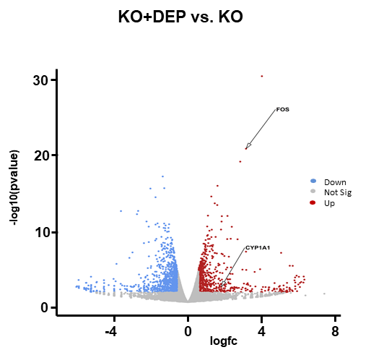
Supplementary Figure 2. Transcriptomic profiles of DEP treated ACP5 KO BEAS-2B cells
Volcano plot of DEGs for ACP5 KO BEAS-2B cells with or without DEP treatment and genes identified in IPA are highlighted. The red dots represent significantly upregulated genes and the blue dots represent significantly downregulated genes (p < 0.05).

