Title:
Symptom clusters and networks analysis in acute-phase stroke patients: a cross-sectional study

Authors:
Siyu Zhou1,#,Yuan Zhang1,3,#, Huijuan He1,2,* , Xiangrong Wang1,2,Mengying Li1,2，Na Zhang1,2，Jiali Song1

Affiliations:
1 School of Nursing, Hubei University of Chinese Medicine, Wuhan, Hubei Province, China.
2 Hubei Shizhen Laboratory
3 Nursing Department, Zhongnan Hospital of Wuhan University.

*Corresponding author:
Huijuan He,
School of Nursing, Hubei University of Chinese Medicine,
No. 16 Huangjiahu Lake Road, Hongshan District,
Wuhan City, Hubei Province, China 430065.
Office: 086-027-6889-0395
Email: hhjiabei@hbtcm.edu.cn

#First Author:
Siyu Zhou and Yuan Zhang contributed equally to this work and share first authorship.

Author contributions：
Siyu Zhou:writing-original draft,methodology,data curation,project administration.
Yuan Zhang:writing-original draft,formal analysis,conceptualisation.
Huijuan He:writing-review & editing,validation,funding acquisition,project administration.
Xiangrong Wang:validation.
Mengying Li:project administration,software.
Na Zhang:data curation,investigation.
Jiali Song:data curation,investigation.

Symptom clusters and networks analysis in acute-phase stroke patients: a cross-sectional study
Abstract
Background:The symptoms of stroke jeopardize patients' health and increase the burden on society and caregivers.Although the traditional symptom cluster research paradigm can enhance management efficiency, it fails to provide targets for intervention, thereby hindering the development of patient-centered precision medicine.However, the symptom network paradigm, as a novel research approach, addresses the limitations of traditional symptom management by identifying core symptoms and determining intervention targets, thereby enhancing the efficiency and precision of symptom management. This study aims to explore the symptom network and core symptoms of acute-phase stroke patients.
Methods: A convenience sample of 505 stroke patients was selected for this study. Symptoms were assessed by the Stroke Symptom Experience Scale.Exploratory factor analysis was utilized to extract symptom clusters, and network analysis was conducted to construct the symptom network and characterize its nodes.
Results: In this study, four symptom clusters were extracted through exploratory factor analysis.
Based on the results of node predictability（re) and node centrality such as strength centrality (rs), it was found that the symptoms of "No interest in surroundings" (rs=1.299, re=1.081), "Be disappointed about future" (rs=0.922, re=0.901), and "Unable to maintain body balance" (rs=0.747, re=0.744) had the highest centrality and predictability values, indicating their core positions within the symptom network.
Conclusion: No interest in surroundings, Be disappointed about future, and Unable to maintain body balance are core symptoms in the symptom network. In the future, intervention methods for core symptoms can be constructed and validated for their intervention effects to further demonstrate the benefits of core symptoms.
Key words: stroke, acute-phase, patient-centered care, symptom network, symptom cluster, core symptom, node centrality

1.INTRODUCTION
Stroke is characterized by high incidence, mortality, recurrence, disability rates, and a significant burden ¹. Stroke is the leading cause of adult disability in China, with the highest incidence rate in the world today ². Research has shown that the range of physical and psychological symptoms experienced by stroke patients can be detrimental to their health. These symptoms not only reduce the patient's mobility and quality of life, but also increase the burden on caregivers and society ^{3,4}. The American Stroke Association (ASA) and the European Stroke Organization (ESO) emphasize in their guidelines that symptom assessment, control, and management of stroke patients are crucial for achieving the goal of patient recovery ^{5,6}. Current research on stroke symptom management predominantly focuses on healthcare professionals perspectives and symptom cluster paradigms, lacking patient-centered approaches and more precise intervention strategies. New research methodologies must be developed to address these deficiencies.
Accurate and comprehensive symptom assessment is a prerequisite for the development of effective symptom management strategies. In their study, Zhang et al. ⁷ found that healthcare professionals often underestimate or overlook the symptoms and severity of stroke patients, with patient-reported symptoms being significantly stronger than those assessed by healthcare professionals. It is evident that the assessment by healthcare professionals does not fully reflect the patient's symptoms. Therefore, establishing patient-centered symptom management strategies may better enhance patients' quality of life. Currently, as an essential component of patient-reported outcomes, symptoms are increasingly recognized by healthcare providers. Symptom management strategies derived from patient self-reported outcomes may be more effective in alleviating symptoms and improving prognosis.
With the advancement of symptom management, the concept of "symptom clusters" has been introduced and widely applied in chronic diseases ⁸. Symptom clusters are defined as groups of two or more symptoms that occur concurrently and interact with each other. The significance of symptom cluster research lies in its potential to manage multiple symptoms concurrently, thereby enhancing the efficiency of symptom management. The study by Yeh revealed that, after treatment with Auricular Point Pressure for breast cancer patients experiencing "pain-fatigue-sleep disturbance" symptom clusters, the severity of several related symptoms was alleviated ⁹. However, Nguyen et al. found in their study on psychological education interventions aimed at improving the severity of the "pain-fatigue-sleep disturbance" symptom cluster that such interventions alleviated fatigue and sleep disturbances in cancer patients but did not reduce pain ¹⁰. This shows that the relationship between symptoms is not a simple linear one, but rather a more complex network of associations.The traditional symptom cluster research paradigm can elucidate the linear relationships between symptoms and enhance the cost-effectiveness of symptom management. However, it fails to elucidate the network structure formed by multiple symptoms and does not provide intervention targets for symptom management, thereby hindering the development of precision in symptom management. As a novel research paradigm, network analysis enables the construction of visualized symptom networks and the identification of core symptoms through quantitative studies of network structures and nodes. Research indicates that intervening on core symptoms can render other nodes originally associated with the core symptom ineffective as targets, and propagate the intervention effects to surrounding nodes, ultimately leading to the alleviation or disappearance of other symptoms¹¹. For instance, Bekhuis et al. identified core symptoms in patients with mild-to-moderate depression through network analysis and implemented interventions based on the core symptoms. The results showed that interventions based on core symptom reduced the severity of depression more than other comprehensive interventions ¹².Therefore, conducting network analysis on the symptoms of stroke patients and identifying their core symptoms can guide healthcare professionals to focus on the interactions between symptoms or symptom clusters ¹³, leading to more targeted, personalized, and efficient therapeutic interventions.
Currently, the majority of symptom network studies focus on cancer and psychiatric disorders ^{14,15}, with few investigations into the symptom networks of acute-phase stroke patients. Therefore, this study explored the interactions between symptoms of stroke patients through symptom networks in order to (1) identify symptoms and extract symptom clusters of acute-phase stroke patients, and (2) construct a symptom network of acute-phase stroke patients and identify their core symptoms.

- METHODS
  - Patients and settings
This study is a cross-sectional study. A convenience sampling method was employed to select 505 stroke patients hospitalized at a tertiary grade A hospital in Wuhan from May 2023 to March 2024. The inclusion criteria were: (1) age ≥18 years; (2) diagnosed with stroke according to the "Chinese Clinical Practice Guidelines for Cerebrovascular Diseases (Second Edition)" ¹⁶, with onset time ≤14 days; (3) informed consent and conscious. The exclusion criteria were: (1) presence of severe comorbidities, such as heart failure or diabetic ketoacidosis; (2) presence of mental illnesses.According to the principles of cross-sectional sample size calculation,the sample size of this study should be 5-10 times of the independent variable ¹⁷, and 10% of invalid questionnaires were considered. The sample size of this study was at least 128 patients. A total of 550 questionnaires were distributed in this study and 505 were returned, with a valid recovery rate of 91.8%. This study was approved by the Ethics Committee of Hubei Provincial Hospital of Traditional Chinese Medicine (No. HBZY2023-C26-01), and all methods of the study were conducted in accordance with relevant guidelines/regulations and the Declaration of Helsinki. Participants gave informed consent before participating in this study and had the right to withdraw at any time. The study guaranteed anonymity and confidentiality to the patients.

  - Measures
2.2.1 Sociodemographic and clinical data
Sociodemographic and health-related data were collected through self-administered questionnaires. Sociodemographic variables included age, gender, BMI (kg/m²), ethnicity, place of residence, marital status, employment status, education status, health care payment method, and monthly income. Health-related variables included time from onset to admission, smoking status, drinking status (alcohol＞20ml/d), taste preference, stroke type, family history, and comorbidities (hypertension, diabetes mellitus, hyperuricemia, hyperlipidemia, etc.).
2.2.2 Stroke Symptom Experience Scale
The Stroke Symptom Experience Scale, developed by Shi et al. ¹⁸, is widely used in China to assess the symptoms of stroke patients.It demonstrates good reliability and validity, with a Cronbach's alpha of 0.805.This Scale consists of 23 items. It contains three dimensions: frequency of occurrence (four-point scale, scores 1-4, the higher the score the more frequent), severity (four-point scale, scores 1-4, the higher the score the more severe), and distress (five-point scale, scores 0-4, the higher the score the more distressing).The mean of the scores for the three dimensions of frequency, severity, and distress indicate the patient's burden of that symptom, with larger means indicating a greater burden of that symptom for the patient.
  - Data collection
A questionnaire survey was conducted among stroke patients in the neurology department of a tertiary hospital. The study's purpose, methods, and significance were explained to the patients by investigators who had undergone standardized training. Following informed consent, patients were guided in completing the questionnaire. If the patient was unable to complete the questions independently due to vision or other problems, the investigator dictated the questions and filled in the answers on his/her behalf. Investigators may have minimal subjective bias when filling out answers on behalf of patients. To reduce subjective bias caused by investigators filling out responses on behalf of patients,we selected individuals with no conflict of interest in this study as investigators.Completed questionnaires were collected and checked for omissions, errors, multiple choices, etc. Questionnaires were invalidated if all answers were the same or if more than 10% of the questions were not answered.

2.4 Data analysis
2.4.1 Demographics and symptom clusters
Data were analyzed using SPSS 29.0. Data conforming to a normal distribution are described as mean ± standard deviation, and data with a skewed distribution are described as median and quartiles. Symptom clusters were identified by principal component analysis in exploratory factor analysis (EFAs) ^{17,19}.Consistent with previous research ^{20,21}, in order to have sufficient variance and covariance for EFAs, only symptoms with an incidence of >20% and <80% were included in the analysis. This may cause a little bias but does not interfere with the identification of core symptoms.Therefore, symptom clusters in this study were extracted based on the following criteria: symptom prevalence >20% and <80%; factor loadings ≥0.4; and number of factors >1.
2.4.2 Developing symptom networks
The statistical analyses related to the symptom network were conducted using R 4.3.3 and R Studio 2023. The Bootnet code ²² defaults to analyzing the relationships between symptoms through the EBICglasso function and Spearman correlation, subsequently constructing a visualized symptom network using the qgraph command. Each node represents a symptom. The edges in the network represent the relationship between two nodes; thicker edges indicate stronger correlations between pairs of nodes.
2.4.3 Node centrality and node predictability
The Centrality command within the bootnet code is employed to obtain network centrality indices and node predictability. Centrality indices include strength centrality (rs), closeness centrality (rc), and betweenness centrality (rb) ¹¹. Strength reflects the sum of direct connections between a symptom and other symptoms. Higher strength centrality indicates that a symptom is more likely to be a core symptom. Closeness centrality reflects the inverse of the distance between a symptom and all other symptoms. Higher closeness centrality suggests that a symptom is more likely to be central within the network. Betweenness centrality reflects the number of shortest paths passing through a symptom. Higher betweenness centrality indicates that a symptom is more likely to be a bridge symptom. Previous research indicates that strength centrality is the most critical criterion for identifying core symptoms ^{11,23}. From the perspective of core symptom characteristics, core symptoms have high stability in the symptom network. Consequently, this study considers both the stability and strength centrality of centrality metrics to determine core symptoms.
Node predictability (Expectedinfluence) is used to assess the ability of all other symptoms in the network to predict the symptom ²⁴. The closer the predictability of a symptom is to 1, the more it can be predicted or identified by other symptoms in the network, and the more likely it is that the symptom can be influenced by intervening with its neighboring symptoms.
2.4.4 Stability,accuracy and difference test of the network
The accuracy of the network, the stability of centrality, and the variability of variables were assessed using the bootstrapping method within the Bootnet code. The accuracy of the network edges was estimated by the 95% confidence interval (CI) of the bootstrap edge weights. The stability of centrality is expressed by correlation stablility coefficient,which should preferably be >0.5 but at the very least be >0.25. Bootstrapped difference tests were conducted between edge weights and centrality indices in the least absolute shrinkage and selection operator regularization of partial correlation networks based on polychoric correlation matrices. Difference tests were conducted to determine if there were differences in the estimates of network connectivity and centrality across variables.

- RESULTS
  - Sociodemographic characteristics of participants
A total of 505 participants are included in this study. The sociodemographic characteristics of the participants are shown in Table 1.
Table 1 Sociodemographic characteristics of participants (n=505)
Characteristics | M(P₂₅,P₇₅)
Age | 67（60，74）
Time from onset to hospitalization (h) | 18（5，48）
n(%)
Gender
Male | 331（66）
Female | 174（34）
BMI（kg/m²）
low | 27（5）
normal | 344（68）
high | 134（27）
Ethnicity
Han | 497（98）
Minority | 8（2）
education attainment
Junior high school and below | 264（52）
High school and above | 241（48）
monthly salary（yuan）
＜3000 | 161（32）
3000～5000 | 206（41）
＞5000 | 138（27）
smoke
yes | 195（39）
no | 310（61）
drink
yes（alcohol＞20ml/d） | 199（39）
no | 306（61）
residence
city | 432（86）
urban | 73（14）
Type of stroke
Cerebral infarction | 486（96）
cerebral hemorrhage | 17（3）
subarachnoid hemorrhage | 2（1）
number of comorbidities
0 | 81（16）
1-3 | 405（80）
＞4 | 19（4）
Family history of cardiovascular disease
yes | 204（40）
no | 301（60）

  - The symptoms experienced by the participants
Table 2 displays the prevalence and mean values of 23 symptoms among stroke patients.The prevalence of symptoms ranged from 6.7% to 83.9%. The three symptoms with the highest prevalence were limb weakness (83.9%), Decreased self-care ability (70.5%), and fatigue (69.7%).
Table 2 Symptom prevalence for stroke patients (n=505)
symptom | Prevalence | mean value | symptom | Prevalence | mean value
Restriction of limb movement | 336（67.5%） | 2.00(0.00,3.00) | Slow response | 211（41.8%） | 0.00(0.00,2.00)
Limb weakness | 424（83.9%） | 2.67(1.67,3.33) | Slurred speech | 238（47.1%） | 0.00(0.00,2.67)
Pain in the limbs | 102（20.2%） | 0.00(0.00,0.00) | Coughing after eating | 131（25.9%） | 0.00(0.00,1.00)
Shoulder pain | 59（11.7%） | 0.00(0.00,0.00) | Be irritable | 188（37.2%） | 0.00(0.00,2.00)
Upper limb flexion | 46（9.1%） | 0.00(0.00,0.00) | Moodiness | 204（40.4%） | 0.00(0.00,2.00)
Foot drop | 34（7%） | 0.00(0.00,0.00) | Be disappointed about future | 110（21.8%） | 0.00(0.00,0.00)
Inversion of foot | 23（6.7%） | 0.00(0.00,0.00) | No interest in surroundings | 149（29.5%） | 0.00(0.00,1.33)
Uncoordinated movements of the limbs | 219（43.4%） | 0.00(0.00,2.67) | Worry about not being able to do what you want | 247（48.9%） | 0.00(0.00,2.00)
Unable to maintain body balance | 272（53.9%） | 1.33(0.00,3.00) | Lack of initiative | 185（36.6%） | 0.00(0.00,1.67)
Hypomesthesia | 240（47.5%） | 0.00(0.00,2.67) | Fatigue | 352（69.7%） | 1.67(0.00,2.67)
Memory decline | 281（55.6%） | 1.33(0.00,2.33) | Decreased self-care ability | 356（70.5%） | 2.33(0.00,3.00)
Decreased attention | 170（33.6%） | 0.00(0.00,1.67)

  - Stroke Symptom clusters
During data analysis, symptoms with occurrence rates less than 20% or greater than 80% were excluded ^{20,21} , including limb weakness, limb pain, shoulder pain, upper limb flexion, foot drop, and foot pronation.Exploratory factor analysis is employed to extract symptom clusters. The symptom clusters are named based on the characteristics of the symptoms within each cluster. The results indicate that four symptom clusters are identified in this study, as shown in Table 3. Factor 1 contains six symptoms, named the Mood symptom cluster, including Be disappointed about future, No interest in surroundings, Moodiness,Lack of initiative,Worry about not being able to do what you want and Be irritable.Factor 2 comprises five symptoms and is labeled as the Coordination-balance symptom cluster, which includes Unable to maintain body balance, Restriction of limb movement, Decreased self-care ability, Uncoordinated movements of the limbs, and Hypomesthesia. Factor 3 encompasses three symptoms and is designated as the Cognitive disorder symptom cluster, including Decreased attention, Memory decline and Slow response. Factor 4 contains two symptoms and is termed the Slurred speech-cough symptom cluster, involving Slurred speech and Coughing after eating. Fatigue, due to factor loadings below 0.4, is not included in any symptom cluster.
Table 3 Exploratory factor analysis of the mean values of the total dimension of symptoms in patients with acute phase stroke（n=505）
symptom | factor 1 | factor 2 | factor 3 | factor 4
symptom | Mood symptom cluster | Coordinate - balance symptom cluster | Cognitive disorder symptom cluster | Slurred speech-cough symptom cluster
no interest in surroundings | 0.817 | 0.190 | 0.110 | -0.016
Be disappointed about future | 0.782 | 0.189 | 0.122 | 0.073
moodiness | 0.741 | 0.257 | -0.057 | 0.181
Worry about not being able to do what you want | 0.696 | 0.044 | 0.170 | -0.169
Lack of initiative | 0.690 | 0.204 | 0.267 | -0.056
Be irritable | 0.481 | 0.001 | 0.104 | 0.310
Unable to maintain body balance | 0.149 | 0.823 | 0.003 | 0.029
Restriction of limb movement | 0.072 | 0.809 | 0.008 | 0.064
Decreased self-care ability | 0.113 | 0.783 | 0.010 | 0.175
Uncoordinated movements of the limbs | 0.219 | 0.749 | 0.094 | 0.094
hypomesthesia | 0.215 | 0.501 | 0.386 | -0.085
Memory decline | 0.140 | 0.033 | 0.851 | -0.002
Decreased attention | 0.113 | 0.043 | 0.847 | 0.125
Slow response | 0.113 | 0.039 | 0.810 | 0.092
Slurred speech | -0.095 | -0.042 | -0.059 | 0.823
Coughing after eating | 0.199 | 0.197 | 0.240 | 0.669
total number of symptoms | 6 | 5 | 3 | 2

3.4 Analysis of the structure of the network and the centrality measure
Network analysis visualizes the relationships among symptoms, with shorter and thicker lines between nodes indicating stronger and closer connections between two symptoms. In the symptom network of acute stroke patients, high correlations are observed between Decreased attention (C1), Memory decline (C2), and Slow response (C3); strong connections are noted between Uncoordinated movements of the limbs (A4) and Unable to maintain body balance (A1); close links exist between Restriction of limb movement (A2) and Decreased self-care ability (A3); high correlations are found between No interest in surroundings (B2) and Lack of initiative (B4); strong connections are evident between Be disappointed about future (B1) and Moodiness (B3), as illustrated in Figure 1.

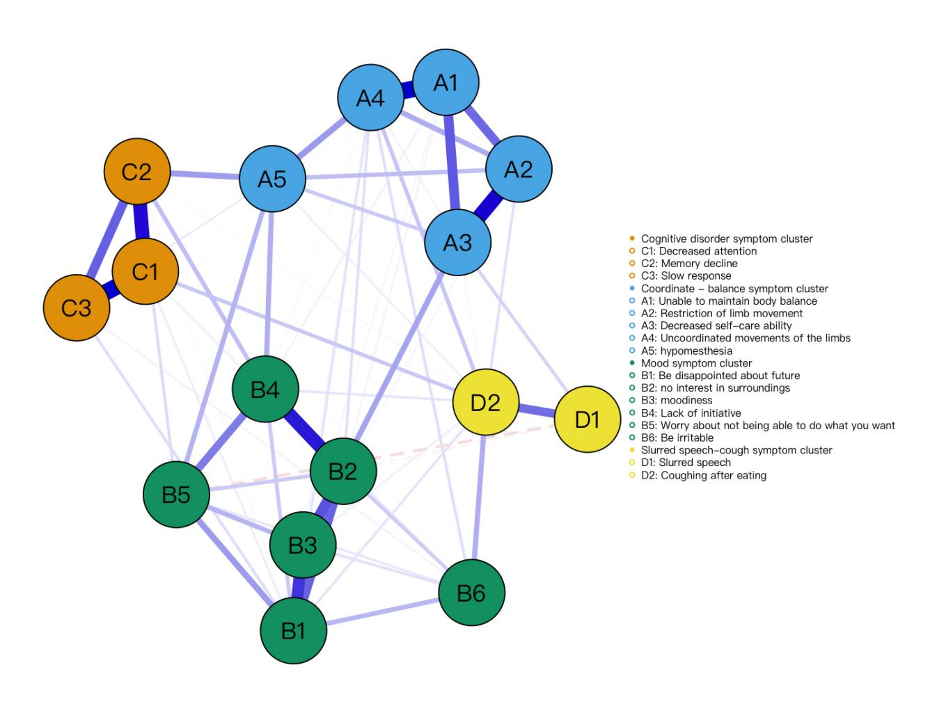
Figure 1 Estimated network plot for symptoms in the total sample（n=505）

The centrality index in Figure 2 shows that the top three strength centrality symptoms are No interest in surroundings (rs=1.299), Be disappointed about future (rs=0.922), and Unable to maintain body balance (rs=0.747); the top three closeness centrality symptoms are Hypomesthesia (rc=1.095), Moodiness (rc=0.931), and Be disappointed about future(rc=0.717); and the top three betweeness centrality symptoms are Memory decline (rc=1.355), Uncoordinated movements of the limbs(rc=1.054), and Hypomesthesia (rc=0.903). Considering the critical role of strength centrality and the stability coefficients of three centrality, this study ultimately identified "No interest in surroundings", "Be disappointed about future ", and "Unable to maintain body balance" as core symptoms of acute-phase stroke patients.

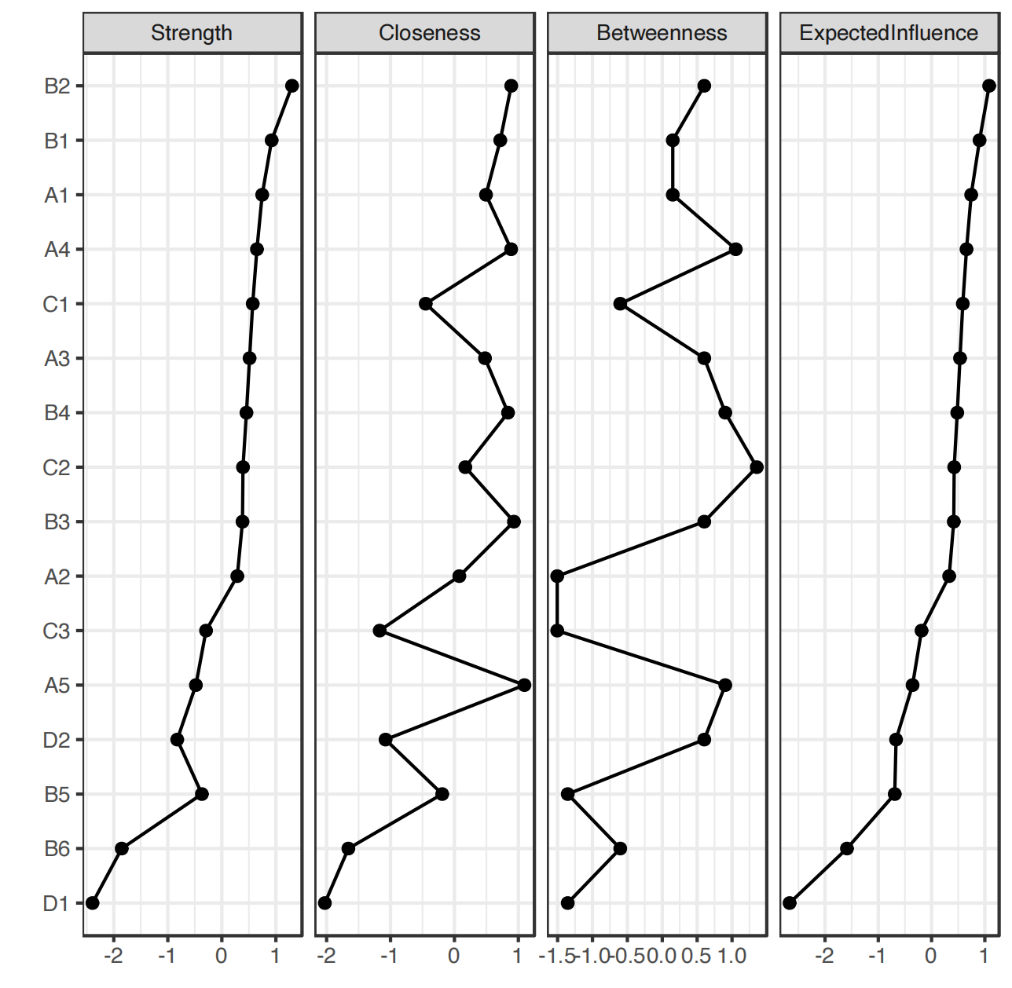
Figure 2 Centrality and predictable measures of all symptoms within the network

The three symptoms with the highest predictability are disinterest in the surrounding environment (re=1.081), disappointment about the future (re=0.901), and inability to maintain physical balance (re=0.744). Symptoms with high predictability can be alleviated by intervening on related peripheral symptoms. For example, interventions targeting "low mood" and "lack of initiative" can mitigate "disinterest in the surrounding environment." Conversely, low-predictive symptoms cannot be alleviated through interventions on peripheral symptoms; for instance, "unclear speech" cannot be mitigated by intervening on other symptoms.

3.5 Accuracy ,stability and difference test
The grey area in Figure 3 represents the 95% confidence interval (CI) for edge weight values. The small 95% CI of edge weight values and the average edge weight value of 0.141 indicate that the results of the network analysis are accurate.
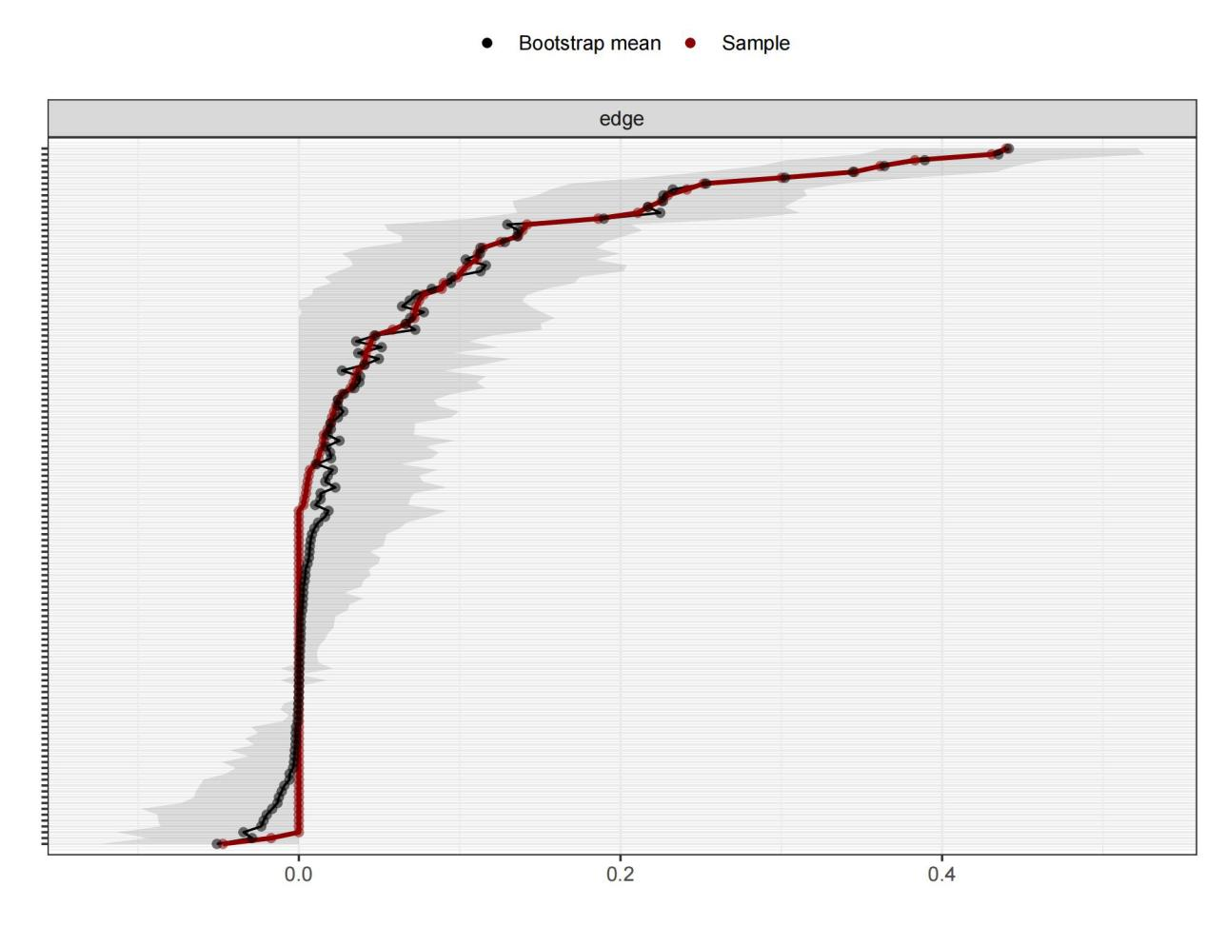
Figure 3 Bootstrap analysis results of the edge weights

Figure 4 displays the correlation stability coefficients of centrality indices. The correlation stability coefficients for strength, expectation, closeness, and betweenness are 0.75, 0.75, 0.36 and 0.129, respectively. Although the stability of betweenness centrality is suboptimal, the stability of strength, expectation, and closeness centrality is satisfactory. Overall, the stability of centrality indicators is deemed acceptable.

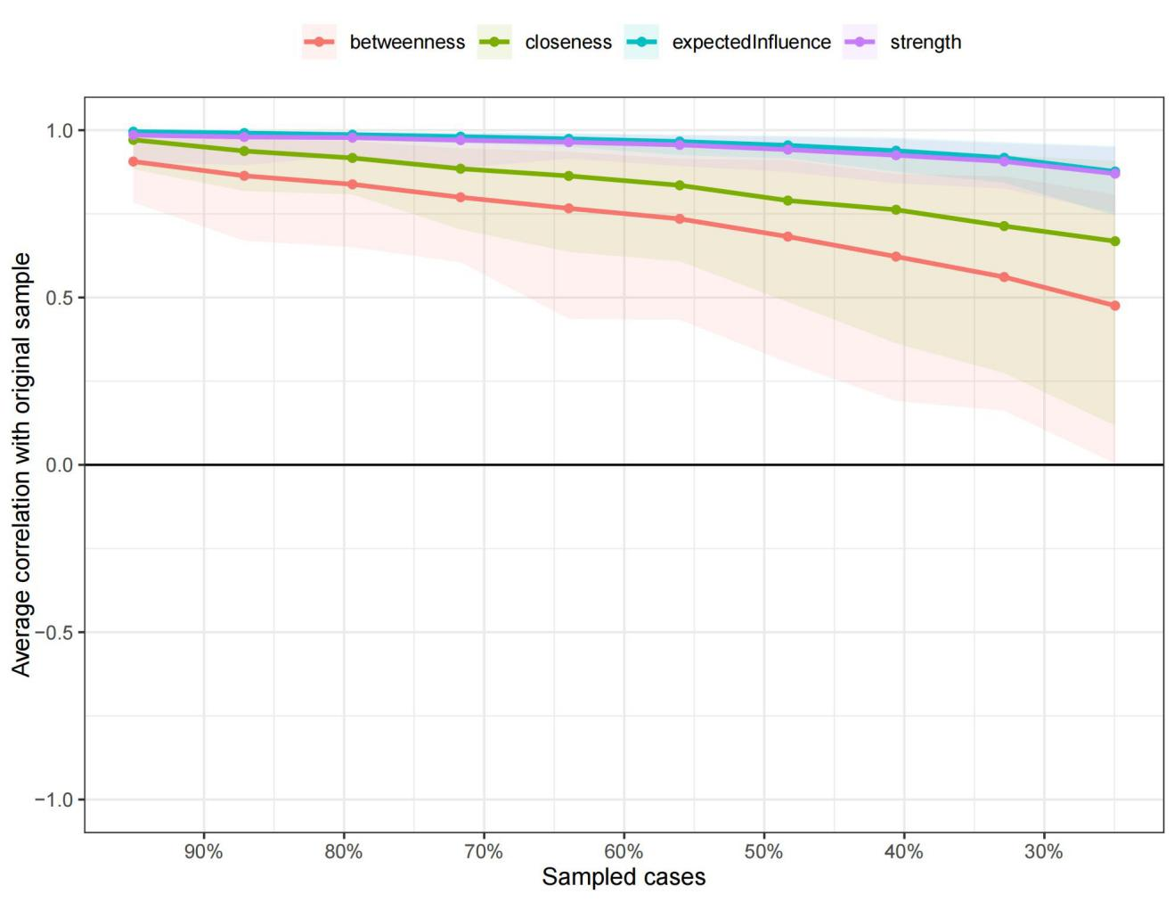
Figure 4 correlation stability coefficient for betweenness,strength, expected influence, and closeness

In Figure 5, the black squares indicate significant differences in the strength centrality of symptoms, suggesting that these results may have important biological or medical implications. The grey squares denote no significant difference in the strength centrality of symptoms, implying that these results might be influenced by other factors. Figure 5 demonstrates that there are no significant differences in the strength centrality among many symptoms within the symptom network. However, B6 (irritability) and D1 (poor articulation) display significant differences compared to the majority of other symptoms.
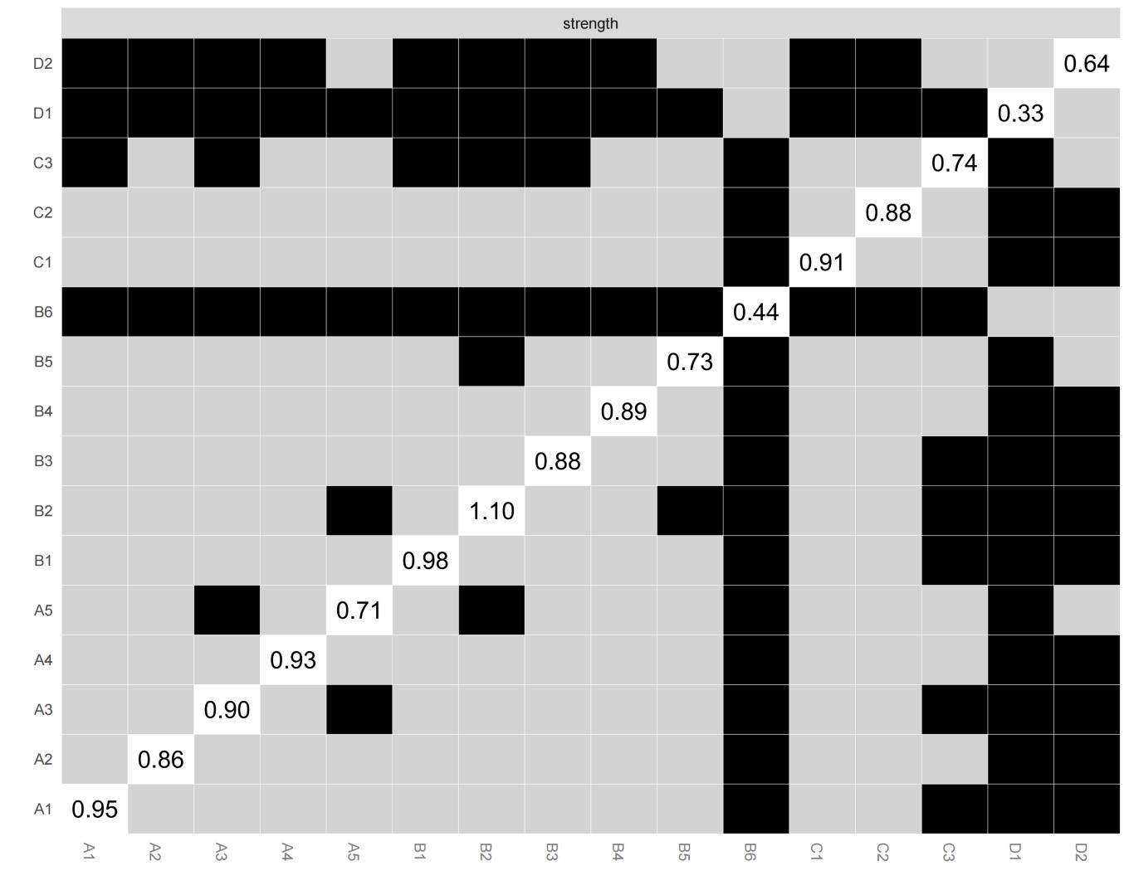
Figure 5 bootstrapped difference test for nodes

- DISCUSSION
We explored symptom clusters and symptom networks in patients with acute-phase stroke, identifying core and predictive symptoms within the network.This provides a foundation for healthcare professionals to develop individualized and precise symptom management strategies, further advancing patient-centered care.
  - Symptom clusters in patients with acute phase stroke
Four symptom clusters were extracted from the symptoms of acute-phase stroke patients: the Mood symptom cluster, the Coordination - balance symptom cluster, the Cognitive disorder symptom cluster, and the Slurred speech-cough symptom cluster. The symptom clusters identified in this study differ in number and type from those extracted by Grady A and Wong A ^{25,26}, yet both include emotional and coordination-balance symptom clusters.Research on symptom clusters in other diseases indicates that different extraction methods and dimensions lead to variations in the type and number of extracted symptom clusters ^{20,21,27}. However, it is unclear whether this hypothesis holds true in the field of stroke, and future studies could test this hypothesis.In contrast to single symptoms, symptom clusters focus on the nature and association of related symptoms. Research indicates that the accurate identification of symptom clusters contributes to the optimization of diagnostic criteria and the prioritization of nursing issues ²⁸. And it facilitates healthcare professionals to accurately predict patients' needs ^{29,30} and provide them with scientific and effective symptom management measures.
  - Core symptoms in patients with acute-phase stroke
Network analysis revealed that Be disappointed about future, No interest in surroundings, and Unable to maintain body balance are core symptoms among patients in acute-phase stroke patients.Studies by Wen H ³¹ and other scholars have demonstrated that, from a mechanistic perspective, core symptoms are the most prominent within the symptom network, exhibiting the strongest connections to other symptoms in the network.Interventions that target core symptoms can accelerate network deactivation, thereby improving the accuracy and efficiency of treatment ^{32,33}. For instance, when healthcare professionals develop precision treatment plans for stroke patients, the incorporation of music therapy or mindfulness therapy to address core symptoms such as "disappointment with the future" and "lack of interest in the surrounding environment" not only alleviates these two core symptoms but also reduces other symptoms to varying degrees. Therefore, this study identifies the core symptoms of patients in acute-phase stroke patients. It provides theoretical guidance for healthcare professionals to develop more efficient, personalized, and refined intervention strategies based on these core symptoms. This contributes to achieving patient-centered care goals and promotes further development in symptom management.
    - Psychological core symptoms
Patients with long-term functional impairment due to stroke often experience negative emotions, including Be disappointed about future and No interest in surroundings.This may lead to a decrease in rehabilitation motivation, poor functional recovery, increased treatment costs due to prolonged hospitalization, and an increased burden on family caregiving ³⁴.Research indicates that approximately 20%-65% of stroke survivors may experience persistent adverse psychological reactions within 3-6 months after stroke ³⁵.In this study, the prevalence of Be disappointed about future and No interest in surroundings in patients with acute-phase stroke was 21.8% and 29.5%, respectively.There are two potential reasons why these two symptoms, despite their central positions within the symptom network, exhibit a low incidence rate. Firstly, the study focused on the acute phase, defined as within 14 days post-onset ¹⁶. Compared to stroke patients at other stages, those in the acute phase have not undergone prolonged treatment and rehabilitation, resulting in a higher prevalence of psychological symptoms characterized by disappointment about the future and increased anxiety, rather than disinterest in surrounding activities. Secondly, "Be disappointed about future" and "No interest in surroundings" exhibit high connectivity with other symptoms. As shown in the symptom network (Figure 1), these core symptoms are associated with every symptom within the network. It has been suggested that Be disappointed about future and No interest in surroundings are more likely to develop into post-stroke depression than other psychological symptoms ³⁶ and and may potentially lead to treatment abandonment ³⁷.Post-stroke depression has been shown to hinder patient rehabilitation and is associated with higher mortality rates ^{38,39}.On the one hand, depression is recognized as an independent risk factor for stroke ³⁹. On the other hand, a dynamic relationship exists between stroke and depression, where an exacerbation of depressive symptoms can increase the severity of stroke, and vice versa. This dynamic interaction is particularly evident within the first six months post-onset ^{40,41}. It indicates that patients with post-stroke depression are more likely to experience a recurrent stroke compared to those without post-stroke depression ⁴².
In conclusion, "No interest in surroundings" and "Be disappointed about future" may serve as precise intervention targets for preventing post-stroke depression, reducing the recurrence rate of stroke, and alleviating related symptoms.It is recommended that healthcare professionals pay particular attention to the core symptoms of "No interest in surroundings" and "Be disappointed about future". Emotional care and physical care are equally important for acute-phase stroke patients who have escaped life-threatening situations.Research indicates that mindfulness therapy ⁴³ and music therapy ⁴⁴ can help alleviate negative emotions in patients.
Numerous traditional Chinese medicine hospitals in China have utilized the Five Elements Music Therapy to alleviate psychological symptoms in patients, with significant therapeutic effects ⁴⁵. Therefore, it is suggested that healthcare professionals incorporate music therapy or mindfulness therapy into symptom management plans to address core symptoms such as "No interest in surroundings" and "Be disappointed about future".

4.2.2 Physical symptom cluster
The Unable to maintain body balance is a common symptom in patients with acute-phase stroke, and the cause may be related to brain injury at the parietotemporal junction, which can lead to poor postural control ⁴⁶.In this study, 53.9% of the patients experienced Unable to maintain body balance, which is consistent with the findings of Hsu AL ⁴⁷. Research indicates that in the physiological development of healthy individuals, stability precedes flexibility. If subsequent development does not adhere to this sequence, optimal performance cannot be achieved ⁴⁸. However, due to damage to the central nervous system, stroke patients exhibit poor body coordination and struggle to maintain balance ⁴⁹.Stability deficits and balance disorders affect the patient's autonomic motor abilities ⁴⁸, such as Unable to maintain body balance, Restriction of limb movement, and Decreased self-care ability. This is depicted in the symptom network diagram, where Unable to maintain body balance (A1) is connected by thick, deep lines to Restriction of limb movement (A2), Decreased self-care ability (A3), and Uncoordinated movements of the limbs (A4) . Meanwhile, Unable to maintain body balance is the leading cause of stroke falls in adults ⁵⁰. Most stroke survivors have a fall rate of up to 70% in the first year after stroke ⁵¹. The fear of falling can lead to a range of negative psychological symptoms in patients. In the symptom network of this study, a thin and shallow line connects Unable to maintain body balance (A1) with No interest in surroundings (B2) and Lack of initiative (B4), suggesting that Unable to maintain body balance may have an indirect impact on psychological symptoms.
In summary, healthcare professionals should focus on patients who are unable to maintain body balance.Patient’s balance abilities can be improved through vestibular rehabilitation therapy ⁵² and ultrasound biofeedback core exercises⁵³ . Additionally, new technologies such as robot-assisted gait training ⁵⁴ and virtual reality therapy ⁵⁵ can be utilized to enhance balance.Meanwhile,home-based exercises are crucial in promoting the recovery of balance capabilities and preventing falls.After nurse training, stroke patients can perform home exercises under the guidance of their family members to improve the coordination of muscle movements ⁵⁶.
4.3 Predictive Symptoms in patients with acute-phase stroke
In our study, an interesting finding is that No interest in surroundings (rs=1.299, re=1.081), Be disappointed about future (rs=0.922, re=0.901) and Unable to maintain body balance (rs=0.747, re=0.744) are not only the core symptoms of acute-phase stroke patients, but also the most predictable symptoms. This further indicates that these three core symptoms are potential precise symptom management targets for acute stroke patients, and their changes will affect the structure of the entire network.
The predictability of a node depends on the number and weight of edges connected to it. Generally, the more edges connected to a node, the higher its strength centrality, resulting in greater predictability ⁵⁷.Expectedinfluence helps guide the selection of intervention goals and the development of interventions ⁵⁸.Research has shown that highly predictive symptoms can be alleviated by intervening with symptoms connected to them ⁵⁹. Clinically, when direct intervention of core symptoms is not feasible or yields inadequate results, healthcare professionals may consider leveraging the high predictive value of these core symptoms to achieve therapeutic goals. Combining the symptom network (Figure 1), it is observed that the connections between Be disappointed about future (B1) and Moodiness (B3) are thick and deep; similarly, the connections between No interest in surroundings (B2) with Moodiness (B3) and Lack of initiative (B4) are thick and deep; as are the connections between Unable to maintain body balance (A1) and Restriction of limb movement (A2); and between Decreased self-care ability (A3) and Uncoordinated movements of the limbs (A4). These results suggest that for patients with acute-phase of stroke, intervening on Moodiness and Lack of initiative can help alleviate No interest in surroundings and Be disappointed about future. Intervening on Restriction of limb movement, Decreased self-care ability, and Uncoordinated movements of the limbs can alleviate the Unable to maintain body balance. However, the effect of neighboring symptoms on highly predictive symptoms is currently theoretical, and few studies have tested this theory clinically.
In conclusion, it is recommended that healthcare professionals consider the highly predictive nature of core symptoms when developing symptom management interventions for stroke patients. Furthermore, this study did not include covariates such as complications and age in the analysis. Future research should consider conducting network analyses that incorporate these covariates to further improve the study design.Additionally, current research on symptom network analysis predominantly remains at the theoretical stage, with few studies constructing intervention programs based on core symptoms and validating their efficacy. Therefore, future research should develop personalized treatment plans targeting core symptoms. The significance of core symptoms can be verified by setting up an intervention group (individualized treatment plan based on core symptoms) and a control group (implementation of conventional treatment measures), and comparing the effects of the two groups before and after the intervention.

5 Limitations
Firstly, this study is based on patients' self-reports and lacks objective indicators. This may increase bias, for instance, certain symptom clusters may be exaggerated by subjective interpretation. It is recommended that future studies add objective measures, such as biological indicators or neuroimaging, to supplement self-reported data and reduce bias. Second, the study sample was selected using convenience sampling and was from a single tertiary care hospital, which could lead to potential generalizability issues. Finally, the cross-sectional design used in this study did not allow for the confirmation of causal relationships between symptoms, which limits our interpretation of the stability of the core symptoms over the course of the disease and the prediction of symptoms.Longitudinal studies, such as follow-up studies, could be conducted in the future to further elucidate the interactions between symptoms.

6 Conclusion
A symptom network was constructed for 505 patients in the acute phase of stroke. Four symptom clusters were extracted through exploratory factor analysis. Core symptoms and highly predictive symptoms, such as No interest in surroundings, Be disappointed about future, and Unable to maintain body balance, were identified through network analysis. Healthcare professionals can develop efficient, targeted, and precise symptom management strategies based on these core symptoms, thereby effectively improving patient outcomes and achieving patient-centered care. Future research should conduct dynamic symptom network studies to determine the stability of core symptoms and predict symptoms through their dynamic trajectories and causal relationships, providing a theoretical basis for developing effective early intervention strategies.

7 Competing interests
The author(s) declare no competing interests.

8 Formatting of funding sources
Funding: This work was supported by the Hubei Provincial Department of Education [grant numbers 22Y087].

9 Data availability statement
The datasets generated during and/or analysed during the current study are not publicly available due to laboratory policies and ethical privacy restrictions but are available from the corresponding author on reasonable request.

References
1 Tu, W. J., Wang, L. D. & Special Writing Group of China Stroke Surveillance, R. China stroke surveillance report 2021. Mil Med Res. 10 (1), 33 (2023), doi:10.1186/s40779-023-00463-x.
2 GBD 2019 Stroke Collaborators. Global, regional, and national burden of stroke and its risk factors, 1990-2019: a systematic analysis for the Global Burden of Disease Study 2019. Lancet Neurol. 20 (10), 795-820 (2021), doi:10.1016/S1474-4422(21)00252-0.
3 Janus-Laszuk, B., Mirowska-Guzel, D., Sarzynska-Dlugosz, I. & Czlonkowska, A. Effect of medical complications on the after-stroke rehabilitation outcome. NeuroRehabilitation. 40 (2), 223-232 (2017), doi:10.3233/NRE-161407.
4 Dou, D. M., Huang, L. L., Dou, J., Wang, X. X. & Wang, P. X. Post-stroke depression as a predictor of caregivers burden of acute ischemic stroke patients in China. Psychol Health Med. 23 (5), 541-547 (2018), doi:10.1080/13548506.2017.1371778.
5 Kleindorfer, D. O. et al. 2021 Guideline for the Prevention of Stroke in Patients With Stroke and Transient Ischemic Attack: A Guideline From the American Heart Association/American Stroke Association. Stroke. 52 (7), e364-e467 (2021), doi:10.1161/STR.0000000000000375.
6 Berge, E. et al. European Stroke Organisation (ESO) guidelines on intravenous thrombolysis for acute ischaemic stroke. Eur Stroke J. 6 (1), I-LXII (2021), doi:10.1177/2396987321989865.
7 Zhang, S. J., Jin, G. H. & Cui, W. X. Research Process of Stroke Patient Reported Outcomes. Chinese Journal of Modern Nursing. 22, 2790-2795 (2016), doi:10.3760/cma.j.issn.1674-2907.2016.19.039.
8 Dodd, M. J., Miaskowski, C. & Paul, S. M. Symptom clusters and their effect on the functional status of patients with cancer. Oncol Nurs Forum. 28 (3), 465-470 (2001).
9 Yeh, C. H., Chien, L. C., Lin, W. C., Bovbjerg, D. H. & van Londen, G. J. Pilot Randomized Controlled Trial of Auricular Point Acupressure to Manage Symptom Clusters of Pain, Fatigue, and Disturbed Sleep in Breast Cancer Patients. Cancer Nurs. 39 (5), 402-410 (2016),
doi:10.1097/NCC.0000000000000303.
10 Nguyen, L. T., Alexander, K. & Yates, P. Psychoeducational Intervention for Symptom Management of Fatigue, Pain, and Sleep Disturbance Cluster Among Cancer Patients: A Pilot Quasi-Experimental Study. J Pain Symptom Manage. 55 (6), 1459-1472 (2018), doi:10.1016/j.jpainsymman.2018.02.019.
11 Zhu, Z. et al. Method overview of symptom contemporaneous network and implementation in R software. Journal of nurse Training. 38 (24), 2235-2239 (2023), doi:10.16821/j.cnki.hsjx.2023.24.006.
12 Bekhuis, E. et al. Symptom-Specific Effects of Psychotherapy versus Combined Therapy in the Treatment of Mild to Moderate Depression: A Network Approach. Psychother Psychosom. 87 (2), 121-123 (2018), doi:10.1159/000486793.
13 Zhu, Z., Xing, W., Hu, Y., Wu, B. & So, W. K. W. Paradigm shift: Moving from symptom clusters to symptom networks. Asia Pac J Oncol Nurs. 9 (1), 5-6 (2022), doi:10.1016/j.apjon.2021.12.001.
14 Zhu, Z. et al. Contemporaneous symptom networks of multidimensional symptom experiences in cancer survivors: A network analysis. Cancer Med. 12 (1), 663-673 (2023), doi:10.1002/cam4.4904.
15 Li, Y. et al. Network analysis of somatic symptoms in Chinese patients with depressive disorder. Front Public Health. 11, 1079873 (2023), doi:10.3389/fpubh.2023.1079873.
16 Chinese Stroke Association. Chinese Guidelines for Clinical Management of Cerebrovascular Diseases (2nd Edition). 521-524 (2023).
17 Sun, Z. & Xu, Y. Medical Statistics. (People's Medical Publishing House2014).
18 Shi, D., Li, Z., Yang, J., Liu, B. Z. & Xia, H. Study on correlation between symptom burden and quality of life in elderly patients with stroke. Nursing Research. 33 (6), 925-929 (2019), doi:10.12102/j.issn.1009-6493.2019.06.004.
19 Brunner, F. et al. Complex regional pain syndrome 1--the Swiss cohort study. BMC Musculoskelet Disord. 9, 92 (2008), doi:10.1186/1471-2474-9-92.
20 Wong, M. L. et al. Differences in Symptom Clusters Identified Using Ratings of Symptom Occurrence vs. Severity in Lung Cancer Patients Receiving Chemotherapy. J Pain Symptom Manage. 54 (2), 194-203 (2017), doi:10.1016/j.jpainsymman.2017.04.005.
21 Ward Sullivan, C. et al. Differences in symptom clusters identified using symptom occurrence rates versus severity ratings in patients with breast cancer undergoing chemotherapy. Eur J Oncol Nurs. 28, 122-132 (2017), doi:10.1016/j.ejon.2017.04.001.
22 Epskamp, S., Borsboom, D. & Fried, E. I. Estimating psychological networks and their accuracy: A tutorial paper. Behav Res Methods. 50 (1), 195-212 (2018), doi:10.3758/s13428-017-0862-1.
23 Hallquist, M. N., Wright, A. G. C. & Molenaar, P. C. M. Problems with Centrality Measures in Psychopathology Symptom Networks: Why Network Psychometrics Cannot Escape Psychometric Theory. Multivariate Behav Res. 56 (2), 199-223 (2021), doi:10.1080/00273171.2019.1640103.
24 Haslbeck, J. M. B. & Waldorp, L. J. How well do network models predict observations? On the importance of predictability in network models. Behav Res Methods. 50 (2), 853-861 (2018), doi:10.3758/s13428-017-0910-x.
25 Grady, A., Carey, M. & Sanson-Fisher, R. Assessing awareness of appropriate responses to symptoms of stroke. Patient Educ Couns. 95 (3), 400-405 (2014), doi:10.1016/j.pec.2014.03.007.
26 Wong, A. et al. Neuropsychiatric Symptom Clusters in Stroke and Transient Ischemic Attack by Cognitive Status and Stroke Subtype: Frequency and Relationships with Vascular Lesions, Brain Atrophy and Amyloid. PLoS One. 11 (9), e0162846 (2016), doi:10.1371/journal.pone.0162846.
27 Harris, C. S. et al. Symptom clusters in outpatients with cancer using different dimensions of the symptom experience. Support Care Cancer. 30 (8), 6889-6899 (2022), doi:10.1007/s00520-022-07125-z.
28 Fan, G., Filipczak, L. & Chow, E. Symptom clusters in cancer patients:a review of the literature. Current Oncology. 14 (5), 173-179 (2007), doi:10.3747/co.2007.145.
29 Komatsu, H. & Yagasaki, K. The power of nursing: guiding patients through a journey of uncertainty. Eur J Oncol Nurs. 18 (4), 419-424 (2014), doi:10.1016/j.ejon.2014.03.006.
30 Shi, D. & Li, Z. Research progress on symptom clusters Chinese Nursing Research. 32 (1), 13-17 (2018), doi:10.3969/j.issn.1009-6493.2018.01.004.
31 Wen, H. et al. Unraveling the central and bridge psychological symptoms of people living with HIV: A network analysis. Front Public Health. 10, 1024436 (2022), doi:10.3389/fpubh.2022.1024436.
32 Montazeri, F., de Bildt, A., Dekker, V. & Anderson, G. M. Network Analysis of Behaviors in the Depression and Autism Realms: Inter-Relationships and Clinical Implications. J Autism Dev Disord. 50 (5), 1580-1595 (2020), doi:10.1007/s10803-019-03914-4.
33 Olatunji, B. O., Levinson, C. & Calebs, B. A network analysis of eating disorder symptoms and characteristics in an inpatient sample. Psychiatry Res. 262, 270-281 (2018), doi:10.1016/j.psychres.2018.02.027.
34 Li, Z., Cui, Y., Feng, J. & Guo, Y. Identifying the pattern of immune related cells and genes in the peripheral blood of ischemic stroke. J Transl Med. 18 (1), 296 (2020), doi:10.1186/s12967-020-02463-0.
35 Sharma, G. S., Gupta, A., Khanna, M. & Prakash, N. B. Post-Stroke Depression and Its Effect on Functional Outcomes during Inpatient Rehabilitation. J Neurosci Rural Pract. 12 (3), 543-549 (2021), doi:10.1055/s-0041-1731958.
36 Raggi, A., Serretti, A. & Ferri, R. A comprehensive overview of post-stroke depression treatment options. Int Clin Psychopharmacol. 39 (3), 127-138 (2024), doi:10.1097/YIC.0000000000000532.
37 Li, J. X., Zhao, X. H. & Tan, Q. F. Analysis of the clinical manifestations of the etiology and related treatments of post-stroke depression. Chinese Journal of Practical Neurological Diseases. 10 (8), 66-67 (2007).
38 Hama, S., Yamashita, H., Yamawaki, S. & Kurisu, K. Post-stroke depression and apathy: Interactions between functional recovery, lesion location, and emotional response. Psychogeriatrics. 11 (1), 68-76 (2011), doi:10.1111/j.1479-8301.2011.00358.x.
39 Williams, L. S. Depression and stroke: cause or consequence? Semin Neurol. 25 (4), 396-409 (2005), doi:10.1055/s-2005-923534.
40 Astrom, M., Adolfsson, R. & Asplund, K. Major depression in stroke patients. A 3-year longitudinal study. Stroke. 24 (7), 976-982 (1993), doi:10.1161/01.str.24.7.976.
41 Robinson, R. G., Starr, L. B., Lipsey, J. R., Rao, K. & Price, T. R. A two-year longitudinal study of post-stroke mood disorders: dynamic changes in associated variables over the first six months of follow-up. Stroke. 15 (3), 510-517 (1984), doi:10.1161/01.str.15.3.510.
42 Das, J. & G, K. R. Post stroke depression: The sequelae of cerebral stroke. Neurosci Biobehav Rev. 90, 104-114 (2018), doi:10.1016/j.neubiorev.2018.04.005.
43 Udvardi, V., Szabo, G., Takacs, J. & Fazekas, G. The effectiveness of mindfulness-based cognitive therapy during poststroke rehabilitation: a randomized controlled trial. Int J Rehabil Res. 47 (3), 169-175 (2024), doi:10.1097/MRR.0000000000000639.
44 Zhong, K., An, X. & Kong, Y. The effectiveness of five-element music therapy for post-stroke depression: A systematic review and meta-analysis. Heliyon. 10 (5), e26603 (2024), doi:10.1016/j.heliyon.2024.e26603.
45 Wu, Y. et al. Effects of Traditional Chinese Medicine Five-Element Music Therapy Combined with Mirtazapine on Depression and Limb Function Recovery After Ischemic Stroke. Altern Ther Health Med. 30 (9), 210-213 (2024).
46 Geurts, A. C., de Haart, M., van Nes, I. J. & Duysens, J. A review of standing balance recovery from stroke. Gait Posture. 22 (3), 267-281 (2005), doi:10.1016/j.gaitpost.2004.10.002.
47 Hsu, A. L., Tang, P. F. & Jan, M. H. Analysis of impairments influencing gait velocity and asymmetry of hemiplegic patients after mild to moderate stroke. Arch Phys Med Rehabil. 84 (8), 1185-1193 (2003), doi:10.1016/s0003-9993(03)00030-3.
48 Puckree, T. & Naidoo, P. Balance and stability-focused exercise program improves stability and balance in patients after acute stroke in a resource-poor setting. PM R. 6 (12), 1081-1087 (2014), doi:10.1016/j.pmrj.2014.06.008.
49 Mansfield, A., Inness, E. L. & McIlroy, W. E. Stroke. Handb Clin Neurol. 159, 205-228 (2018), doi:10.1016/B978-0-444-63916-5.00013-6.
50 Abdollahi, M. et al. A Systematic Review of Fall Risk Factors in Stroke Survivors: Towards Improved Assessment Platforms and Protocols. Front Bioeng Biotechnol. 10, 910698 (2022), doi:10.3389/fbioe.2022.910698.
51 Simpson, L. A., Miller, W. C. & Eng, J. J. Effect of stroke on fall rate, location and predictors: a prospective comparison of older adults with and without stroke. PLoS One. 6 (4), e19431 (2011), doi:10.1371/journal.pone.0019431.
52 Meng, L. et al. Vestibular rehabilitation therapy on balance and gait in patients after stroke: a systematic review and meta-analysis. BMC Med. 21 (1), 322 (2023), doi:10.1186/s12916-023-03029-9.
53 Park, C. & Yoon, H. The effectiveness of core stabilization exercise using ultrasound biofeedback on motor function, balance control, gait speed and activities of daily living in stroke patients. Technol Health Care. 32 (S1), 477-486 (2024), doi:10.3233/THC-248042.
54 Lee, S. Y., Choi, Y. S., Kim, M. H. & Chang, W. N. Effects of robot-assisted walking training on balance, motor function, and ADL depending on severity levels in stroke patients. Technol Health Care. (2024), doi:10.3233/THC-232015.
55 Dabrowska, M. et al. Effect of Virtual Reality Therapy on Quality of Life and Self-Sufficiency in Post-Stroke Patients. Medicina (Kaunas). 59 (9) (2023), doi:10.3390/medicina59091669.
56 Jovic, E., Ahuja, K. D. K., Lawler, K., Hardcastle, S. & Bird, M. L. Carer-supported home-based exercises designed to target physical activity levels and functional mobility after stroke: a scoping review. Disabil Rehabil. 1-12 (2023), doi:10.1080/09638288.2023.2256663.
57 Yu, J. W., Zhu, J. & HU, T. T. Symptoms network specificity index. The nurse gastroenterol. 38 (24), 2229-2234 (2023).
58 Haslbeck, J. M. B. & Fried, E. I. How predictable are symptoms in psychopathological networks? A reanalysis of 18 published datasets. Psychol Med. 47 (16), 2767-2776 (2017), doi:10.1017/S0033291717001258.
59 Fang, F., Xu, L. L. & Liu, C. Q. Multidimensional symptoms chemotherapy of leukemia children experience the same symptoms of network analysis. Journal of nursing management. 30 (16), 1-6 (2023).

