Supplementary data
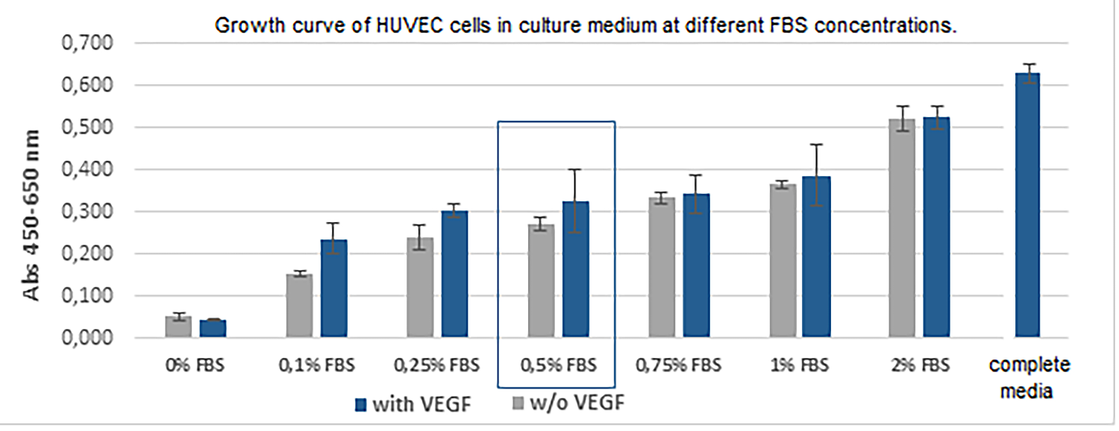Figure S1. Growth curve of HUVEC cells in Endothelial Basal Medium 2 (EBM-2) supplemented with different FBS concentrations.

