Plasma-Assisted MnO Surface Engineered Activated Carbon Felt for Enhanced Heavy Metal Adsorption
Chandrika Ashwinikumar Pal¹, Yu-Lim Choi¹, Lakshmi Prasanna Lingamdinne¹, Rakesh Kulkarni¹, Rama Rao Karri²*, Janardhan Reddy Koduru¹*, Yoon-Young Chang¹*
¹ Department of Environmental Engineering, Kwangwoon University, Seoul 139-701, Republic of Korea.
² Petroleum and Chemical Engineering, Faculty of Engineering, Universiti Teknologi Brunei, Bandar Seri Begawan, BE1410, Brunei Darussalam.
*Corresponding author: kramarao.iitd@gmail.com (RR Karri); reddyjchem@gmail.com (JR Koduru); yychang@kw.ac.kr (YY Chang)
2.3. Characterizations
For investigating the successful surface functionalisation of the modified ACF material, FTIR studies were done using Attenuated Total Reflectance Fourier transform infrared (ATR-FTIR) spectrometer (QATR™-S, Shimadzu) with a diamond crystal. The microstructural surface characteristics of the modified ACF was studied using scanning electron microscope-energy dispersive X-ray spectrometer (SEM-EDS) (7100F, Jeol Korea), S-4300 & EDX-350 (Hitachi, Japan). The BET studies were employed using (Micrometrics model ASAP2425, USA) for uncovering the surface area by the adsorption of nitrogen onto the pores of the adsorbent. Further to understand the changes in the crystallinity of the modified ACF felt surface XRD studies using Rigaku D/Max–2500 X-ray diffraction meter (Japan) were operated. During that analysis the Cu Kα X-rays radiation used was operated at 40 kV and 40 mA. The samples were scanned within the range of 10° to 60° (2θ) at the speed of 4°min⁻ ¹. To gain deeper insights about the C/O ratio and elemental composition X-ray photoelectron spectroscopy (Spectrum GX & ESCALAB–210 (Spain) was done.The XPS evaluation was were conducted at Chungbuk National University, South Korea with an Ulvac PHI Quantera-II Instrument spectrometer equipped with a monochromatic Al K Alpha X-ray source (1486.6 eV) at a power of 20 kV. Deconvulated spectra for finding the integrated peak of C1s, O1s, N1s and Mn 2p spectra were produced after integrating the peak areas with each of the respective atomic sensitivity factors using the XPSpeakfit program. ICP OES was used to analyse Cu(II) and Cd(II) species in the study using (Optima 2100 DV, PerkinElmer, USA) equipped with an auto-sampler. All graphs were plotted using Origin2018 software.

Equations for calculations
The following equation was applied to calculate the equilibrium adsorption capacity at an interval of time Q_{t} (mg/g) and at equilibrium time Q_{e} (mg/g) adsorption, are calculated as shown below:
$Q_{t}=\frac{V\left(c_{o}-c_{t}\right)}{m}$ (Eqn.1)
$Q_{e}=\frac{V\left(c_{o}-c_{e}\right)}{m}$ (Eqn.2)

Table S1: Surface area analysis results
Materials | S_{BET} (m²/g) | V_{p} (cm³/g) | d_{p} (nm)
Raw ACF | 836.65 | 0.3578 | 1.7111
PT-ACF | 835.01 | 0.3160 | 1.5140
MnO-ACF | 588.28 | 0.2450 | 1.6663
Modified ACF | 692.05 | 0.2977 | 1.7207

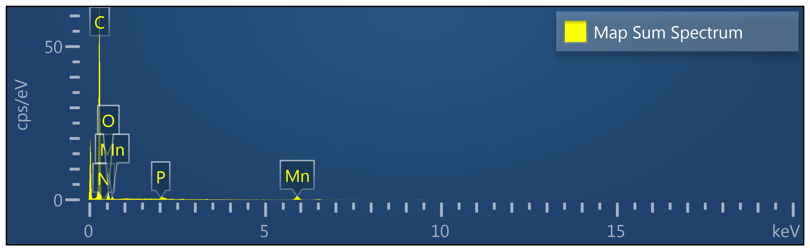
Figure S1: EDX spectra of modified ACF (coated with KMnO₄+Plasma treated)

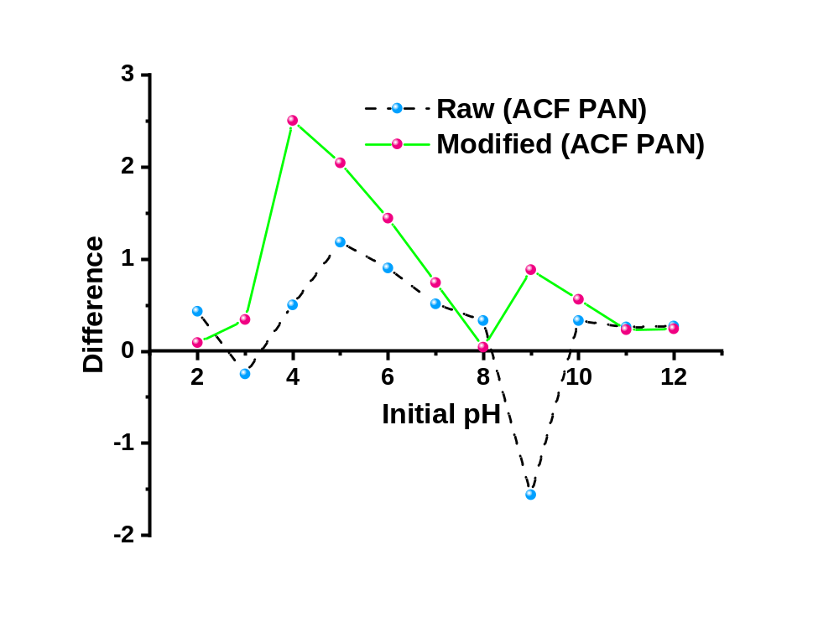
Figure S2: pH_{zpc} of raw and modified ACF (coated with KMnO₄+Plasma treated)
(Adsorption conditions: Initial concentration of Cu(II) and Cd(II): 20 mg/L, ACF Dosage: 0.5g/L, pH: 5)
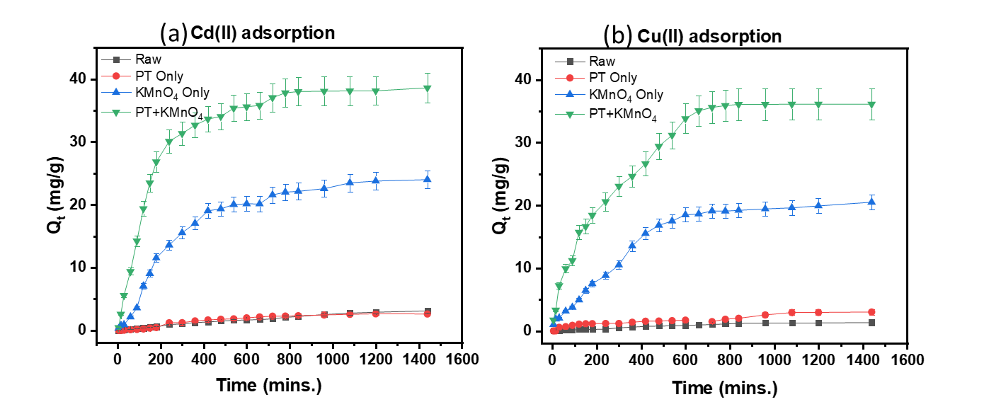
Figure S3: Kinetics of adsorption of Cu(II) and Cd(II) by modified ACFs at different conditions.
Table S2: Thermodynamical parameters for adsorption of Cu(II) and Cd(II) onto modified ACF
Metals | Temperature (°K) | Ln K_{c} | ∆G°=-RTLnK_{c}, (kJ/mol) | ∆H°, (kJ/mol) | ∆S° (J/K. mol) | R²
Cd(II) | 298 | 13.06 | -32.35 | 52.64 | 286.03 | 0.9829
Cd(II) | 308 | 14.03 | -35.94 | 52.64 | 286.03 | 0.9829
Cd(II) | 318 | 14.39 | -38.04 | 52.64 | 286.03 | 0.9829
Cu(II) | 298 | 12.33 | -30.55 | 19.02 | 166.53 | 0.9606
Cu(II) | 308 | 13.20 | -33.82 | 19.02 | 166.53 | 0.9606
Cu(II) | 318 | 12.8 | -33.88 | 19.02 | 166.53 | 0.9606

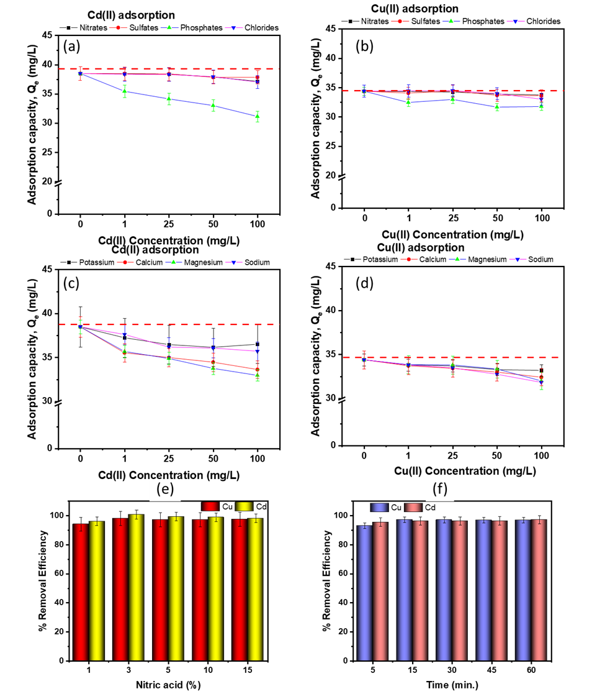
Figure S4: (a-d) Effect of co-existing ions on adsorption of Cu(II) and Cd(II) on modified ACF at pH 5, dose – 0.5 g/L, time – 720 mins. 298K; (e-f) Regeneration studies using nitric acid at different concentrations (for 15 min sonication) and times ( for 3% Nitric acid).
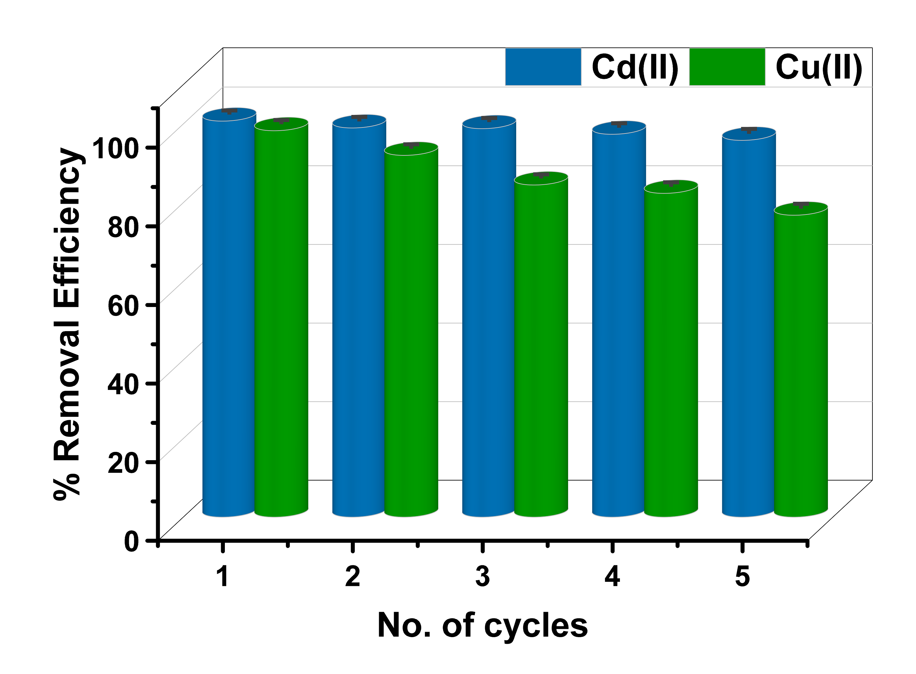
Figure S5: Recycling studies using 3% nitric acid and sonication for 15 minutes for adsorption-desorption cycles of modified ACF after adsorption of Cu(II) and Cd(II).

