Supplementary Materials
Theoretical study of Ti and Cr as candidate assisted metals for mechanical exfoliation of monolayer transition metal dichalcogenides
Guoliang Liu ^{1, *}
¹ School of Information technology, Jiangsu open university, Nanjing 210017 China
* Corresponding authors
E-mail address: liuguol@jsou.edu.cn (Guoliang Liu)

Figure S1. The 8 layers, 7 layers and monolayer slab models of MoS₂.

Table S1. The space group and interlayer bonding energy of TMD materials.
TMD | Space group | Interlayer bonding energy 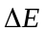 (eV/Å²)
TiS₂ | P-3m1 | 0.0243
TiSe₂ | P-3m1 | 0.0264
TiTe₂ | P-3m1 | 0.0246
ZrS₂ | P-3m1 | 0.0205
HfS₂ | P-3m1 | 0.0206
VS₂ | P-3m1 | 0.0284
NbS₂ | P-3m1 | 0.0295
TaS₂ | P-3m1 | 0.0172
MoS₂ | P6₃/mmc | 0.0276
MoSe₂ | P6₃/mmc | 0.0299
MoTe₂ | P6₃/mmc | 0.0284
WS₂ | P6₃/mmc | 0.0287
TcS₂ | P-1 | 0.0249
ReS₂ | P-1 | 0.0252
PdS₂ | Pbca | 0.0317
PdSe₂ | Pbca | 0.0343
PdTe₂ | Pbca | 0.0339
PtS₂ | P-3m1 | 0.0349

Section S1: The variations of interlayer bonding energy with the number of layers
To calculate the variations of interlayer bonding energy and interlayer distance with the number of layers, we firstly constructed the 11layers, 10 layers, 9 layers, 8 layers and 7 layers slab models for TiS₂, MoS₂ and PdS₂, as shown in Figure S2. Then, their structure optimizations were performed by setting the thickness of 15 Å vacuum and fixing the bottom 4 layers to obtain the most stable structures. Finally, the interlayer bonding energy is calculated according to the following equation:
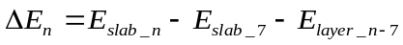 (Eq. S1)
where, E_{slab_n,}, E_{slab_7} and E_{layer_n-7} represent the total energies of the initial slab model with 8, 9, 10 or 11 layers, the final slab model with 7 layers and monolayer, two layers, three layers or four layers structures of 2D TMD crystal, respectively. The calculated results are shown in Figure 4 (a)-(c).

Figure S2. The 11-layer, 10-layer, 9-layer, 8-layer, and 7-layer slab models of MoS₂.

Section S2: Surface energy of metal
To determine the most stable surface of Ti, Cr and Au, we calculated the surface energies of the common surfaces of the corresponding metal according to the following equation:
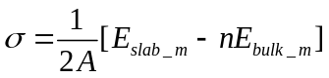 (Eq. S2)
where, E_{slab_m} represents the total energy of the slab model of metal surface, E_{bulk_m} is the total energy of the formula unit of metal bulk; A is the surface area of the slab model and n is the number of formula units of the slab model. The calculated results are listed in Table S2.
Generally, surface energy σ quantifies the disruption of intermolecular bonds that occur when a surface is created. Lower surface energy implies a more stable surface. The calculated surface energy in Table S2 demonstrates that the most stable surfaces of Ti, Cr, and Au are (110), (110), and (111) surfaces, respectively.
Table S2. The calculated surface energy of Ti, Cr, and Au.
Metal | Space group | Surface | Surface Area  A (Å²) | Surface energy σ (J/m²)
Ti | P6₃/mmc | (100) | 13.599 | 2.218
Ti | P6₃/mmc | (001) | 7.429 | 2.010
Ti | P6₃/mmc | (110) | 23.554 | 1.932
Ti | P6₃/mmc | (101) | 15.494 | 1.959
Ti | P6₃/mmc | (111) | 24.696 | 2.106
Cr | Im-3m | (100) | 8.071 | 3.767
Cr | Im-3m | (110) | 5.706 | 3.257
Cr | Im-3m | (111) | 13.977 | 3.658
Au | Fm-3m | (100) | 8.638 | 0.848
Au | Fm-3m | (110) | 12.217 | 0.919
Au | Fm-3m | (111) | 7.482 | 0.714

Figure S3. The adhesion structures of monolayer MoS₂ on Ti (110) (a), Cr (110) (b), and Au (111) (c) surfaces.

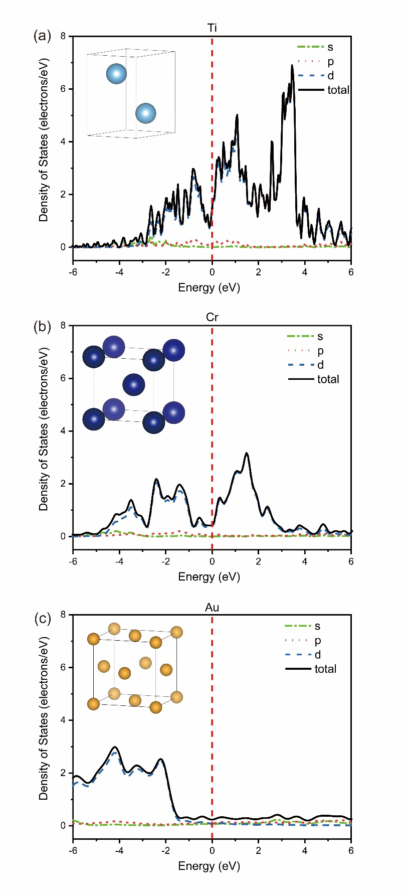
Figure S4. The total and partial density of states (TDOS and PDOS) for Ti (a), Cr (b), and Au (c).

Figure S5. The adhesion structures of 4 layers MoS₂ on Ti (110) (a), Cr (110) (b), and Au (111) (c) surfaces.

Figure S6. The adhesion structures of monolayer TiS₂ (a), MoS₂ (b) and PdS₂ (c) on SiO₂ surface.

Figure S7. The calculated adhesion energies of TiS₂, MoS₂ and PdS₂ on SiO₂.

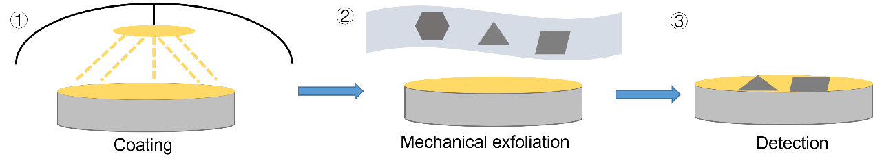
Figure S8. The flow chart of metal-assisted mechanical exfoliation for preparing monolayer 2D TMD materials, ① metal films were deposited on Si/SiO₂ substrate by magnetron sputtering; ② press the master tape containing TMD bulk onto the metal film; ③ when the master tape is removed, 2D TMD remains on the surface of the metal film. The residual TMDs were observed by microscope to determine its size and thickness.

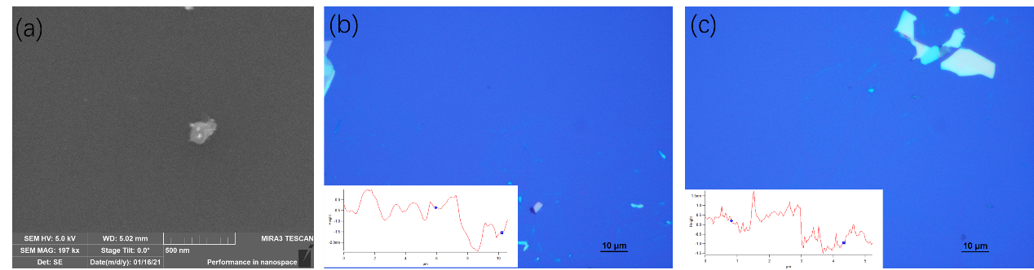
Figure S9. The microscope photographs (a) and AFM measurements (b), (c) of monolayer MoS₂ prepared by Ti-assisted mechanical exfoliation.

