Supplementary Information
Table S1 Table reporting land use categories, type and inclusion in the imperviousness gradient used in this study
Category | Type | Imperviousness
Rivers | Other | No
Annual croplands | Farmland | No
Permanent croplands | Farmland | No
Prairies | Farmland | No
Woodlands | Forest/shrublands | No
Shrubby prairies and shrublands | Forest/shrublands | No
Beaches, dunes and coastal habitats | Other | No
Industrial and commercial areas | Impervious non-residential | Yes
Airports | Other | No
Quarries and dumps | Other | No
Construction sites | Other | Yes
Degraded, non-vegetated and non-used areas | Other | Yes
Green urban areas | Green urban | No
Leisure and sport areas | Residential | Yes
Continuous residential areas (buildings >80% cover) | Residential | Yes
Discontinuous residential areas (buildings >80% cover) | Residential | Yes
Medium density discontinuous residential areas (buildings 50 - 80% cover) | Residential | Yes
Low density discontinuous residential areas (buildings 30 – 50% cover) | Residential | Yes
Very low density discontinuous residential areas (buildings 10 – 30% cover) | Residential | Yes
Isolated residential areas (buildings <10% cover) | Residential | Yes
Roads and street | Other | Yes
Railways | Other | Yes

Table S2 Output table from the GLMMS on species occurrence. Both models (i.e. without and with quadratic term of imperviousness) are shown here. Model selection was conducted based on the lowest AIC. Chi-squared, p-values and AIC are reported.
 |  | Non-quadratic model |  |  | Quadratic model
Species | Variable | χ² | p-value | AIC | χ² | p-value | AIC
Aegithalos caudatus | Imperviousness | 18.77 | <0.001 | 418.66 | 1.05 | 0.304 | 415.07
 | Imperviousness^2 |  |  |  | 5.21 | 0.022
 | Season | 0.16 | 0.690 |  | 0.16 | 0.690
 | Imperviousness*Season | 0.25 | 0.620 |  | 0.30 | 0.587
Carduelis carduelis | Imperviousness | 3.23 | 0.072 | 409.43 | 6.81 | 0.009 | 400.84
 | Imperviousness^2 |  |  |  | 10.59 | 0.001
 | Season | 73.72 | <0.001 |  | 75.20 | <0.001
 | Imperviousness*Season | 0.98 | 0.322 |  | 1.60 | 0.205
Certhia brachydactyla | Imperviousness | 62.883 | <0.001 | 255.51 | 4.55 | 0.033 | 257.51
 | Imperviousness^2 |  |  |  | 0.001 | 0.990
 | Season | 0.65 | 0.421 |  | 0.65 | 0.421
 | Imperviousness*Season | 0.20 | 0.655 |  | 0.20 | 0.654
Chloris chloris | Imperviousness | 0.32 | 0.572 | 359.79 | 2.21 | 0.136 | 358.23
 | Imperviousness^2 |  |  |  | 3.41 | 0.065
 | Season | 34.79 | <0.001 |  | 33.91 | <0.001
 | Imperviousness*Season | 1.73 | 0.188 |  | 1.97 | 0.160
Columba livia | Imperviousness | 26.64 | <0.001 | 470.28 | 4.55 | 0.033 | 472.12
 | Imperviousness^2 |  |  |  | 0.15 | 0.691
 | Season | 14.91 | <0.001 |  | 14.93 | <0.001
 | Imperviousness*Season | 0.30 | 0.587 |  | 0.25 | 0.613
Columba palumbus | Imperviousness | 4.95 | 0.026 | 468.86 | 5.67 | 0.017 | 461.32
 | Imperviousness^2 |  |  |  | 8.74 | 0.003
 | Season | 51.74 | <0.001 |  | 52.56 | <0.001
 | Imperviousness*Season | 0.47 | 0.492 |  | 0.29 | 0.590
Corvus cornix | Imperviousness | 4.61 | 0.031 | 454.33 | 0.62 | 0.428 | 454.56
 | Imperviousness^2 |  |  |  | 1.84 | 0.173
 | Season | 4.05 | 0.044 |  | 4.03 | 0.044
 | Imperviousness*Season | 1.23 | 0.266 |  | 1.22 | 0.269
Corvus monedula | Imperviousness | 0.01 | 0.918 | 267.71 | 2.54 | 0.011 | 267.02
 | Imperviousness^2 |  |  |  | 2.68 | 0.101
 | Season | 3.44 | 0.063 |  | 3.47 | 0.063
 | Imperviousness*Season | 0.28 | 0.596 |  | 0.34 | 0.558
Cyanistes caeruleus | Imperviousness | 14.72 | <0.001 | 552.37 | 1.96 | 0.161 | 547.00
 | Imperviousness^2 |  |  |  | 6.83 | 0.009
 | Season | 0.42 | 0.512 |  | 0.43 | 0.513
 | Imperviousness*Season | 4.51 | 0.033 |  | 4.68 | 0.031
Dendrocopos major | Imperviousness | 31.22 | <0.001 | 335.46 | 0.14 | 0.706 | 335.73
 | Imperviousness^2 |  |  |  | 2.19 | 0.139
 | Season | 7.35 | 0.006 |  | 7.30 | 0.007
 | Imperviousness*Season | 0.12 | 0.720 |  | 0.06 | 0.813
Erithacus rubecula | Imperviousness | 26.97 | <0.001 | 411.86 | 1.05 | 0.304 | 406.68
 | Imperviousness^2 |  |  |  | 6.62 | 0.010
 | Season | 42.07 | <0.001 |  | 45.22 | <0.001
 | Imperviousness*Season | 1.02 | 0.311 |  | 0.03 | 0.864
Fringilla coelebs | Imperviousness | 32.49 | <0.001 | 499.95 | 0.01 | 0.924 | 499.97
 | Imperviousness^2 |  |  |  | 1.98 | 0.159
 | Season | 0.59 | 0.441 |  | 0.59 | 0.441
 | Imperviousness*Season | 0.17 | 0.679 |  | 0.16 | 0.688
Garrulus glandarius | Imperviousness | 16.50 | <0.001 | 233.69 | 0.14 | 0.703 | 232.14
 | Imperviousness^2 |  |  |  | 3.14 | 0.076
 | Season | 0.01 | 0.997 |  | 0.00 | 0.995
 | Imperviousness*Season | 0.69 | 0.405 |  | 0.82 | 0.364
Larus michahellis | Imperviousness | 24.47 | <0.001 | 218.10 | 0.94 | 0.331 | 220.09
 | Imperviousness^2 |  |  |  | 0.01 | 0.928
 | Season | 0.12 | 0.731 |  | 0.11 | 0.731
 | Imperviousness*Season | 0.01 | 0.936 |  | 0.01 | 0.937
Motacilla alba | Imperviousness | 8.72 | 0.003 | 360.65 | 0.13 | 0.714 | 362.46
 | Imperviousness^2 |  |  |  | 0.18 | 0.664
 | Season | 10.68 | 0.001 |  | 10.68 | 0.001
 | Imperviousness*Season | 0.14 | 0.712 |  | 0.15 | 0.696
Myiopsitta monachus | Imperviousness | 0.05 | 0.829 | 101.35 | 0.03 | 0.858 | 103.34
 | Imperviousness^2 |  |  |  | 0.02 | 0.894
 | Season | 0.35 | 0.555 |  | 0.34 | 0.555
 | Imperviousness*Season | 0.37 | 0.542 |  | 0.37 | 0.542
Parus major | Imperviousness | 30.76 | <0.001 | 534.56 | 1.09 | 0.295 | 528.85
 | Imperviousness^2 |  |  |  | 7.11 | 0.008
 | Season | 0.87 | 0.349 |  | 0.89 | 0.346
 | Imperviousness*Season | 0.09 | 0.757 |  | 0.07 | 0.794
Passer italiae | Imperviousness | 15.42 | <0.001 | 466.97 | 11.31 | <0.001 | 461.76
 | Imperviousness^2 |  |  |  | 6.49 | 0.011
 | Season | 26.77 | <0.001 |  | 26.43 | <0.001
 | Imperviousness*Season | 0.15 | 0.691 |  | 0.00 | 0.945
Phoenicurus ochruros | Imperviousness | 1.78 | 0.182 | 429.09 | 1.00 | 0.316 | 430.02
 | Imperviousness^2 |  |  |  | 1.06 | 0.301
 | Season | 49.89 | <0.001 |  | 49.94 | <0.001
 | Imperviousness*Season | 6.29 | 0.012 |  | 6.87 | 0.008
Phylloscopus collybita | Imperviousness | 0.80 | 0.371 | 306.03 | 0.01 | 0.912 | 307.91
 | Imperviousness^2 |  |  |  | 0.12 | 0.727
 | Season | 115.51 | <0.001 |  | 115.52 | <0.001
 | Imperviousness*Season | 0.04 | 0.831 |  | 0.04 | 0.825
Pica pica | Imperviousness | 0.95 | 0.329 | 455.47 | 4.07 | 0.043 | 451.12
 | Imperviousness^2 |  |  |  | 5.62 | 0.018
 | Season | 0.01 | 0.890 |  | 0.02 | 0.891
 | Imperviousness*Season | 1.69 | 0.193 |  | 1.75 | 0.185
Picus viridis | Imperviousness | 64.23 | <0.001 | 188.93 | 10.71 | 0.001 | 190.11
 | Imperviousness^2 |  |  |  | 0.81 | 0.365
 | Season | 3.68 | 0.055 |  | 3.76 | 0.052
 | Imperviousness*Season | 0.98 | 0.323 |  | 0.68 | 0.407
Psittacula krameri | Imperviousness | 16.86 | <0.001 | 283.53 | 0.18 | 0.665 | 284.38
 | Imperviousness^2 |  |  |  | 1.10 | 0.292
 | Season | 2.05 | 0.152 |  | 2.05 | 0.151
 | Imperviousness*Season | 0.27 | 0.605 |  | 0.24 | 0.619
Regulus ignicapilla | Imperviousness | 11.91 | <0.001 | 340.79 | 0.06 | 0.793 | 340.92
 | Imperviousness^2 |  |  |  | 1.78 | 0.181
 | Season | 0.234 | 0.629 |  | 0.23 | 0.629
 | Imperviousness*Season | 0.00 | 0.936 |  | 0.01 | 0.921
Serinus serinus | Imperviousness | 3.13 | 0.076 | 377.07 | 26.44 | <0.001 | 355.12
 | Imperviousness^2 |  |  |  | 23.95 | <0.001
 | Season | 157.53 |  | <0.001 | 164.36 | <0.001
 | Imperviousness*Season | 0.03 |  | 0.846 | 0.38 | 0.536
Sitta europaea | Imperviousness | 23.45 | <0.001 | 137.97 | 0.239 | 0.624 | 139.06
 | Imperviousness^2 |  |  |  | 0.907 | 0.341
 | Season | 0.46 | 0.496 |  | 0.457 | 0.498
 | Imperviousness*Season | 0.972 | 0.324 |  | 1.22 | 0.267
Streptopelia decaocto | Imperviousness | 6.94 | 0.008 | 393.87 | 8.95 | 0.003 | 385.73
 | Imperviousness^2 |  |  |  | 7.13 | 0.007
 | Season | 22.72 | <0.001 |  | 22.10 | <0.001
 | Imperviousness*Season | 0.01 | 0.952 |  | 0.22 | 0.636
Sturnus vulgaris | Imperviousness | 8.54 | 0.003 | 465.45 | 2.06 | 0.151 | 461.67
 | Imperviousness^2 |  |  |  | 5.39 | 0.020
 | Season | 31.33 | <0.001 |  | 31.64 | <0.001
 | Imperviousness*Season | 3.46 | 0.062 |  | 3.29 | 0.069
Sylvia atricapilla | Imperviousness | 16.75 | <0.001 | 499.13 | 5.71 | 0.017 | 487.65
 | Imperviousness^2 |  |  |  | 12.44 | <0.001
 | Season | 44.01 | <0.001 |  | 45.60 | <0.001
 | Imperviousness*Season | 8.82 | 0.002 |  | 6.25 | 0.012
Curruca melanocephala | Imperviousness | 1.89 | 0.169 | 279.45 | 1.80 | 0.179 | 275.45
 | Imperviousness^2 |  |  |  | 4.96 | 0.026
 | Season | 0.02 | 0.885 |  | 0.02 | 0.885
 | Imperviousness*Season | 4.27 | 0.038 |  | 4.74 | 0.030
Troglodytes troglodytes | Imperviousness | 21.92 | <0.001 | 365.93 | 0.21 | 0.643 | 367.06
 | Imperviousness^2 |  |  |  | 0.86 | 0.352
 | Season | 4.15 | 0.041 |  | 4.17 | 0.041
 | Imperviousness*Season | 0.01 | 0.920 |  | 0.02 | 0.886
Turdus merula | Imperviousness | 6.98 | 0.008 | 435.67 | 8.52 | 0.003 | 426.46
 | Imperviousness^2 |  |  |  | 11.50 | <0.001
 | Season | 13.51 | <0.001 |  | 14.50 | <0.001
 | Imperviousness*Season | 7.41 | 0.006 |  | 5.66 | 0.017

Fig S1 Correlation matrix for continuous breeding traits, showing the correlation coefficient and positive (blue) and negative (orange) correlations. Darker colours and bigger circle size mean stronger correlations.
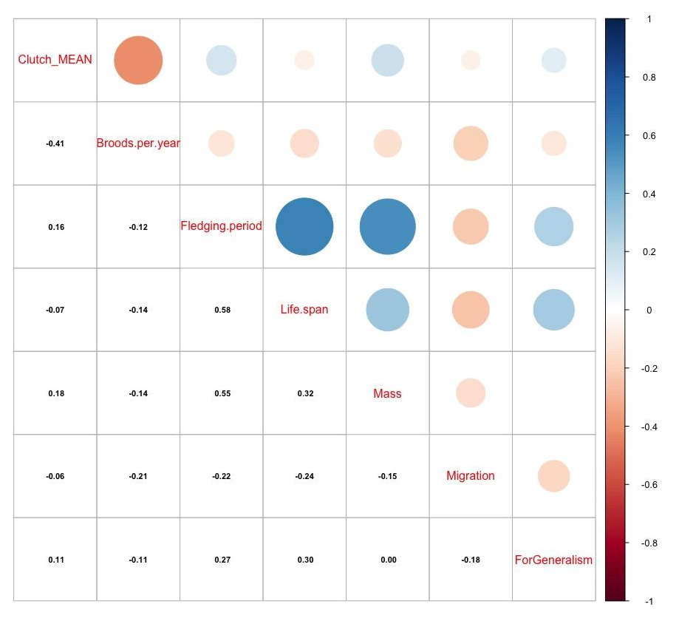
Fig S2 Correlation matrix for continuous wintering traits, showing the correlation coefficient and positive (blue) and negative (orange) correlations. Darker colours and bigger circle size mean stronger correlations.
