SUPPLEMENTARY INFORMATION

EPITOPE MAPPING OF SARS-CoV-2 SPIKE PROTEIN USING NATURALLY-ACQUIRED IMMUNE RESPONSES TO DEVELOP MONOCLONAL ANTIBODIES

Lopez-Aladid Rubén^{‡1,2}, Bueno-Freire Leticia^{‡1,2}, Farriol-Duran Roc^{‡3,4}, Porta-Pardo Eduard^{3,4}, Aguilar Ruth⁵, Vidal Marta⁵, Jiménez Alfons^{5,6} , Cabrera Roberto^{1,2}, Vázquez Nil^{1,2}, López-Gavin Àlex^{1,2}, Moncunill Gemma^{5,7}, Montserrat Carrascal⁸, Teresa García⁸, Lozano Miquel⁹, García-Basteiro Alberto L.^{5,6,7}, Dobaño Carlota^{5,7}, Martalu D. Pazos¹⁰, M.-Carmen Estevez¹⁰, Laura M. Lechuga¹⁰, Torres Antoni*^{1,2}, Fernández-Barat Laia*^{1,2}.

1 Cellex laboratory, Centro de Investigación Biomédica en Red de Enfermedades Respiratorias (CIBERES, 06/06/0028), Fundació de Recerca Clínic Barcelona-Institut d'Investigacions Biomèdiques August Pi i Sunyer (FRCB-IDIBAPS), School of Medicine, Universitat de Barcelona, Spain.
2 Pulmonology Service, Hospital Clínic de Barcelona, Barcelona, Spain.
3 Cancer Immunogenomics Institut Josep Carreras (Spain).
4 Barcelona Supercomputing Center (BSC), 08034 Barcelona, Spain.
5 ISGlobal, Barcelona, Spain.
6 Spanish Consortium for Research in Epidemiology and Public Health (CIBERESP), Barcelona, Spain.
7 Centro de Investigación Biomédica en Red de Enfermedades Infecciosas (CIBERINFEC), Barcelona, Spain.
8 Biological and Environmental Proteomics Group, Institute of Biomedical Research of Barcelona, Spanish National Research Council (IIBB-CSIC/IDIBAPS), Barcelona, Spain.
9 Institut Clínic del Càncer i Malalties de la Sang. Hospital Clínic. Institut d'Investigacions Biomèdiques August Pi i Sunyer (FRCB-IDIBAPS), Universitat de Barcelona ES
10 Nanobiosensors and Bioanalytical Applications group (NanoB2A), Catalan Institute of Nanoscience and Nanotechnology (ICN2), CSIC, BIST, and CIBER-BBN, Bellaterra, 08193, Barcelona, Spain.

‡Co-first authors
*Co-senior authors

Correspondence to:
Laia Fernández-Barat, PhD (ORCID:0000-0001-7528-9636)
Cellex laboratory, Centro de Investigación Biomédica en Red de Enfermedades Respiratorias (CIBERES, 06/06/0028), Fundació de Recerca Clínic Barcelona-Institut d'Investigacions Biomèdiques August Pi i Sunyer (FRCB-IDIBAPS), School of Medicine, Universitat de Barcelona, Spain.
Voice/Fax: 0034 932275549
Email: lfernan1@recerca.clinic.cat

Rubén López-Aladid
Cellex laboratory, Centro de Investigación Biomédica en Red de Enfermedades Respiratorias (CIBERES, 06/06/0028), Fundació de Recerca Clínic Barcelona-Institut d'Investigacions Biomèdiques August Pi i Sunyer (FRCB-IDIBAPS), School of Medicine, Universitat de Barcelona, Spain.
Voice/Fax: 0034 932275549
Email: rlopeza@recerca.clinic.cat

Antoni Torres
Pulmonology Service, Hospital Clínic de Barcelona, 172 Villarroel Street, 08036, Barcelona Spain.
Email: atorres@recerca.clinic.cat

Figures

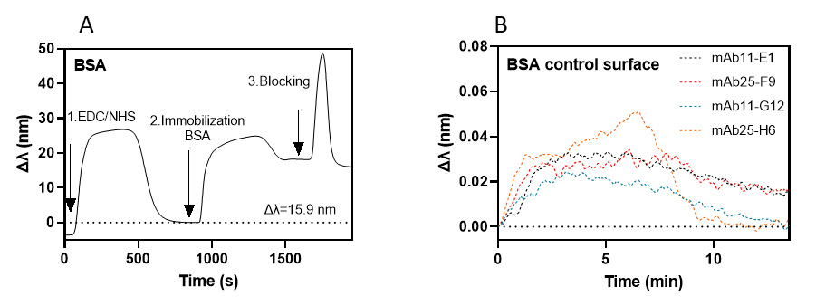
Figure S1. Control experiments. A) Sensor chip biofunctionalization with BSA protein as a control nonspecific surface; B) Real-time sensorgrams of the binding of the four antibodies: (black) [mAb11-E1] 66 nM; (red) [mAb25-F9] 264 nM; (blue) [mAb11-G12] 66nM; (orange) [mAb25-H6] 264 nM.

Figure S2. Conservation of Peptides 11 and 25 in the Spike protein across SARS-CoV-2 Variants of Concern (VOCs). The table shows the sequences of each peptide (peptide_seq) and their corresponding location in the variant-specific Spike protein sequences (voc_seq) for Alpha, Beta, Gamma, Delta, and Omicron. Peptide 11 remained conserved across all variants. Peptide 25 exhibited a single mutation (T482K) in the Delta variant, introducing a lysine at position 482 of the Spike protein, potentially affecting epitope recognition.

