Cell therapy with placenta-derived mesenchymal stem cells for secondary progressive multiple sclerosis patients in a phase 1 clinical trial
Supplementary data file includes Fig S.1 to S.3 and Tables S.1 to S.5:

S.1 Over 80 % of MS patients begin with a relapsing-remitting (RR) phase marked by periods of inflammation-induced relapses, followed by incomplete or complete remission. Within 5 to 15 years of the initial stages, approximately 50% of patients progress to SPMS, during which pre-existing neurological problems gradually worsen from the initial stages with intermittent relapses. Axonal degeneration and loss characterize this phase, leading to brain atrophy and gliosis. MS follows the primary-progressive (PP) phase in around 15 % of individuals, exhibiting a faster accumulation of disability compared to the early RR phase. Finally, progressive-relapsing MS (PRMS) is the least common form of MS, is characterized by a continuous neurological decline punctuated by episodic attacks experienced by the patients.

Table.S1 EDSS changes for three years prior to the injection and up to one year after MSCs injection (P < 0.0001).

EDSS | P1 | P2 | P3 | P4 | P5
Date of cell therapy | November 15, 2021 | August 29, 2021 | October 9, 2021 | December 27, 2021 | January 14, 2022
36months before injection | 5.5 | 5 | 5 | 5 | 6.5
30months before injection | 5.5 | 5 | 5.5 | 5 | 6.5
24months before injection | 6 | 5.5 | 5.5 | 5 | 6.5
18months before injection | 6 | 5.5 | 5.5 | 5 | 6.5
12 months before injection | 6.5 | 6 | 5.5 | 5 | 7
6 months before injection | 6.5 | 6 | 6 | 5.5 | 7
baseline | 7 | 6 | 6 | 5/5 | 7
3 months later | 6 | 4/5 | 5 | 4 | 6/5
6 months later | 6 | 4/5 | 5 | 4 | 6/5
9 months later | 6 | 4/5 | 5 | 4 | 6/5
12months later | 6 | 4/5 | 5 | 4 | 6/5

Table.S2 History of disease-modifying therapies (DMTs) for patients with SPMS before and after MSC injection.

History of DMTs | P1 | P2 | P3 | P4 | P5
Disease duration(years) before MSCs injection | 7 | 10 | 4 | 10 | 16
DMT1 | Cinnovex | RTX | RTX | RTX | Cinnovex
Duration of taking DMT1 | 1 | 10 | 4 | 10 | 7
DMT2 | Natalizumab | * | * | * | Novantron
Duration of taking DMT2 | 1 | … | … | … | 1
DMT3 | RTX | * | * | * | RTX
Duration of taking DMT3 | 5 | … | … | … | 8
Date of MSCs injection | November 15, 2021 | August 29, 2021 | October 9, 2021 | December 27, 2021 | January 14, 2022
DMT4 | RTX | RTX | RTX | RTX | RTX
Duration of taking DMT4 | 3 | 3 | 3 | 3 | 3

*The same medication as before has been used.

Table. S3 Demographic data of participants (patients with MS disorder).

Patient ID | Patient 1 | Patient 2 | Patient 3 | Patient 4 | Patient 5
Gender | Female | Female | Female | Female | Female
Age (years) | 49 | 39 | 45 | 35 | 41
Weight(kg) | 70 | 90 | 69 | 100 | 66
MS type | SPMS | SPMS | SPMS | SPMS | SPMS
Disease duration(years) | 7 | 10 | 4 | 10 | 16
EDSS at entry | 7 | 6 | 6 | 5.5 | 7
Treatment | Rituximab | Rituximab | Rituximab | Rituximab | Rituximab

Table. S4 The changes of cognitive performance of participants at the base of study, 3 months after intervention, and 6 months after intervention.

Variables | Baseline | The third month | The sixth month | P value¹ | P value² | P value³ | P value⁴
CVLT-II | 41.0(16.0) | 42.0(20.5) | 56.0(24.5) | 0.04 | 0.27 | 0.06 | 0.06
PASAT | 36.0(21.0) | 38.0(24.5) | 42.0(20.5) | 0.07 | 0.13 | 0.04 | 0.22
SDMT | 41.0(12.0) | 32.0(17.0) | 44.0(18.0) | 0.44 | 0.78 | 0.10 | 0.41
BVMT-R | 23.0(10.0) | 30.0(16.5) | 30.0(11.0) | 0.05 | 0.49 | 0.04 | 0.19
CVLT_Delay | 7.0(6.5) | 11.0(4.0) | 10.0(5.0) | 0.46 | 0.58 | 0.28 | 0.49
BVMT_Delay | 10.0(3.5) | 10.0(3.0) | 12.0(4.5) | 0.60 | 0.27 | 1.00 | 0.45
COWAT | 31.0(17.5) | 29.0(9.0) | 33.0(13.5) | 0.36 | 0.68 | 0.27 | 0.13
D_KEFS_Sorting | 7.0(1.5) | 7.0(2.0) | 9.0(2.0) | 0.02 | 0.56 | 0.05 | 0.03
D_KEFS_Descriptive | 28.0(9.0) | 27.0(6.5) | 34.0(9.0) | 0.02 | 0.89 | 0.04 | 0.04
JLO | 24.0(10.5) | 19.0(3.5) | 17.0(9.0) | 0.34 | 0.46 | 0.27 | 0.27
Data are presented as median (Interquartile range)
CVLT-II: California Verbal Learning Test second edition; PASAT: Paced Auditory Serial Addition Test; SDMT: Symbol Digit Modalities Test; BVMT-R: Brief Visuospatial Memory Test-Revised; D-KEFS: Delis–Kaplan Executive Function System; JLO: Judgment of Line Orientation Test; COWAT: Controlled Oral Word Association Test
P value¹: Calculated by Friedman test for comparison of scores between three times.
P value²: Calculated by Wilcoxon test for comparison of scores between baseline and the third month.
P value³: Calculated by Wilcoxon test for comparison of scores between baseline and the sixth month.
P value⁴: Calculated by Wilcoxon test for comparison of scores the third and the sixth month.

Variables | Baseline | The third month | The sixth month | P value¹ | P value² | P value³ | P value⁴
Somatization | 1.00(0.96) | 0.33(0.70) | 0.50(0.59) | 0.16 | 0.22 | 0.04 | 0.89
Obsessive-Compulsive | 0.50(0.75) | 0.30(0.50) | 0.30(0.35) | 0.36 | 0.14 | 0.14 | 0.31
Interpersonal Sensitivity | 0.66(0.78) | 0.22(0.55) | 0.11(0.50) | 0.06 | 0.10 | 0.10 | 0.31
Depression | 0.76(1.23) | 0.30(0.33) | 0.23(0.53) | 0.24 | 0.08 | 0.10 | 0.58
Anxiety | 0.20(0.45) | 0.20(0.25) | 0.20(0.60) | 0.48 | 0.25 | 0.78 | 0.46
Hostility | 0.16(0.75) | 0.00(0.00) | 0.00(0.41) | 0.02 | 0.06 | 0.06 | 0.18
Phobic Anxiety | 0.42(1.07) | 0.00(0.64) | 0.42(0.48) | 0.60 | 0.41 | 0.46 | 1.00
Paranoid | 0.50(1.17) | 0.14(0.74) | 0.15(0.33) | 0.06 | 0.22 | 0.04 | 1.00
Psychotic | 0.00(0.45) | 0.00(0.00) | 0.00(0.05) | 0.15 | 0.18 | 0.18 | 0.31
SCL-90 Global Severity | 0.40 (0.77) | 0.19 (0.33) | 0.19(0.37) | 0.24 | 0.13 | 0.08 | 0.89
Fatigue | 53.00(18.00) | 40.00(33.00) | 42.00(19.50) | 0.02 | 0.04 | 0.04 | 0.49
Data are presented as median (Interquartile range)
P value¹: Calculated by Friedman test for comparison of scores between three times.
P value²: Calculated by Wilcoxon test for comparison of scores between baseline and the third month.
P value³: Calculated by Wilcoxon test for comparison of scores between baseline and the sixth month.
P value⁴: Calculated by Wilcoxon test for comparison of scores the third and the sixth month.
Table. S5 The changes of psychologic function of participants according to SLC-90 scale at the base of study, 3 months after intervention, and 6 months after intervention

Table. S6 Lesion formation trends (gadolinium enhancement) in MRI for patients three years prior to the injection and up to one year after MSCs injection.

Gadolinium enhancement in MRI analysis | P1 | P2 | P3 | P4 | P5
36months before injection | 0 | 0 | 0 | 0 | 0
30months before injection | 0 | 0 | 0 | 0 | 0
24months before injection | 0 | 0 | 0 | 0 | 0
18months before injection | 0 | 0 | 0 | 0 | 0
12 months before injection | 0 | 0 | 0 | 1 | 0
6 months before injection | 0 | 0 | 0 | 0 | 0
Baseline | 0 | 0 | 0 | 0 | 0
3months later | 0 | 0 | 0 | 0 | 0
6months later | 0 | 0 | 0 | 0 | 0
9months later | 0 | 0 | 0 | 0 | 0
12months later | 0 | 0 | 0 | 0 | 0

Table. S7 Lesion formation trends (new T2 lesions) in MRI for patients three years prior to the injection and up to one year after MSCs injection.

New T2 lesions in MRI analysis | P1 | P2 | P3 | P4 | P5
36months before injection | 0 | 0 | 0 | 1 | 0
30months before injection | 0 | 0 | 1 | 0 | 0
24months before injection | 0 | 0 | 0 | 0 | 0
18months before injection | 0 | 0 | 0 | 0 | 0
12 months before injection | 0 | 0 | 0 | 1 | 0
6 months before injection | 0 | 0 | 0 | 0 | 0
Baseline | 0 | 0 | 0 | 0 | 0
3months later | 0 | 0 | 0 | 0 | 0
6months later | 0 | 0 | 0 | 0 | 0
9months later | 0 | 0 | 0 | 0 | 0
12months later | 0 | 0 | 0 | 0 | 0

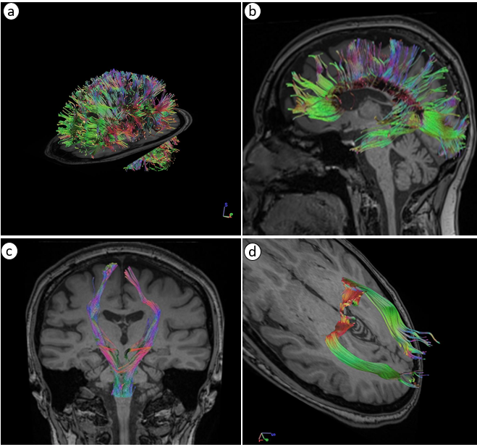

Fig.S1 Tractography of whole brain and specific fiber Pathways
(a) Whole brain tractography showing major white matter pathways, including the corticospinal- tract (CST), corpus callosum (CC), and optic radiation (OR). The colors represent different fiber orientations.
(b) Zoomed-in view of the corticospinal tract originating from the motor cortex and descending through the internal capsule to innervate the spinal cord.
(c) Detailed visualization of the corpus callosum, which connects the right and left brain ‘s hemispheres allowing for interhemispheric communication.
(d) Optic radiation depicted with high resolution, illustrating its course from the lateral geniculate nucleus in human thalamus to primary visual cortex located within the occipital lobe.

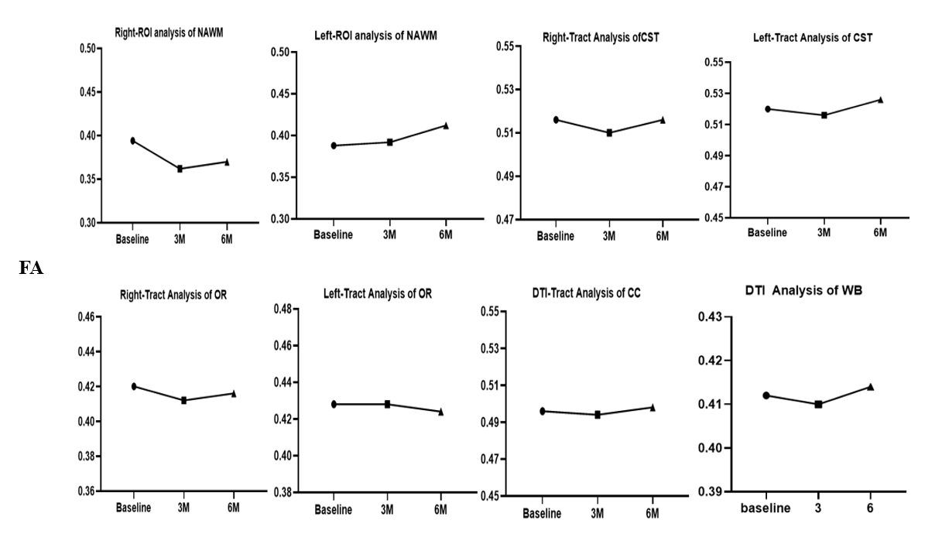

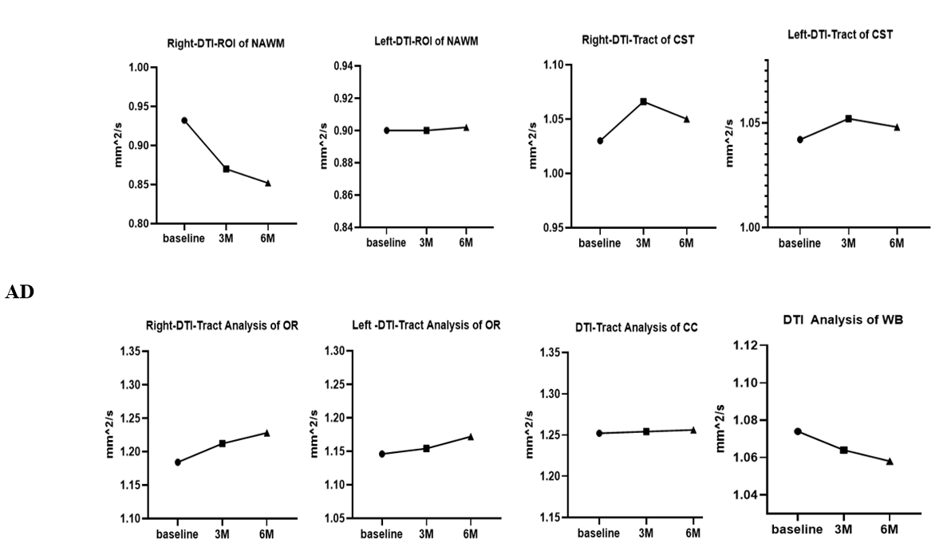

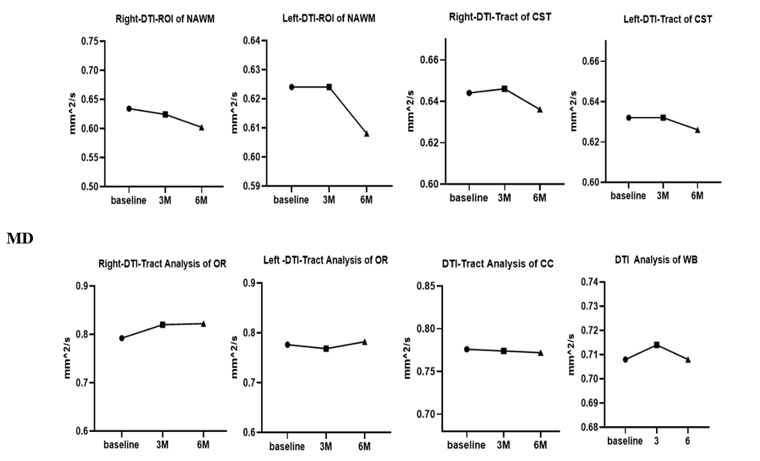

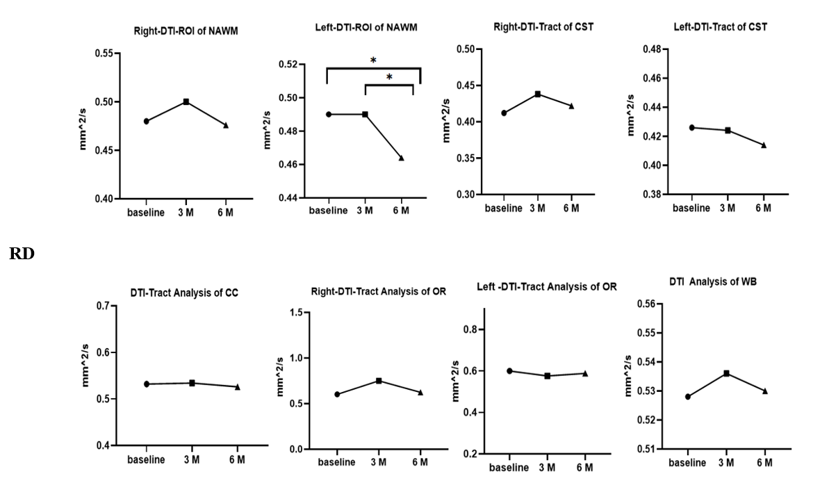

Fig S2. DTI indices include FA (fractional anisotropy), AD (axial diffusivities), MD (mean diffusivity), and RD (radial diffusivity).

Table. S8 DTI data of participants (patients with MS disorder).

A:DTI Analysis of WB | Baseline  Mean (SD) | 3-month  Mean (SD) | 6-month  Mean (SD) | F | P value
FA | 0.4180(0.02280) | 0.4100(0.02345) | 0.4140(0.01140) | 0.5161 | 0.5933
MD | 0.7080(0.03421) | 0.7140(0.04506) | 0.7080(0.03701) | 1.161 | 0.3559
RD | 0.5280(0.03421) | 0.5360(0.04561) | 0.5300(0.03464) | 1.000 | 0.3902
AxD | 1.074(0.06841) | 1.064(0.04219) | 1.058(0.04438) | 0.5665 | 0.5009
Total Lesion Count & Volumes(cm3) | 52.80(52.75) | 22.20(19.51) | 23.20(23.56) | 1.092 | 0.3573

B:DTI-ROI analysis of NAWM |  | Baseline  Mean (SD) | 3-month  Mean (SD) | 6-month  Mean (SD) | F | P value
FA | Right | 0.4180(0.02280) | 0.4100(0.02345) | 0.4140(0.01140) | 0.5161 | 0.5933
FA | Left | 0.3920(0.05805) | 0.3920(0.05805) | 0.4120(0.04140) | 2.667 | 0.1778
MD | Right | 0.7080(0.03421) | 0.7140(0.04506) | 0.7080(0.03701) | 1.161 | 0.3559
MD | Left | 0.6240(0.02302) | 0.6240(0.02302) | 0.6080(0.02280) | 2.977 | 0.1596
RD | Right | 0.5280(0.03421) | 0.5360(0.04561) | 0.5300(0.03464) | 1.000 | 0.3902
RD | Left | 0.4900(0.03536) | 0.4900(0.03536) | 0.4640(0.02881) | 14.70 | 0.0186
AxD | Right | 1.074(0.06841) | 1.064(0.04219) | 1.058(0.04438) | 0.5665 | 0.5009
AxD | Left | 0.9000(0.04743) | 0.9000(0.04743) | 0. 9020(0.04712) | 0.007782 | 0.9339

C:DTI-Tract Analysis of CST |  | Baseline  Mean(SD) | 3-month  Mean(SD) | 6-month  Mean(SD) | F | P value
FA | Right | 0.5180 (0.02950) | 0.5100 (0.02550) | 0.5160 (0.02510) | 0.3312 | 0.6407
FA | Left | 0.5060(0.04669) | 0.5160(0.02608) | 0.5260(0.02302) | 1.875 | 0.2278
MD | Right | 0.6440(0.03286) | 0.6460(0.03647) | 0.6360(0.02074) | 0.4221 | 0.6342
MD | Left | 0.6320(0.01924) | 0.6320(0.02588) | 0.6260(0.01817) | 0.2647 | 0.7687
RD | Right | 0.4220(0.02280) | 0.4120(0.05020) | 0.4380(0.03899) | 1.391 | 0.3053
RD | Left | 0.4260(0.03975) | 0.4240(0.02302) | 0.4140(0.01517) | 0.3769 | 0.6553
AxD | Right | 1.030(0.08456) | 1.066(0.03782) | 1.050(0.02236) | 1.354 | 0.3095
AxD | Left | 1.042(0.05357) | 1.052(0.05215) | 1.048(0.04712) | 0.5802 | 0.5542

D:Tract Analysis of CC | Baseline  Mean (SD) | 3-month  Mean (SD) | 6-month  Mean (SD) | F | P value
FA | 0.4940(0.03362) | 0.4940(0.04561) | 0.4980(0.03439) | 0.3478 | 0.6642
MD | 0.7760(0.1130) | 0.7740(0.1001) | 0.7720(0.09884) | 0.1237 | 0.8461
RD | 0.5320(0.1031) | 0.5340(0.1021) | 0.5260(0.09209) | 1.000 | 0.3950
AxD | 1.252(0.1434) | 1.254(0.09581) | 1.256(0.1184) | 0.02810 | 0.8844

F:Tract Analysis of OR |  | Baseline  Mean (SD) | 3-month  Mean (SD) | 6-month  Mean (SD) | F | P value
FA | Right | 0.4180 (0.04438) | 0.4120(0.05762) | 0.4160(0.04615) | 0.3373 | 0.6702
FA | Left | 0.4220(0.05541) | 0.4280(0.05891) | 0.4240(0.06066) | 0.5833 | 0.5159
MD | Right | 0.7920(0.08871) | 0.8200(0.1247) | 0.8220(0.1252) | 1.375 | 0.3076
MD | Left | 0.7760(0.1558) | 0.7680(0.1359) | 0.7820(0.1743) | 0.4077 | 0.5700
RD | Right | 0.6020(0.09257) | 0.7500(0.2378) | 0.6240(0.1150) | 1.168 | 0.3412
RD | Left | 0.6000(0.1478) | 0.5760(0.1367) | 0.5880(0.1721) | 0.7487 | 0.4956
AxD | Right | 1.184(0.1301) | 1.212(0.1256) | 1.228(0.1507) | 0.6503 | 0.5107
AxD | Left | 1.146(0.1717) | 1.154(0.1252) | 1.172(1.792) | 0.5802 | 0.5382

Table. S9 Change in patients’ serum biomarker levels (IL-17, IL-6, TNF-α, and IL-10) on days 0 (baseline) and 1&3 months after the cell’s infusion.

IL6 |  | P1 |  |  | P2 |  |  | P3 |  |  | P4 |  |  | P5
baseline | 13.71 | 14.83 | 15.12 | 14.33 | 13.86 | 15.93 | 19.7 | 18.53 | 21.77 | 12.63 | 11.33 | 12.92 | 14.43 | 12.09 | 13.25
1month later | 16.73 | 18 | 16.62 | 13.72 | 12.67 | 14.08 | 17.77 | 16.83 | 18.01 | 8.54 | 8.88 | 9.52 | 16.56 | 16.63 | 18.32
3month later | 7.67 | 9.77 | 7.87 | 16.42 | 15.31 | 16.23 | 5.27 | 5.78 | 4.33 | 3.93 | 4.99 | 4.025 | 10.28 | 9.53 | 10.07
IL10 |  | P1 |  |  | P2 |  |  | P3 |  |  | P4 |  |  | P5
baseline | 14.44 | 14.6 | 13.5 | 18.64 | 19.22 | 20.69 | 12.3 | 11.4 | 11.12 | 16.88 | 16.98 | 18.64 | 26.77 | 25.1 | 26.84
1month later | 14.62 | 12.1 | 13.11 | 21.28 | 23.26 | 22.91 | 24.45 | 21.38 | 22.38 | 25.94 | 24.79 | 25.55 | 21.03 | 22.07 | 20.86
3months later | 19.29 | 18.97 | 17.11 | 24.44 | 24.4 | 24.81 | 26.45 | 28.31 | 28.93 | 27.62 | 29.93 | 28.48 | 29.35 | 32.14 | 30.57
TNF-α |  | P1 |  |  | P2 |  |  | P3 |  |  | P4 |  |  | P5
baseline | 24.56 | 24.57 | 25.61 | 20.39 | 20.74 | 22.04 | 9.43 | 9.91 | 11.48 | 7.82 | 7.78 | 8.52 | 14.43 | 12.09 | 13.25
1month later | 8 | 6.17 | 7.95 | 11.21 | 12.91 | 11.22 | 6.04 | 5.35 | 4.61 | 15.73 | 13.45 | 15.45 | 16.56 | 16.63 | 18.32
3months later | 6.78 | 2.96 | 4.17 | 3.47 | 2.61 | 1.65 | 3.43 | 3.65 | 3.04 | 4.91 | 4.74 | 4.26 | 10.28 | 9.53 | 10.07
IL17 |  | P1 |  |  | P2 |  |  | P3 |  |  | P4 |  |  | P5
baseline | 10.08 | 8.89 | 8.22 | 23.58 | 22.84 | 22.95 | 21.02 | 20.45 | 21.66 | 26 | 25.61 | 27.08 | 25.8 | 23.74 | 24.84
1month later | 19.3 | 20.79 | 19 | 27.86 | 30.32 | 30.89 | 29.88 | 29.53 | 30.76 | 31.91 | 33.71 | 31.71 | 33.13 | 33.45 | 31.45
3months later | 16.83 | 16.13 | 16 | 20.11 | 21.21 | 23.61 | 4.69 | 3.97 | 4.18 | 27.55 | 28.08 | 28.74 | 23.11 | 21.74 | 24.26

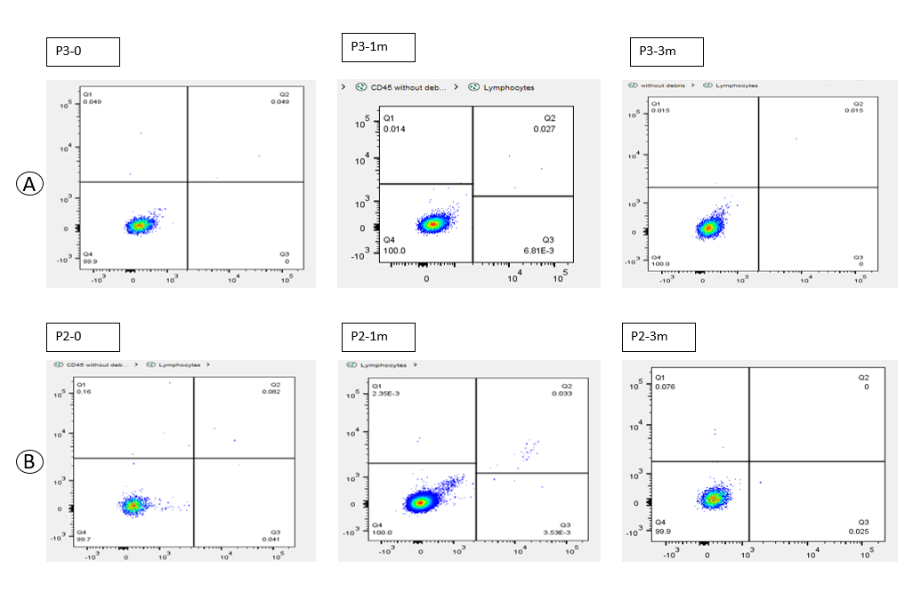

Fig S3.
A. Patient 3, B Lymphocyte, a. base (before MSCs injection), b. Month 3, and c. Month 6 after MSCs injection.
B. Patient 2, B Lymphocyte, a. base (before MSCs injection), b. Month 3, and c. Month 6 after MSCs injection

