Supporting Information for
Novel Two dimensional B2C3 Monolayer as a High Theoretical Capacity Anode Material for Li or Na Ion Batteries
Xi Zhu^{,1}, Keyang Wu^{,2}, Beibei Ma³, Xiao Wang⁴, Detong Kong^{2,*}, Yuan Wang^{2,*}
1 Chongqing Electromechanical Holdings (Group) Co., Ltd, Chongqing 401123, China;
2 School of Machinery and Communications, Southwest Forestry University, Kunming 650224, China;
3 CNOOC Fujian Natural Gas Co., Ltd, Fujian, 350001, China;
4 City College, Kunming University of Science and Technology, Kunming 650093, China;
* Corresponding author at: City College, Kunming University of Science and Technology, Kunming 650093, China.
E-mail addresses: 228276045@qq.com (D. Kong), wyuan88@126.com (Y. Wang).
Xi Zhu and Keyang Wu contributed equally to this work and should be considered co-first authors.

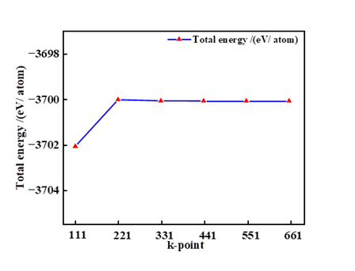
Figure S1. Convergence of Total Energy with k-Point Sampling

