Network Pharmacology-based Study in Polymetformin’s New Function of Blocking AGE/RAGE Pathway Curing Diabetic Complications

Linghong Kong ^{a,b}& Hui Wang ª, Weiwei Jiang ª, Yun Chen ª, Zhuoling Du ª, Qiong Zhang ª, Jianyue Dong ª, Changchun Zeng ^{c*}, Hanping Liu ^{a*}.
&These authors contributed equally to this work and should be considered co-first authors.

ª MOE Key Laboratory of Laser Life Science & Institute of Laser Life Science, College of Biophotonics, School of Optoelectronic Science and Engineering, South China Normal University, Guangzhou 510631, China
^{b} Guangzhou Key Laboratory of Spectral Analysis and Functional Probes，College of Biophotonics, School of Optoelectronic Science and Engineering, South China Normal University, Guangzhou 510631, China
^{c} Department of Medical Laboratory, Shenzhen Longhua District Central Hospital, Shenzhen, 518110, China.

Synthesis and characterization of PL.
To prepare polymetformin (PL), 60 mg of poly-ethylenimine linear and 2 g of dicyandiamide were mixed in 5 mL 12 M HCl solution, then added 25 mL deionized water. The mixed solution reacted at 100℃ for 6 h. Filter the solution through a 0.45 μm membrane filter to remove any large particulate impurities. Dialyze to remove any unreacted dicyandiamide, HCl, and small molecular weight by-products. After concentration, the PL was acquired after freeze-drying.
The ultraviolet (UV) spectroscopy absorbance (UV-6300, MASADA, China) was used to observe the characteristic absorption peak of Met at 230 nm. Fourier transform infrared (FT-IR) spectrum of PL were used to analyze the functional group changes using a Nicolet iS50 spectrometer. Nuclear magnetic resonance (NMR) spectroscopy of ¹H and ¹³C (Bruker AVANCE NEO, Germany) were used to further clarify the specific structure in the d₆-DMSO solvent. The gel permeation chromatography (GPC) was used to test the molecular weight of PL. To define the positive charge patch, stability of PL, the zeta-potential was proceeded in deionized water (pH=7) by DLS (Zetasizer Ultra, Malvern Instruments, U.K.).

Figure S1. (A) schematic diagram of PL, (B)UV absorption spectra, (C) GPC and (D) zeta potential for PL.

PEI
¹H NMR (600 MHz, d₆-DMSO) δ 3.81, 3.70, 2.61, 2.46, 2.38.
¹³C NMR (151 MHz, d₆-DMSO) δ 40.51, 40.36.
PL
¹H NMR (600 MHz, d₆-DMSO) δ 8.69, 7.21, 7.09, 7.04, 7.00, 5.44, 3.38, 2.61, 2.38, 1.22.
¹³C NMR (151 MHz, d₆-DMSO) δ 166.52, 163.33, 156.82, 156.38, 152.36.

Figure S2. NMR Spectra of PEI and PL.

Synthesis and characterization of PL.
The Root Mean Square Deviation (RMSD) is used to measure the average change in displacement of a selection of atoms for a particular frame with respect to a reference frame. It is calculated for all frames in the trajectory. The RMSD for frame x is:
RMSD_{x}=$\sqrt{\frac{1}{N}\sum_{i=1}^{N}{{\left(r_{i}^{'}\left(tx^{1}\right)−r_{i}\left(t_{r_{ef}}\right)\right)}^{2}}}$
where N is the number of atoms in the atom selection; t_{ref} is the reference time, (typically the first frame is used as the reference and it is regarded as time t=0); and r' is the position of the selected atoms in frame x after superimposing on the reference frame, where frame x is recorded at time t_{x}. The procedure is repeated for every frame in the simulation trajectory.
The RMSD analysis revealed the structural stability of the protein-ligand complex. The average RMSD value for the protein was within the acceptable range, indicating minimal conformational changes and stable binding over the simulation period.

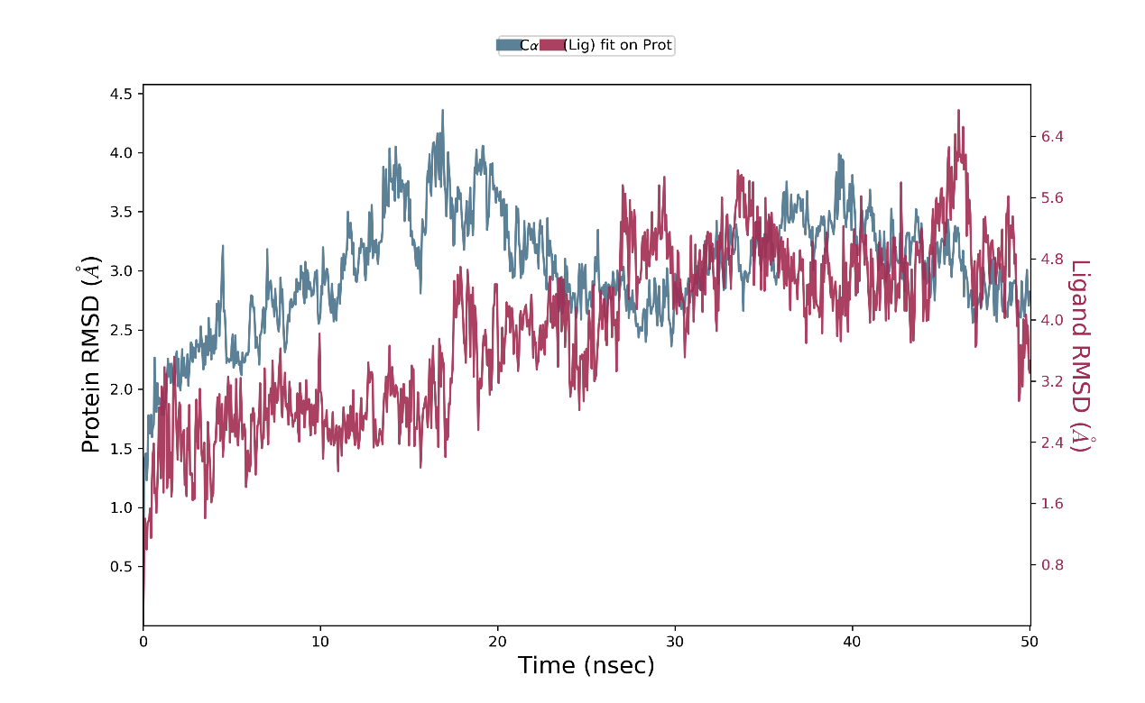
Figure S3. Protein-Ligand RMSD.
The Root Mean Square Fluctuation (RMSF) is useful for characterizing local changes along the protein chain.
The RMSF for residue i is:
RMSF_{i}=$\sqrt{\frac{1}{T}\sum_{T=1}^{T}{{<\left(r_{i}^{'}\left(t\right)−−r_{i}{\left(t_{r_{ef}}\right)}^{2}\right)}^{}}}$
where T is the trajectory time over which the RMSF is calculated,$t_{r_{ef}}$ is the reference time, $r_{i}^{}$ is the position of residue i; $r_{i}^{'}$ is the position of atoms in residue i after superposition on the reference, and the angle brackets indicate that the average of the square distance is taken over the selection of atoms in the residue. On this plot, peaks indicate areas of the protein that fluctuate the most during the simulation. Typically you will observe that the tails (N- and C-terminal) fluctuate more than any other part of the protein. Secondary structure elements like alpha helices and beta strands are usually more rigid than the unstructured part of the protein, and thus fluctuate less than the loop regions.
Ligand Contacts: Protein residues that interact with the ligand are marked with green-colored vertical bars
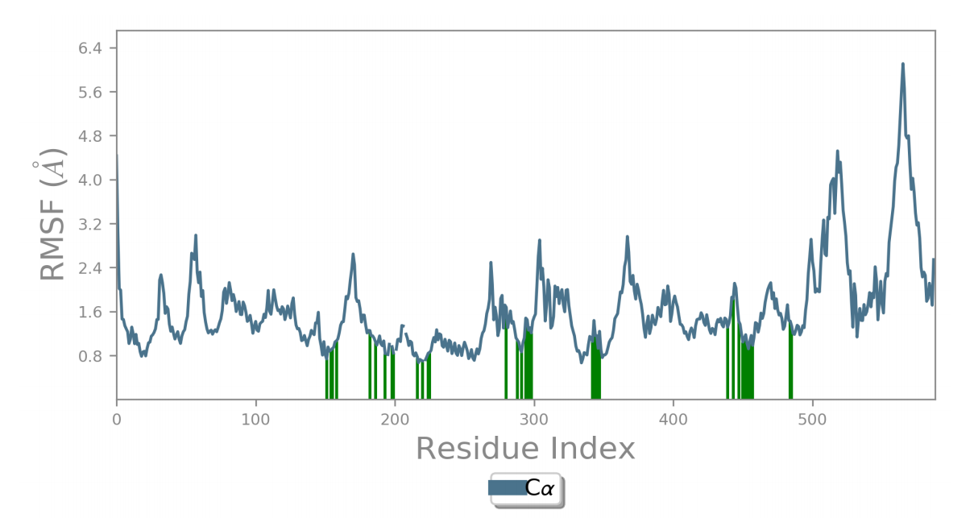
Figure S4. Protein RMSF.

Figure S5 shows the total number of specific contacts the protein makes with the ligand over the course of the trajectory. The bottom panel shows which residues interact with the ligand in each trajectory frame. Some residues make more than one specific contact with the ligand, which is represented by a darker shade of orange, according to the scale to the right of the plot.

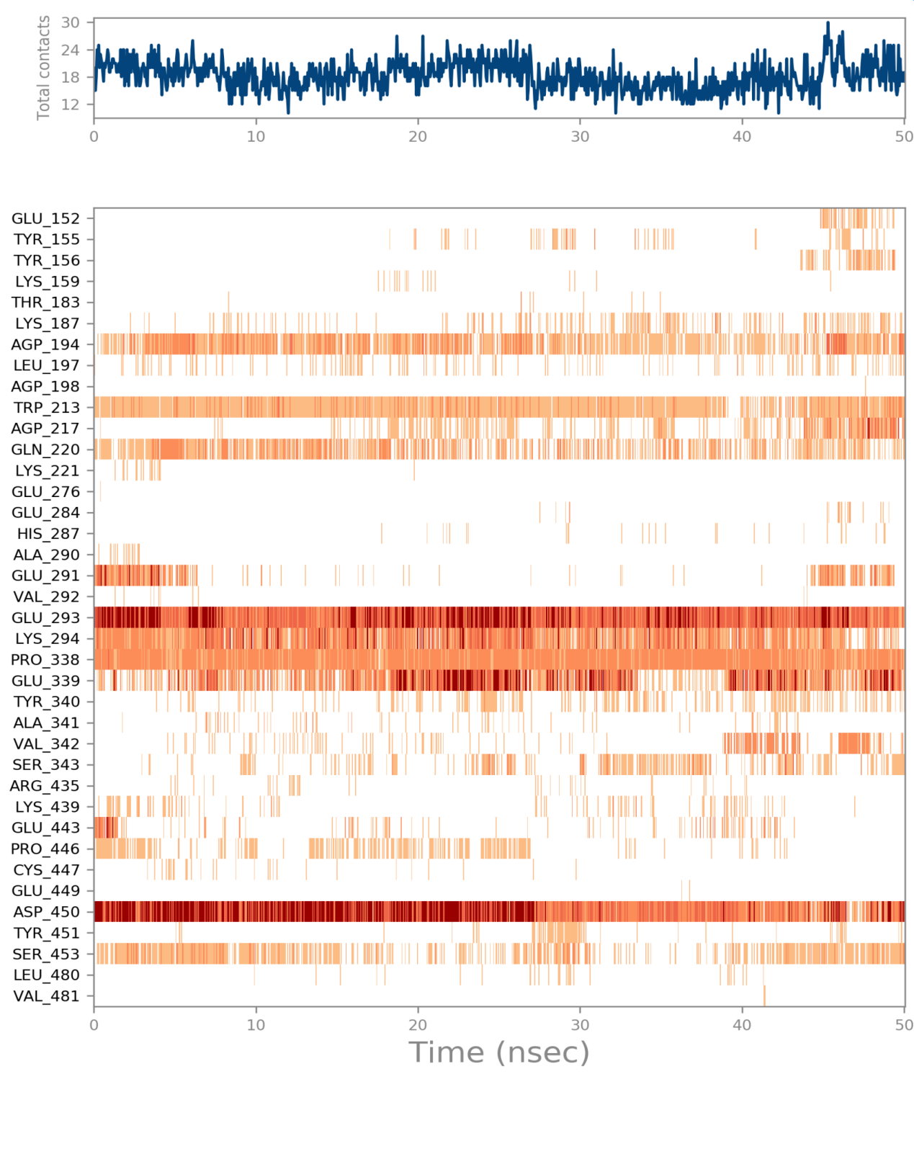
Figure S5. A timeline representation of the interactions and contacts (H-bonds, Hydrophobic, Ionic, Water bridges).

The ligand torsions plot summarizes the conformational evolution of every rotatable bond (RB) in the ligand throughout the simulation trajectory ( 0.00 through 50.05 nsec). The top panel shows the 2d schematic of a ligand with color-coded rotatable bonds. Each rotatable bond torsion is accompanied by a dial plot and bar plots of the same color.
Dial (or radial) plots describe the conformation of the torsion throughout the course of the simulation. The beginning of the simulation is in the center of the radial plot and the time evolution is plotted radially outwards.
The bar plots summarize the data on the dial plots, by showing the probability density of the torsion. If torsional potential information is available, the plot also shows the potential of the rotatable bond (by summing the potential of the related torsions). The values of the potential are on the left Y-axis of the chart, and are expressed in kcal/mol. Looking at the histogram and torsion potential relationships may give insights into the conformational strain the ligand undergoes to maintain a protein-bound conformation.
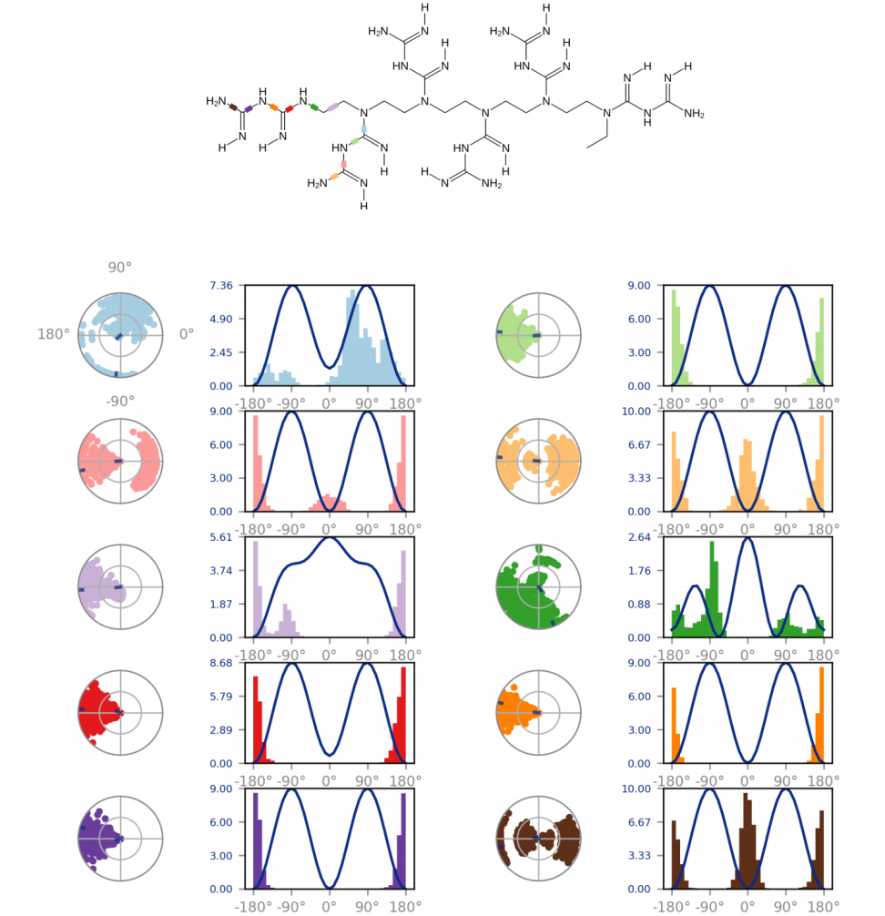
Figure S6. Ligand Torsion Profile (cont.).

Ligand RMSD: Root mean square deviation of a ligand with respect to the reference conformation (typically the first frame is used as the reference and it is regarded as time t=0).
Radius of Gyration (rGyr): Measures the 'extendedness' of a ligand, and is equivalent to its principal moment of inertia.
Intramolecular Hydrogen Bonds (intraHB): Number of internal hydrogen bonds (HB) within a ligand molecule.
Molecular Surface Area (MolSA): Molecular surface calculation with 1.4 Å probe radius. This value is equivalent to a van der Waals surface area.
Solvent Accessible Surface Area (SASA): Surface area of a molecule accessible by a water molecule.
Polar Surface Area (PSA): Solvent accessible surface area in a molecule contributed only by oxygen and nitrogen atoms.
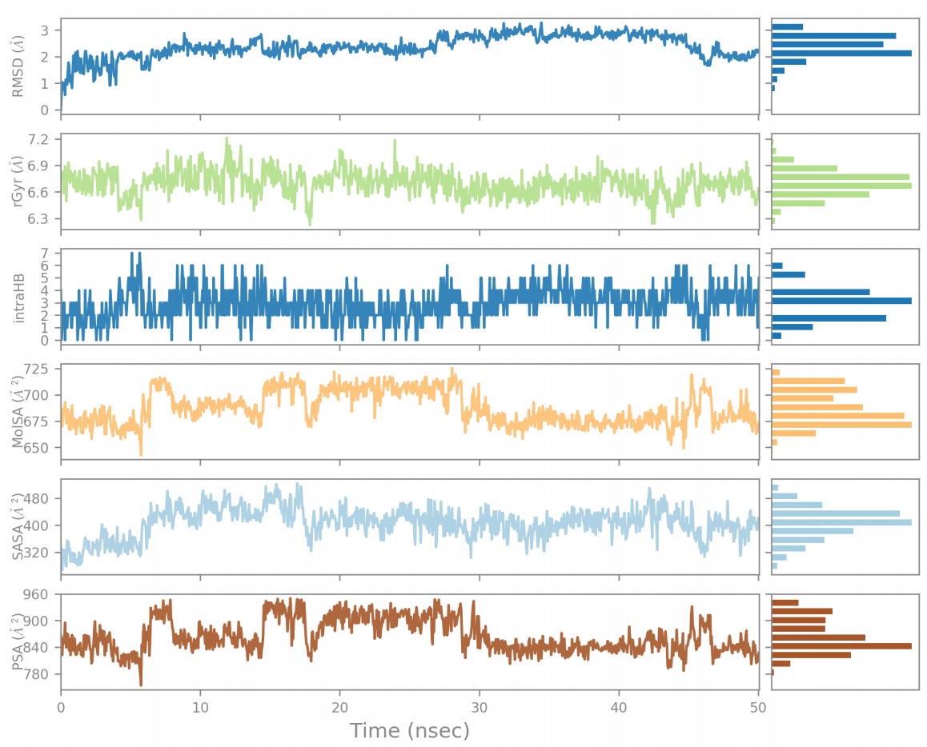
Figure S7. Ligand Properties.

PL Interaction with AGEs: absorption spectra of AGEs-PL, AGEs, BSA.
The absorbance spectra showed maximum peaks at 300 nm for BSA and 420 nm for AGEs, with negligible absorption for AGEs-PL in this range.

Figure S8. Absorption spectra of AGEs-PL, AGEs, BSA.

Antagonistic effect of PL on hA₂ damage to HUVEC migration ability.
The capability of cells to migrate is similarly impacted by activation of the AGEs-RAGE pathway. Wound healing will be difficult or delayed if HUVEC migration is compromised. Thus, assessed the impact of PL on HUVEC's ability to migrate in AGEs and high-glucose settings, scratch experiments have been conducted. The migration ability of HUVECs was assessed using the scratch assay. HUVECs (3 × 10⁵ cells/mL) were seeded in 6-well plates. Once confluent, a scratch was made in the center of each well with a 200 µL pipette tip and washed three times with PBS. HUVECs were treated with. Images were taken at 0 h, 4 h, and 12 h using an MSHOT inverted fluorescence microscope (MF52, MSHOT, China). Scratch width was measured with ImageJ software, and the percentage of scratch closure was calculated as follows:
%Cell migration = $(A0−At)/A0$× 100%
$A0$ is the initial scratch width, and $At$ is the scratch width at time point.
Figure S9. PL improves the ability of cells damaged by AGEs to migrate. Compared with ctrl, * P < 0.05, *** P < 0.001, ns was no significant difference. Compared with hA₂ , ▲P < 0.05. n=3.

