Supplementary file

Content…………………………………………………………………...…………………...page
Supplementary 1: ¹H NMR of compound 9a…………...…………………………………………2
Supplementary 2: ¹³C NMR of compound 9a…………………………………………………..…2
Supplementary 3: ¹H NMR of compound 9b……………………………….…………………….3
Supplementary 4: ¹³C NMR of compound 9b…………………………………………………….3
Supplementary 5: ¹H NMR of compound 9c……………………….……………………………..4
Supplementary 6: ¹³C NMR of compound 9c………………………………………….………….4
Supplementary 7: ¹H NMR of compound 9d……………………………..………………………5
Supplementary 8: ¹³C NMR of compound 9d……………………………………...……………..5
Supplementary 9: ¹H NMR of compound 9e………………………………………..…………….6
Supplementary 10: ¹³C NMR of compound 9e…………………………………………..………..6
Supplementary 11: ¹H NMR of compound 9f…….………………………………………………7
Supplementary 12: ¹³C NMR of compound 9f……………………..……………………………..7
Supplementary 13: ¹H NMR of compound 9g………………………………………….…………8
Supplementary 14: ¹³C NMR of compound 9g……………………………………………………8
Supplementary 15: ¹H NMR of compound 9h…………………………..………………………..9
Supplementary 16: ¹³C NMR of compound 9h…………………………………….……………..9
Supplementary 17: ¹H NMR of compound 9i……………………………………………...…….10
Supplementary 18: ¹³C NMR of compound 9i…………………………………..………………10
Supplementary 19: ¹H NMR of compound 9j………………………………………….………..11
Supplementary 20: ¹³C NMR of compound 9j………………………………….……...………..11
Supplementary 21: ¹H NMR of compound 9k………………………………………..…………12
Supplementary 22: ¹³C NMR of compound 9k……………………………………………….…12
Supplementary 23: ¹H NMR of compound 9l………………………….………………..………13
Supplementary 24: ¹³C NMR of compound 9l…………………………………………….….…13
Supplementary 25: ¹H NMR of compound 9m………………………………...………………..14
Supplementary 26: ¹³C NMR of compound 9m…………………………………….……..…….14
Supplementary 27: ¹H NMR of compound 9n…………………………………………..………15
Supplementary 28: ¹³C NMR of compound 9n……………………………………………...…..15
Supplementary 29: ¹H NMR of compound 9o…………………………………………...………16
Supplementary 30: ¹³C NMR of compound 9o…………………………………………….…….16
Supplementary 31: ¹H NMR of compound 9o………………………………………...…………17
Supplementary 32: ¹³C NMR of compound 9p………………………………………………….17
Supplementary 33: HPLC chromatography of compound 9f……………………………………18
Supplementary 34: HPLC chromatography of compound 9j……………………………………18
Supplementary 35: Mass spectrum of compound 9f…………………………………………….19
Supplementary 36: Mass spectrum of compound 9g…………………………………….………20
Supplementary 37: Mass spectrum of compound 9j………………………………….………….21
Supplementary 38: Mass spectrum of compound 9o…………………………………………….22

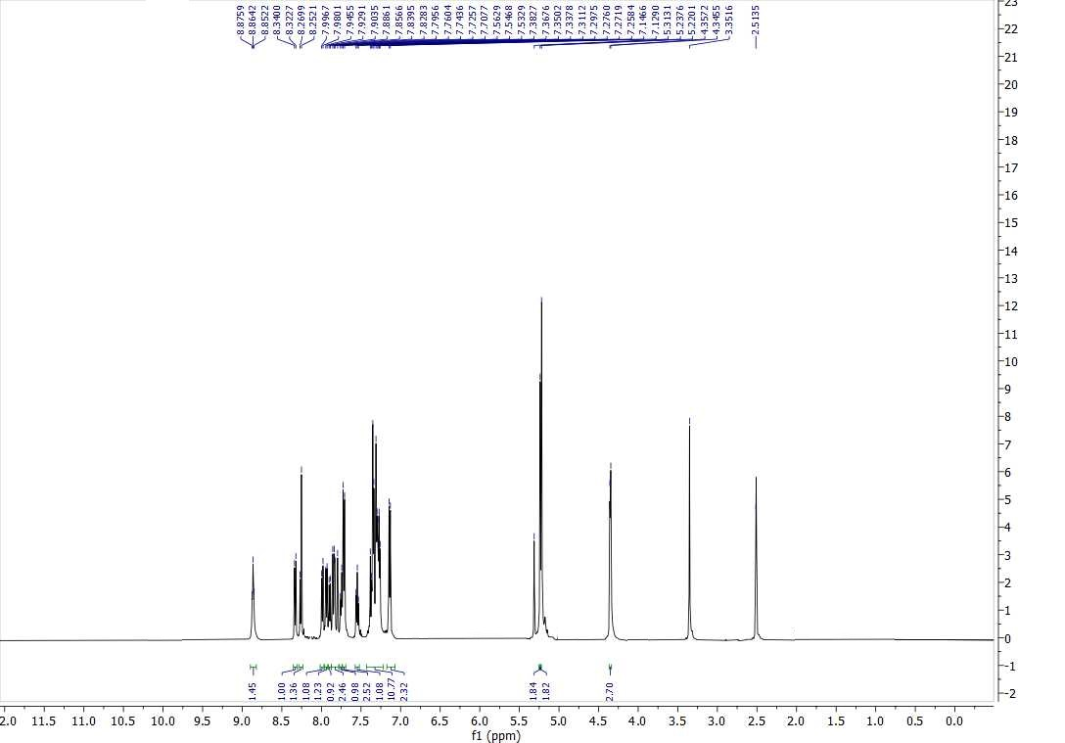
Supplementary 1: ¹H NMR of compound 9a

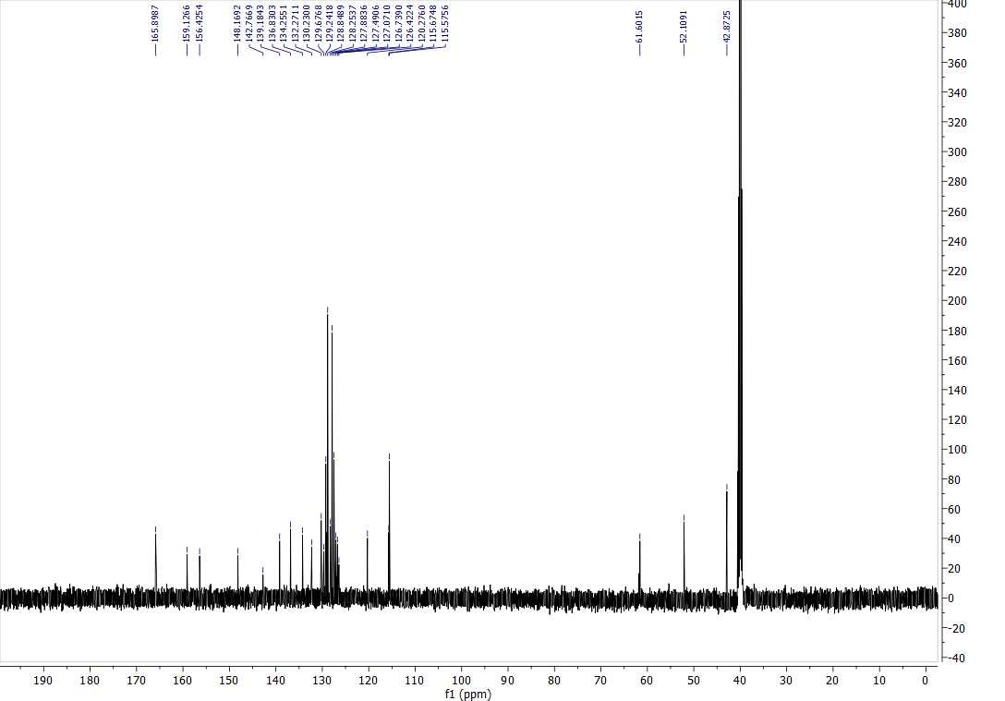
Supplementary 2: ¹³C NMR of compound 9a
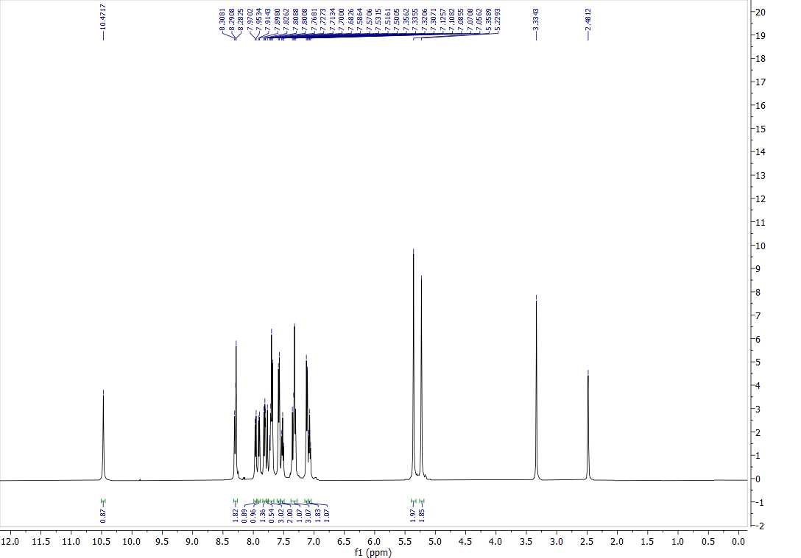
Supplementary 3: ¹H NMR of compound 9b

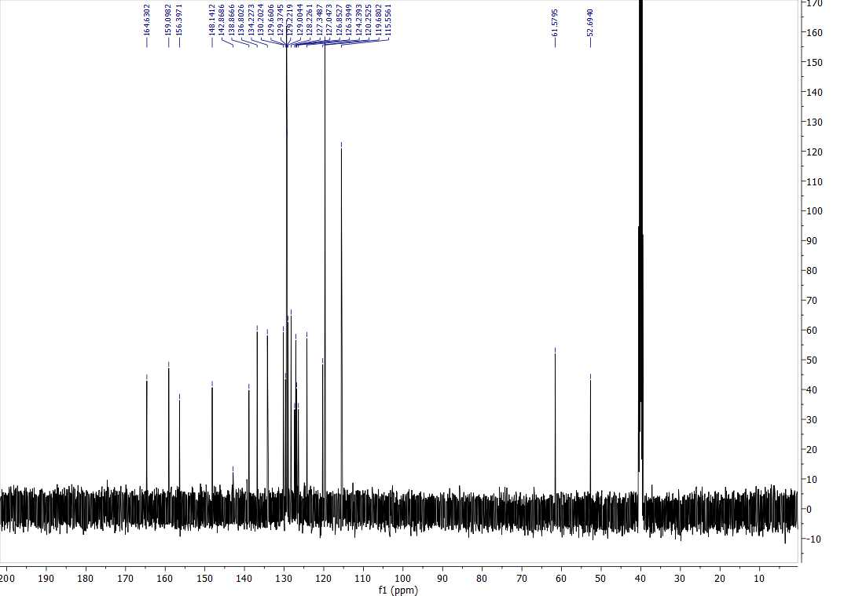
Supplementary 4: ¹³C NMR of compound 9b
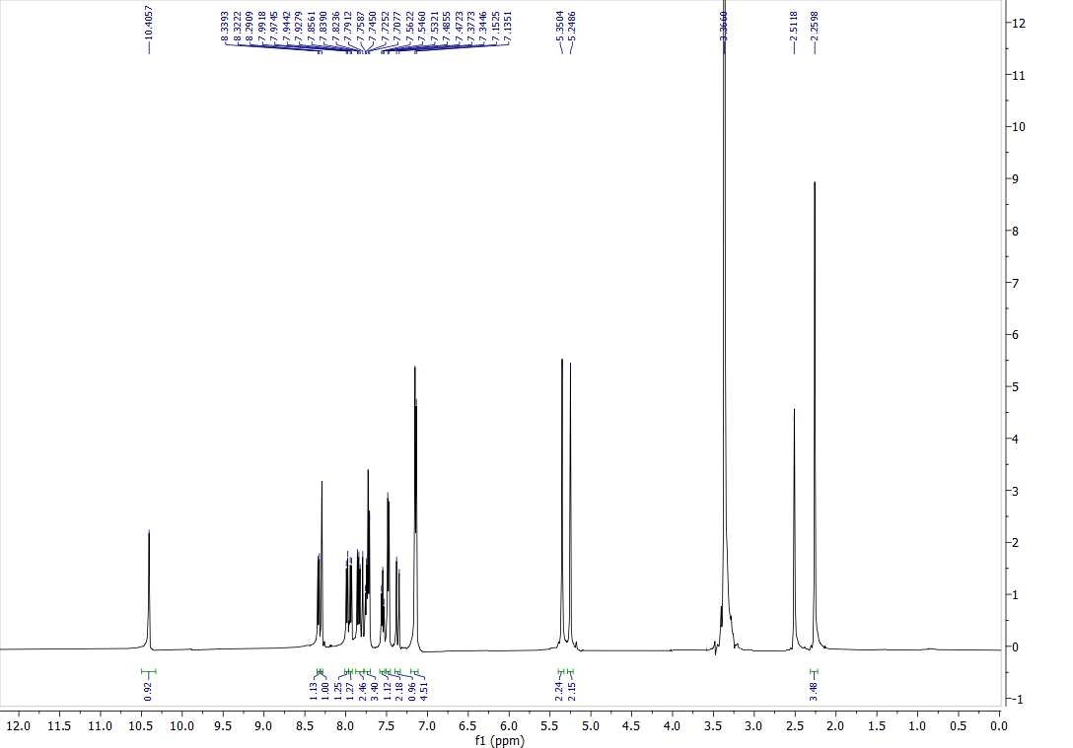
Supplementary 5: ¹H NMR of compound 9c

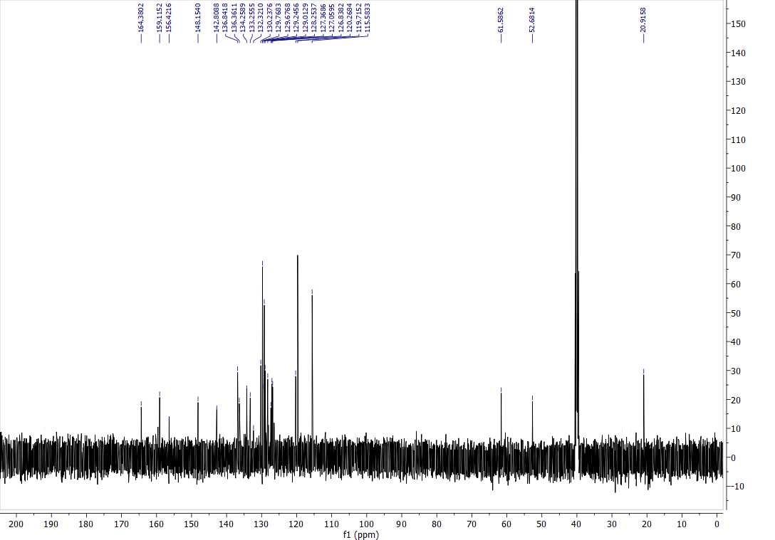
Supplementary 6: ¹³C NMR of compound 9c
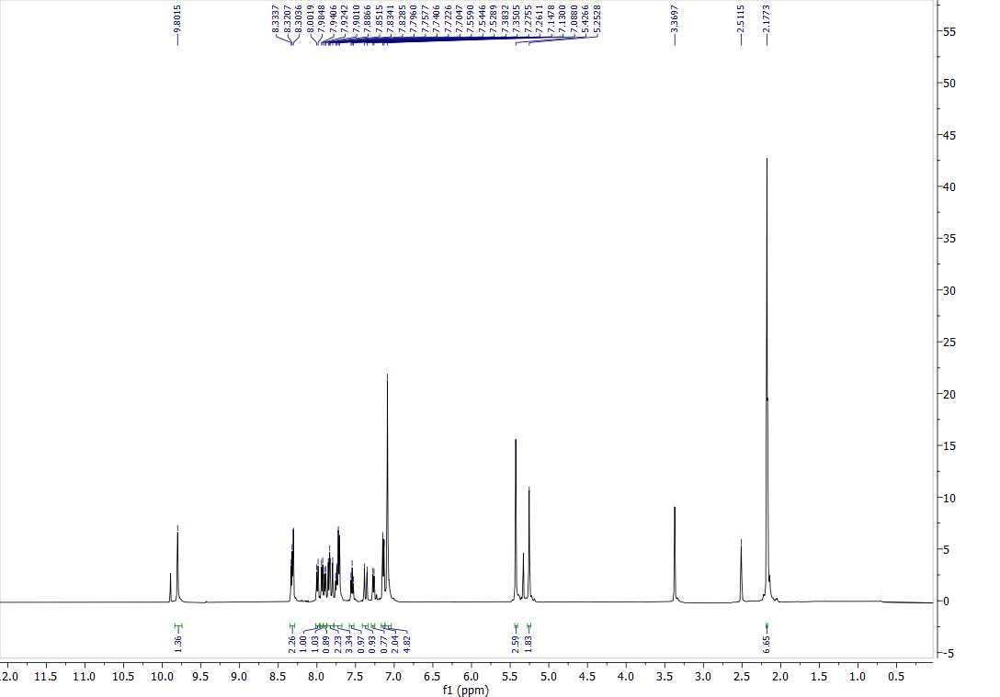
Supplementary 7: ¹H NMR of compound 9d

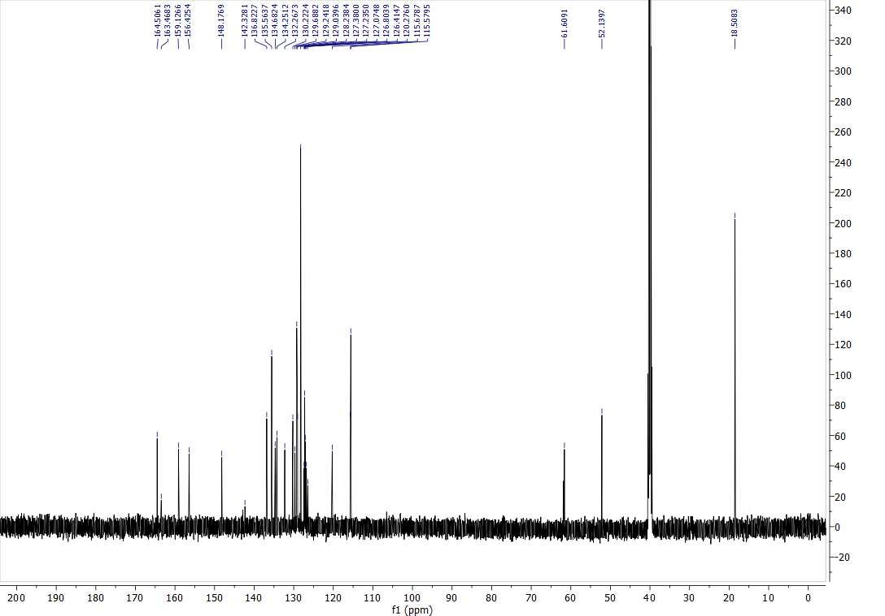
Supplementary 8: ¹³C NMR of compound 9d
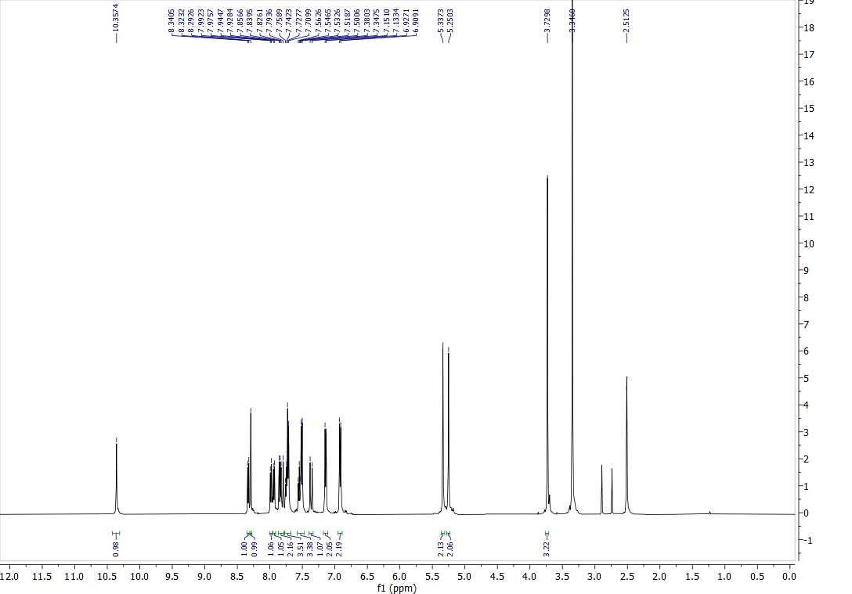
Supplementary 9: ¹H NMR of compound 9e

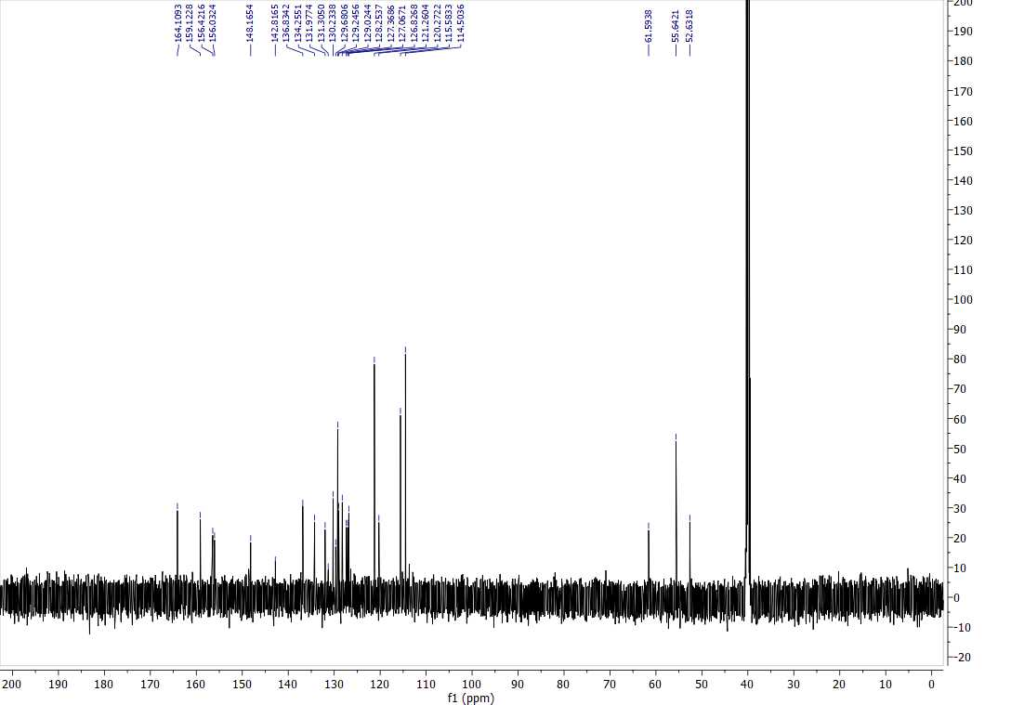
Supplementary 10: ¹³C NMR of compound 9e

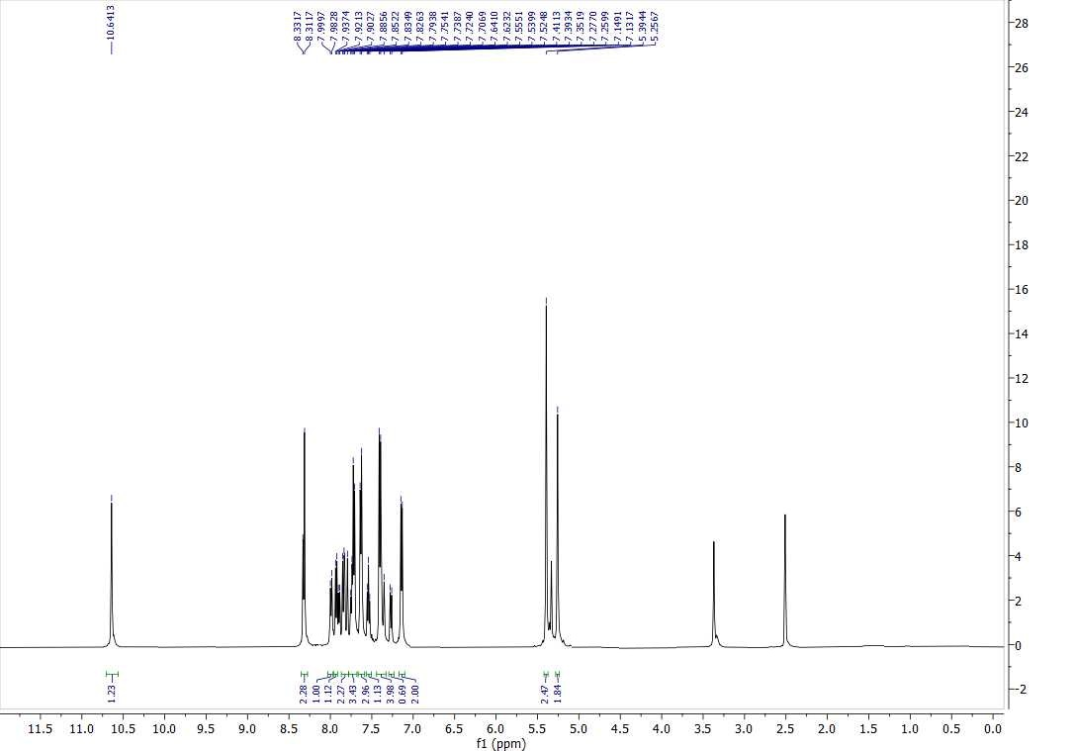
Supplementary 11: ¹H NMR of compound 9f

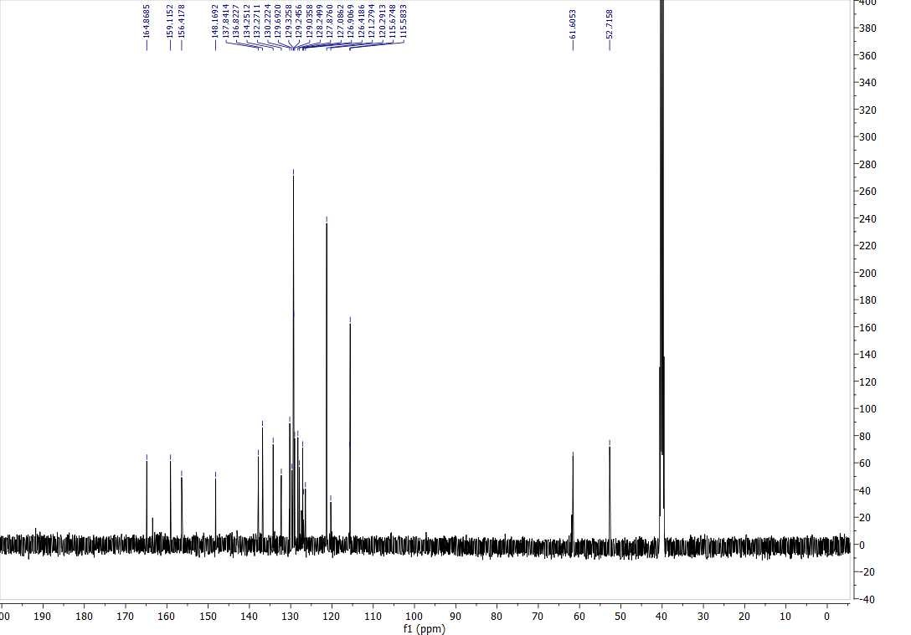
Supplementary 12: ¹³C NMR of compound 9f
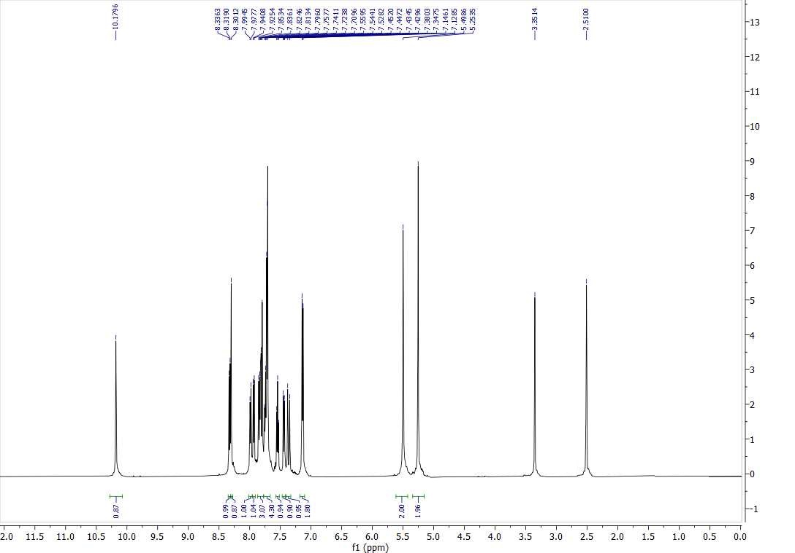
Supplementary 13: ¹H NMR of compound 9g

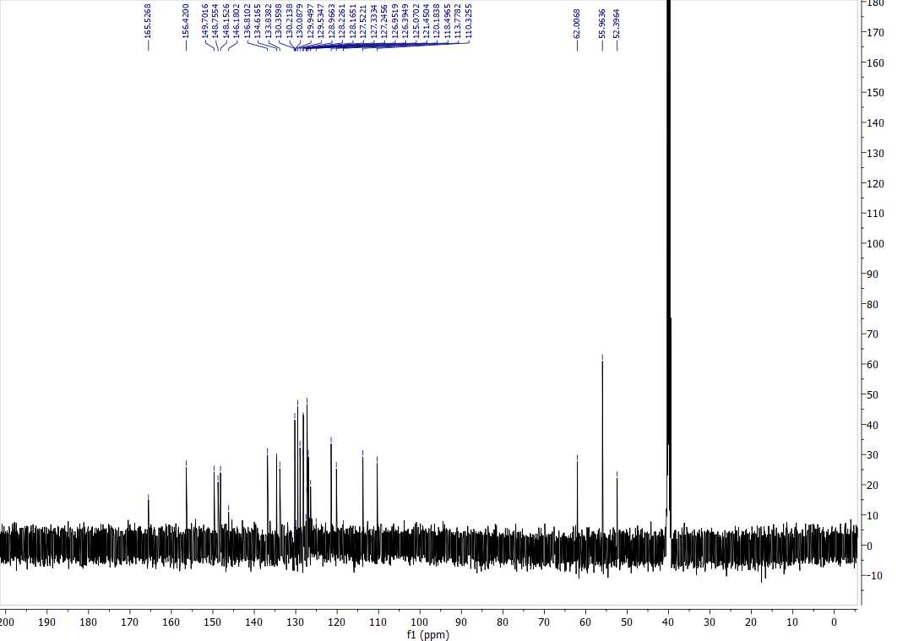
Supplementary 14: ¹³C NMR of compound 9g

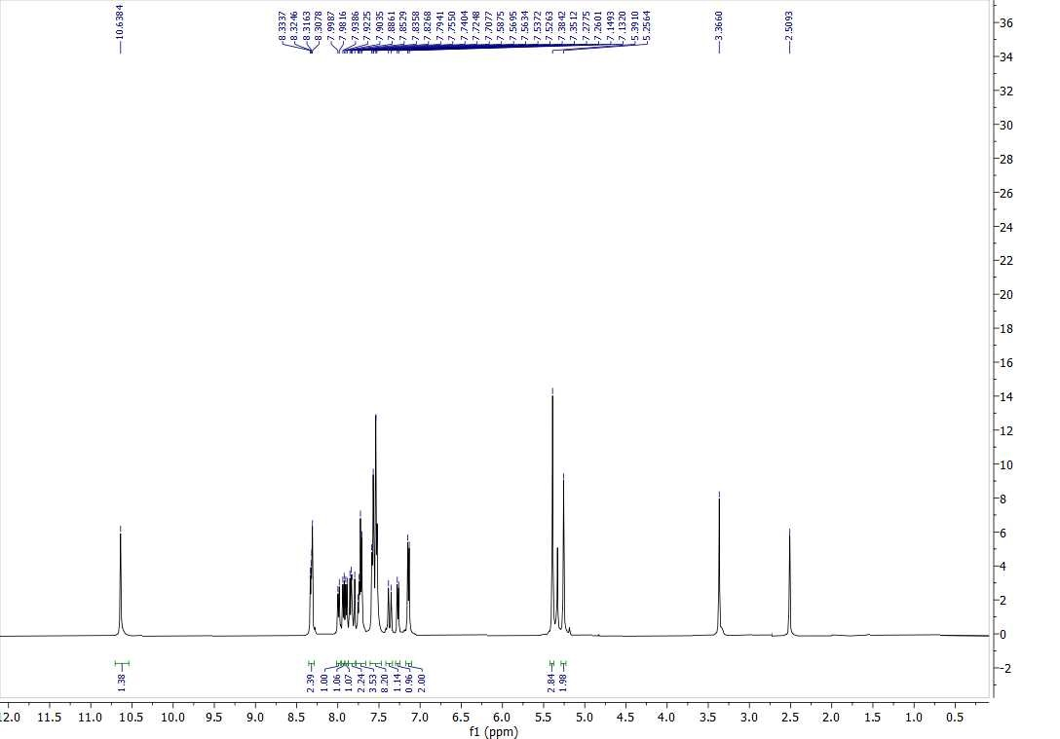
Supplementary 15: ¹H NMR of compound 9h

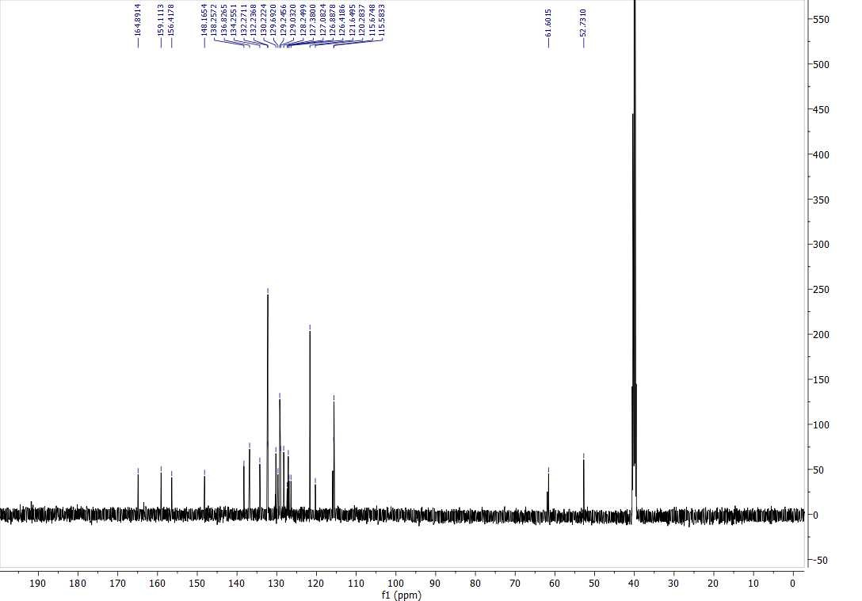
Supplementary 16: ¹³C NMR of compound 9h

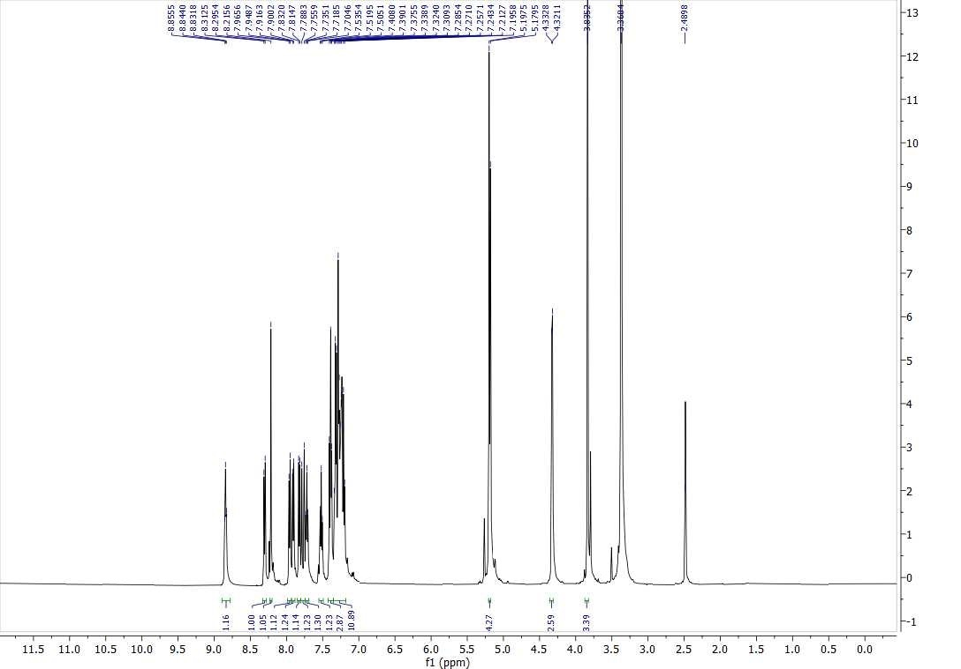
Supplementary 17: ¹H NMR of compound 9i

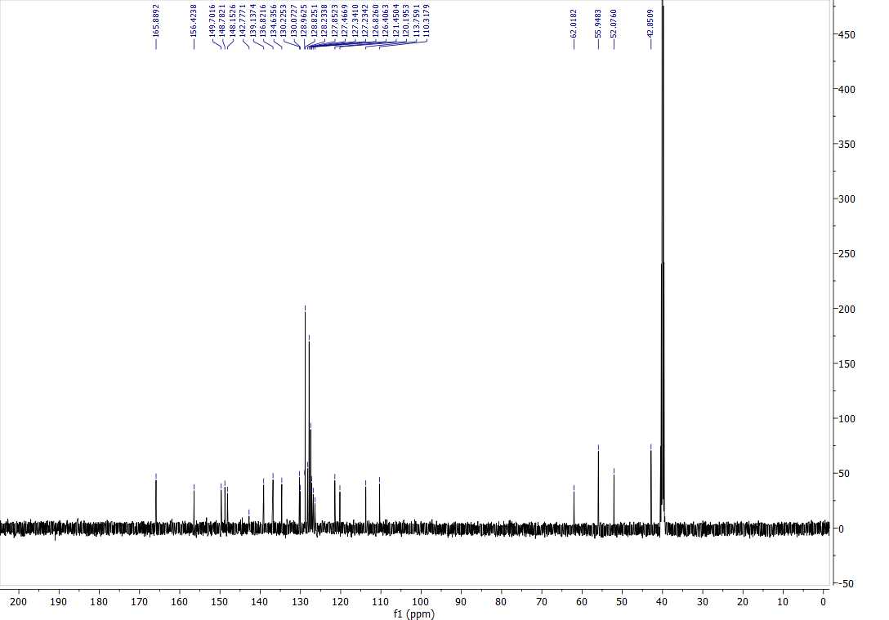
Supplementary 18: ¹³C NMR of compound 9i
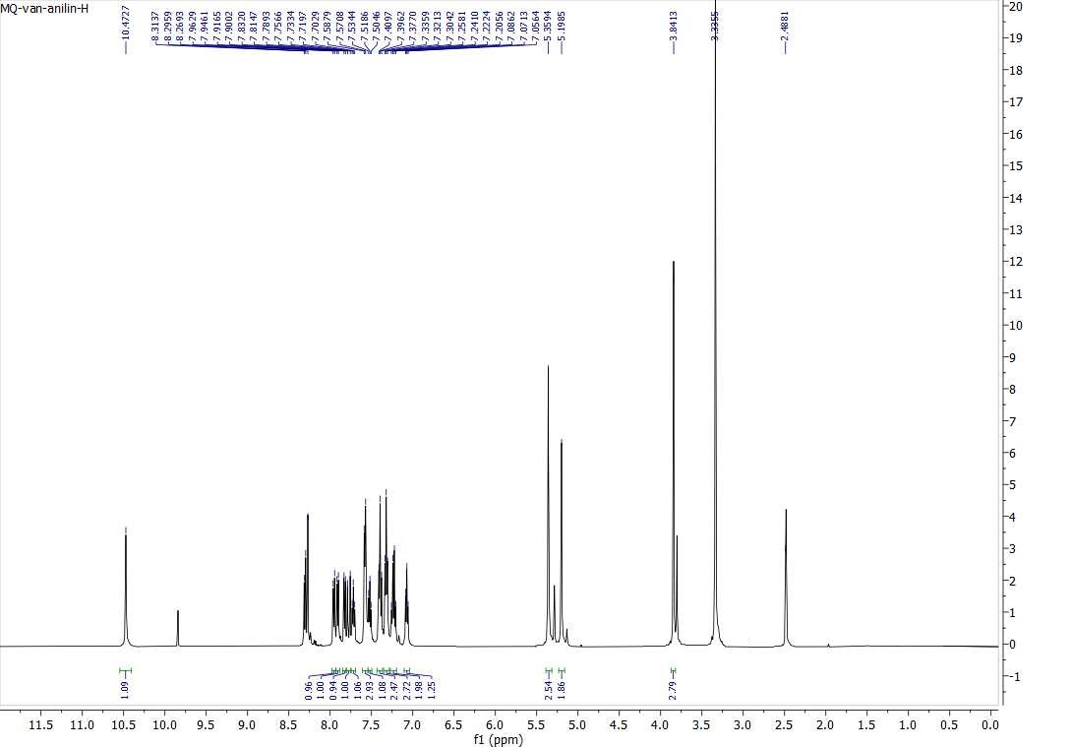
Supplementary 19: ¹H NMR of compound 9j

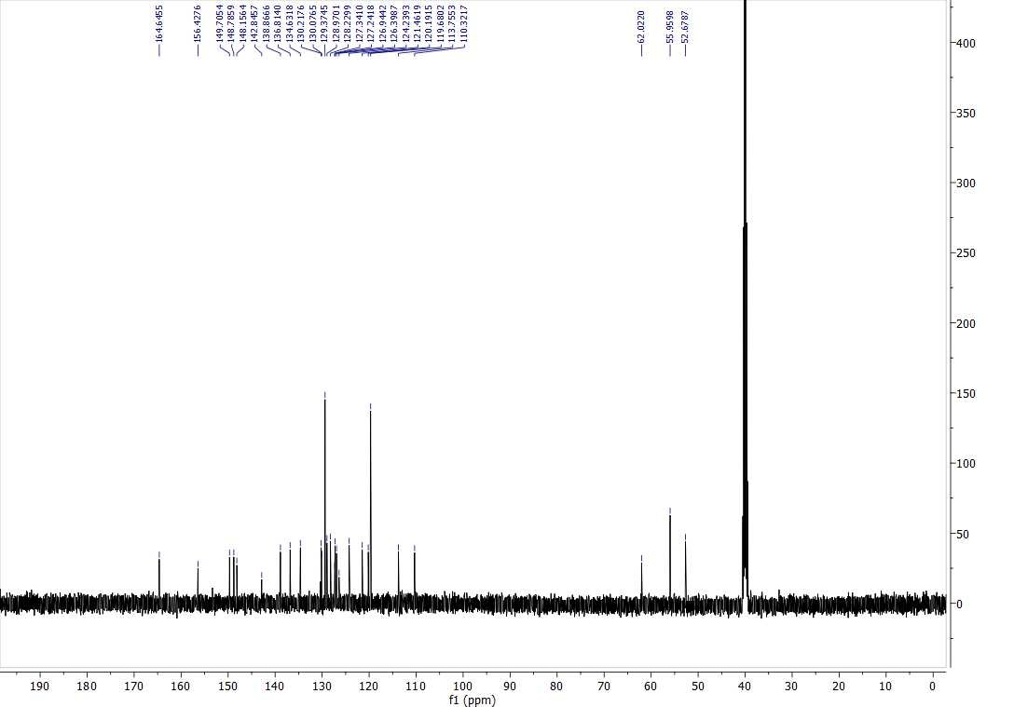
Supplementary 20: ¹³C NMR of compound 9j

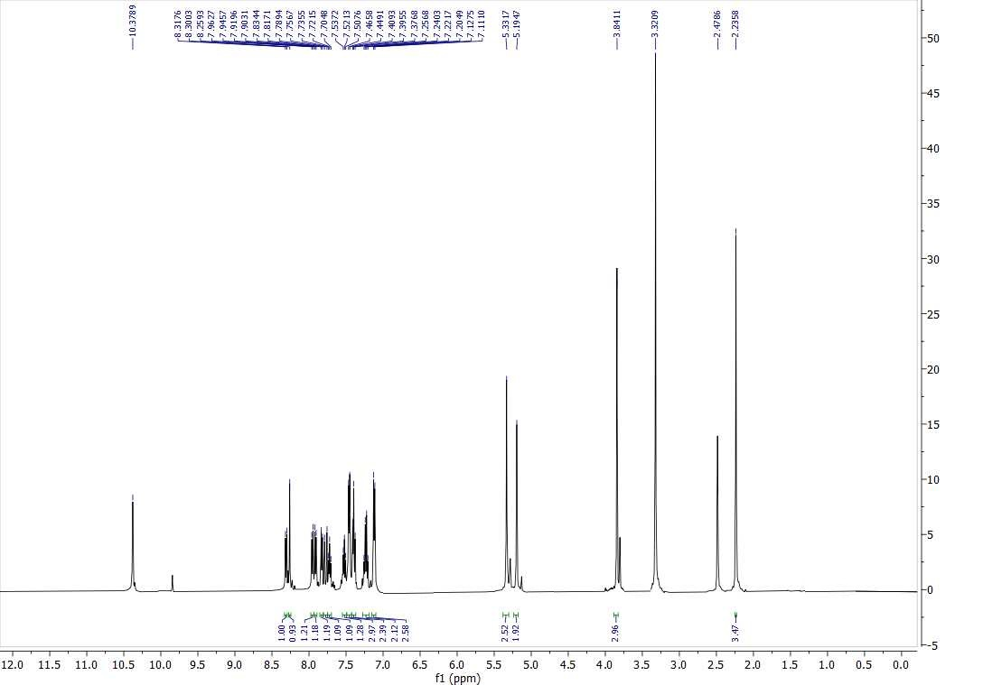
Supplementary 21: ¹H NMR of compound 9k

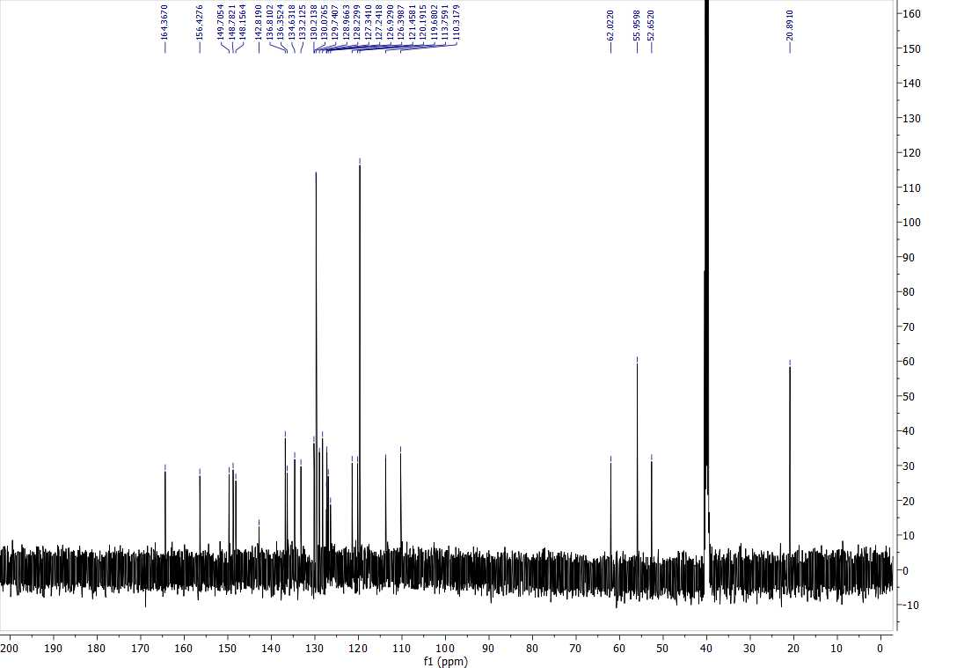
Supplementary 22: ¹³C NMR of compound 9k
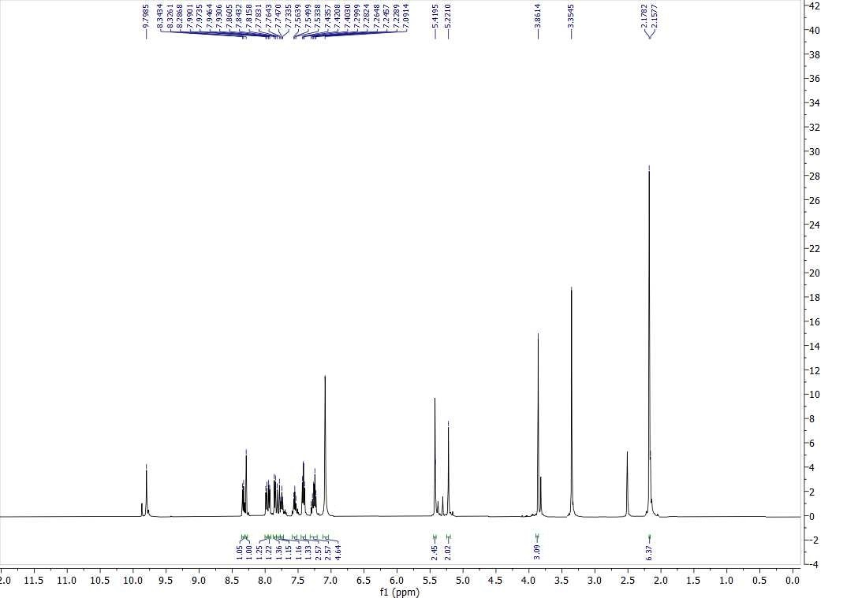
Supplementary 23: ¹H NMR of compound 9l

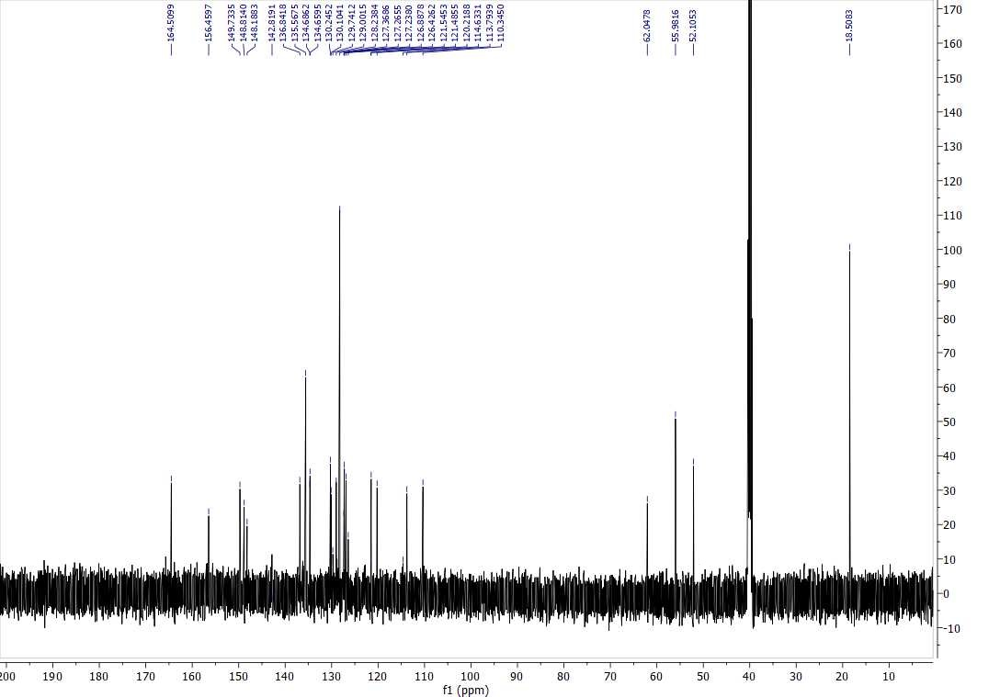
Supplementary 24: ¹³C NMR of compound 9l

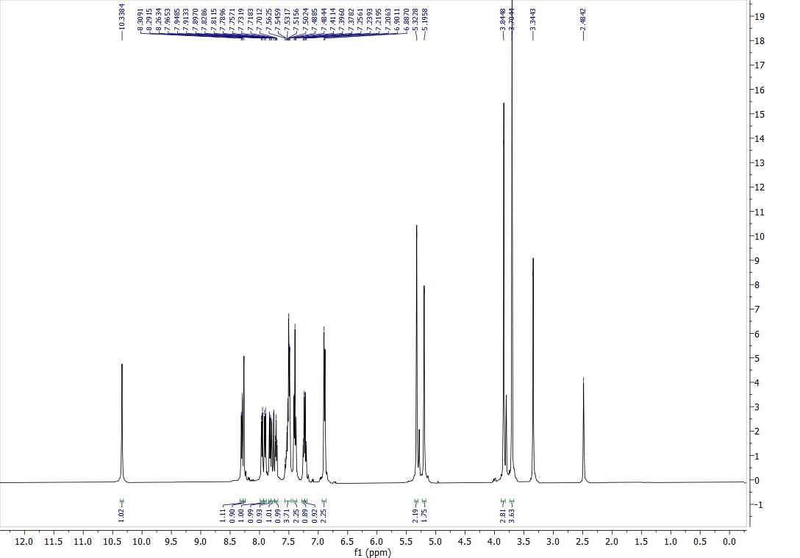
Supplementary 25: ¹H NMR of compound 9m

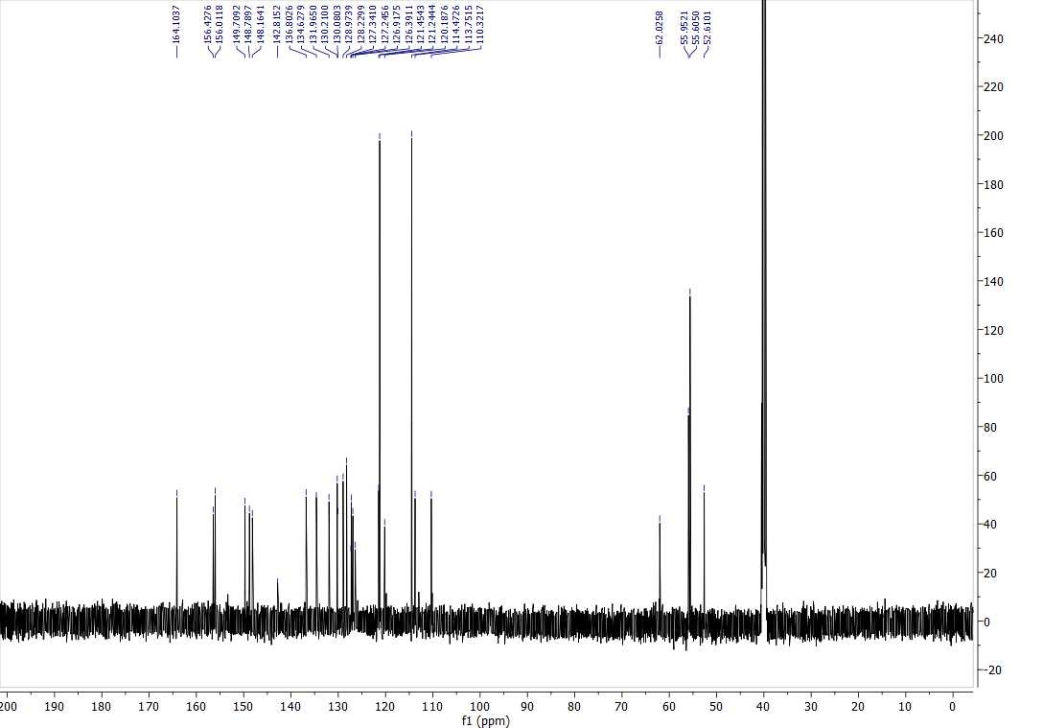
Supplementary 26: ¹³C NMR of compound 9m
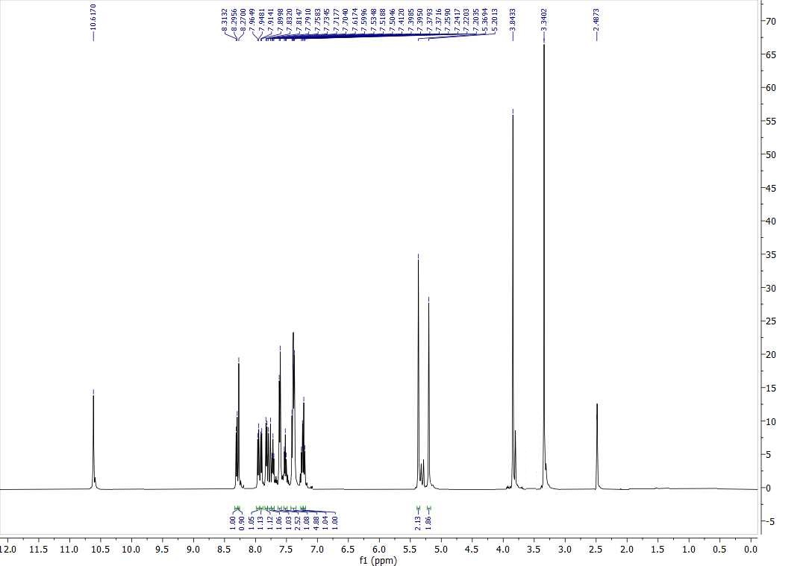
Supplementary 27: ¹H NMR of compound 9n

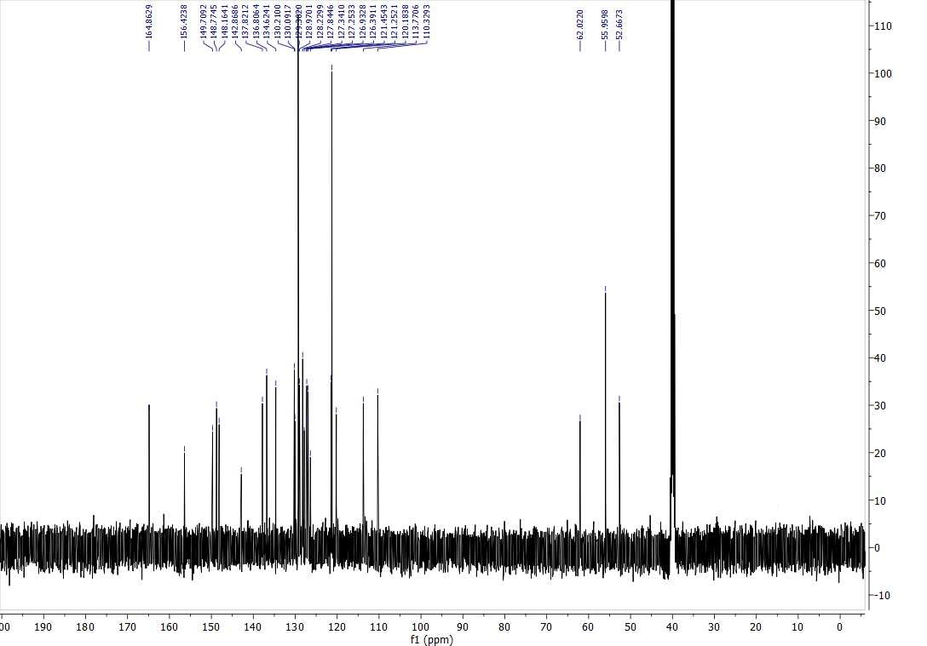
Supplementary 28: ¹³C NMR of compound 9n

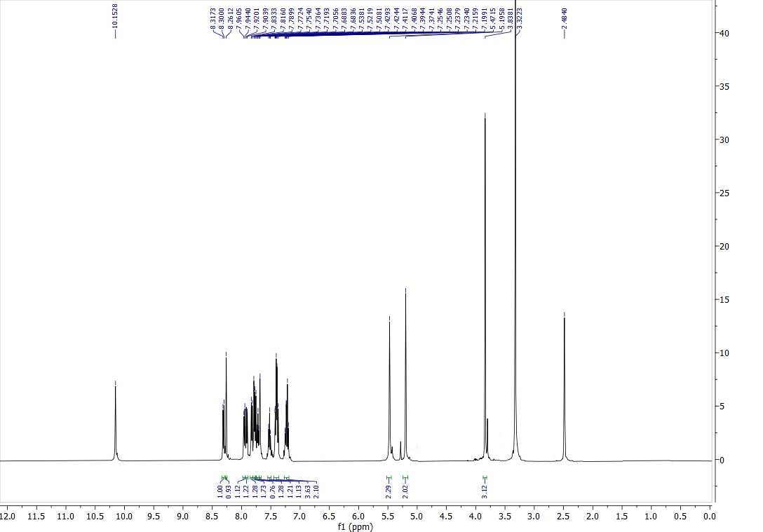
Supplementary 29: ¹H NMR of compound 9o

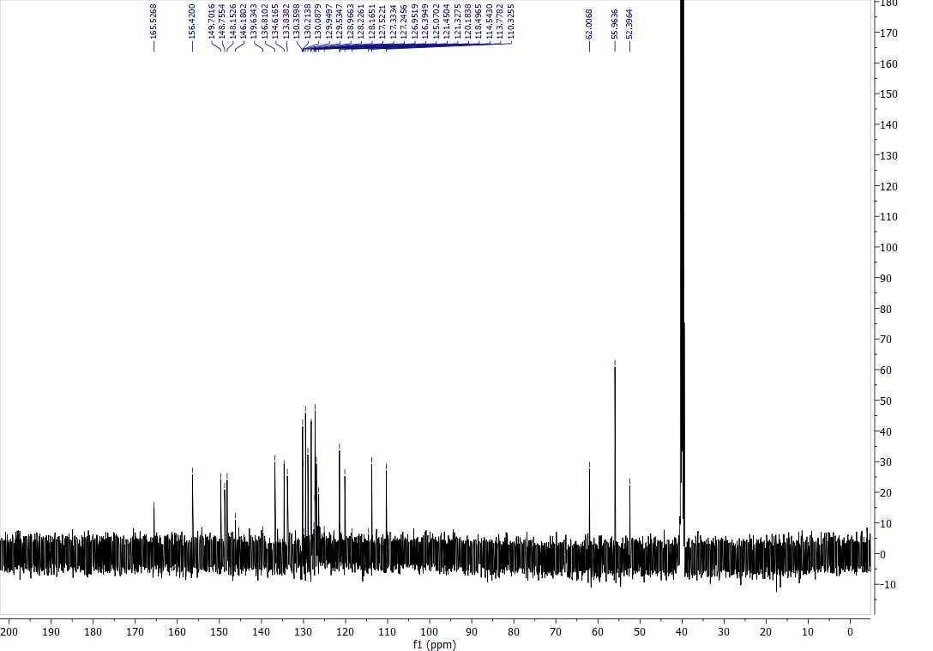
Supplementary 30: ¹³C NMR of compound 9o
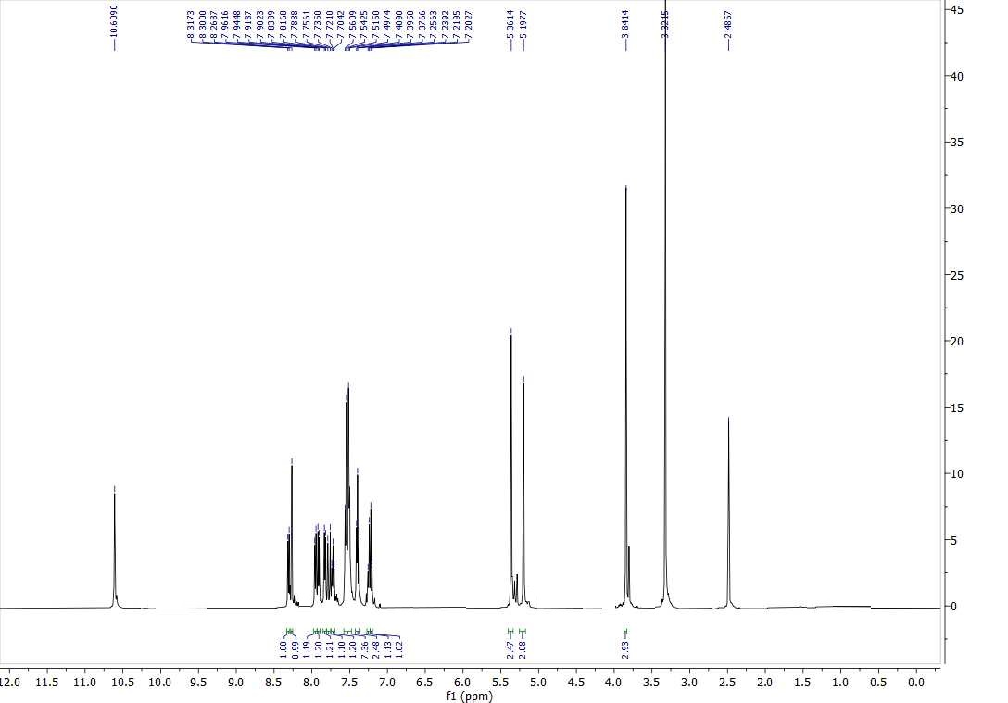
Supplementary 31: ¹H NMR of compound 9o

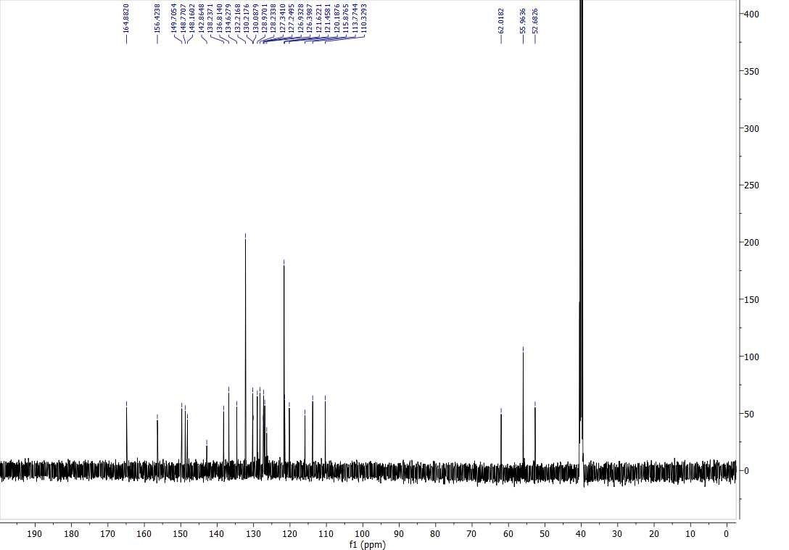
Supplementary 32: ¹³C NMR of compound 9p

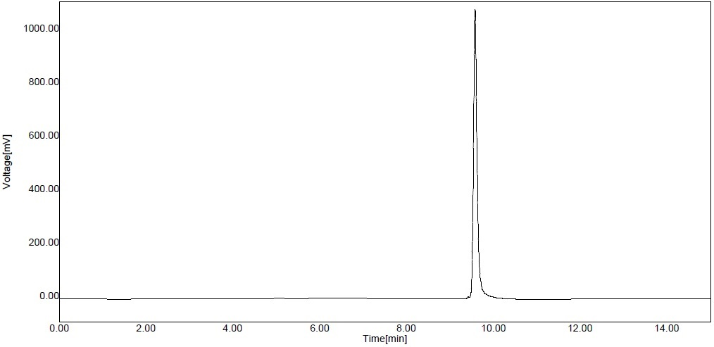
Supplementary 33: HPLC chromatography of compound 9f

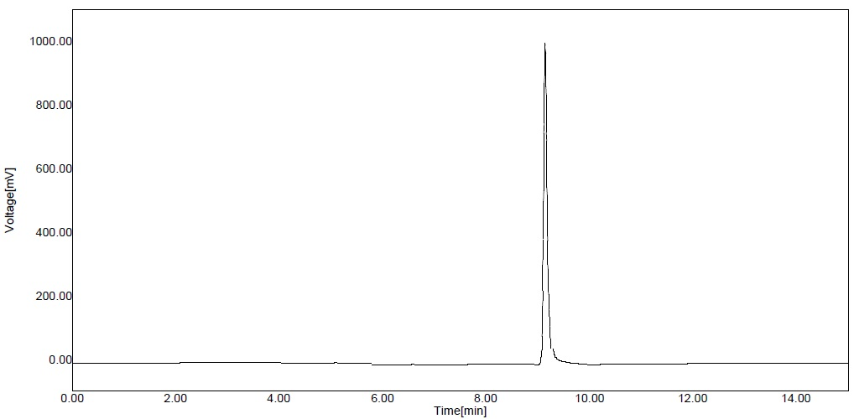
Supplementary 34: HPLC chromatography of compound 9j

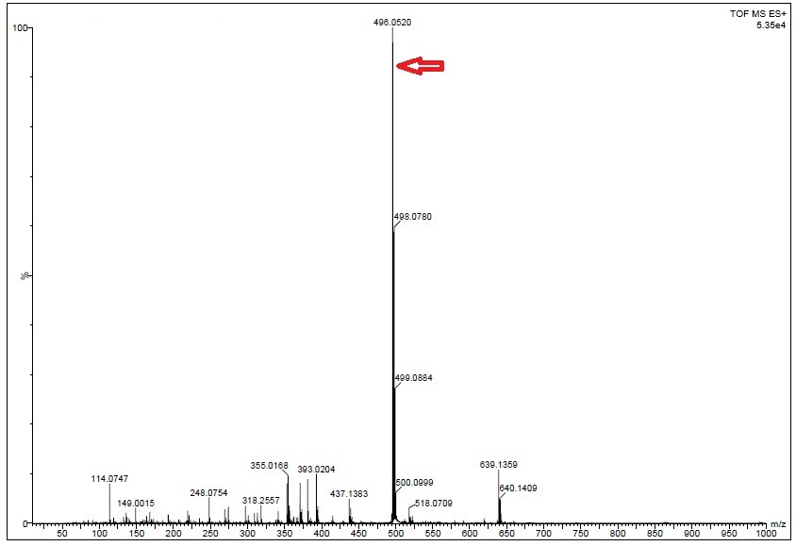
Supplementary 35: Mass spectrum of compound 9f

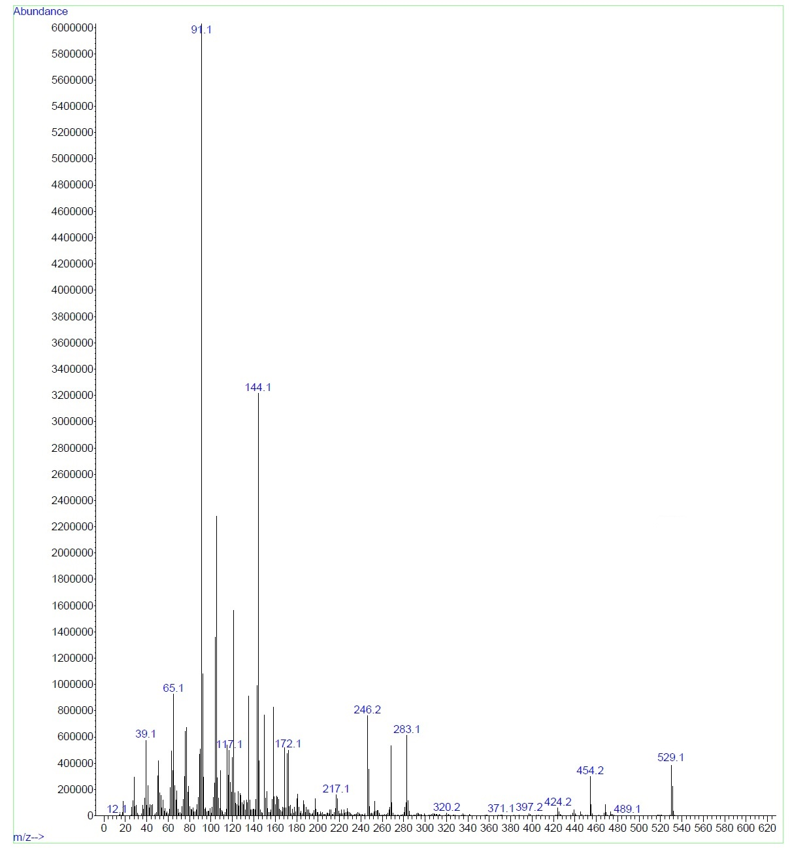
Supplementary 36: Mass spectrum of compound 9g

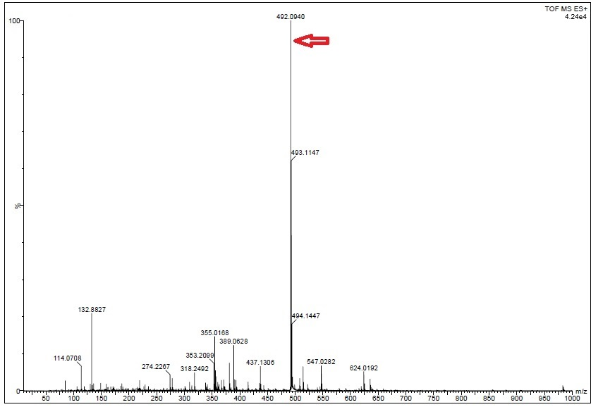
Supplementary 37: Mass spectrum of compound 9j

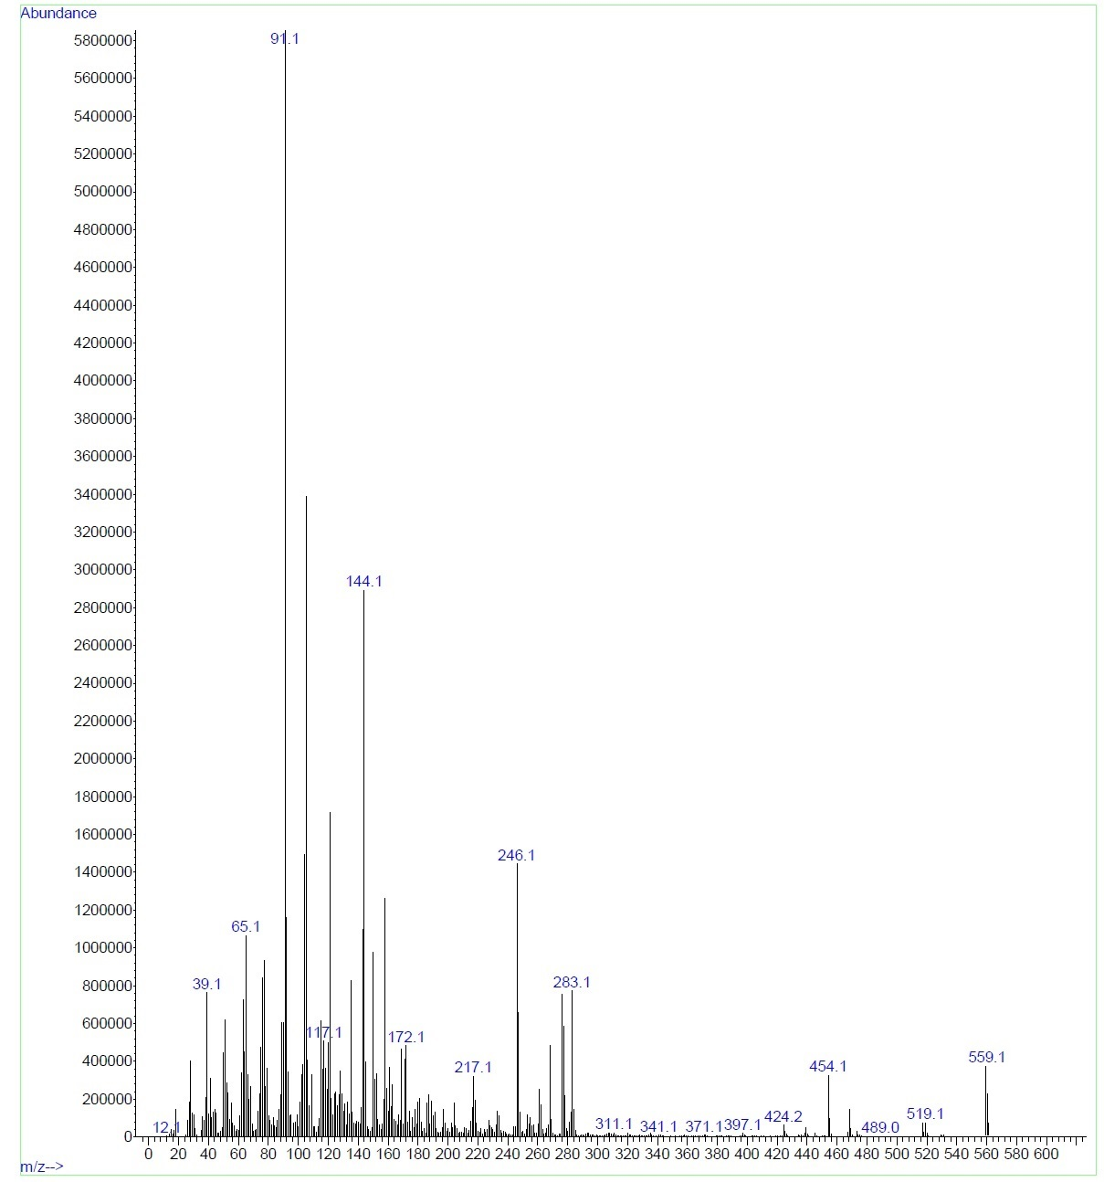
Supplementary 38: Mass spectrum of compound 9o

