Supporting information

Facile Fabrication of Zn_{0.6}Cd_{0.4}S/ZnO/g-C₃N₄ dual Z-scheme heterostructure with Enhanced Performance under Visible Light: An Experimental and Theoretical Study

Yuqi Dong¹, Qing-an Qiao^{1*}, Ruping Wang¹, Yueyue Yang¹, Honglan Cai^{1*}, Hongwei Gao²

¹ School of Chemistry and Materials Science, Ludong University, Yantai 264025, PR China
² School of Life Science, Ludong University, Yantai 264025, PR China

Table S1 Specific surface area, pore size and pore volume analysis of prepared samples
Samples | S_{BET}  (m²/g) | Pore volume(cm³/g) | Average pore size(nm)
Zn_{0.6}Cd_{0.4}S | 45.8612 | 0.087020 | 22.8148
g-C₃N₄ | 7.2868 | 0.017385 | 20.7587
Z_{0.6}C_{0.4}S /ZnO/CN-35% | 70.8393 | 0.169922 | 22.7369
Fig S1 XRD patterns of Zn_{0.6}Cd_{0.4}S
Fig S2 Mott-Schottky curves of (a) Zn_{0.6}Cd_{0.4}S, (b) g-C₃N₄, (c)ZnO
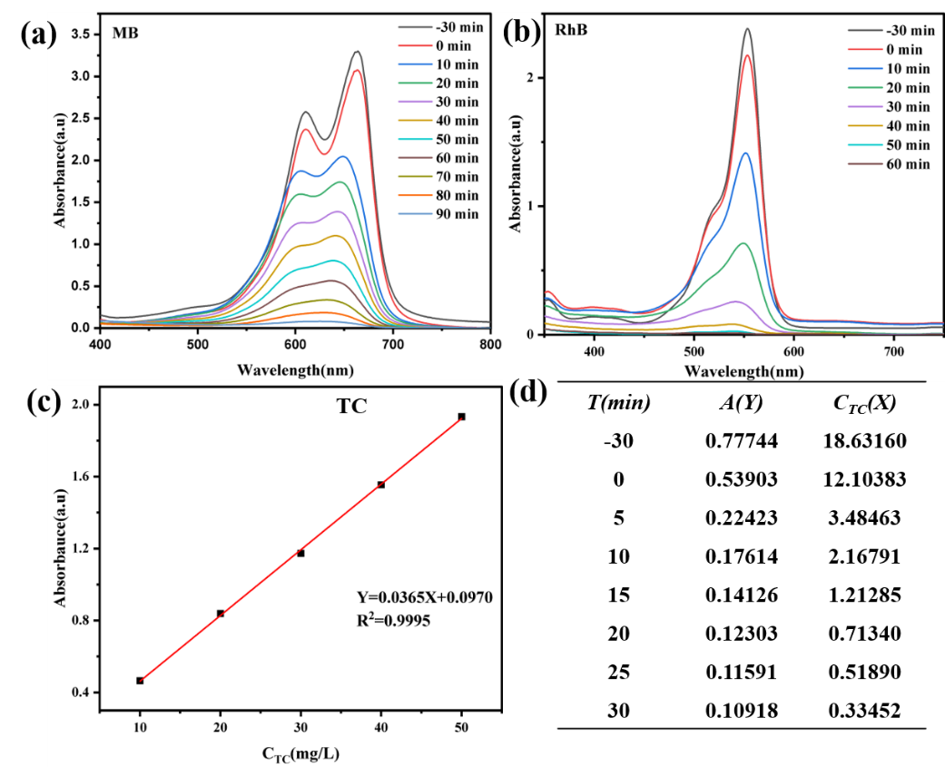
Fig S3. Photocatalytic degradation of pollutants spectra: (a)MB (C_{MB}: 20 mg/L, pH: 7, catalysts dose: 0.6g/L, irradiation time:90 min), (b)RhB (C_{RhB}: 20 mg/L, pH: 7, catalysts dose: 0.6g/L, irradiation time:60 min), (c-d) TC (C_{TC}: 20 mg/L, pH: 7, catalysts dose: 0.3 g/L, irradiation time:30 min)

Fig S4 Electronic band structures, total density of states (TDOS) and projected density of states (PDOS) of (a-b) Zn_{0.6}Cd_{0.4}S, (c-d) ZnO, (e-f) g-C₃N₄

* Corresponding authors: E-mail addresses: qiaoqa@ldu.edu.cn (Qing-an Qiao), hognlancai74@ldu.edu.cn(Honglan Cai)

