Supporting Information

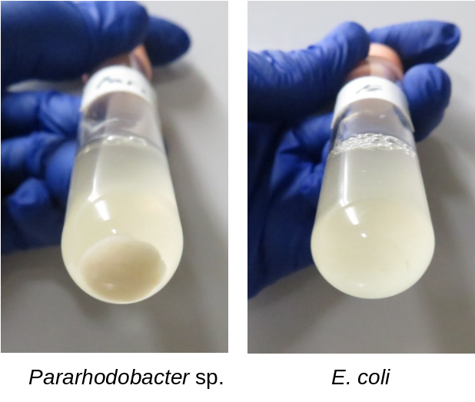

Figure S1. Precipitation by bacteria in a liquid culture medium containing urea and Ca²⁺ ion.

