Supporting Information for

The Influence of Sn Particle Incorporation on the Photocatalytic Activity of Sprayed ZnO−SnO₂ Nanocomposites

S. Mahjoubi ^{a,}, M. Mezyen ª, G.Elfidha ^{a, b} and N.Bitri ª, E. Llobet ^{c},

ª Université de Tunis El Manar, Ecole Nationale d’Ingénieurs de Tunis, Laboratoire de Photovoltaïque et Matériaux semi-conducteurs, 1002 Tunis, Tunisie
^{b} Université de Tunis, Ecole Nationale Supérieure d'ingénieurs de Tunis, Avenue Taha Hussein Montfleury, 1008 Tunis, Tunisia
^{c} Universitat Rovira i Virgili, ETSE, Avda. Països Catalans, 26, 43007, Tarragona

*Corresponding authors e-mails: nabila.bitri@enit.utm.tn ; eduard.llobet@urv.cat

Structural parameters
The samples deposited with 50% and 80% of SnO₂ show the smallest crystallites size (11 and 17). Which indicates increased grain boundaries act as defects. It may be due to the displacement of Sn²⁺ ions by Zn²⁺ ions in the lattice and/or the movement of Zn²⁺ ions in the interstitial sites replaced by Sn⁴⁺ depending on the incorporation of the high amount of Sn.
The microstrain ε and the dislocation δ were calculated with the following relations:
(1)
(2)
Where θ is the diffraction angle and β is the full width at half-maximum FWHM.
As shown in Table S1, there is an observable reduction in the dislocation and an increase in the strain with the SnO₂ content in the films. It is noteworthy that smaller values suggest less deformation in the structure.

Table S1: Structural parameters of different percentages of SnO₂.
Material | Preferential Orientation | ε×10⁻⁴  (rad) | δ ×10⁻⁴  (nm⁻²)
ZnO | 002 H | 5.60 | 2.68
Zn:Sn(20%) | 002 H | 10.30 | 9.76
Zn:Sn(50%) | 110 T  002 H | 32.21 | 0.82
Zn:Sn(80%) | 110 T  002 H | 19.13 | 0.34
SnO₂ | 110 T | 12.70 | 0.12

Chemical composition
The element compositions were analyzed using spectra obtained by energy dispersive spectroscopy (EDS). Table S2 shows the atomic percentages of Zn, Sn, and O elements, as well as the Zn/O and Sn/O atomic ratios for all films. EDS analysis confirmed that the samples consisted of Zn, Sn, and O. We can note the decrease in Zn/O value and the increase in Sn/O value, which indicate that there are significant deviations from the stoichiometric ratio due to the increasing amount of Sn. These results are consistent with the XRD results mentioned previously.
Table S2. EDS results of analyzed samples with different percentages of SnO₂.
 | Zn ( at.%) | Sn ( at.%) | O ( at.%) | Sn / O | Zn / O
ZnO | 44 | 0 | 56 | - | 0.78
SnO₂ | 0 | 45 | 55 | 0.81 | -
Zn:Sn(20%) | 49.10 | 9.90 | 41 | 0.24 | 1.19
Zn:Sn(50%) | 29.16 | 25.17 | 45.67 | 0.55 | 0.63
Zn:Sn(80%) | 10.51 | 38.50 | 50.99 | 0.75 | 0.20

AFM analysis
The surface roughness of pure oxides (ZnO and SnO₂) and the nanocomposite ZnO−SnO₂ for different percentage of tin oxide were studied by Atomic force microscopy AFM.

The three-dimensional atomic force microscopy (AFM) images in Figure S1, covering a 5 μm × 5 μm area, were obtained as part of a critical analysis of surface roughness. Understanding and characterizing surface roughness are imperative in studying photocatalytic efficiency, as demonstrated by various studies. Higher surface roughness contributes significantly to an increased specific surface area, a key factor known to have a remarkable effect on photocatalytic activity. Therefore, the AFM analyses were conducted to precisely assess and correlate the surface roughness with the photocatalytic performance [1]. As evident from Table 2 (main manuscript), the roughness values show a consistent increase with the rise in the percentage of SnO₂, with the sample prepared using 80% tin oxide exhibiting the highest roughness value, approximately 143 nm. This result explains the highest thickness value recorded for the sample obtained with 80% percent of tin oxide.

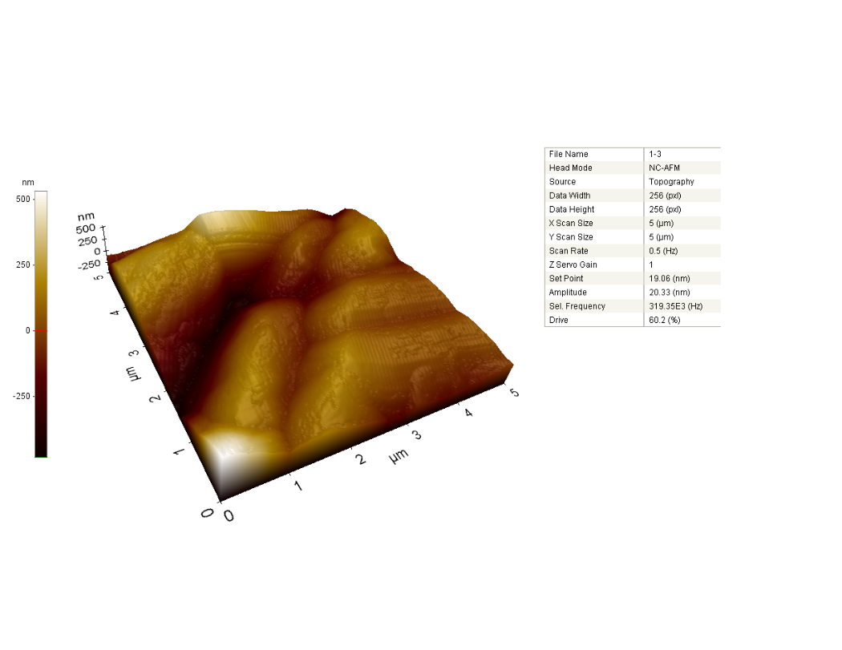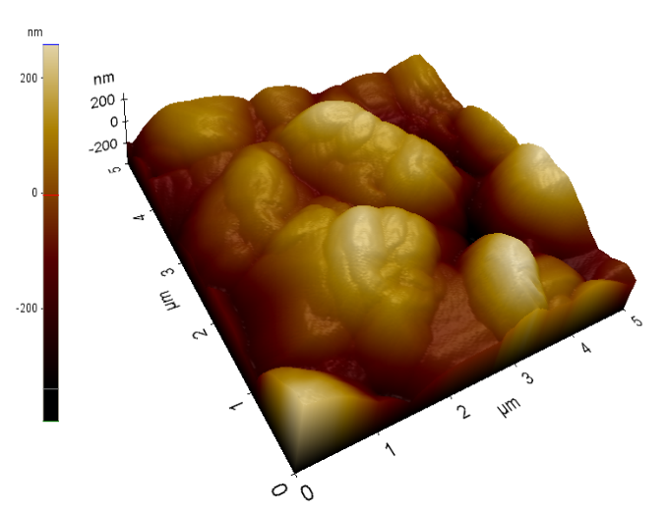
a
b
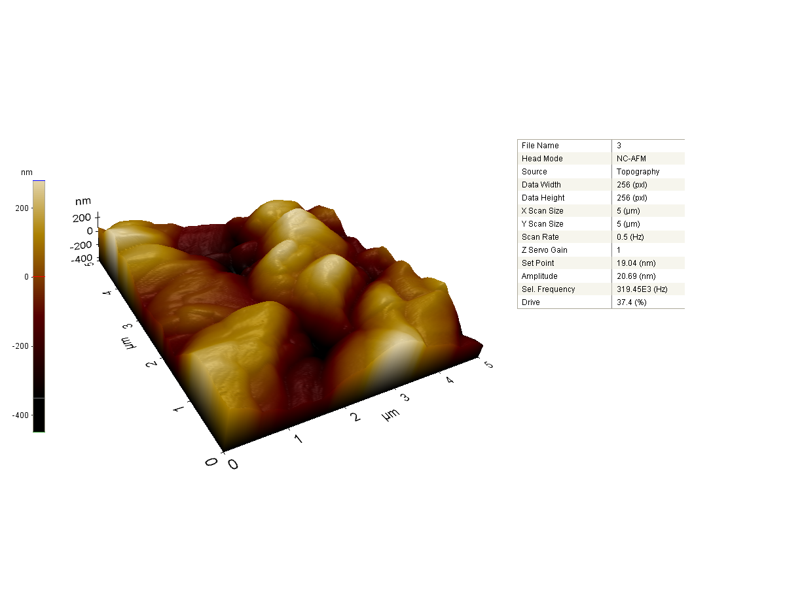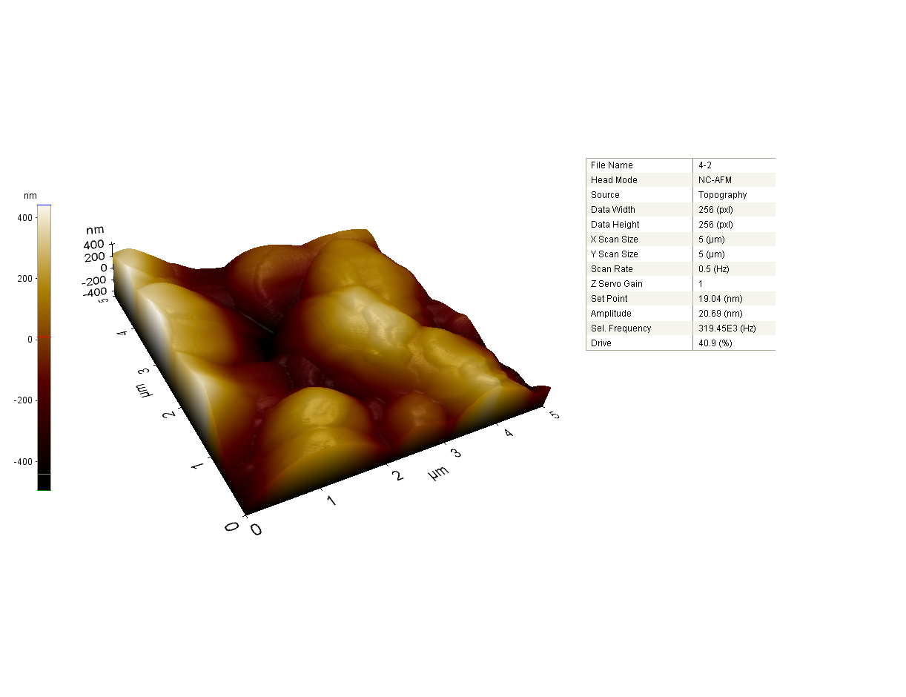
c
d

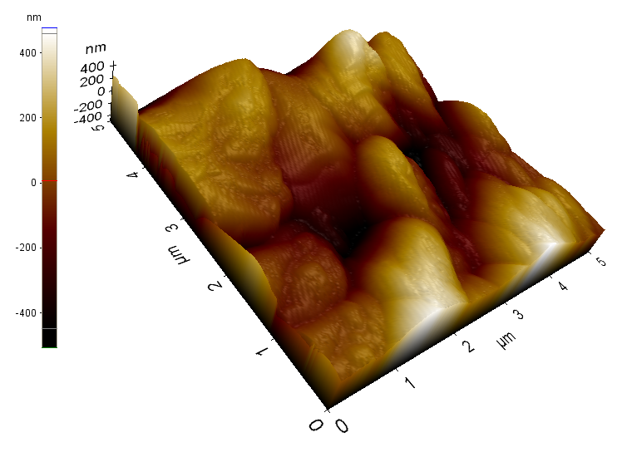
e

Figure S1. AFM images of ZnO−SnO₂ thin films: a) ZnO pure, b)SnO₂ pure,c) SnO₂=20%, d) SnO₂=50% and e) SnO₂=80%
References
[1] Y.F. Wang, Y. Ding, J.S. Zhao, X. Wang, D.J. Li, X.F. Li, Optimized Zn₂SnO₄ nanoparticles with enhanced performance for photodetectors and photocatalysts, RCS Adv. 6 (2016) 69191.

