Supporting Information

Surface modification of MXene using cationic CTAB surfactant for adsorptive elimination of cefazolin antibiotic from water

Jafar Abdi ^{a, b, *}, Golshan Mazloom ^{c}, Yeojoon Yoon ^{d}

ª Faculty of Chemical and Materials Engineering, Shahrood University of Technology, 3619995161 Shahrood, Iran
^{b} Center for International Scientific Studies and Collaborations, Tehran, Iran
^{c} Department of Chemical Engineering, Faculty of Engineering, University of Mazandaran, 47416-13534 Babolsar, Iran
^{d} Department of Environmental and Energy Engineering, Yonsei University, Wonju, Republic of Korea

Corresponding authors (*):
Jafar.abdi@shahroodut.ac.ir (J. Abdi)

Evaluation of the kinetic and isotherm models quality
The quality and reliability of the kinetic and isotherm models were assessed using different statistical techniques described as follows:
1. The average absolute relative deviation of the model results from the experimental values was calculated by the average absolute relative error (AARE):
$AARE\left(\%\right)=\frac{100}{n}\sum_{i=1}^{n}{\left|\frac{X{(i)}_{model}-X{(i)}_{exp}}{X{(i)}_{exp}}\right|}$
2. The root mean square error (RMSE), which indicates the error dispersion, is calculated by:
$RMSE={\left(\frac{\sum_{i=1}^{n}{(X{\left(i\right)}_{model}-X{(i)}_{exp})^{2}}}{n}\right)}^{1/2}$
3. The dispersion of data is investigated by the standard deviation of errors (STD), which can be calculated using:
$STD=\frac{1}{n}\sum_{i=1}^{n}{{{\left(X{\left(i\right)}_{model}-{\overline{X(i)}}_{model}\right)}^{2})}^{1/2}}$
4. The coefficient of determination $\left(R^{2}\right)$ which assigns the accuracy of the predictions. The $R^{2}$ value close to 1 determines that the estimation of experimental data is more accurate.
$R^{2}=1-\frac{\sum_{i=1}^{n}{{\left(X{(i)}_{model}-X{(i)}_{exp}\right)}^{2}}}{\sum_{i=1}^{n}{{\left(X{(i)}_{model}-{\overline{X(i)}}_{exp}\right)}^{2}}}$

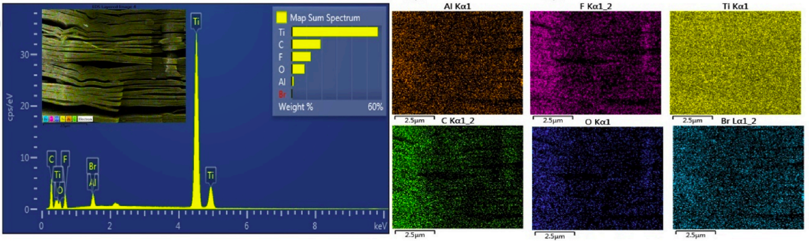
Fig. S1. EDS spectrum and elemental mapping of CTAB@MXene.

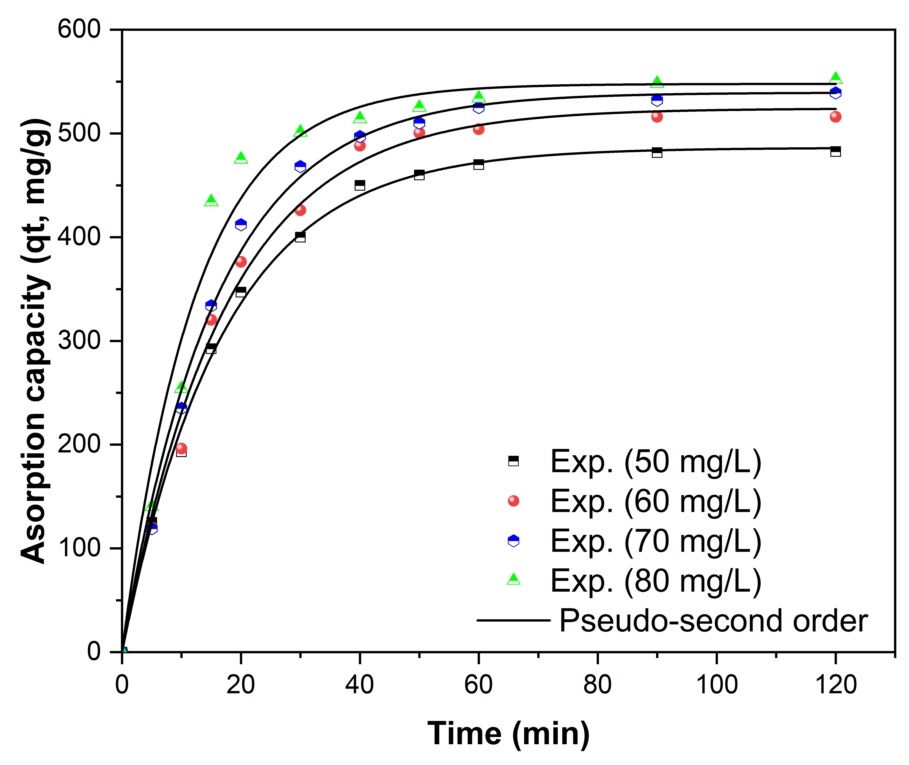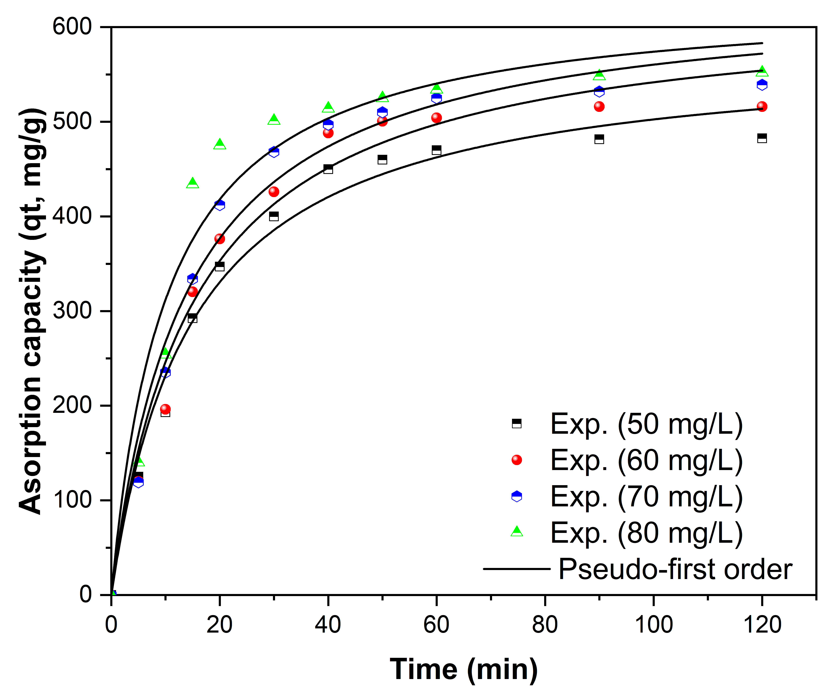
(b)
(a)
Fig. S2. Non-linear kinetic plots for CFZ adsorption onto CTAB@MXene.
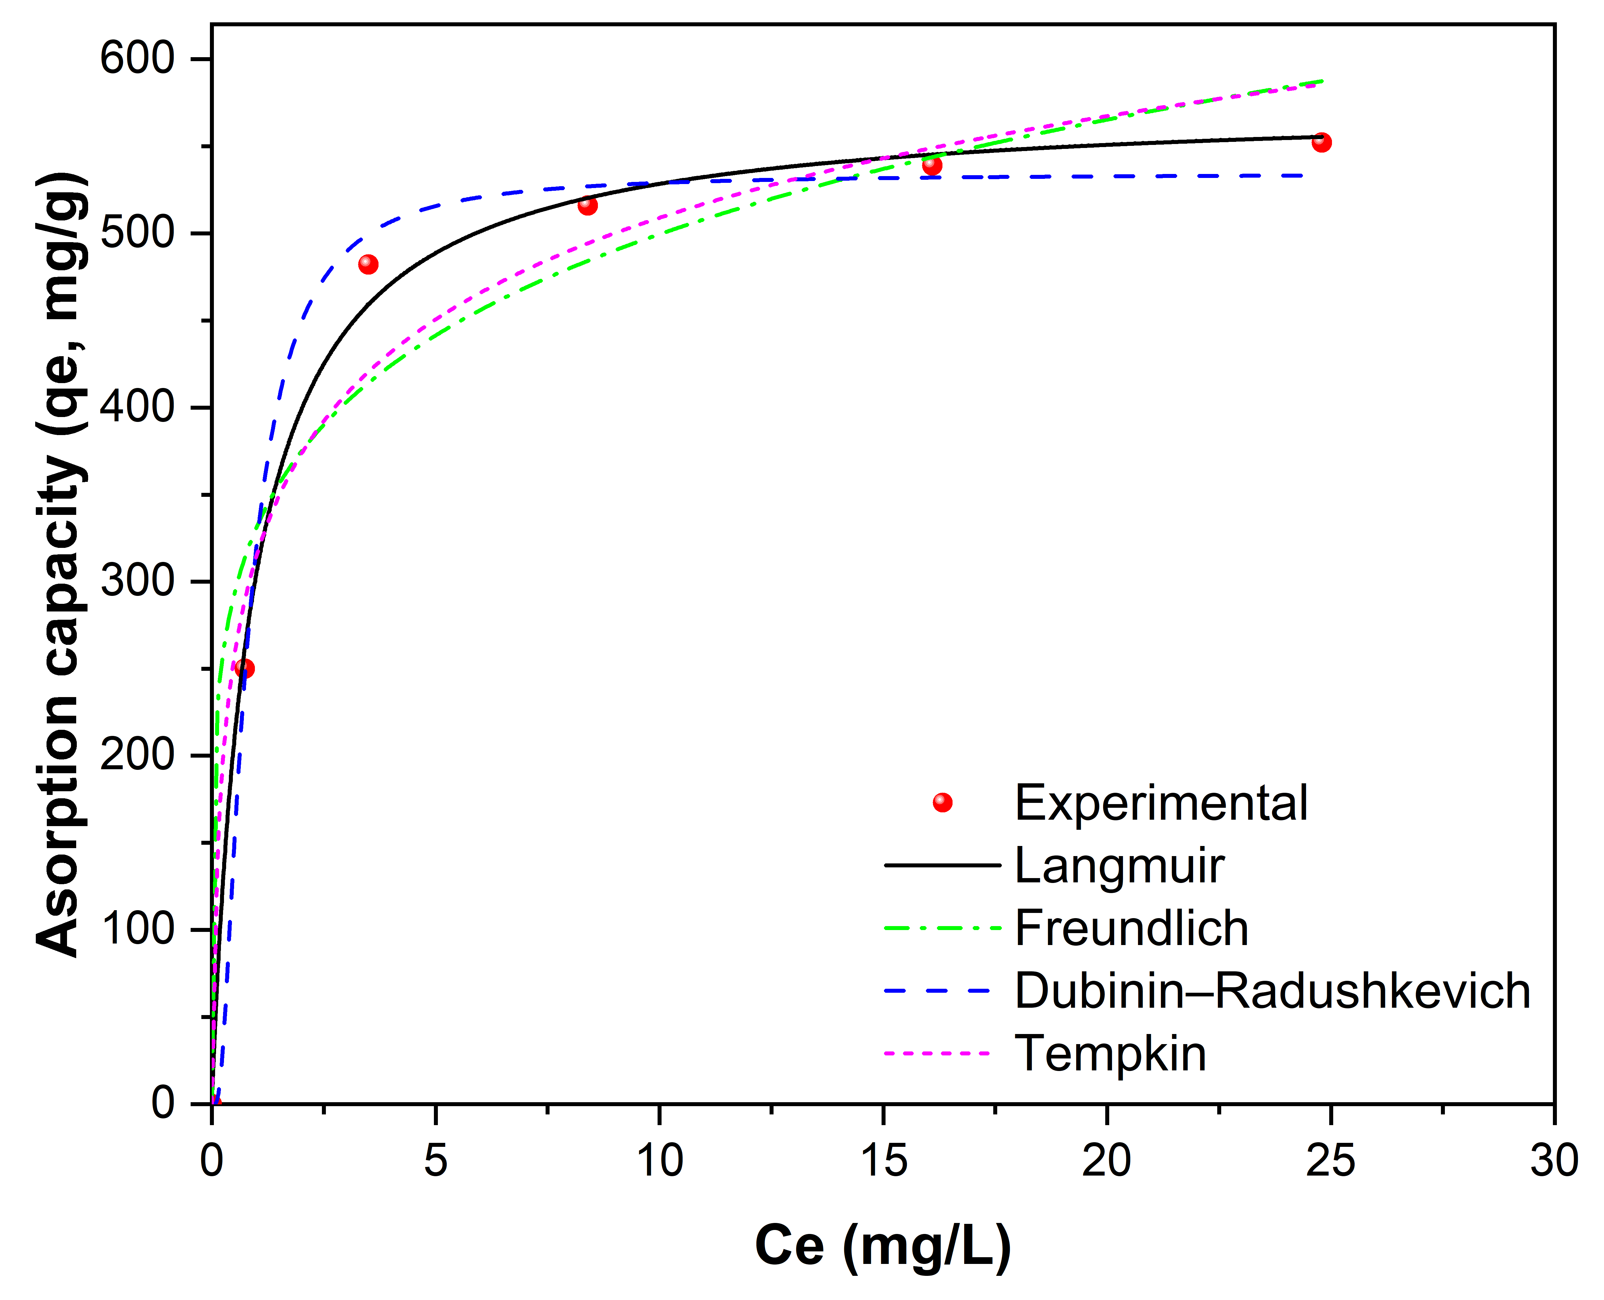
Fig. S3. Non-linear adsorption isotherm plots for CFZ adsorption onto CTAB@MXene.

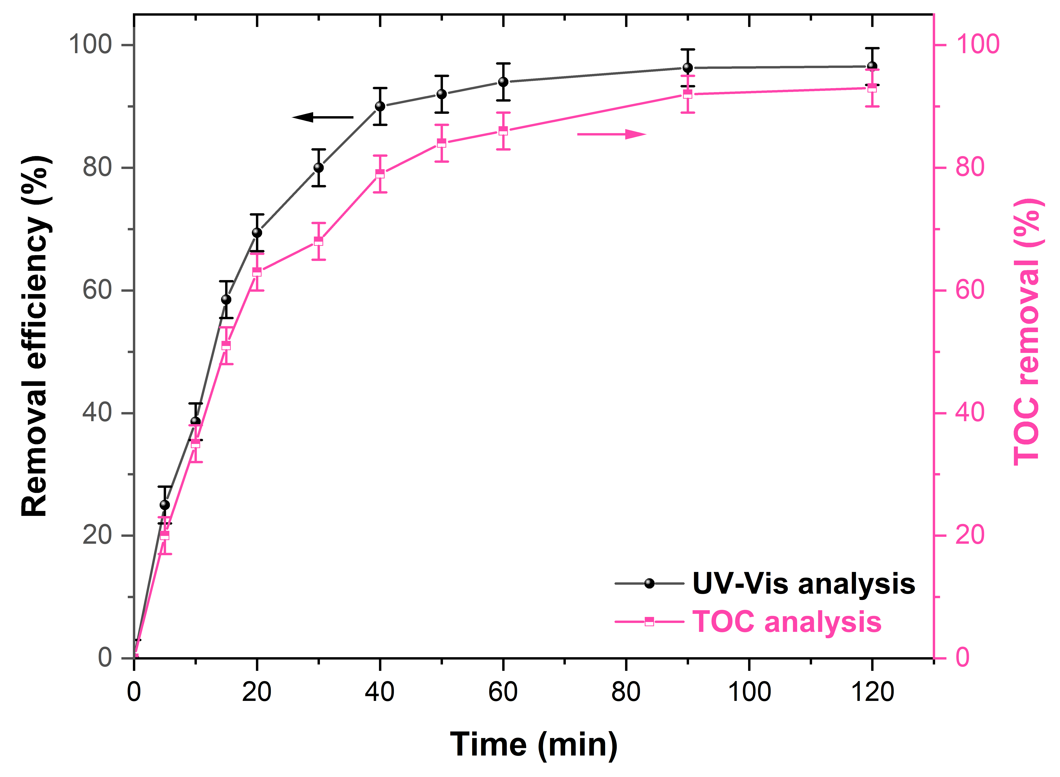
Fig. S4. TOC removal rates and adsorption efficiencies observed via UV-Vis for CFZ removal.

Table S1. The results of TOC analysis from the remaining CFZ solution after different adsorption cycles under the optimized conditions.
Sample | [TOC]₀ (mg/L)
Pure water | 5.21
First cycle | 11.7
Second cycle | 13.8
Third cycle | 14.6
Forth cycle | 15.2

