Supplementary Table 1. Collinearity analysis
Variables | Variance inflation factor (VIF)
Age | 1.205
Gender | 1.216
BMI | 1.119
Marital status | 1.161
Race | 1.018
Hypertension | 1.387
AMI | 1.228
HF | 1.554
stroke | 1.311
ARF | 1.366
WBC | 1.178
RBC | 7.359
PLT | 1.191
HGB | 9.359
RDW | 1.516
HCT | 1.398
K+ | 1.243
GA2+ | 1.170
CL- | 1.178
GLU | 1.138
INR | 1.105
TG | 1.073
BUN | 2.163
CREA | 2.053
Body Mass Index (BMI), Acute Myocardial Infarction（AMI）, Heart Failure（HF）, Acute Renal Failure（ARF）, White Blood Cell Count（WBC）, Red Blood Cell Count（RBC）, Platelet Count（PLT）, Hemoglobin（HGB）, Red Blood Cell Distribution Width（RDW）, Hematocrit（HCT）、Potassium（K+）、Calcium, Total（CA2+）、Chloride（CL-）、Glucometer（GLU）、 International Normalized Ratio（INR）、Triglyceride（TG）、Blood Urea Nitrogen（BUN）、Creatinine（CREA）

Supplementary Table 2. Comparison of the predictive abilities of BMI, GLU, TG, and TYG-BMI.
Variables | AUC (95%CI) | Sensitivity (95%CI) | Specificity (95%CI) | Cut off
BMI | 0.57 (0.54-0.59) | 0.28 (0.25 - 0.30) | 0.63 (0.59 - 0.66) | 26.1
GLU | 0.52 (0.49-0.55) | 0.60 (0.57 - 0.63) | 0.48 (0.44 - 0.52) | 152.5
TG | 0.54 (0.51-0.56) | 0.26 (0.24 - 0.28) | 0.65 (0.62 - 0.69) | 90.5
TYG-BMI | 0.64 (0.62-0.67) | 0.54 (0.52 - 0.57) | 0.68 (0.64 - 0.72) | 229.8
Body Mass Index (BMI)、 Glucometer（GLU）、Triglyceride（TG）、Triglyceride-glucose to body mass index (TyG-BMI)

Supplementary Table 3. After deleting samples with missing variables, a sensitivity analysis of the association between the TyG - BMI index and 1 year mortality and 180 days mortality in the population with stage 4 CKM syndrome.
Categories | Model 1 |  | Model 2 |  | Model 3
Categories | HR (95% CI) | P-value | HR (95% CI) | P-value | HR (95% CI) | P-value
180days mortality
TyG-BMI(Per SD change) | 0.88 (0.80 ~ 0.96) | 0.007 | 0.84 (0.76 ~ 0.93) | <0.001 | 0.84 (0.76 ~ 0.93) | ＜0.001
Quartile
Q1 (N = 410) | 1.00 (Reference) |  | 1.00 (Reference) |  | 1.00 (Reference)
Q2 (N = 409) | 0.81 (0.64 ~ 1.03) | 0.088 | 0.82 (0.64 ~ 1.04) | 0.102 | 0.80 (0.62 ~ 1.02) | 0.072
Q3 (N = 410) | 0.86 (0.68 ~ 1.09) | 0.224 | 0.84 (0.66 ~ 1.07) | 0.152 | 0.83 (0.65 ~ 1.07) | 0.156
Q4 (N = 410) | 0.67 (0.52 ~ 0.87) | <0.001 | 0.61 (0.47 ~ 0.80) | <0.001 | 0.52 (0.39 ~ 0.69) | <0.001
1 year mortality
TyG-BMI(Per SD change) | 0.86 (0.79 ~ 0.95) | 0.001 | 0.84 (0.76 ~ 0.92) | <0.001 | 0.84 (0.76 ~ 0.92) | <0.001
Quartile
Q1 (N = 410) | Reference |  | 1.00 (Reference) |  | 1.00 (Reference)
Q2 (N = 409) | 0.81 (0.65 ~ 1.01) | 0.063 | 0.82 (0.66 ~ 1.03) | 0.087 | 0.81 (0.64 ~ 1.02) | 0.072
Q3 (N = 410) | 0.84 (0.67 ~ 1.05) | 0.122 | 0.83 (0.67 ~ 1.05) | 0.118 | 0.84 (0.67 ~ 1.06) | 0.152
Q4 (N = 410) | 0.64 (0.51 ~ 0.82) | <0.001 | 0.59 (0.46 ~ 0.76) | <0.001 | 0.52 (0.40 ~ 0.68) | <0.001
Model 1：crude model
Model 2：Adjusted according to age, gender, BMI, race, marital status, hypertension, AMI, HF, stroke, andARF.
Model 3：Adjusted according to age, gender, BMI,race, marital status, hypertension, AMI, HF, stroke, ARF,WBC,RBC,PLT,HGB, RDW, HCT, K⁺, GA²⁺, CL⁻, GLU, INR, TG, BUN,and CREA.

Supplementary Table 4. Sensitivity analysis of the association between TyG-BMI and 180-days mortality and 1-year mortality, according to the tertiles of TyG-BMI.
Categories | Model 1 |  | Model 2 |  | Model 3
Categories | HR (95% CI) | P-value | HR (95% CI) | P-value | HR (95% CI) | P-value
180 days mortality
TyG-BMI(Per SD change) | 0.87 (0.80 ~ 0.95) | 0.002 | 0.83 (0.76 ~ 0.90) | <0.001 | 0.83 (0.76 ~ 0.91) | ＜0.001
TyG-BMI levels
Q1 (N = 622) | 1.00 (Reference) |  | 1.00 (Reference) |  | 1.00 (Reference)
Q2 (N = 641) | 0.74 (0.61 ~ 0.91) | 0.003 | 0.75 (0.62 ~ 0.92) | 0.005 | 0.73 (0.60 ~ 0.90) | 0.003
Q3 (N = 622) | 0.78 (0.64 ~ 0.95) | 0.012 | 0.70 (0.57 ~ 0.87) | <0.001 | 0.64 (0.51 ~ 0.80) | <0.001
1 year mortality
TyG-BMI(Per SD change) | 0.86 (0.79 ~ 0.94) | <0.001 | 0.83 (0.76 ~ 0.91) | <0.001 | 0.78 (0.71 ~ 0.86) | <0.001
TyG-BMI levels
Q1 (N = 622) | Reference |  | 1.00 (Reference) |  | 1.00 (Reference)
Q2 (N = 641) | 0.73 (0.61 ~ 0.88) | <0.001 | 0.75 (0.62 ~ 0.90) | 0.002 | 0.74 (0.61 ~ 0.89) | 0.002
Q3 (N = 622) | 0.75 (0.62 ~ 0.90) | 0.002 | 0.69 (0.57 ~ 0.84) | <0.001 | 0.64 (0.52 ~ 0.79) | <0.001
Model 1：crude model
Model 2：Adjusted according to age, gender, BMI, race, marital status, hypertension, AMI, HF, stroke, andARF.
Model 3：Adjusted according to age, gender, BMI,race, marital status, hypertension, AMI, HF, stroke, ARF,WBC,RBC,PLT,HGB, RDW, HCT, K⁺, GA²⁺, CL⁻, GLU, INR, TG, BUN,and CREA.

Supplementary Table 5. A sensitivity analysis of the association between the TyG - BMI index and 1 year mortality and 180 days mortality in the population with stage 4 CKM syndrome after removing samples beyond mean ± 3SD.
Categories | Model 1 |  | Model 2 |  | Model 3
Categories | HR (95% CI) | P-value | HR (95% CI) | P-value | HR (95% CI) | P-value
180days mortality
TyG-BMI(Per SD change) | 0.86 (0.79 ~ 0.94) | <0.001 | 0.88 (0.80 ~ 0.96) | <0.001 | 0.80 (0.73 ~ 0.88) | ＜0.001
Quartile
Q1 (N = 410) | 1.00 (Reference) |  | 1.00 (Reference) |  | 1.00 (Reference)
Q2 (N = 409) | 0.78 (0.62 ~ 0.97) | 0.028 | 0.82 (0.65 ~ 1.02) | 0.079 | 0.79 (0.63 ~ 0.99) | 0.045
Q3 (N = 410) | 0.83 (0.66 ~ 1.03) | 0.089 | 0.88 (0.70 ~ 1.10) | 0.273 | 0.82 (0.65 ~ 1.04) | 0.097
Q4 (N = 410) | 0.66 (0.52 ~ 0.84) | <0.001 | 0.70 (0.55 ~ 0.89) | 0.004 | 0.56 (0.43 ~ 0.72) | <0.001
1 year mortality
TyG-BMI(Per SD change) | 0.84 (0.78 ~ 0.91) | <0.001 | 0.86 (0.79 ~ 0.94) | <0.001 | 0.79 (0.72 ~ 0.87) | <0.001
Quartile
Q1 (N = 410) | 1.00 (Reference) |  | 1.00 (Reference) |  | 1.00 (Reference)
Q2 (N = 409) | 0.77 (0.63 ~ 0.95) | 0.015 | 0.82 (0.66 ~ 1.01) | 0.058 | 0.79 (0.64 ~ 0.98) | 0.034
Q3 (N = 410) | 0.82 (0.67 ~ 1.01) | 0.058 | 0.89 (0.72 ~ 1.10) | 0.286 | 0.84 (0.68 ~ 1.04) | 0.107
Q4 (N = 410) | 0.63 (0.50 ~ 0.79) | <0.001 | 0.67 (0.53 ~ 0.84) | <0.001 | 0.54 (0.43 ~ 0.69) | <0.001
Model 1：crude model
Model 2：Adjusted according to age, gender, BMI, race, marital status, hypertension, AMI, HF, stroke, andARF.
Model 3：Adjusted according to age, gender, BMI,race, marital status, hypertension, AMI, HF, stroke, ARF,WBC,RBC,PLT,HGB, RDW, HCT, K⁺, GA²⁺, CL⁻, GLU, INR, TG, BUN,and CREA.

Supplementary Table 6. A sensitivity analysis of the association between the TyG - BMI index and 1 - year mortality and 180 - day mortality in the population with stage 4 CKM syndrome after adding additional covariates such as glucocorticoids, antihypertensive drugs, insulin, and statins.
Categories | Model 1 |  | Model 2 |  | Model 3
Categories | HR (95% CI) | P-value | HR (95% CI) | P-value | HR (95% CI) | P-value
180days mortality
TyG-BMI(Per SD change) | 0.87 (0.80 ~ 0.95) | 0.002 | 0.83 (0.76 ~ 0.90) | <0.001 | 0.82 (0.74 ~ 0.90) | ＜0.001
Quartile
Q1 (N = 471) | 1.00 (Reference) |  | 1.00 (Reference) |  | 1.00 (Reference)
Q2 (N = 471) | 0.78 (0.62 ~ 0.97) | 0.028 | 0.79 (0.63 ~ 0.99) | 0.037 | 0.80 (0.64 ~ 1.01) | 0.062
Q3 (N = 471) | 0.83 (0.67 ~ 1.04) | 0.105 | 0.81 (0.65 ~ 1.01) | 0.065 | 0.86 (0.68 ~ 1.08) | 0.196
Q4 (N = 472) | 0.66 (0.53 ~ 0.84) | <0.001 | 0.59 (0.46 ~ 0.75) | <0.001 | 0.57 (0.45 ~ 0.74) | <0.001
1 year mortality
TyG-BMI(Per SD change) | 0.86 (0.79 ~ 0.94) | <0.001 | 0.83 (0.76 ~ 0.91) | <0.001 | 0.81 (0.74 ~ 0.89) | <0.001
Quartile
Q1 (N = 471) | Reference |  | 1.00 (Reference) |  | 1.00 (Reference)
Q2 (N = 471) | 0.77 (0.63 ~ 0.95) | 0.014 | 0.79 (0.64 ~ 0.97) | 0.028 | 0.80 (0.64 ~ 0.98) | 0.035
Q3 (N = 471) | 0.83 (0.67 ~ 1.01) | 0.069 | 0.83 (0.67 ~ 1.02) | 0.073 | 0.86 (0.69 ~ 1.07) | 0.166
Q4 (N = 472) | 0.64 (0.51 ~ 0.80) | <0.001 | 0.58 (0.46 ~ 0.73) | <0.001 | 0.55 (0.44 ~ 0.70) | <0.001
Model 1：crude model
Model 2：Adjusted according to age, gender, BMI,race, marital status, hypertension, AMI, HF, stroke，andARF.
Model 3：Adjusted according to age, gender, BMI,race, marital status, hypertension, AMI, HF, stroke, ARF,WBC,RBC,PLT,HGB, RDW, HCT, K⁺, GA²⁺, CL⁻, GLU, INR, TG, BUN,CREA,Glucocorticoids, Antihypertensive drugs, Lnsulin,and Statins.

Statistical analysis
This investigation employed insulin as an instrumental variable, utilizing a two-stage residual inclusion (2SRI) approach to examine the causal relationship between the triglyceride glucose-body mass index (TyG-BMI) and all-cause mortality. The instrumental variable analysis revealed a significant correlation between insulin and TyG-BMI (r=0.17, P<0.001), with an F-statistic of 56.88, meeting the strength requirements for instrumental variables while maintaining independence from outcome measures. Endogeneity testing demonstrated residual hazard ratios (HR) of 1.45 (95%CI: 1.18-1.78, P=0.003) and 1.38 (95%CI: 1.12-1.70, P=0.008) for 1-year and 180-day mortality models, respectively, confirming the presence of endogeneity in TyG-BMI. Following instrumental variable adjustment, the protective effect of TyG-BMI exhibited substantial enhancement: standardized TyG-BMI effects increased by 4.8-5.1%, while quartile comparisons showed 4.0-10.0% improvement. Specifically, after adjustment, each standard deviation increase in TyG-BMI was associated with a 25% reduction in 1-year mortality risk (compared to 21% in naive estimates), while the highest quartile demonstrated a 55% risk reduction relative to the lowest quartile (compared to 50% in naive estimates). All comparisons yielded P-values <0.01, indicating robust negative associations between TyG-BMI and mortality risk.
Sensitivity analyses for unmeasured confounding factors further validated the reliability of these findings. E-value analysis revealed an instrumental variable analysis E-value of 1.96 (95%CI: 1.63-2.26), exceeding that of the Cox regression model (1.70, 95%CI: 1.43-1.96), suggesting that unmeasured confounders would need to exhibit risk ratios of at least 1.96 with both exposure and outcome to fully explain the observed protective association (HR=0.76). Bias effect curve analysis demonstrated that the protective effect (HR=0.83) in the Cox regression model would require either positive bias of RR≈5.5 or negative bias of RR≈2.8 to be nullified, while the instrumental variable analysis (HR=0.76) would require positive bias of RR≈7.5 or negative bias of RR≈2.3. Given the comprehensive control of known confounding factors, the likelihood of unmeasured confounders reaching such magnitudes appears low. This study, through addressing endogeneity and unmeasured confounding, provides estimates closer to true causal relationships, thereby reinforcing the clinical value of TyG-BMI as a prognostic marker.

Supplementary Table 7.Table of the Results of Instrumental Variable Analysis of the Relationship between TyG-BMI and All-Cause Mortality
Analysis Type | Mortality Risk | Measure | Hazard Ratio (HR) (95% CI) | Change relative to naïve Cox regression (%) | P-value
Naïve Cox Regression | 1-year | Standardized TyG-BMI (per 1 SD increase) | 0.79 (0.71 to 0.87) | - | <0.001
Instrumental Variable Analysis Adjusted | 1-year | Standardized TyG-BMI (per 1 SD increase) | 0.75 (0.67 to 0.84) | -5.1 | <0.001
Naïve Cox Regression | 1-year | TyG-BMI Quartiles (Q4 vs Q1) | 0.50 (0.39 to 0.65) | - | <0.001
Instrumental Variable Analysis Adjusted | 1-year | TyG-BMI Quartiles (Q4 vs Q1) | 0.45 (0.34 to 0.60) | -10.0 | <0.001
Naïve Cox Regression | 180-day | Standardized TyG-BMI (per 1 SD increase) | 0.83 (0.76 to 0.91) | - | <0.001
Instrumental Variable Analysis Adjusted | 180-day | Standardized TyG-BMI (per 1 SD increase) | 0.79 (0.72 to 0.87) | -4.8 | <0.01
Naïve Cox Regression | 180-day | TyG-BMI Quartiles (Q4 vs Q1) | 0.50 (0.38 to 0.65) | - | <0.001
Instrumental Variable Analysis Adjusted | 180-day | TyG-BMI Quartiles (Q4 vs Q1) | 0.48 (0.35 to 0.64) | -4.0 | <0.001
Residual Endogeneity Test | 1-year | - | 1.45 (1.18 to 1.78) | - | 0.003
Residual Endogeneity Test | 180-day | - | 1.38 (1.12 to 1.70) | - | 0.008
Adjusted according to age, gender, BMI,race, marital status, hypertension, AMI, HF, stroke, ARF,WBC,RBC,PLT,HGB, RDW, HCT, K⁺, GA²⁺, CL⁻, GLU, INR, TG, BUN,CREA,Glucocorticoids, Antihypertensive drugs, Lnsulin,and Statins.
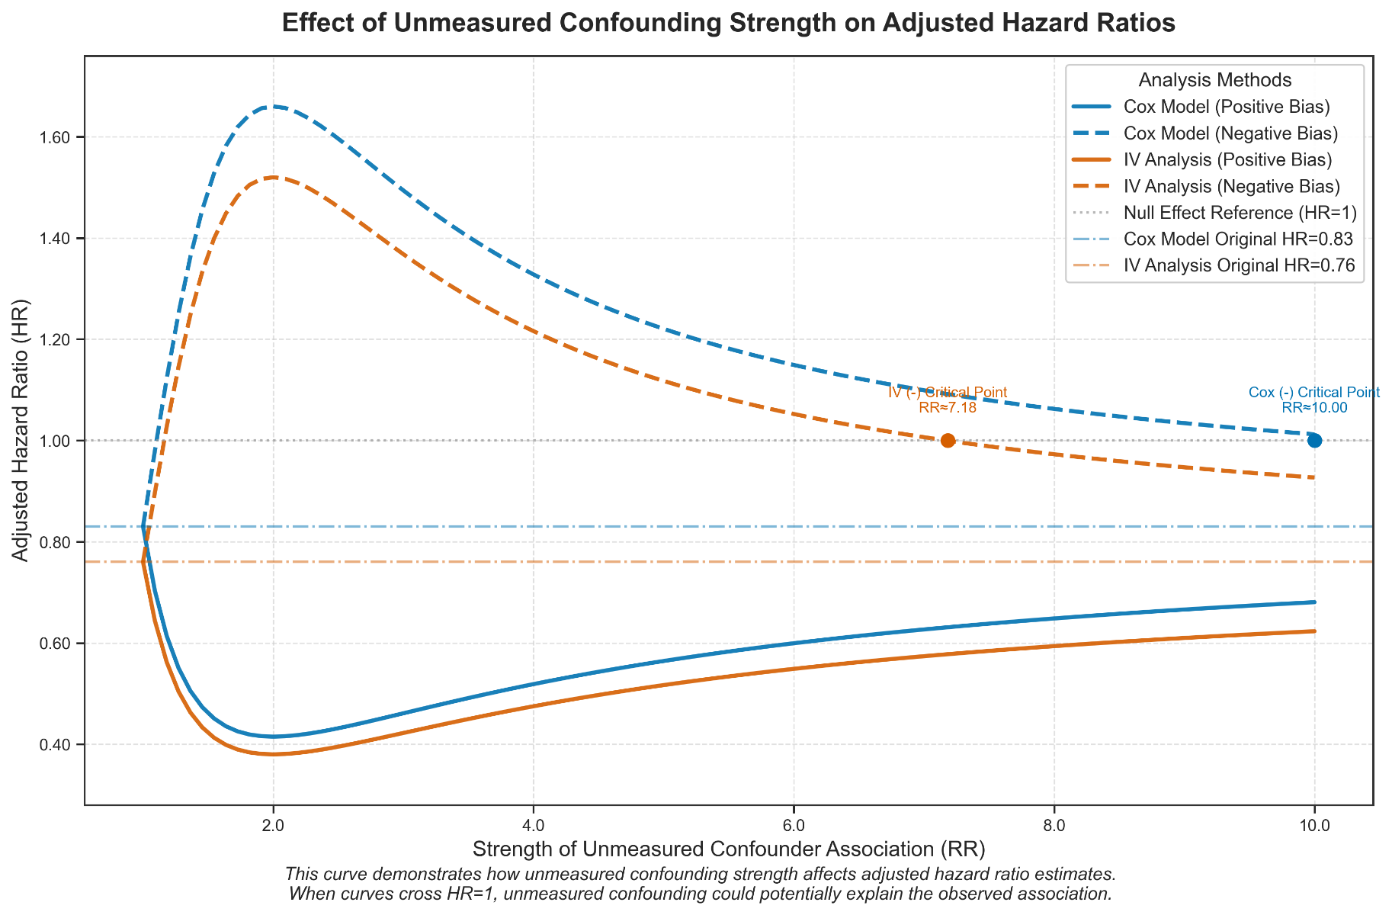
Supplementary Table 1, The influence curve of the intensity of unmeasured confounding factors on the adjusted hazard ratio (HR).

