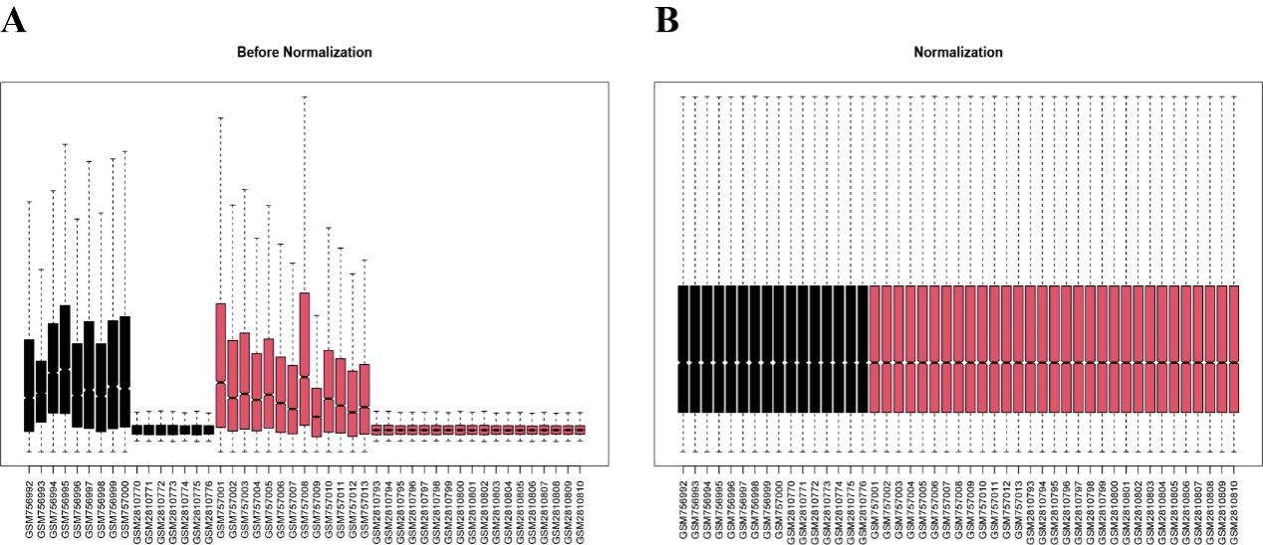
Supplement Figure 1. The gene expression schematic of the chosen GEO datasets for before and after standardization. (A) The array expression datasets (GSE30528 and GSE104948) were not standardized. (B) The array expression datasets (GSE30528 and GSE104948) have undergone standardization.
Supplement Figure 2. Validation of three machine learning methods. (A) ROC curve of LASSO model in the independent dataset (GSE96804). (B) ROC curve of SVM model in the independent dataset (GSE96804). (C) ROC curve of RF model in the independent dataset (GSE96804).
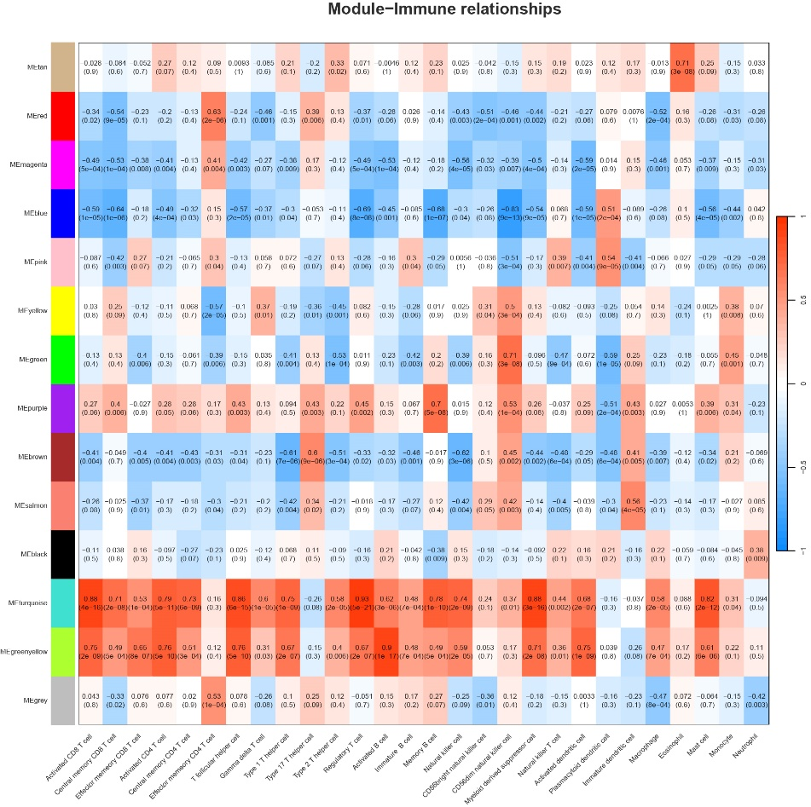
Supplement Figure 3. Immune infiltration analysis of 14 modules in weighted gene co expression network analysis (WGCNA).
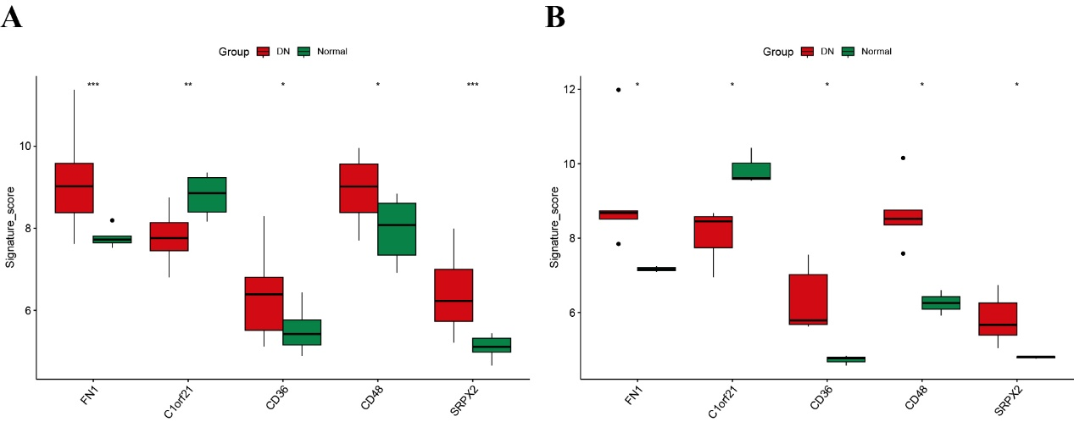
Supplement Figure 4. Expression level validation in external datasets. (A) Differential analysis of expression levels of five biomarkers between DN and control group in dataset GSE99339. (B) Differential analysis of expression levels of five biomarkers between DN and control group in dataset GSE104948.

