Exploration of 1-(2,4-difluorophenyl)-5-oxopyrrolidine-3-carboxylic acid derivatives effect on triple-negative breast, prostate cancer and melanoma cell 2D and 3D cultures
Guoda Pranaitytė¹, Birutė Grybaitė¹, Ugne Endriulaityte², Vytautas Mickevičius¹*, Vilma Petrikaitė^{2,3}*
¹ Kaunas University of Technology, Radvilėnų Rd. 19, Kaunas LT-50254, Lithuania
² Laboratory of Drug Targets Histopathology, Institute of Cardiology, Lithuanian University of Health Sciences, Sukileliu pr. 13, Kaunas LT-50162, Lithuania
³ Institute of Biotechnology, Life Sciences Center, Vilnius University, Saulėtekio Ave. 7, LT-10257 Vilnius, Lithuania
*Corresponding authors: vilma.petrikaite@lsmuni.lt, vytautas.mickevicius@ktu.lt

Supplementary material

¹H and ¹³C NMR spectra of compounds 2−16
(in DMSO-d₆)

1-(2,4-difluorophenyl)-5-oxopyrrolidine-3-carboxylic acid (2)
Figure S1. ¹H NMR spectrum of compound 2
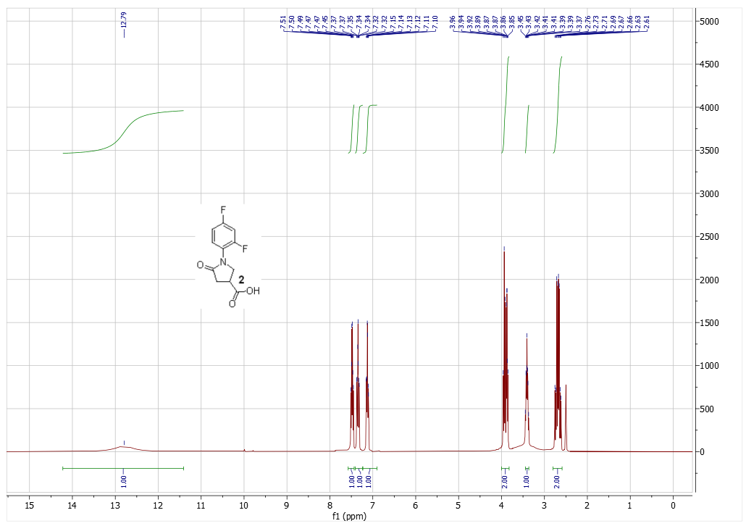
Figure S2. ¹³C NMR spectrum of compound 2
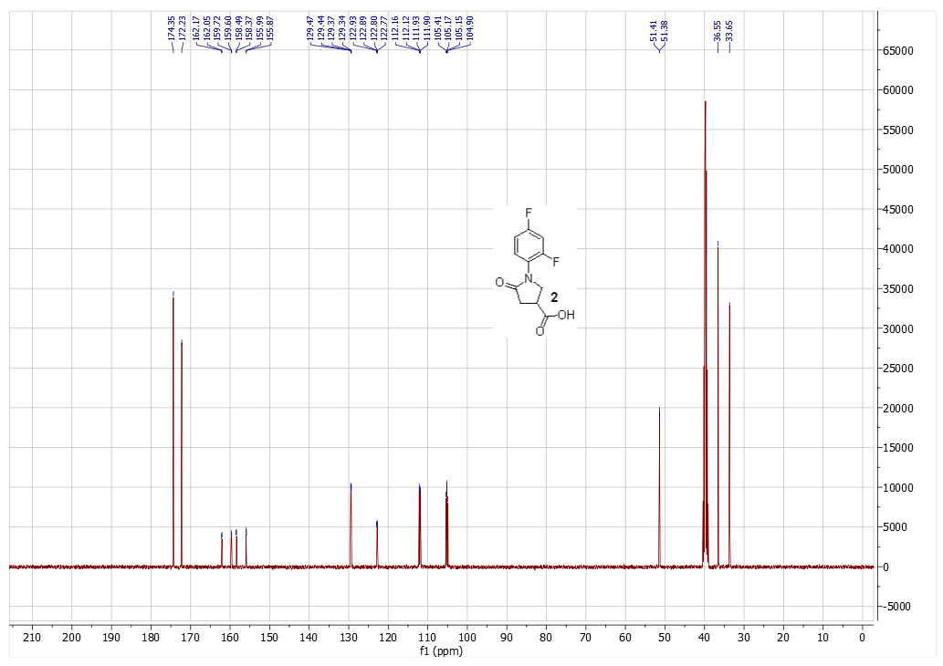

4-(1H-benzo[d]imidazol-2-yl)-1-(2,4-difluorophenyl)pyrrolidin-2-one (3a)
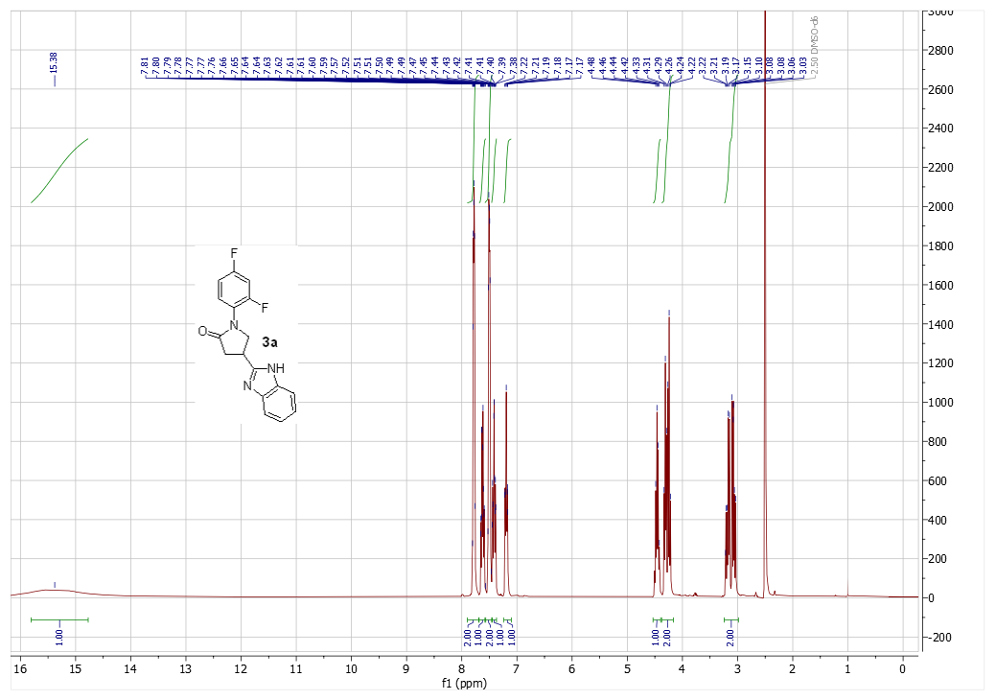
Figure S3. ¹H NMR spectrum of compound 3a
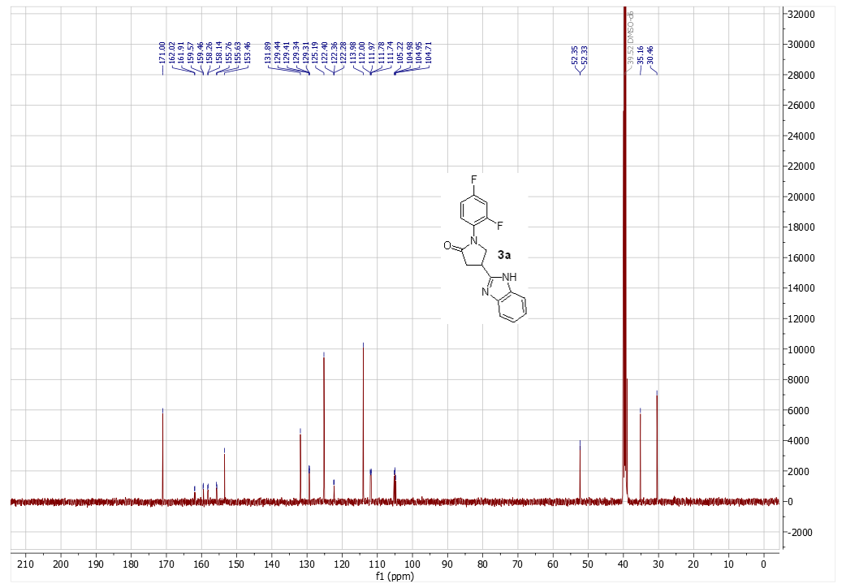
Figure S4. ¹³C NMR spectrum of compound 3a

1-(2,4-difluorophenyl)-4-(6-fluoro-1H-benzo[d]imidazol-2-yl)pyrrolidin-2-one (3b)
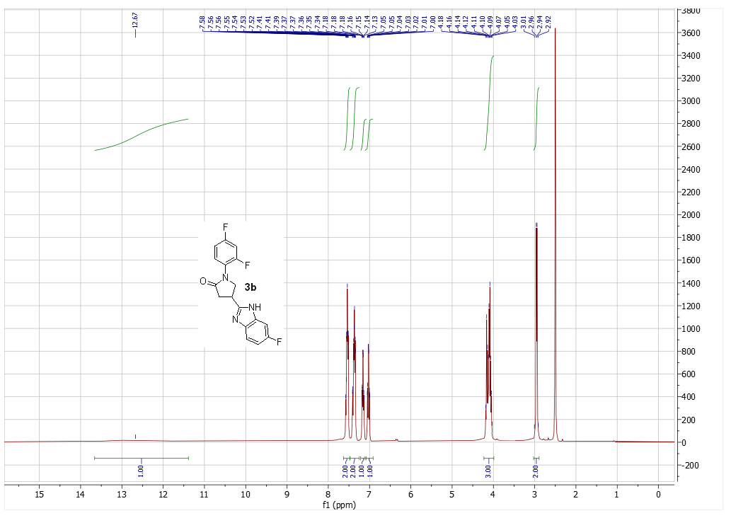
Figure S5. ¹H NMR spectrum of compound 3b
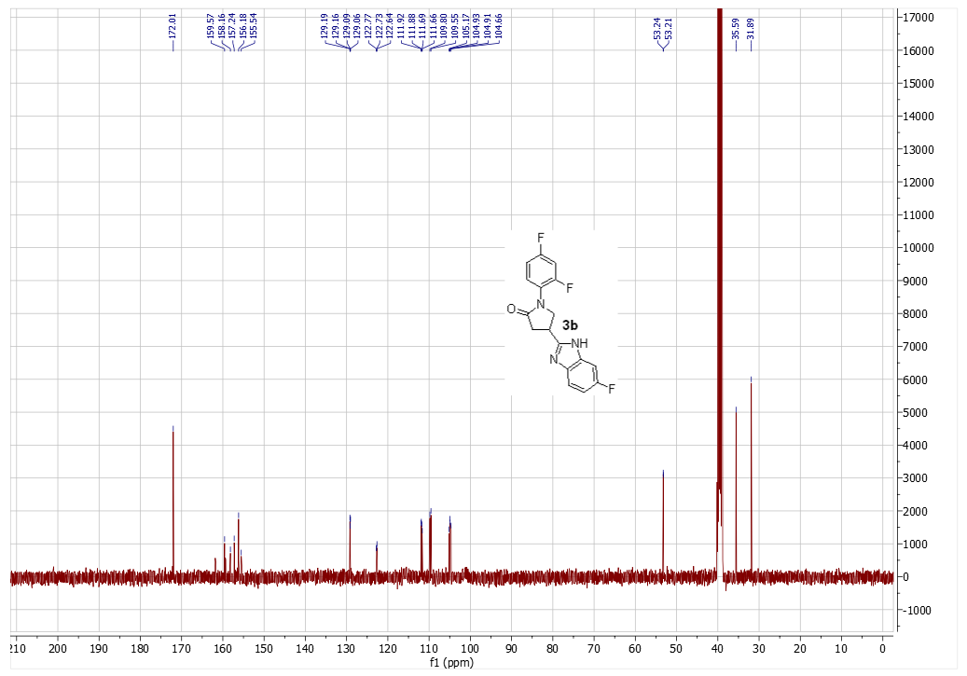
Figure S6. ¹³C NMR spectrum of compound 3b

4-(6-chloro-1H-benzo[d]imidazol-2-yl)-1-(2,4-difluorophenyl)pyrrolidin-2-one (3c)
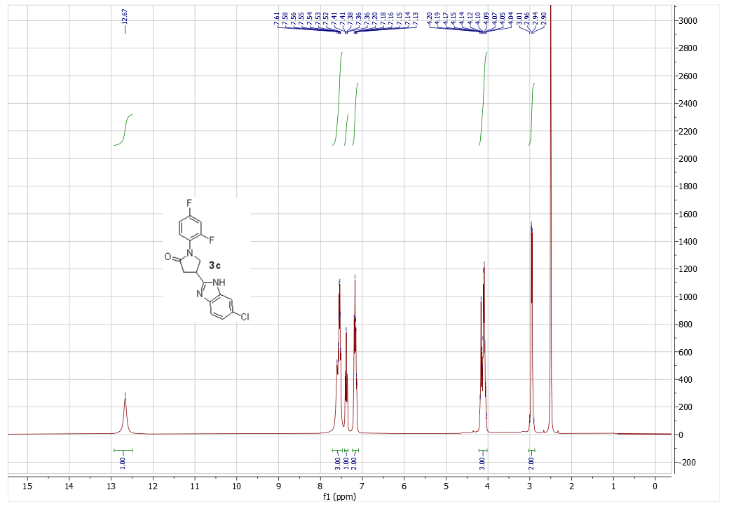
Figure S7. ¹H NMR spectrum of compound 3c
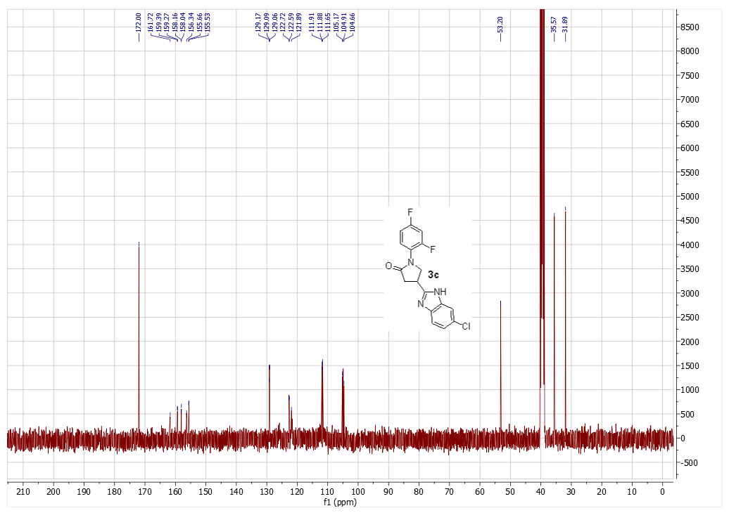
Figure S8. ¹³C NMR spectrum of compound 3c

1-(2,4-difluorophenyl)-4-(1-ethyl-1H-benzo[d]imidazol-2-yl)pyrrolidin-2-one (4)
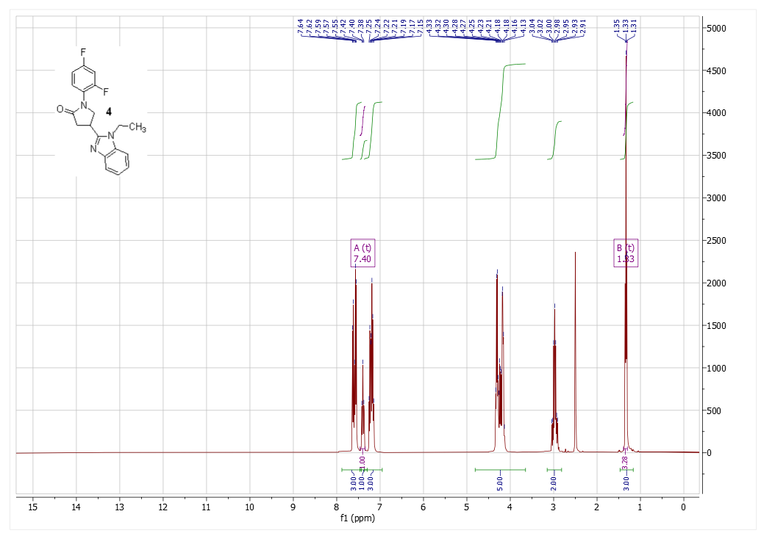
Figure S9. ¹H NMR spectrum of compound 4
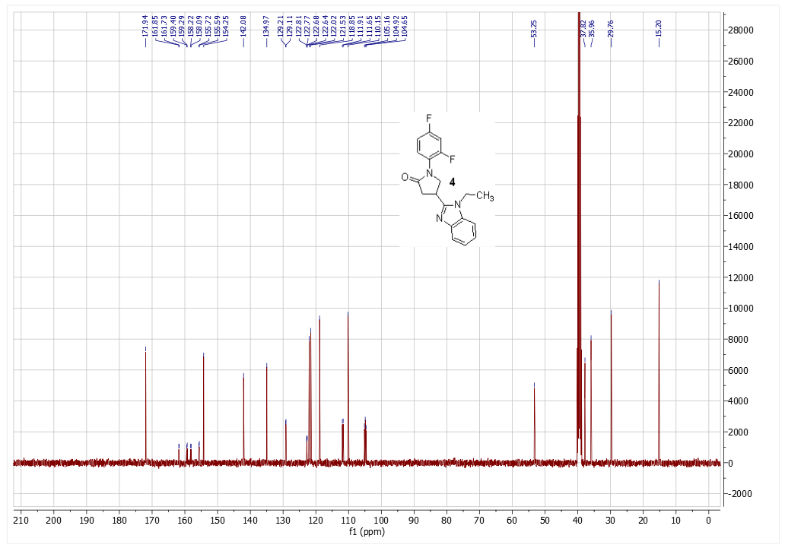
Figure S10. ¹³C NMR spectrum of compound 4

methyl 1-(2,4-difluorophenyl)-5-oxopyrrolidine-3-carboxylate (5)
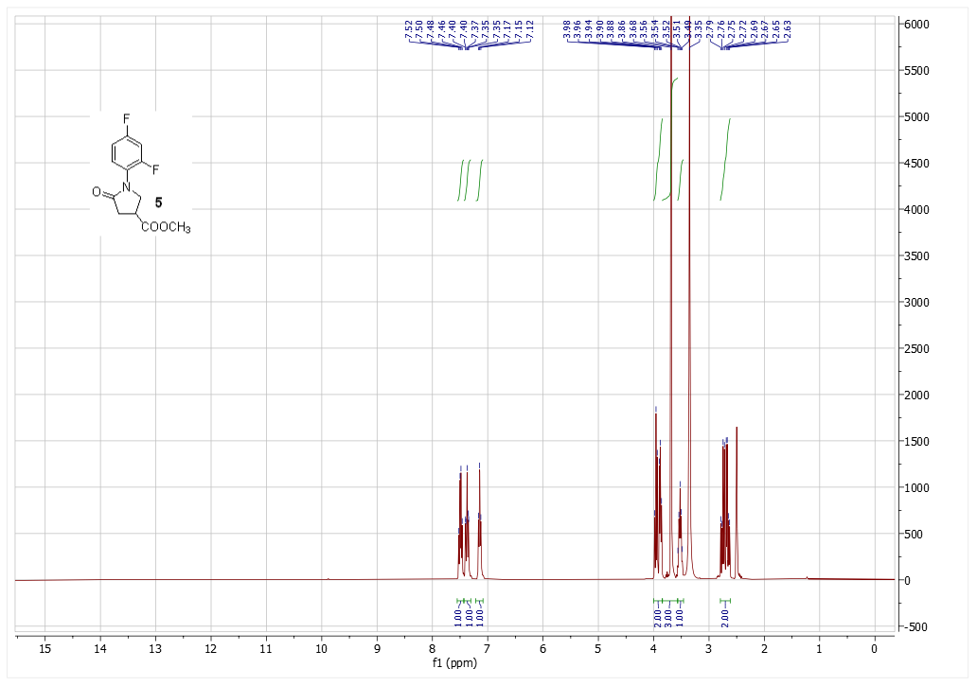
Figure S11. ¹H NMR spectrum of compound 5
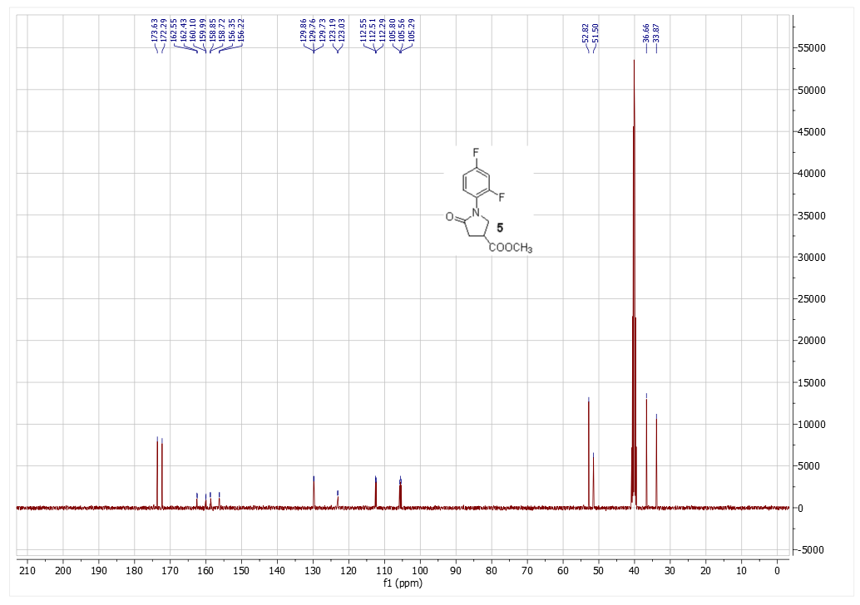
Figure S12. ¹³C NMR spectrum of compound 5

1-(2,4-difluorophenyl)-5-oxopyrrolidine-3-carbohydrazide (6)
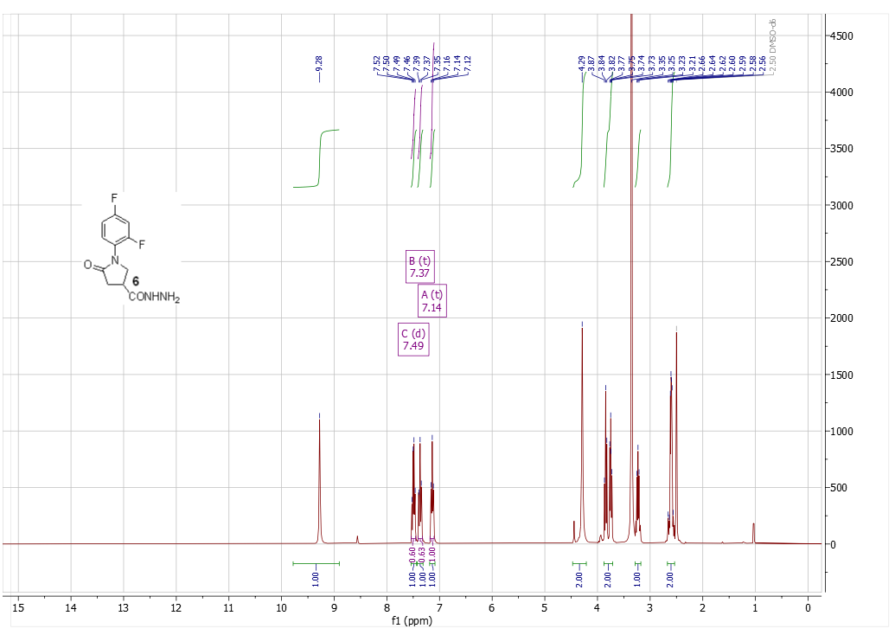
Figure S13. ¹H NMR spectrum of compound 6
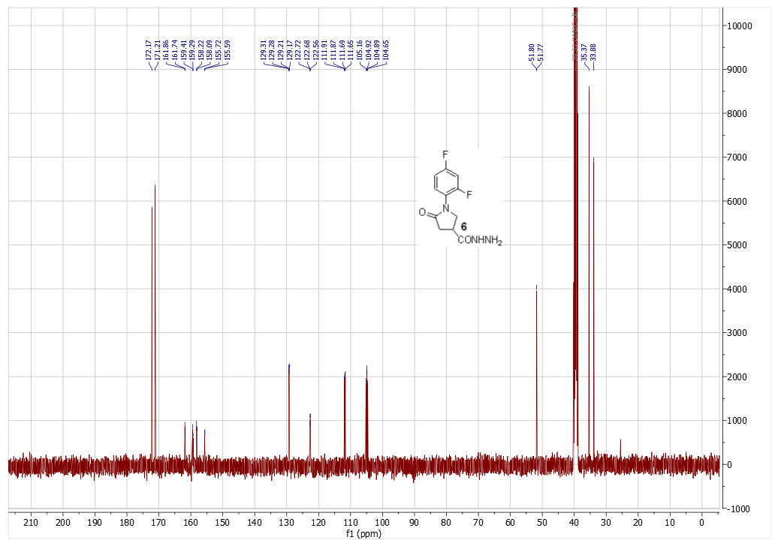
Figure S14. ¹³C NMR spectrum of compound 6

1-(2,4-difluorophenyl)-5-oxo-N'-(thiophen-2-ylmethylene)pyrrolidine-3-carbohydrazide (7a)
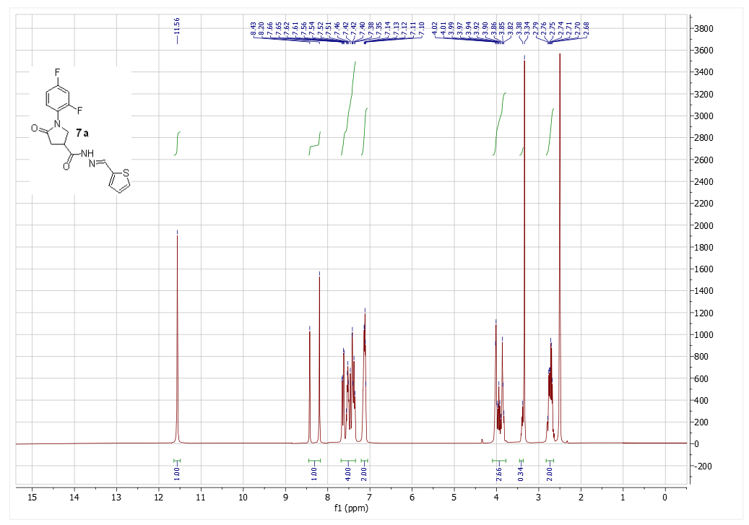
Figure S15. ¹H NMR spectrum of compound 7a
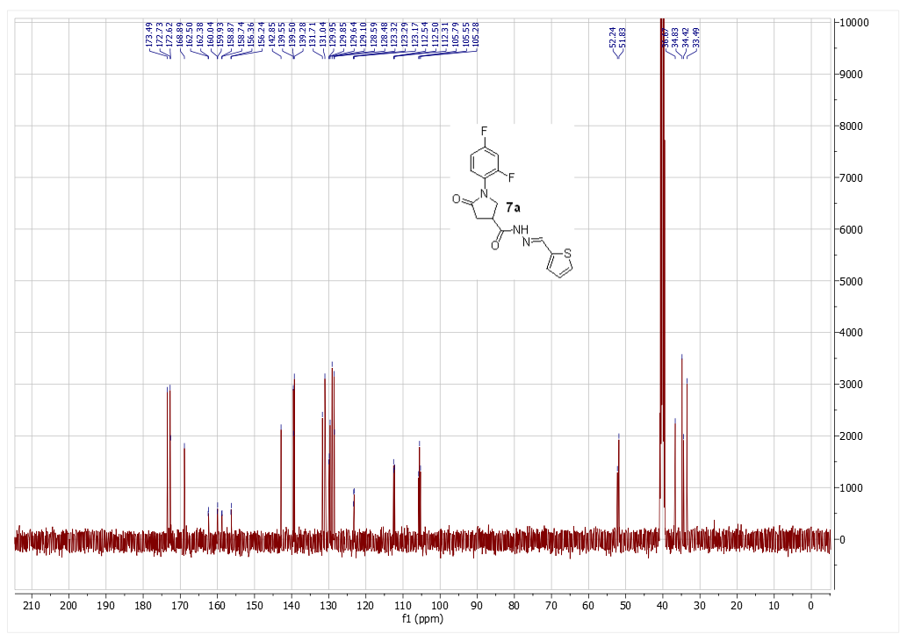
Figure S16. ¹³C NMR spectrum of compound 7a

1-(2,4-difluorophenyl)-N'-((5-nitrothiophen-2-yl)methylene)-5-oxopyrrolidine-3-carbohydrazide (7b)
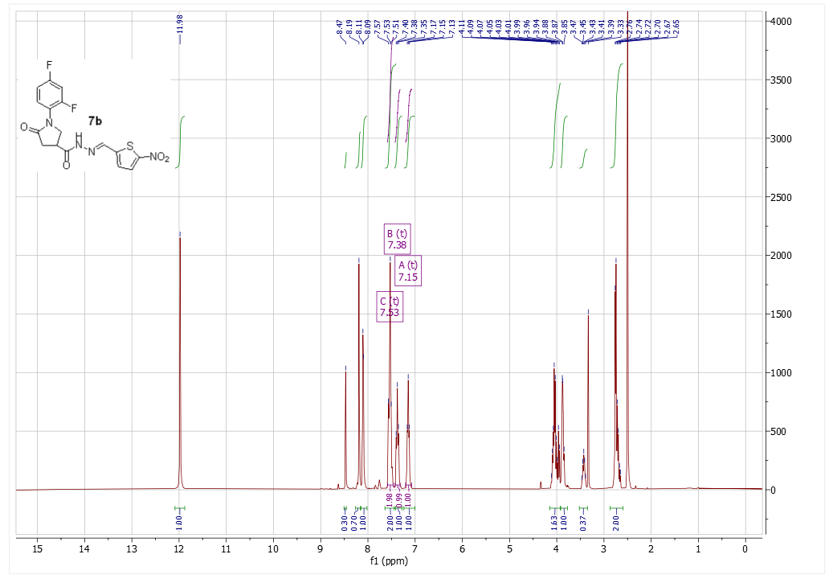
Figure S17. ¹H NMR spectrum of compound 7b
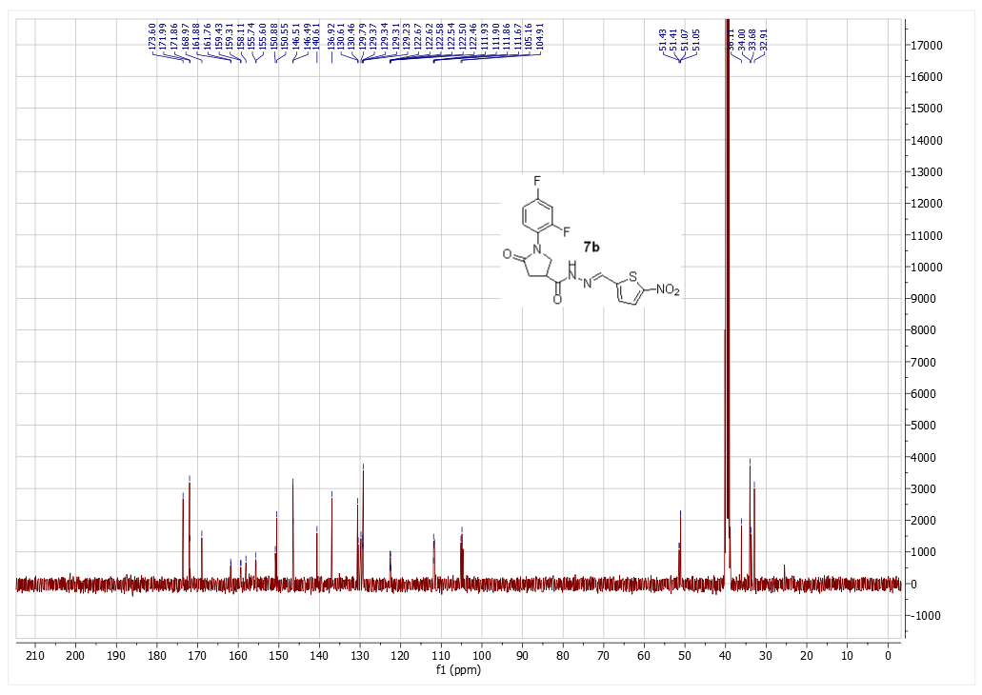
Figure S18. ¹³C NMR spectrum of compound 7b

1-(2,4-difluorophenyl)-5-oxo-N'-(propan-2-ylidene)pyrrolidine-3-carbohydrazide (8a)
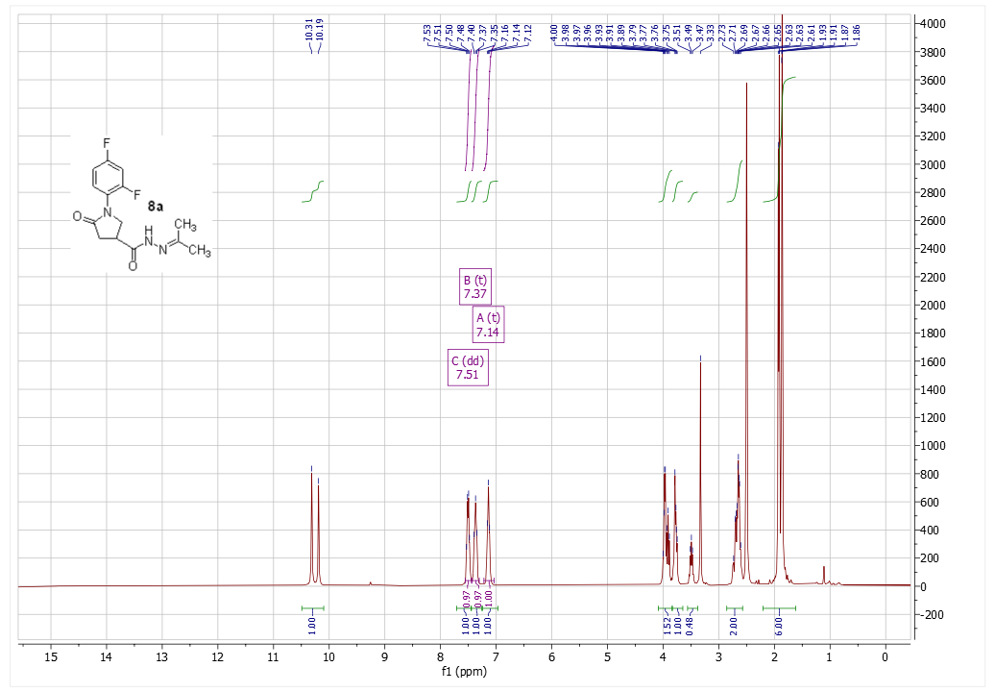
Figure S19. ¹H NMR spectrum of compound 8a
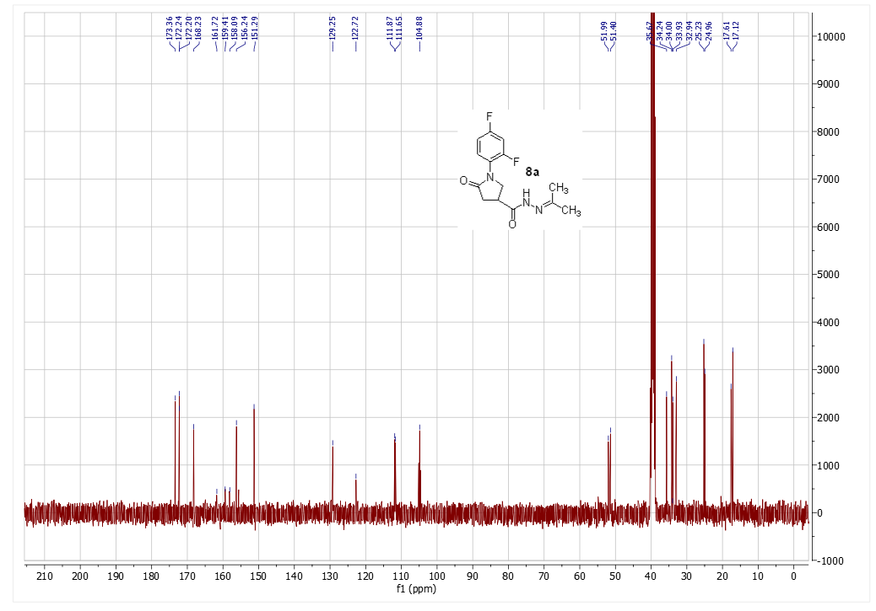
Figure S20. ¹³C NMR spectrum of compound 8a

N'-(butan-2-ylidene)-1-(2,4-difluorophenyl)-5-oxopyrrolidine-3-carbohydrazide (8b)
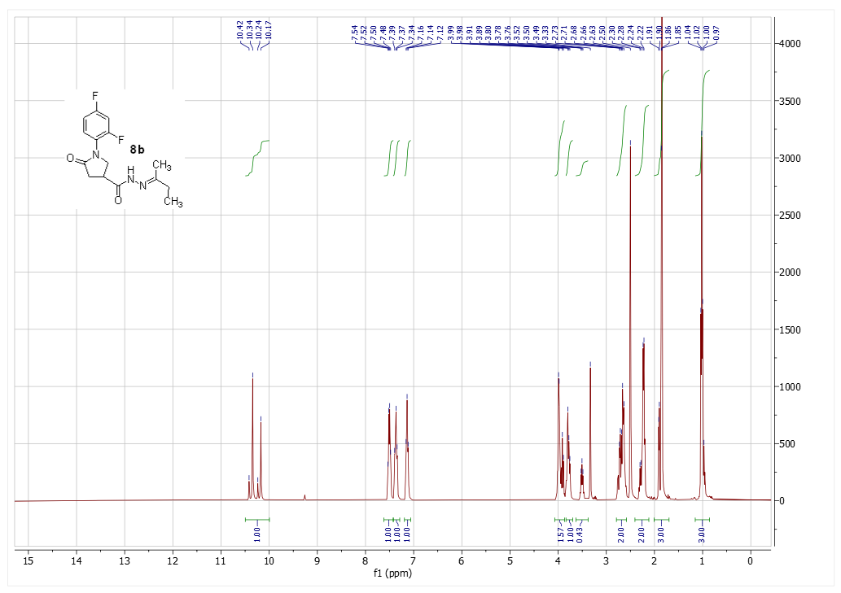
Figure S21. ¹H NMR spectrum of compound 8b
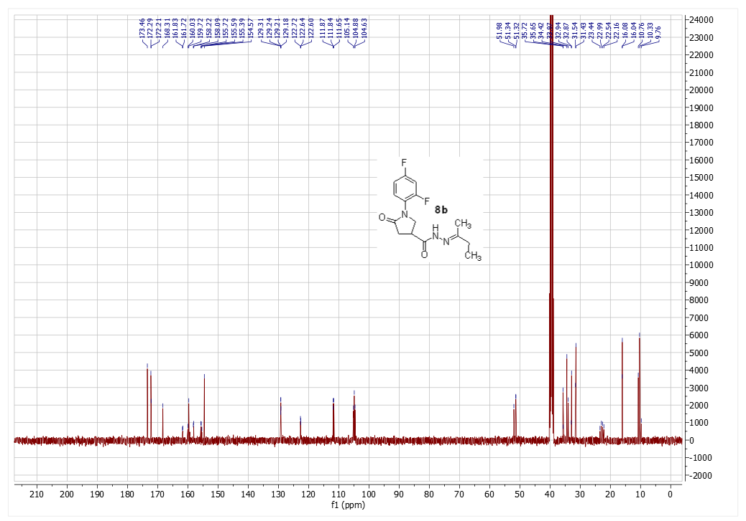
Figure S22. ¹³C NMR spectrum of compound 8b

N'-(1-(4-aminophenyl)ethylidene)-1-(2,4-difluorophenyl)-5-oxopyrrolidine-3-carbohydrazide (8c)
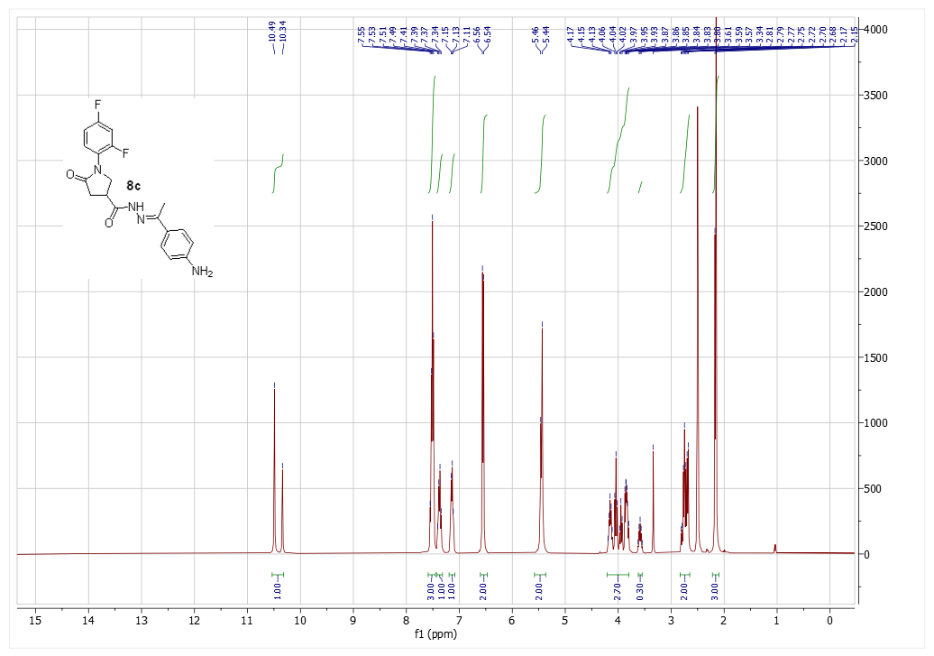
Figure S23. ¹H NMR spectrum of compound 8c
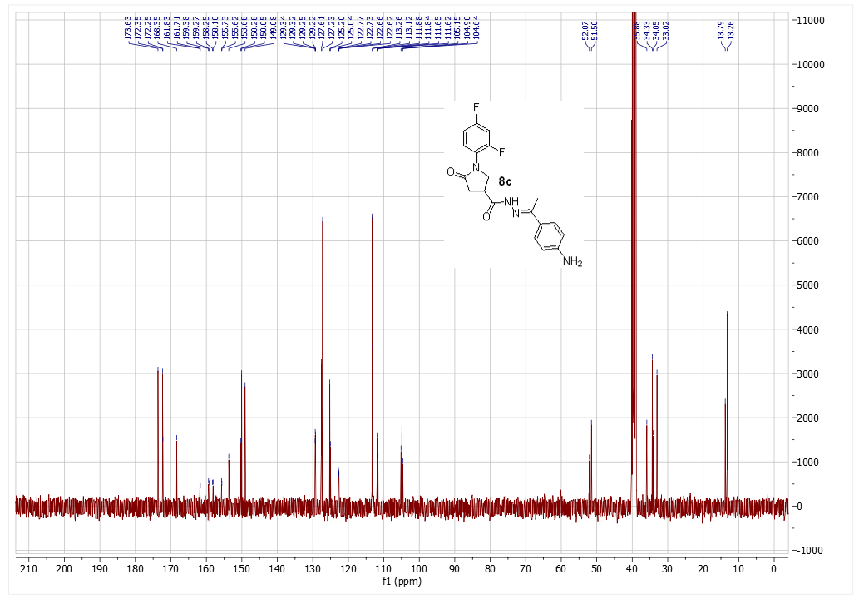
Figure S24. ¹³C NMR spectrum of compound 8c

N'-benzylidene-1-(2,4-difluorophenyl)-5-oxopyrrolidine-3-carbohydrazide (9a)
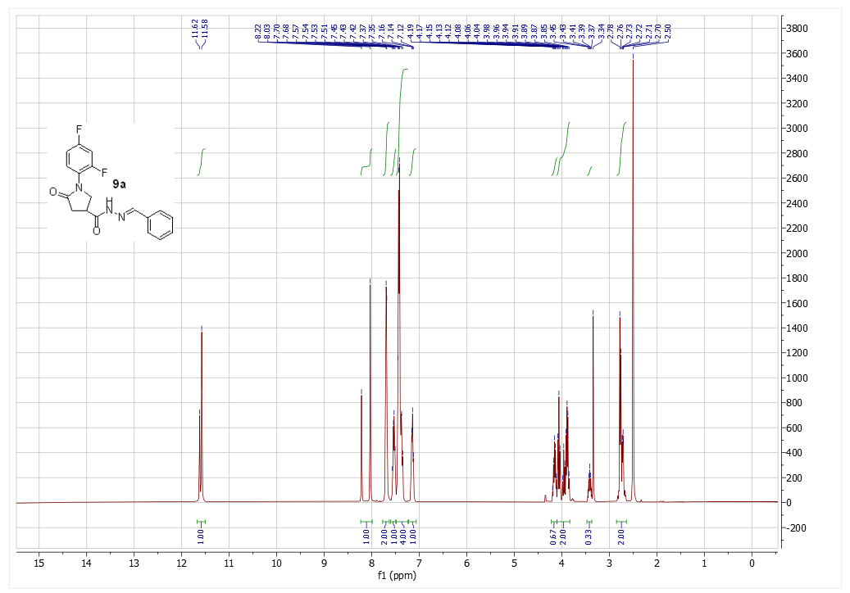
Figure S25. ¹H NMR spectrum of compound 9a
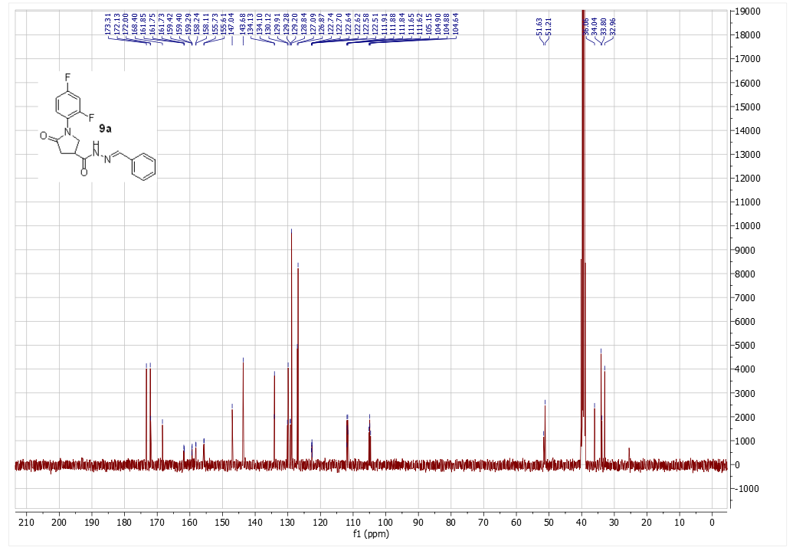
Figure S26. ¹³C NMR spectrum of compound 9a

1-(2,4-difluorophenyl)-N'-(4-fluorobenzylidene)-5-oxopyrrolidine-3-carbohydrazide (9b)
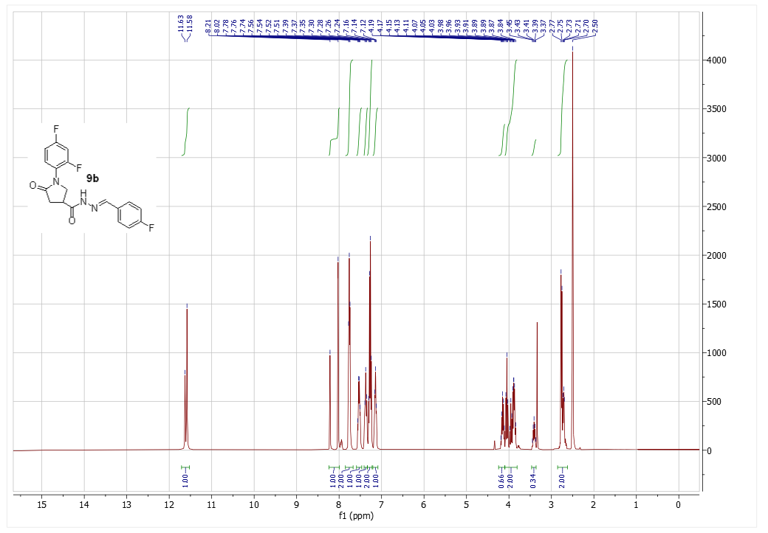
Figure S26. ¹H NMR spectrum of compound 9b
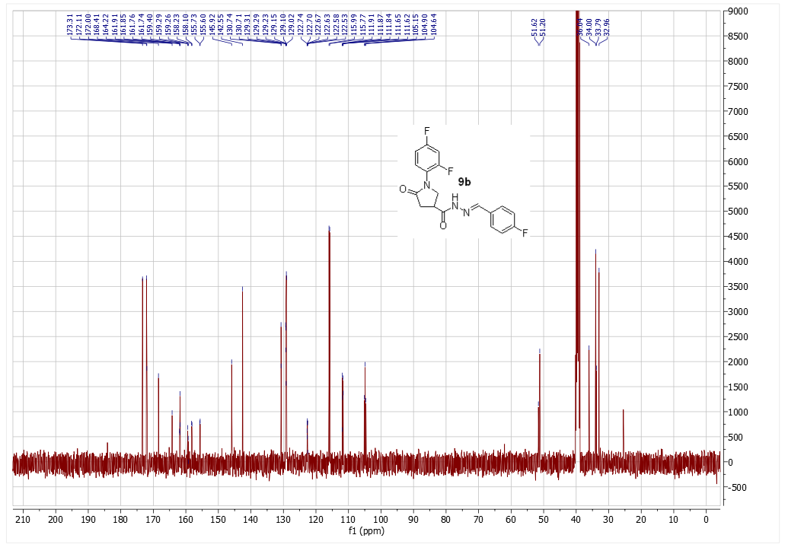
Figure S27. ¹³C NMR spectrum of compound 9b

N'-(4-chlorobenzylidene)-1-(2,4-difluorophenyl)-5-oxopyrrolidine-3-carbohydrazide (9c)
Figure S28. ¹H NMR spectrum of compound 9c
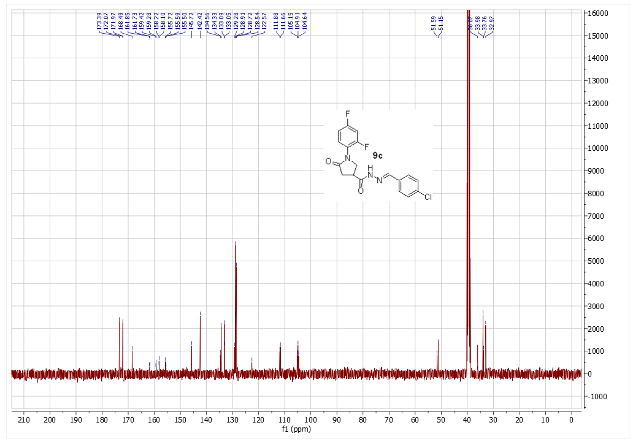
Figure S29. ¹³C NMR spectrum of compound 9c

N'-(2,4-difluorobenzylidene)-1-(2,4-difluorophenyl)-5-oxopyrrolidine-3-carbohydrazide (9d)
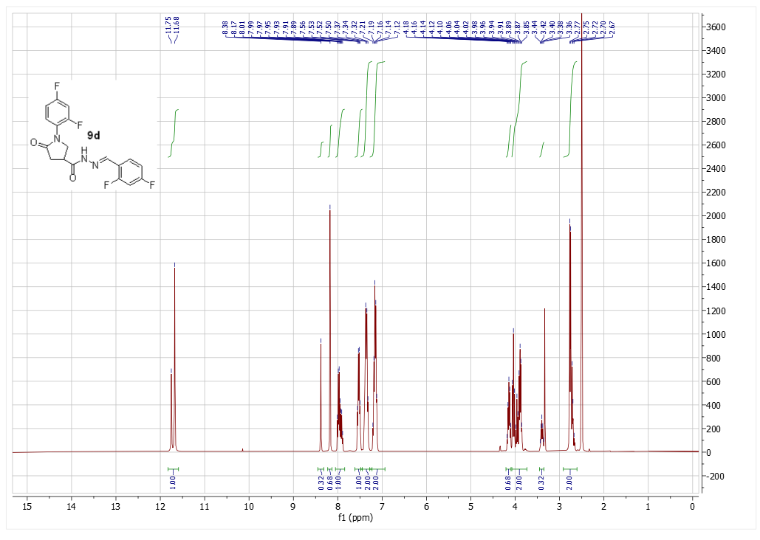
Figure S30. ¹H NMR spectrum of compound 9d
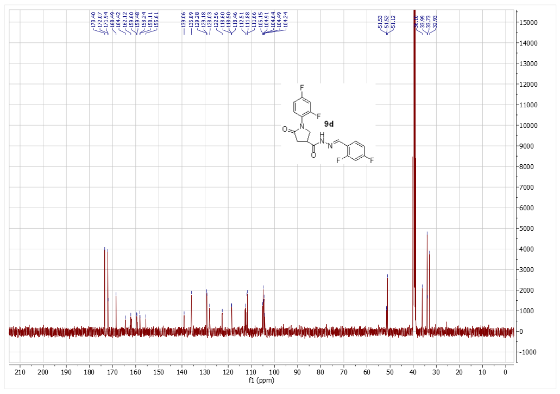
Figure S31. ¹³C NMR spectrum of compound 9d

N'-(4-bromobenzylidene)-1-(2,4-difluorophenyl)-5-oxopyrrolidine-3-carbohydrazide (18)
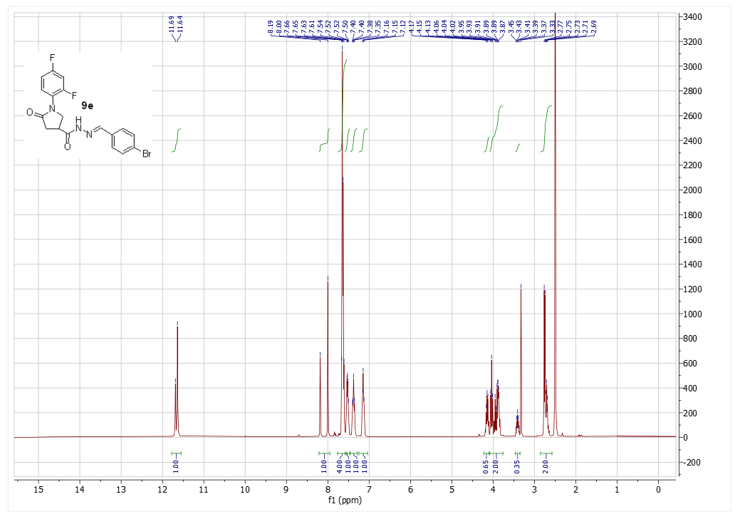
Figure S32. ¹H NMR spectrum of compound 9e
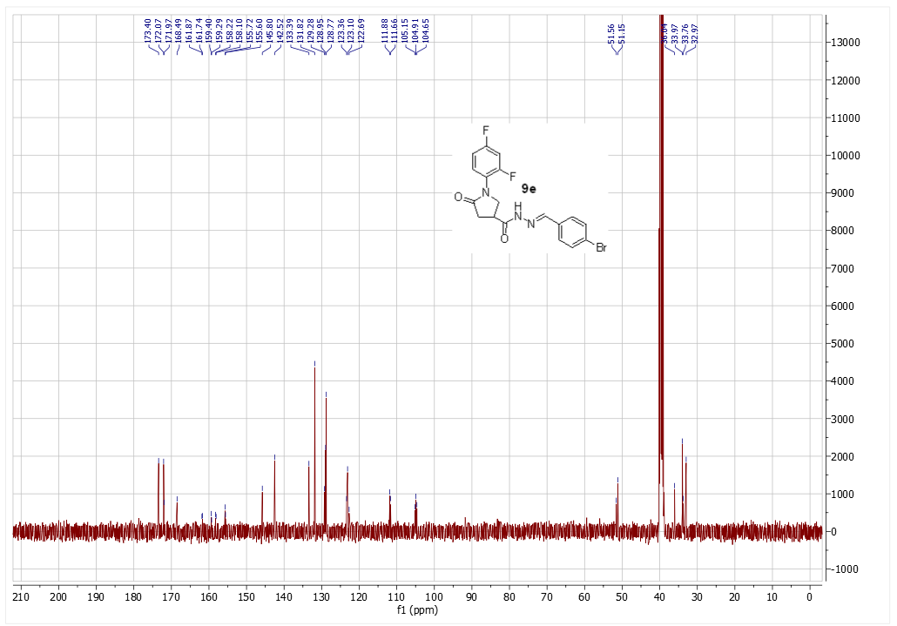
Figure S33. ¹³C NMR spectrum of compound 9e

1-(2,4-difluorophenyl)-N'-(4-methylbenzylidene)-5-oxopyrrolidine-3-carbohydrazide (9f)
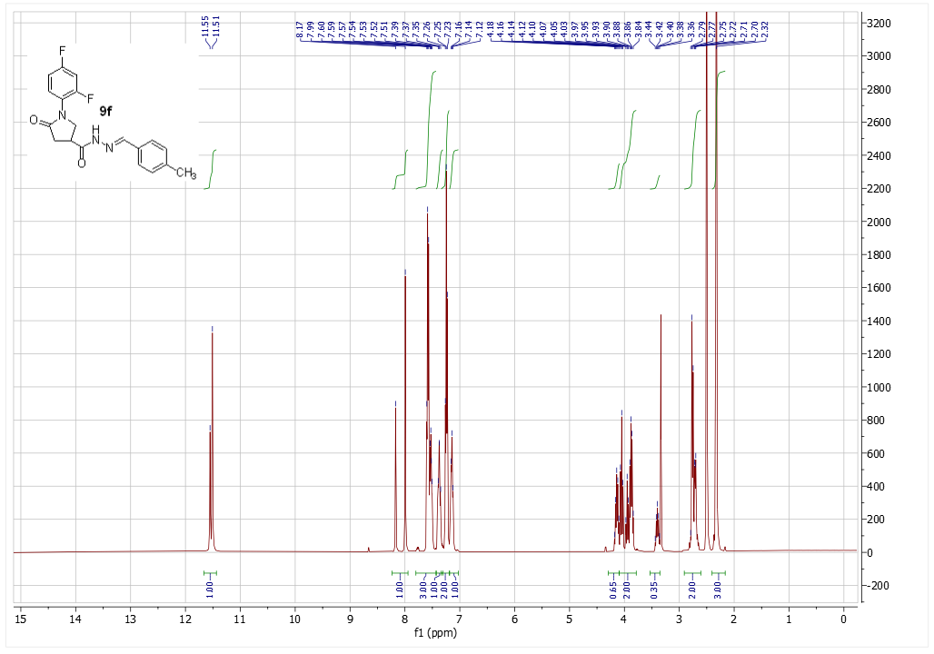
Figure S34. ¹H NMR spectrum of compound 9f
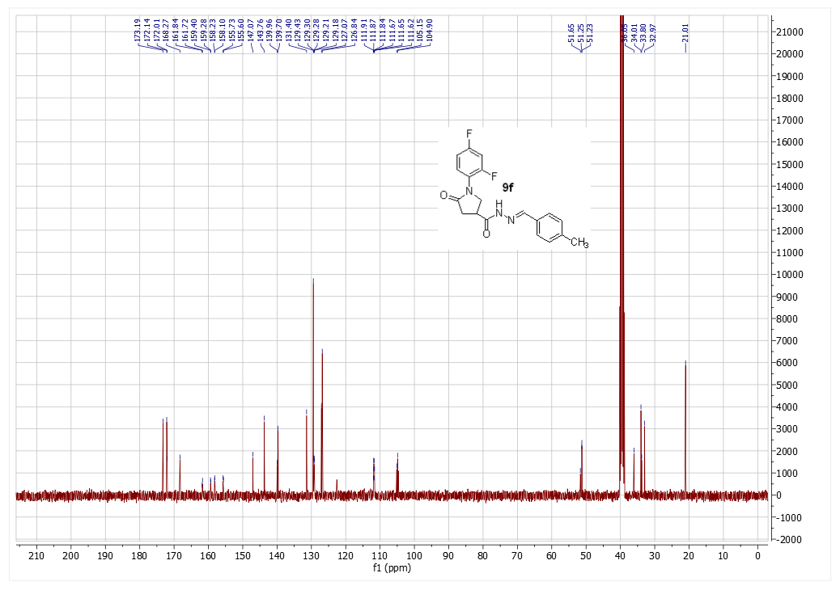
Figure S35. ¹³C NMR spectrum of compound 9f

1-(2,4-difluorophenyl)-N'-(4-(dimethylamino)benzylidene)-5-oxopyrrolidine-3-carbohydrazide (9g)
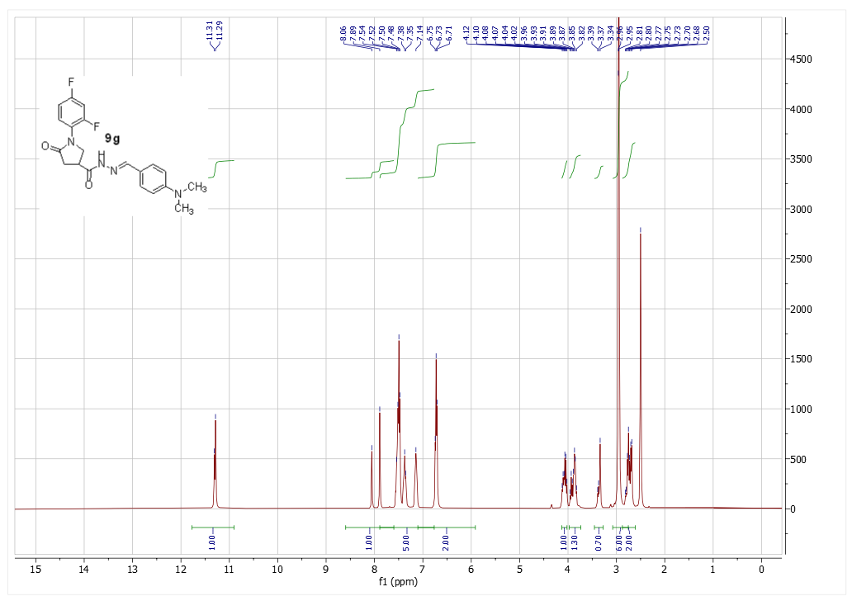
Figure S36. ¹H NMR spectrum of compound 9g
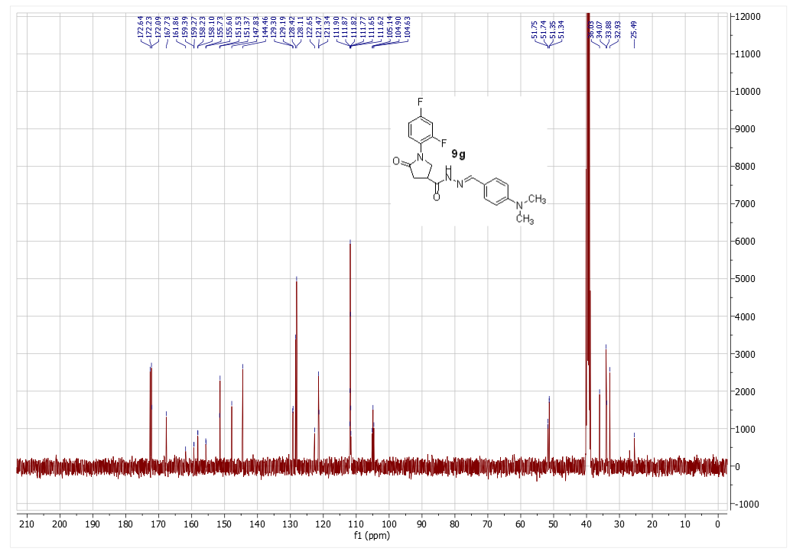
Figure S37. ¹³C NMR spectrum of compound 9g

1-(2,4-difluorophenyl)-N'-(4-nitrobenzylidene)-5-oxopyrrolidine-3-carbohydrazide (9h)
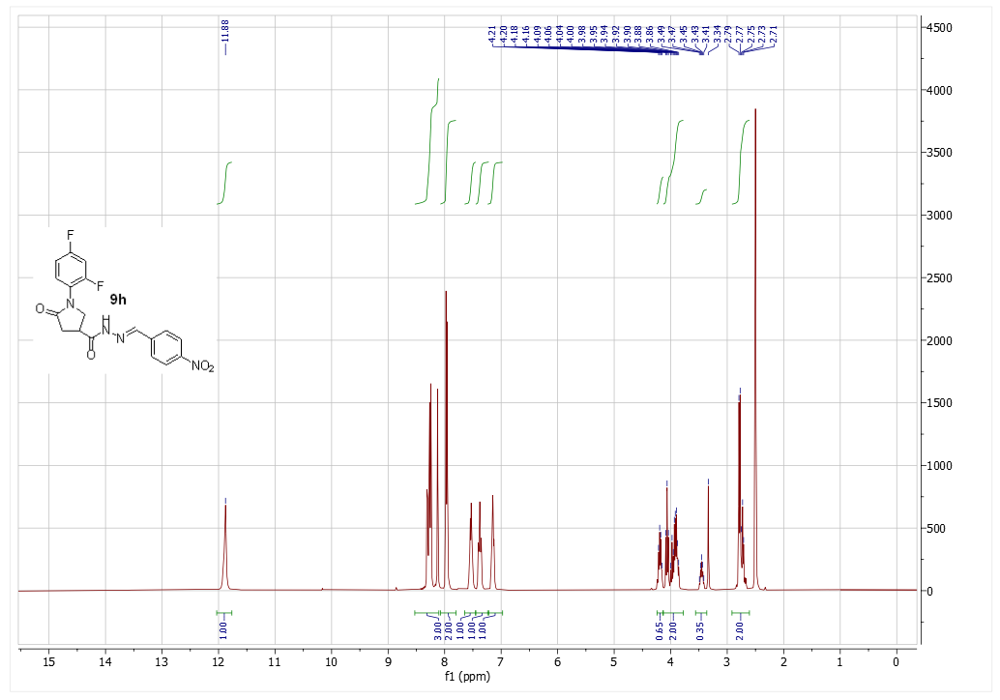
Figure S38. ¹H NMR spectrum of compound 9h
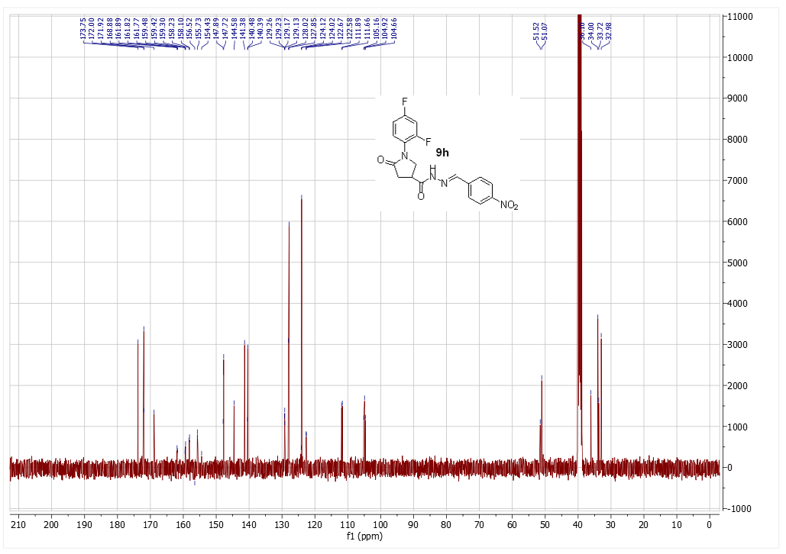
Figure S39. ¹³C NMR spectrum of compound 9h
N'-(4-bromobenzylidene)-1-(2,4-difluorophenyl)-N-ethyl-5-oxopyrrolidine-3-carbohydrazide (10)
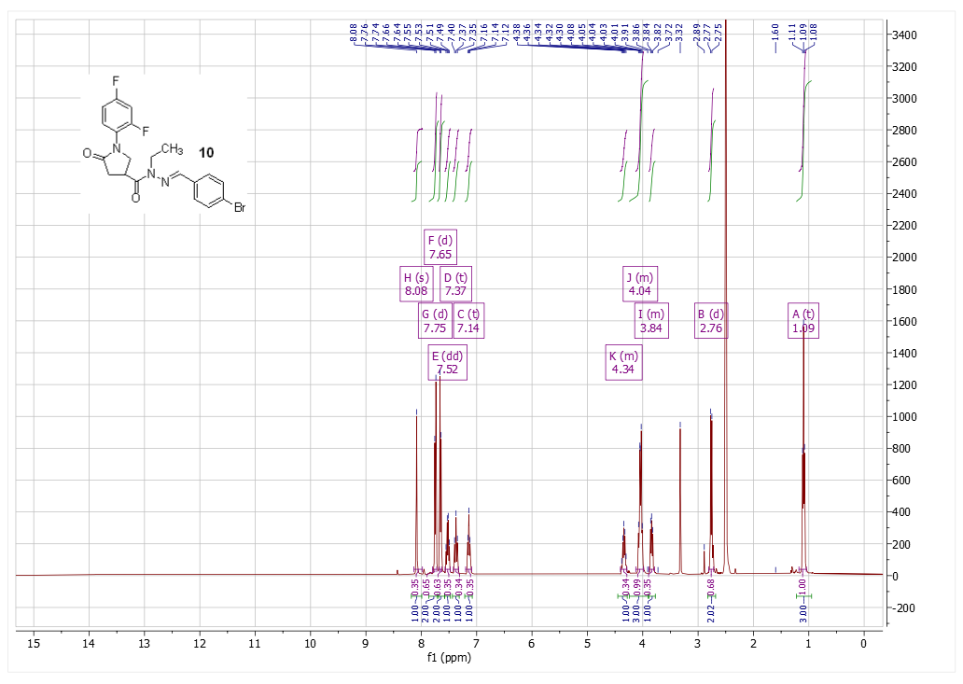
Figure S40. ¹H NMR spectrum of compound 10
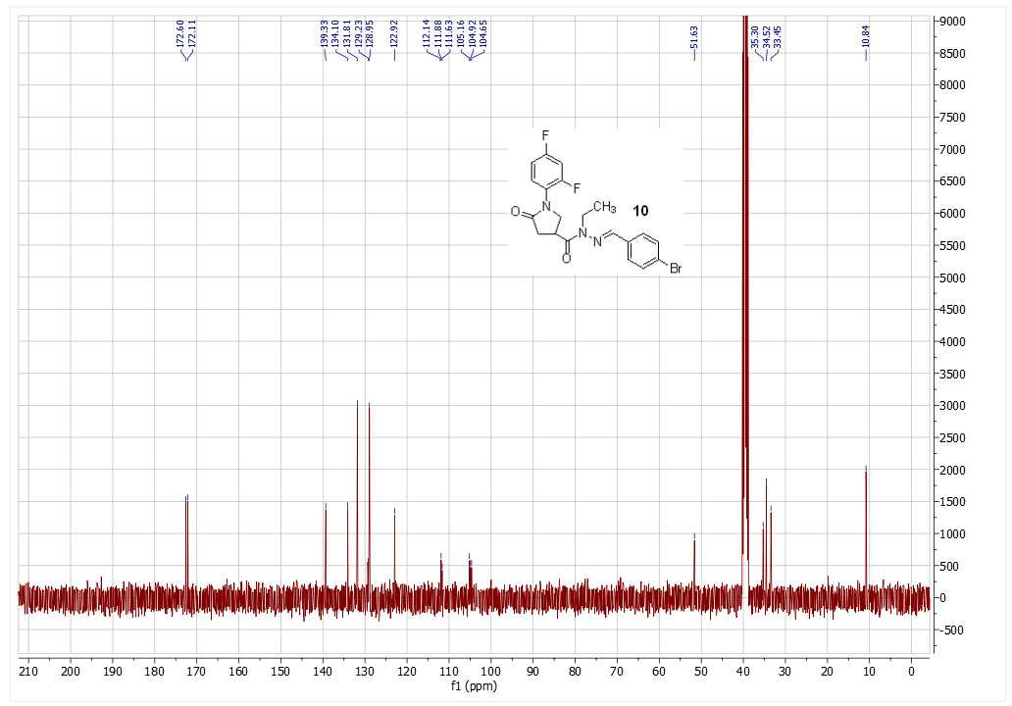
Figure S41. ¹³C NMR spectrum of compound 10

1-(2,4-difluorophenyl)-N-(2,5-dimethyl-1H-pyrrol-1-yl)-5-oxopyrrolidine-3-carboxamide (11)
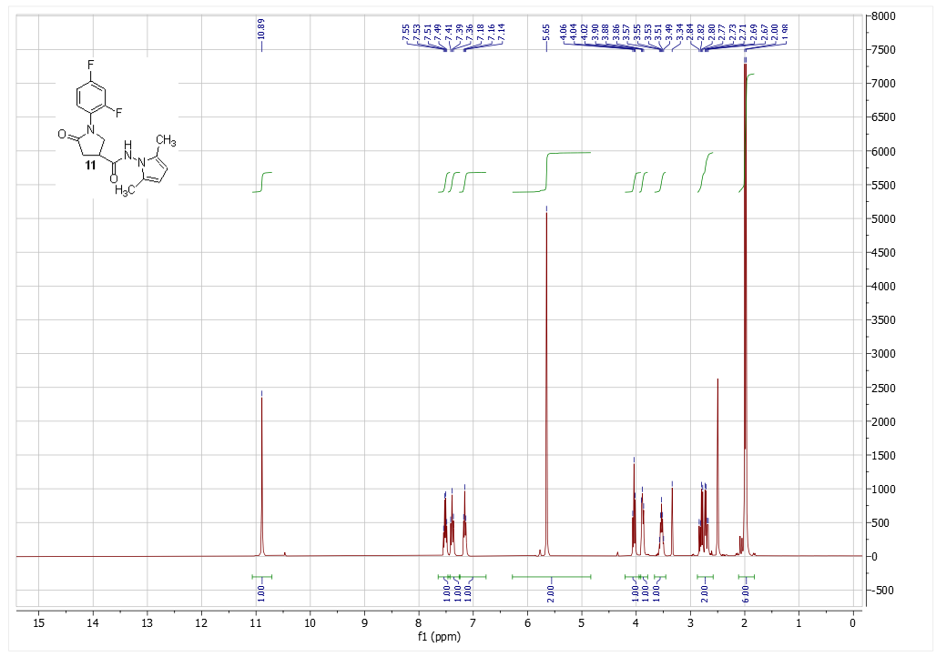
Figure S42. ¹H NMR spectrum of compound 11
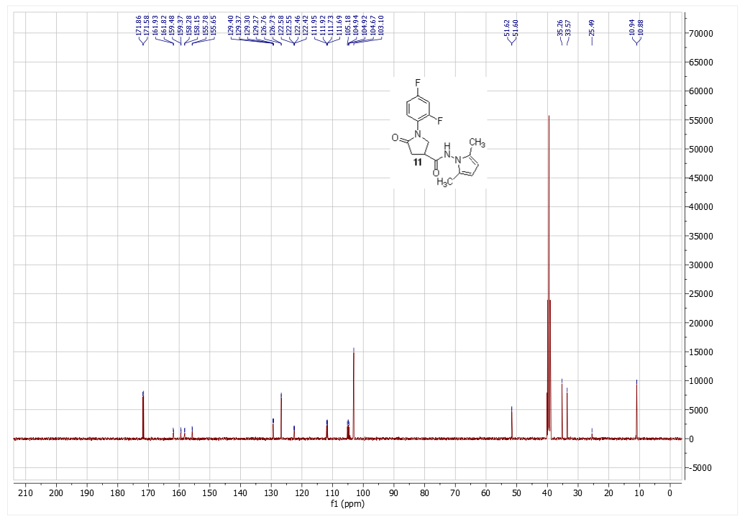
Figure S43. ¹³C NMR spectrum of compound 11

1-(2,4-difluorophenyl)-4-(3,5-dimethyl-1H-pyrazole-1-carbonyl)pyrrolidin-2-one (12)
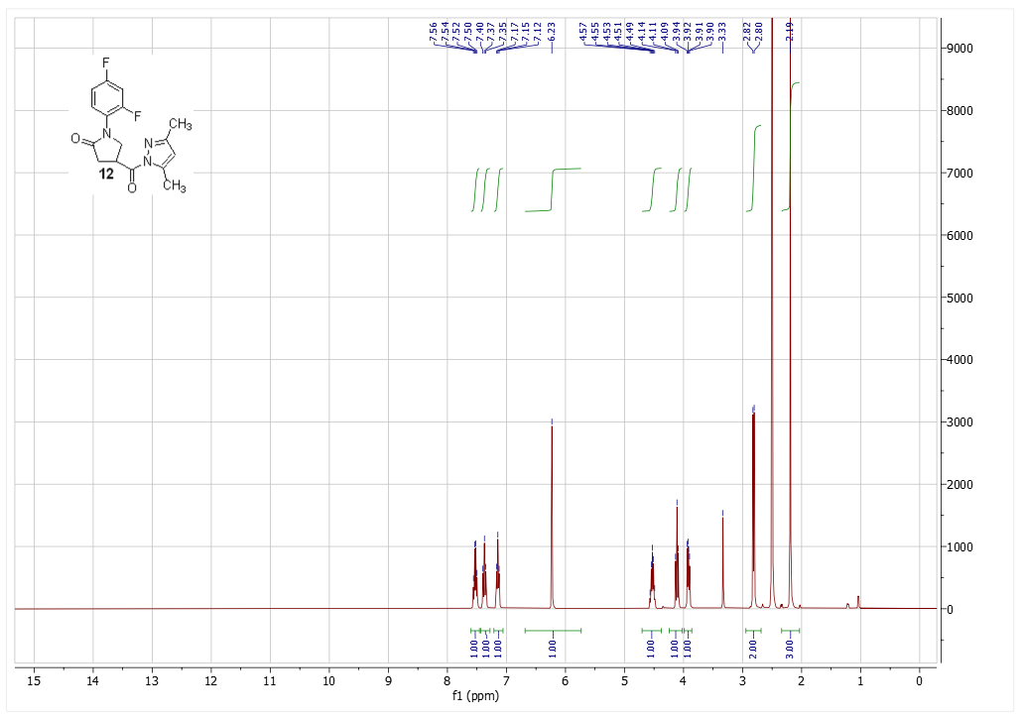
Figure S44. ¹H NMR spectrum of compound 12
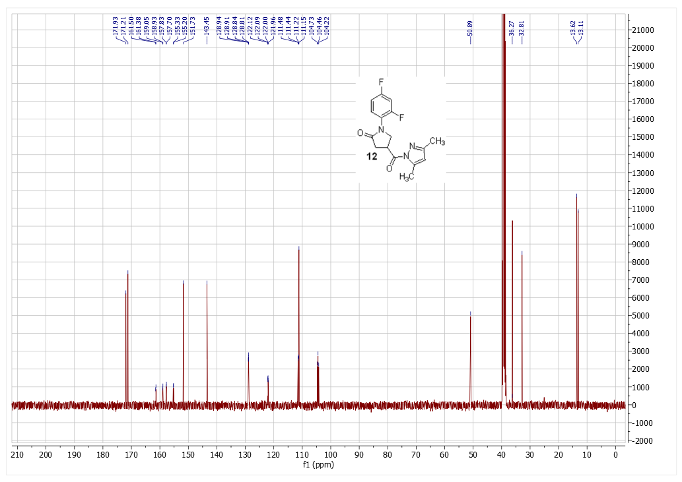
Figure S45. ¹³C NMR spectrum of compound 12

2-(1-(2,4-difluorophenyl)-5-oxopyrrolidine-3-carbonyl)-N-phenylhydrazine-1-carboxamide (13)
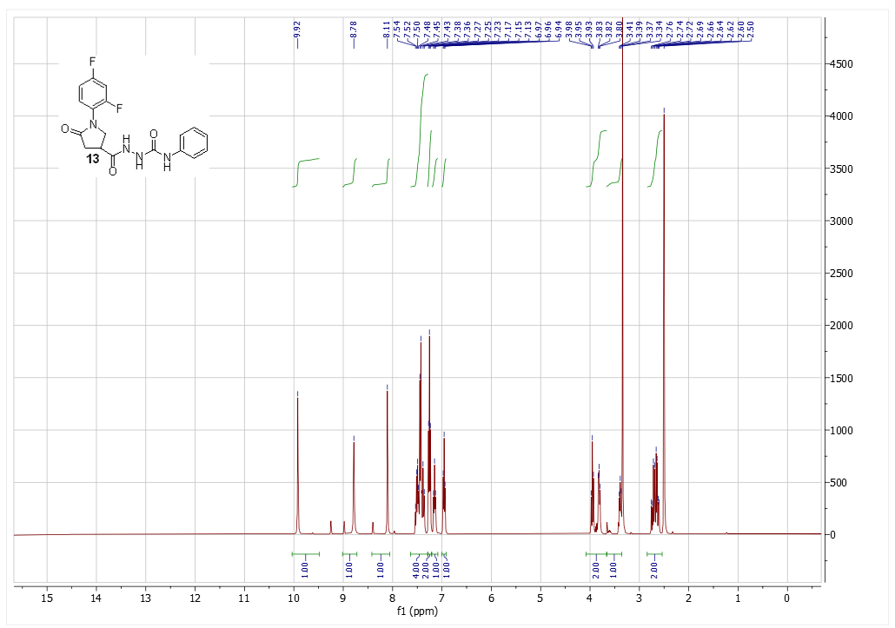
Figure S46. ¹H NMR spectrum of compound 13
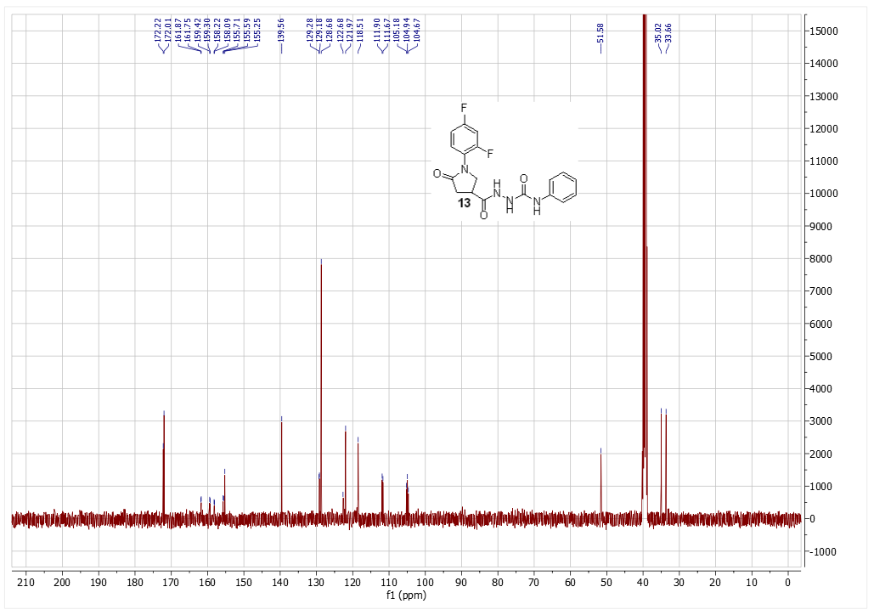
Figure S47. ¹³C NMR spectrum of compound 13

4-((2,4-difluorophenyl)amino)-3-(5-oxo-4-phenyl-4,5-dihydro-1H-1,2,4-triazol-3-yl)butanoic acid (14)
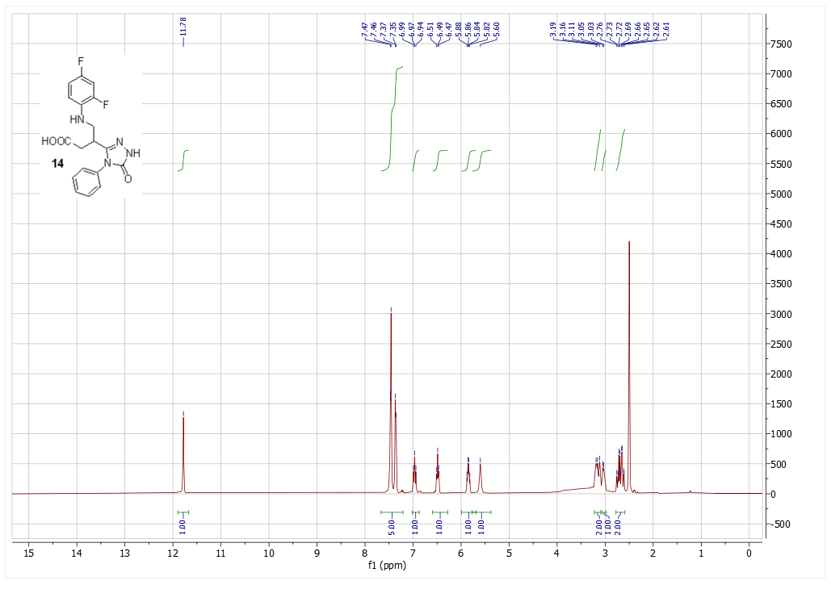
Figure S48. ¹H NMR spectrum of compound 14
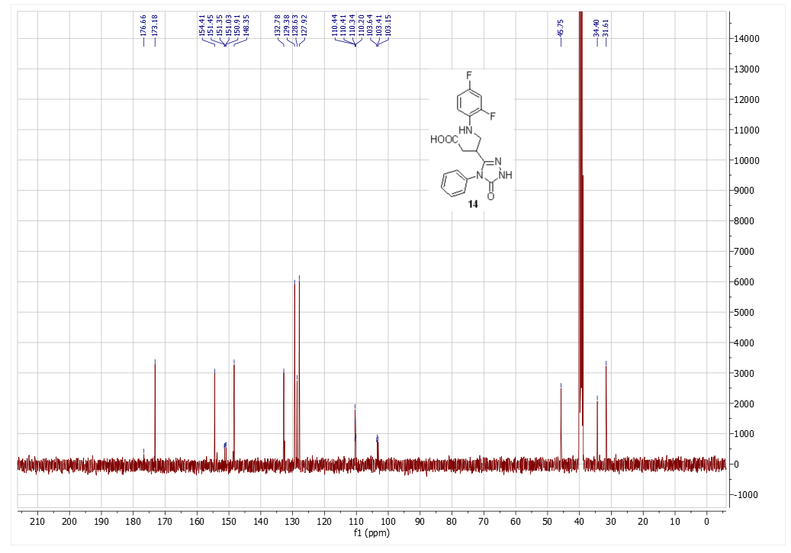
Figure S49. ¹³C NMR spectrum of compound 14
2-(1-(2,4-difluorophenyl)-5-oxopyrrolidine-3-carbonyl)-N-phenylhydrazine-1-carbothioamide (15)
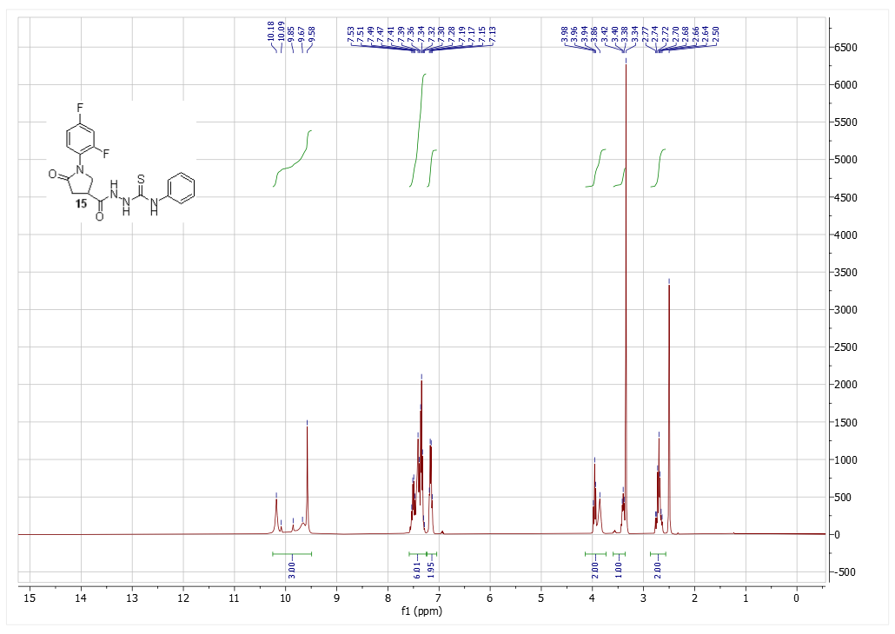
Figure S50. ¹H NMR spectrum of compound 15
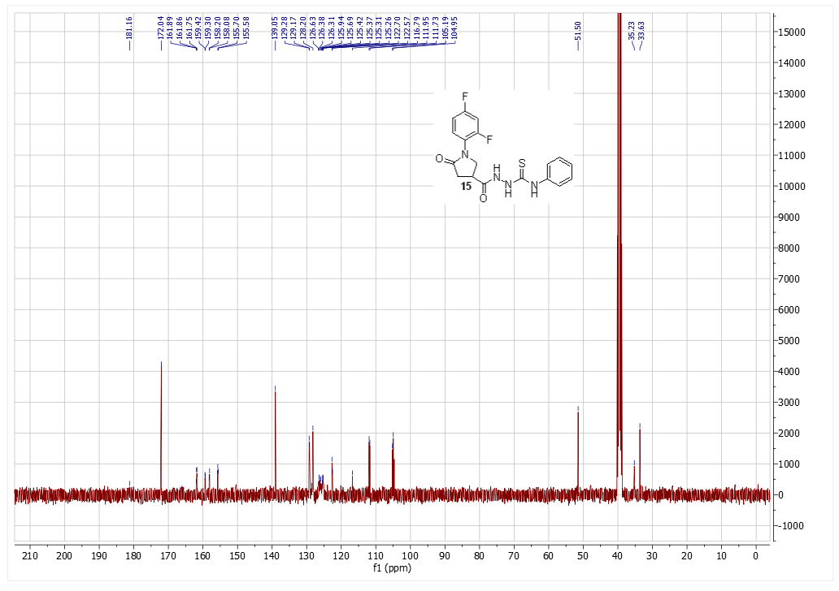
Figure S51. ¹³C NMR spectrum of compound 15
4-((2,4-difluorophenyl)amino)-3-(4-phenyl-5-thioxo-4,5-dihydro-1H-1,2,4-triazol-3-yl)butanoic acid (16)
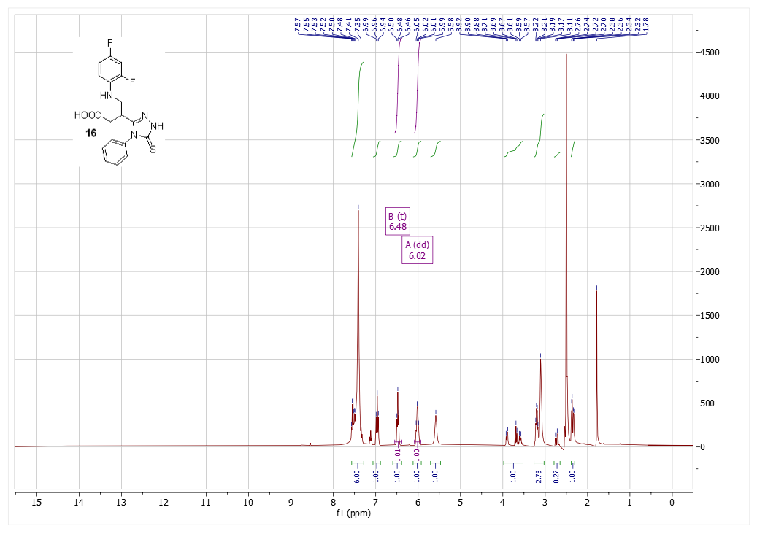
Figure S52. ¹H NMR spectrum of compound 16
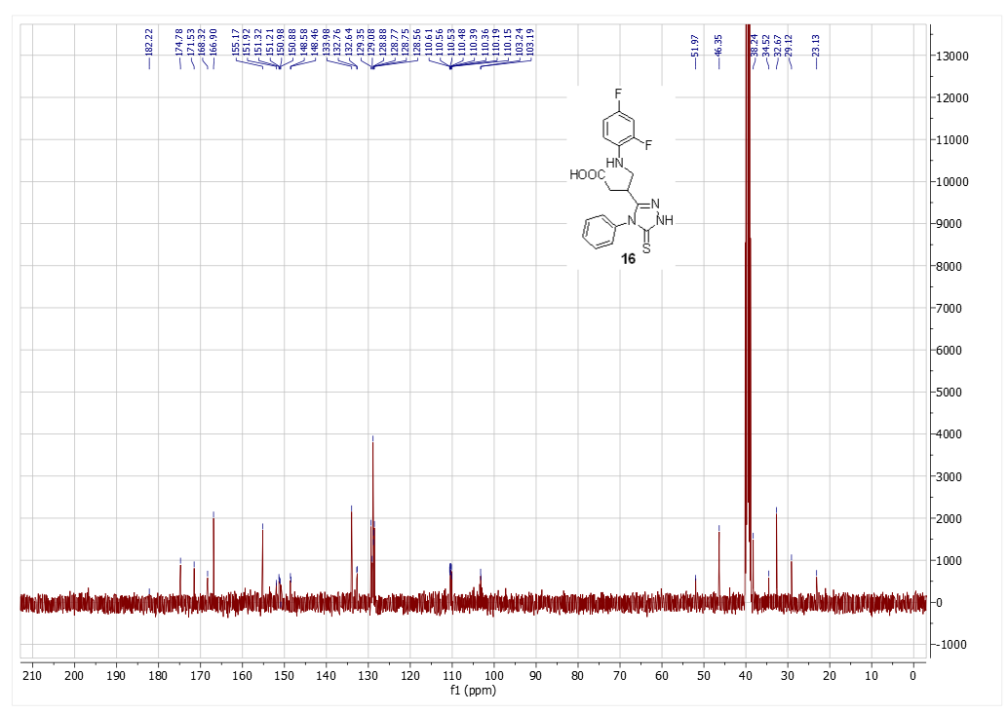
Figure S53. ¹³C NMR spectrum of compound 16

