SUPPLEMENTARY INFORMATION

Boene et al. Antimalarial drug resistance and population structure of Plasmodium falciparum in Mozambique using genomic surveillance at health facilities (2021-2022)

Supplementary Figures
Supplementary Figure 1. Read depth for 24 amplicons covering drug resistance markers of interest
Supplementary Figure 2. Allele accumulation curves for 2021 and 2022 rainy seasons, by region.
Supplementary Figure 3. Genetic diversity of P. falciparum in samples from 2022 rainy season, by province.
Supplementary Figure 4. Genetic diversity in 2021 as compared to 2022 rainy season, by region.
Supplementary Figure 5. Relative frequency of pfdhps-436-437-540 haplotypes, by province.
Supplementary Figure 6. Malaria positivity rates for children under 5 year in Maputo and Manica provinces, by transmission season in 2022.
Supplementary Tables
Supplementary Table 1. Prevalence of antimalarial drug-resistance markers in 2021 rainy season, by province.
Supplementary Table 2. Prevalence of antimalarial drug-resistance markers in 2022, by province.
Supplementary Table 3. Multivariable logistic regression model for drug-resistance markers in 2021.
Supplementary Table 4. Multivariable logistic regression model for drug-reisstance markers in 2022.
Supplementary Table 5. Multivariable logistic regression model for factors associated with genetic diversity metrics in 2022.
Supplementary Table 6. Multivariable logistic regression model for factors associated with drug-resistance markers in the provinces of Maputo and Manica in 2022, including seasonality.

Supplementary Figure 1. Read depth for 24 amplicons covering drug resistance markers of interest. Reads per amplicon and sample are stratified by experiment runs conducted in 2021 (A, MiSeq system, Illumina; CISM) or 2022 samples (B, NextSeq system, Illumina; ISGlobal). Amplicon are labelled based on gene targeted with main codon of interest in brackets. White lines indicate median and interquartile range.

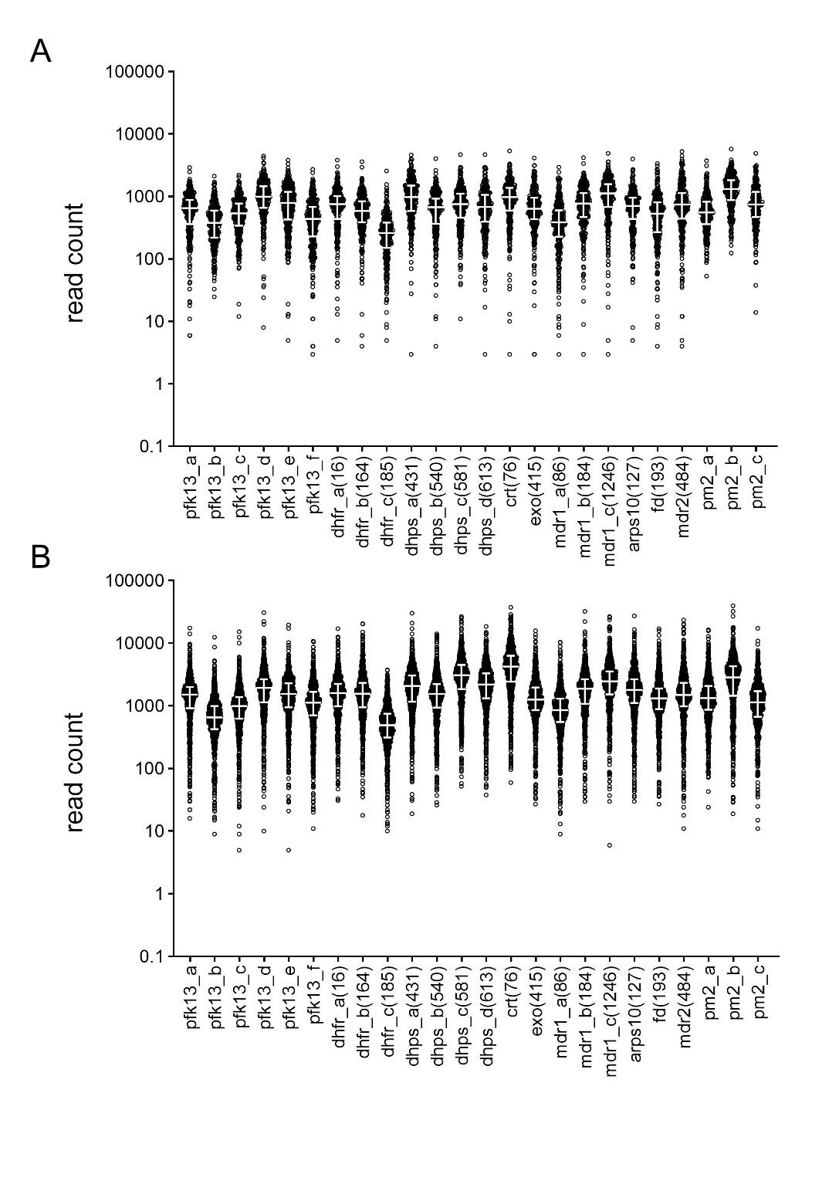

Supplementary Figure 2. Allele accumulation curves for 2021 and 2022 rainy seasons, by region. Number of new alleles accumulated at the 165 diversity amplicons with increasing sample size (x axis), using regional stratification in 2021 (A) and 2022 (B)
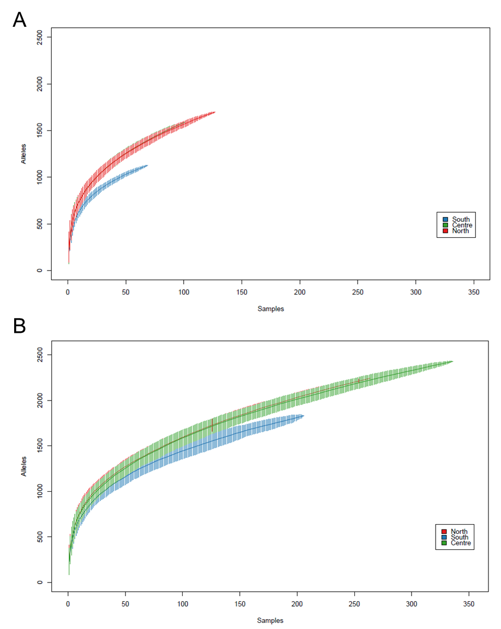

Supplementary Figure 3. Genetic diversity of P. falciparum in samples from 2022 rainy season, by province. A) Effective COI; B) % of polyclonal infections; C) 1-Fws; D) heterozygosity estimate and 95% confidence intervals. P-values: ***< 0.001, **< 0.01, *< 0.05. Colors indicate administrative regions (red tones, North; green tones, Centre; blue tones, South)

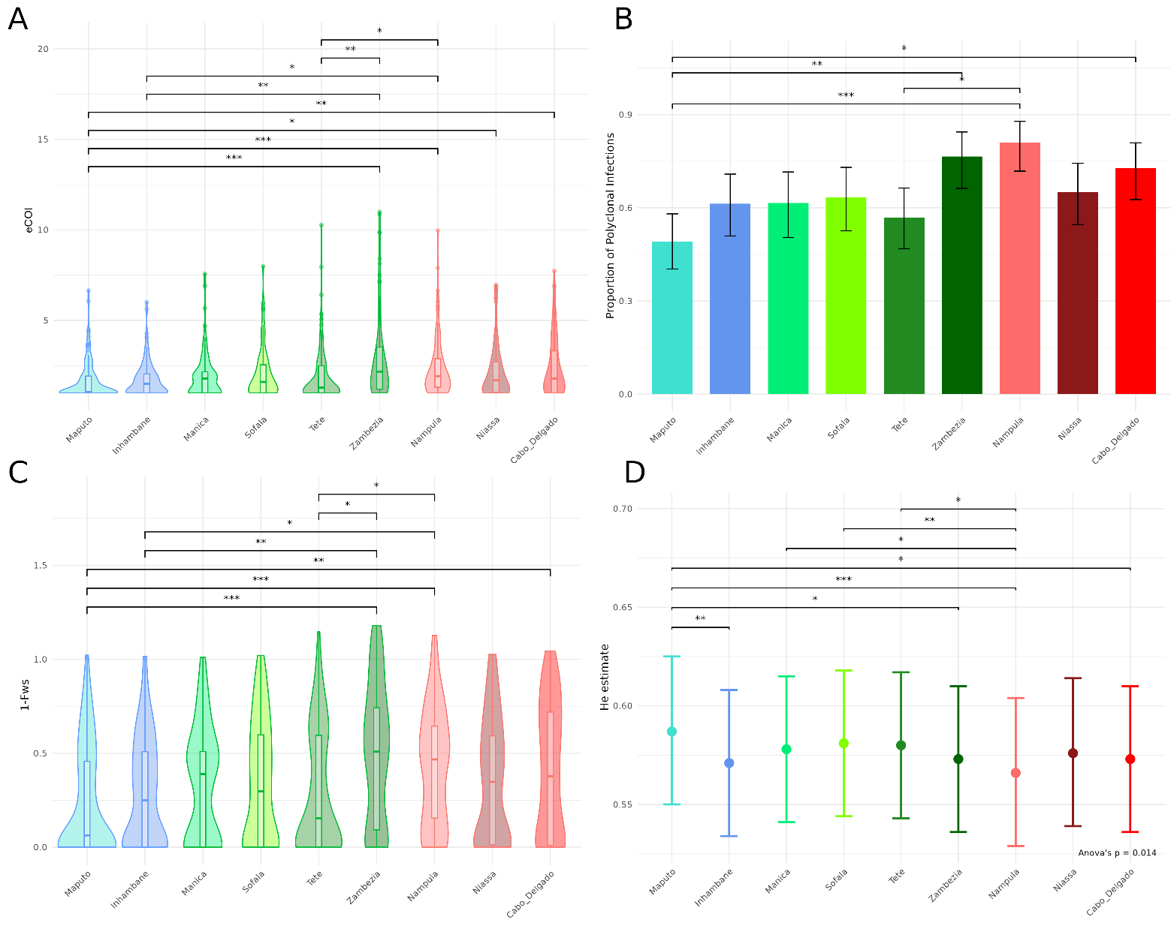
Supplementary Figure 4. Genetic diversity in 2021 as compared to 2022 rainy season, by region. A) effective COI; B) % of polyclonal infections; C) 1-Fws; D) heterozygosity and 95% confidence intervals

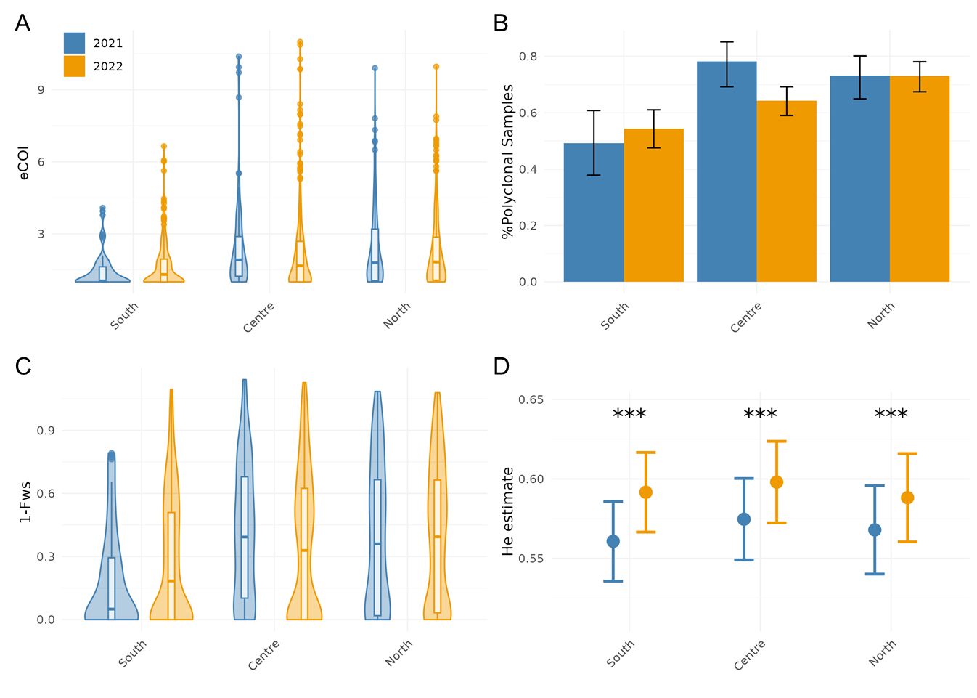

Supplementary Figure 5. Relative frequency of pfdhps 436-437-540 haplotypes, by province. Colors indicate administrative regions (red tones, North; green tones, Centre; blue tones, South)
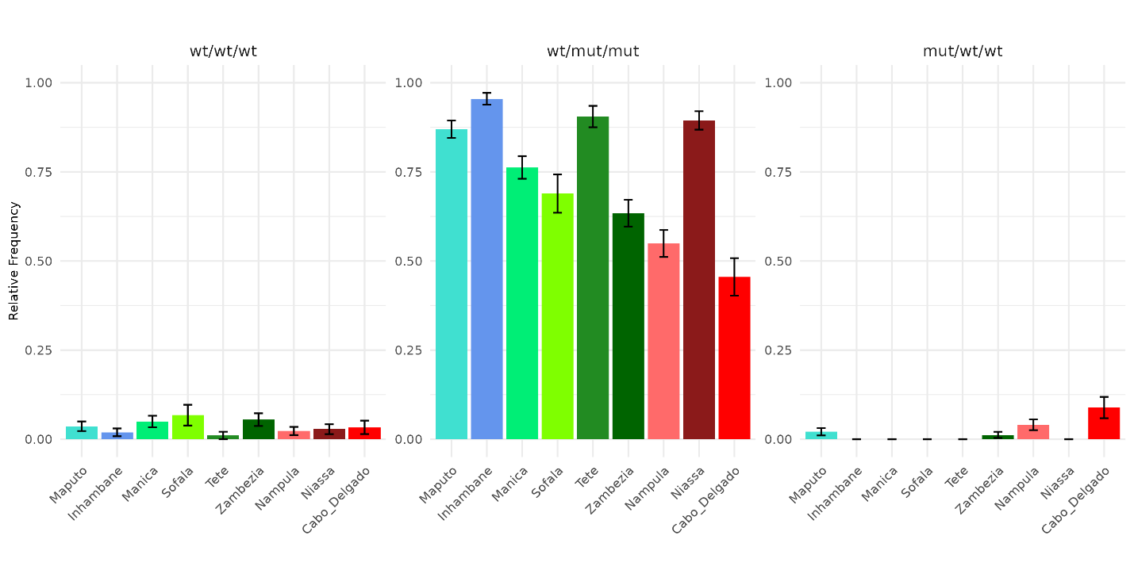

Supplementary Figure 6. Malaria positivity rates for children under 5 year in Maputo and Manica provinces, by transmission season in 2022. Figure shows the number of children with positive malaria rapid diagnostic tests (RDT) out of the total number of cases tested at health facilities (HF) reporting at least 96 tests done (Maputo: 21058 tests in 9 HF; Manica: 394861 tests in 75 HF). Data was obtained from the Health Information System for Monitoring and Evaluation (SIS-MA, Ministry of Health, Mozambique). Transmission season was defined as rainy (January to May) or dry (June to September).

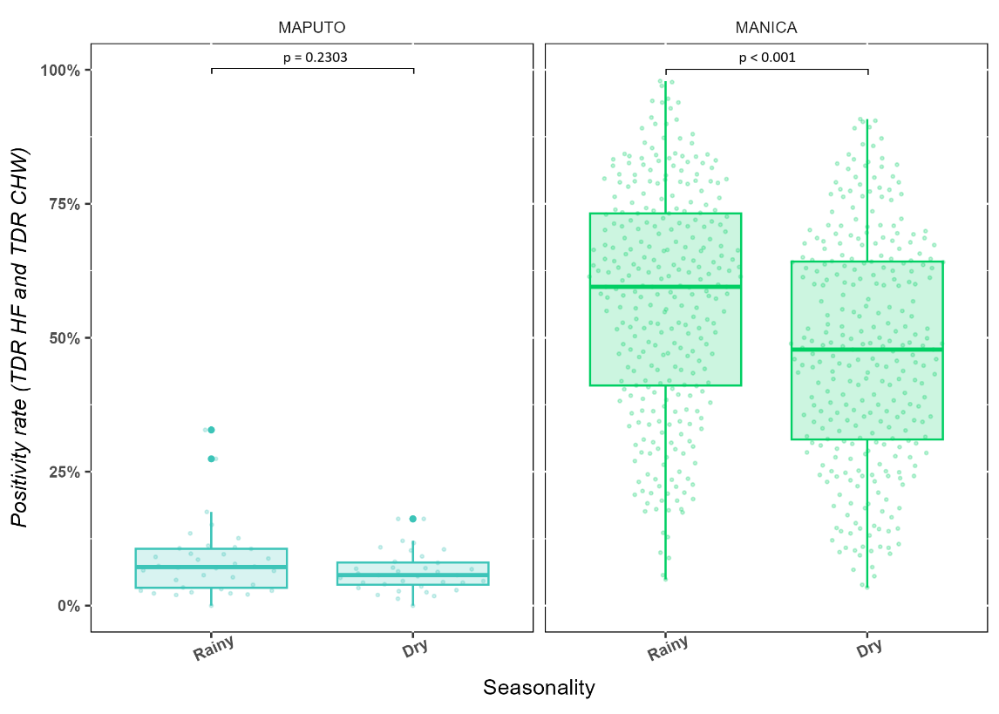

Supplementary Table 1. Prevalence of antimalarial drug-resistance markers in 2021 rainy season, by province.

 | Maputo |  | Inhambane |  | Manica |  | Zambézia |  | Niassa |  | Nampula
pfk13
Validated mutants | 0/4 | 0% | 0/68 | 0% | 0/26 | 0% | 0/82 | 0% | 0/51 | 0% | 0/80 | 0%
Any nsyn mutants | 0/4 | 0% | 0/64 | 0% | 0/26 | 0% | 2/78 | 2.6% | 1/49 | 2.0% | 3/76 | 4%
pfpm2 multicopy | 0/3 | 0% | 0/55 | 0% | 0/13 | 0% | 0/56 | 0% | 0/34 | 0% | 0/57 | 0%
pfdhfr
N51I | 4/4 | 100% | 68/68 | 100% | 26/26 | 100% | 81/81 | 100% | 53/53 | 100% | 80/80 | 100%
C59R | 4/4 | 100% | 68/68 | 100% | 26/26 | 100% | 80/81 | 99% | 53/53 | 100% | 80/80 | 100%
S108N | 5/5 | 100% | 67/67 | 100% | 26/26 | 100% | 81/81 | 100% | 54/54 | 100% | 80/80 | 100%
I164L | 0/5 | 0% | 0/67 | 0% | 0/26 | 0% | 0/81 | 0% | 1/54 | 2% | 0/80 | 0%
triple 51-59-108 | 4/4 | 100% | 66/66 | 100% | 20/20 | 100% | 55/56 | 98% | 48/48 | 100% | 45/45 | 100%
pfdhps
I431V | 0/4 | 0% | 0/67 | 0% | 0/26 | 0% | 0/80 | 0% | 0/54 | 0% | 0/81 | 0%
S436A/C/F/H | 0/4 | 0% | 1/67 | 1% | 0/26 | 0% | 8/80 | 10% | 2/54 | 4% | 30/81 | 37%
A437G | 4/4 | 100% | 65/67 | 97% | 26/26 | 100% | 75/80 | 94% | 53/54 | 98% | 75/81 | 93%
K540E | 5/5 | 100% | 65/67 | 97% | 26/26 | 100% | 75/81 | 93% | 52/53 | 98% | 73/81 | 90%
A581G | 0/5 | 0% | 0/67 | 0% | 0/26 | 0% | 3/84 | 4% | 2/53 | 4% | 0/82 | 0%
A613S/T | 0/5 | 0% | 0/63 | 0% | 0/26 | 0% | 2/79 | 3% | 1/49 | 2% | 1/76 | 1%
double 437-540 | 4/4 | 100% | 64/66 | 97% | 20/20 | 100% | 51/56 | 91% | 47/48 | 98% | 39/45 | 87%
pfdhfr/pfdhps quintuple | 4/4 | 100% | 64/66 | 97% | 20/20 | 100% | 51/56 | 91% | 47/48 | 98% | 39/45 | 87%
pfcrt 72-76 CVIET | 0/4 | 0% | 0/68 | 0% | 0/26 | 0% | 0/83 | 0% | 0/54 | 0% | 0/82 | 0%
pfmdr1
N86Y | 0/4 | 0% | 0/67 | 0% | 0/26 | 0% | 0/82 | 0% | 0/53 | 0% | 0/80 | 0%
Y184F | 3/4 | 75% | 34/67 | 51% | 16/26 | 62% | 60/81 | 74% | 35/54 | 65% | 68/81 | 84%
D1246Y | 0/5 | 0% | 1/67 | 1% | 0/26 | 0% | 0/82 | 0% | 0/54 | 0% | 1/81 | 1%

 | Maputo |  | Inhambane |  | Manica |  | Sofala |  | Tete |  | Zambézia |  | Niassa |  | Nampula |  | Cabo Delgado |  |  |  | Maputo (dry) |  | p* | Manica (dry) |  | p*
pfk13
Validated mutants | 0/99 | 0% | 0/89 | 0% | 0/78 | 0% | 0/82 | 0% | 0/95 | 0% | 0/84 | 0% | 0/89 | 0% | 0/88 | 0% | 0/90 | 0% |  | 1/68 |  | 2% | 0.226 | 0/76 | 0% | -
Any nsyn mutants | 2/95 | 2% | 0/89 | 0% | 1/76 | 1% | 0/81 | 0% | 1/90 | 1% | 1/81 | 1% | 3/84 | 4% | 6/87 | 7% | 0/89 | 0% |  | 4/66 |  | 6% | 0.193 | 0/72 | 0% | 0.329
pfpm2 multicopy | 0/80 | 0% | 0/81 | 0% | 0/59 | 0% | 0/69 | 0% | 0/88 | 0% | 0/58 | 0% | 0/59 | 0% | 0/52 | 0% | 0/90 | 0% |  | 0/57 |  | 0% | - | 0/65 | 0% | -
pfdhfr
N51I | 100/100 | 100% | 89/90 | 99% | 77/78 | 99% | 81/83 | 98% | 94/95 | 99% | 84/85 | 99% | 90/90 | 100% | 91/91 | 100% | 89/90 | 99% |  | 69/69 |  | 100% | - | 76/78 | 97% | 0.560
C59R | 100/100 | 100% | 90/90 | 100% | 77/78 | 99% | 83/83 | 100% | 91/95 | 96% | 84/85 | 99% | 90/90 | 100% | 91/91 | 100% | 90/90 | 100% |  | 69/69 |  | 100% | - | 76/78 | 97% | 0.560
S108N | 100/100 | 100% | 90/90 | 100% | 79/79 | 100% | 84/84 | 100% | 96/96 | 100% | 83/84 | 99% | 90/90 | 100% | 92/92 | 100% | 90/90 | 100% |  | 70/70 |  | 100% | - | 78/78 | 100% | -
I164L | 0/100 | 0% | 0/90 | 0% | 0/79 | 0% | 0/84 | 0% | 0/96 | 0% | 0/84 | 0% | 0/90 | 0% | 0/92 | 0% | 0/90 | 0% |  | 0/70 |  | 0% | - | 0/78 | 0% | -
triple 51-59-108 | 94/94 | 100% | 87/88 | 99% | 56/59 | 95% | 66/67 | 99% | 85/90 | 94% | 52/54 | 96% | 83/83 | 100% | 67/67 | 100% | 55/56 | 98% |  | 62/62 |  | 100% | - | 60/64 | 94% | 0.780
pfdhps
I431V | 0/100 | 0% | 0/89 | 0% | 0/79 | 0% | 0/84 | 0% | 0/96 | 0% | 0/84 | 0% | 0/89 | 0% | 0/92 | 0% | 0/90 | 0% |  | 0/70 |  | 0% | - | 0/78 | 0% | -
S436A/C/F/H | 4/100 | 4% | 0/89 | 0% | 0/79 | 0% | 1/84 | 1% | 2/96 | 2% | 5/84 | 6% | 5/89 | 6% | 26/92 | 28% | 35/90 | 39% |  | 4/70 |  | 6% | 0.603 | 0/78 | 0% | -
A437G | 95/100 | 95% | 88/89 | 99% | 72/79 | 91% | 76/84 | 90% | 95/96 | 99% | 78/84 | 93% | 86/89 | 97% | 89/92 | 97% | 78/90 | 87% |  | 66/70 |  | 94% | 0.838 | 76/78 | 97% | 0.090
K540E | 93/100 | 93% | 88/89 | 99% | 72/79 | 91% | 76/83 | 92% | 93/95 | 98% | 78/84 | 93% | 85/89 | 96% | 88/92 | 96% | 78/90 | 87% |  | 65/69 |  | 94% | 0.755 | 74/78 | 95% | 0.360
A581G | 1/100 | 1% | 0/89 | 0% | 0/79 | 0% | 0/83 | 0% | 1/95 | 1% | 2/84 | 2% | 2/89 | 2% | 0/92 | 0% | 0/90 | 0% |  | 0/70 |  | 0% | 0.401 | 0/78 | 0% | -
A613S/T | 2/96 | 2% | 0/88 | 0% | 0/75 | 0% | 0/80 | 0% | 0/90 | 0% | 2/82 | 2% | 1/82 | 1% | 4/91 | 4% | 5/88 | 6% |  | 0/69 |  | 0% | 0.228 | 0/73 | 0% | -
double 437-540 | 88/94 | 94% | 87/88 | 99% | 52/59 | 88% | 58/67 | 87% | 88/90 | 98% | 49/54 | 91% | 79/83 | 95% | 64/67 | 96% | 44/56 | 79% |  | 58/62 |  | 94% | 0.986 | 62/64 | 97% | 0,063
pfdhfr/pfdhps quintuple | 88/94 | 94% | 86/88 | 98% | 49/59 | 83% | 58/67 | 87% | 83/90 | 92% | 47/54 | 87% | 79/83 | 95% | 64/67 | 96% | 43/56 | 77% |  | 58/62 |  | 94% | 0.986 | 58/64 | 91% | 0.212
pfcrt 72-76 CVIET | 0/100 | 0% | 0/89 | 0% | 0/78 | 0% | 0/84 | 0% | 0/97 | 0% | 0/83 | 0% | 0/90 | 0% | 1/93 | 1% | 0/90 | 0% |  | 0/70 |  | 0% | - | 0/77 | 0% | -
pfmdr1
N86Y | 0/100 | 0% | 0/90 | 0% | 0/78 | 0% | 0/84 | 0% | 0/96 | 0% | 0/84 | 0% | 0/89 | 0% | 1/91 | 1% | 0/89 | 0% |  | 0/70 |  | 0% | - | 0/74 | 0% | -
Y184F | 54/100 | 54% | 60/90 | 67% | 52/79 | 66% | 64/84 | 76% | 65/96 | 68% | 61/84 | 73% | 74/89 | 83% | 68/91 | 75% | 67/90 | 74% |  | 52/70 |  | 74% | 0.007 | 50/76 | 66% | 0.997
D1246Y | 0/100 | 0% | 1/88 | 1% | 0/80 | 0% | 0/83 | 0% | 0/97 | 0% | 0/85 | 0% | 0/90 | 0% | 0/93 | 0% | 0/90 | 0% |  | 0/70 |  | 0% | - | 2/76 | 3% | -
*as compared to the same province in the raiy season
Supplementary Table 2. Prevalence of antimalarial drug-resistance markers in 2022, by province.

Supplementary Table 3. Multivariable logistic regression model for factors associated with drug -resistance markers in 2021.

2021 | pfk13 n-syn  (N=137) |  |  |  | dhfr-dhps quintuple  (N=239) |  |  |  | pfdhps-S436A/C/F/H  (N=312) |  |  |  | pfdhps-A581G  (N=245) |  |  |  | pfmdr1-Y184F  (N=313)
2021 | OR | (95%CI) | p-value |  | OR | (95%CI) | p-value |  | OR | (95%CI) | p-value |  | OR | (95%CI) | p-value |  | OR | (95%CI) | p-value
Region
South | 1 |  |  |  | 1 |  |  |  | 1 |  |  |  | 1 |  |  |  | 1
Centre | 0.4 | (0.8, 2.6) | 0.360 |  | 0.3 | (0.1, 1.9) | 0.224 |  | 6.3 | (0.8, 52.9) | 0.086 |  | 1.7 | (0.3, 10.4) | 0.578 |  | 2.1 | (1.1, 4.0) | 0.026
North | - | - | - |  | 0.4 | (0.1, 1.8) | 0.213 |  | 23.0 | (3.0, 174.2) | 0.002 |  | - | - | - |  | 2.9 | (1.5, 5.4) | 0.001
Age
<5 yr | 1 |  |  |  | 1 |  |  |  | 1 |  |  |  | 1 |  |  |  | 1
≥5 yr | - | - | - |  | 1.2 | (0.4, 3.6) | 0.794 |  | 0.9 | (0.5, 1.8) | 0.796 |  | 1.2 | (0.2, 7.4) | 0.860 |  | 0.9 | (0.6, 1.5) | 0.752
Gender
Female | 1 |  |  |  | 1 |  |  |  | 1 |  |  |  | 1 |  |  |  | 1
Male | 0.2 | (0.02, 1.9) | 0.166 |  | 0.4 | (0.1, 1.2) | 0.097 |  | 1.4 | (0.7, 2.8) | 0.341 |  | 0.7 | (0.1, 4.6) | 0.740 |  | 0.7 | (0.4, 1.1) | 0.138
Parasitemia
<500 p/uL | 1 |  |  |  | 1 |  |  |  | 1 |  |  |  | 1 |  |  |  | 1
≥500 p/uL | 0.8 | (0.1, 4.81) | 0.831 |  | 0.6 | (0.2, 2.4) | 0.516 |  | 2.1 | (0.9, 5.0) | 0.109 |  | 0.3 | (0.04, 1.8) | 0.175 |  | 1.0 | (0.6, 1.8) | 0.930

Supplementary Table 4. Multivariable logistic regression model for factors associated with drug-resistance markers in 2022.

2022 | pfk13 n-syn  (N=761) |  |  |  | dhfr-dhps quintuple  (N=658) |  |  |  | pfdhps-S436A/C/F/H  (N=792) |  |  |  | pfdhps-A581G  (N=790) |  |  |  | pfmdr1-Y184F  (N=803)
2022 | OR | (95%CI) | p-value |  | OR | (95%CI) | p-value |  | OR | (95%CI) | p-value |  | OR | (95%CI) | p-value |  | OR | (95%CI) | p-value
Region
South | 1 |  |  |  | 1 |  |  |  | 1 |  |  |  | 1 |  |  |  | 1
Centre | 0.6 | (0.1, 4.6) | 0.653 |  | 0.4 | (0.2, 0.8) | 0.019 |  | 0.7 | (0.2, 2.3) | 0.537 |  | 1.9 | (0.2, 19.8) | 0.581 |  | 1.7 | (1.1, 2.5) | 0.012
North | 1.7 | (0.3, 10.3) | 0.551 |  | 0.5 | (0.2, 1.2) | 0.144 |  | 7.7 | (2.6, 22.6) | <0.001 |  | 1.8 | (0.1, 23.6) | 0.664 |  | 2.4 | (1.6, 3.8) | <0.001
Age
<5 yr | 1 |  |  |  | 1 |  |  |  | 1 |  |  |  | 1 |  |  |  | 1
≥5 yr | 0.5 | (0.1, 2.0) | 0.333 |  | 1.3 | (0.7, 2.3) | 0.443 |  | 0.24 | (0.1, 0.6) | 0.001 |  | 1.8 | (0.3, 9.7) | 0.488 |  | 1.1 | 0.8, 1.5 | 0.752
Gender
Female | 1 |  |  |  | 1 |  |  |  | 1 |  |  |  | 1 |  |  |  | 1
Male | 0.5 | (0.1, 1.5) | 0.195 |  | 0.6 | (0.4, 1.1) | 0.098 |  | 1.1 | (0.6, 1.8) | 0.793 |  | 4.7 | (0.6, 40.8) | 0.157 |  | 0.9 | 0.7, 1.2 | 0.587
Parasitemia
<500 p/uL | 1 |  |  |  | 1 |  |  |  | 1 |  |  |  | 1 |  |  |  | 1
≥500 p/uL | 0.02 | (0.01, 0.1) | <0.001 |  | 1.3 | (0.6, 2.5) | 0.529 |  | 0.9 | (0.5, 1.8) | 0.875 |  | 1.1 | (0.1, 9.8) | 0.926 |  | 1.1 | 0.7, 1.6 | 0.758

Supplementary Table 5. Multivariable logistic regression model for factors associated with genetic diversity metrics in 2022.
 | eCOI  (N=137) |  |  |  | % polyclonal  (N=239) |  |  |  | 1-Fws  (N=312)
 | Coef. | (95%CI) | p-value |  | OR | (95%CI) | p-value |  | Coef. | (95%CI) | p-value
Region
South | 1 |  |  |  | 1 |  |  |  | 1
Centre | 0.5 | (0.2, 0.8) | 0.001 |  | 1.4 | (0.9, 2.0) | 0.115 |  | 0.1 | (0.03, 0.2) | 0.003
North | 0.6 | (0.3, 0.9) | <0.001 |  | 2.0 | (1.3, 3.1) | 0.002 |  | 0.1 | (0.06, 0.2) | <0.001
Age
<5 yr | 1 |  |  |  | 1 |  |  |  | 1
≥5 yr | -0.05 | (-0.3, 0.2) | 0.693 |  | 0.8 | (0.6, 1.1) | 0.264 |  | -0.01 | (-0.1, 0.04) | 0.597
Gender
Female | 1 |  |  |  | 1 |  |  |  | 1
Male | 0.08 | (-0.1, 0.3) | 0.451 |  | 1.1 | (0.8, 1.5) | 0.483 |  | -0.001 | (-0.04, 0.04) | 0.969
Parasitemia
<500 p/uL | 1 |  |  |  | 1 |  |  |  | 1
≥500 p/uL | 0.2 | (-0.1, 0.5) | 0.110 |  | 0.9 | (0.6, 1.5) | 0.865 |  | 0.04 | (-0.2, 0.1) | 0.157

Supplementary Table 6. Multivariable logistic regression model for factors associated with drug-resistance markers in the provinces of Maputo and Manica in 2022, including seasonality. There were insufficient observations to build models for pfk13-non synonymous and pfdhps-436 variants in Manica province, and for pfdhps-581 in both provinces.

 |  | Maputo |  |  |  |  |  |  |  |  |  |  |  |  |  |  |  |  | Manica
 | pfk13 n-syn  (N=160) |  |  |  | dhfr-dhps quintuple  (N=137) |  |  |  | pfdhps-S436A/C/F/H  (N=169) |  |  |  | pfmdr1-Y184F  (N=169) |  |  |  |  | dhfr-dhps quintuple  (N=155) |  |  |  |  | pfmdr1-Y184F  (N=155)
 | OR | (95%CI) | p-value |  | OR | (95%CI) | p-value |  | OR | (95%CI) | p-value |  | OR | (95%CI) | p-value |  |  | OR |  | (95%CI) | p-value |  | OR | (95%CI) | p-value
Season
Rainy | 1 |  |  |  | 1 |  |  |  | 1 |  |  |  | 1 |  |  |  |  | 1 |  |  |  |  | 1
Dry | 10.5 | (1.1, 99.1) | 0.040 |  | 1.5 | (1.7, 29.9) | 0.594 |  | 1.5 | (0.3, 6.4) | 0.594 |  | 2.4 | (1.2, 4.7) | 0.010 |  |  | 2.1 |  | (0.7, 6.5) | 0.210 |  | 1 | (0.5, 1.9) | 0.991
Age
<5 yr | 1 |  |  |  | 1 |  |  |  | 1 |  |  |  | 1 |  |  |  |  | 1 |  |  |  |  | 1
≥5 yr | 0.3 | (0.01, 5.4) | 0.384 |  | 7.1 | (1.7, 29.9) | 0.007 |  | 1.1 | (0.2, 6.0) | 0.909 |  | 1.1 | (0.5, 2.3) | 0.795 |  |  | 1.1 |  | (0.3, 3.2) | 0.908 |  | 1.1 | (0.6, 2.2) | 0.712
Gender
Female | 1 |  |  |  | 1 |  |  |  | 1 |  |  |  | 1 |  |  |  |  | 1 |  |  |  |  | 1
Male | 0.3 | (0.03, 2.6) | 0.276 |  | 0.6 | (0.15, 2.4) | 0.478 |  | 7.3 | (0.9, 61.1) | 0.067 |  | 1.1 | (0.6, 2.2) | 0.690 |  |  | 0.2 |  | (0.05, 0.7) | 0.015 |  | 0.9 | (0.5, 1.7) | 0.728
Parasitemia
<500 p/uL | 1 |  |  |  | 1 |  |  |  | 1 |  |  |  | 1 |  |  |  |  | 1 |  |  |  |  | 1
≥500 p/uL | 0.01 | (0.001, 0.2) | 0.002 |  | - | - | - |  | 0.4 | (0.1, 2.5) | 0.359 |  | 1.1 | (0.4, 2.7) | 0.832 |  |  | 0.3 |  | (0.03, 2.3) | 0.234 |  | 0.9 | (0.4, 2.4) | 0.876

