Supporting Information
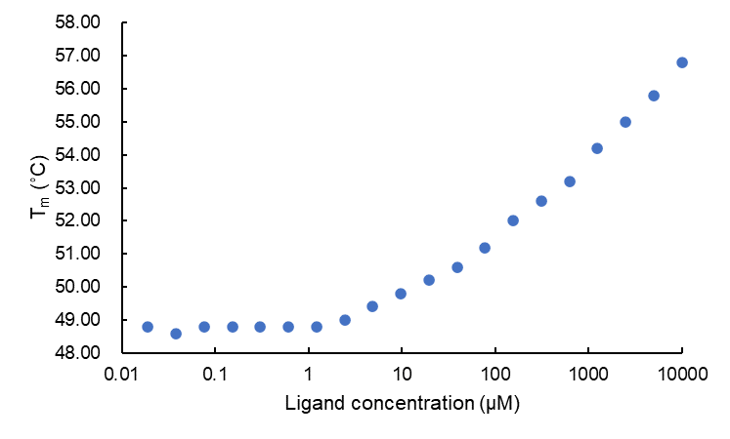
Figure S1. Melting temperature of SPs0871 in the presence of various concentrations of maltotriose

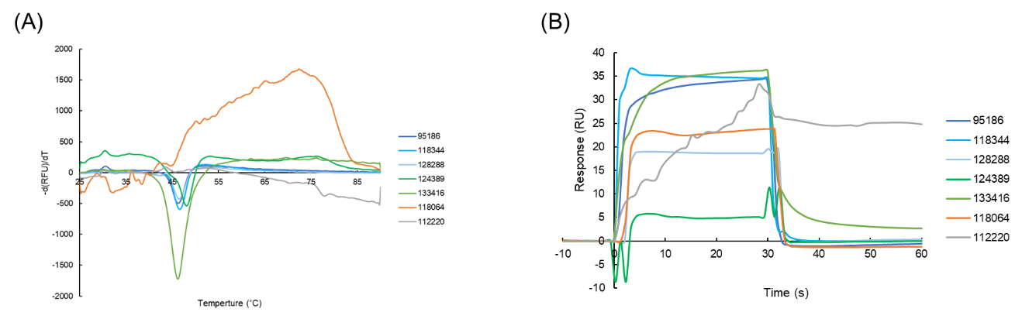

Figure S2. Melting curve and SPR sensorgram of temperature for the seven compounds. (A) DSF screening. (B) SPR screening

