APPENDIX A

Sample Course Plan (45-60 minutes)
Seq No. | Activity | Duration & Remarks
1 | Starting Prayer "AUM" Chanting | 3 Rounds  (in any comfortable seated position)
2 | Arms Up and Down with Syllable Chanting | Any choice of syllable
3 | Standing Samasthiti | -
4 | Tādāsana (Palm Tree) | 6 Rounds (with heels down)
5 | Uttānāsana  (Standing Forward Bend) | 6 Rounds
6 | Shavāsana (Corpse) | -
7 | Lying Supine Samasthiti | -
8 | Dvīpādapīṭham (Bridge) | 6 Rounds
9 | Apānāsana (Knees to Chest) | 6 Rounds
10 | Shavāsana (Corpse) | -
11 | Lying prone Samasthiti | -
12 | Bhujangāsana (Cobra) | -
13 | Prone rest | -
14 | Kneeling Samasthiti | -
15 | Bālāsana to Mārjariāsana  (Child to Cat) | 6 Rounds
16 | Seated rest | -
17 | Dandāsana (Seated Samasthiti) (Stick) | 6 Rounds  (with arms raised across the ears)
18 | Seated rest | -
19 | Closing Prayer "AUM Shanti" | 3 Rounds  in any comfortable seated position)

APPENDIX B
Sample yoga protocol prescription shared with the caregiver as reference during the transition workshop before the start of home setting intervention.
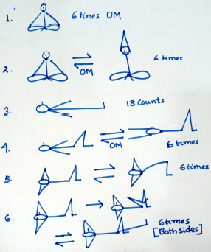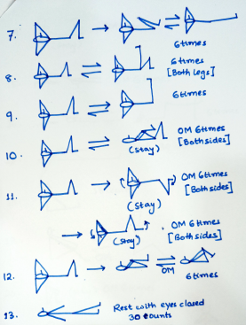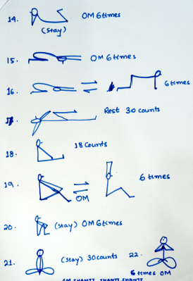

APPENDIX C

The Cohen’s d indices were calculated between baseline(B) to respective intervention phases (II & IH), i.e., the Baseline(B) vs Institute Setting (II) and Baseline(B) vs Home Setting (IH) is reported in the article. The Cohen’s d changes from Institute (II) to Home (IH) setting was calculated and however, lack confidence to report any concluding outcome. This is due to the following reason:
- The rigor of home setting practices was not feasible to govern compared to the institute settings for every participant. However, intermittent fortnight interventions assured continuity to some extent. The assessments however, continued in the same manner and frequency as that of institute setting. Possibly, the assessment outcome in home setting could be a result of carry forward effect from institute setting. Thus, any insights based on effectiveness comparison between two settings for a participant was inconclusive and hence it was not reported. For reference, the Cohen’s d score between institute (II) and home setting (IH) is as follows:
Parameter | P#1 | P#2 | P#3 | P#4 | P#5 | P#6
Cognitive Component | -0.40 | -0.22 | 0.56 | 0.04 | -0.07 | NA
Language | 0.40 | 5.78 | 0.99 | 2.36 | 3.75 | NA
Reading-Writing | 1.17 | 1.00 | 1.35 | - | -0.09 | NA
Number -Time | -0.23 | 6.90 | 3.26 | 1.94 | 12.10 | NA
Behaviour Patterns | -0.26 | 0.02 | -0.25 | -0.31 | 0.03 | NA
Hyperactivity-Inattention | -0.08 | 0.10 | NA | -0.14 | 0.03 | NA
Repetitive Behaviour | -0.25 | -0.25 | NA | -0.05 | -0.32 | NA
Emotional Responsiveness | -0.47 | -0.15 | 0.13 | 0.20 | -0.04 | NA
Violent and Destructive Behaviour | NA | -0.88 | -5.48 | -0.46 | -0.06 | NA
Temper Tantrums | -0.05 | -0.18 | NA | -0.10 | 0.00 | NA
Self-Injurious Behaviours | NA | NA | -1.73 | 0.01 | 0.05 | NA
Odd Behaviours | -0.53 | -0.10 | -0.50 | -0.15 | 0.03 | NA

