Supplementary File 1

Genome-wide analysis provides insight into the genetic diversity and adaptability of Kazakhstan local goats
Nelly Kichamu^{1,2,3}, George Wanjala^{4,5}, Kairat Dossybayev^{6,7,8}, Zoltán Bagi¹, Bakhytzhan Bekmanov^{6,8}, Szilvia Kusza^{1,}*

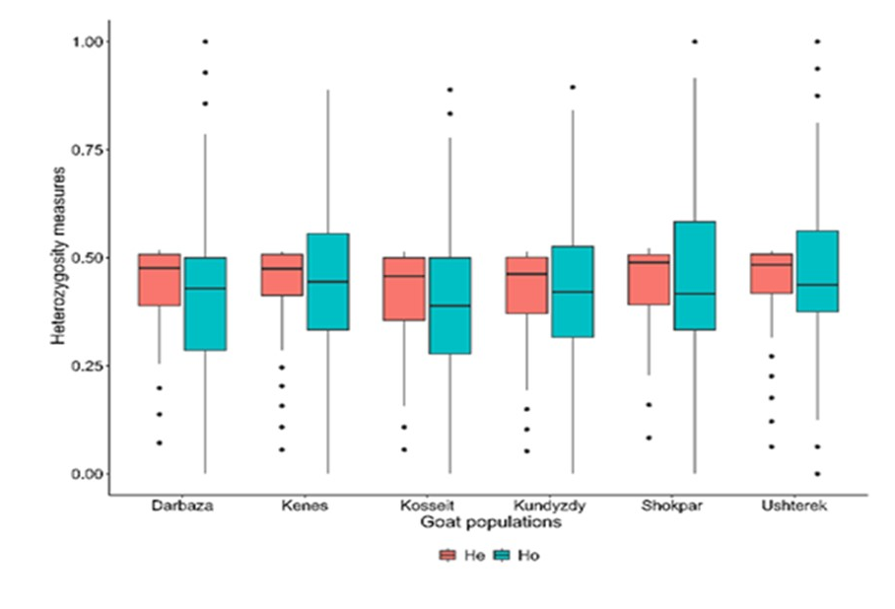
Figure S1: Observed (Ho) and expected (He) heterozygosity
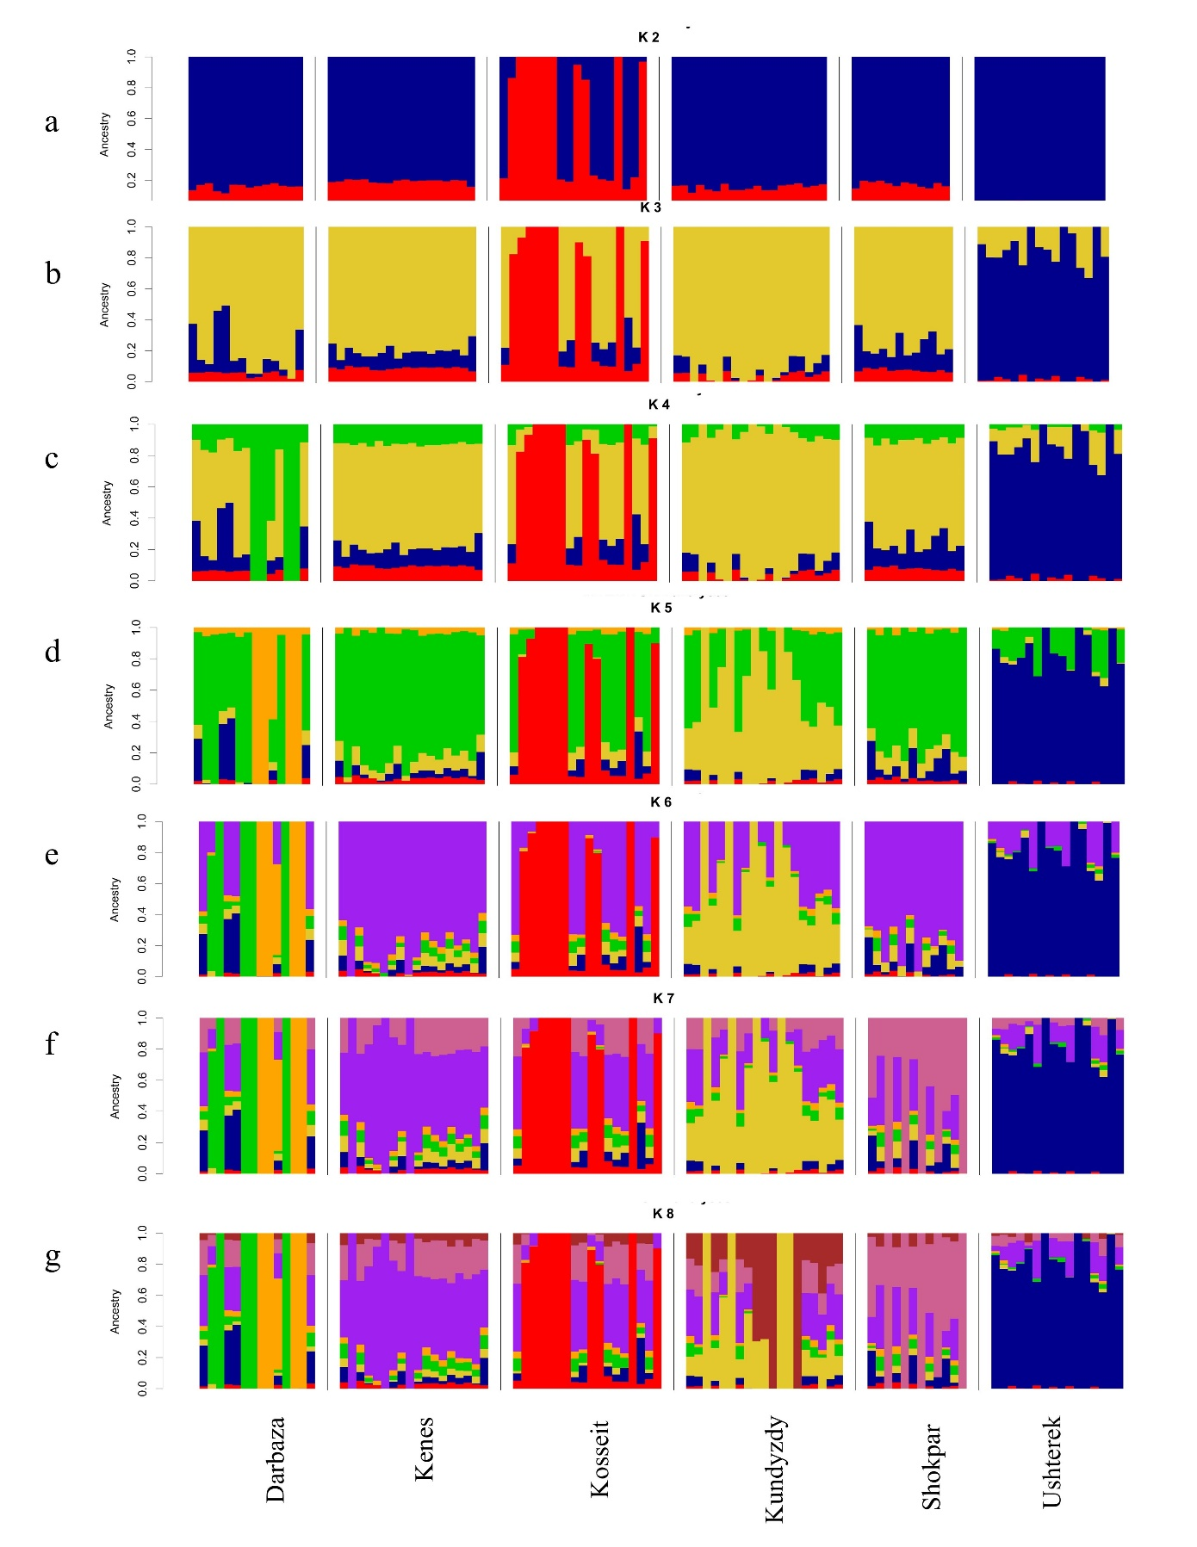 Figure S2: Admixture analysis for Kazakhstan goats from six different regions showing the proportions of ancestral populations for K value from 2 to 8. Each vertical bar exemplifies an individual
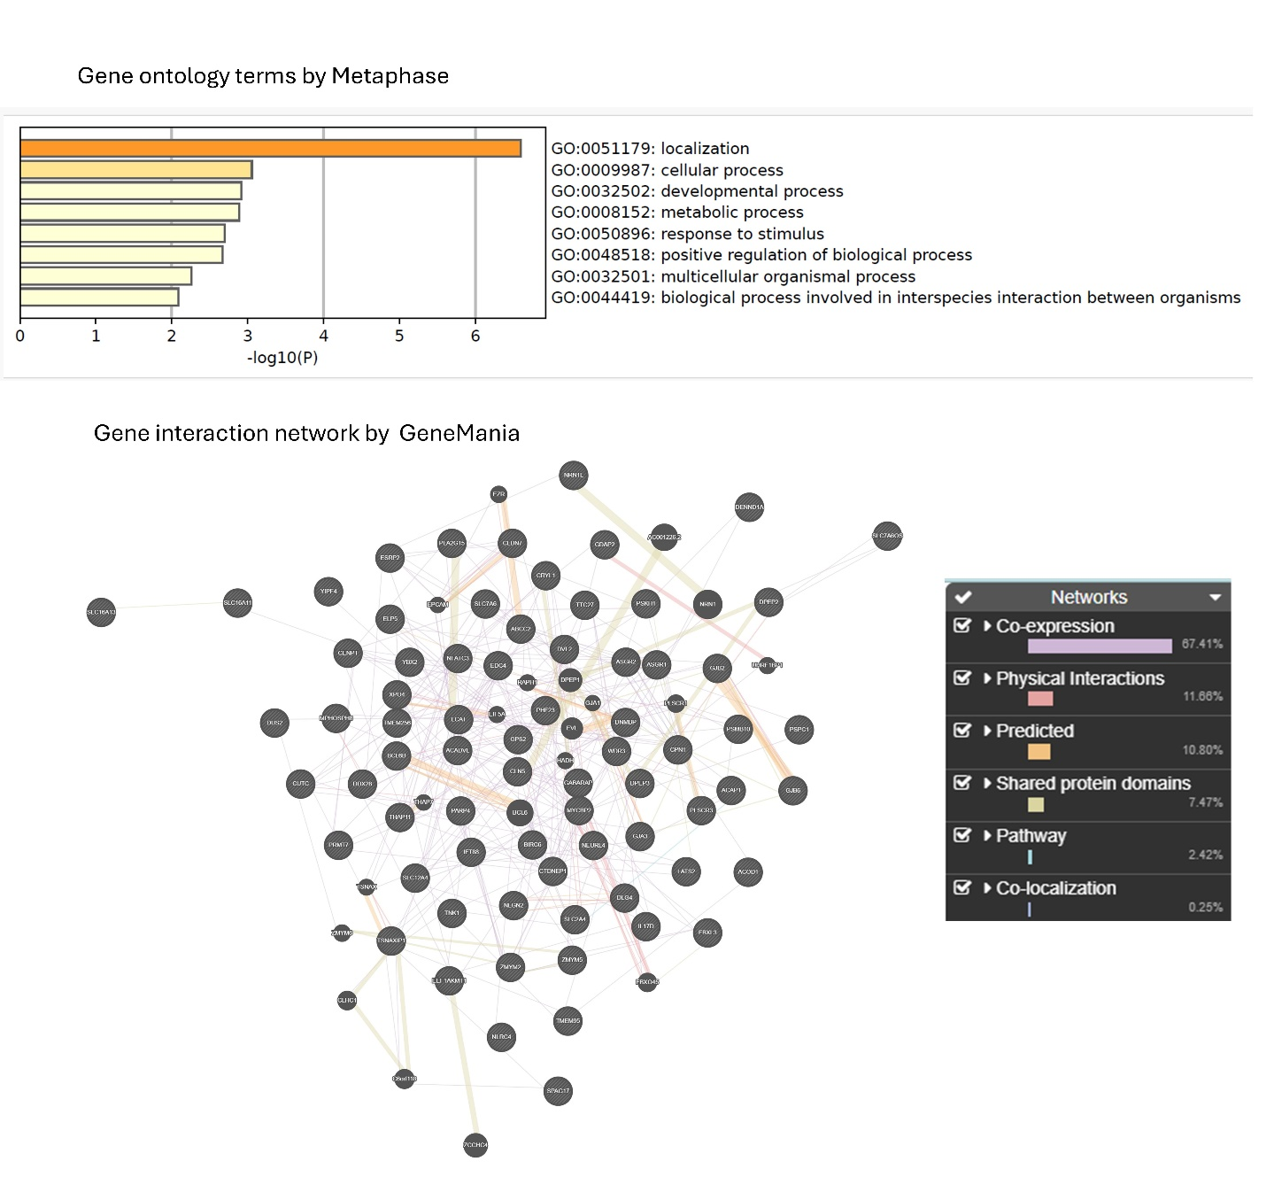
b
a
Figure S3: (a) Gene Ontology Enrichment (b) Gene Interaction Network for six goat population in Kazakhstan

