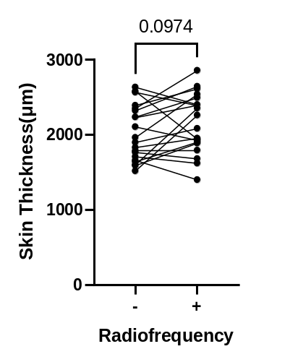
MNRF
MN
(a)
Supplementary Figure 1.
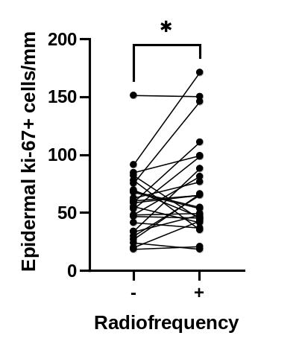
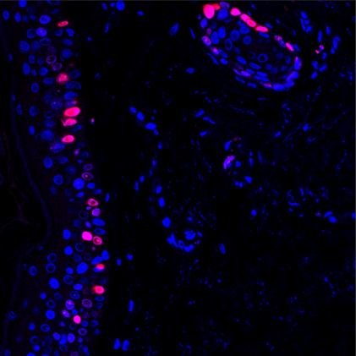
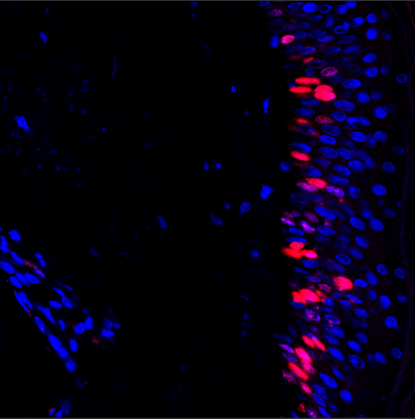
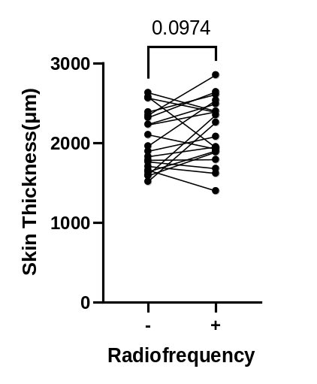
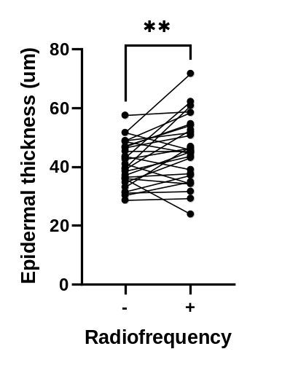
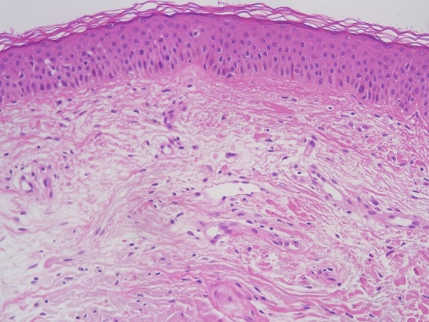
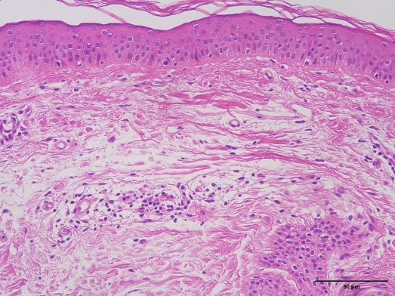
ki-67 DAPI
MNRF
MN
(b)

Supplementary figure legends
Figure S1. Increase in epidermal thickness resulted by MNRF treatment
(a) Representative images of H&E staining in the skin treated with MN and MNRF respectively. The graphs on the right indicate the quantitative evaluation of epidermal thickness (n=27) and total skin thickness (n=20). Scale bar=50µm. (b) Representative images of immunofluorescence staining for ki-67 after MN and MNRF treatment respectively. The right graph indicates the number of epidermal ki-67-positive cells after MN or MNRF treatment (n=26). Original magnification ×400. Statistical significance: *p<0.05, **p<0.01. Abbreviations: MN, microneedling; MNRF, microneedle radiofrequency

Supplementary Material and Methods
Non-invasive skin parameter measurements
Skin biophysical parameters measured at baseline and at 3 and 5 months included: melanin index and erythema index measured by Mexameter (MX 18, Courage+Khazaka Electronic GmbH, Cologne, Germany); trans-epidermal water loss (TEWL) measured by Tewameter (TM 300, Courage+Khazaka Electronic GmbH); skin hydration measured by Corneometer (CM 825, Courage+Khazaka Electronic GmbH); skin elasticity measured by Cutometer (MPA 580, Courage+Khazaka Electronic GmbH) ; skin wrinkles measured by Visiometer (SV 600, Courage+Khazaka Electronic GmbH) and Visioscan (VC 20plus, Courage+Khazaka Electronic GmbH). Due to technical issues with the equipment, Visioscan measurements were only obtained from 20 subjects.
Histological analysis for Masson's trichrome and hematoxylin and eosin staining
For quantitative analysis of collagen deposition from Masson's trichrome (MT)-stained slides, the ImageJ software (NIH, Bethesda, MD) was used to separate the original MT-stained image into 8-bit RGB images. For each section, three regions of interest (ROIs, 0.01 mm²) were randomly selected in the papillary and reticular dermis and mean integrated density value was driven for analysis. The papillary dermis was defined as an area up to 0.3 mm from the epidermal-dermal junction, and the reticular dermis was defined as an area deeper than 0.7 mm as mentioned in a previous article.¹ To evaluate the epidermal thickness from the hematoxylin and eosin (H&E)-stained skin tissue, five random points were selected solely on the inter-rete ridge areas of the epidermis and measured from the basement membrane to the top of the granular layer. Full skin thickness was assessed by measuring randomly chosen five points from the tip of the epidermis to the point before reaching the subcutaneous fat, for tissue sections where the full skin length was visible (n=20). The mean values of each measurement were used for comparative analysis.
Immunohistochemical analysis
To evaluate HSP47, CD45, CD68, and procollagen-1 expression, marker-positive cells were counted at 400x magnification, and values were then converted to the number of cells per dermal area (mm²). For p16^{INK4A} analysis, the number of strongly nuclei-stained cells in a given area (mm²) and length (mm) as well as the proportion of p16^{INK4A}-positive cells among the nuclei-positive cells were examined. To assess the expression of ki-67, nuclei-stained epidermal cells were quantified and converted to the number of cells per basement membrane length (mm). Skin appendages and blood vessels were excluded from dermal evaluation, and the mean values of the five images acquired from each section were used for the analysis. For elastin evaluation, immunofluorescence-stained images were transformed into an 8-bit format. Raw integrated intensities were then measured in three ROIs (0.01 mm²) within both the papillary and reticular dermis. After quantification, mean values were derived for analysis. The areas of the papillary and reticular dermis were set the same as those in the MT staining analysis.

References
1 Mine S, Fortunel NO, Pageon H, Asselineau D. Aging Alters Functionally Human Dermal Papillary Fibroblasts but Not Reticular Fibroblasts: A New View of Skin Morphogenesis and Aging. PLoS ONE 2008; 3:e4066.

