Supplementary Data
Material characterization. The optical and electron-microscopic imaging shows that HaH 346 exhibits a recrystallized texture, dominated by equilibrated olivine, low-Ca pyroxene grains, FeNi metal and troilite. A few well-defined chondrules are visible, though most are recrystallized and integrated into the matrix. In Fig. S1, the BSE image of the 1 x 1 cm cube shows at least 13 recognizable chondrules, up to 1.5 mm. The matrix contains minerals such as plagioclase, chromite, merrillite, troilite, taenite, and kamacite, with plagioclase grains measuring <60 µm. Shock-melt veins are rare but occasionally present in localized pockets. The x-ray maps and BSE images show that Fe-Ni metal and troilite are evenly distributed throughout the polished section. Kamacite grain size is typically 200 to 1000 µm, with scattered grains to 1.5 mm. Taenite is rarer and with grains typically 100 to 200 µm. Troilite grain size is typically 50 to 350 µm, though grains <10 µm are common.
The x-ray element maps show the texture, relationship between, and aerial distribution of the different minerals. Together with the EDS point analysis, we identified specific elements associated with distinct phases in the x-ray maps: Mg is indicative of the olivine and low-Ca pyroxene, Ni corresponds primarily with Fe-Ni metal and S is primarily from troilite Fig. S1. It is difficult to distinguish between the olivine with low Fe and low-Ca pyroxene from the Mg and Fe maps alone. However, the Si map is necessary as olivine contains less SiO2 than low-Ca pyroxene: olivine corresponds to the blue regions. The green in the Si map is dominantly low-Ca pyroxene with small regions between the grains for plagioclase – see the Na map.
Physical and mechanical properties. The average bulk and grain densities for the eleven $10-mm$ cubes of HaH 346, as determined by $N₂$ gas pycnometer, is $3.3374 ± 0.0672 g/{cm}^{3}$ and $3.5666 ± 0.0167 g/{cm}^{3}$, respectively. The porosity at the macroscale was calculated with an average of 8.82$± 3.12 \%$. The elastic wave velocity measurements for the 11 cubes have an average Young’s modulus of $26 ± 7 GPa$, an average shear modulus of $11 ± 3 GPa$, and an average Poisson’s ratio of $0.24 ± 0.028$as summarized in Table S1. Using elastic wave velocity measurements, variations in material heterogeneity, such as microcracks, porosity, and inter-grain boundaries, can reduce wave velocities and elastic moduli. These weak points in OC lower the material’s elastic moduli and cause variability in compressive strength (Fig. S2), where the variation in compressive strength for the tested samples is as follows: 67.7 MPa for sample 1, 72.9 MPa for sample 2, and 65.1 MPa for sample 3.
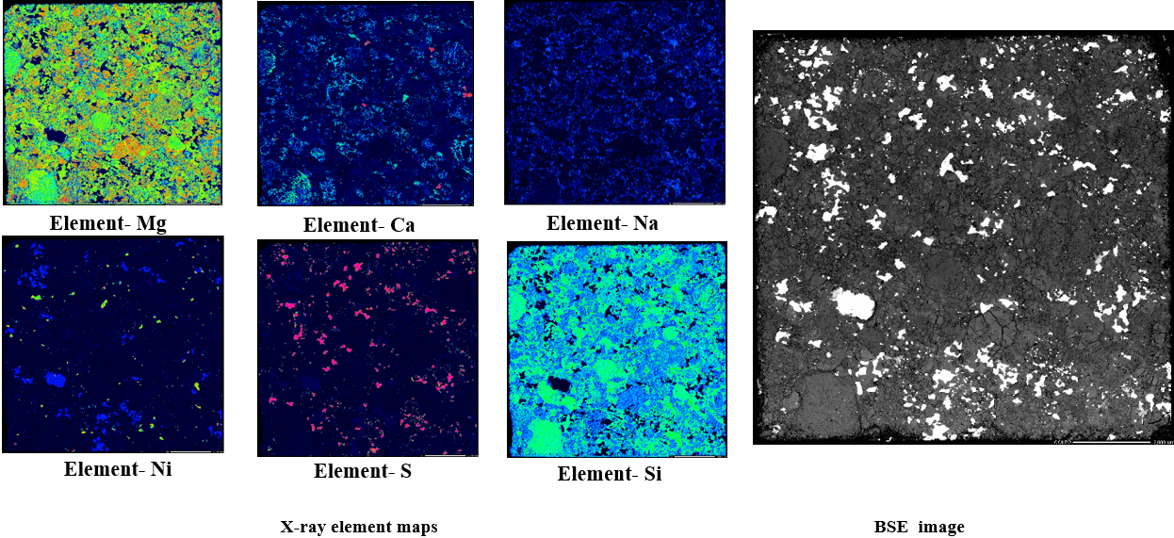
Fig. S1: BSE image and selected X-ray element maps for HaH 346.
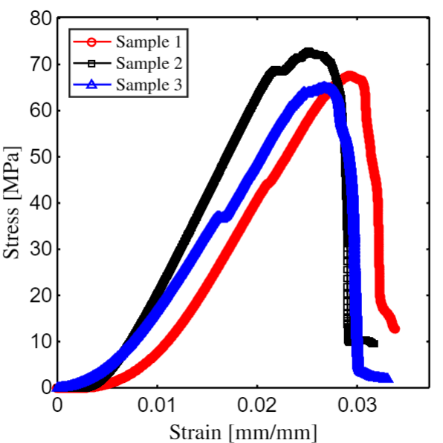
Fig. S2: Stress-strain responses for three 10 mm cubes of HaH 346 at a displacement rate of 0.25 mm/min.

Table S1: Elastic properties of the 11 HaH 346 cubes measured using elastic wave velocity. Normal wave velocity ($V_{N})$, Shear wave velocity ($V_{s})$, elastic longitudinal modulus (E), shear modulus (G), and Poisson’s ratio ($υ)$.
Sample No. | $V_{N}$  [m/s] | $V_{S}$  [m/s] | $E$  [GPa] | $G$  [GPa] | $$υ$$ | Porosity [%]
1 | 3247.9 | 1944.1 | 30 | 12.3 | 0.2208 | 4.0
2 | 3390 | 1883.3 | 31.6 | 12.4 | 0.2768 | 14.0
3 | 3371.1 | 1879.2 | 29.6 | 11.6 | 0.2746 | 10.0
4 | 2966.7 | 1658.4 | 23.9 | 9.4 | 0.2727 | 8.0
5 | 2680.2 | 1529.7 | 19.5 | 7.8 | 0.2584 | 9.0
6 | 2597.0 | 1546.5 | 19.7 | 8.0 | 0.2253 | 6.0
7 | 2715.0 | 1662.2 | 21.9 | 9.1 | 0.2002 | 10.0
8 | 2712.6 | 1622.1 | 21.6 | 8.8 | 0.2217 | 6.0
9 | 2653.3 | 1541.4 | 19.6 | 7.9 | 0.2453 | 8.0
10 | 3814.0 | 2138.4 | 37.9 | 14.9 | 0.2708 | 8.0
11 | 3488.4 | 2103.6 | 35.6 | 14.7 | 0.2143 | 14.0
Mean | 3058 | 1774 | 26 | 11 | 0.24 | 8.82
Standard Deviation | 420 | 225 | 7 | 3 | 0.028 | 3.12

