Supplementary Information
Novel Selective Indole based Histone Deacetylase 10 Inhibitors as Anticancer Therapeutics Amer H. Tarawneh^{1,*}, Salah A. Al-Trawnehb^{2,3,*}, Talha Z. Yesiloglu⁴, Matthes Zessin⁵, Dina Robaa⁴, Cyril Barinka⁶, Mike Schutkowski⁵, Wolfgang Sippl^{4,*}, Samir A. Ross^{3,7,*}
1 Department of Chemistry, Tafila Technical University, P.O. Box 179, Tafila, Jordan
2 Chemistry Department, Faculty of Science, Mu'tah University, Karak 61710, Jordan
3 National Center for Natural Products Research, Research Institute of Pharmaceutical Sciences, School of Pharmacy, University of Mississippi, University, MS, 38677, USA
4 Institute of Pharmacy, Martin-Luther University of Halle-Wittenberg, 06120 Halle/Saale, Germany
5 Institute of Biotechnology, Martin-Luther University of Halle-Wittenberg, 06120 Halle/Saale, Germany
6 Institute of Biotechnology of the Czech Academy of Sciences, BIOCEV, Prumyslova 595, 252 50 Vestec, Czech Republic
7 Department of BioMolecular Sciences, School of Pharmacy, University of Mississippi, University, MS, 38677, USA
* Correspondence:

Dr, A.H. Tarawneh, Department of Chemistry, Tafila Technical University, Tafila 66110, Jordan
Email: amer.tarawneh@ttu.edu.jo
Prof. S. A. Al-Trawneh, Chemistry Department, Mu'tah University, Karak 61710, Jordan
Email: laratr@mutah.edu.jo
Prof. W. Sippl, Institute of Pharmacy, Martin-Luther University of Halle-Wittenberg, 06120 Halle/Saale, Germany
Email: wolfgang.sippl@pharmazie.uni-halle.de
Prof. S. A. Ross, National Center for Natural Products Research, University of Mississippi, University, MS, 38677, USA
Email: sross@olemiss.edu

Table of Contents
Figure S1: | Predicted binding modes of compounds 2c, 2d, 2f and 2g in drHDAC10 (PDB ID 6UHU)
Figure S2: | RMSD plots of drHDAC10 (PDB ID 6UHU)-compound 2a
Figure S3: | RMSD plots of the crystalized ligands heavy atoms in humanized drHDAC10 (PDB ID 7U6A)
Figure S4: | RMSD plots of the crystalized ligands heavy atoms in humanized drHDAC10 (PDB ID 7U6B)
Figure S5: | RMSD plots of the crystalized ligands heavy atoms in humanized drHDAC10 (PDB ID 7U69)
Figure S6: | RMSD plots of the crystalized ligands heavy atoms in humanized drHDAC10 (PDB ID 7U59)
Figure S7: | IC50 value for compound 2a and 2f against human HDAC 1
Figure S8: | IC50 value for compounds 2a, 2b, 2c, 2d, 2f, , 2g, and tubastatin against human HDAC 6
Figure S9: | IC50 value for compounds 2a, 2b , 2f, and 2g against human HDAC 8
Figure S10: | IC50 value for all synthesized compounds (2a-2g) in vitro against zebrafish HDAC10 (drHDAC10).
Figure S11: | ¹H NMR and ¹³C NMR of compound 2a in DMSO-d₆
Figure S12: | ¹H NMR and ¹³C NMR of compound 2b in DMSO-d₆
Figure S13: | ¹H NMR and ¹³C NMR of compound 2c in DMSO-d₆
Figure S14: | ¹H NMR and ¹³C NMR of compound 2d in DMSO-d₆
Figure S15: | ¹H NMR and ¹³C NMR of compound 2e in DMSO-d₆
Figure S16: | ¹H NMR and ¹³C NMR of compound 2f in DMSO-d₆
Figure S17: | ¹H NMR and ¹³C NMR of compound 2g in DMSO-d₆
Figure S18: | ¹H NMR and 13C NMR of compound 1a in CDCl₃-d
Figure S19: | ¹H NMR and 13C NMR of compound 1b in CDCl₃-d
Figure S20: | ¹H NMR and 13C NMR of compound 1c in CDCl₃-d
Figure S21: | ¹H NMR and 13C NMR of compound 1d in CDCl₃-d
Figure S22: | ¹H NMR and 13C NMR of compound 1e in CDCl₃-d
Figure S23: | ¹H NMR and 13C NMR of compound 1f in CDCl₃-d
Figure S24: | ¹H NMR and 13C NMR of compound 1g in CDCl₃-d
Figure S25 | HRMS of compound 1a
Figure S26 | HRMS of compound 1b
Figure S27 | HRMS of compound 1c
Figure S28 | HRMS of compound 1d
Figure S29 | HRMS of compound 1e
Figure S30 | HRMS of compound 1f
Figure S31 | HRMS of compound 1g
Figure S32 | HRMS of compound 2a
Figure S33 | HRMS of compound 2b
Figure S34 | HRMS of compound 2c
Figure S35 | HRMS of compound 2d
Figure S36 | HRMS of compound 2e
Figure S37 | HRMS of compound 2f
Figure S38 | HRMS of compound 2g

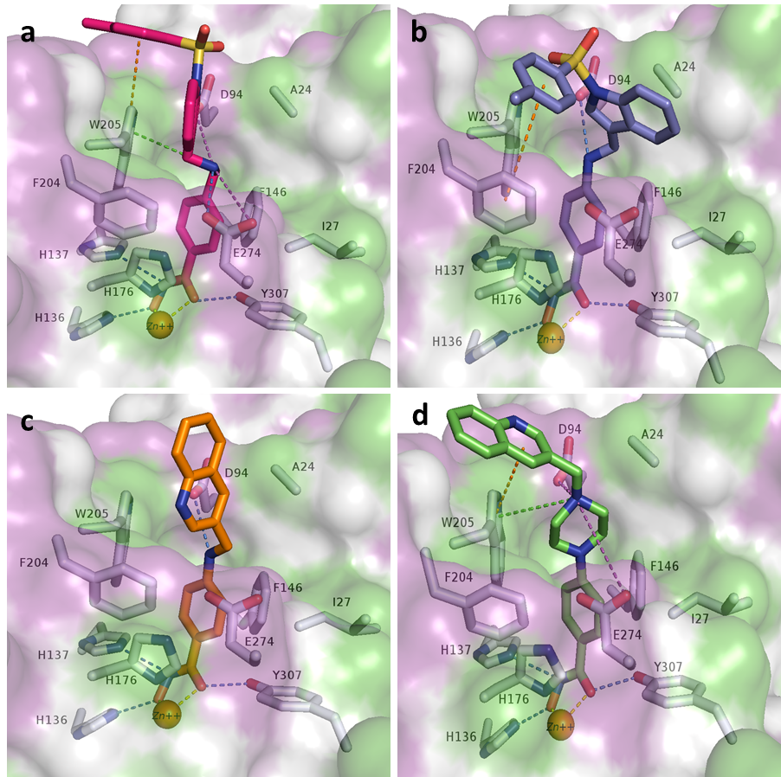Figure S1. Predicted binding modes of compounds, a) 2c (magenta sticks), b) 2d (violet sticks), c) 2f (orange sticks), and d) 2g (light green sticks) in drHDAC10 (PDB ID 6UHU). The surface of the proteins is colored according to lipophilicity; green for hydrophobic and magenta for hydrophilic. Side chains of binding site residues are shown as white sticks and the catalytic zinc ion as orange spheres. H-bond interactions are depicted as blue-dashed lines, salt bridge interactions as magenta-dashed lines, π-π interactions as orange-dashed lines, cation-π interactions as green-dashed lines, and coordination of the zinc ion by the ligand as yellow-dashed lines.

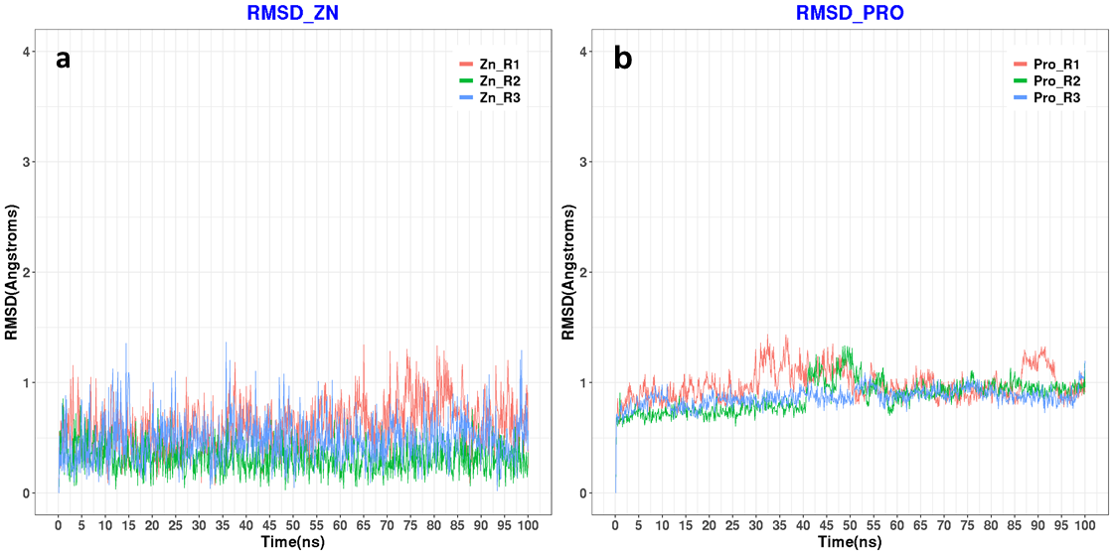Figure S2. a) RMSD plots of protein-heavy atoms in drHDAC10 (PDB ID 6UHU)-compound 2a docked complexes for 3 repeated MD runs each for 100 ns. b) RMSD plots of the Zn ion in drHDAC10 (PDB ID 6UHU)-compound 1 complexes for 3 repeated MD runs each for 100 ns.

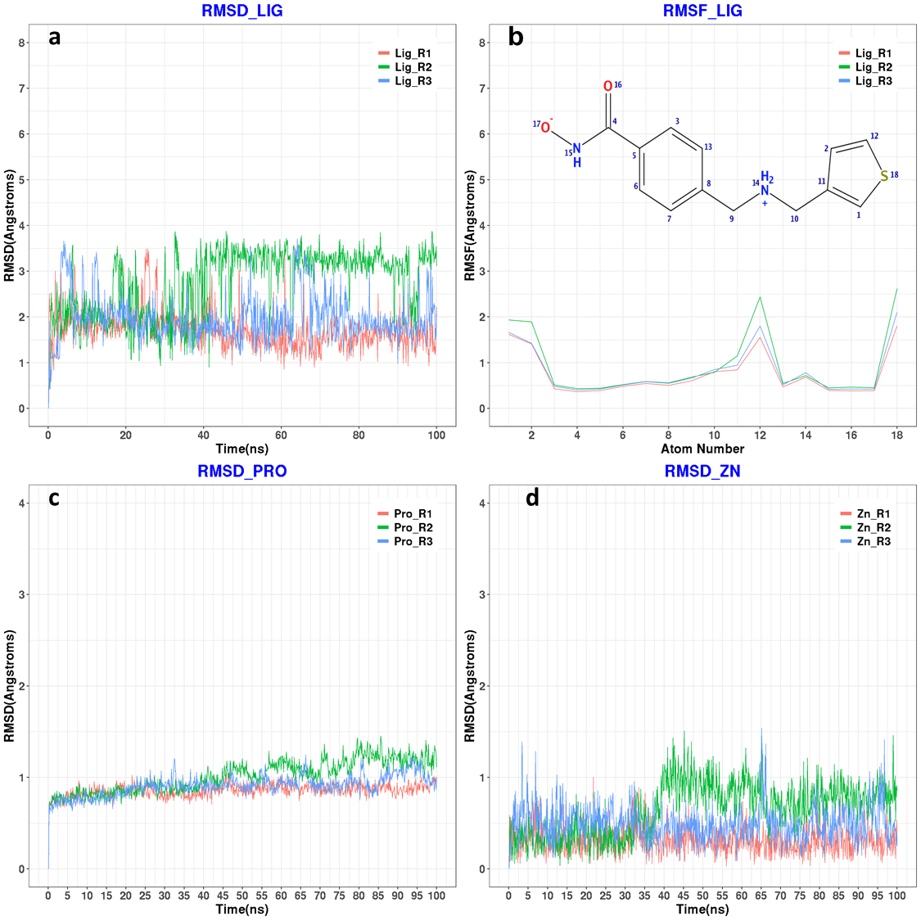
Figure S3. a) RMSD plots of the crystalized ligands heavy atoms in humanized drHDAC10 (PDB ID 7U6A) crystalized complexes for 3 repeated MD runs each for 100 ns. b) RMSF plots of the crystalized ligands heavy atoms in humanized drHDAC10 (PDB ID 7U6A) crystalized complexes for 3 repeated MD runs each for 100 ns. c) RMSD plots of protein heavy atoms in humanized drHDAC10 (PDB ID 7U6A) crystalized complexes for 3 repeated MD runs each for 100 ns. d) RMSD plots of the Zn ion in humanized drHDAC10 (PDB ID 7U6A) crystalized complexes for 3 repeated MD runs each for 100 ns.
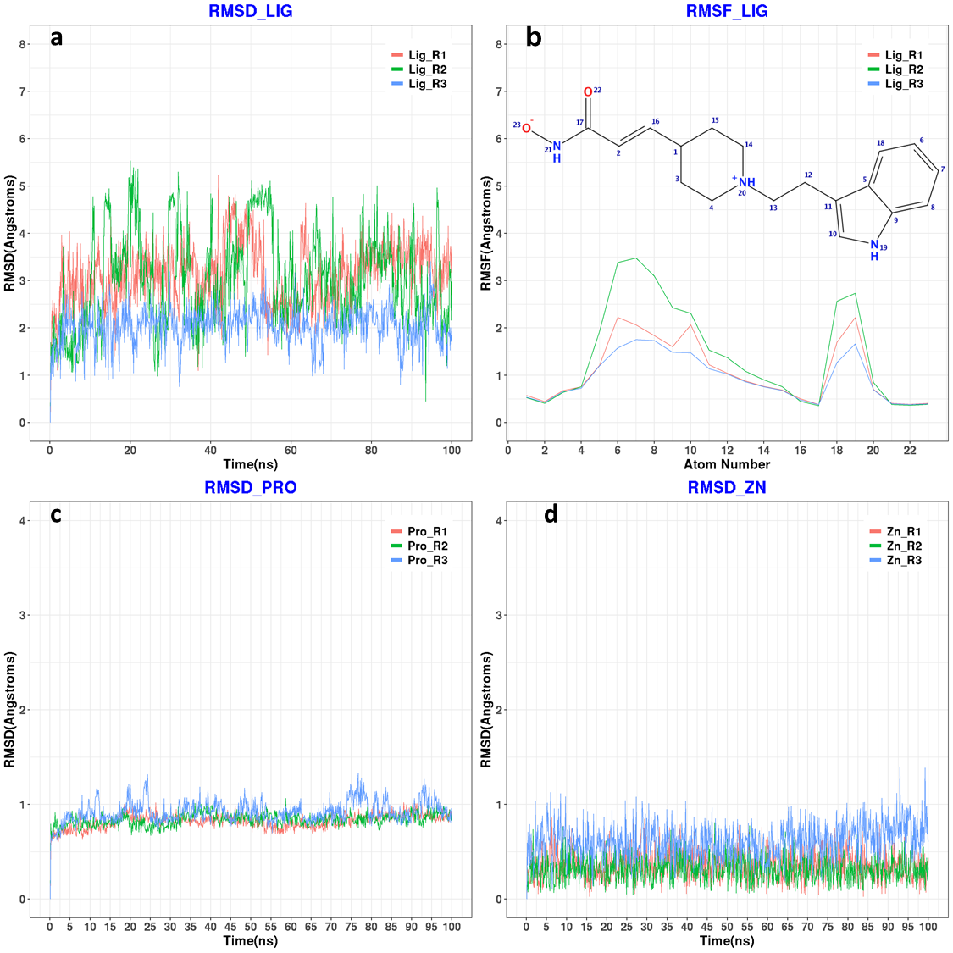
Figure S4. a) RMSD plots of the crystalized ligands heavy atoms in humanized drHDAC10 (PDB ID 7U6B) crystalized complexes for 3 repeated MD runs each for 100 ns. b) RMSF plots of the crystalized ligands heavy atoms in humanized drHDAC10 (PDB ID 7U6B) crystalized complexes for 3 repeated MD runs each for 100 ns. c) RMSD plots of protein-heavy atoms in humanized drHDAC10 (PDB ID 7U6B) crystalized complexes for 3 repeated MD runs each for 100 ns. b) RMSD plots of the Zn ion in humanized drHDAC10 (PDB ID 7U6B) crystalized complexes for 3 repeated MD runs each for 100 ns.
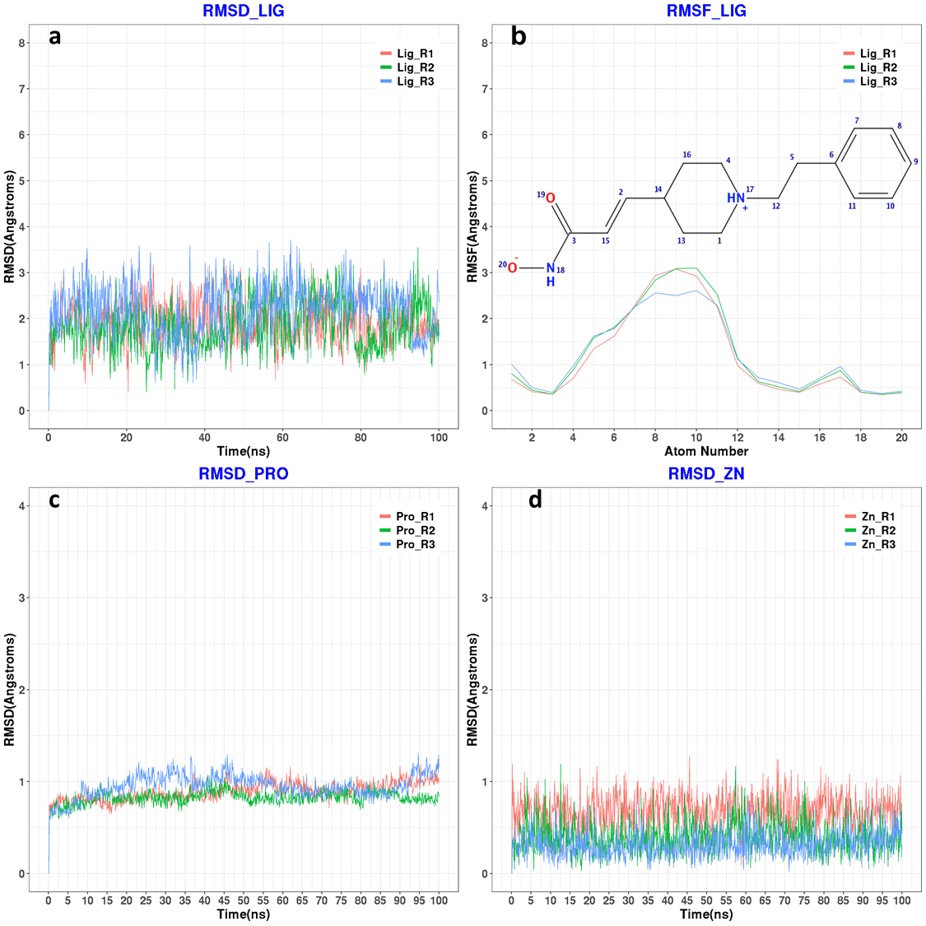
Figure S5. a) RMSD plots of the crystalized ligands heavy atoms in humanized drHDAC10 (PDB ID 7U69) crystalized complexes for 3 repeated MD runs each for 100 ns. b) RMSF plots of the crystalized ligands heavy atoms in humanized drHDAC10 (PDB ID 7U69) crystalized complexes for 3 repeated MD runs each for 100 ns. c) RMSD plots of protein-heavy atoms in humanized drHDAC10 (PDB ID 7U69) crystalized complexes for 3 repeated MD runs each for 100 ns. d) RMSD plots of the Zn ion in humanized drHDAC10 (PDB ID 7U69) crystalized complexes for 3 repeated MD runs each for 100 ns.
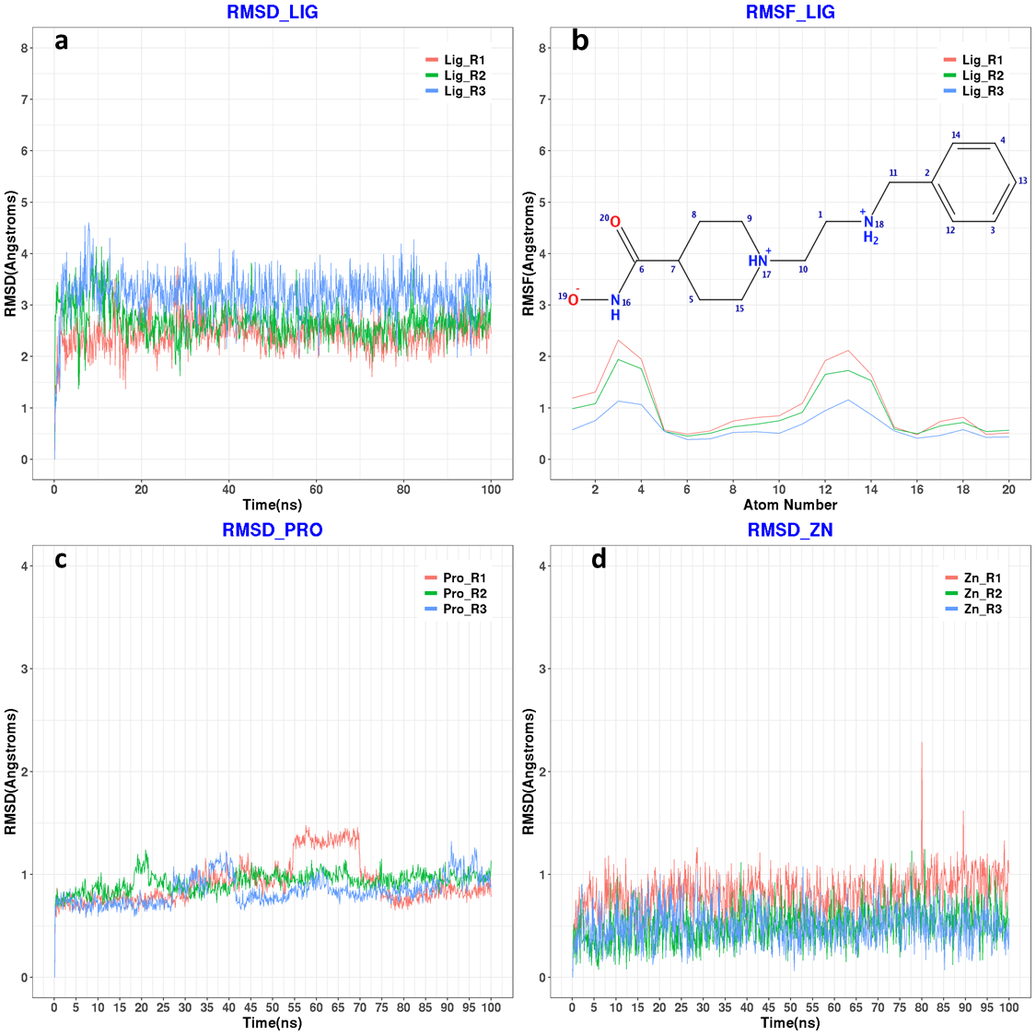
Figure S6. a) RMSD plots of the crystalized ligands heavy atoms in humanized drHDAC10 (PDB ID 7U59) crystalized complexes for 3 repeated MD runs each for 100 ns. b) RMSF plots of the crystalized ligands heavy atoms in humanized drHDAC10 (PDB ID 7U59) crystalized complexes for 3 repeated MD runs each for 100 ns. c) RMSD plots of protein-heavy atoms in humanized drHDAC10 (PDB ID 7U59) crystalized complexes for 3 repeated MD runs each for 100 ns. d) RMSD plots of the Zn ion in humanized drHDAC10 (PDB ID 7U59) crystalized complexes for 3 repeated MD runs each for 100 ns.

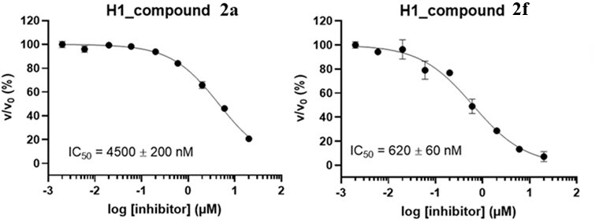
Figure S7. IC50 value for compound 2a and 2f against human HDAC 1.

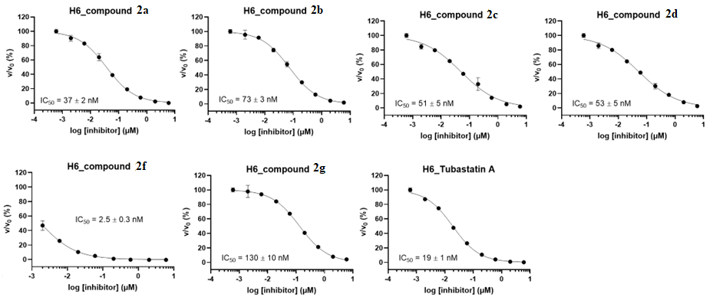
Figure S8. IC50 value for compounds 2a, 2b, 2c, 2d, 2f, 2g and tubastatin against human HDAC 6.

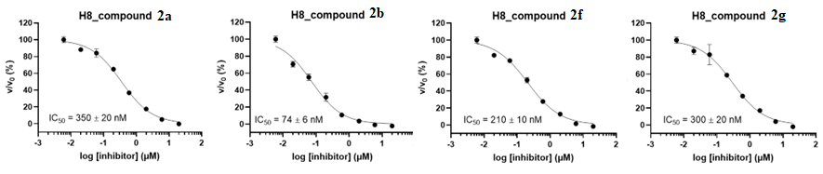
Figure S9. IC50 value for compounds 2a, 2b, 2f and 2g against human HDAC 8.

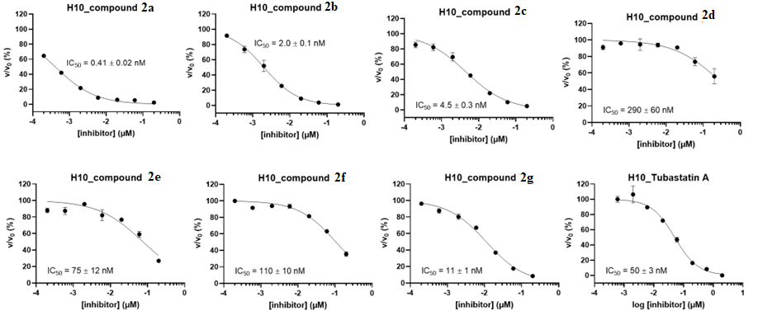
Figure S10. IC50 value for all synthesized compounds (2a-2g) in vitro against zebrafish HDAC10 (drHDAC10).

Figure S11: ¹H NMR and ¹³C NMR of compound 2a in DMSO-d₆.
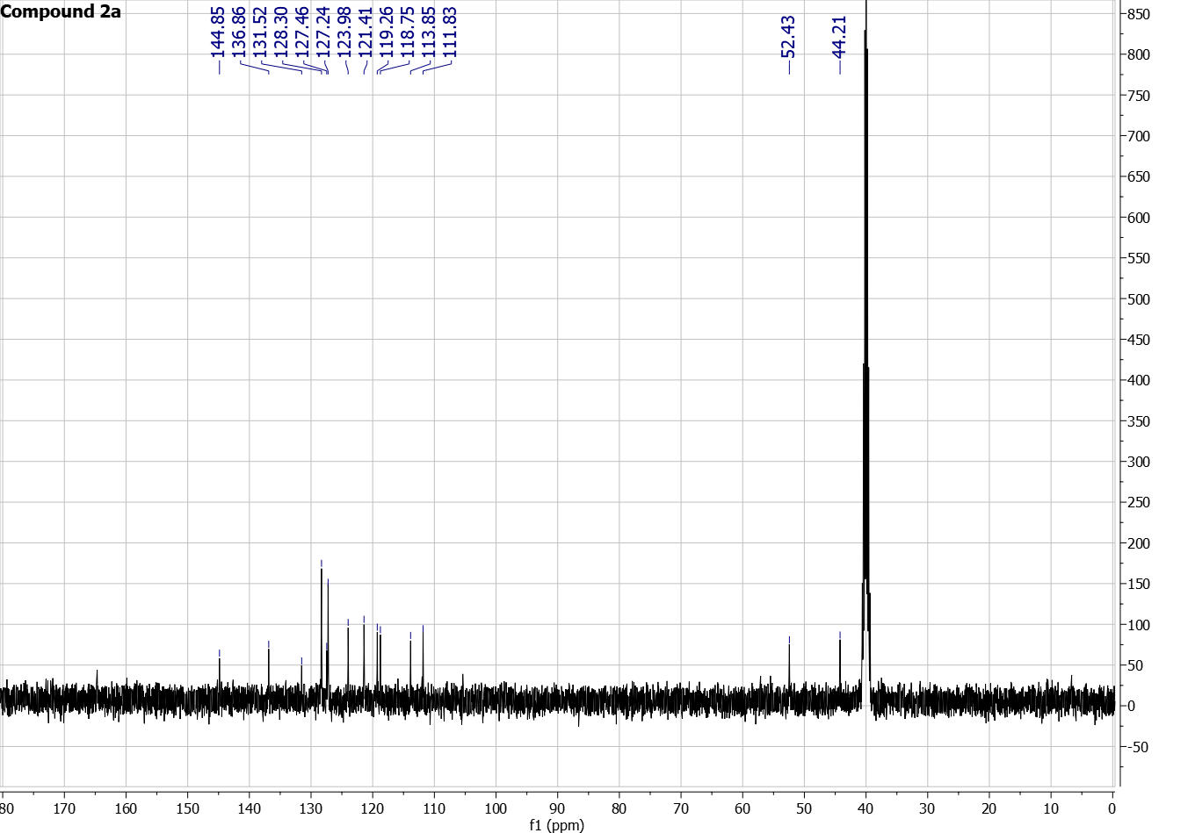
Figure S12: ¹H NMR and ¹³C NMR of compound 2b in DMSO-d₆.
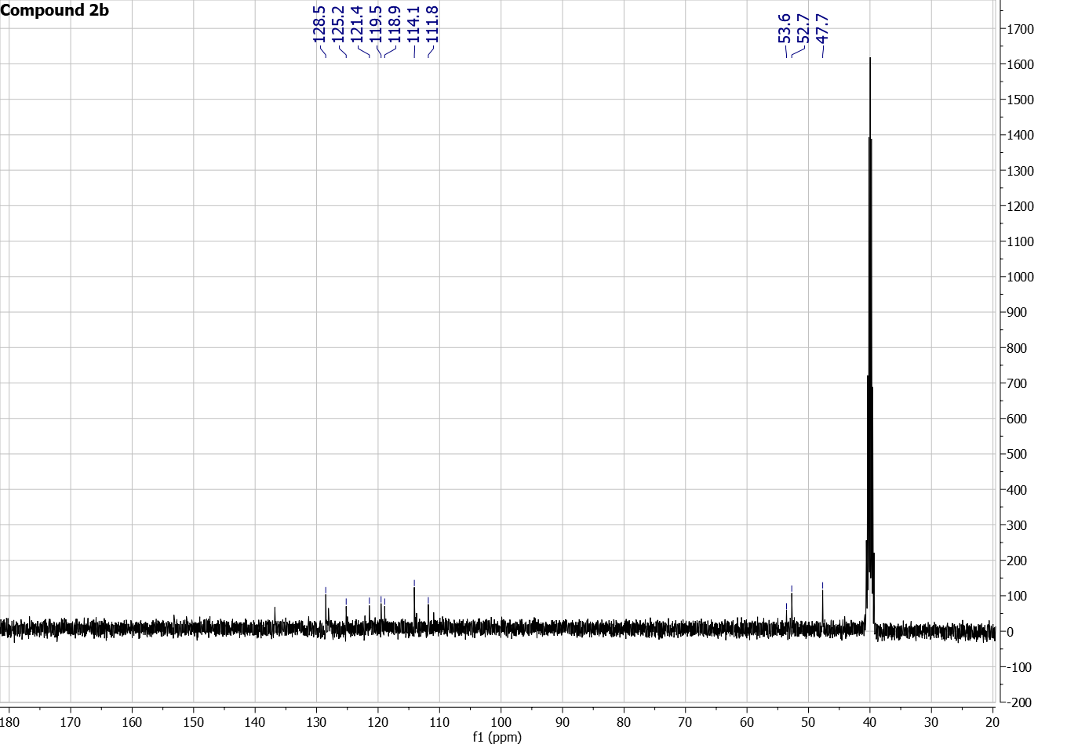
Figure S13: ¹H NMR and ¹³C NMR of compound 2c in DMSO-d₆
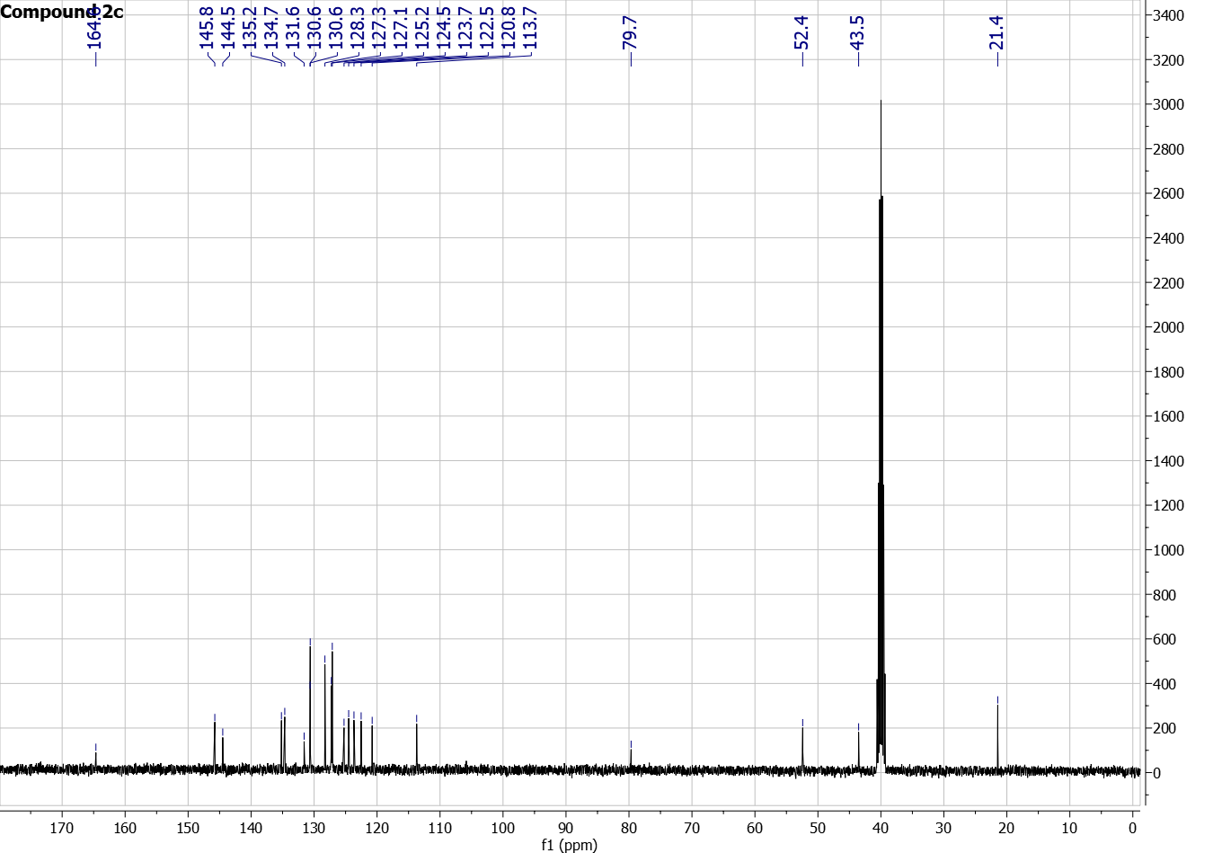
Figure S14: ¹H NMR and ¹³C NMR of compound 2d in DMSO-d₆
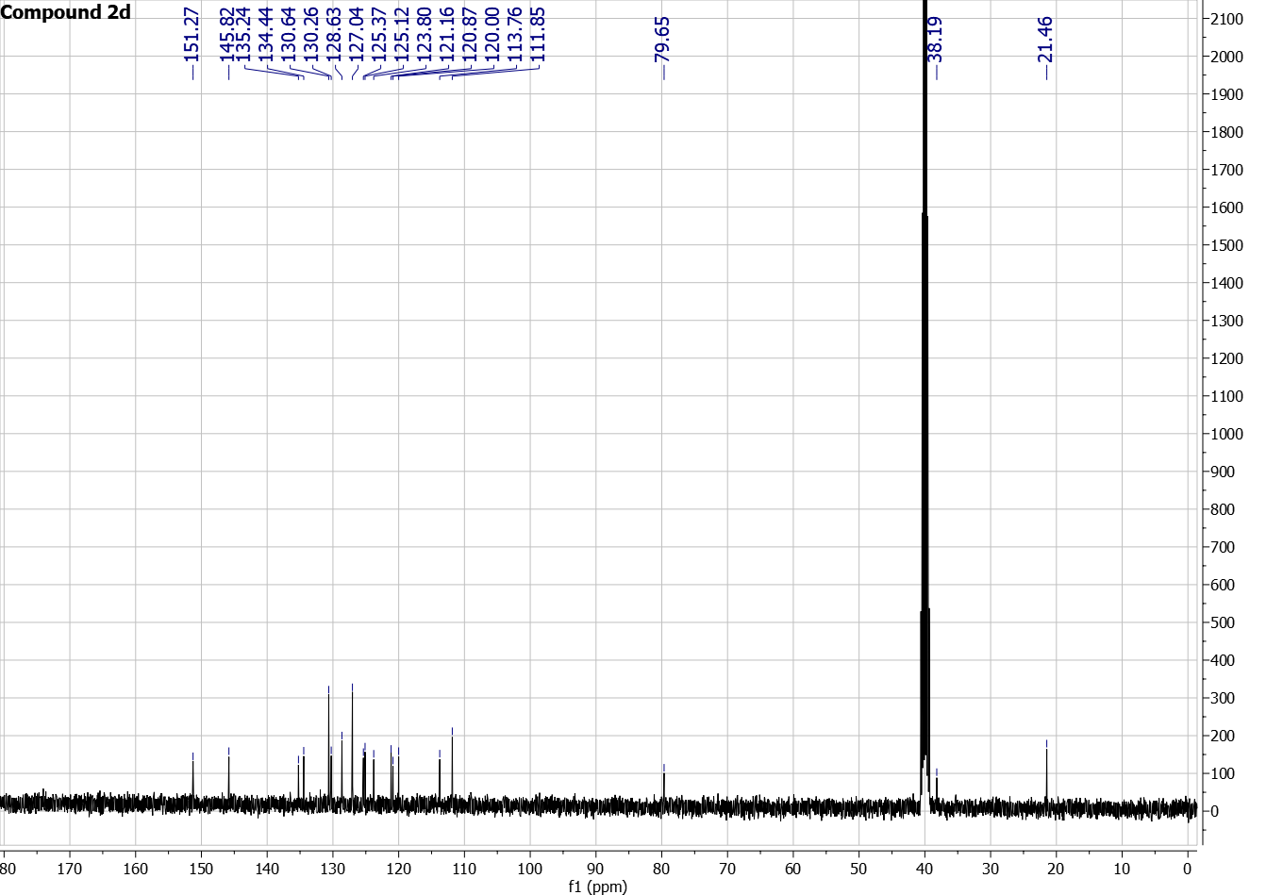
Figure S15: ¹H NMR and ¹³C NMR of compound 2e in DMSO-d₆
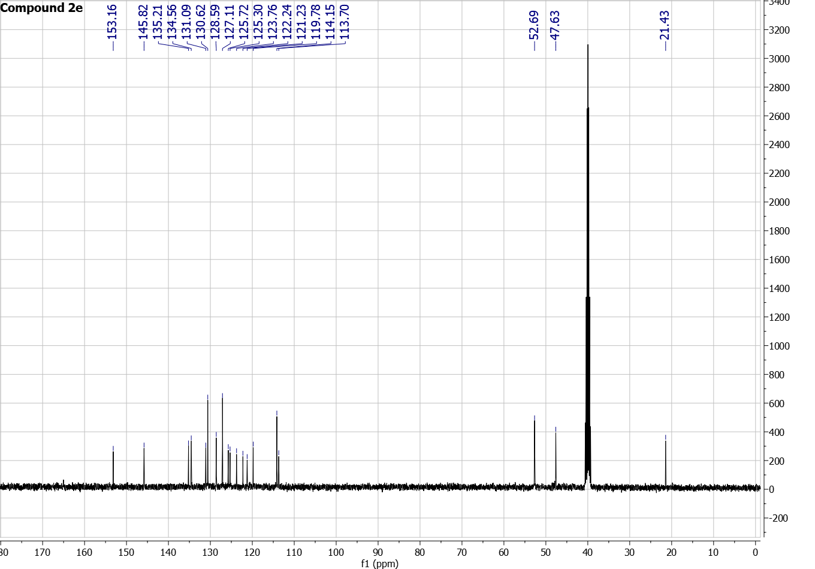

Figure S16: ¹H NMR and ¹³C NMR of compound 2f in DMSO-d₆
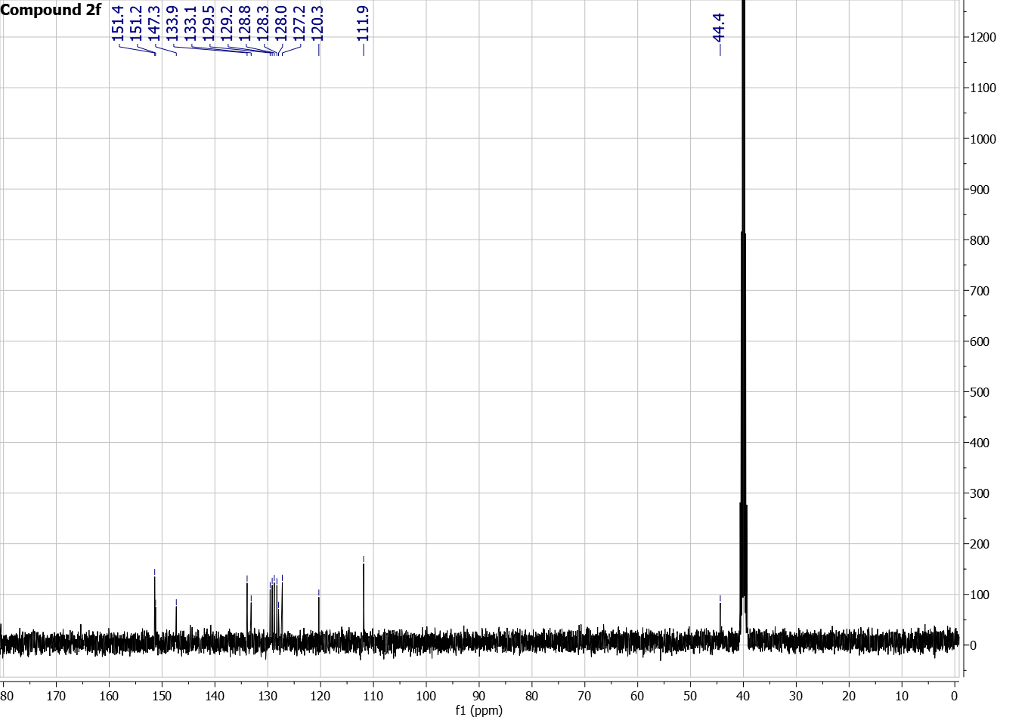
Figure S17: ¹H NMR and ¹³C NMR of compound 2g in DMSO-d₆
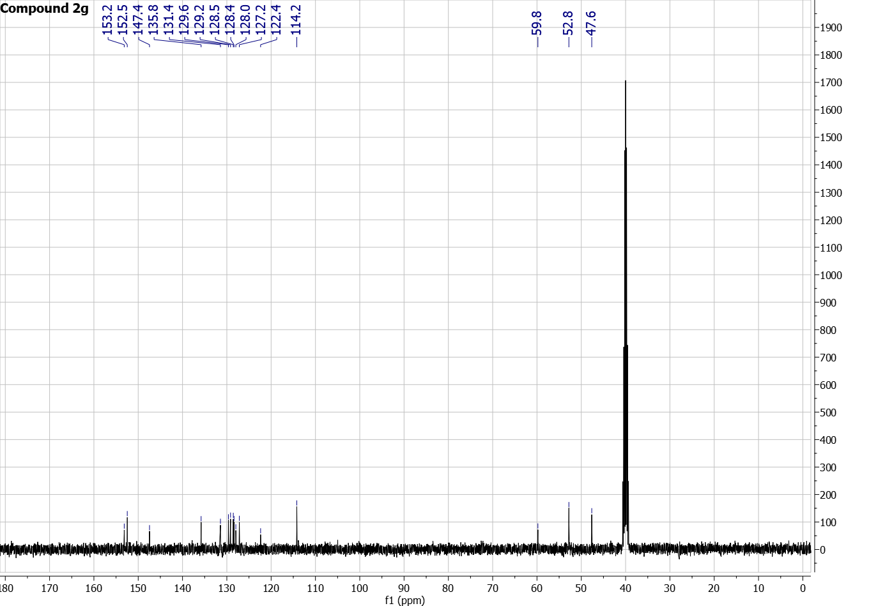
Figure S18: ¹H NMR and ¹³C NMR of compound 1a in CDCl₃-d
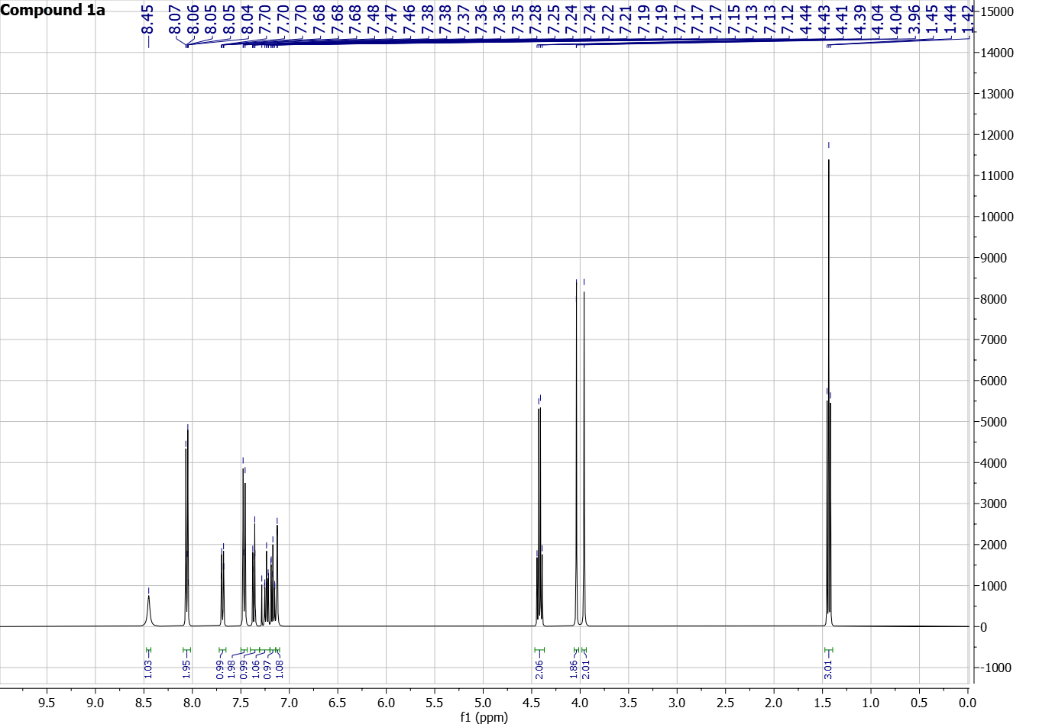
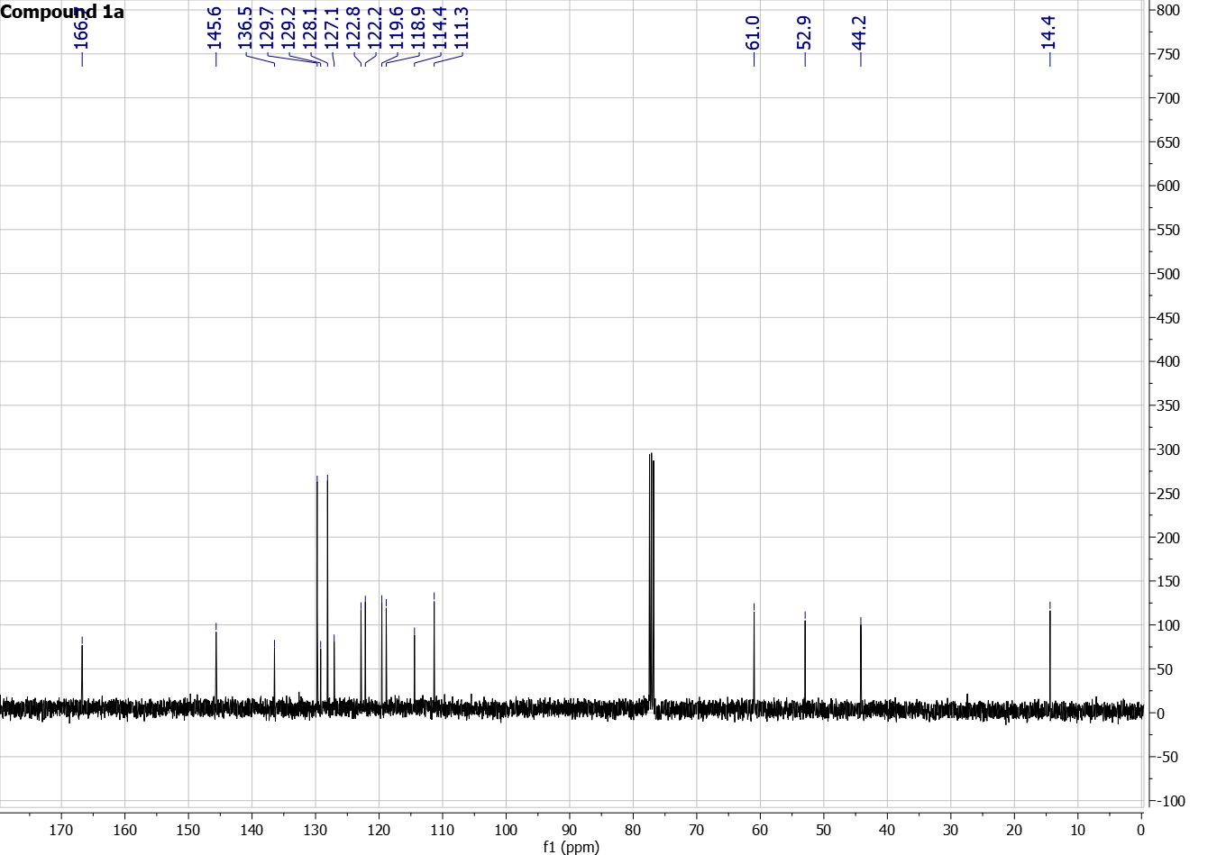

Figure S19: ¹H NMR and ¹³C NMR of compound 1b in CDCl₃-d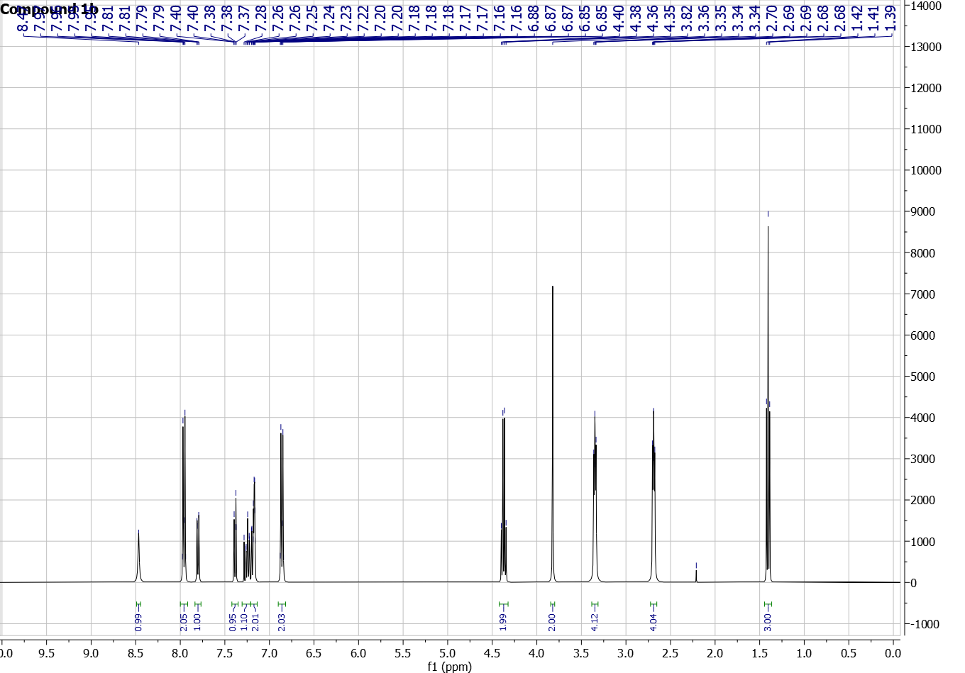
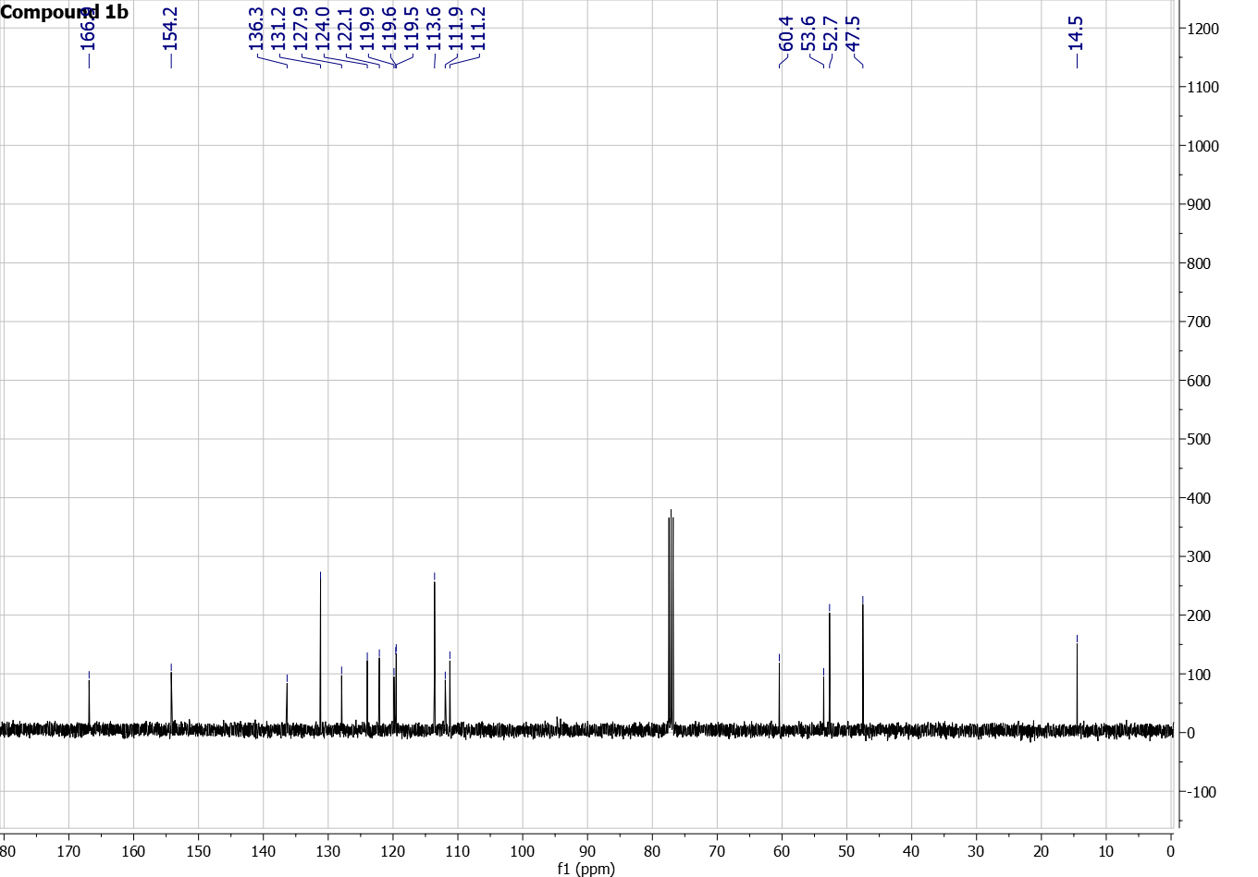
Figure S20: ¹H NMR and ¹³C NMR of compound 1c in CDCl₃-d
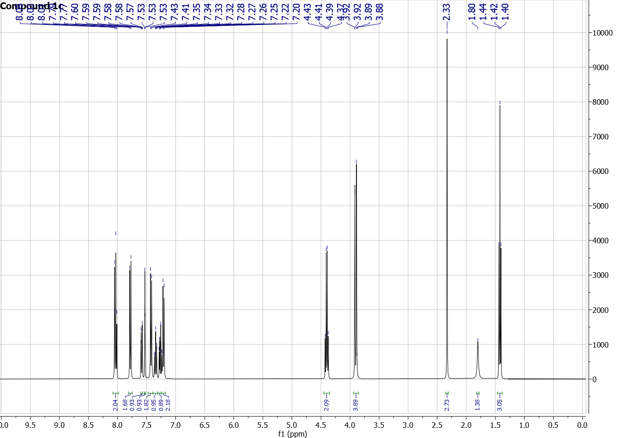
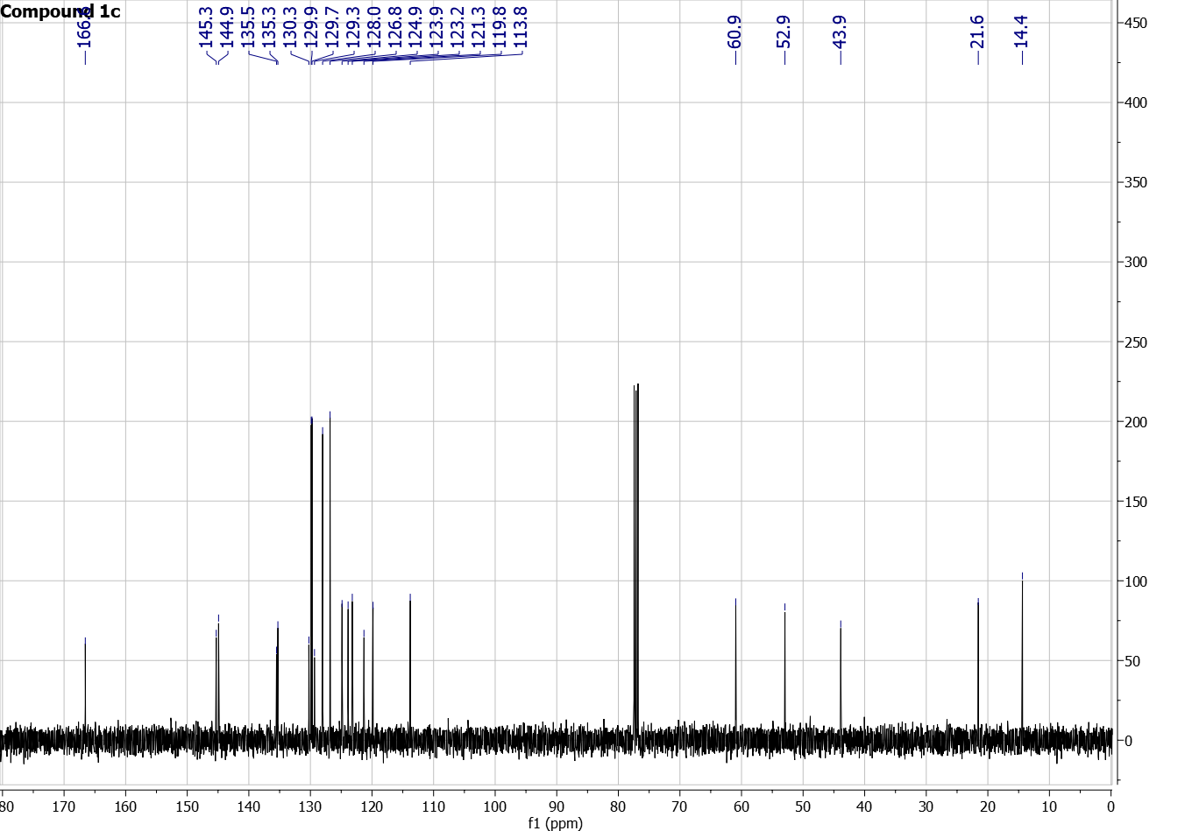
Figure S21: ¹H NMR and ¹³C NMR of compound 1d in CDCl₃-d
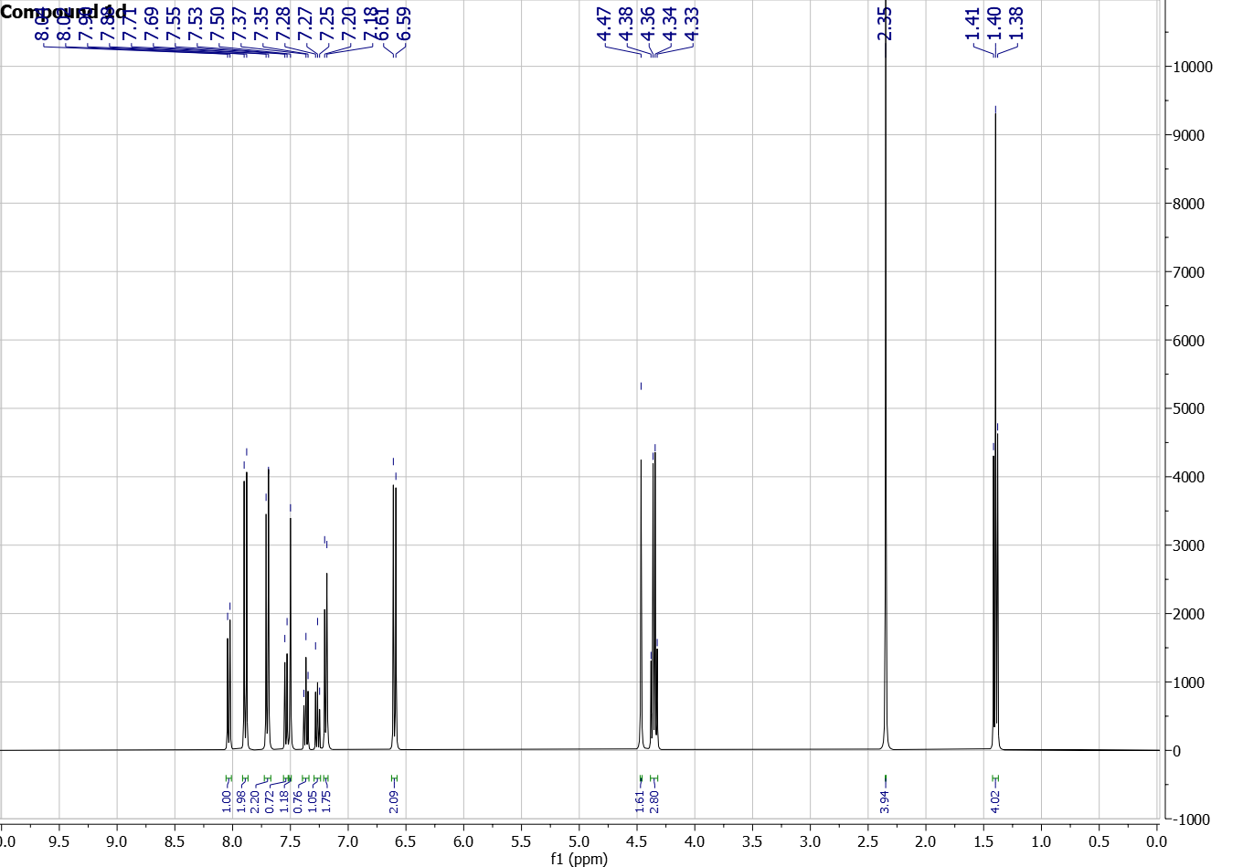
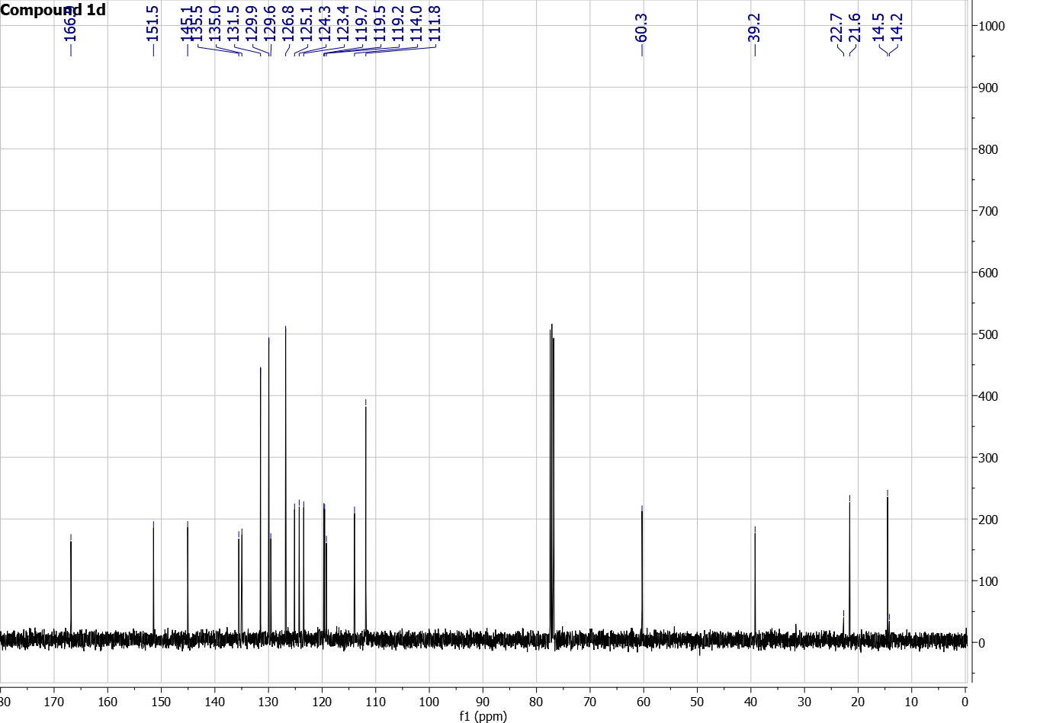
Figure S22: ¹H NMR and ¹³C NMR of compound 1e in CDCl₃-d
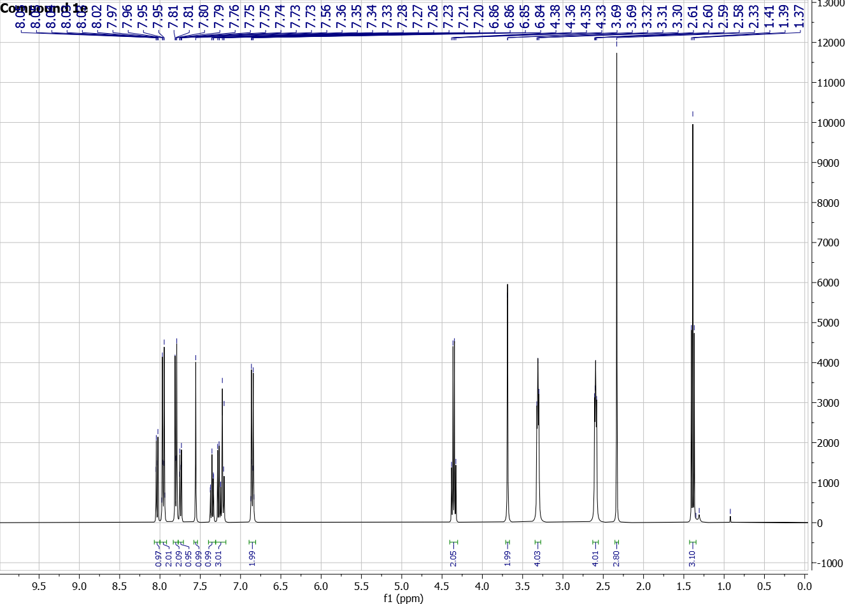
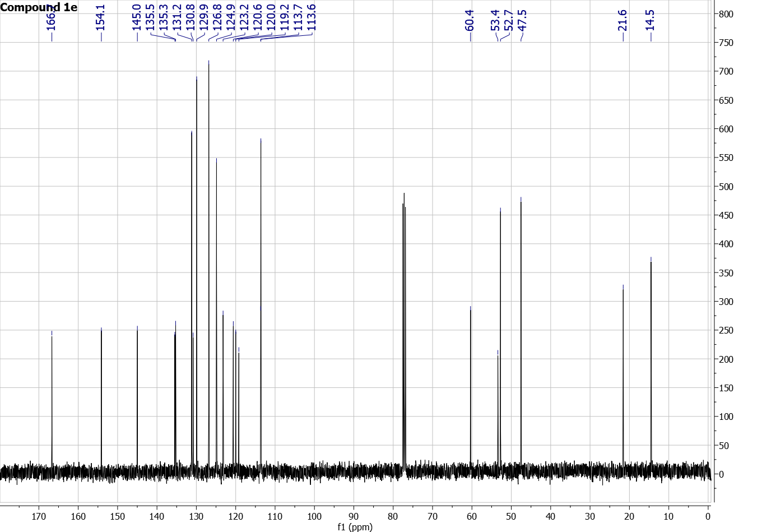
Figure S23: ¹H NMR and ¹³C NMR of compound 1f in CDCl₃-d
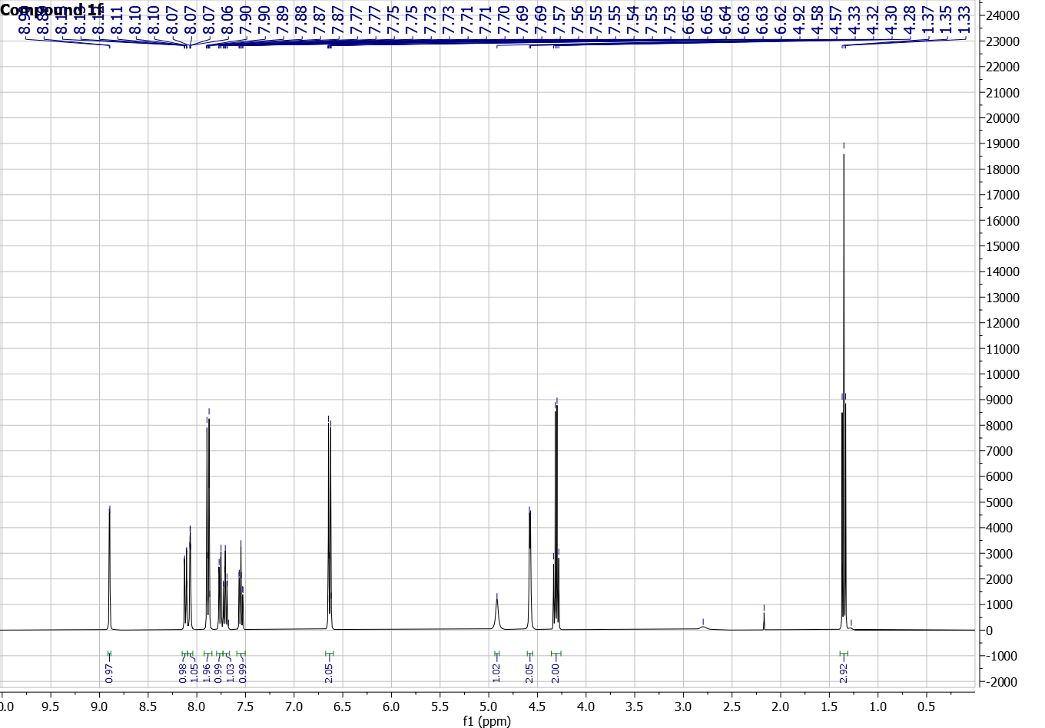
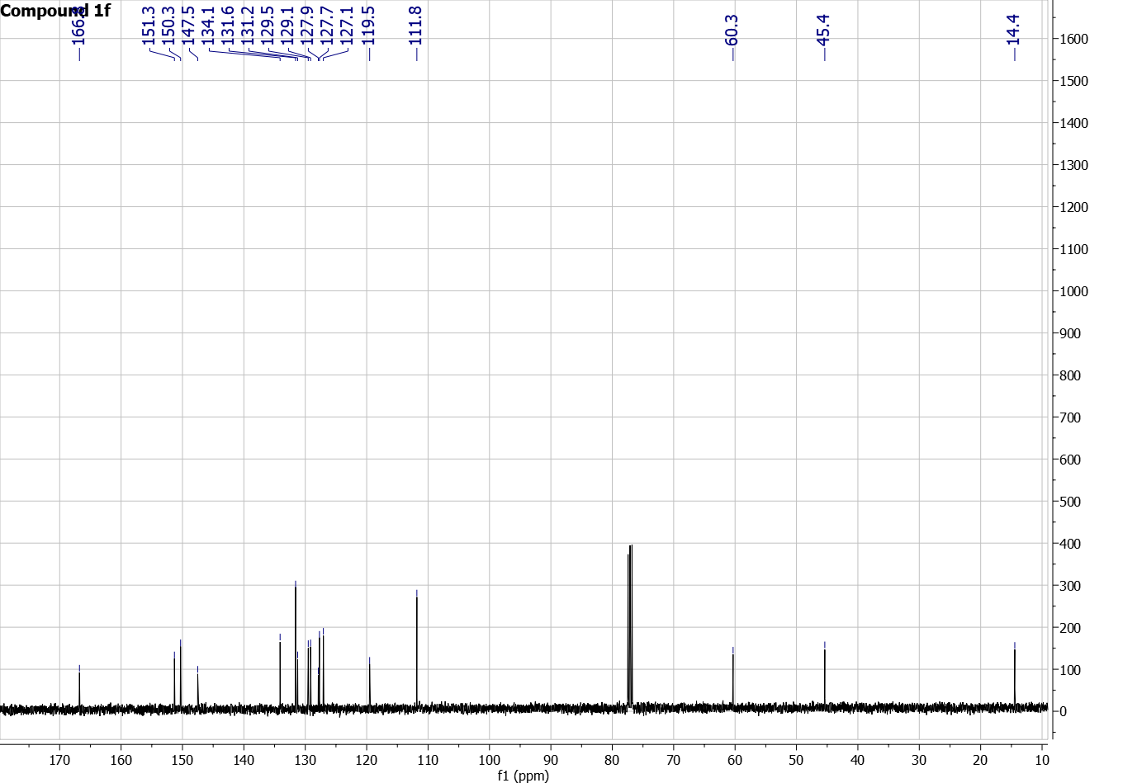

Figure S24: ¹H NMR and ¹³C NMR of compound 1g in CDCl₃-d
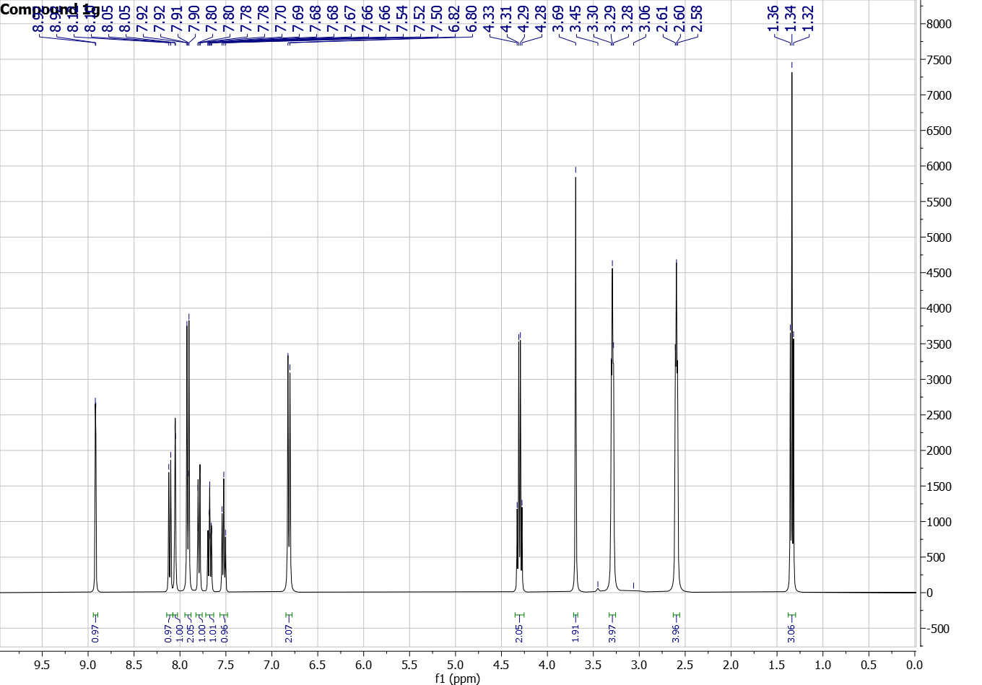
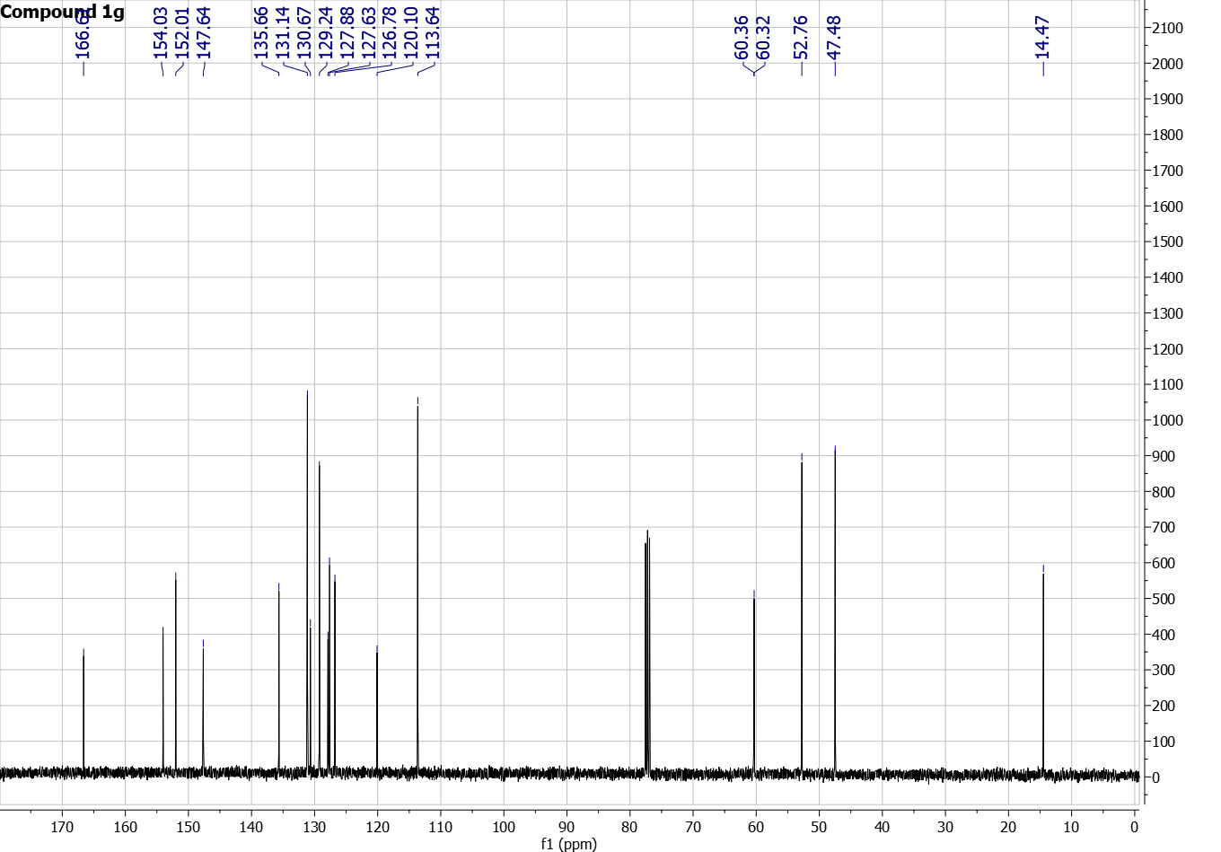
Figure S25: HRMS of compound 1a
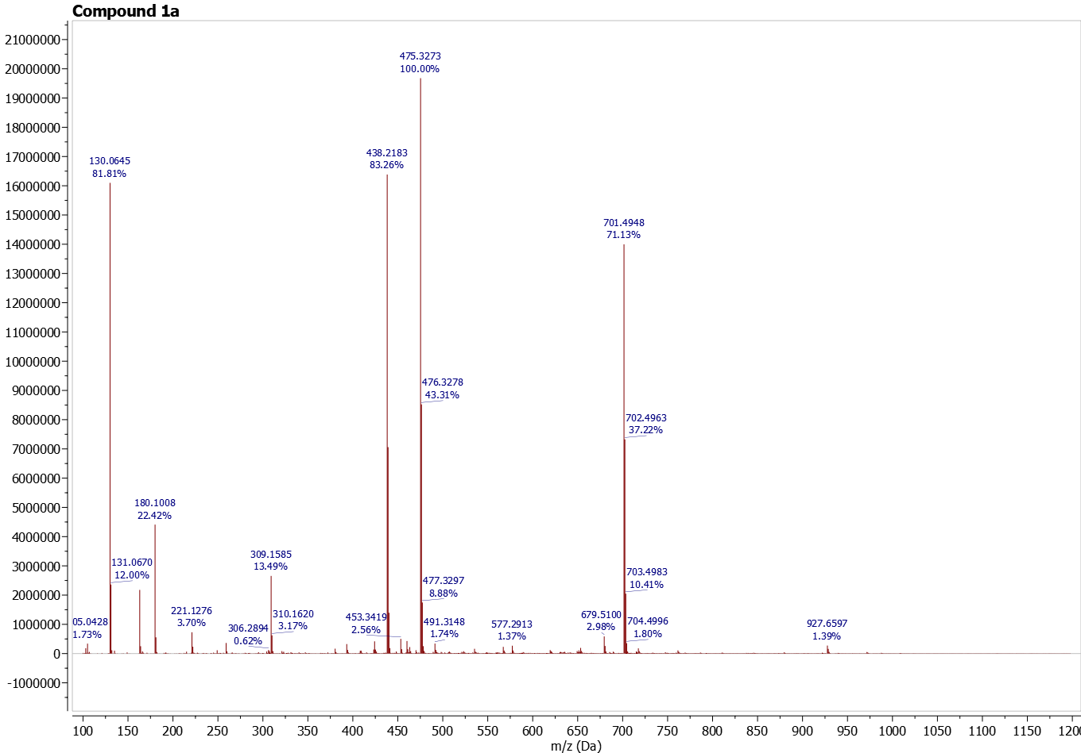
Figure S26: HRMS of compound 1b
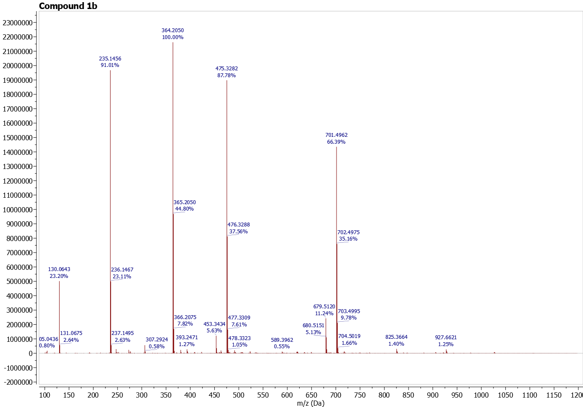
Figure S27: HRMS of compound 1c
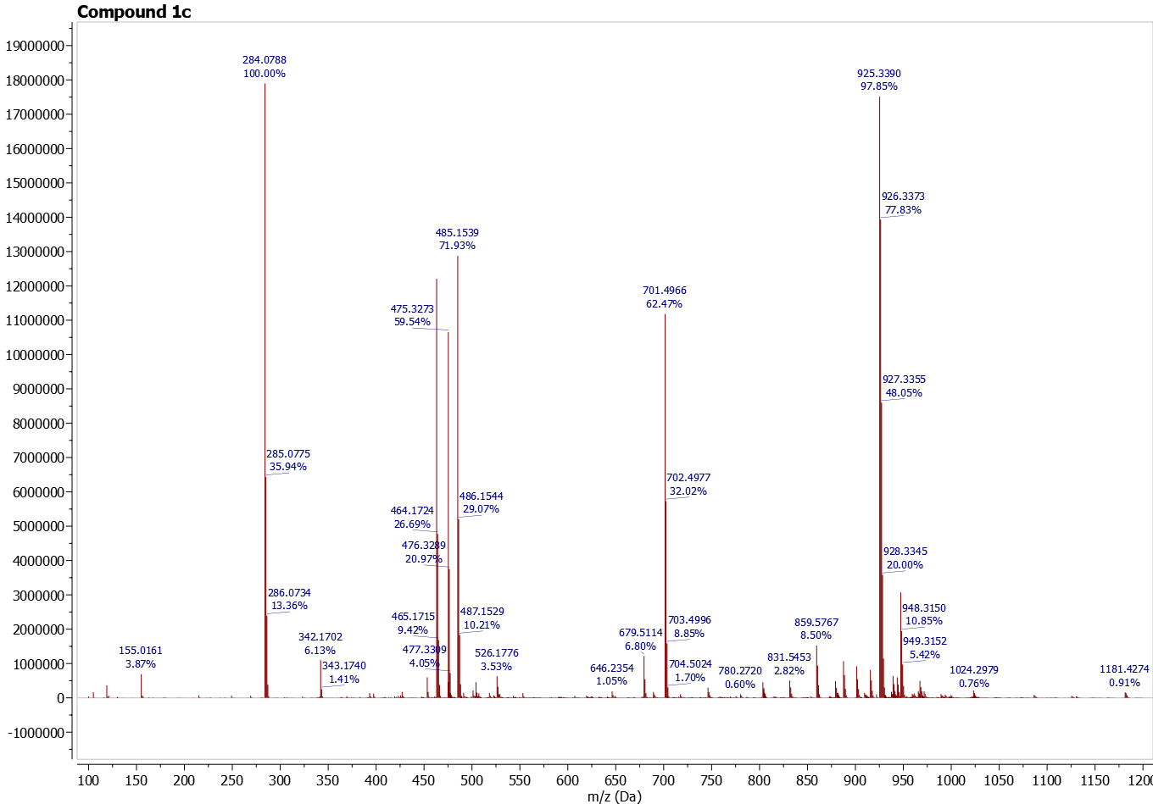
Figure S28: HRMS of compound 1d
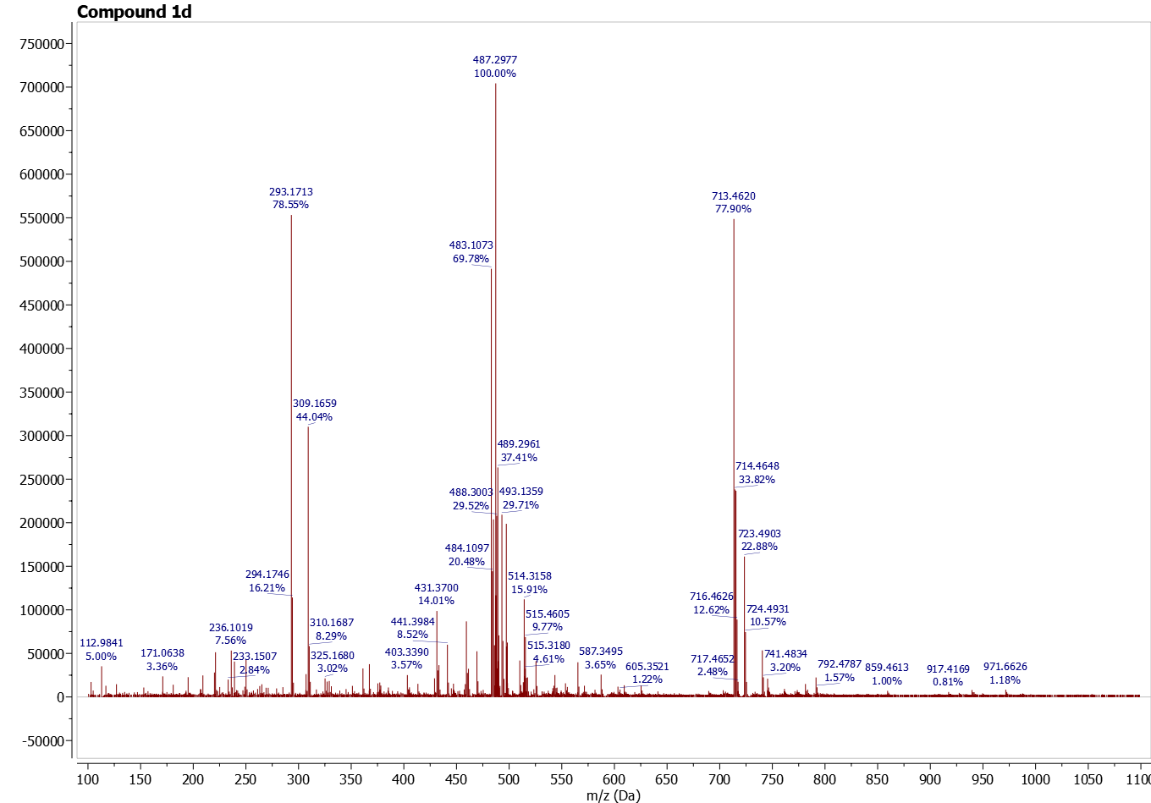

Figure S29: HRMS of compound 1e
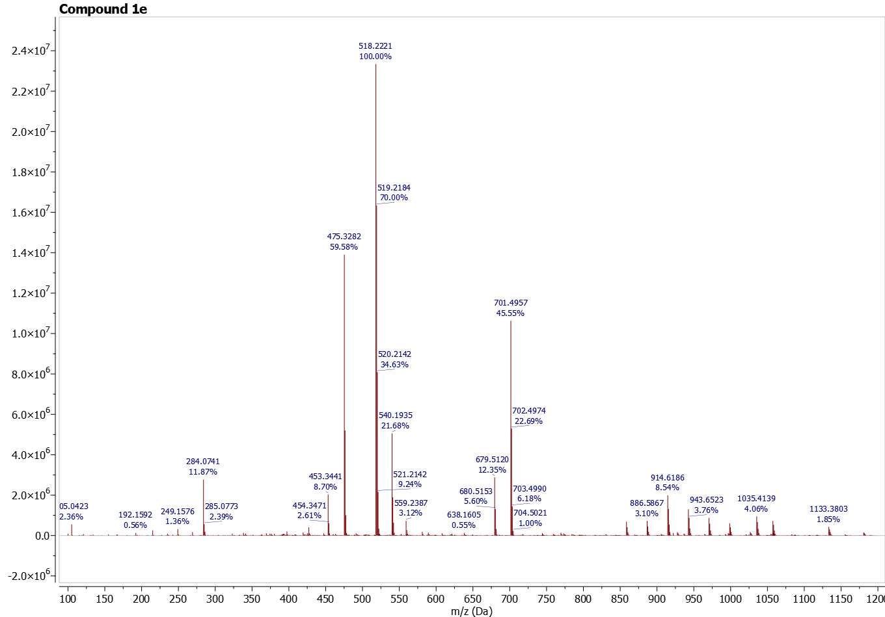
Figure S30: HRMS of compound 1f
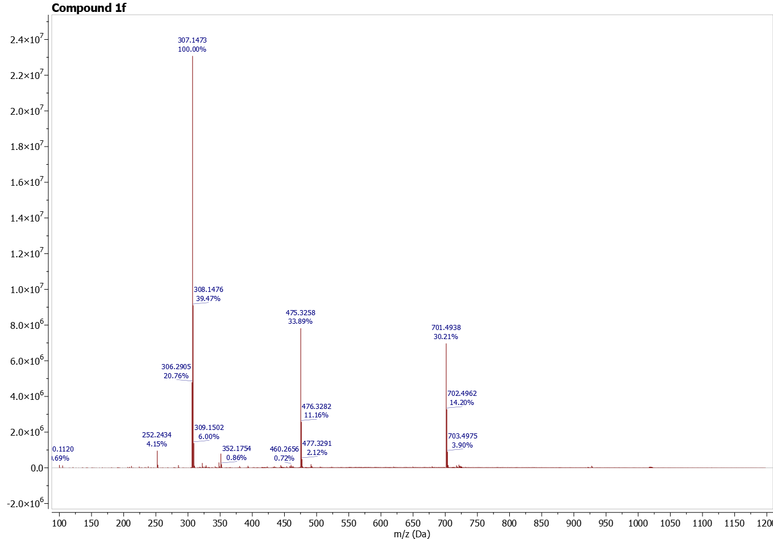
Figure S31: HRMS of compound 1g
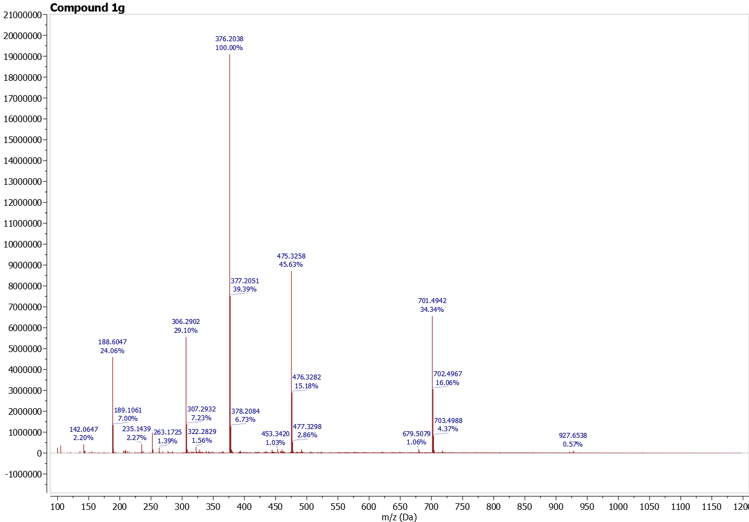
Figure S32: HRMS of compound 2a
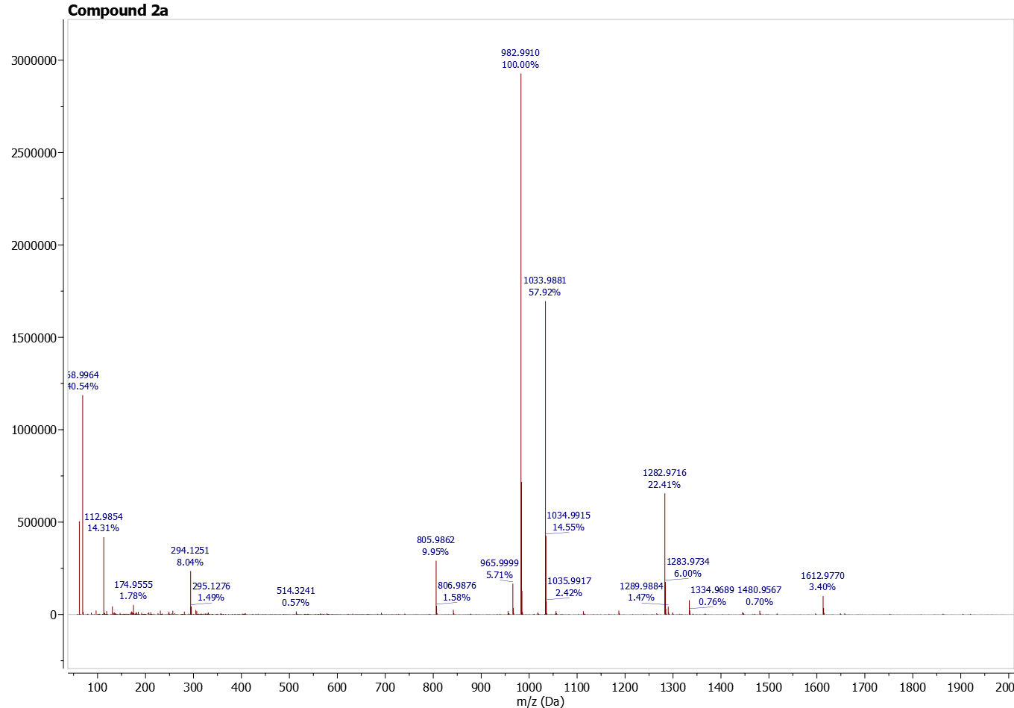

Figure S33: HRMS of compound 2b
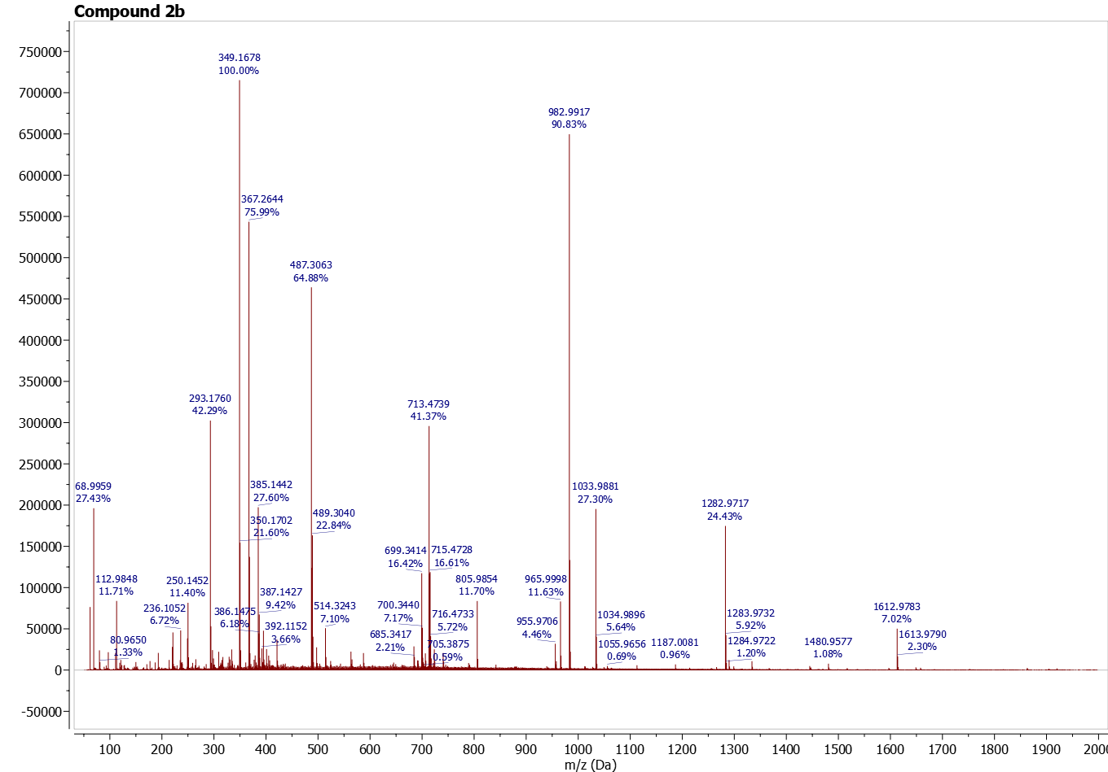
Figure S34: HRMS of compound 2c
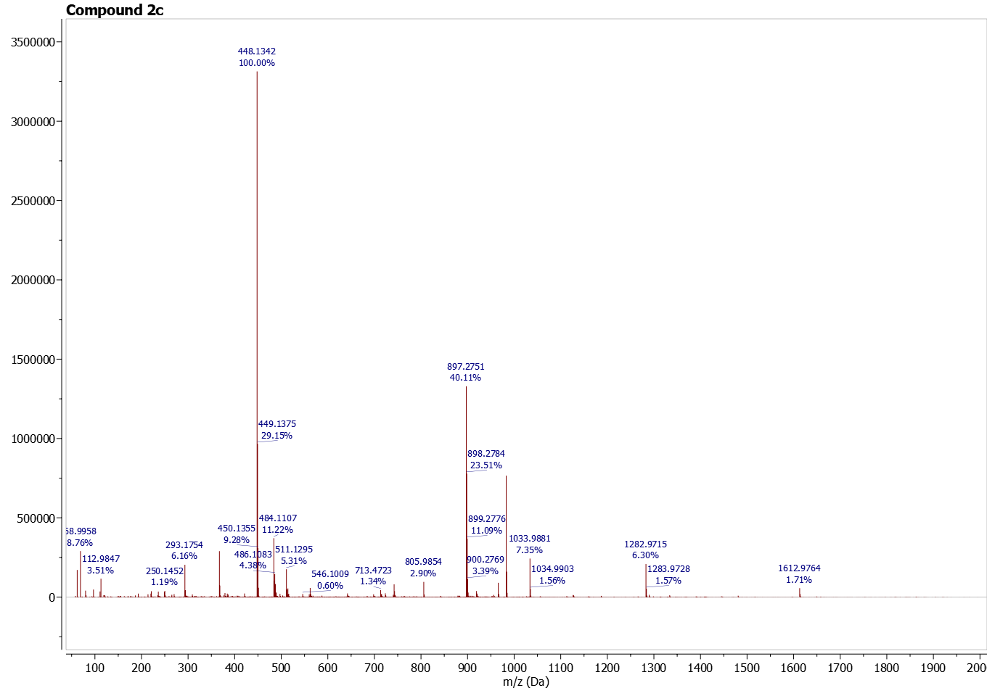
Figure S35: HRMS of compound 2d
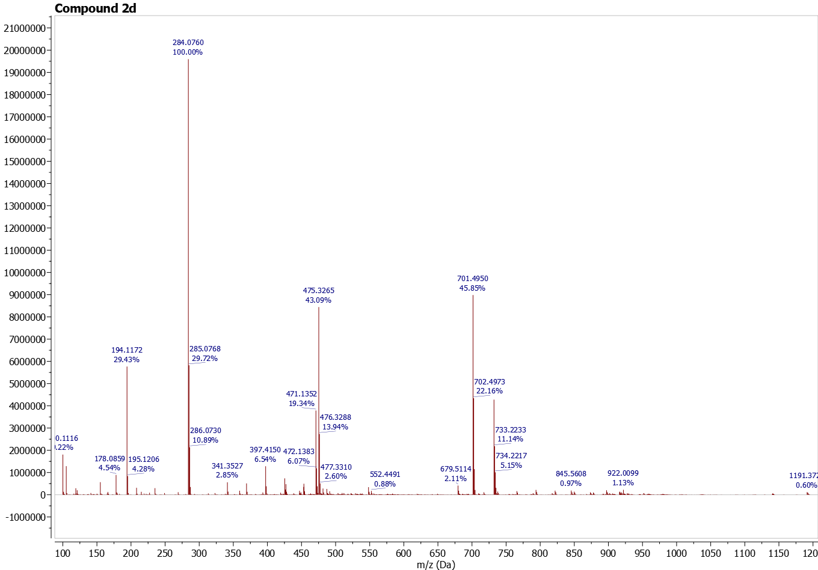
Figure S36: HRMS of compound 2e
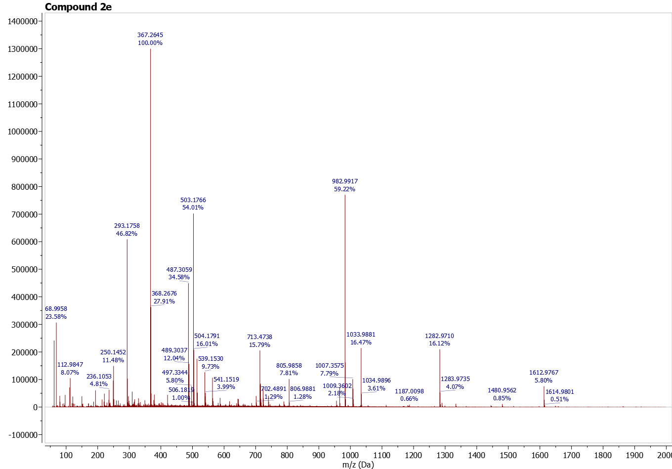

Figure S37: HRMS of compound 2f
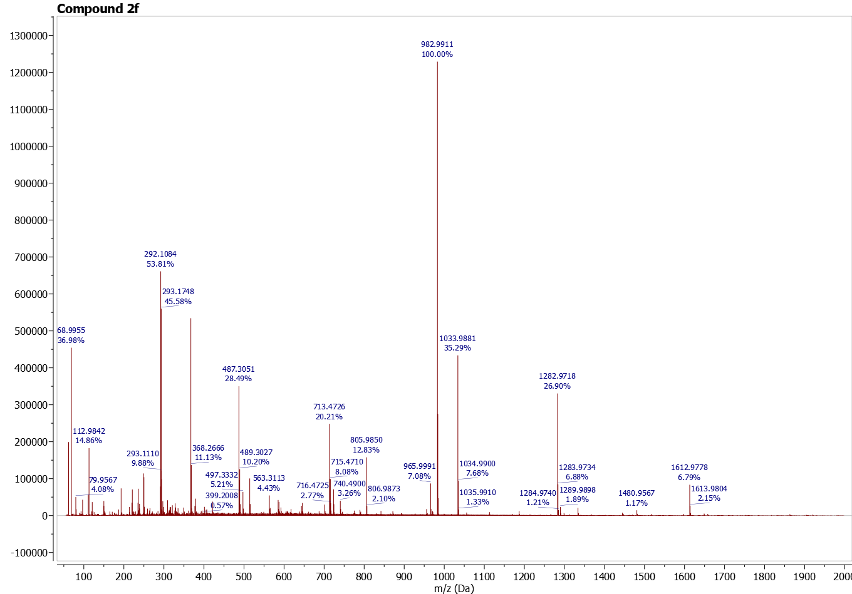
Figure S38: HRMS of compound 2g
