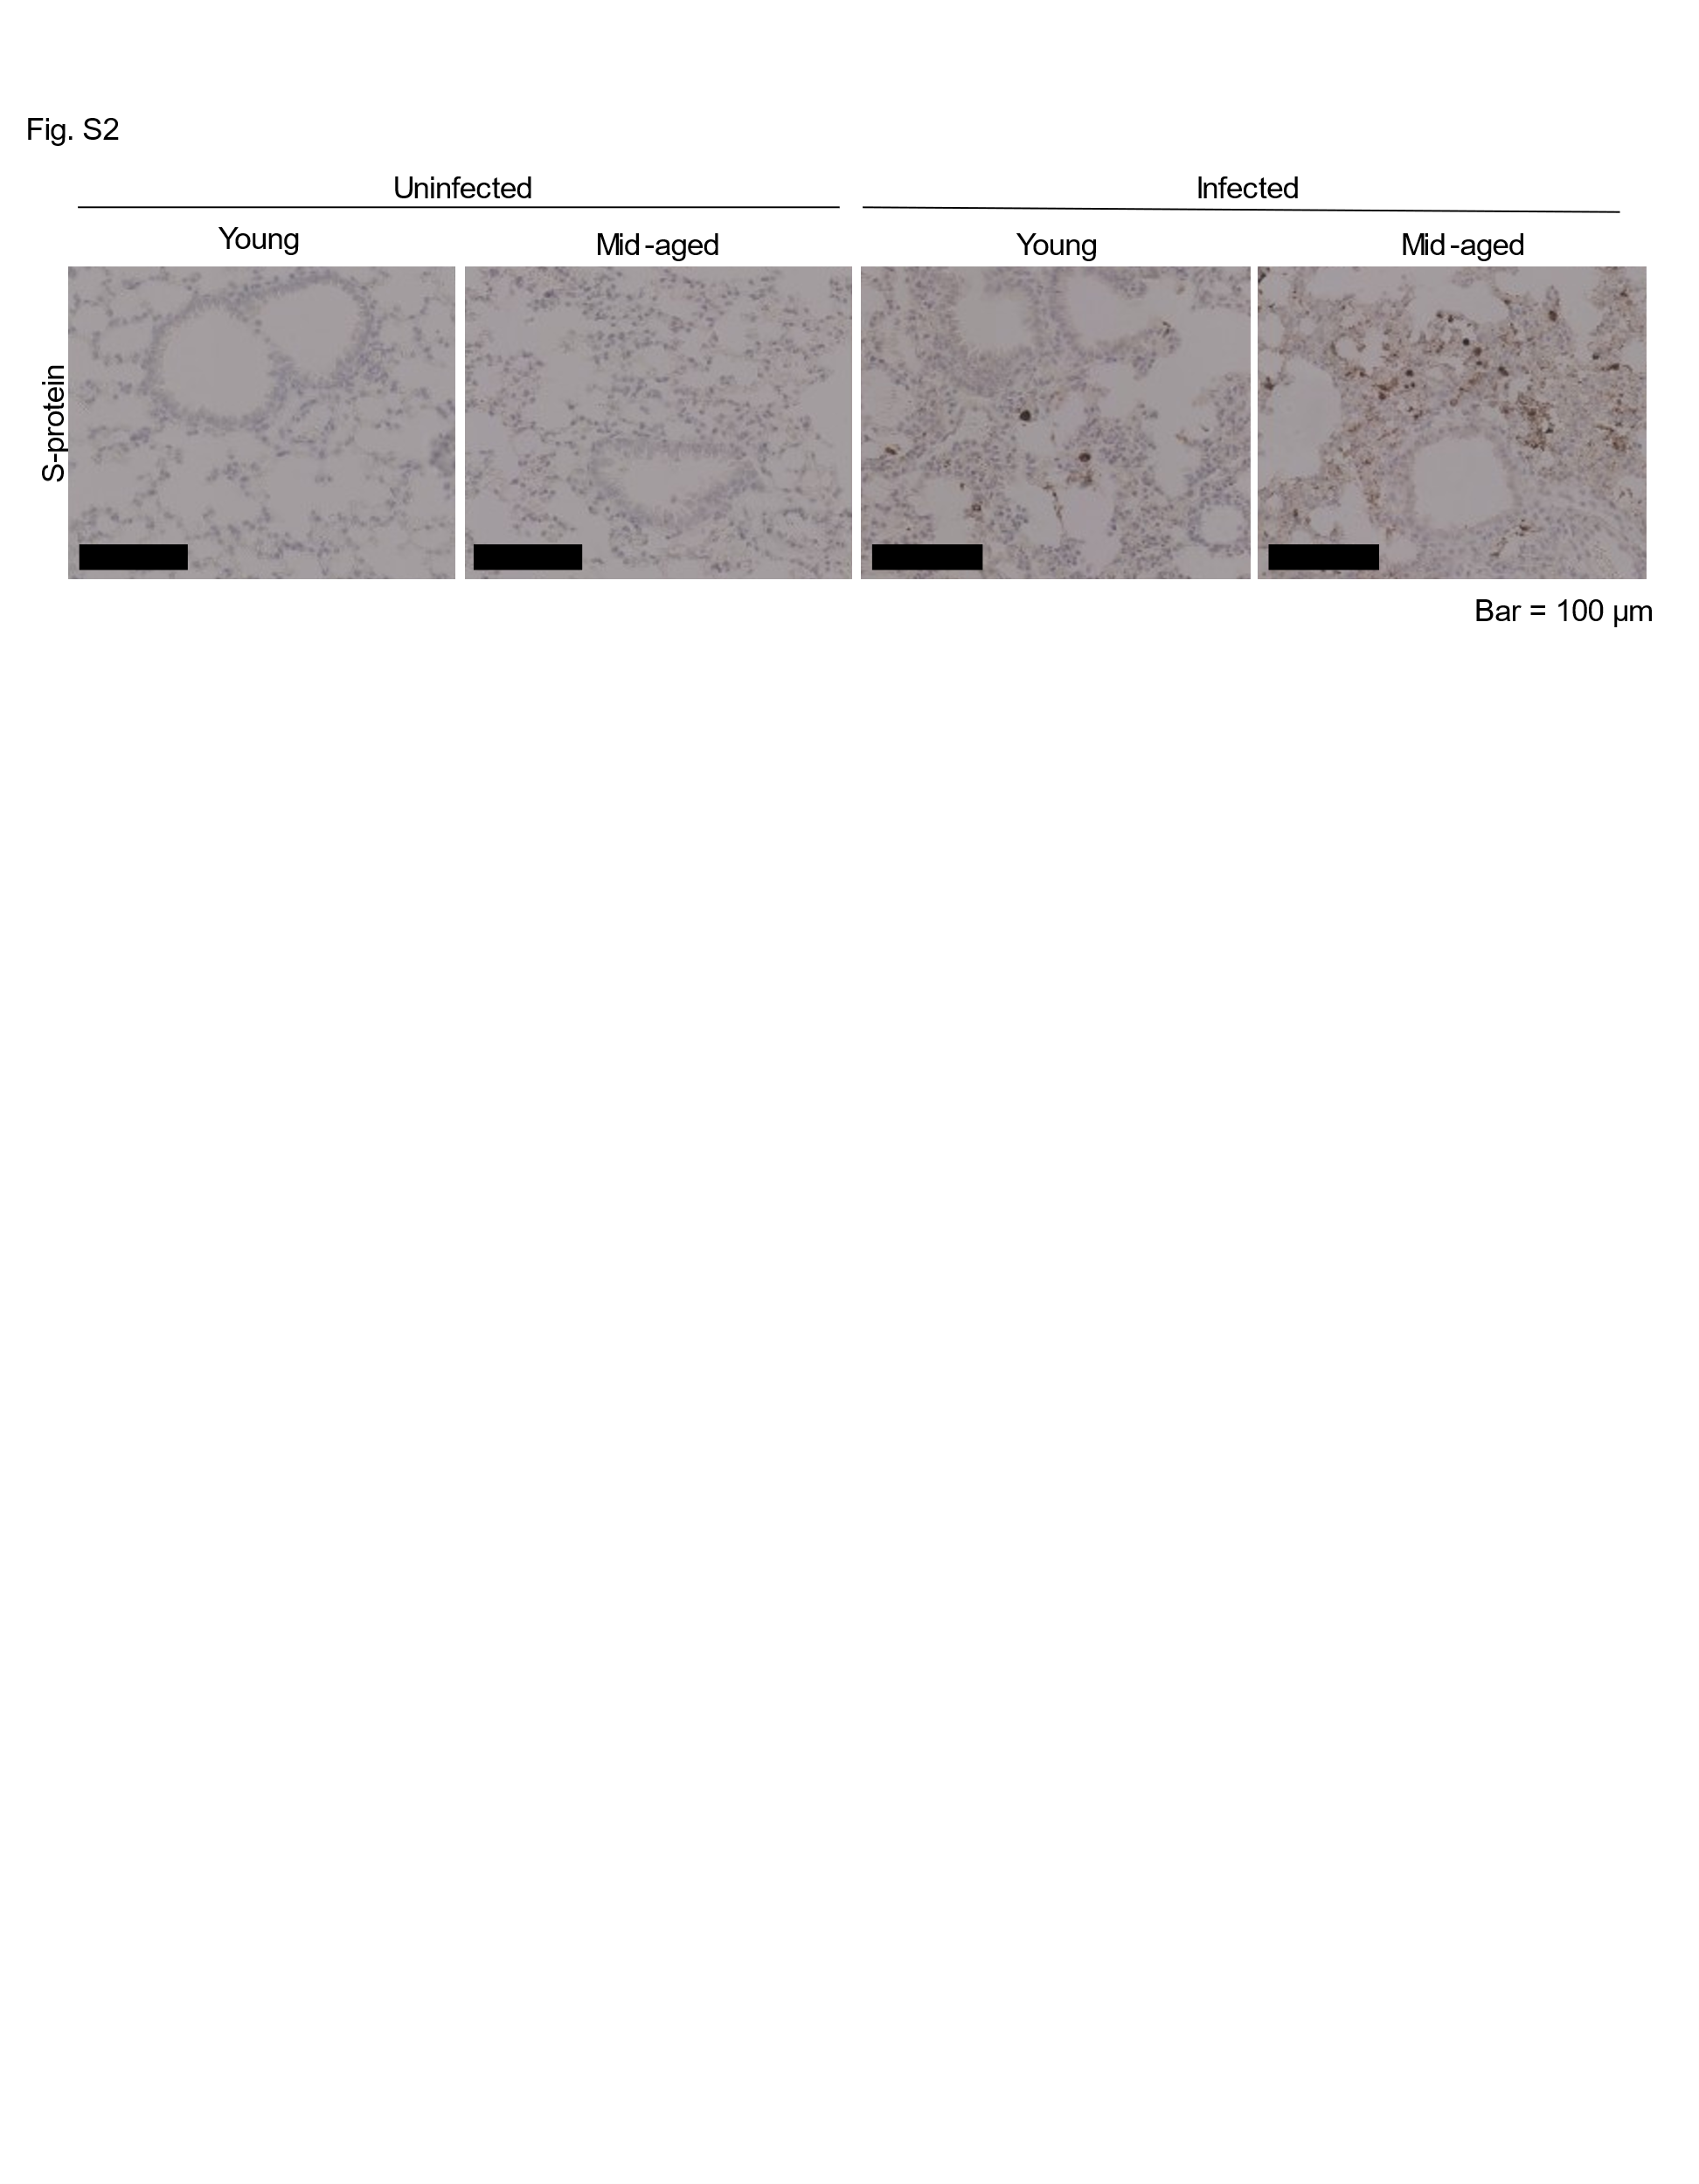Fig. S2 Staining image of S-protein in mouse lungs
Representative immunohistochemical staining images of the S-protein in the lungs of young and mid-aged infected mice. Scale bar = 100 μm.

