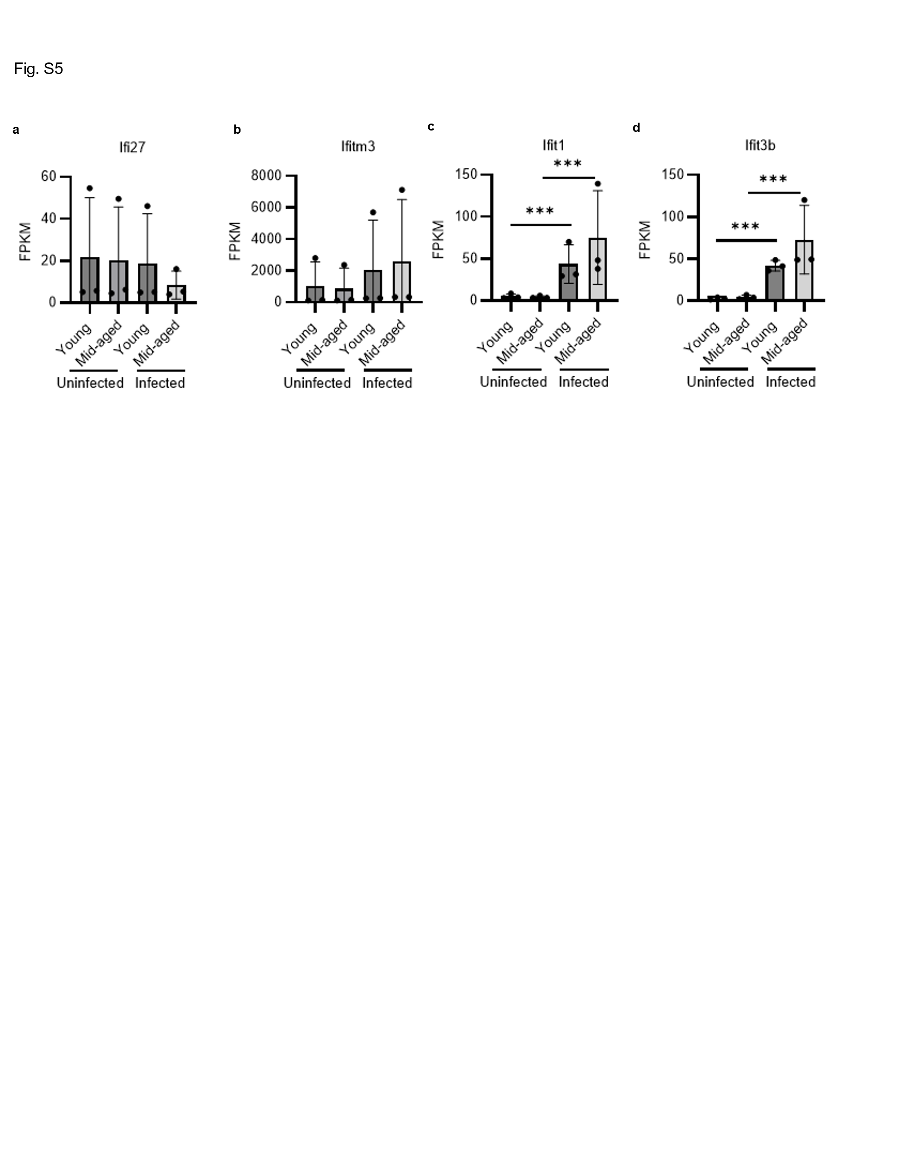
Fig. S5 Expression of platelet-related interferon response genes in pulmonary ECs from infected mice
(a-d) FPKM values of Ifi27 and other platelet-related interferon response genes (Ifitm3, Ifit1, and Ifit3b) in pulmonary ECs from SARS-CoV-2-infected mice. Statistical analysis was conducted using the Wald test, **q-value < 0.01, ***q-value < 0.005 (uninfected young: n = 3; uninfected mid-aged: n = 3; infected young: n = 3; infected mid-aged: n = 3).

