Figure S1
1) Oceanographic campaigns

For this study, seven scientific programs were combined. These were the following:
- “MALIMO program” is located in Madagascar and created by the CETAMADA association and funded by the Western Indian Ocean Marine Science Association (WIOMSA), aiming to establish the first baseline of marine litter beached on the island. Microplastics sampling was carried out on Ste Marie Island (Northeast of Madagascar) in October 2019;
- “Megafauna and plastic debris monitoring program” is undertaken from visual survey onboard the OSIRIS II vessel every three months in the French exclusive economic zone (EEZ) of the Southwest Indian Ocean (SWIO). This corresponds to a partnership between the Direction de la Mer Sud-Océan Indien and Globice Reunion. Sampling was conducted from 2021 to 2023;
- “Plast program” is located in Reunion Island created by IRD, to study pathogens fixed on plastic. Sampling was conducted in October 2021;
- “DEchets MARins Reunion” (DEMARRE) is a quarterly plastic debris monitoring program of the sea surface and on the coastline of Reunion island. Sampling was conducted from 2021 to 2023;
- “South Indian Ocean Mission 1” (SIOM1) is a program set up by The Ocean Cleanup to collect plastic debris in the SWIO during January 2022;
- "Ecole Bleue Outre Mer” is a cruise from University of Reunion island, sampling was done in July 2022;
- “Initiation à l'Océanographie TropicAle” (IOTA) is a cruise from University of Reunion island, sampling was done in October 2022;
- “Microplastics AnD CorAls PathogenS” (MADCAPS) was a project to study plastic debris pathogens in the SWIO, sampling was done during October-November 2022;

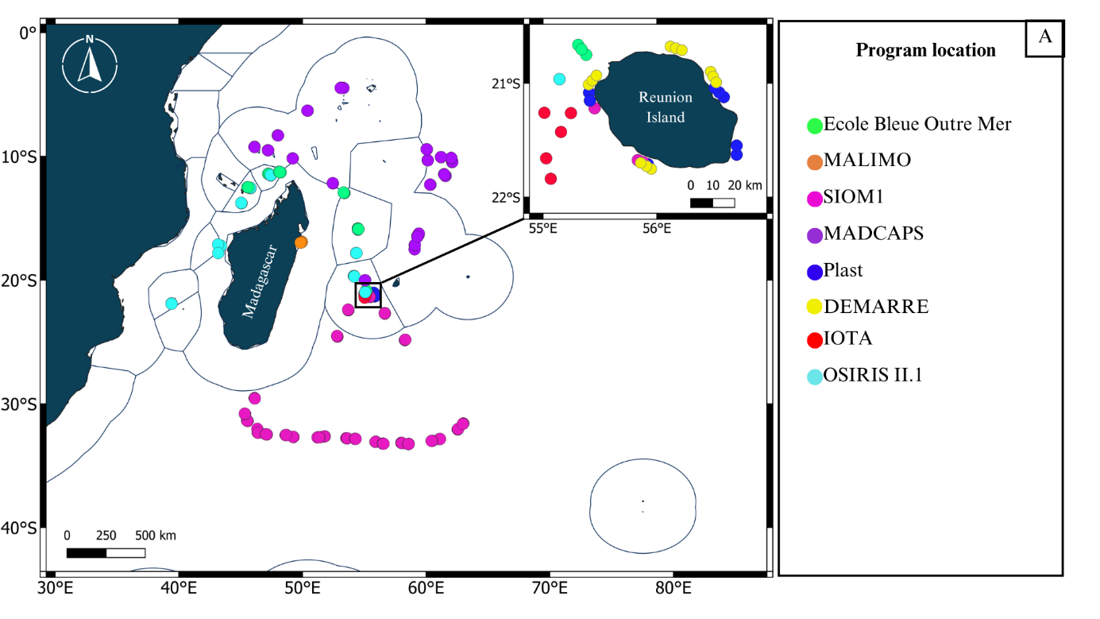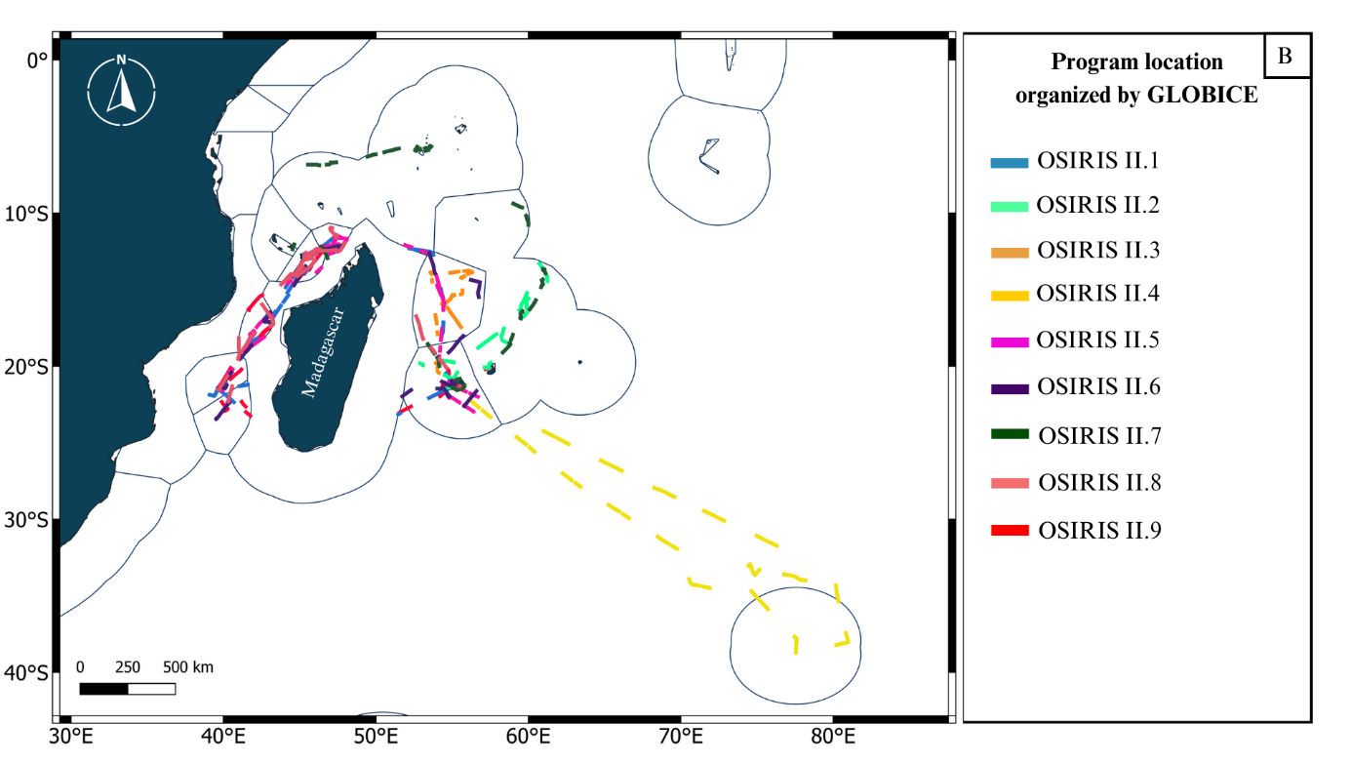

Figure S2. Location of all oceanographic campaigns A) with manta trawling and visual surveys (to note only for DEMARRE project there is not manta trawling) B) organized by the Globice association

Figure S3. Script R _ Normality of datas tests
GAM model to study the variation of the plastic debris concentration
1) For plastic debris collected from visual survey
data=read.csv ("Visual_survey.csv", header = TRUE, sep = ';', dec = ".")
# Normality tests
hist(data$item.km2, breaks = 30, col = "skyblue", main = "Histogram of item.km2", xlab = "item.km2")
qqnorm(data$item.km2, main = "Q-Q Plot of item.km2")
qqline(data$item.km2, col = "red")
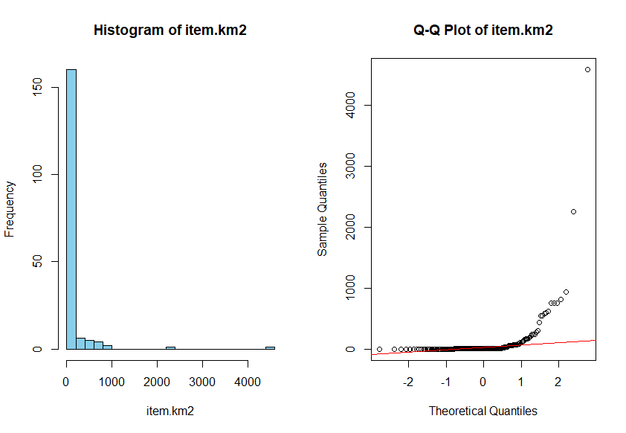
shapiro.test(data$item.km2)
Shapiro-Wilk normality test

data: data$item.km2
W = 0.25425, p-value < 2.2e-16 # datas non normal

2) For plastic debris collected from manta sampling
hist(data$Correction_depthmanta_toc_TOTAL, breaks = 30, col = "skyblue", main = "Histogram of Correction_depthmanta_toc_TOTAL", xlab = "Correction_depthmanta_toc_TOTAL")

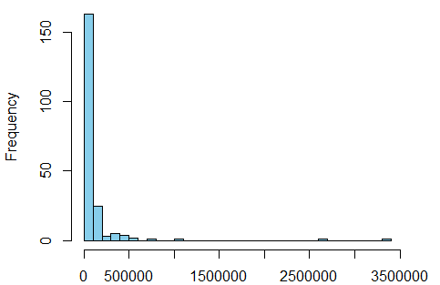

> qqnorm(data$Correction_depthmanta_toc_TOTAL, main = "Q-Q Plot of Correction_depthmanta_toc_TOTAL")
> qqline(data$Correction_depthmanta_toc_TOTAL, col = "red")

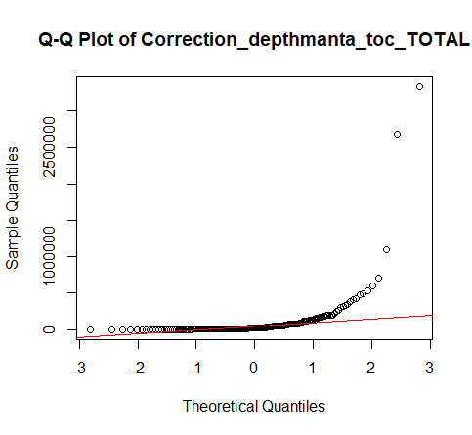
> shapiro.test(data$Correction_depthmanta_toc_TOTAL)

Shapiro-Wilk normality test

data: data$Correction_depthmanta_toc_TOTAL
W = 0.28055, p-value < 2.2e-16 #non normal

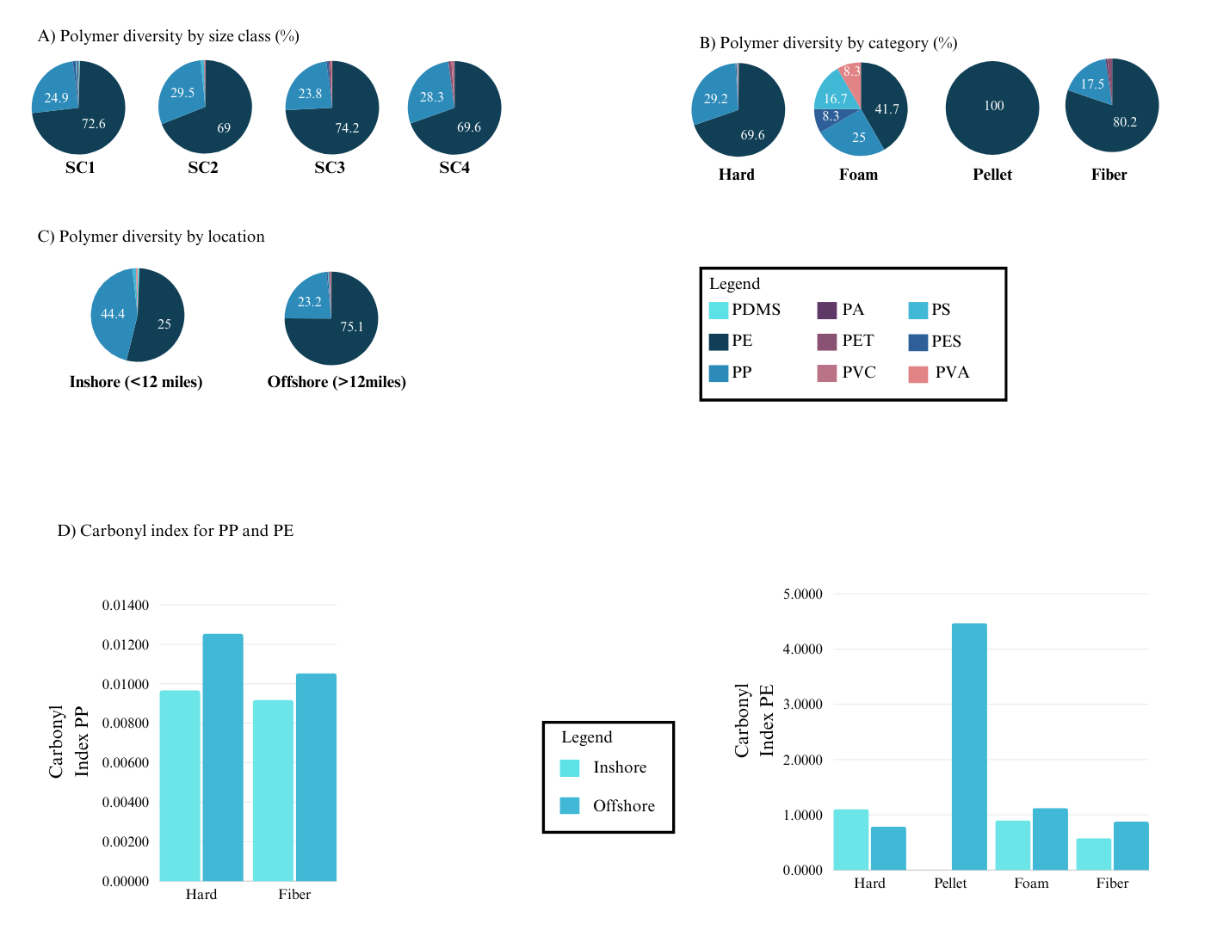

Figure S4. Polymer proportion from plastic debris collected by manta sampling (%) by A) size class (cm): SC1 (0.05-0.15 cm), SC2 (0.15-0.5 cm), SC3 (0.5-1.5 cm), SC4 (1.5-5 cm), B) category: Hard, Foam, Pellet, Fiber, C) location: Inshore (< 12 miles), Offshore (>12 miles). D) Carbonyl Index for polypropylene and polyethylene by location and category. PP (polypropylene), PE (polyethylene), PDMS (polydimethylsiloxane), PES (polyester), PS (polystyrene), PA (polyamide), PET (polyethylene terephthalate), PVC (polyvinyl chloride), PVA (polyvinylacetate)

Figure S5:
1) Modèle GAM for concentration of plastic debris observed from visual survey

gam_model <- gam(item.km2 ~ s(longitude_start) + s(latitude_start)+season + platform_height + sea_state + cloud_coverage,
+ data = data,
+ family = poisson())

summary(gam_model)
Family: poisson
Link function: log

Formula:
item.km2 ~ s(longitude_start) + s(latitude_start) +
season + platform_height + sea_state + cloud_coverage
Family: poisson
Link function: log

Formula:
item.km2 ~ s(longitude_start) + s(latitude_start) + season +
platform_height + sea_state + cloud_coverage

Parametric coefficients:
Estimate Std. Error z value Pr(>|z|)
(Intercept) 5.42851 0.12303 44.123 < 2e-16 ***
seasonInterseason 1.52387 0.03285 46.393 < 2e-16 ***
seasonWet 2.09448 0.03620 57.865 < 2e-16 ***
platform_height03_05 -6.58594 0.57870 -11.381 < 2e-16 ***
platform_height05_08 -6.03571 0.15278 -39.507 < 2e-16 ***
platform_height08_12 -6.37682 0.19634 -32.478 < 2e-16 ***
sea_state -0.75567 0.02188 -34.530 < 2e-16 ***
cloud_coveragelight 1.85903 0.09009 20.635 < 2e-16 ***
cloud_coveragenone 0.55647 0.09152 6.080 1.2e-09 ***
cloud_coveragevery cloudy -1.19311 0.12466 -9.571 < 2e-16 ***
---
Signif. codes: 0 ‘***’ 0.001 ‘**’ 0.01 ‘*’ 0.05 ‘.’ 0.1 ‘ ’ 1

Approximate significance of smooth terms:
edf Ref.df Chi.sq p-value
s(longitude_start) 8.979 9 3321 <2e-16 ***
s(latitude_start) 8.997 9 6920 <2e-16 ***
---
Signif. codes: 0 ‘***’ 0.001 ‘**’ 0.01 ‘*’ 0.05 ‘.’ 0.1 ‘ ’ 1

R-sq.(adj) = 0.72 Deviance explained = 65.9%
UBRE = 144.76 Scale est. = 1 n = 178

par(mfrow = c(2, 2)) # Organisation des graphiques
plot(gam_model, pages = 1, se = TRUE, rug = TRUE)
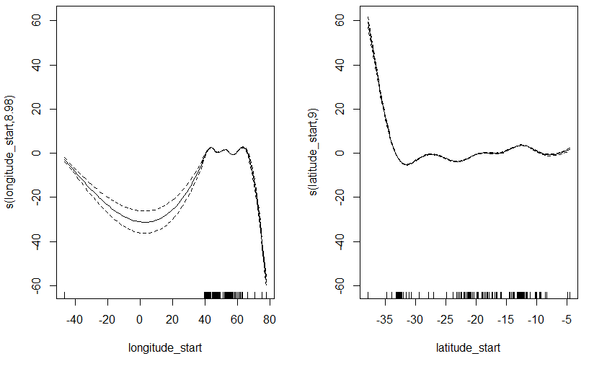

> full_model <- gam(item.km2 ~ s(longitude_start) + s(latitude_start) +
Campaign + season + platform_height + sea_state + cloud_coverage,
+ family = poisson(link = "log"), data = data)

# We deleted latitude_start variable as they had not significativity and to improve the AIC criteria

# Simplified model without latitude variable
> reduced_model <- gam(item.km2 ~ s(longitude_start) + season + sea_state +
+ cloud_coverage,
+ family = poisson(link = "log"), data = data)
> # Comparison of two models
> anova(full_model, reduced_model, test = "Chisq")

Analysis of Deviance Table

Model 1: item.km2 ~ s(longitude_start) + s(latitude_start) + season +
platform_height + sea_state + cloud_coverage
Model 2: item.km2 ~ s(longitude_start) + season + sea_state + cloud_coverage
Resid. Df Resid. Dev Df Deviance Pr(>Chi)
1 150 25890
2 162 41635 -12.001 -15746 < 2.2e-16 ***
---
Signif. codes: 0 ‘***’ 0.001 ‘**’ 0.01 ‘*’ 0.05 ‘.’ 0.1 ‘ ’ 1
> AIC(full_model, reduced_model)
df AIC
full_model 27.97553 26550.22
reduced_model 15.95284 42271.62

2) Modele GAM for concentration of plastic debris collected from manta sampling
gam_model <- gam(
+ Correction_depthmanta_toc_TOTAL ~ s(Long) + s(Lat) + Season + Distance,
+ data = data,
+ family = poisson() # Ajuste selon la nature des données de la réponse
+ )
# Résumé du modèle
summary(gam_model)

Family: poisson
Link function: log

Formula:
Correction_depthmanta_toc_TOTAL ~ s(Long) + s(Lat) + Season +
Distance

Parametric coefficients:
Estimate Std. Error z value Pr(>|z|)
(Intercept) 12.8533435 0.0008827 14561 <2e-16 ***
SeasonInterseason1 -4.0798971 0.0107640 -379 <2e-16 ***
SeasonInterseason2 -0.9708912 0.0007108 -1366 <2e-16 ***
SeasonWet -3.2264702 0.0019099 -1689 <2e-16 ***
DistanceOnshore -1.6414203 0.0007915 -2074 <2e-16 ***
---
Signif. codes: 0 ‘***’ 0.001 ‘**’ 0.01 ‘*’ 0.05 ‘.’ 0.1 ‘ ’ 1

Approximate significance of smooth terms:
edf Ref.df Chi.sq p-value
s(Long) 8.984 9 5113798 <2e-16 ***
s(Lat) 8.982 9 5544675 <2e-16 ***
---
Signif. codes: 0 ‘***’ 0.001 ‘**’ 0.01 ‘*’ 0.05 ‘.’ 0.1 ‘ ’ 1

R-sq.(adj) = 0.416 Deviance explained = 46.3%
UBRE = 1.5813e+05 Scale est. = 1 n = 206

# Visualisation des effets lissés
> par(mfrow = c(2, 2)) # Organisation des graphiques
> plot(gam_model, pages = 1, se = TRUE, rug = TRUE) # Visualisation des splines

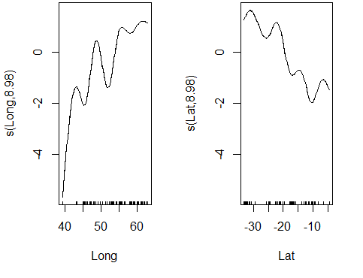
reduced_model <- gam(Correction_depthmanta_toc_TOTAL ~ s(Long) + Season + Distance
+ ,
+ family = poisson(link = "log"), data = data)
# Résumé du modèle
> summary(reduced_model)

Family: poisson
Link function: log

Formula:
Correction_depthmanta_toc_TOTAL ~ s(Long) + Season + Distance

Parametric coefficients:
Estimate Std. Error z value Pr(>|z|)
(Intercept) 12.0147013 0.0006845 17552 <2e-16 ***
SeasonInterseason1 -3.7452254 0.0107625 -348 <2e-16 ***
SeasonInterseason2 -0.9859353 0.0007144 -1380 <2e-16 ***
SeasonWet -1.3121901 0.0008175 -1605 <2e-16 ***
DistanceOnshore -1.1449404 0.0005988 -1912 <2e-16 ***
---
Signif. codes: 0 ‘***’ 0.001 ‘**’ 0.01 ‘*’ 0.05 ‘.’ 0.1 ‘ ’ 1

Approximate significance of smooth terms:
edf Ref.df Chi.sq p-value
s(Long) 8.986 9 12163778 <2e-16 ***
---
Signif. codes: 0 ‘***’ 0.001 ‘**’ 0.01 ‘*’ 0.05 ‘.’ 0.1 ‘ ’ 1

R-sq.(adj) = 0.201 Deviance explained = 35.6%
UBRE = 1.8953e+05 Scale est. = 1 n = 206

# Comparaison des deux modèles
anova(full_model, reduced_model, test = "Chisq")
Analysis of Deviance Table

Model 1: Correction_depthmanta_toc_TOTAL ~ s(Long) + s(Lat) + Season +
Distance
Model 2: Correction_depthmanta_toc_TOTAL ~ s(Long) + Season + Distance
Resid. Df Resid. Dev Df Deviance Pr(>Chi)
1 183 32574835
2 192 39043577 -8.9999 -6468741 < 2.2e-16 ***
---
Signif. codes: 0 ‘***’ 0.001 ‘**’ 0.01 ‘*’ 0.05 ‘.’ 0.1 ‘ ’ 1

