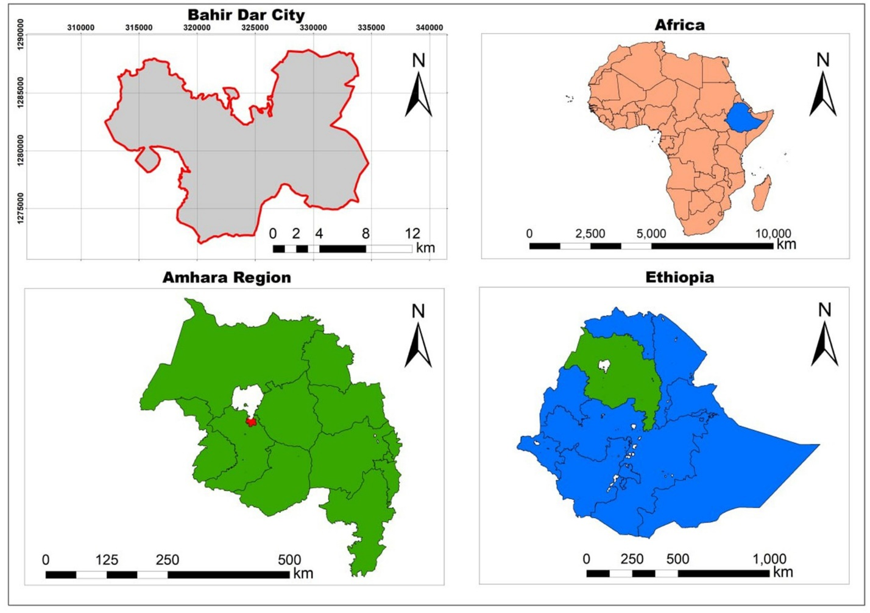
Figure S1: Map of the study area, Bahir Dar city, Northwest Ethiopia [26]

