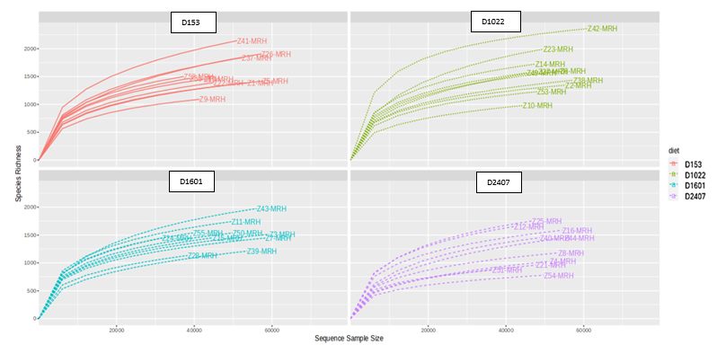
Figure S1. Rarefaction plot showing the total number of raw sequences reads and richness obtained per sample and dietary group.

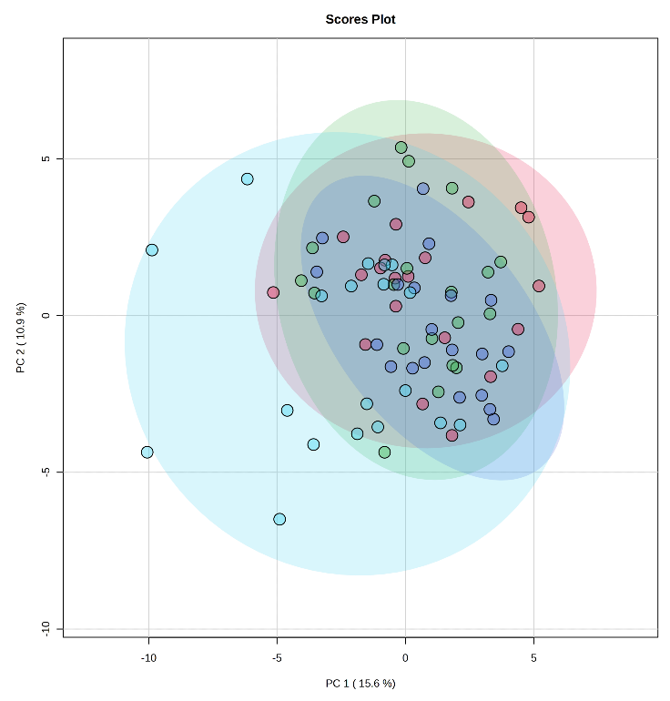
(a)
Figure S2. PCA Score plots, positive (a) and negative (b) modes.
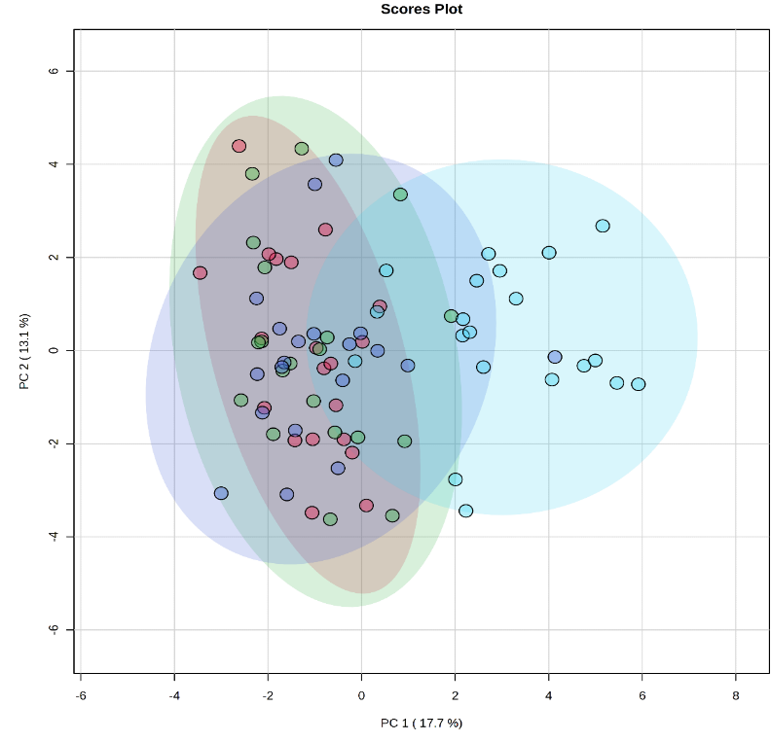
(b)
D153
D1022
D1601
D2407

