Supplementary material 1

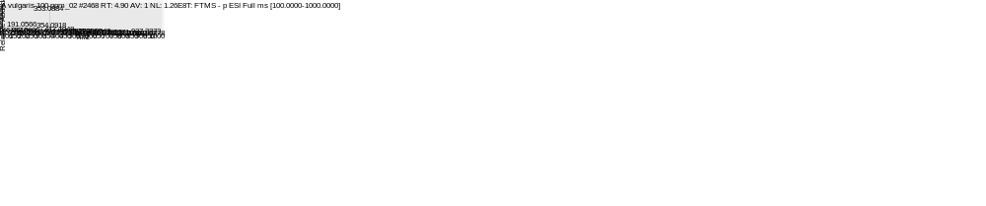
A
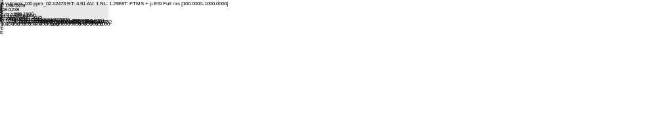
B
Figure S1 Mass spectra at retention time 4.850 min detected with (A) full scan at 100-1000 m/z with negative mode and (B) full scan at 100-1000 m/z with positive mode.

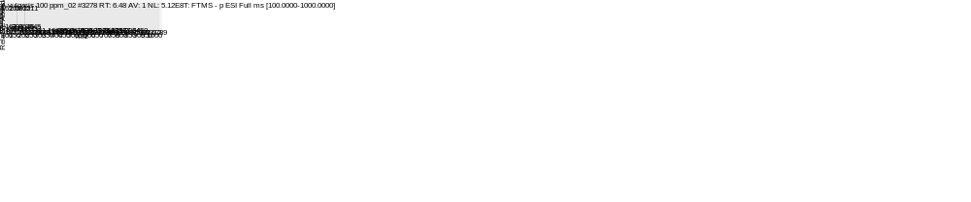
A
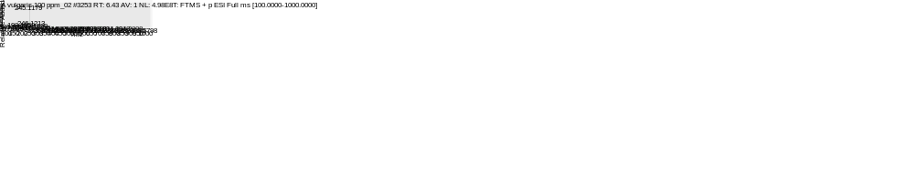 Figure S2 Mass spectra at retention time 6.407 min detected with (A) full scan at 100-1000 m/z with negative mode and (B) full scan at 100-1000 m/z with positive mode.
B

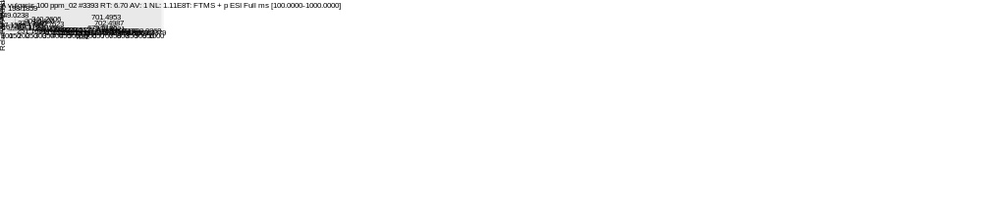
A
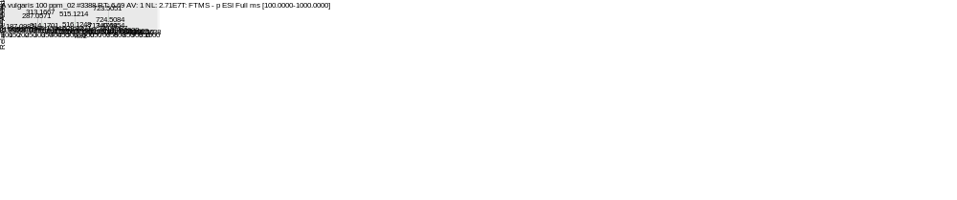
B
Figure S3 Mass spectra at retention time 6.520 min detected with (A) full scan at 100-1000 m/z with negative mode and (B) full scan at 100-1000 m/z with positive mode.

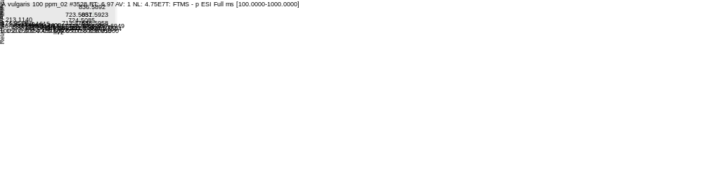
A
Figure S4 Mass spectra at retention time 7.020 min detected with full scan at 100-1000 m/z with negative mode

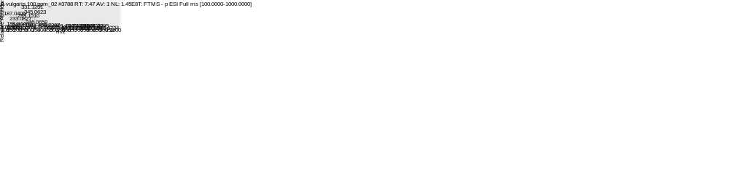
A
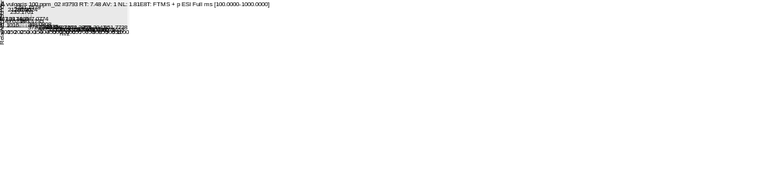
B
Figure S5 Mass spectra at retention time 7.410 min detected with (A) full scan at 100-1000 m/z with negative mode and (B) full scan at 100-1000 m/z with positive mode.

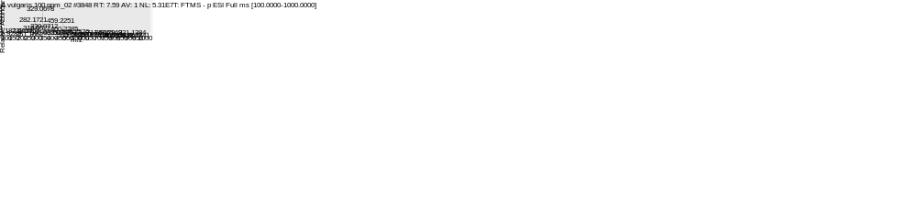
A
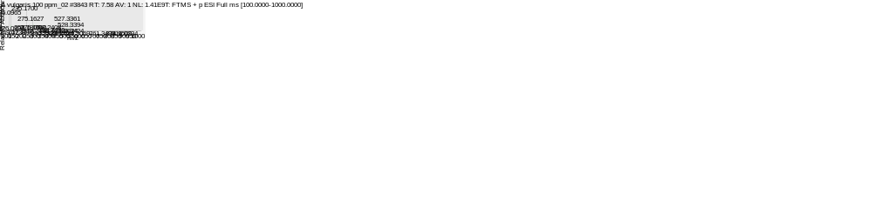
B
Figure S6 Mass spectra at retention time 7.520 min detected with (A) full scan at 100-1000 m/z with negative mode and (B) full scan at 100-1000 m/z with positive mode.

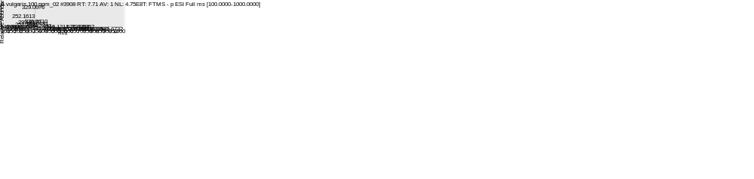
A
B
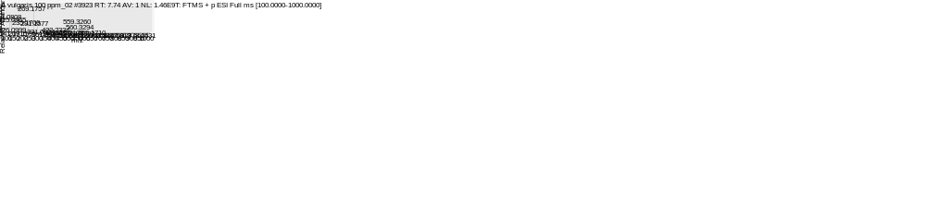
Figure S7 Mass spectra at retention time 7.660 min detected with (A) full scan at 100-1000 m/z with negative mode and (B) full scan at 100-1000 m/z with positive mode.

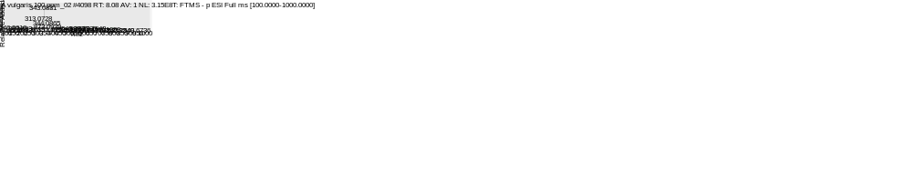
A
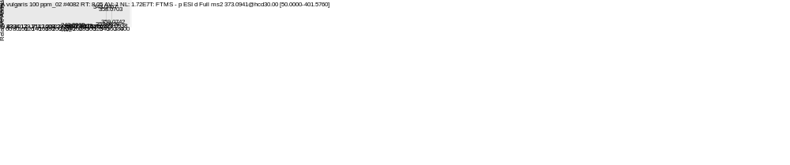
B
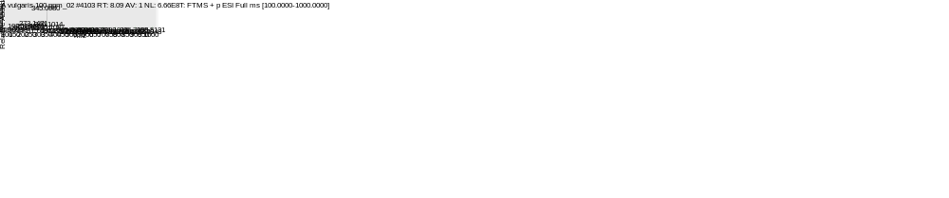
C
Figure S8 Mass spectra at retention time 8.027 min detected with (A) full scan at 100-1000 m/z with negative mode, (B) MS² fragmentation in negative mode with precursor of 373.0941 m/z and (C) full scan at 100-1000 m/z with positive mode.

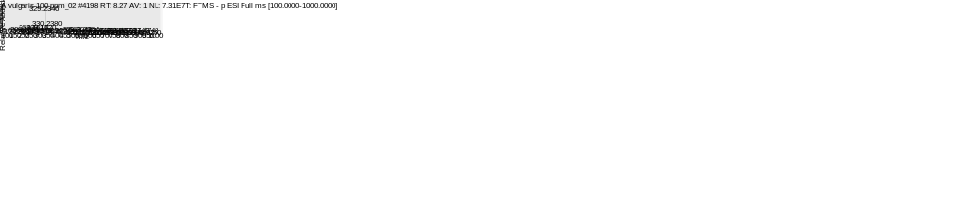
A
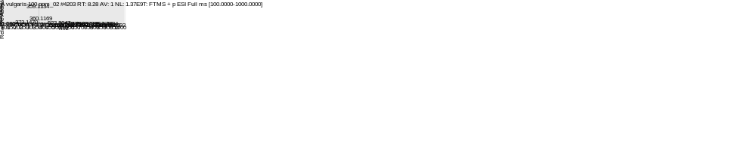
B
Figure S9 Mass spectra at retention time 8.217 min detected with (A) full scan at 100-1000 m/z with negative mode and (B) full scan at 100-1000 m/z with positive mode.

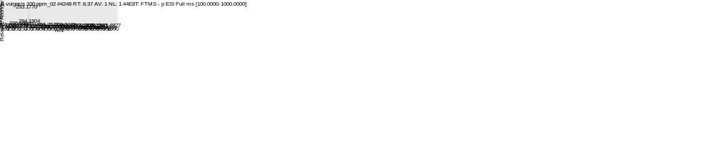
A
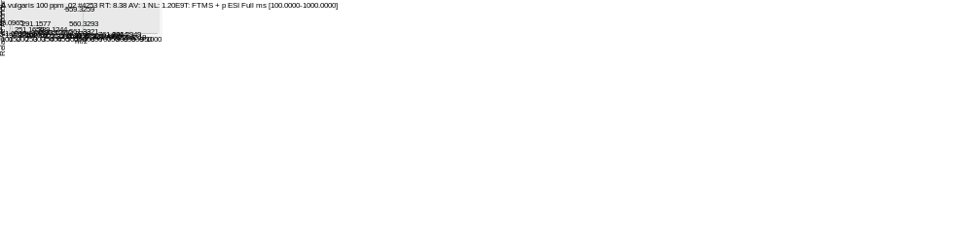
B
Figure S10 Mass spectra at retention time 8.333 min detected with (A) full scan at 100-1000 m/z with negative mode and (B) full scan at 100-1000 m/z with positive mode.

