Development and verification of a novel tiling PCR method for long-range HIV-1 sequencing in a diagnostic setting

Supplementary Methods and Results
Control Sample
RNA generated from HIV-1 BaL was kindly donated by Dr Scott Ledger from the Kirby Institute.

RNA Extraction
Viral RNA from samples used for assay optimisation were extracted using the QIAamp mini viral RNA kit (Qiagen #52904) as per the manufacturer’s protocol, except all spins were performed at 6000 g and all mixing was done by inversion only. 1 μl yeast RNA per sample (10 μg/extracted sample) was used as carrier RNA (ThermoFisher #AM7118).

Primer Quality Control
To determine if the designed primers bound correctly to HIV, the prototypic primers were first trialled in silico to determine that binding of at least one forward and reverse primer occurred for all segments in Geneious Prime 2. This was tested using both the subtype reference alignments (all full-length (>8500bp) subtype B (n=6757), C (n=2588) and CRF01_AE (n=1505) HIV-1 genome sequences (GenBank, 19 January 2022)) and the Australian sequence reference alignment (all full-length HIV-1 sequences labelled as of Australian origin (n=111) (GenBank, 19 January 2022))). Amplification as per manufacturer’s protocol for SuperFi II (ThermoFisher #12369050) was then attempted, using all possible primer pair combinations for each segment to confirm these results in vitro. The presence of any catastrophic primer interactions was determined by combining all primers from both pools at a 1:1 ratio and performing PCR at the same unoptimized conditions.

Primer and PCR Optimisation
The Q5 polymerase enzyme (New England Biolabs, #M0491S), recommended for use as part of the Midnight protocol tiling PCR for SARS-CoV-2, was tested against SuperFi II over a dilution series of cDNA derived from HIV-1 BaL. A band was visible when using SuperFi II at a 100x lower dilution than what was seen for Q5.

VILO reverse transcriptase (ThermoFisher #11756500) was then compared with Lunascript (New England Biolabs #E3010S) (also part of the Midnight protocol), to determine if there was a more favourable enzyme for reverse transcription. PCR was performed over the same dilution series as above, using SuperFi II as the polymerase. There was no difference in terms of the limit of visualisation for both enzymes, however, yield was slightly improved for samples reverse transcribed using VILO.

PCR conditions were then optimised: three alternative extension times, 30 vs 40 cycles, three alternate DNA input concentrations, and three primer concentrations were systematically tested using HIV-1 BaL RNA as input to determine optimal conditions for amplification. There was no overall improvement in the assay when changing PCR reaction volumes, therefore smaller reaction volumes were used to decrease running costs.

The optimised PCR was then trialled on 15 patient samples from the ENCORE and SECOND-LINE cohorts (Supplementary Table 2) as a pilot study. Sequencing revealed that there was adequate coverage of pol, though significant drop out of env. Given the importance of pol for diagnostic sequencing, the assay was therefore modified to cover the 5' genome only (gag-vpu) to ensure pol could be routinely sequenced. The concentration of the segment six primers (vif-vpu) in the pool were also halved, to favour coverage of the gene regions important for current standard of care resistance testing.

Library Preparation and Analysis: Oxford Nanopore Sequencing
Oxford Nanopore Technology (ONT) sequencing was used for all optimisation sequencing due to the fast turnaround time compared with Illumina sequencing. ONT was also used to resequence all tiling PCR verification samples that failed to generate virus-specific reads following Illumina sequencing, to confirm the negative result. Equivalency of these two sequencing methods for tiling PCRs has been demonstrated previously throughout the SARS-Cov-2 pandemic (Bull et al. 2020). Library preparation was performed using the Rapid Barcoding Kit 96 (#SQK-RBK110.96) as per the manufacturer’s protocol. Sequencing was performed using R9.4.1 flow cells (#FLO-MIN106D) using fast basecalling for 24 hours, or until at least 20,000 reads were generated per sample.

The resulting reads were reassembled using Geneious Prime 2 (2023.2.1) software. The fastq reads were first trimmed for barcode sequences, tiling PCR primers and Phred quality score <10 using BBduk. Trimmed reads were then mapped to the HIV-1 HXB2 reference sequence (Accession: K03455) using minimap2 to generate a draft consensus sequence. The trimmed reads were then remapped to the draft consensus to generate the final consensus sequence. The consensus was taken as the major (>50%) nucleotide at each position. A gap (-) was used if <20 reads were present at any site.

To compare sequencing of the amplicons using both ONT and Illumina sequencing methods, the first 10 samples from the comparison panel were sequenced using both library preparation methods. All samples generated consensus sequence that were >98% identical using both methods (average: 99.6%) except for sample 03 (Supplementary Figure 1). Sample 03 had less than <10,000 HIV specific reads generated during library preparation. As such, Illumina and ONT sequencing was found to be equivalent, as a long as >10,000 HIV specific reads are generated during ONT sequencing.
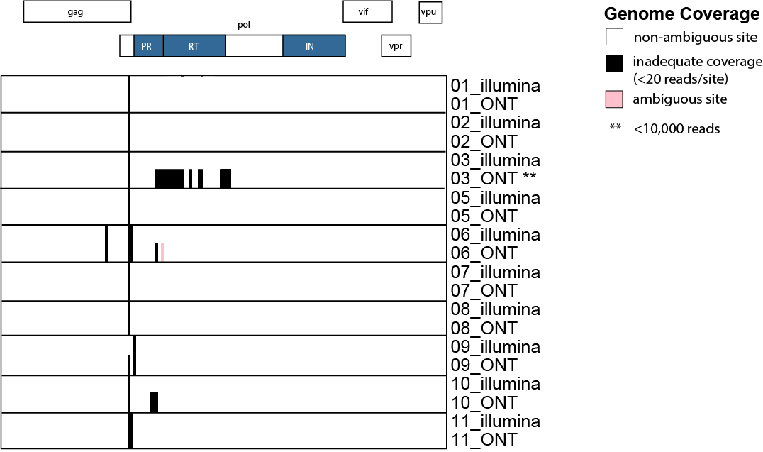
Supplementary Figure 1: Sequence coverage of panel samples using the HIV-1 tiling assay sequenced using both Illumina and Oxford Nanopore (ONT) sequencing. Any site where under 20 reads were generated, that is where gaps or an N was present in the consensus sequence, is represented in black. Ambiguous nucleotides are represented in pink. Sample 03 was found to have suboptimal read numbers (<10,000 HIV specific reads) generated during ONT sequencing.

Supplementary Table 1: Demographic information for samples used as part of NGS HIV-1 sequencing assay development and testing. One sample was unable to be sequenced using original methods, therefore there is no sequence or subtype data available for this sample.
Inclusion Purpose | Study | Country of Origin | Viral Load of Undiluted Sample (copies/mL) | Subtype | Previously Identified  DRMs in Sanger | Repeats in Comparison Panel (no.)
Pilot Study | SECOND- LINE | MALAYSIA | 172532 | B | Yes
Pilot Study | ENCORE | AUSTRALIA | 149743 | B
Pilot Study | ENCORE | SINGAPORE | 270039 | B | Yes
Pilot Study | ENCORE | SINGAPORE | 216971 | B
Pilot Study | ENCORE | THAILAND | 444837 | B | Yes
Pilot Study | ENCORE | MALAYSIA | 493647 | C
Pilot Study | ENCORE | AUSTRALIA | 305058 | CRF01_AE
Pilot Study | ENCORE | AUSTRALIA | 199924 | B
Pilot Study | ENCORE | AUSTRALIA | 326258 | B
Pilot Study | ENCORE | AUSTRALIA | 273965 | B
Pilot Study | ENCORE | AUSTRALIA | 180628 | CRF01_AE
Pilot Study | ENCORE | AUSTRALIA | 399767 | B
Pilot Study | ENCORE | THAILAND | 162924 | CRF01_AE
Accuracy | ENCORE | AUSTRALIA | 108399 | CRF01_AE | Yes | 1
Accuracy | SECOND- LINE | SINGAPORE | 48859 | C | Yes | 1
Accuracy | SECOND- LINE | SINGAPORE | 125521 | C | Yes | 1
Accuracy | SECOND- LINE | SINGAPORE | 9933 | C | Yes | 1
Accuracy | SECOND- LINE | SINGAPORE | 8732 | B | Yes | 1
Accuracy | SECOND- LINE | THAILAND | 16881 | CRF01_AE | Yes | 1
Accuracy | ENCORE | THAILAND | 80423 | CRF01_AE | Yes | 1
Accuracy | ENCORE | SINGAPORE | 28280 | CRF01_AE | Yes | 1
Pilot Study; Accuracy | ENCORE | THAILAND | 266371 | CRF01_AE | Yes | 1
Accuracy | ENCORE | SINGAPORE | 10711 | B | Yes | 1
Accuracy | SECOND- LINE | MALAYSIA | 108733 | B | Yes | 1
Accuracy | SECOND- LINE | THAILAND | 49532 | CRF01_AE | Yes | 1
Accuracy | SECOND- LINE | ARGENTINA | 23527 | B | Yes | 1
Accuracy | SECOND- LINE | SINGAPORE | 125521 | CRF01_AE | Yes | 1
Accuracy | ENCORE | ISRAEL | 14704 | D | Yes | 1
Accuracy (VL <5000) | SECOND- LINE | THAILAND | 2268 | CRF01_AE | Yes | 1
Accuracy (VL <5000) | SECOND- LINE | MALAYSIA | 3866 | B | Yes | 1
Accuracy (VL <5000) | SECOND- LINE | INDIA | 3017 | C | Yes | 1
Accuracy (VL <5000) | SECOND- LINE | THAILAND | 4946 | CRF01_AE | Yes | 1
Accuracy (VL <5000) | SECOND- LINE | MALAYSIA | 1295 | CRF01_AE | Yes | 1
Sensitivity (VL > 10,000) | ENCORE | SINGAPORE | 28474 | CRF02_AG |  | 1
Sensitivity (VL > 10,000) | ENCORE | GERMANY | 1301198 | CRF02_AG |  | 1
Sensitivity (VL > 10,000) | ENCORE | UK | 165164 | D |  | 1
Sensitivity (VL > 10,000) | ENCORE | MALAYSIA | 148066 | G | Yes | 1
Sensitivity (VL > 10,000) | ENCORE | UK | 287200 | F |  | 1
Sensitivity (VL > 10,000) | SECOND- LINE | AUSTRALIA | 74144 | CRF01_AE | Yes | 1
Sensitivity (VL > 10,000) | ENCORE | AUSTRALIA | 16963 | C | Yes | 1
Sensitivity (VL > 10,000) | ENCORE | AUSTRALIA | 34361 | B | Yes | 1
Pilot Study, Sensitivity (VL > 10,000) | ENCORE | AUSTRALIA | 358436 | B | Yes | 2
Sensitivity (VL > 10,000) | ENCORE | AUSTRALIA | 69801 | CRF01_AE |  | 1
Sensitivity (VL > 10,000) | ENCORE | AUSTRALIA | 11295 | C |  | 1
Sensitivity (VL > 10,000) | ENCORE | AUSTRALIA | 29636 | C |  | 1
Sensitivity (VL > 10,000) | ENCORE | AUSTRALIA | 15614 | B |  | 1
Sensitivity (VL > 10,000) | ENCORE | AUSTRALIA | 28869 | B |  | 2
Sensitivity (VL > 10,000) | ENCORE | AUSTRALIA | 61532 | B |  | 1
Sensitivity (VL > 10,000) | ENCORE | AUSTRALIA | 9893 | B |  | 1
Sensitivity (VL > 10,000) | ENCORE | AUSTRALIA | 6851 | CRF01_AE | Yes | 1
Sensitivity (VL > 10,000) | ENCORE | AUSTRALIA | 5051 | B |  | 1
Sensitivity (VL < 5000) | ENCORE | AUSTRALIA | 3407 | B |  | 2
Sensitivity (VL < 5000) | ENCORE | AUSTRALIA | 4990 | B |  | 2
Sensitivity (VL < 5000) | ENCORE | AUSTRALIA | 3039 | B |  | 2
Sensitivity (VL < 5000) | ENCORE | AUSTRALIA | 3143 | C |  | 2
Sensitivity (VL < 5000) | ENCORE | AUSTRALIA | 1977 | UNKNOWN |  | 2
Sensitivity (VL < 5000) | ENCORE | AUSTRALIA | 3949 | B |  | 2
Sensitivity (VL < 5000) | ENCORE | THAILAND | 3891 | B |  | 2
Sensitivity (VL < 5000) | ENCORE | THAILAND | 4513 | B |  | 2
Sensitivity (VL < 5000) | ENCORE | THAILAND | 3531 | B |  | 2
Sensitivity (VL < 5000) | ENCORE | SINGAPORE | 3587 | B |  | 2
Intra-Assay Testing 1. | ENCORE | AUSTRALIA | 43052 | B | Yes | 5
Intra-Assay Testing 2. | ENCORE | AUSTRALIA | 59213 | CRF01_AE |  | 5
Intra-Assay Testing 3. | ENCORE | AUSTRALIA | 24889 | B |  | 5
inter-Assay Testing 1. | ENCORE | AUSTRALIA | 108399 | B | Yes | 5
inter-Assay Testing 2. | ENCORE | AUSTRALIA | 19939 | B |  | 5
inter-Assay Testing 3. | ENCORE | AUSTRALIA | 40373 | C |  | 5
Uninfected Control | VIMM | AUSTRALIA |  |  |  | 6

Supplementary Table 2: Primers for HIV Tiling PCR Assay. Note that all primers are pooled equally in the final primer pool, except for the segment six primers for which half volumes are added.
Pool | Segment | Primer | Sequence (5'-3') | Reference
A | 1 | Seg1_allHIV_LEFTv2 | TAGCAGTGGCGCCCGAACAG | Modified from Hiener et al. 2017
A | 1 | G01 | AGGGGTCGTTGCCAAAGA | Sanders-Buell et al. 1995
A | 3 | Seg3_allHIV_LEFT | CCTACACCTGTCAACATAATTGGAMG
A | 3 | Seg3_allHIV_RIGHT | TCWGCTAYYAAGTCTTTTGATGGGTCA
A | 5 | 4115 | GTACCAGCACACAAAGGRATTG | Chrystostomou et al. 2020
A | 5 | 5755 | TCTGGGGCTTGTTCCATCTATC | Chrystostomou et al. 2020
B | 2 | Seg2_allHIV_RIGHTv2 | TTTGGKCCATCCATTCCTGG
B | 2 | Seg2_HIV_AE_LEFT | AAACTCTCAGAGCRGAACAAGC
B | 2 | Seg2_HIV_B_LEFT | TTGGATGACAGAAACCTTGTTGG
B | 2 | Seg2_HIV_C_LEFT | GAATGTAYAGCCCTGTCAGCAT
B | 4 | Seg4_allHIV_RIGHTv3 | TATCCACTGGCTACATGRACTG
B | 4 | Seg4_HIV_AE_LEFT | CCACTGACTGAAGAAGCAGAATTAG
B | 4 | Seg4_HIV_B_LEFTv2 | GCACTAACAGAAGTARTACCACTAAC
B | 4 | Seg4_HIV_C_LEFT | GGGCAAGTCAGATTTACSCAGG
B | 6 | Seg6_allHIV_LEFTv2 | AAACAGATGGCAGGTGMTGATTG
B | 6 | Seg6_allHIV_RIGHTv3 | TCCGCTTCTTCCTGCCATRG

Supplementary Table 3: Additional samples with data available for precision analysis of the HIV-1 tiling PCR over the 5’ HIV-1 genome region. Samples were duplicated in panel due to the limited availability of samples with a viral load <5000 copies/mL.

Sample | Viral Load (Copies/mL) | Subtype | Percentage Pairwise Identity over 5’ genome region
A | 3407 | B | 98.4
B | 358436 | B | 100
C | 3143 | BC | 99.8
D | 28869 | B | 99.6
E | 4513 | B | 98.1
F | 3891 | B | 99.8
G | 3949 | B | 99.3
H | 3531 | B | 100
I | 3039 | B | 96.6
J | 1977 | B | 100
K | 4990 | B | 99.8
L | 3587 | B | 99.6

