Blowing in the wind: bird mortality at wind farms in a tropical desert

Authors: Aritra Roy¹, Sumandrita Banerjee¹, Mohib Uddin¹, Yadvendradev Jhala¹, Sutirtha Dutta^{1,2}

¹ Wildlife Institute of India, Chandrabani, Dehradun, India 248001
² Corresponding author. Email: sutirthadutta@gmail.com, sutirtha@wii.gov.in
Appendix

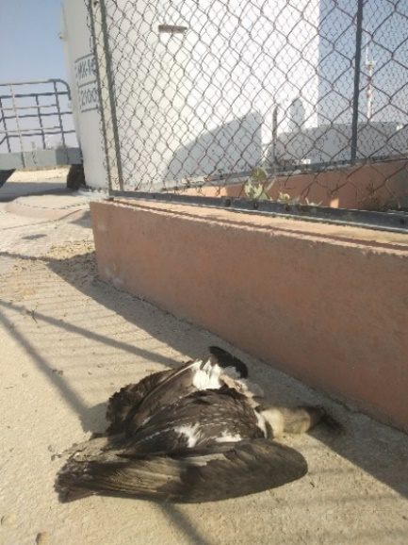
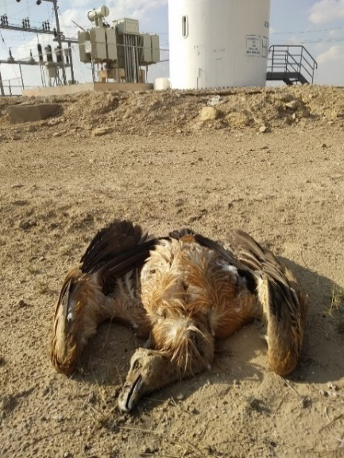
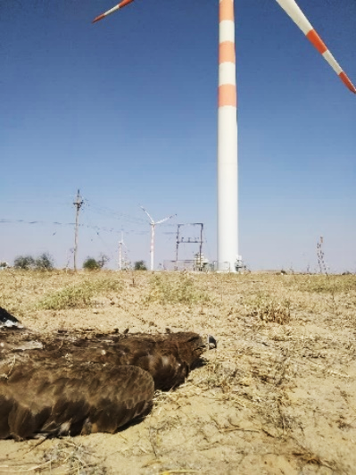

Figure A.1. Images showing carcasses of White-rumped Vulture, Griffon Vulture and Tawny Eagle (left to right) found during carcass survey at wind turbines in Thar Desert during 2020-21

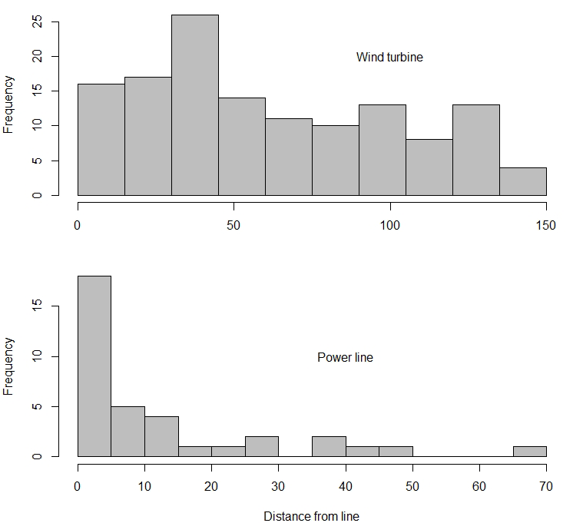
Figure A.2. Frequency of carcasses detected at increasing distance from the wind turbine (top) and the associated power-lines (bottom) in Thar desert during 2020–21.

