Supplementary Materials

Title: Comparative phytochemicals profiling, biological potentials and docking studies of three different peel varieties of Pakistani pomegranate

Supplementary Figures

Structures of major compounds identified by GCMS.

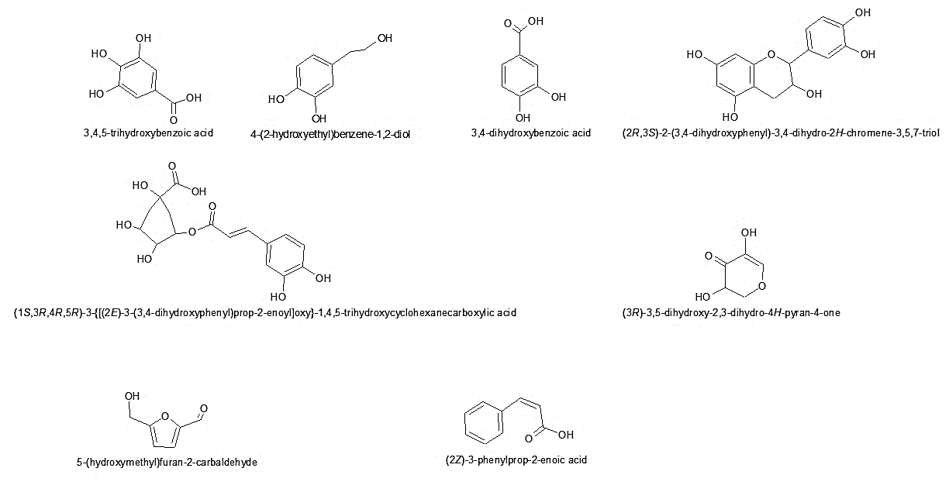
Fig S1. Structures of major identified compounds via GCMS.

S2. Identification of phenolic compound in PPE-1, PPE-2, and PPE-3 by HPLC
The identification of phenolic compounds in PPE-1 sample was performed using high-performance liquid chromatography (HPLC). This analysis revealed the presence of 14 different polyphenolic compounds. The highest concentration of polyphenolic compounds was found in chlorogenic acid, with a value of 27.39. On the other hand, the lowest concentration was found in catechin. Interestingly, catechol was not detected in PPE-1 pomegranate peels. These results provide valuable insights into polyphenolic composition depicted in Table S1. Chlorogenic acid, a key compound in this analysis, is known for its antioxidant and anti-inflammatory properties. The presence of this compound in PPE-1 suggests that these peels may have significant bioactive potential.
The investigation aimed to analyze the phenolic compounds present in the PPE-2 and revealed that several phenolic compounds were detected, including Quercetin, Benzoic acid, Cinemic acid, Gallic acid, 3-hydroxy tyrosol, Protocatechuic acid, Catechin, and Chlorogenic acid. The results, outlined in Table S2, detail the percentage compositions of each identified compound. Notably, chlorogenic acid exhibited the highest concentration at 36.13%, indicating its prevalence in the PPE-2 peel extract of pomegranate. Following chlorogenic acid, benzoic acid was the next most abundant compound, comprising 12.80% of the total composition as shown in Table S2. This data sheds light on the phenolic profile of pomegranate peels, emphasizing the significance of chlorogenic and benzoic acids in this botanical extract.
Identification of phenolic compound in pomegranate peel sample PPE-3 was also utalized and determined that the sample contained all expected phenolic compounds, except for catechol. Interestingly, the investigation revealed notable variances in the concentrations of specific phenolic compounds. Cinemic acid exhibited the highest concentration among the detected compounds, signifying its prominence in the composition of PPE-3 sample. Following closely behind was benzoic acid, suggesting its significant presence as well. Conversely, quercetin showed the lowest concentration among the observed phenolic compounds in the white peels as showed in Table S3.

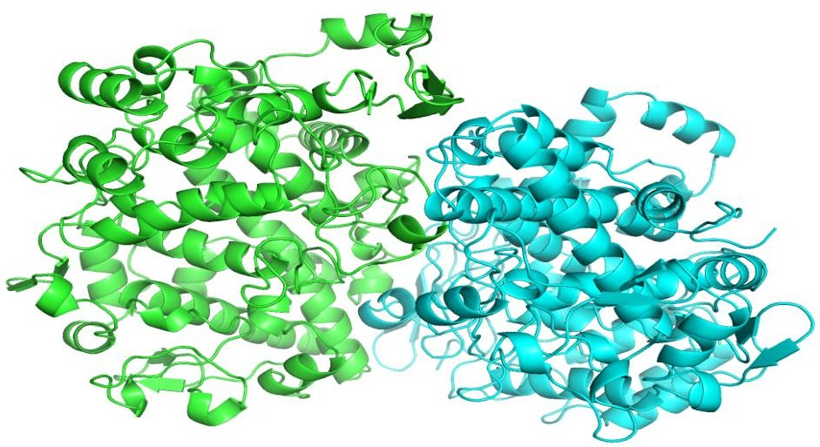

Fig S2. Selected structure of human COX-Ⅱ, consisted of two chains retrieved by PDB ID 51KT from protein data bank.

Fig S3. Major identified Compounds structures of (a) Furan and (b) Chlorogenic acid.

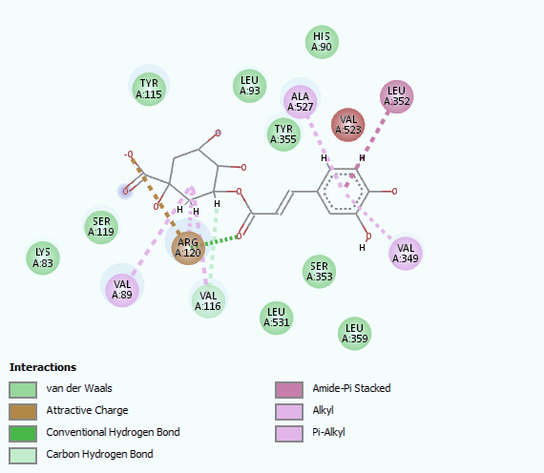
(a)
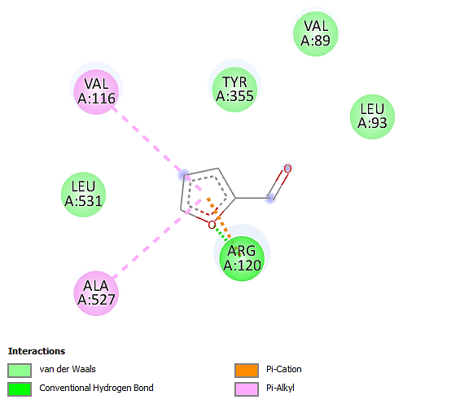
(b)
Fig S4. (a) 2-D interaction diagram of chlorogenic acid and (b) furan.

Supplementary Tables

Table S1
Identified phenolic compounds composition of PPE-1 by HPLC
Retention Time | Phenolic Compound | Composition (%)
4.13±0.39 | Quercetin | 5.65
4.85 | Unknown | 13.34
5.04±0.05 | Benzoic acid | 7.75
5.33±0.38 | Cinemic acid | 7.84
5.94±0.07 | Gallic acid | 2.60
6.11 | Unknown | 6.36
6.78 | Unknown | 19.26
7.37±0.002 | 3-hydroxy tyrosol | 2.66
7.69±0.07 | Protocatechuic acid | 1.26
8.23±0.23 | Catechin | 0.36
9.22±0.87 | Chlorogenic acid | 27.39
10.62 | Unknown | 0.87
11.55 | Unknown | 1.83
13.30 | Unknown | 2.75

Table S2
Identified phenolic compounds composition of PPE-2 by HPLC

Retention Time | Phenolic Compound | Composition (%)
3.79±0.05 | Quercetin | 0.27
4.07 | Unknown | 1.64
4.78 | Unknown | 8.97
5.01±0.08 | Benzoic acid | 12.80
5.23 | Unknown | 5.11
5.52±0.19 | Cinemic acid | 0.47
5.81±0.05 | Gallic acid | 10.85
6.618 | Unknown | 21.75
7.18±0.20 | 3-hydroxy tyrosol | 0.76
7.49±0.12 | Protocatechuic acid | 0.88
8.26±0.26 | Catechin | 0.32
8.96±0.64 | Chlorogenic acid | 36.13

Table S3
Identified phenolic compounds composition of PPE-3 by HPLC
Retention Time | Phenolic Compound | Composition (%)
3.81±0.07 | Quercetin | 0.98
4.12 | Unknown | 5.15
4.63 | Unknown | 0.15
4.81 | Unknown | 10.86
5.01±0.08 | Benzoic acid | 6.87
5.27±0.44 | Cinemic acid | 8.70
5.87±0.002 | Gallic acid | 3.50
6.03 | Unknown | 6.74
6.67 | Unknown | 18.46
7.24±0.15 | 3-hydroxy tyrosol | 3.02
7.55±0.06 | Protocatechuic acid | 2.37
8.10±0.10 | Catechin | 2.32
8.30±0.05 | Chlorogenic acid | 1.28
9.04 | Unknown | 25.86
13.06 | Unknown | 1.67

