Supplementary Document

scMSCF: A Precise Single-Cell RNA Sequencing Data Analysis Framework Based on Multi-Scale Clustering and Transformer

Songrun Jiang¹, Chunyan Wang^{1,}*, Qiucheng Sun^{1,}* and Zhi Zhang¹

¹College of Computer Science and Technology, Changchun Normal University, Changchun 130032, China;

Supplementary Notes
SN1. Performance of Transformer Model Using ARI, NMI, and ACC with Two Different Data Preprocessing Methods
SN2. Detailed Description of the Elbow Method
SN3. Illustrative Example of Weighted Ensemble Meta-Clustering
SN4. Parameter Settings for the Transformer Model
SN5. Analysis of Runtime Efficiency and Scalability
SN6. Pseudotime Trajectory Analysis
SN7. Functional Annotation of Marker Genes across Cell Clusters
SN8. Sensitivity Analysis of Key Hyperparameters in scMSCF
SN9. Runtime and Resource Efficiency of scMSCF Across Different Hardware Configurations

Supplementary Figures
SF1. Comparison of VI Values Across Multiple Datasets Using Different Methods
SF2. Comparison of DBI Values Across Multiple Datasets Using Different Methods
SF3-9. t-SNE Visualizations of Cell Embeddings in Seven scRNA-seq Datasets (FearMem, LymphTIM, iPSCMid, PBMCv3, MouseKidney, Lymphoma, and PBMCChrome) Processed by scMSCF and Nine Competing Methods
SF10. Overlap Rate Between Marker Genes Identified by scMSCF and True Marker Genes Across Multiple Datasets for Each Cluster

Supplementary Tables
ST1. Comparative Analysis of Technical Strategies, Pros & Cons, and Use Cases of Additional Algorithms in scRNA-seq Clustering.

SN1. Tailored Application of Two Preprocessing Strategies for Dimensionality Reduction and Transformer Modeling and the parameter configuration of SCTransform.

- Tailored Application of Two Preprocessing Strategies for Dimensionality Reduction and Transformer Modeling
Through the selection of highly variable genes (HVGs), PCA dimensionality reduction and K-means clustering can effectively reduce noise by focusing on the most informative genes. This step minimizes the influence of low-variance genes, which often contribute noise rather than meaningful biological signals, thus enhancing clustering robustness and accuracy.
However, for the Transformer model, we exclusively used the gene expression data processed through SCTransform, leveraging its unique advantages in normalizing and stabilizing gene expression while preserving all biological information.
Results in Fig. SN1 demonstrate that, across multiple datasets, the Transformer model achieves superior performance on clustering metrics such as ARI, NMI, and ACC when using gene expression data processed solely through SCTransform. The comprehensive input significantly enhances overall accuracy, information connectivity, and clustering consistency, validating the tailored preprocessing strategy. Furthermore, the use of SCTransform minimizes preprocessing complexity while maximizing downstream analytical robustness, reinforcing its suitability for large-scale single-cell RNA sequencing analysis.

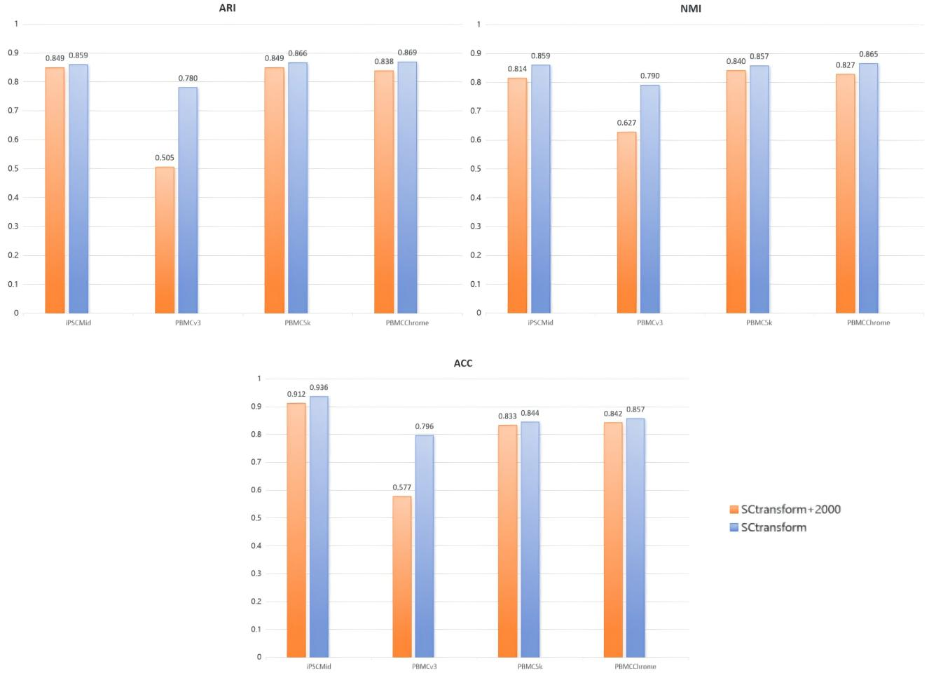
Figure SN1. Comparison of ARI, NMI, and ACC Across Different Data Preprocessing Methods

- The Parameter Configuration of SCTransform
SCTransform applies a regularized negative binomial regression model to remove technical noise, correct sequencing depth variations, and stabilize gene expression variance. Unlike traditional log-normalization methods, SCTransform directly models and mitigates confounding effects in a single step. This approach preserves the biological signal of all genes, making it ideal for preprocessing data for deep learning models that rely on high-dimensional gene expression patterns.
By using the complete gene expression matrix, SCTransform ensures no information loss, allowing the model to learn richer expression patterns and biological signals. Moreover, simplicity and computational efficiency of SCTransform make it particularly suited for deep learning applications. Unlike conventional pipelines that require multiple steps, SCTransform consolidates normalization, variance stabilization, and feature selection into one function, enhancing reproducibility and ease of use across different datasets.
In summary, SCTransform addresses the high sparsity and noise in scRNA-seq data through a Pearson residual transformation that stabilizes variance, mitigates batch effects, and improves clustering accuracy. This part explores the impact of key SCTransform() parameters on data preprocessing and clustering accuracy.
  - vars.to.regress (Regression Variables): This parameter determines which technical confounders are regressed out during normalization. Common choices include mitochondrial gene percentage (percent.mt) and cell cycle scores. Removing percent.mt improves clustering robustness by eliminating biases introduced by dying cells or technical artifacts. Additionally, regressing out cell cycle effects enhances the separation of functionally distinct cell populations.
  - n_genes (Highly Variable Genes Selection): SCTransform() selects a subset of highly variable genes (HVGs) to retain biologically relevant signals while reducing noise. Using 2000–3000 HVGs strikes a balance between information retention and computational efficiency. A lower threshold (e.g., 1000 genes) may lead to loss of key biological signals, whereas an excessively high threshold (e.g., 5000 genes) introduces noise and degrades clustering performance.
  - method (Regression Method): SCTransform() supports different statistical models, including glmGamPoi, poisson, and nb (negative binomial). The default glmGamPoi is computationally efficient and well-suited for large datasets. In contrast, nb handles overdispersed data but increases runtime significantly.
We systematically evaluated the impact of SCTransform() configurations on the FearMem dataset (GSE246147), containing 6361 cells and 44272 genes. By varying vars.to.regress, n_genes, and regression Method, we assessed clustering performance using ARI and Normalized Mutual Information (NMI).
Regressing both percent.mt and cell cycle effects increases ARI from 0.73 to 0.89, demonstrating improved robustness. Selecting 2000 HVGs achieves the highest clustering accuracy (ARI = 0.89), while using only 1000 HVGs results in suboptimal clustering (ARI = 0.76). Using glmGamPoi maintains superior clustering performance (ARI = 0.89).
Based on our experimental findings, we recommend the following SCTransform() parameter settings to optimize clustering performance:
  - vars.to.regress: c("percent.mt", "cell cycle") to eliminate technical confounders.
  - n_genes: 2000–3000 HVGs to balance biological signal retention and noise reduction.
  - method: glmGamPoi for computational efficiency and scalability.
By carefully tuning these parameters, SCTransform() enhances the preprocessing pipeline, leading to improved clustering accuracy and stability in scRNA-seq data analysis.

SN2. Detailed Description of the Elbow Method. The Elbow Method is a common technique for determining the optimal number of clusters, K, in clustering algorithms. This method involves plotting the sum of squared errors (SSE) against the number of clusters, allowing identification of an "elbow" point, which typically represents the optimal cluster count. The process begins by running the K-means algorithm with a range of K values (e.g., from 2 to 20) and recording the SSE for each K, calculated as the sum of squared distances between each data point and its respective cluster center. As K increases, SSE generally decreases, as more clusters improve data fit. A graph is then created with K on the x-axis and SSE on the y-axis, showing the SSE trend with changes in K. Figure SN2 demonstrates this process, where the elbow point can be seen as the point where the SSE's rate of decrease slows. This point indicates the best balance between clustering performance and model complexity.
In the context of this study, we combined the Elbow Method with a multi-resolution dimensionality reduction approach, referred to in the manuscript as multi-dimensional PCA. Specifically, PCA was applied repeatedly on the same gene expression dataset using five different numbers of retained components: 30, 35, 40, 45, and 50. Each PCA run produced a different projection of the data, capturing complementary structural aspects at varying levels of abstraction. The Elbow Method was applied independently to each PCA-reduced space to determine appropriate cluster numbers. From each elbow plot, we selected two candidate K values to ensure stability and diversity across clustering results. These settings were then used for subsequent meta-clustering integration.
This strategy of combining multiple PCA projections with adaptive K selection enhances robustness and enables better exploration of cellular heterogeneity across scales.

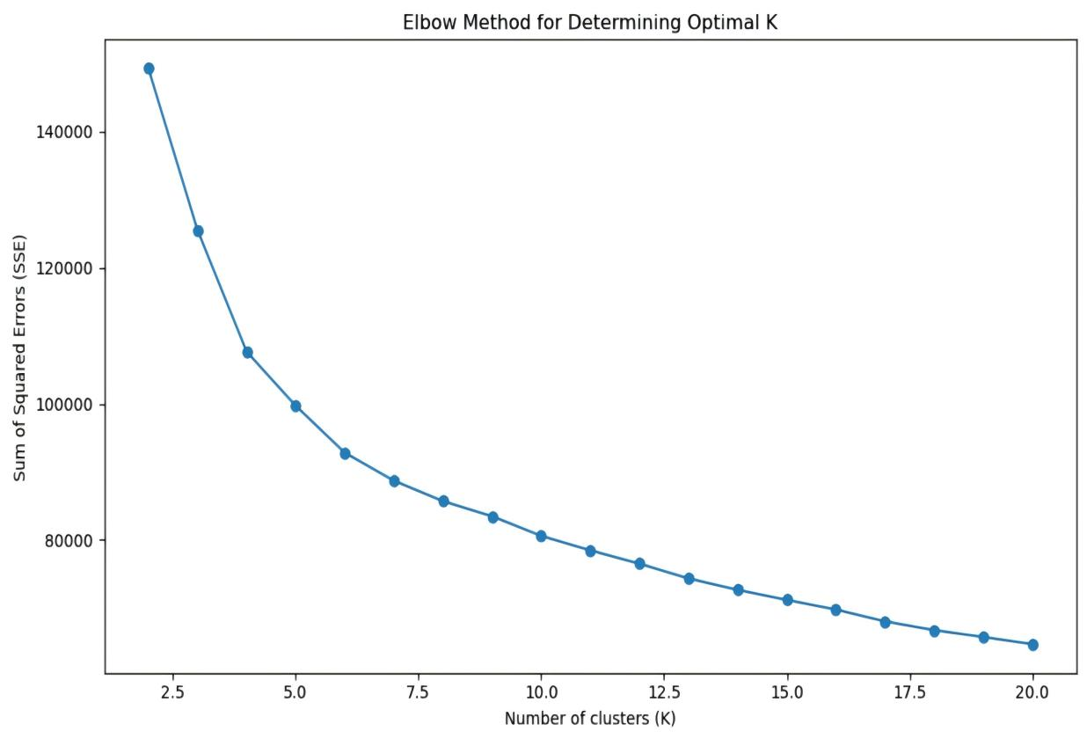
Figure SN2. The Elbow Method for selecting the optimal number of clusters, with the elbow point indicating a balance between clustering accuracy and model complexity.

SN3. Illustrative Example of Weighted Ensemble Meta-Clustering. To complement the description in the main manuscript (Step 2), we provide an illustrative example to demonstrate how the weighted ensemble meta-clustering process works, particularly the calculation and interpretation of pairwise weights and the weighted similarity matrix.
Example Setup
Consider a simplified dataset with five single cells: C1, C2, C3, C4, and C5. Suppose we perform three independent clustering runs (e.g., at different PCA dimensions or parameter settings), resulting in the following cluster assignments:
Cell | Clustering 1 | Clustering 2 | Clustering 3
C1 | A | A | A
C2 | A | B | A
C3 | B | B | B
C4 | B | B | A
C5 | C | C | C

Table SN3.1. An illustrative example of cluster assignments for five synthetic cells across three independent clustering results

Step 1: Compute Pairwise Similarity. For each pair of cells, we compute how often they appear in the same cluster across the three clustering runs. For example:
- C1 and C2 are together in Cluster A in runs 1 and 3 → Similarity = 2/3
- C1 and C3 are never together → Similarity = 0/3
- C3 and C4 are together in runs 1 and 2 → Similarity = 2/3
These similarities are used to derive weights. Pairs with higher similarity (frequently grouped together) receive lower weights, reflecting high confidence in their relationship. Conversely, lower similarity results in higher weights, emphasizing instability.
Step 2: Construct Weighted Similarity Matrix Between Clusters. Assuming we want to merge clusters from the base clustering outputs, we calculate a weighted similarity between entire clusters by aggregating the pairwise weights of the cells they contain (as described in formula 5). This results in a cluster-level similarity matrix that better reflects the stability of relationships between cells.
Step 3: Hierarchical Clustering and Voting. Using the weighted similarity matrix, we perform hierarchical clustering to merge the most stable clusters. After merging, each cell is assigned a final cluster based on majority voting across all clustering runs.
Key Intuition Recap
- Cells that frequently co-occur in clusters are treated as more stable and thus weighted lower.
- Inconsistent cells receive more influence in integration to ensure their position is resolved carefully.
- This strategy reduces noise from outlier clustering results and reinforces stable groupings.

SN4. Parameter Settings for the Transformer Model. To optimize the Transformer model's classification performance on single-cell RNA-seq data, key hyperparameters, including learning rate, batch size, feature dimension (d_model), number of attention heads (num_heads), number of layers (num_layers), and dropout rate, were tuned. Initially, the learning rate and batch size were fine-tuned using the Adam optimizer by testing four learning rates (0.1, 0.01, 0.001, 0.0001) and four batch sizes (16, 32, 64, 128), with validation loss and accuracy recorded for each. For instance, a learning rate of 0.001 and batch size of 32 minimized validation loss and maximized accuracy, indicating an optimal balance for convergence and stability.
In the Transformer model, key parameters such as feature dimension (d_model), number of attention heads (num_heads), number of layers (num_layers), and dropout rate significantly impact model performance. The selection of these parameters is closely tied to the dataset size. For larger datasets, using a higher feature dimension, more attention heads, and deeper layers can enhance the model's ability to leverage the data's complexity and improve performance. In contrast, for smaller datasets, it is essential to select a lower d_model, moderate num_heads and num_layers, along with an appropriate dropout rate, to prevent overfitting. Additionally, computational resources and training time also affect parameter selection; when resources are limited, a balance between model complexity and feasibility is necessary.
To provide practical guidance for hyperparameter selection, we present empirically optimized parameter combinations from three representative datasets covering small, medium, and large scales (see Table SN4.1). These combinations have demonstrated superior validation performance in our experiments. For datasets with sizes not explicitly listed, we recommend dynamically adjusting these parameters:
- For datasets smaller than the small-scale example (767 cells), slightly decrease the feature dimension, attention heads, and layer numbers.
- For datasets falling between the provided examples, interpolate the recommended values proportionally.
- For datasets larger than the largest example (6361 cells), gradually increase the feature dimension and potentially attention heads or layers to capture more complex information, keeping in mind computational feasibility and the risk of overfitting.
By following these guidelines and adjusting parameters according to dataset size and task requirements, the Transformer model's performance in single-cell RNA-seq classification tasks can be effectively optimized.

 | Small dataset | Medium dataset | Large dataset
Dataset | iPSC Midbrain Neuron PD | PBMCs - v3 | BLA Fear Memory
Number of Cells | 767 | 4352 | 6361
Feature Dimension (d_model) | 1024 | 1024 | 1280
Attention Heads (num_heads) | 4 | 16 | 16
Transformer Layers (num_layers) | 2 | 8 | 8
Learning Rate | 0.001 | 0.001 | 0.001
Batch Size | 32 | 64 | 64
Dropout Rate | 0.1 | 0.1 | 0.1
Table SN4.1: Optimal Transformer Hyperparameter Configurations for Representative Datasets.

SN5. Analysis of Runtime Efficiency and Scalability. To assess the scalability and efficiency of the scMSCF algorithm on datasets of varying sizes, we used the Splatter package of the R language to generate six simulated datasets, each with 2000 genes. These datasets contained 1000, 3000, 5000, 10000, 15000, and 20000 cells, with noise and variability parameters introduced during data generation. For this experiment, we set seven cell groups, with 50% differentially expressed genes, a biological variability coefficient of 0.4, and a differential expression scale factor of 4.
The experimental workflow consisted of data preprocessing, initial clustering, model training, model prediction, and total runtime calculation. Notably, initial clustering refers mainly to the weighted ensemble meta-clustering step. Since PCA combined with K-means clustering requires manual determination of the $k$-value using the elbow method, this step was not automated in the experiment. Fig.SN5(A) displays the runtime distribution for each step across different dataset sizes, while Fig.SN5(B) presents the ARI values achieved by scMSCF, assessing clustering performance. Results show that as cell counts increase, both total runtime and the runtime for each module in scMSCF increase linearly, demonstrating its time efficiency and scalability. In terms of clustering accuracy, scMSCF maintained high ARI values across all datasets, with values approaching 1 on large datasets, indicating its effectiveness in distinguishing cell subpopulations and affirming its excellent scalability and stability.
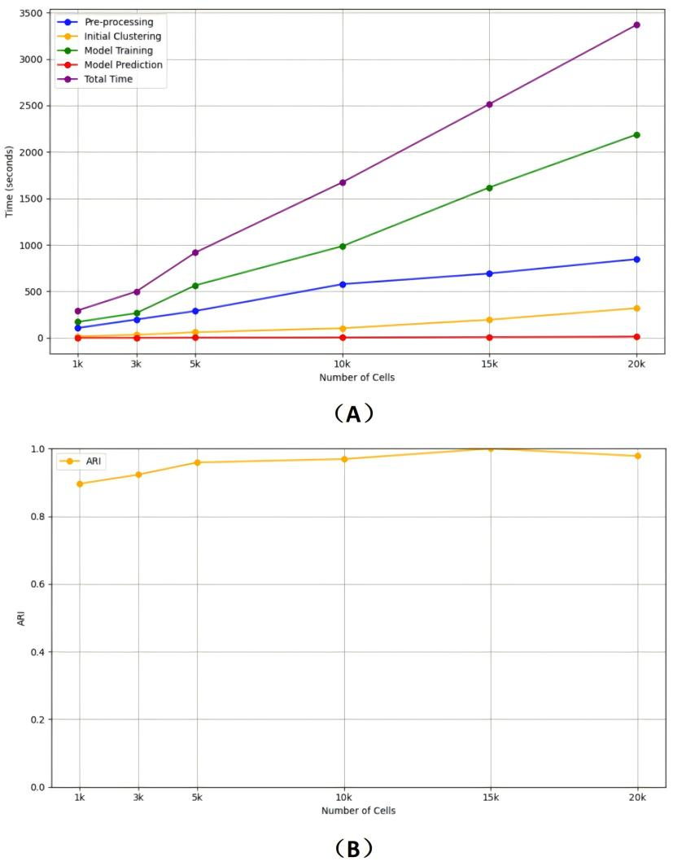
Figure SN5. Scalability and Efficiency of the scMSCF Algorithm Across Datasets of Varying Sizes. (A) Runtime distribution for the five stages of the scMSCF algorithm (preprocessing, initial clustering, model training, model prediction, and total runtime) across different dataset sizes. (B) ARI values for the scMSCF algorithm on six datasets of different sizes, illustrating clustering performance across varying scales.

SN6. Pseudotime Trajectory Analysis. In cellular biology research, pseudotime trajectory analysis is an innovative method that reveals the dynamic progression of cells over time, providing essential insights into disease mechanisms and progression. Using the scMSCF single-cell RNA sequencing clustering algorithm, researchers can effectively identify and categorize cell states in single-cell RNA sequencing data. scMSCF demonstrates substantial advantages in capturing cell cycle changes and differentiation states, enhancing both the precision and depth of analysis. In this study, the iPSC midbrain neuronal Parkinson's disease (PD) dataset was used to illustrate the analytical capabilities and flexibility of scMSCF, underscoring its potential value in biomedical research. Fig.SN6(A) presents the results on this dataset generated by scMSCF, with different colors representing distinct cell clusters, thus revealing cell distribution patterns along the pseudotime trajectory.
In Fig.SN6(B), different color markers reveal the varying activity stages of cells in the S phase of the cell cycle, with distinct distributions of low, medium, and high S.Scores. In the scMSCF clustering map, specific clusters align closely with each cell cycle stage: clusters 2 and 3 primarily contain cells with high S.Scores, while clusters 1 and 7 mostly include cells with low S.Scores, with occasional cells showing medium S.Scores. This pattern suggests that these clusters represent cells entering or exiting the S phase, indicating critical transition states within the cycle. These findings demonstrate scMSCF's accuracy in capturing changes in S phase activity. Similarly, in Fig.SN6(C), the G2M.Score map shows the distribution of cell activity in the G2/M phase. Clusters 1, 4, and 5 primarily contain cells with low G2M.Scores, cluster 6 is dominated by cells with medium G2M.Scores, and clusters 3 and 7 mainly consist of cells with high G2M.Scores, while cluster 2 includes cells with medium to high G2M.Scores. This precise mapping further confirms scMSCF's effectiveness in identifying cell cycle stages, providing valuable insights into cellular states in both normal and disease conditions.
This pseudotime trajectory analysis not only enhances our understanding of cellular dynamics but also has important implications for studying disease progression and developing therapeutic strategies. In Fig.SN6(D), by aligning the pseudotime trajectory with scMSCF clustering results and actual time points, we observe dynamic changes in cell states over time, highlighting scMSCF's efficiency in capturing cell state transitions. Notably, at early developmental stages, clusters 1 and 7 are located on the right branch of the pseudotime trajectory, closely associated with the D21 time point. This distribution illustrates scMSCF’s ability to detect early biological changes. In the mid-stage, clusters 2, 3, and 4 concentrate in the lower-middle branches, corresponding to D30, with cluster 4 primarily in the left-middle branch, consistent with D30 to D45 time points. At the late stage, D65 cells span multiple clusters, with clusters 5 and 6 being most prominent; cluster 6 is on the left branch, while cluster 5 occupies the center-right, reflecting marked changes in late cell states.
Overall, scMSCF's pseudotime trajectory aligns closely with biological time progression. This approach excels in early and mid-stages and provides valuable insights at later stages, underscoring scMSCF's potential to identify and interpret complex cellular processes in time-series data. Additionally, scMSCF allows researchers to associate specific clusters with time points, optimizing experimental design and improving the accuracy and efficiency of biological data analysis.
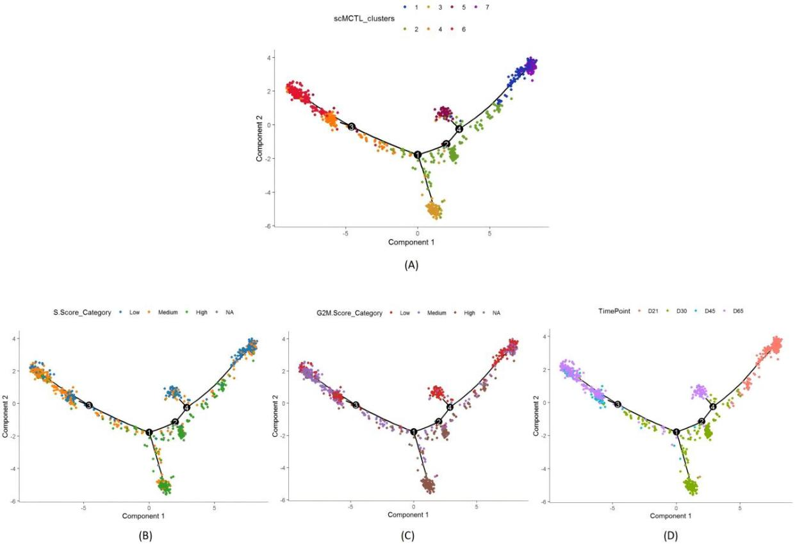
Figure SN6. Pseudotime Trajectory Analysis Results Using the scMSCF Algorithm on the iPSC Midbrain Neuron PD Dataset. (A) shows the single-cell clustering results of the iPSC Midbrain Neuron PD dataset along the pseudotime trajectory; (B) and (C) illustrate the relationship between clustering and cell cycle activity in the S phase and G2/M phase, respectively. (D) presents the alignment of pseudotime trajectory with actual time points, capturing the dynamic changes in cell states over time.

SN7. Functional Annotation of Marker Genes across Cell Clusters. We performed Gene Ontology (GO) biological process (BP) enrichment analyses to elucidate the biological significance of the key marker genes identified by the scMSCF method in each cell cluster. These analyses were conducted using the Zeisel single-cell RNA-seq dataset, which provides a well-annotated reference for mouse brain cell types. The results demonstrate that scMSCF accurately captures the core functional features of diverse cell populations. While each cluster showed highly relevant biological enrichment results, we present detailed descriptions for three selected clusters as examples to clearly illustrate the accuracy and biological interpretability of scMSCF.
In the Astrocytes/Ependymal Cells cluster, marker genes identified by scMSCF were significantly enriched in carboxylic acid transport, organic acid transport, and organic anion transport. These enriched biological processes precisely match the critical metabolic support functions of astrocytes, particularly their essential roles in neuronal energy metabolism and maintaining the balance of neurotransmitter concentrations, such as glutamate clearance, within the neural microenvironment.
In the Microglia cluster, scMSCF identified marker genes that were significantly enriched in four highly specific immune-related biological processes: immunoglobulin-mediated immune response, B cell mediated immunity, lymphocyte mediated immunity, and adaptive immune response based on somatic recombination of immune receptors. While microglia are not lymphocytes, they are known to express Fc receptors and play an integral role in responding to antibody complexes and modulating immune signaling in the CNS. These enriched GO terms reflect microglia’s functional integration within the adaptive immune environment, particularly through immunoglobulin recognition and immune surveillance.
In the Endothelial-Mural cluster, scMSCF identified marker genes that were significantly enriched in biological processes including bicellular tight junction assembly, tight junction organization, and cell-cell junction assembly. These processes are central to the structural and barrier functions of endothelial cells, which line blood vessels and regulate selective permeability through tight junctions.
These results indicate that scMSCF not only identifies differentially expressed genes across clusters, but more importantly, selects marker genes that are biologically coherent with the known functions of their respective cell types. The close alignment between enriched GO terms and expected cellular roles—including metabolic support by astrocytes, immune surveillance by microglia, and barrier maintenance by endothelial-mural cells—supports the functional validity of the method. This highlights scMSCF's capability to produce biologically meaningful and interpretable outputs, reinforcing its utility in downstream single-cell analyses and cell-type characterization.
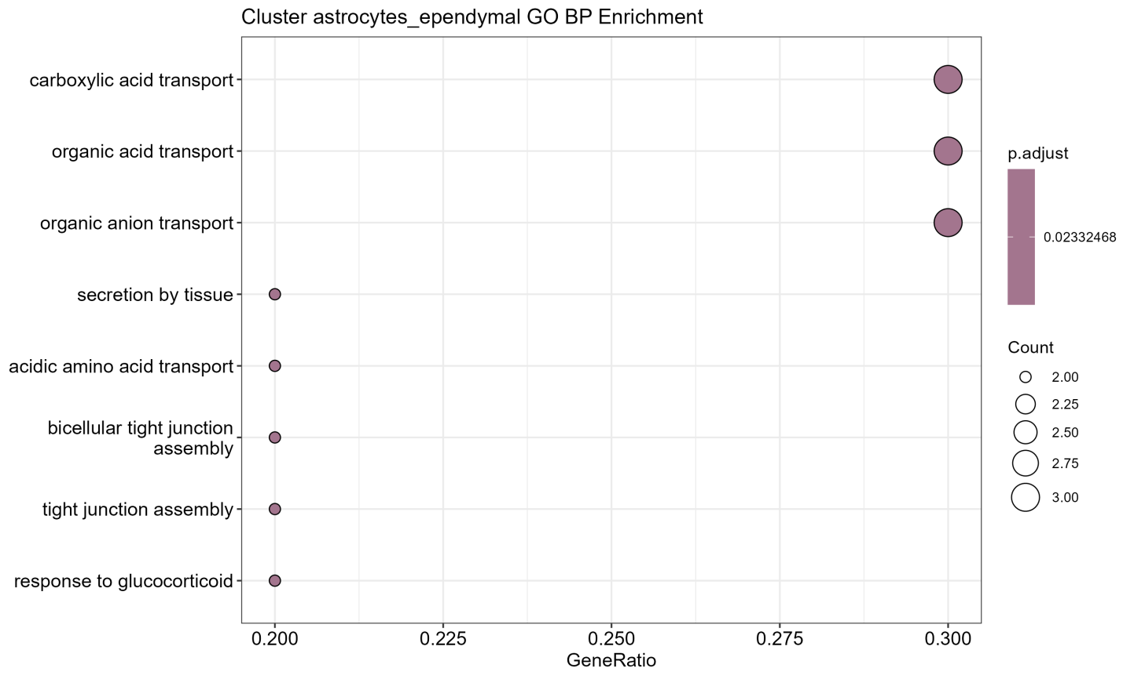
Figure SN7.1. GO enrichment analysis of marker genes in the Astrocytes/Ependymal cluster.
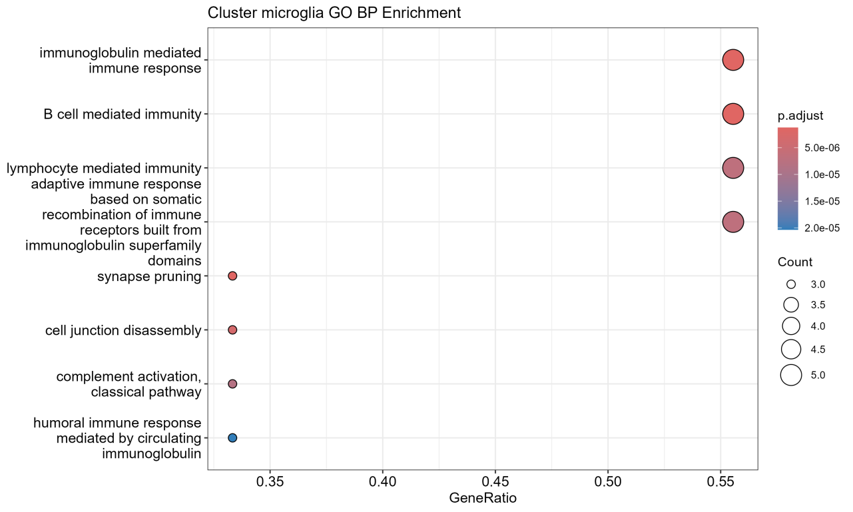
Figure SN7.2. GO enrichment analysis of marker genes in the Microglia cluster.
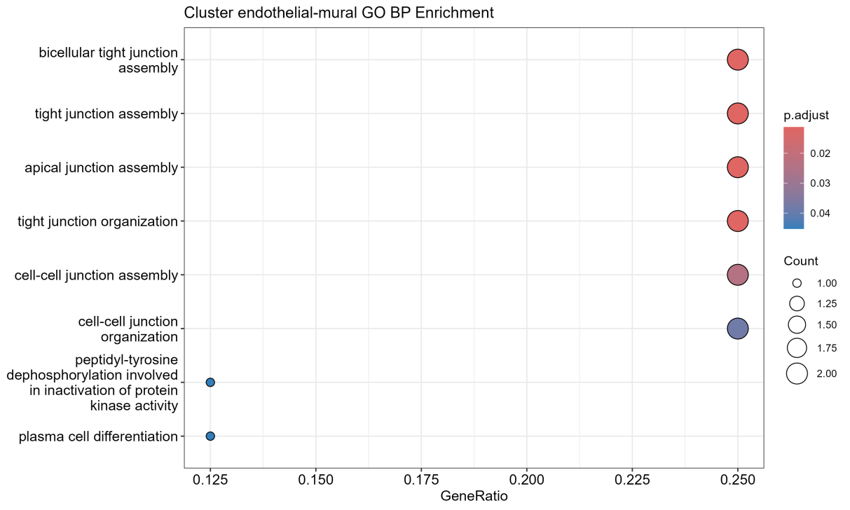
Figure SN7.3. GO enrichment analysis of marker genes in the endothelial-mural cluster.

SN8. Sensitivity Analysis of Key Hyperparameters in scMSCF. To comprehensively evaluate the sensitivity of scMSCF’s performance to critical hyperparameters, we conducted sensitivity analyses focusing on the Transformer layers, feature dimension (d_model), and learning rate. These hyperparameters significantly influence the clustering performance and stability of the Transformer model. The confidence threshold sensitivity analysis has already been thoroughly discussed in the Ablation Study section of the main manuscript.
1. Transformer Layers Sensitivity Analysis
We analyzed the impact of varying the number of Transformer layers using the PBMC5k dataset, holding other hyperparameters constant at their optimal settings. Results are shown in Table SN8.1.
Transformer Layers | ARI | ACC | Observations
2 | 0.71 | 0.85 | Slight underfitting
4 | 0.82 | 0.91 | Optimal performance
6 | 0.79 | 0.89 | Potential overfitting

Table SN8.1. Transformer Layers Sensitivity Analysis (PBMC5k Dataset)
- Feature Dimension (d_model) Sensitivity Analysis
We also explored the influence of feature dimension (d_model) on model performance, again using the PBMC5k dataset with other parameters held constant. Results are summarized in Table SN8.2.
Feature Dimension | ARI | ACC | Observations
128 | 0.76 | 0.90 | Limited capacity
256 | 0.83 | 0.92 | Optimal performance
512 | 0.80 | 0.91 | Potential overfitting
Table SN8.2. Feature Dimension Sensitivity Analysis (PBMC5k Dataset)

- Learning Rate Sensitivity Analysis
Finally, we investigated the impact of learning rate variation, keeping other hyperparameters constant. Results using the PBMC5k dataset are detailed in Table SN8.3.
Learning Rate | ARI | ACC | Observations
0.01 | 0.74 | 0.86 | Unstable convergence
0.001 | 0.83 | 0.92 | Optimal performance
0.0001 | 0.79 | 0.91 | Slow convergence
Table SN8.3. Feature Dimension Sensitivity Analysis (PBMC5k Dataset)
These sensitivity analyses clearly illustrate how variations in key hyperparameters impact the clustering accuracy and stability of the scMSCF method, providing valuable guidelines for practical hyperparameter tuning.

SN9. Runtime and Resource Efficiency of scMSCF Across Different Hardware Configurations.
To evaluate the practical feasibility and scalability of scMSCF under varying computational environments, we conducted runtime and resource profiling on two distinct hardware platforms using representative small- and medium-scale datasets. Specifically, we selected the PBMC5k dataset (5,025 cells) and the iPSC Midbrain dataset (767 cells), which reflect common use cases in real-world single-cell RNA-seq analyses.
Hardware Platforms
- Device A: High-performance server equipped with an NVIDIA A800 80GB PCIe GPU, 512 GB RAM, running PyTorch with CUDA 11.8.
- Device B: High-performance GPU server running Microsoft Windows Server 2016, equipped with dual Intel Xeon Platinum 8358P processors, 2TB RAM, and 10 × NVIDIA A100-PCIE-40GB GPUs, using CUDA 12.2 and NVIDIA driver version 538.15.
Experimental Setup
Each dataset was processed using the full scMSCF pipeline, including pseudo-label generation, confidence filtering, Transformer-based classification, and final meta-clustering. Runtime measurements were separated into training and inference phases, and GPU memory usage was recorded where applicable.

Results Summary
Dataset | #Cells | Device | Training Time | Inference Time | GPU Used | Peak Memory Usage
iPSC Midbrain | 767 | Device A | 108 sec | 15 sec | NVIDIA A800 80GB | 4.6 GB
iPSC Midbrain | 767 | Device B | 87 sec | 7 sec | NVIDIA A100-PCIE-40GB | 5.2 GB
PBMC5k | 5,025 | Device A | 672 sec | 60 sec | NVIDIA A800 80GB | 8.1 GB
PBMC5k | 5,025 | Device B | 493 sec | 54 sec | NVIDIA A100-PCIE-40GB | 9.1 GB
Table SN9.1. Runtime and Memory Profiling of scMSCF Across Devices
These results reinforce the feasibility of deploying scMSCF in various high-performance computing environments, including both institutional GPU clusters and dedicated GPU servers. This profiling offers practical insights into the resource requirements and execution efficiency of scMSCF, helping researchers plan deployments based on their available infrastructure.

SF1. Comparison of VI Scores Between scMSCF and Nine Other Methods.
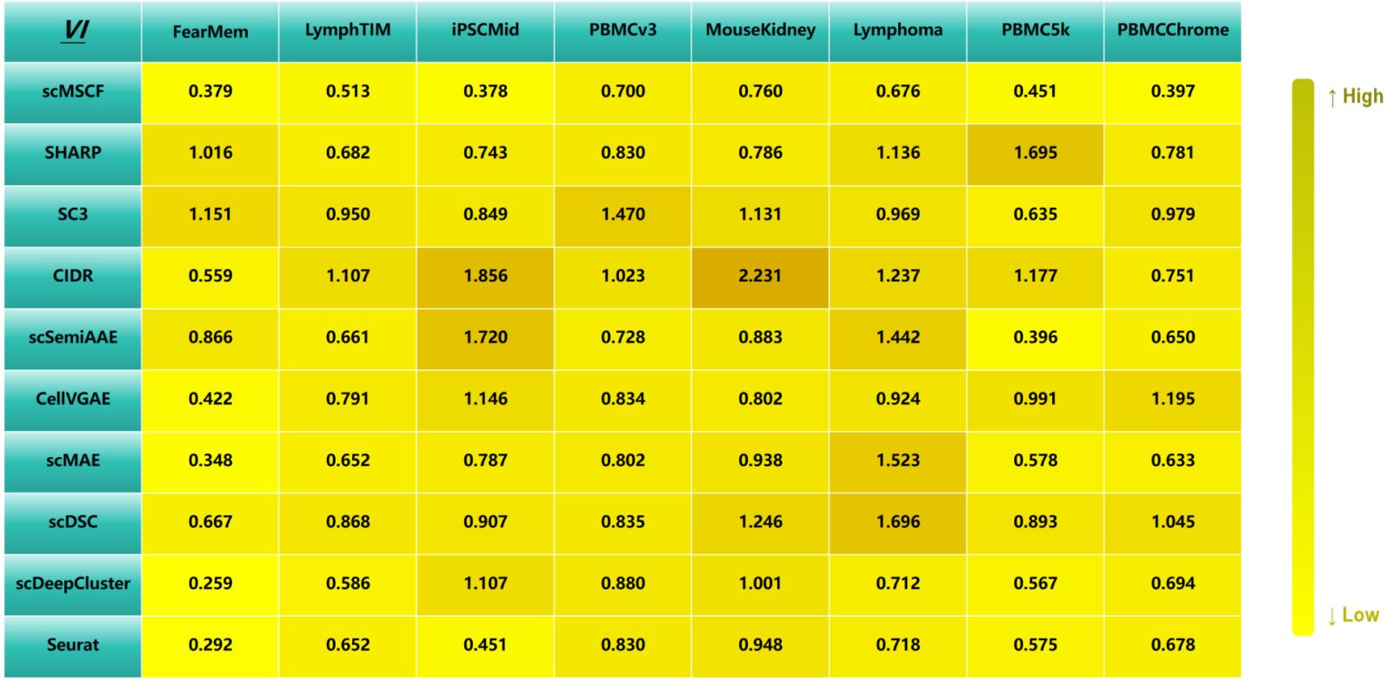

SF2. Comparison of DBI Scores Between scMSCF and Nine Other Methods.
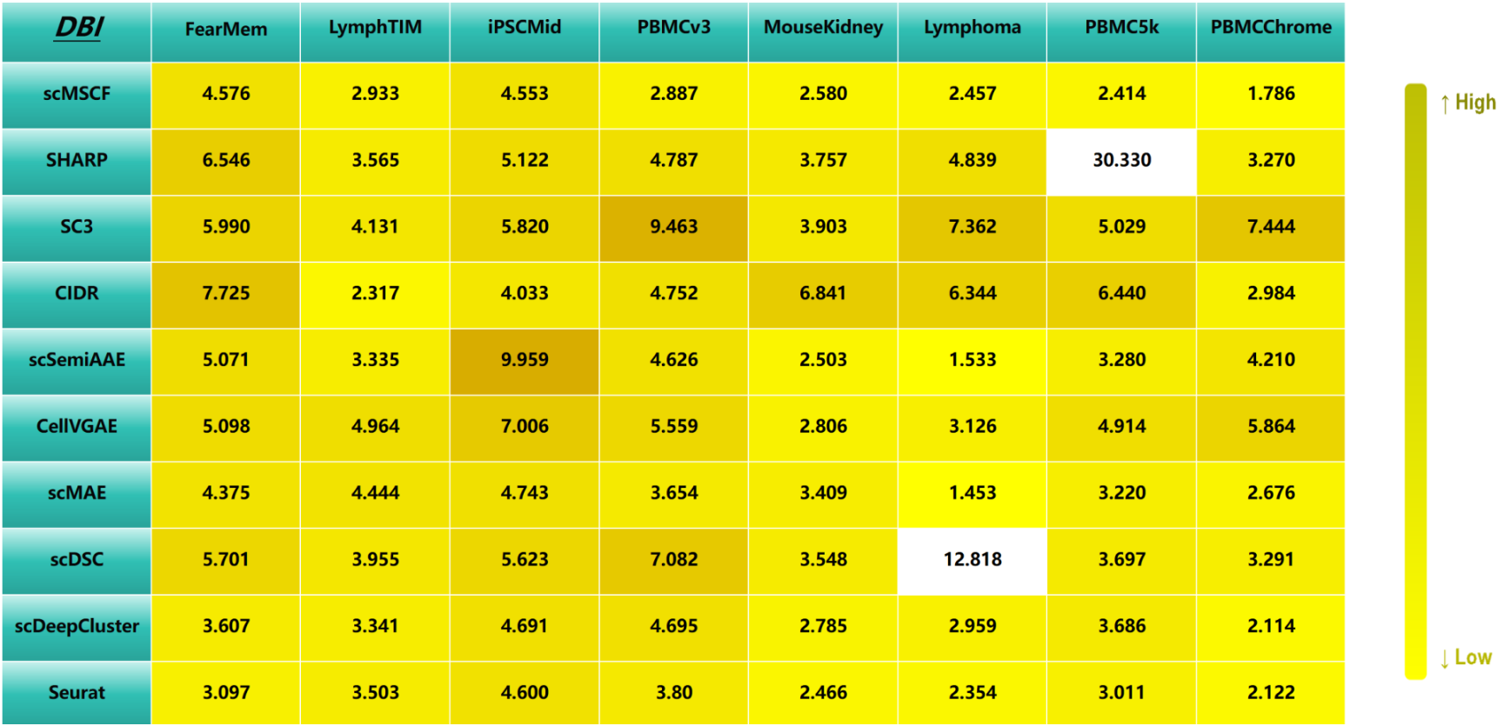

SF3. Clustering Visualization of scMSCF and Nine Competing Methods on the FearMem Dataset.
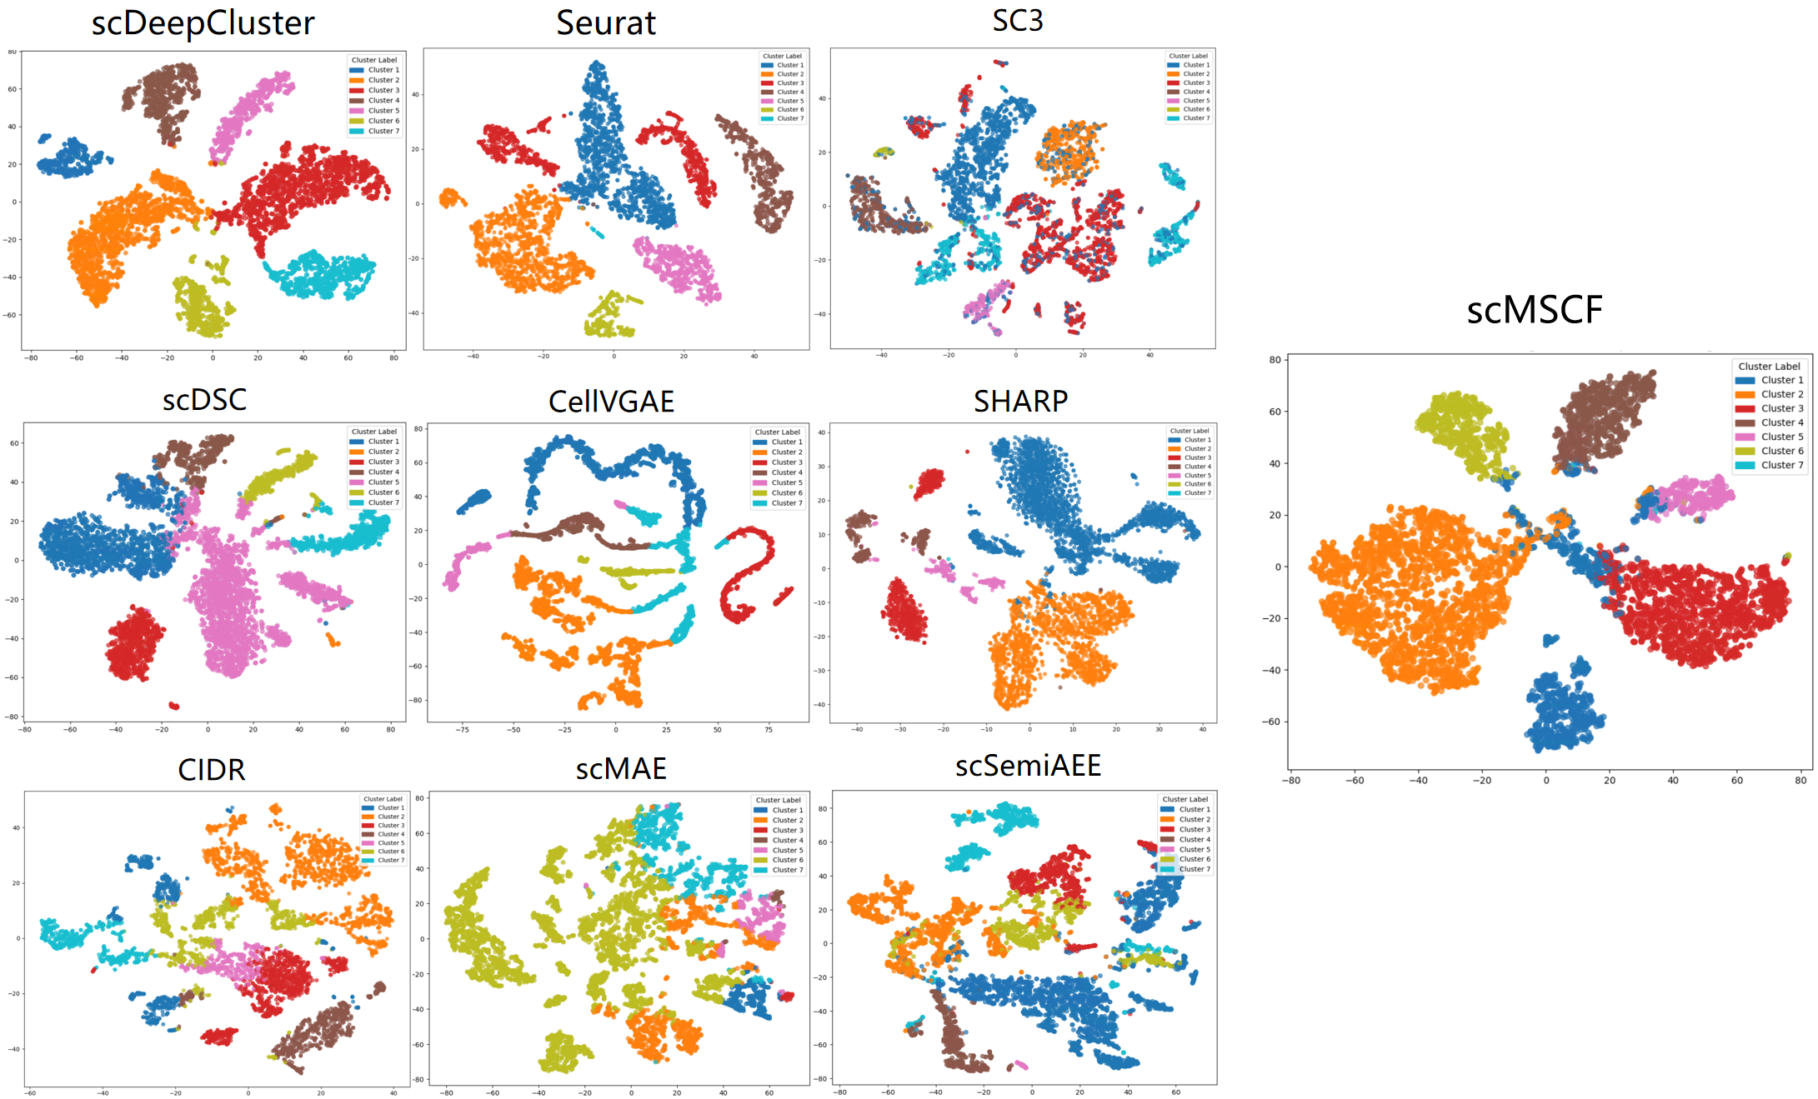

SF4. Clustering Visualization of scMSCF and Nine Competing Methods on the LymphTIM Dataset.
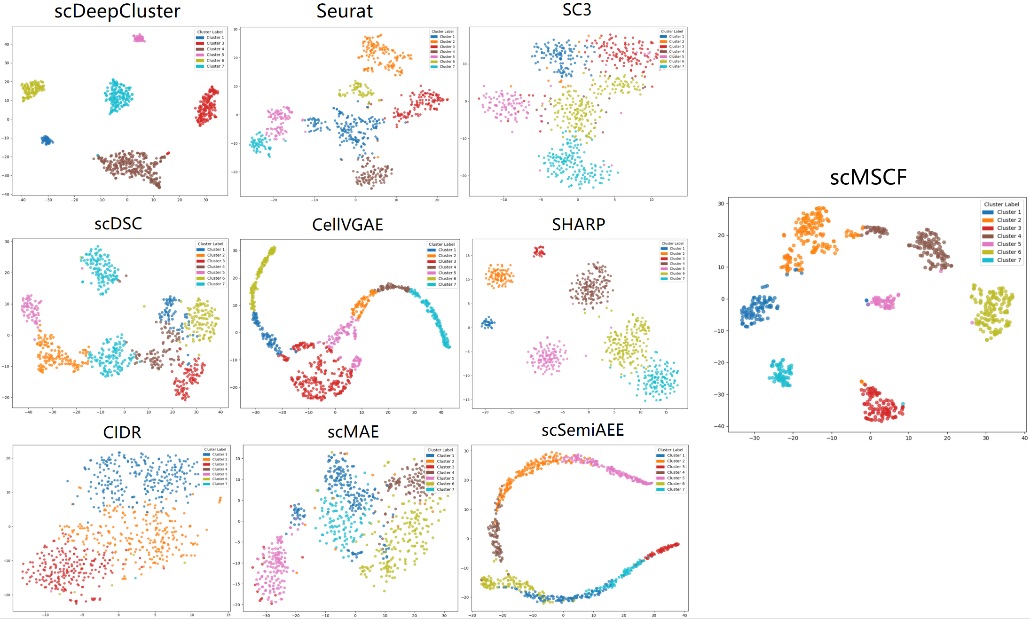

SF5. Clustering Visualization of scMSCF and Nine Competing Methods on the iPSCMid Dataset.
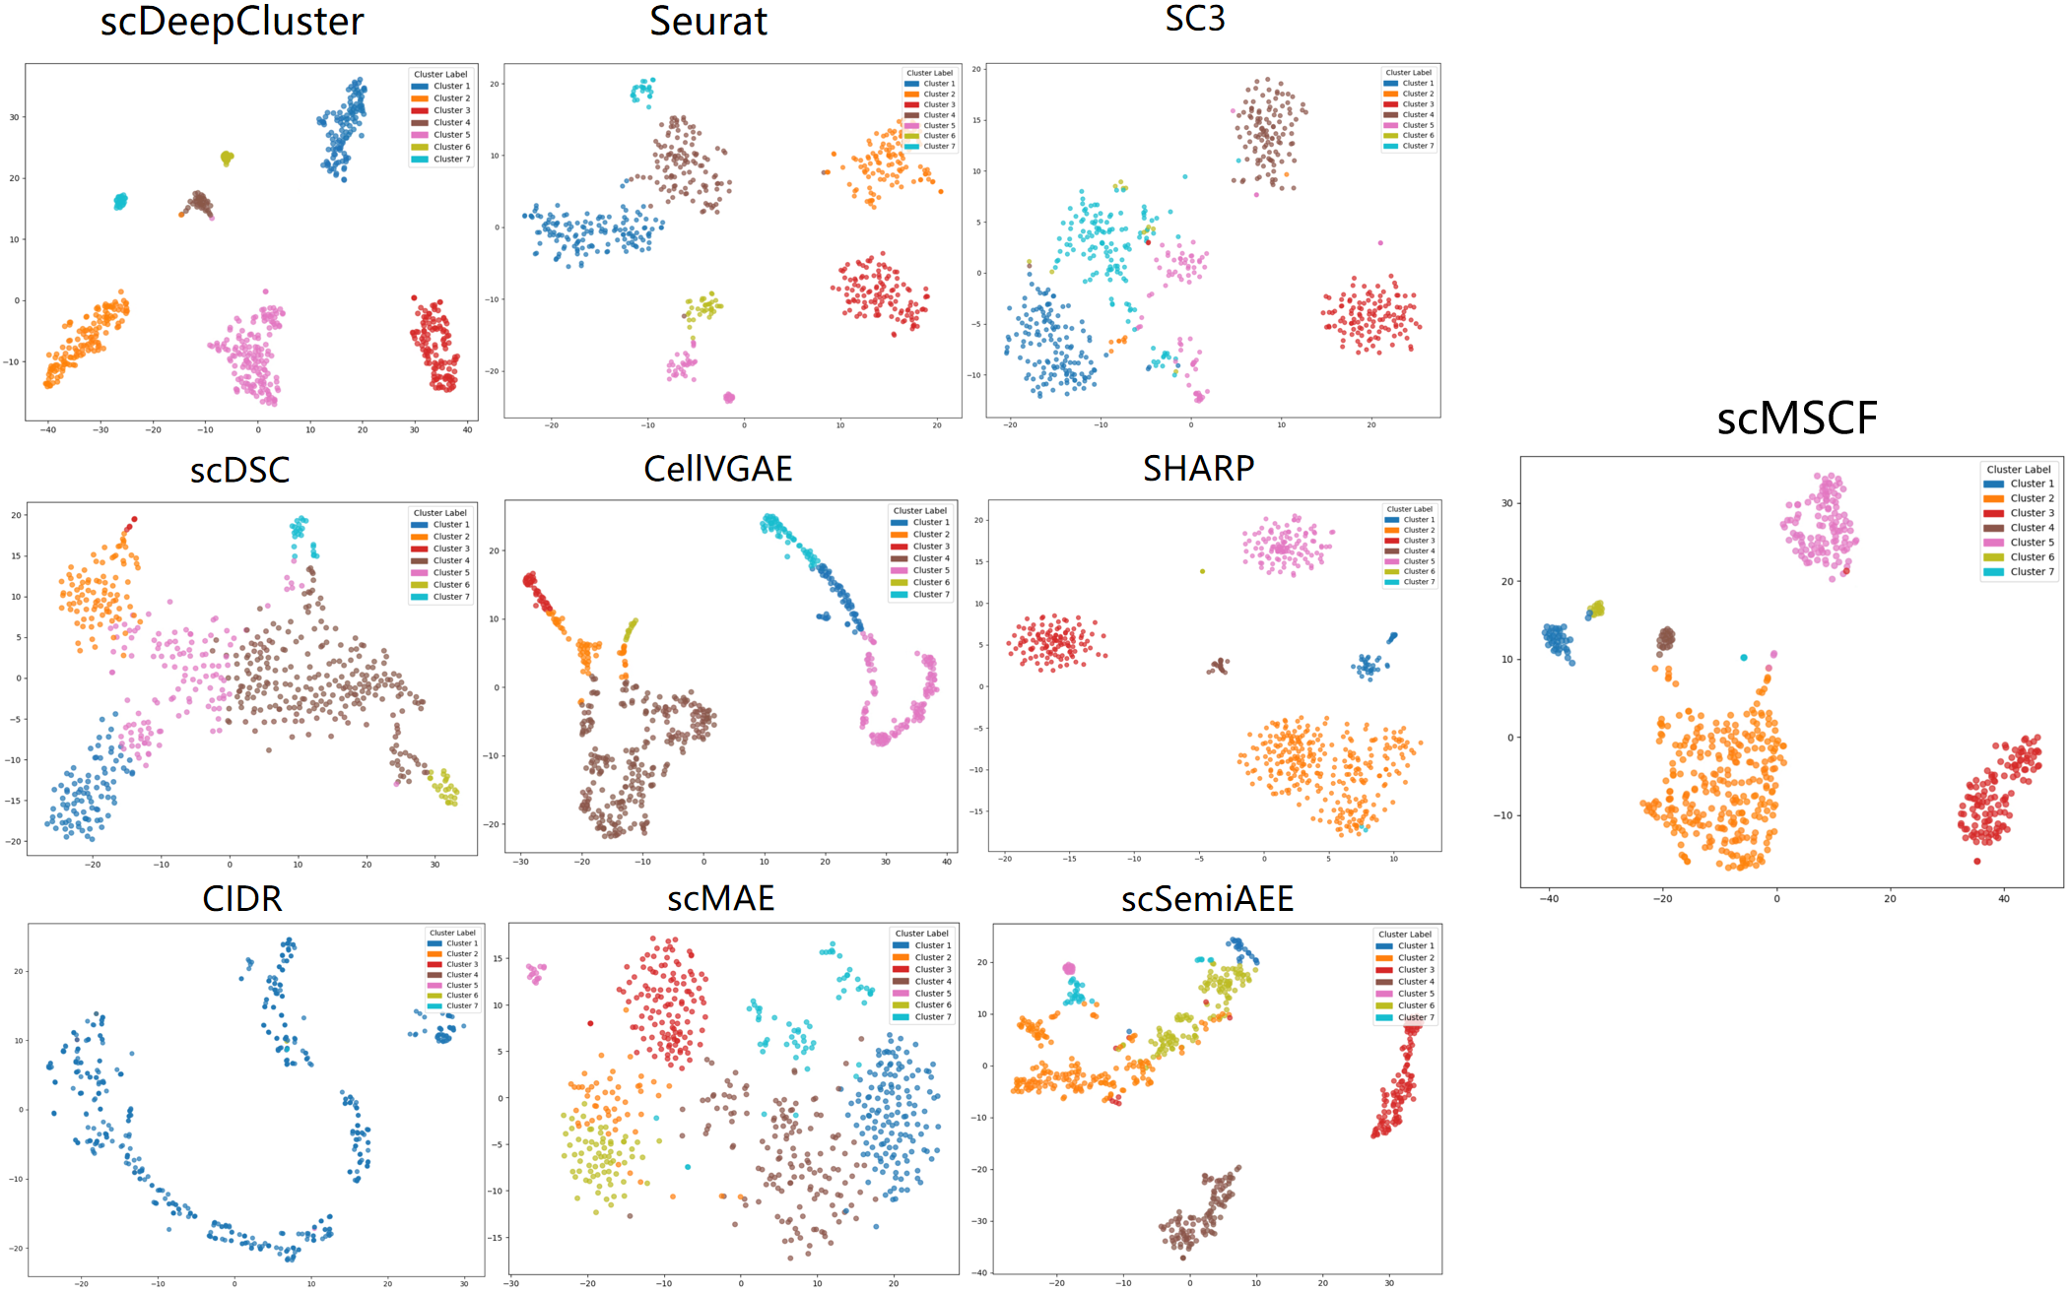

SF6. Clustering Visualization of scMSCF and Nine Competing Methods on the PBMCv3 Dataset.
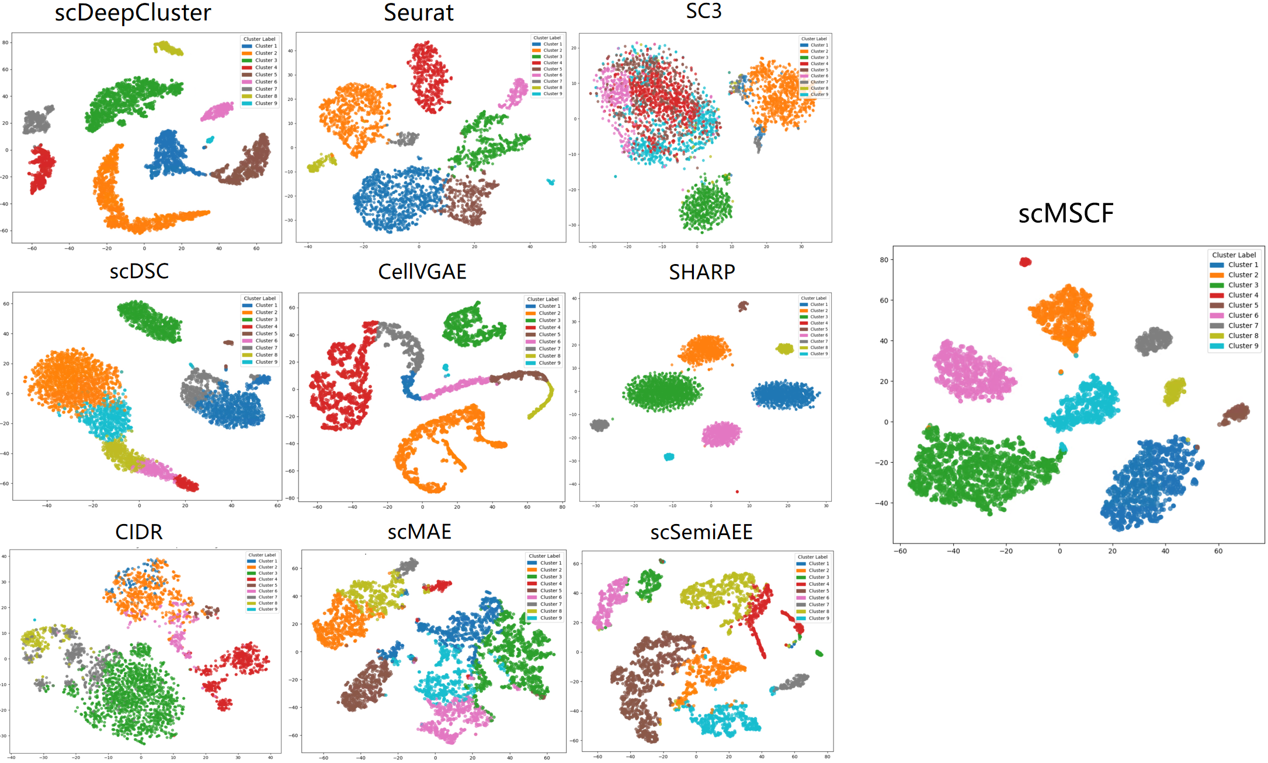

SF7. Clustering Visualization of scMSCF and Nine Competing Methods on the MouseKidney Dataset.
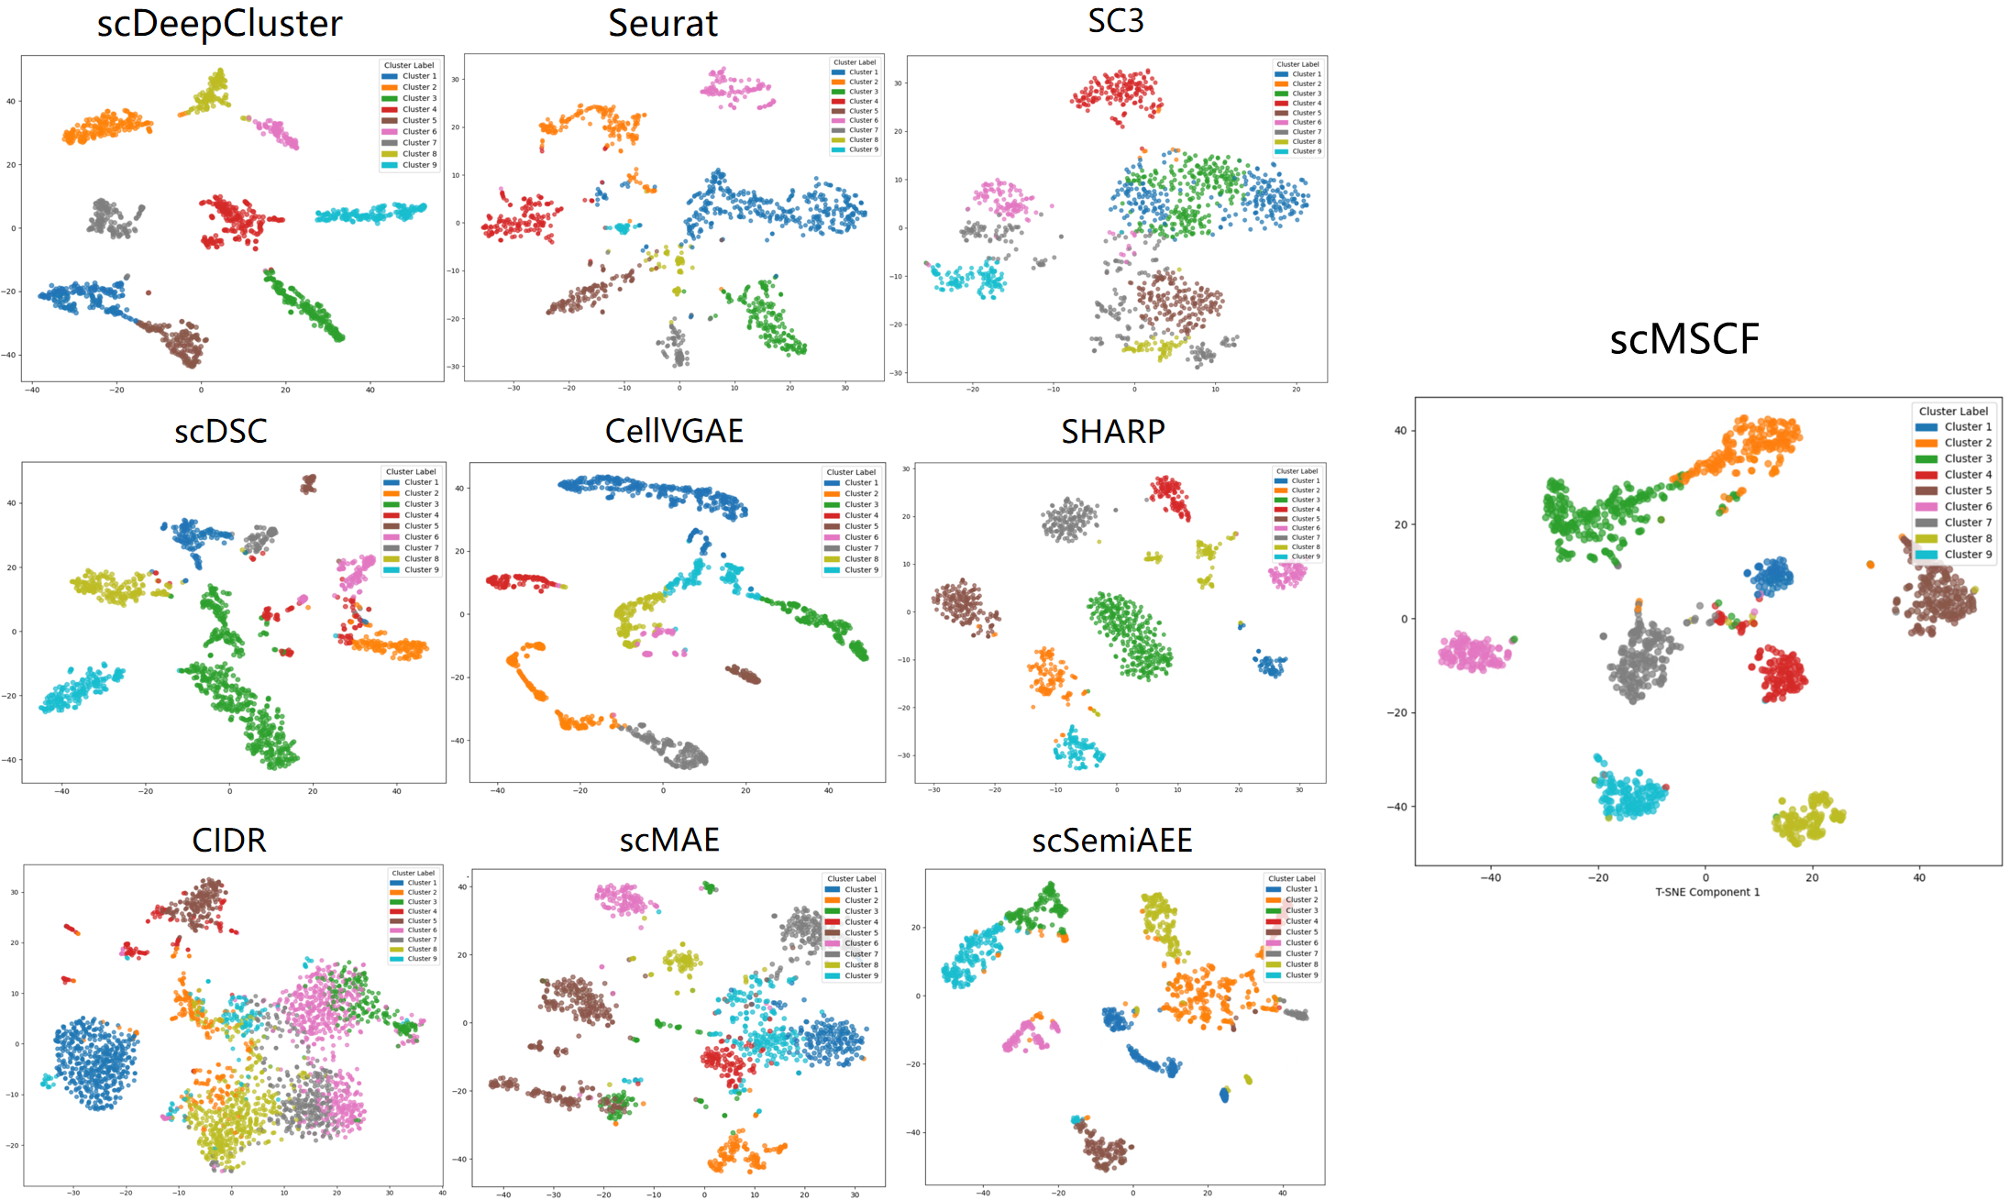

SF8. Clustering Visualization of scMSCF and Nine Competing Methods on the Lymphoma Dataset.
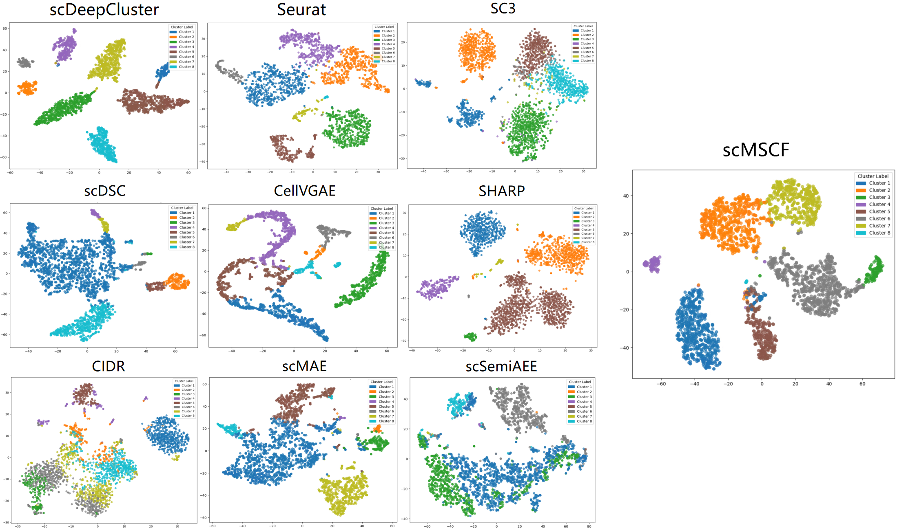

SF9. Clustering Visualization of scMSCF and Nine Competing Methods on the PBMCChrome Dataset.
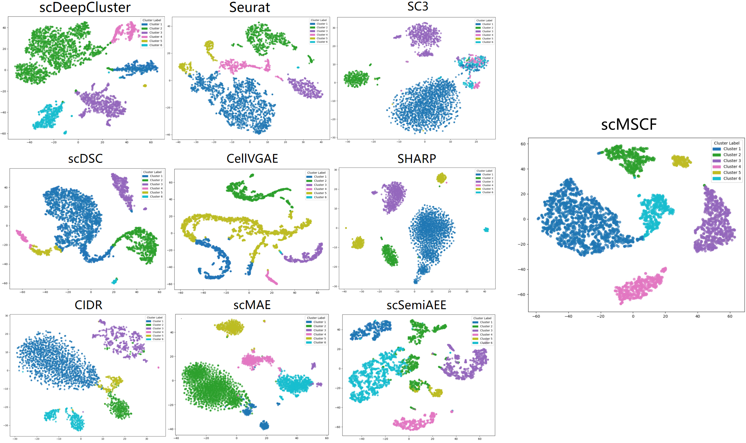

SF10. Overlap Rate of Identified Marker Genes with True Marker Genes for Each Cluster in the Mouse Skin Cells, Mouse Aorta Myeloid, and Human Bone Vascular Cells Datasets by scMSCF.
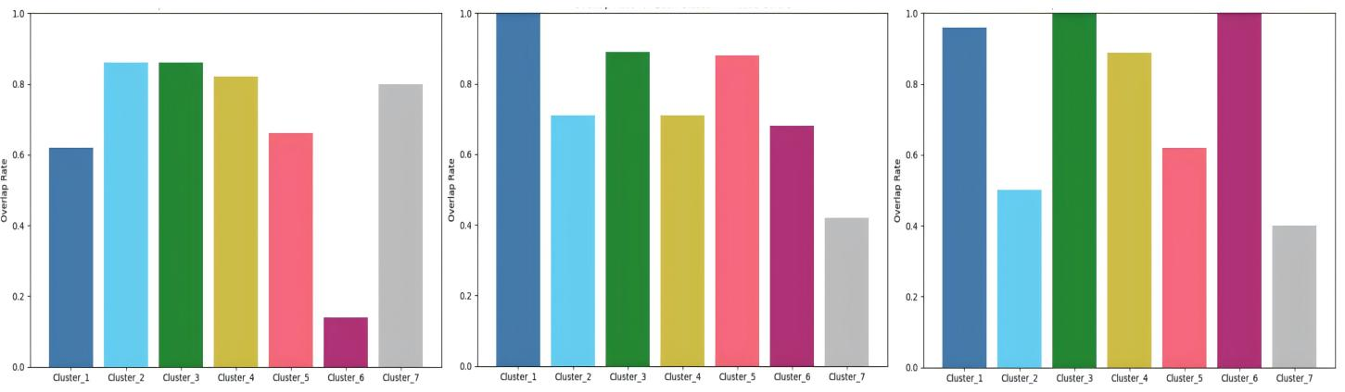

ST1. Comparative Analysis of Technical Strategies, Advantages, and Use Cases of Additional Algorithms in scRNA-seq Clustering.
Method | Technical Strategy | Advantages | Use Cases
scTPC | ZINB Denoising AE + Label-guided Clustering | Models dropout and overdispersion in count data | Clear-cluster-boundary data
scSSA | Semi-supervised AE + FastICA dimensionality reduction | Effective for rare subtype identification | Sparse large-scale data
GraphSCC | Graph Convolution + Contrastive Learning | Captures complex inter-cell relationships | Small-scale fine-grained data
scDeepCluster | Deep Clustering + Autoencoder | End-to-end learning; scalable to large datasets | Partially labeled data

