Appendix S1. Detailed laboratory and bioinformatic protocols, and sequencing results
Laboratory conditions
DNA extraction and PCR preparation were conducted in a dedicated pre-PCR laboratory, with separate rooms assigned to each processing step. Personnel working in the pre-PCR lab wore coveralls, masks, hairnets, and disposable nitrile gloves to minimize contamination. PCR amplification took place in a designated PCR/post-PCR laboratory.
To prevent contamination, all bench spaces and laboratory equipment were thoroughly cleaned with a 20% bleach solution, followed by rinsing with distilled water. Aerosol barrier filter tips were consistently used to prevent cross-contamination between samples.
Modifications of the DNA extraction protocol
We followed the Qiagen Blood and Tissue kit manufacturer’s protocol for tissue with the following modifications: 1) we added 540 µL of ATL buffer and 60 µL of proteinase K to the tubes and shook them at 160 rpm during overnight incubation at 56°C, 2) we used 600 µL of buffer AL and 600 µL of ethanol, and 3) we added 60 µL of AE buffer directly onto the pad, centrifuged after a 5-minutes incubation, and pipetted the 60 µL eluate onto the pad again for another 5 minutes incubation before final centrifugation.
Detailed library preparation
PCR1 were performed in 15 µL reaction volumes using 7.5 µL of Qiagen Master Mix (2X), 0.25µL (10µM) of each primer, 4 µL of UltraPure DNase/RNase-Free Distilled Water (ThermoFisherScientific) and 3 µL of DNA. We amplified five regions targeting vertebrates, mammals, birds, arthropods, and plants and fungi. For vertebrates, we used the mam1/2 primers^{1,2} (mam1: 5’-CGGTTGGGGTGACCTCGGA-3’; mam2: 5’-GCTGTTATCCCTAGGGTAACT-3’) to amplify a ~90bp region of the 16S gene. The thermocycling conditions were: 95°C for 15min, followed by 40 cycles of 94°C for 30secs, 55°C for 90secs, 72°C for 90secs, and a final extension of 72°C for 10 mins. To target mammals, we used the MiMammal-U-F/R primers³ (MiMammal-U-F: 5’- GGGTTGGTAAATTTCGTGCCAGC-3’; MiMammal-U-R: 5’-CATAGTGGGGTATCTAATCCCAGTTTG-3’) amplifying a 171bp region of the 12S gene. The thermocycling conditions were: 94°C for 5 min, five cycles of 94°C for 1 min, 45°C for 1 min 50 sec, 72°C for 1 min, followed by 35 cycles of 94°C for 1 min, 60°C for 1 min 50 sec, 72°C for 1 min and a final extension at 72°C for 10min. For birds, we amplified a ~277bp region of the COI gene with the birT-F/R primers⁴ (birT-F: 5’-YGGTAAATCYTGTGCCAGC-3’; birT-R: 5’-AAGTCCTTAGAGTTTYAAGCGTT-3’). The thermocycling conditions were: 95°C for 10min, followed by 35 cycles of 95°C for 30secs, 60°C for 30s, 72°C for 90secs, and a final extension of 72°C for 10 mins. For arthropods, we amplified a 157bp region of the COI gene using the ZBJ-ArtF1c/R2c primers⁵ (ZBJ-ArtF1c: 5’-AGATATTGGAACWTTATATTTTATTTTTGG-3’; ZBJ-ArtR2c: 5’- WACTAATCAATTWCCAAATCCTCC-3’), and the following thermocycling conditions: 95°C for 15min, followed by 35 cycles of 94°C for 40secs, 40°C for 1min, 72°C for 30secs, and a final extension of 72°C for 10 mins. Finally, for plants and fungi we amplified a 580bp region of the ITS2 region with the S2F/ITS4 primers⁶ (S2F: 5’-ATGCGATACTTGGTGTGAAT-3’; ITS4: 5’-TCCTCCGCTTATTGATATGC-3’). The thermocycling conditions were: 95°C for 10min, followed by 40 cycles of 94°C for 40secs, 49°C for 40secs, 72°C for 40secs, and a final extension of 72°C for 10 mins. All the primers were modified with the CS1/CS2 adaptors. We included six PCR negative controls and the PCR1 reactions were performed in triplicates, except for 12S birds (birT-F/R) which was run only on a subset of samples from the following sites: Coedgwilym Cemetery, Belfast Center, Port Talbot Margam, Scunthorpe Low Santon, Chadwell St Mary, London Marylebone Road, Sheffield Devonshire Green and Auchencorth Moss. We also included a positive control for each region: brown anole (Anolis sagrei) for 16S vertebrates and 12S mammals, black guillemot (Cepphus grylle) for 12S birds, Daphnia pulex for COI and banana (Musa) for ITS2. The technical replicates were pooled and transported on ice to the Canadian Centre for DNA Barcoding (CCDB, Guelph, Ontario) for PCR2 (indexing including the M13 tails), cleaning, quantification, normalization, pooling and sequencing on Illumina NextSeq2000 sequencer (2x300 PE cycle run, P1 reagent kit).
Note that we selected the MiMammal-U-F/R (mammals), mam1/2 (vertebrates), ZBJ-ArtF1c/R2c (arthropods), and S2F/ITS4 (plants) primers to capture a broad taxonomic diversity across trophic levels. These primers have previously demonstrated success in amplifying airborne eDNA in previous studies, including air quality monitoring networks¹². To our knowledge, the birT-F/R (birds) primers had not been previously tested on airborne eDNA samples. However, they were specifically designed for avian environmental DNA metabarcoding, making them a suitable candidate for evaluation in this study.
Bioinformatic steps and parameters
Raw reads were first processed by the CCDB. R1 and R2 reads were assembled using the PEAR v0.9.11 program⁷ with the following parameters: statistical method = OES, p-value = 0.01, quality score threshold trimming = 0, maximum assembly length = 999999, minimum assembly length = 50, minimum read size after trimming = 1, maximal ratio of uncalled bases = 1, minimum overlap = 10 bp, and scoring method = scaled score. Cutadapt v3.7⁸ was used to demultiplex assembled reads by sample, remove M13 adapters (-e 0.2 -m 100 -u -17/18), and filter reads (-m 100 -e 0.125 --action=none -g sequence --discard-untrimmed). The full index combinations were searched during the demultiplexing step even if they were not used in our project (“ghost plates”) to estimate assignment errors.
Using cutadapt 4.5, the reads were split by primer pair and the adapters CS1/2 were trimmed using the linked adapters option (-g "CGGTTGGGGTGACCTCGGA;e=0.2...AGTTACCCTAGGGATAACAGC;e=0.2" -m 10). Then, the reads were processed using the DADA2 pipeline v1.26.0⁹ in R 4.4.0¹⁰ and RStudio¹¹. Using the filterAndTrim function, reads were truncated after 157 bp (COI ZBJ-ArtF1c/R2c), 171 bp (12S MiMammal-U-F/R), 90 bp (16S mam1/2), 265 bp (12S birT-F/R) or 230 bp (ITS2 S2F/ITS4), and reads matching against the phiX genome (rm.phix = T), with ambiguous bases (maxN = 0), or with more than 2 expected errors (maxEE = 2) were discarded. All identical sequencing reads were then combined into unique sequences (dereplication) using derepFastq with default parameters. The error rate (learnErrors function) was used to make ASVs with the dada() function. Finally, chimeras were removed using the removeBimeraDenovo function (consensus method).
Taxonomic assignment was kept at the species level only with query cover > 60% and percentage of identity ≥ 97%, and at the order level with percentage of identity < 97% (Appendix S1). In cases where multiple species matched with the same percentage of identity, the closest common ancestor (e.g., genus) was retained. To avoid overinflation of taxonomic assignments at the species level for ITS2 and COI, genus-level identifications were retained for these two regions¹². For the 16S and two 12S markers we used the online BLAST tool (NCBI full nucleotide collection) to manually assign taxonomy to the ASVs. For the primers with large numbers of ASV (4,389 and 7,550 ASVs for ITS2 and COI, respectively) we combined automated (non-Bayesian taxonomy classifier, sintax command of the usearch v11.0.667 pipeline¹³ and manual (online BLAST tool, NCBI full nucleotide collection) approaches. For COI, we used syntax against the BOLD database. ASVs with a sintax probability at the genus level ≥ 0.60 were checked manually in GenBank (May 2024). For those with a probability at the genus level < 0.60 and family level ≥ 0.60, the ASV was assigned at the family level. If the probability was < 0.60 at the family level, we checked the order level: if the probability was ≥ 0.60, then the ASV was assigned at the order level. This was repeated up to the phylum level: if the phylum level probability was < 0.60, then the ASV was identified as "no match". The same backward strategy was applied to ITS2, with two databases PLANiTS_29_03_2023¹⁴ and Unite all eukaryotes v10.0¹⁵.
Sequencing results
A total of 118,240,346 raw reads were generated, 117,051,477 were assembled and 97,963,931 were trimmed, filtered and demultiplexed by sample. Following demultiplexing by primer pair in cutadapt and filtering, denoising and chimera removal in DADA2, we obtained 14,381,711 reads and 2,422 ASVs for 12S MiMammal-U-F/R, 24,074,614 reads and 1,496 ASVs for 16S mam1/2, 7,576,673 reads and 1,180 ASVs for 12S birT-F/R, 16,222,647 reads and 7,550 ASVs for ZBJ-ArtF1c/R2c, and 11,813,754 reads and 4,389 ASVs for ITS2 S2F/ITS4 (Table S1). The final dataset, following removal of no match and suspected contaminants, filtering with control “ghost” plates and negative controls, removal of positive control samples and merging of ASVs with identical identifications, had a total of 18,373,005 reads and 1,556 ASVs (details in Table S1) with an average of 1,224,867 ± 486,829 reads and 334 ± 93 ASVs per sampling site (min: 201 at Heigham Holmes, max: 568 at Low Santon).
References
1. Taylor, P. Reproducibility of ancient DNA sequences from extinct Pleistocene fauna. Molecular biology and evolution 13, 283–5 (1996).
2. Calvignac-Spencer, S. et al. Carrion fly-derived DNA as a tool for comprehensive and cost-effective assessment of mammalian biodiversity. Molecular Ecology 22, 915–924 (2013).
3. Ushio, M. et al. Environmental DNA enables detection of terrestrial mammals from forest pond water. Molecular Ecology Resources 17, e63–e75 (2017).
4. Thalinger, B., Empey, R., Cowperthwaite, M., Coveny, K. & Steinke, D. BirT: a novel primer pair for avian environmental DNA metabarcoding. bioRxiv 2023–08 (2023).
5. Zeale, M. R. K., Butlin, R. K., Barker, G. L. A., Lees, D. C. & Jones, G. Taxon-specific PCR for DNA barcoding arthropod prey in bat faeces. Molecular Ecology Resources 11, 236–244 (2011).
6. Cheng, T. et al. Barcoding the kingdom Plantae: new PCR primers for regions of plants with improved universality and specificity. Molecular Ecology Resources 16, 138–149 (2016).
7. Zhang, J., Kobert, K., Flouri, T. & Stamatakis, A. PEAR: a fast and accurate Illumina Paired-End reAd mergeR. Bioinformatics 30, 614–620 (2014).
8. Martin, M. Cutadapt removes adapter sequences from high-throughput sequencing reads. EMBnet.journal 17, 10–12 (2011).
9. Callahan, B. J. et al. DADA2: High-resolution sample inference from Illumina amplicon data. Nat Methods 13, 581–583 (2016).
10. R Core Team. R: A language and environment for statistical computing. R Foundation for Statistical Computing (2024).
11. Posit team. RStudio: Integrated Development Environment for R. Posit Software (2024).
12. Littlefair, J. E. et al. Air-quality networks collect environmental DNA with the potential to measure biodiversity at continental scales. Current Biology 33, R426–R428 (2023).
13. Edgar, R. SINTAX: a simple non-Bayesian taxonomy classifier for 16S and ITS sequences. biorxiv 074161 (2016).
14. Banchi, E. et al. PLANiTS: a curated sequence reference dataset for plant ITS DNA metabarcoding. Database 2020, baz155 (2020).
15. Abarenkov, K. et al. The UNITE database for molecular identification and taxonomic communication of fungi and other eukaryotes: sequences, taxa and classifications reconsidered. Nucleic Acids Research 52, D791–D797 (2024).

Appendix S2. Effect of filter storage time at ambient temperature on ASV recovery.
Methods
We assessed the effect of storage time at ambient temperature (measured in months between sample collection and storage at -20°C) on the number of ASV recovered. We used the glmmTMB function of the glmmTMB package¹ to run a GLMM of negative binomial family (nbinom2) with ambient storage time (months), sequencing depth (transformed read count with the scale function) and their interaction as fixed effects. Site and taxonomic group (vertebrate, arthropod, plant, fungi) variables were included as random effects (intercept). The model results were visualized and reported using the plot_model and tab_model functions of the sjplot package², and the image, contour and persp functions of the rsm package³. The analysis was performed on i) all taxa, ii) taxa identified at the species level only, iii) taxa identified at the genus level only, iv) taxa identified at the family level only, and v) taxa identified at the order level only. Note that at the species level, we performed a simpler model (GLM with negative binomial family) because: 1) there was only one taxonomic group (only vertebrates were identified at the species level) so it was not included in the model, and 2) the random effect “site” was not contributing additional explanatory power to the model with null between-group variance of the random effect.
Results
We observed a negative effect of ambient storage time, regardless of the taxonomic level, and a positive effect of read count at all levels but family (Appendix 2 Figure 1 and Table below). The negative IRR of the interaction between ambient storage time and read counts at the species level indicates that the longer the ambient storage time, the less “beneficial” the total read count becomes for species richness (Appendix 2 Figure 2).

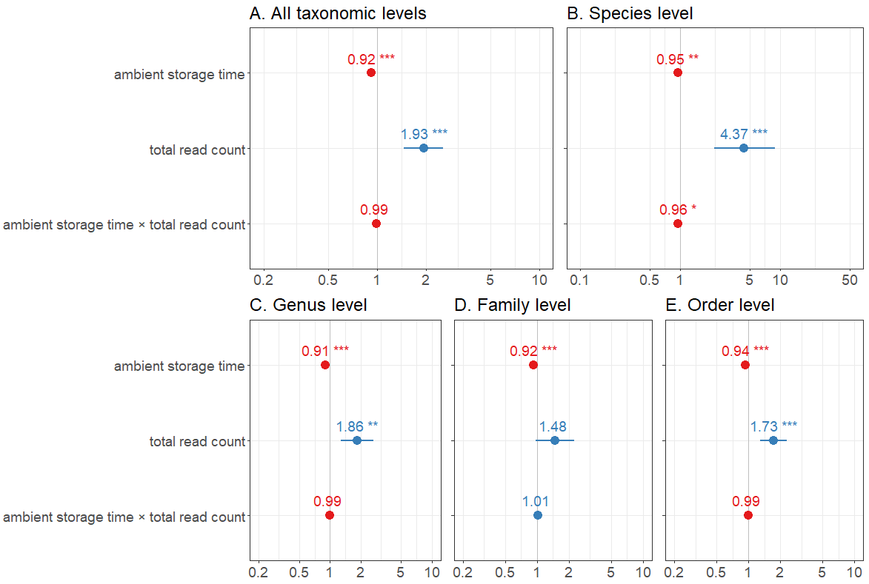
Appendix 2 Figure 1. Incidence rate ratios (IRR) and standard errors for each predictor (ambient storage time, total read count and their interaction, for A) ASV identified at any taxonomic level, ii) ASV identified at the species level only, iii) ASV identified at the genus level only, iv) ASV identified at the family level only, and v) ASV identified at the order level only. Predictors with ICC < 1 (left of the grey line; red) have a negative effect, while those >1 (on the right; blue) have a positive effect. The significance (p-value) is indicated by stars.

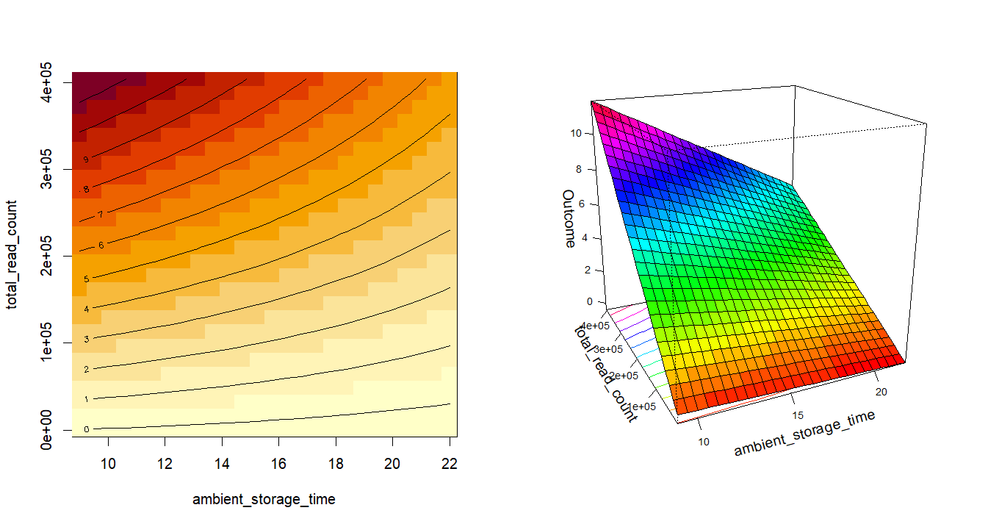
Appendix 2 Figure 2. Interaction plots representing the negative interaction between the two predictor variables at the species level: ambient storage time (months) and read counts. Each contour line of the left plot corresponds to a specific level of predicted species richness (e.g. along the line labeled "4" the predicted species richness is 4 for the specific combinations of ambient storage time and total read count that lie along that line), with warmer colors (red) representing higher values of predicted species richness. The right plot is a 3D representation of the outcome (predicted species richness, untransformed estimate) variation across the range of values of the read count and ambient storage time variables. Both plots demonstrate that species richness declines with storage time and reduction in read counts.

Appendix 2 Table. Output of the models investigating the effect of ambient storage time of the filters (‘time’), sequencing depth (‘read’) and their interaction on the number of ASV identified at any taxonomic levels, species only, genus only, family only and order only, respectively.
 | All taxonomic levels (negative binomial GLMM) |  |  |  | Species level (negative binomial GLM) |  |  |  | Genus level (negative binomial GLMM) |  |  |  | Family level (negative binomial GLMM) |  |  |  | Order level (negative binomial GLMM)
Predictors | Estimate | Std. Error | z value | p | Estimate | Std. Error | z value | p | Estimate | Std. Error | z value | p | Estimate | Std. Error | z value | p | Estimate | Std. Error | z value | p
(Intercept) | 3.057 | 0.374 | 8.178 | 2.88e-16 | 0.908 | 0.260 | 3.494 | 0.0004 | 2.599 | 0.504 | 5.160 | 2.47e-07 | 0.239 | 0.839 | 0.285 | 0.776 | 0.723 | 0.314 | 2.302 | 0.021
time | -0.080 | 0.007 | -11.122 | < 2e-16 | -0.051 | 0.017 | -3.000 | 0.003 | -0.097 | 0.010 | -9.864 | < 2e-16 | -0.084 | 0.013 | -6.331 | 2.43e-10 | -0.062 | 0.011 | -5.887 | 3.94e-09
read | 0.660 | 0.143 | 4.621 | 3.82e-06 | 1.475 | 0.236 | 6.247 | 4.18e-10 | 0.619 | 0.189 | 3.270 | 0.001 | 0.395 | 0.212 | 1.859 | 0.063 | 0.548 | 0.148 | 3.696 | 0.0002
time × read | -0.013 | 0.010 | -1.326 | 0.185 | -0.041 | 0.016 | -2.517 | 0.012 | -0.006 | 0.013 | -0.492 | 0.623 | 0.011 | 0.014 | 0.800 | 0.424 | -0.009 | 0.010 | -0.863 | 0.388
Random Effects | Type | Variance | Std. Dev |  | Type | Variance | Std. Dev |  | Type | Variance | Std. Dev |  | Type | Variance | Std. Dev |  | Type | Variance | Std. Dev
Supergroup | Intercept | 0.618 | 0.786 |  | N/A |  |  |  | Intercept | 0.073 | 0.269 |  | Intercept | 2.926 | 1.711 |  | Intercept | 0.341 | 0.584
site | Intercept | 0.031 | 0.178 |  |  |  |  |  | Intercept | 1.117 | 1.057 |  | Intercept | 0.075 | 0.274 |  | Intercept | 0.022 | 0.150
Marginal / Conditional R² | 0.223 / 0.641 |  |  |  | 0.309 (R² Nagelkerke) |  |  |  | 0.186 / 0.680 |  |  |  | 0.100 / 0.786 |  |  |  | 0.165 / 0.400

References
1. Brooks, M. E. et al. glmmTMB Balances Speed and Flexibility Among Packages for Zero-inflated Generalized Linear Mixed Modeling. The R Journal 9, 378–400 (2017).
2. Lüdecke, D. sjPlot: Data Visualization for Statistics in Social Science. R package version 2.8.16. (2024)
3. Russell V. Lenth. Response-Surface Methods in R, Using rsm. Journal of Statistical Software, 32(7), 1-17. (2009)
Appendix S3. Comparison of iNaturalist and airborne eDNA datasets within an 18.6 km radius
Similarly to eBird, the iNaturalist dataset comprised more taxa than airborne eDNA, with 2,942 taxa from 17,078 observations compared to 1,227 taxa from 185 samples, respectively. However, the overlap in shared species-site detections between the two datasets was lower (7.4%) than when comparing eBird and eDNA with a higher overall detection rate by iNaturalist than airborne eDNA (McNear’s Chi-squared 𝜒 = 6005.8, p < 0.001), with 43.0% found only in the iNaturalist dataset, and 49.9% found only in the eDNA dataset (Appendix 3 Figure 1). Airborne eDNA detected some taxa not recovered with iNaturalist (Branchiopoda, Copepoda, Nematoda, Rotifera, Tardigrada, Chytriomycota, Chlorophyta, Charophyta and Cryptista) (Appendix 3 Figure 1, Table S4). Similarly, iNaturalist detected some taxa not recovered with eDNA (Reptilia, Mollusca, Pycnogonida, Cnidaria, Porifera, Echinodermata, platyhelminthes, tunicates, Chromista, Protozoa, Rodophyta, Mucoromycota, Polypodiopsida, Ceratophyllales, Eumagnoliids, Nymphaeales and Lycophytes) (Appendix 3 Figure 1, Table S4).
Airborne eDNA recovered more detections of Ascomycota (𝜒 = 26, p < 0.001), Chlorophyta (𝜒 = 101.4, p < 0.001) and mammals (𝜒 = 5.7, p = 0.016). iNaturalist recovered more detections of Basidiomycota (𝜒 = 630.9, p < 0.001), Bryophyta (𝜒 = 164.5, p < 0.001), Monocots (𝜒 = 299.6, p < 0.001), Eudicots (𝜒 = 2231.5, p = 0), Marchantiophyta (𝜒 = 47.2, p < 0.001), Insecta (𝜒 = 2424.8, p = 0), Arachnida (𝜒 = 141.5, p < 0.001), Malacostraca (𝜒 = 49.9, p < 0.001), Diplopoda (𝜒 = 18.2, p < 0.001), Fish (𝜒 = 54.8, p < 0.001), Bird (𝜒 = 615.8, p < 0.001) and Amphibian (𝜒 = 45.2, p < 0.001). No significant difference was observed for Bryozoa (p = 1.000), Ostracoda (p = 1.000), Gymnosperm (p = 0.371), Thecostraca (p = 0.617), Entognatha (p = 0.065) and Annelida (p = 0.742).

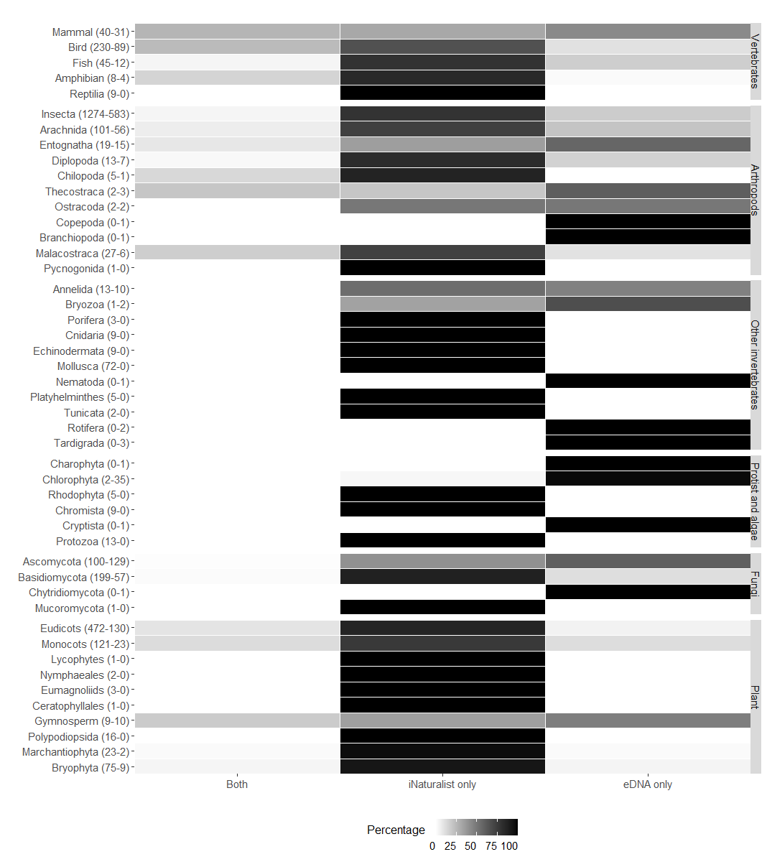
Appendix 3 Figure 1. Detection source percentage per taxonomic group (vertebrates, arthropods, other invertebrates, fungi, plants, protists and algae) in a 18.6km radius around the sampling sites. “Both” = percentage of detections in both the iNaturalist and eDNA datasets, “iNaturalist only” = percentage of detections in the iNaturalist dataset only, and “eDNA only” = percentage of detections in the eDNA dataset only. The numbers of taxa in the iNaturalist checklists (total of 2,942 taxa from 17,078 observations) and the eDNA dataset (1,227 taxa from 185 samples) are indicated between brackets for each taxonomic group.

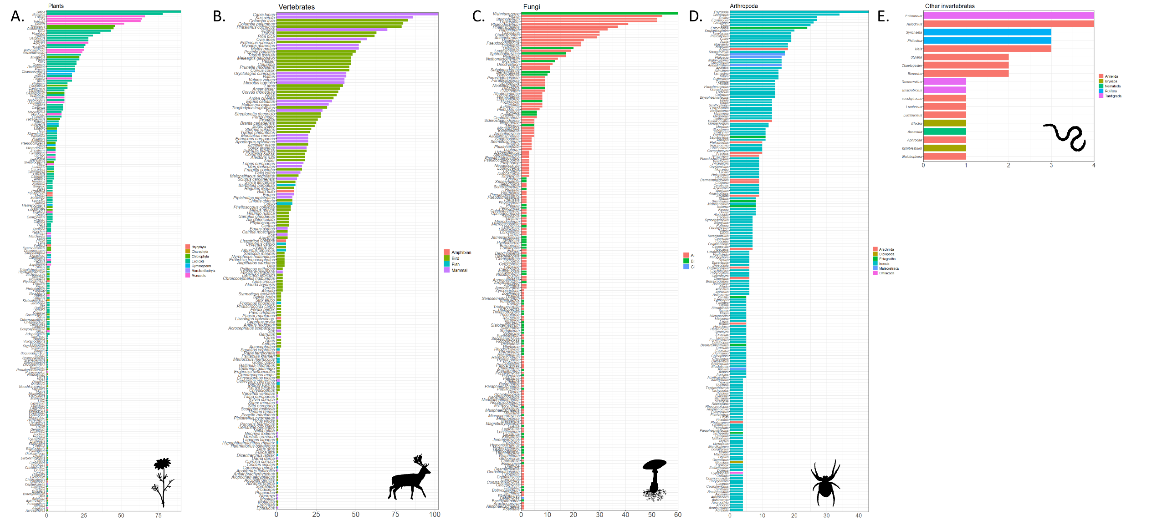
Figure S1. Detection counts (i.e. positive samples) of each A) plant (genus), B) vertebrate (genus and species), C) fungi (genus), D) arthropod (genus) and E) non-arthropod invertebrate (genus) taxa in the airborne eDNA dataset, sorted from the most to the least detected in our dataset. For more clarity, arthropod taxa with less than three detections are not represented here.

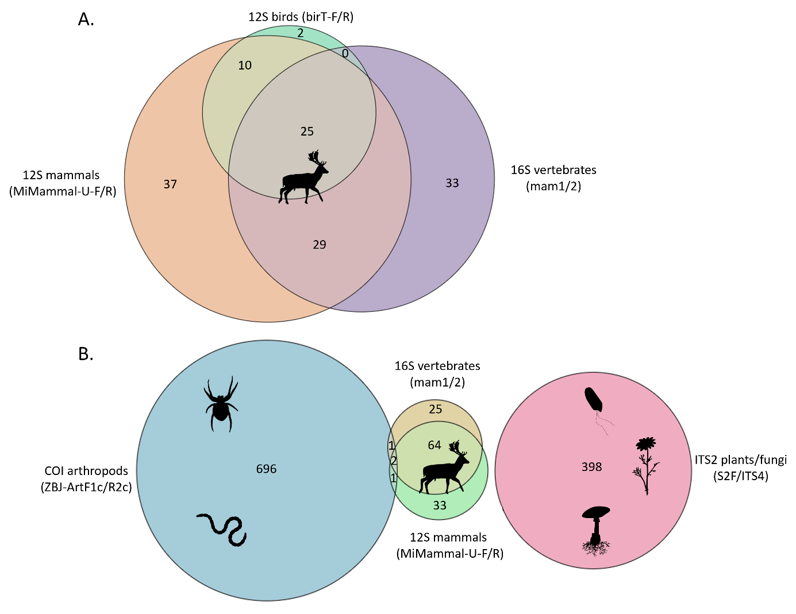
Figure S2. Overlap of A) vertebrate taxa at the species level (birds, mammals, fish, amphibians) based on two markers in three primer pairs: 12S birds (birT-F/R), 12S mammals (MiMammal-U-F/R), 16S vertebrates (mam1/2), and B) all taxa at the genus level (arthropods, other invertebrates, vertebrates, fungi, plants and protists) based on four markers in five primer pairs: 12S birds (birT-F/R), 12S mammals (MiMammal-U-F/R), 16S vertebrates (mam1/2), COI arthropods (ZBJ-ArtF1c/R2c), ITS2 plants/fungi (S2F/ITS4). Circle size is proportional to the number of taxa. Note that 12S birds (birT-F/R) completely overlaps with the other primers pairs at the genus level.

