Supplementary Information

Supplementary Tables
Supplementary Table S1 Active ingredients of QJZG
TCMSP ID | Molecule Name | OB (%) | DL | Source
MOL000020 | 12-senecioyl-2E,8E,10E-atractylentriol | 62.40 | 0.22 | Atractylodes macrocephala
MOL000021 | 14-acetyl-12-senecioyl-2E,8E,10E-atractylentriol | 60.31 | 0.31 | Atractylodes macrocephala
MOL000022 | 14-acetyl-12-senecioyl-2E,8Z,10E-atractylentriol | 63.37 | 0.30 | Atractylodes macrocephala
MOL000028 | α-Amyrin | 39.51 | 0.76 | Atractylodes macrocephala
MOL000049 | 3β-acetoxyatractylone | 54.07 | 0.22 | Atractylodes macrocephala
MOL000072 | 8β-ethoxy atractylenolide Ⅲ | 35.95 | 0.21 | Atractylodes macrocephala
MOL000273 | (2R)-2-[(3S,5R,10S,13R,14R,16R,17R)-3,16-dihydroxy-4,4,10,13,14-pentamethyl-2,3,5,6,12,15,16,17-octahydro-1H-cyclopenta[a]phenanthren-17-yl]-6-methylhept-5-enoic acid | 30.93 | 0.81 | Poria cocos
MOL000275 | trametenolic acid | 38.71 | 0.80 | Poria cocos
MOL000276 | 7,9(11)-dehydropachymic acid | 35.11 | 0.81 | Poria cocos
MOL000279 | Cerevisterol | 37.96 | 0.77 | Poria cocos
MOL000280 | (2R)-2-[(3S,5R,10S,13R,14R,16R,17R)-3,16-dihydroxy-4,4,10,13,14-pentamethyl-2,3,5,6,12,15,16,17-octahydro-1H-cyclopenta[a]phenanthren-17-yl]-5-isopropyl-hex-5-enoic acid | 31.07 | 0.82 | Poria cocos
MOL000282 | ergosta-7,22E-dien-3beta-ol | 43.51 | 0.72 | Poria cocos
MOL000283 | Ergosterol peroxide | 40.36 | 0.81 | Poria cocos
MOL000285 | (2R)-2-[(5R,10S,13R,14R,16R,17R)-16-hydroxy-3-keto-4,4,10,13,14-pentamethyl-1,2,5,6,12,15,16,17-octahydrocyclopenta[a]phenanthren-17-yl]-5-isopropyl-hex-5-enoic acid | 38.26 | 0.82 | Poria cocos
MOL000287 | 3beta-Hydroxy-24-methylene-8-lanostene-21-oic acid | 38.70 | 0.81 | Poria cocos
MOL000289 | pachymic acid | 33.63 | 0.81 | Poria cocos
MOL000290 | Poricoic acid A | 30.61 | 0.76 | Poria cocos
MOL000291 | Poricoic acid B | 30.52 | 0.75 | Poria cocos
MOL000292 | poricoic acid C | 38.15 | 0.75 | Poria cocos
MOL000300 | dehydroeburicoic acid | 44.17 | 0.83 | Poria cocos
MOL001002 | ellagic acid | 43.06 | 0.43 | Rubus chingii
MOL001941 | Ammidin | 34.55 | 0.22 | Rubus chingii
MOL008433 | (1R,2R,4aS,6aS,6aR,6bR,8aR,12aR,14bS)-1,11-dihydroxy-1,2,6a,6b,9,9,12a-heptamethyl-10-oxo-3,4,5,6,6a,7,8,8a,13,14b-decahydro-2H-picene-4a-carboxylic acid | 51.16 | 0.72 | Rubus chingii
MOL000211 | Mairin | 55.38 | 0.78 | Astragalus mongholicus
MOL000239 | Jaranol | 50.83 | 0.29 | Astragalus mongholicus
MOL000371 | 3,9-di-O-methylnissolin | 53.74 | 0.48 | Astragalus mongholicus
MOL000374 | 5'-hydroxyiso-muronulatol-2',5'-di-O-glucoside | 41.72 | 0.69 | Astragalus mongholicus
MOL000378 | 7-O-methylisomucronulatol | 74.69 | 0.30 | Astragalus mongholicus
MOL000379 | 9,10-dimethoxypterocarpan-3-O-β-D-glucoside | 36.74 | 0.92 | Astragalus mongholicus
MOL000380 | (6aR,11aR)-9,10-dimethoxy-6a,11a-dihydro-6H-benzofurano[3,2-c]chromen-3-ol | 64.26 | 0.42 | Astragalus mongholicus
MOL000387 | Bifendate | 31.10 | 0.67 | Astragalus mongholicus
MOL000392 | formononetin | 69.67 | 0.21 | Astragalus mongholicus
MOL000398 | isoflavanone | 109.99 | 0.30 | Astragalus mongholicus
MOL000417 | Calycosin | 47.75 | 0.24 | Astragalus mongholicus
MOL000433 | FA | 68.96 | 0.71 | Astragalus mongholicus
MOL000438 | (3R)-3-(2-hydroxy-3,4-dimethoxyphenyl)chroman-7-ol | 67.67 | 0.26 | Astragalus mongholicus
MOL000439 | isomucronulatol-7,2'-di-O-glucosiole | 49.28 | 0.62 | Astragalus mongholicus
MOL000442 | 1,7-Dihydroxy-3,9-dimethoxy pterocarpene | 39.05 | 0.48 | Astragalus mongholicus
MOL001494 | Mandenol | 42.00 | 0.19 | Rosa laevigata
MOL005030 | gondoic acid | 30.70 | 0.20 | Rosa laevigata
MOL008622 | Methyl trametenolate | 42.88 | 0.82 | Rosa laevigata
MOL008628 | 4'-Methyl-N-methylcoclaurine | 53.43 | 0.26 | Rosa laevigata
MOL000310 | Denudatin B | 61.47 | 0.38 | Dioscorea polystachya
MOL000322 | Kadsurenone | 54.72 | 0.38 | Dioscorea polystachya
MOL000546 | diosgenin | 80.88 | 0.81 | Dioscorea polystachya
MOL001559 | piperlonguminine | 30.71 | 0.18 | Dioscorea polystachya
MOL001736 | (-)-taxifolin | 60.51 | 0.27 | Dioscorea polystachya
MOL005429 | hancinol | 64.01 | 0.37 | Dioscorea polystachya
MOL005430 | hancinone C | 59.05 | 0.39 | Dioscorea polystachya
MOL005435 | 24-Methylcholest-5-enyl-3belta-O-glucopyranoside_qt | 37.58 | 0.72 | Dioscorea polystachya
MOL005438 | campesterol | 37.58 | 0.71 | Dioscorea polystachya
MOL005458 | Dioscoreside C_qt | 36.38 | 0.87 | Dioscorea polystachya
MOL005461 | Doradexanthin | 38.16 | 0.54 | Dioscorea polystachya
MOL005463 | Methylcimicifugoside_qt | 31.69 | 0.24 | Dioscorea polystachya
MOL005465 | AIDS180907 | 45.33 | 0.77 | Dioscorea polystachya
MOL000184 | NSC63551 | 39.25 | 0.76 | Cuscuta chinensis
MOL001558 | sesamin | 56.55 | 0.83 | Cuscuta chinensis
MOL005043 | campest-5-en-3beta-ol | 37.58 | 0.71 | Cuscuta chinensis
MOL005944 | matrine | 63.77 | 0.25 | Cuscuta chinensis
MOL006649 | sophranol | 55.42 | 0.28 | Cuscuta chinensis
MOL000033 | (3S,8S,9S,10R,13R,14S,17R)-10,13-dimethyl-17-[(2R,5S)-5-propan-2-yloctan-2-yl]-2,3,4,7,8,9,11,12,14,15,16,17-dodecahydro-1H-cyclopenta[a]phenanthren-3-ol | 36.23 | 0.78 | Atractylodes macrocephala, Astragalus mongholicus
MOL000296 | hederagenin | 36.91 | 0.75 | Poria cocos, Astragalus mongholicus
MOL000098 | quercetin | 46.43 | 0.28 | Rubus chingii, Astragalus mongholicus, Rosa laevigata, Cuscuta chinensis
MOL000422 | kaempferol | 41.88 | 0.24 | Rubus chingii, Astragalus mongholicus, Rosa laevigata, Cuscuta chinensis
MOL000358 | beta-sitosterol | 36.91 | 0.75 | Rubus chingii, jinyinzi, Cuscuta chinensis
MOL000359 | sitosterol | 36.91 | 0.75 | Rubus chingii, Prepared Rehmannia glutinosa
MOL000354 | isorhamnetin | 49.60 | 0.31 | Astragalus mongholicus, Cuscuta chinensis
MOL000449 | Stigmasterol | 43.83 | 0.76 | Dioscorea polystachya, Prepared Rehmannia glutinosa
MOL000953 | CLR | 37.87 | 0.68 | Dioscorea polystachya, Cuscuta chinensis
MOL005440 | Isofucosterol | 43.78 | 0.76 | Dioscorea polystachya, Cuscuta chinensis

Supplementary Table S2 Potential targets of QJZG against SS
No. | Gene | No. | Gene | No. | Gene | No. | Gene
1 | CHRM3 | 26 | CASP8 | 51 | MAPK1 | 76 | PARP1
2 | CHRM1 | 27 | TGFB1 | 52 | IL10 | 77 | CXCL11
3 | NOS3 | 28 | PON1 | 53 | EGF | 78 | CLDN4
4 | CHRM2 | 29 | NOS2 | 54 | IL6 | 79 | PPARA
5 | NR3C2 | 30 | PPARG | 55 | CDKN2A | 80 | CRP
6 | IGHG1 | 31 | AKT1 | 56 | TP53 | 81 | CXCL10
7 | LYZ | 32 | TNF | 57 | TOP1 | 82 | CHUK
8 | PTGS1 | 33 | MAPK8 | 58 | HIF1A | 83 | SPP1
9 | ESR1 | 34 | XDH | 59 | HERC5 | 84 | E2F1
10 | HSP90AA1 | 35 | STAT1 | 60 | HSPA5 | 85 | CTSD
11 | RELA | 36 | HMOX1 | 61 | MYC | 86 | CD40LG
12 | MMP2 | 37 | CYP3A4 | 62 | F3 | 87 | IRF1
13 | MMP9 | 38 | CYP1A1 | 63 | IL1B | 88 | PIM1
14 | NFKBIA | 39 | ICAM1 | 64 | CCL2 | 89 | ADRA2C
15 | CXCL8 | 40 | SELE | 65 | HSPB1 | 90 | CHRM5
16 | GSTM1 | 41 | VCAM1 | 66 | IL2 | 91 | KDR
17 | GSTM2 | 42 | CYP1B1 | 67 | PLAT | 92 | IL4
18 | PIK3CG | 43 | ALOX5 | 68 | THBD | 93 | SIRT1
19 | CHRM4 | 44 | NR1I3 | 69 | IFNG | 94 | SAA4
20 | SLC6A4 | 45 | INSR | 70 | PTEN | 95 | CA2
21 | BCL2 | 46 | SLPI | 71 | IL1A | 96 | NR3C1
22 | BAX | 47 | MMP3 | 72 | MPO | 97 | MTOR
23 | CASP9 | 48 | EGFR | 73 | TOP2A | 98 | CYP2B6
24 | JUN | 49 | BCL2L1 | 74 | NCF1 | 99 | CD44
25 | CASP3 | 50 | FOS | 75 | ABCG2

Supplementary Table S3 Topological parameters of core components
TCMSP ID | Names of Core Ingredients | BC | CC | DC
MOL000098 | quercetin | 11082.66 | 0.270 3 | 75.00
MOL000358 | β-sitosterol | 743.40 | 0.215 2 | 16.00
MOL000378 | 7-O-methylisomucronulatol | 638.86 | 0.214 5 | 14.00
MOL000392 | formononetin | 784.15 | 0.213 1 | 12.00
MOL000422 | kaempferol | 2340.51 | 0.2301 | 31.00
BC, Betweenness Centrality; CC, Closeness Centrality; DC, Degree Centrality

Supplementary Table S4 Topological parameters of hub targets
Hub Targets | BC | CC | DC | EC | LAC | NC
JUN | 36.30 | 0.70 | 15.00 | 0.24 | 6.93 | 10.02
TP53 | 29.03 | 0.70 | 15.00 | 0.21 | 7.20 | 12.18
IL1B | 31.00 | 0.72 | 16.00 | 0.26 | 7.88 | 12.10
AKT1 | 31.11 | 0.70 | 15.00 | 0.23 | 6.93 | 10.39
TNF | 88.81 | 0.84 | 21.00 | 0.32 | 8.95 | 18.26
IL6 | 40.93 | 0.76 | 18.00 | 0.29 | 8.89 | 14.99
BCL2 | 9.48 | 0.65 | 12.00 | 0.20 | 7.00 | 8.82
BC, Betweenness Centrality; CC, Closeness Centrality; DC, Degree Centrality, EC, Eigenvector Centrality;LAC, Local Average Connectivity; NC, Network Centrality

Supplementary Table S5 Binding energies of molecular docking between core ingredients and target proteins
Core ingredients | IL1B | TNF | IL6
quercetin | -7.0 | -9.5 | -6.9
β-sitosterol | -6.3 | -11.0 | -6.6
7-O-methylisomucronulatol | -6.0 | -8.8 | -6.1
formononetin | -6.8 | -9.1 | -6.8
kaempferol | -6.5 | -9.5 | -6.8

Supplementary Table S6 The contribution and significance of each herb in QJZG
Chinese herbs | Prescription compatibility | Efficacy | Total degree values of each herb’s active ingredients
Astragalus mongholicus | monarch herb | tonifying the middle, enhancing vital energy | 176
Cuscuta chinensis | monarch herb | nourishing the liver and kidneys | 147
Dioscorea polystachya | minister herb | strengthening the spleen and kidneys | 38
Prepared Rehmannia glutinosa | minister herb | nourishing Yin, and replenishing blood | 7
Poria cocos | assistant herb | promote diuresis and drain dampness | 9
Atractylodes macrocephala | assistant herb | eliminate dampness and facilitate diuresis | 4
Rosa laevigata | assistant herb | consolidate essence and reduce urination | 133
Rubus chingii | assistant herb | benefit the kidneys and secure the essence | 134

Supplementary Figure
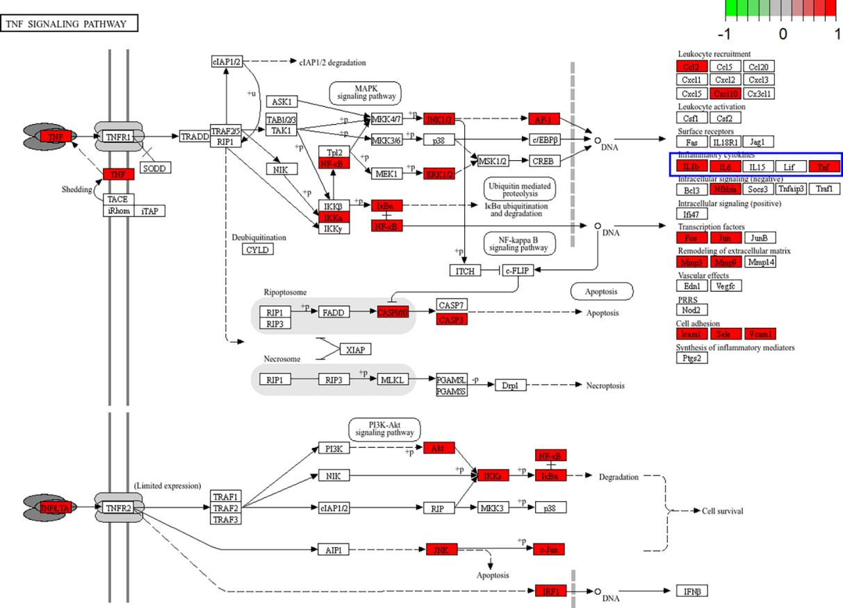
Supplementary Figure S1 TNF Signaling Pathway Diagram. The red rectangles represent potential targets that may be influenced by QJZG，including IL1B, TNF, and IL6 (highlighted in the blue box).

