SUPPLEMENTARY INFORMATION

S1 Table. Barcodes used with primers sequences to distinguish samples
Direction | Name | Sequence | Direction | Name | Sequence
Forward | BC1N | CTATCACG | Reverse | BC11N | ATGGCTAG
Forward | BC2N | TCCAGTGT | Reverse | BC12N | GACTTGGT
Forward | BC3N | GATCAGTA | Reverse | BC13N | TCGATCAC
Forward | BC4N | AGTGTCGG | Reverse | BC14N | ACACGTCA
Forward | BC5N | GTAGCGCT | Reverse | BC15N | CAATGTGC
Forward | BC6N | CATCTAAC | Reverse | BC16N | GGGACTAC
Forward | BC7N | TACAGATC | Reverse | BC17N | ACGTACTG
Forward | BC8N | CGTCTTGT | Reverse | BC18N | TGATTGCC
Forward | BC9N | TATGATCA | Reverse | BC19N | AACTCTAC
Forward | BC10N | GGTAGCTT | Reverse | BC20N | TGACTCAA

S2 Table. Amp-seq assay primers used in multiplex 1 and 2 combinations
Multiplex 1
Forward Name | Forward | Reverse Name | Reverse
DomainIV_F1 | GCGATCTSATCGAGAAGTA | DomainIV_R1 | ATGCTAGCAARTACGTGATG
DomainII_F5 | ACAATGTGGATCGCTTCCCG | DomainII_NR1 | TGAACCGAAATTGGACAAAAG
Ace_NF1 | TGGGGAACGCTRGGAATCTGCG | ACE_NR1 | GCATATCGCTGGGCAAACTC
LCO1490 | GGTCAACAAATCATAAAGATATTGG* | HCO2198 | TAAACTTCAGGGTGACCAAAAAATCA*
GSTE_111_F | ATGACGAAGCTCATTTTGTACACG | GSTE_111_R | ACAAAAATAAGCCACACACTACTG
Multiplex 2
Forward Name | Forward | Reverse Name | Reverse
DomainIIS4_F1 | TCTAGATTTAGYGACTCCAR | DomainIIS4_R1 | TACCGATGTAGTTCTTGCC
DomainI_F1 | TTTCGTCTAATGACCCAAGA | DomainI_R1_N | ARAGAWTTCGCTCACCCG
DomainIIIExon35_F2 | GGATCCAGATCATGAACGA | DomainIIIExon35_R1 | CATGTCGAACTTCTTATTGGT
RDL_NF1 | CTTCTAATTTCTCTCATCAC | Primer-Aeg-R1 | CTGGTTATTTGTACAAGTAGCA
GSTE_150_F | GAACCAATCCTTTTCGCC | GSTE_150_R | TGCCTTTTGAGCATTCTTCT
*²²

S3 Table. Average coverage per amplicon, amplicon length, and described mutations found in that amplicon.
Forward Amplicon Name | Reverse Amplicon Name | Mean Coverage | Amplicon Size | Insecticide Resistance mutations
Ace_NF1 | Ace_NR3 | 550.8 | 468 | G119S
DomainIIIExon35_F2 | DomainIIIExon35_R1 | 304.3 | 474 | T1520I, F1534C
DomainIIS4_F1 | DomainIIS4_R1 | 284.9 | 444 | G923V
DomainII_F5 | II_NR1 | 61.2 | 466 | L982W, S989P, I1011V/M, V1016I/G
DomainIV_F1 | DomainIV_R1 | 149.3 | 495 | D1763Y
DomainI_F1 | Domain1_R1_N | 244.5 | 464 | V410L
GSTE2_111 | GSTE2_111_R1 | 7.3 | 462 | L111S (Ae. aegypti), C155F
GSTE2_150 | GSTE2_150_R | 256.0 | 321 | L119F, I150V (Ae. aegypti)
RDL_NF1 | Primer-Aeg-R1 | 40.4 | 482 | A301S
LCO1490 | HCO1298 | 6.5 | 709 | -

S4 Table. Summary of synonymous mutations detected in the 178 samples screened. Rdl mutations were based on the AAEL008354-RF transcript, vgsc mutations utilised the AAEL023266-RL transcript and ace-1 mutations refer to the AAEL034366-RD transcript.
Chrom | Gene | Position | Nucleic acid change | Annotation | Genotype |  |  | Alt. Allele Frequency
 |  |  |  |  | Homo. ref | Hetero | Homo.  alt | Alt. Allele Frequency
3 | ace-1 | 161500076 | T > A | 506T | 0 | 7 | 97 | 96.6%
3 | ace-1 | 161500136 | C > T | 486L | 102 | 4 | 0 | 1.9%
3 | ace-1 | 161500262 | G > A | 444D | 100 | 4 | 0 | 1.9%
3 | ace-1 | 161500301 | G > A | 431P | 100 | 4 | 0 | 1.9%
3 | ace-1 | 161500361 | T > C | 411I | 45 | 100 | 0 | 34.5%
3 | vgsc | 315931749 | T > C | 1847Y | 16 | 91 | 0 | 42.5%
3 | vgsc | 315932072 | G > A | 1762L | 179 | 1 | 0 | 0.3%
3 | vgsc | 315932184 | G > A | 1724V | 88 | 2 | 0 | 1.1%
3 | vgsc | 315932226 | G > C | 1710L | 80 | 80 | 0 | 25.0%
3 | vgsc | 315984096 | C > T | 978L | 60 | 0 | 60 | 50.0%
3 | vgsc | 315984129 | A > G | 967F | 0 | 0 | 62 | 100.0%
3 | vgsc | 315984159 | C > T | 957K | 0 | 0 | 61 | 100.0%
3 | vgsc | 316080738 | C > T | 402L | 225 | 10 | 1 | 2.5%
3 | vgsc | 316081058 | G > A | 375D | 0 | 1 | 118 | 99.6%

S5 Table. SNPs nomenclature based on reference organism and Ae. aegypti from this study.
Gene | Reference organism | Mutation reference | Mutation Ae. aegypti | Ae. aegypti transcript
vgsc | Musca domestica | V410L | V408L | AAEL023266-RL
vgsc | Musca domestica | L994I | L921I | AAEL023266-RL
vgsc | Musca domestica | V1016I/G | V1012I/G | AAEL023266-RL
vgsc | Musca domestica | F1534C | F1554C | AAEL023266-RL
rdl | Drosophila melanogaster | A296S | A301S | AAEL008354-RF
Ace-1 | Torpedo californica | NA | NA | AAEL034366-RD

S6 Table. Filtered linked SNP position with R² > 0.8
Position 1 | Position 2 | R² | Position 1 | Position 2 | R²
161500136 | 161500301 | 1.000 | 315983956 | 315984096 | 0.943
315983762 | 316080895 | 1.000 | 315983973 | 315984096 | 0.943
315983762 | 316080896 | 1.000 | 315931749 | 315932226 | 0.934
315983762 | 316080903 | 1.000 | 315998798 | 316080620 | 0.911
315983762 | 316080916 | 1.000 | 316080722 | 316080983 | 0.909
315983809 | 315984129 | 1.000 | 315983762 | 315983763 | 0.899
315983956 | 315984130 | 1.000 | 315983763 | 316080895 | 0.899
315998609 | 315998611 | 1.000 | 315983763 | 316080896 | 0.899
315998609 | 315998782 | 1.000 | 315983763 | 316080903 | 0.899
315998610 | 315998613 | 1.000 | 315983763 | 316080916 | 0.899
316080830 | 316080845 | 1.000 | 316080830 | 316080847 | 0.895
316080895 | 316080896 | 1.000 | 316080845 | 316080847 | 0.895
316080895 | 316080903 | 1.000 | 316080952 | 316081058 | 0.857
316080895 | 316080916 | 1.000 | 315983762 | 316080942 | 0.856
316080896 | 316080903 | 1.000 | 315983762 | 316080950 | 0.856
316080896 | 316080916 | 1.000 | 316080895 | 316080942 | 0.856
316080903 | 316080916 | 1.000 | 316080895 | 316080950 | 0.856
316080942 | 316080950 | 1.000 | 316080896 | 316080942 | 0.856
315983809 | 315983956 | 0.986 | 316080896 | 316080950 | 0.856
315983809 | 315983973 | 0.986 | 316080903 | 316080942 | 0.856
315983809 | 315984159 | 0.986 | 316080903 | 316080950 | 0.856
315983956 | 315984129 | 0.986 | 316080916 | 316080942 | 0.856
315983973 | 315984129 | 0.986 | 316080916 | 316080950 | 0.856
315984129 | 315984159 | 0.986 | 315983763 | 316080830 | 0.850
315984096 | 315984159 | 0.972 | 315983763 | 316080845 | 0.850
315983956 | 315983973 | 0.971 | 315983762 | 316080847 | 0.844
315983956 | 315984159 | 0.971 | 316080847 | 316080895 | 0.844
315983973 | 315984159 | 0.971 | 316080847 | 316080896 | 0.844
315983809 | 315984096 | 0.957 | 316080847 | 316080903 | 0.844
315984096 | 315984129 | 0.957 | 316080847 | 316080916 | 0.844
316080722 | 316080942 | 0.954 | 315983762 | 316080722 | 0.816
316080722 | 316080950 | 0.954 | 315983762 | 316080983 | 0.816
316080942 | 316080983 | 0.954 | 316080722 | 316080895 | 0.816
316080950 | 316080983 | 0.954 | 316080722 | 316080896 | 0.816
315983762 | 316080830 | 0.945 | 316080722 | 316080903 | 0.816
315983762 | 316080845 | 0.945 | 316080722 | 316080916 | 0.816
316080830 | 316080895 | 0.945 | 316080895 | 316080983 | 0.816
316080830 | 316080896 | 0.945 | 316080896 | 316080983 | 0.816
316080830 | 316080903 | 0.945 | 316080903 | 316080983 | 0.816
316080830 | 316080916 | 0.945 | 316080916 | 316080983 | 0.816
316080845 | 316080895 | 0.945 | 316080830 | 316080942 | 0.808
316080845 | 316080896 | 0.945 | 316080830 | 316080950 | 0.808
316080845 | 316080903 | 0.945 | 316080845 | 316080942 | 0.808
316080845 | 316080916 | 0.945 | 316080845 | 316080950 | 0.808

S1 Figure. The log coverage of each amplicon sequenced separated by the multiplex reaction in which they were combined (see Table 1).
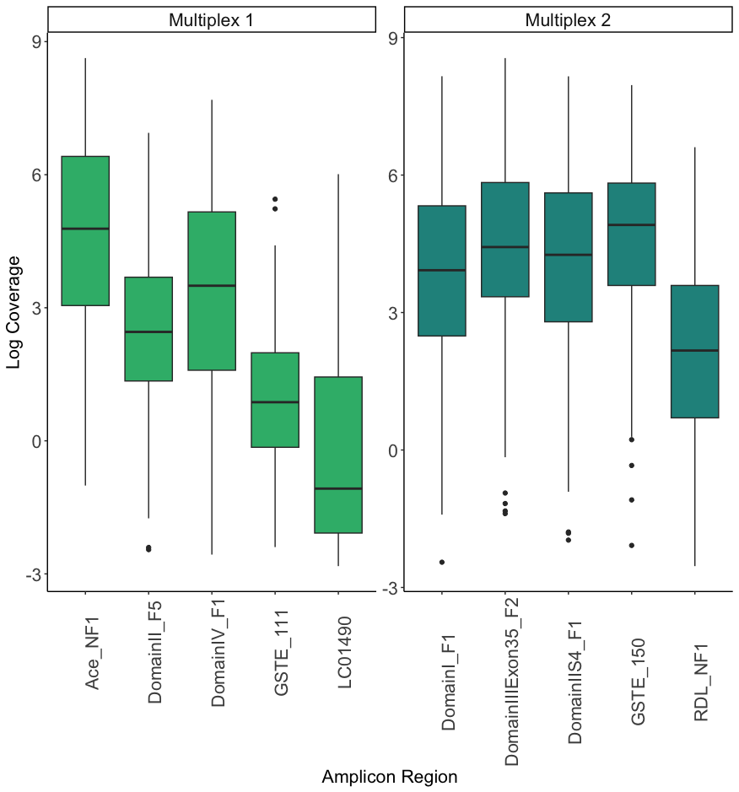

SI Figure 2. Alignment of protein for voltage-gated sodium channel for Triatoma infestans (sensitive AGW21773.1 and resistant AWG21772.1 forms), Bemisia tabaci and two isoforms of Aedes aegypti and Drosophila melanogaster showing position of L921I mutation described to be associated with pyrethroid insecticide resistance (28,29).
