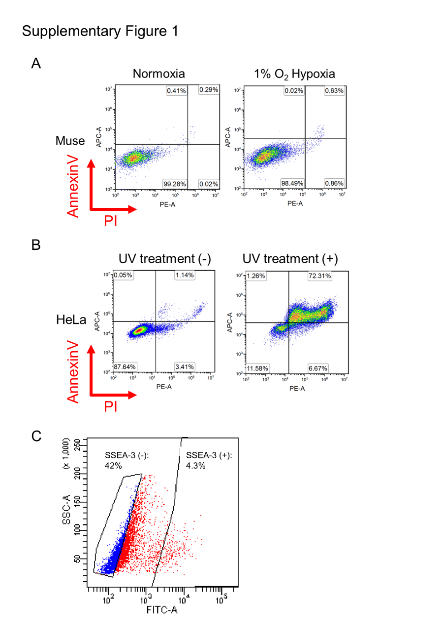
Supplementary Figure 1. 1% O₂ hypoxia did not induce apoptosis in Muse cells.
- Flow cytometry analysis of apoptosis under normoxia or 1% O₂ hypoxia using AnnexinV-PI staining.
- Flow cytometry analysis with Annexin V-PI staining was conducted on UV-treated HeLa cells, which were used as a positive control.
- Gating strategy for sorting Muse and non-Muse cells.

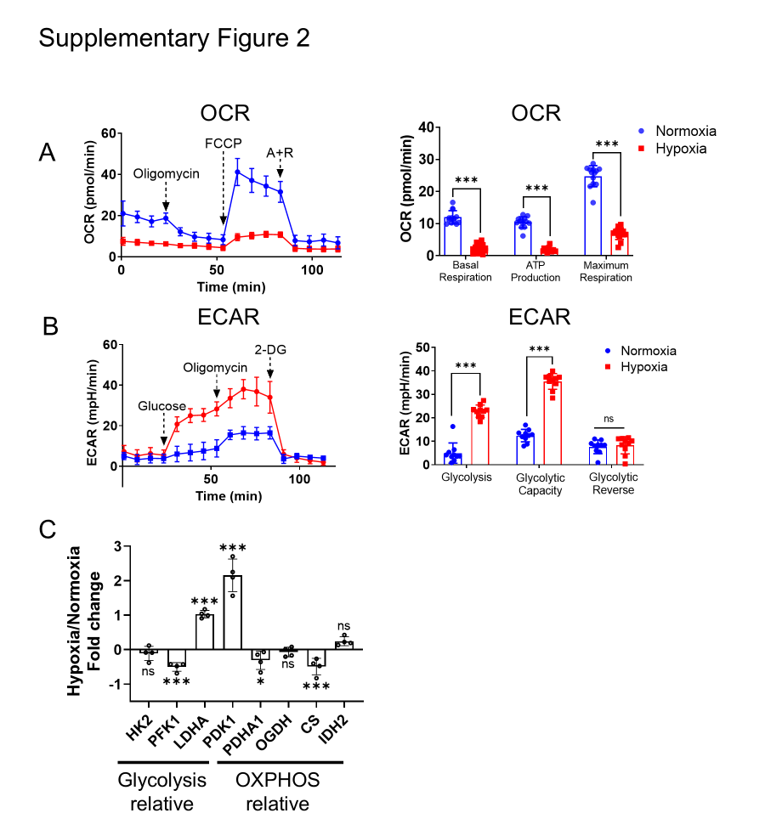
Supplementary Figure 2. Hypoxia caused the metabolism of Muse cells to shift from OXPHOS to glycolysis.
- Comparison of OCR in Muse cells under normoxia and 1% O₂ hypoxia culture (n=10 for both conditions).
- Comparison of ECAR in Muse cells under normoxia and 1% O₂ hypoxia culture (n=10 for both conditions).
- qPCR comparison of glycolysis- and OXPHOS-related gene expression in Muse cells under normoxia and 1% O₂ hypoxia (n=3 for both conditions).
* p<0.05, ***p<0.001, ns: no significant.
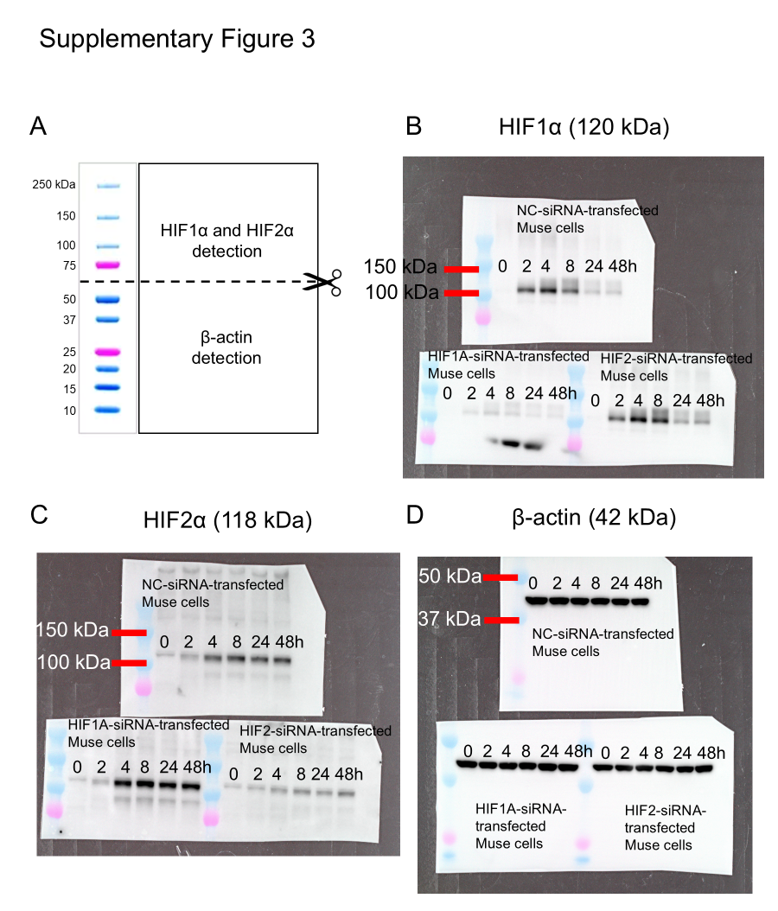
Supplementary Figure 3. Original Western blot membranes supporting the data in Figure 2.
- Membranes were cut between 50 kDa and 75 kDa to detect HIFs and β-actin.
- Original Western blot membranes for detecting HIF1α.
- Original Western blot membranes for detecting HIF2α.
- Original Western blot membranes for detecting β-actin.

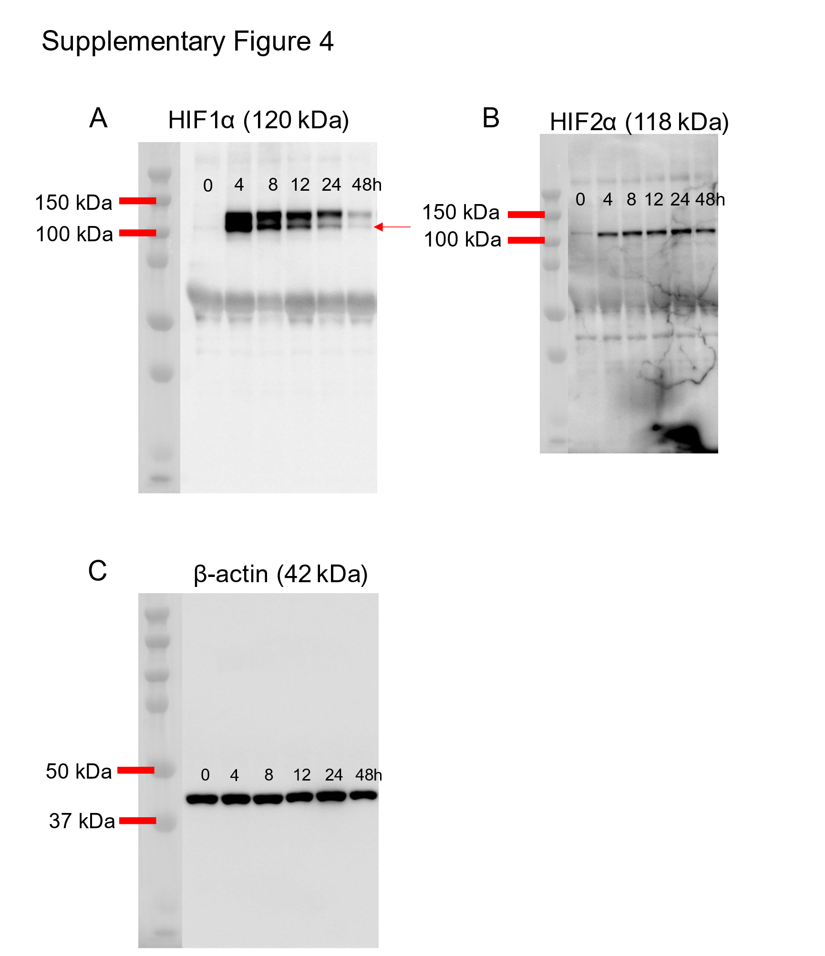
Supplementary Figure 4. Original Western blot membranes supporting the data in Figure 4A.
- Original Western blot membranes for detecting HIF1α in Figure 4A.
- Original Western blot membranes for detecting HIF2α in Figure 4A.
- Original Western blot membranes for detecting β-actin in Figure 4A.

