This document includes the supplementary material of “Differences in the activity intensity distribution over the day between boys and girls aged 3 to 17 years”
Jaime López García¹, Eivind Aadland², Nicolas Berger³, Bjorge Herman Hansen⁴, Mohamed Amine Benadjaoud⁵, Vincent van Hees⁶, Ian Meneghel Danilevicz¹, Séverine Sabia ^{1,7}
¹Université Paris Cité, Inserm, Center for Research in Epidemiology and Statistics (CRESS), EpiAgeing, F-75004 Paris, France;
²Department of Sport, Food and Natural Sciences, Western Norway University of Applied Sciences, Sogndal, Norway;
³Department of Epidemiology and Public Health, Sciensano (Belgian Scientific Institute of Public Health), Brussels, Belgium;
⁴Department of Sport Science and Physical Education, University of Agdder, Kristiansand, Norway;
⁵Institute for Radiological Protection and Nuclear Safety, Fontenay-Aux-Roses, France;
⁶Accelting, Almere, The Netherlands;
⁷Department of Epidemiology and Public Health, University College London, United Kingdom

Methods 3
Method 1. Function data analysis for activity distribution over the time of day 3
Method 2. Function data analysis for activity intensity distribution 5
Supplementary Tables 8
Supplementary Table S1. Comparison of participants included and excluded in the study sample 8
Supplementary Table S2. Characteristics of the study population. 9
Supplementary Table S3. Sex differences in activity intensity levels at each age on weekdays and weekend days by study. 10
Supplementary Figures 11
Supplementary Figure S1. Study Flowchart. 11
Supplementary Figure S2. Sex differences in activity intensity (time of the day) in each age group during weekdays and weekend days for each age in the BFCS study. 12
Supplementary Figure S3. Sex differences in activity intensity (time of the day) on weekdays and weekend days in preschoolers by study. 13
Supplementary Figure S4. Sex differences in activity intensity (time of the day) on weekdays and weekend days in children by study. 14
References: 15

Methods

Method 1. Function data analysis for activity distribution over the time of day
For each participant the number of counts per 15 seconds in vector magnitude (VM) over the waking time window (06:00 to 22:00) is retained. This corresponds to 3840 epochs of 15 seconds per day. We aggregated each four epochs in one episode of 60 seconds. Then, the number of counts per minute for each participant is viewed as a functional outcome over the waking time window (06:00 to 22:00). Let us consider $Y_{ij}\left(t\right)$ as the number of counts for the i^{th} participant, on the j^{th} day, at the time $t=1,…,960$, eg, $t=1$means 6:00 and $t=2$ means 6:01 We split the analysis between weekdays and weekend days in each age group (pre-schoolers, children and adolescents). Therefore, $Y_{i}\left(t\right)$is the average number of counts for the i^{th} participant at the time $t$ for weekdays or for weekend days, which is given by equation 1 as follows:
$$Y_{i}\left(t\right)= α\left(t\right)+ β_{sex}\left(t\right)*{sex}_{i}+β_{age}\left(t\right)*{age}_{i}+β_{education}\left(t\right)*{education}_{i} + β_{season}\left(t\right)*{season}_{i}+ β_{study}\left(t\right)*{study}_{i}+β_{wear}\left(t\right)*T_{i}+X_{i}\left(t\right)+ε_{i}\left(t\right),$$ | (1)
where$α \left(t\right)$ is the functional intercept of the model; $β_{sex}\left(t\right)$, $β_{age}\left(t\right)$, $β_{education}\left(t\right)$, $β_{season}\left(t\right)$, $β_{study}\left(t\right)$ and $β_{wear}\left(t\right)$ are the functional coefficients associated with the respective covariates ${sex}_{i}$(binary variable with boys as the reference), ${age}_{i}$ (continuous variable with age of each participant), ${education}_{i}$ (factor variable with high school as the reference for parents’ education level), ${season}_{i}$ (factor variable with winter as the reference), ${study}_{i}$ (factor variable with BFCS as the reference) and $T_{i}$ (continuous variable with the average total wear time in minutes per day centered by total wear time); $X_{i}\left(t\right)$ is the structured error, and $ε_{i}\left(t\right)$ is independent Gaussian error such as the random intercept in a mixed model (see equation 5.5 on page 160 in Crainiceanu et al).¹ The structured error is decomposed as $X_{i}\left(t\right)=B(t)ξ_{i}$ where $B(t)$ is a $k$ dimensional row vector of basis functions evaluated at $t$ and $ξ_{i}$ is the $k$ dimensional vector participant coefficients. We estimated the parameters from equation 1 by functional additive mixed models (FAMM), such as suggested by Crainiceanu et al (2024) on page 166-167.¹
This analysis was conducted using the refund R package. The estimation of FAMM demands spline optimization. We set up 50 cubic B-splines bases with first order difference penalty for the functional intercept $α \left(t\right)$, an unfixed number of cubic B-splines bases with first order difference penalty for the other functional coefficients $β \left(t\right)$and smooth functional random intercepts ($X_{i}\left(t\right)$). The final number of cubic B-splines and $k$ are defined by restricted maximum likelihood (REML).² The general lines are similar to the code suggested by Crainiceanu et al. (2024) on page 167. More details are available on GitHub (https://github.com/jaimelopez98/Sex-differences-in-youth-using-functional-data-analysis-FDA-.git).

Method 2. Function data analysis for activity intensity distribution
For these analysis, we identified the waking period, as previously explained in the main paper and we consider $Y_{ij}\left(a\right)=T_{ij}* f_{ij}\left(a\right)$, where $T_{ij}$ is the total wear time in minutes for the i^{th} participant, on the j^{th} day, and $f_{ij}\left(a\right)$ is the density function for the respective participant and day for the acceleration intensity $a$ which takes its values over the range of the recorded acceleration. We split the analysis between weekdays and weekends. Therefore, $T_{i}$is the average total wear time in minutes for the i^{th} participant, and $f_{i}\left(a\right)$ is the average density function for the respective participant for the acceleration intensity $a$ for weekdays or for weekends. In this manner, the time spent in each acceleration intensity is given by equation 2 as follows:
$$Y_{i}\left(a\right)=T_{i}* f_{i}\left(a\right),$$ | (2)

where $T_{i}$ and $f_{i}\left(a\right)$ were defined above, this equation was inspired by the equation proposed by Chen et al (2022)³ in the supplementary material. The integral of $Y_{i}\left(a\right)$ over any range of acceleration represents the time (minutes) spent in this acceleration range per day, with integral over the total range of acceleration representing the daily waking time.
For each participant, the density function of acceleration during waking period was estimated by kernel density estimation on an equally distributed 200-point grid, using a Gaussian kernel and a plug-in bandwidth selector. However, the values higher than the 0.995 percentile were previously excluded from the grid as they were considered extreme values.

The time spent in each acceleration intensity for weekdays or weekend days is given by equation 3:
$$Y_{i}\left(a\right)= α\left(a\right)+ β_{sex}\left(a\right)*{sex}_{i} +β_{age}\left(a\right)*{age}_{i}+β_{education}\left(a\right)*{education}_{i} + β_{season}\left(a\right)*{season}_{i}+ β_{study}\left(a\right)*{study}_{i}+β_{wear}\left(a\right)*T_{i}+X_{i}\left(a\right)+ε_{i}\left(a\right),$$ | (3)
where$α\left(a\right)$ is the functional intercept of the model; $β_{sex}\left(a\right)$, $β_{education}\left(a\right)$, $β_{season}\left(a\right)$, $β_{study}\left(a\right)$ and $β_{wear}\left(a\right)$ are the functional coefficients associated with the respective covariates ${sex}_{i}$(binary variable with boys as the baseline), ${age}_{i}$ (continuous variable with age of each participant), ${education}_{i}$ (factor variable with high school as the baseline for parents’ education level), ${season}_{i}$ (factor variable with winter as the baseline), ${study}_{i}$ (factor variable with BFCS as the baseline) and $T_{i}$ (continuous variable with the total wear time in minutes); $X_{i}\left(a\right)$ is the structured error, and $ε_{i}\left(a\right)$ is independent Gaussian error such as the random intercept in a mixed model (see equation 5.5 on page 160 of Crainiceanu et al)¹.
The analysis was conducted using the refund R package using similarly as for equation 1.

Software and packages
All analyses were undertaken using R statistical software (version 3.6.1, http://www.r-project.org/).
Accelerometer data was processed using the package GGIR (version 3.0.9, https://cran.r-project.org/web/packages/GGIR/index.html).
Kernel smoothing was implemented using the package ks (version 1.14.2, https://cran.rproject.org/web/packages/ks/ks.pdf ) of R.
All function-on-scalar regressions were conducted using the REFUND package in R (version 0.1-36, https://cran.r-project.org/web/packages/refund/refund.pdf).
The trapezoidal integration of functional coefficients was undertaken using the pracma R package (version 2.4.4, https://cran.r-project.org/web/packages/pracma/pracma.pdf).
Plots were created/illustrated using the package ggplot2 (version 3.5.1, https://cran.r-project.org/web/packages/ggplot2/ggplot2.pdf).

Supplementary Tables

Supplementary Table S1. Comparison of participants included and excluded in the study sample
 | Included (n =2507) | Excluded (n = 830) | p-value*
Age, mean (SD) | 8.0 (3.5) | 9.2 (4.2) | < 0.001
Boys, n (%) | 1268 (50.6) | 436 (52.3) | 0.350
Parental education, n (%)
Upper secondary education | 755 (30.1) | 314 (37.8) | < 0.001
University | 742 (29.6) | 265 (31.9) | 0.725
Higher university | 1010 (40.3) | 251 (30.2) | < 0.001
Cohort study, n (%)
ACTNOW | 872 (34.8) | 193 (23.3) | < 0.001
ASK | 827 (33.0) | 199 (24.0) | < 0.001
BFCS | 808 (32.2) | 438 (52.8) | < 0.001

Abbreviations=standard deviation. ACTNOW=Active Learning Norwegian Preschool(er)s. ASK=Active Smarter Kids. BFCS=Belgian food consumption survey.
*A Student’s t test was performed for age variable and a chi-squared test, for other variables.

Supplementary Table S2. Characteristics of the study population.
 |  | ALL COHORTS |  |  | ACTNOW |  |  | ASK |  |  | BFCS
 | Boys  N=1268  (50.6%) | Girls  N=1239  (49.4%) | p-value* for  difference  by sex | Boys  N=1268  (50.6%) | Girls  N=1239  (49.4%) | p-value* for  difference  by sex | Boys  N=1268  (50.6%) | Girls  N=1239  (49.4%) | p-value* for  difference  by sex | Boys  N=1268  (50.6%) | Girls  N=1239  (49.4%) | p-value* for  difference  by sex
Age, mean (SD) | 8.0 (3.5) | 8.1 (3.6) | 0.368 | 4.4 (0.8) | 4.5 (0.8) | 0.261 | 10.2 (0.3) | 10.2(0.3) | 0.991 | 9.5 (3.9) | 9.8 (4.1) | 0.368
Parental education level, n (%)
Upper secondary education | 367 (28.9) | 388 (31.3) | 0.211 | 111 (25.1) | 108 (25.2) | 0.999 | 131 (31.2) | 133 (32.7) | 0.701 | 125 (30.9) | 147 (36.5) | 0.107
University | 393 (31.0) | 349 (28.2) | 0.132 | 131 (29.57) | 114 (26.6) | 0.363 | 127 (30.2) | 116 (28.5) | 0.637 | 135 (33.3) | 119 (29.5) | 0.276
Higher university | 508 (40.1) | 502 (40.5) | 0.849 | 201 (45.4) | 207 (48.3) | 0.433 | 162 (38.6) | 158 (38.8) | 0.998 | 145 (35.8) | 137 (34.0) | 0.642
Season, n (%)
Winter | 186 (14.7) | 195 (15.7) | 0.490 | 0 | 0 | - | 0 | 0 | - | 186 (45.9) | 195 (48.4) | 0.529
Spring | 410 (32.3) | 388 (31.3) | 0.614 | 0 | 0 | - | 313 (74.5) | 295 (72.5) | 0.557 | 97 (24.0) | 93 (23.1) | 0.834
Summer | 274 (21.6) | 276 (22.3) | 0.722 | 244 (55.1) | 251 (58.5) | 0.340 | 3 (0.7) | 3 (0.7) | 0.999 | 27 (6.7) | 22 (5.5) | 0.568
Autumn | 398 (31.4) | 380 (30.7) | 0.730 | 199 (44.9) | 178 (41.5) | 0.340 | 104 (24.8) | 109 (26.8) | 0.559 | 95 (23.4) | 93 (23.1) | 0.964
Abbreviations: SD=standard deviation; ACTNOW=Active Learning Norwegian Preschool(er)s; ASK=Active Smarter Kids; BFCS=Belgian food consumption survey
*A Student’s t test was performed for age variable and a chi-squared test for other variables.

Supplementary Table S3. Sex differences in activity intensity levels at each age on weekdays and weekend days by study.

Mean difference (95%CI) in time in:
 |  | SB |  |  | LIPA |  |  | MPA |  |  | VPA
Age groups | n | Weekdays | Weekend days |  | Weekdays | Weekend days |  | Weekdays | Weekend days |  | Weekdays | Weekend days
Pre-schoolers (3-5y)
BFCS (3-5y) | 187 | 11.9  (-3.5, 27.3) | 9.3  (-12.9, 31.5) |  | 9.4  (-0.4, 19.2) | 9.1  (-3.5, 21.7) |  | -7.0  (-11.4, -2.7) | -7.6  (-13.4, -1.8) |  | -14.3  (-19.7, -8.9) | -10.1  (-17.0, -3.1)
ACTNOW (3-5y) | 870 | 22.8  (16.7, 28.9) | 7.2  (-2.6, 17.0) |  | -3.0  (-6.7, 0.8) | 1.2  (-4.4, 6.8) |  | -10.1  (-12.1, -8.2) | -8.2  (-10.6, -5.8) |  | -9.6  (-12.1, -7.2) | -9.1  (-12.0, -6.1)
Children (6-11y)
BFCS (6-10y) | 326 | 21.5  (10.1, 33) | -13.9  (-31.3, 3.5) |  | 6.8  (-0.3, 13.9) | 7.5  (-3.2, 18.2) |  | -10.4  (-13.2, -7.6) | -8.0  (-12.4, -3.7) |  | -17.9  (-22.5, -13.4) | -15.0  (-21.2, -8.8)
ASK (9-11y) | 825 | 11.7  (5.3, 18.2) | -12.1  (-23.2, -1.0) |  | 11.7  (7.8, 15.7) | 13.6  (7.5, 19.8) |  | -7.0  (-8.7, -5.3) | -2.2  (-4.6, 0.3) |  | -16.4  (-19.4, -13.5) | -11.0  (-15.4, -6.7)

Abbreviations: CI=confidence interval; SB=sedentary behaviour (0-180 counts/15s); LIPA=light physical activity (181-756 counts/15s); MPA=moderate physical activity (757-1111counts/15s); VPA=vigorous physical activity (>1111counts/15s).
Positive values indicate that girls spend more time in the related activity intensity level.
Bold estimates means that differences are significant at p < 0.05.

Supplementary Figures

Supplementary Figure S1. Study Flowchart.
ASK
n = 1137
ACTNOW
n = 1255
BFCS
n = 1295
DATA AVAILABLE
n = 3687
DATA WITH DEMOGRAPHIC INFORMATION
n = 3337
ANALYTICAL SAMPLE
n = 2507
Missing demographic data
n = 350
Less than 3 WD and 1 WE of accelerometer data with 8h/day of wear time
n = 830

Abbreviations: ACTNOW=Active Learning Norwegian Pre-school(er)s. ASK=Active Smarter Kids. BFCS=Belgian food consumption survey. WD=weekday. WE=weekend days.

Supplementary Figure S2. Sex differences in activity intensity (time of the day) in each age group during weekdays and weekend days for each age in the BFCS study.
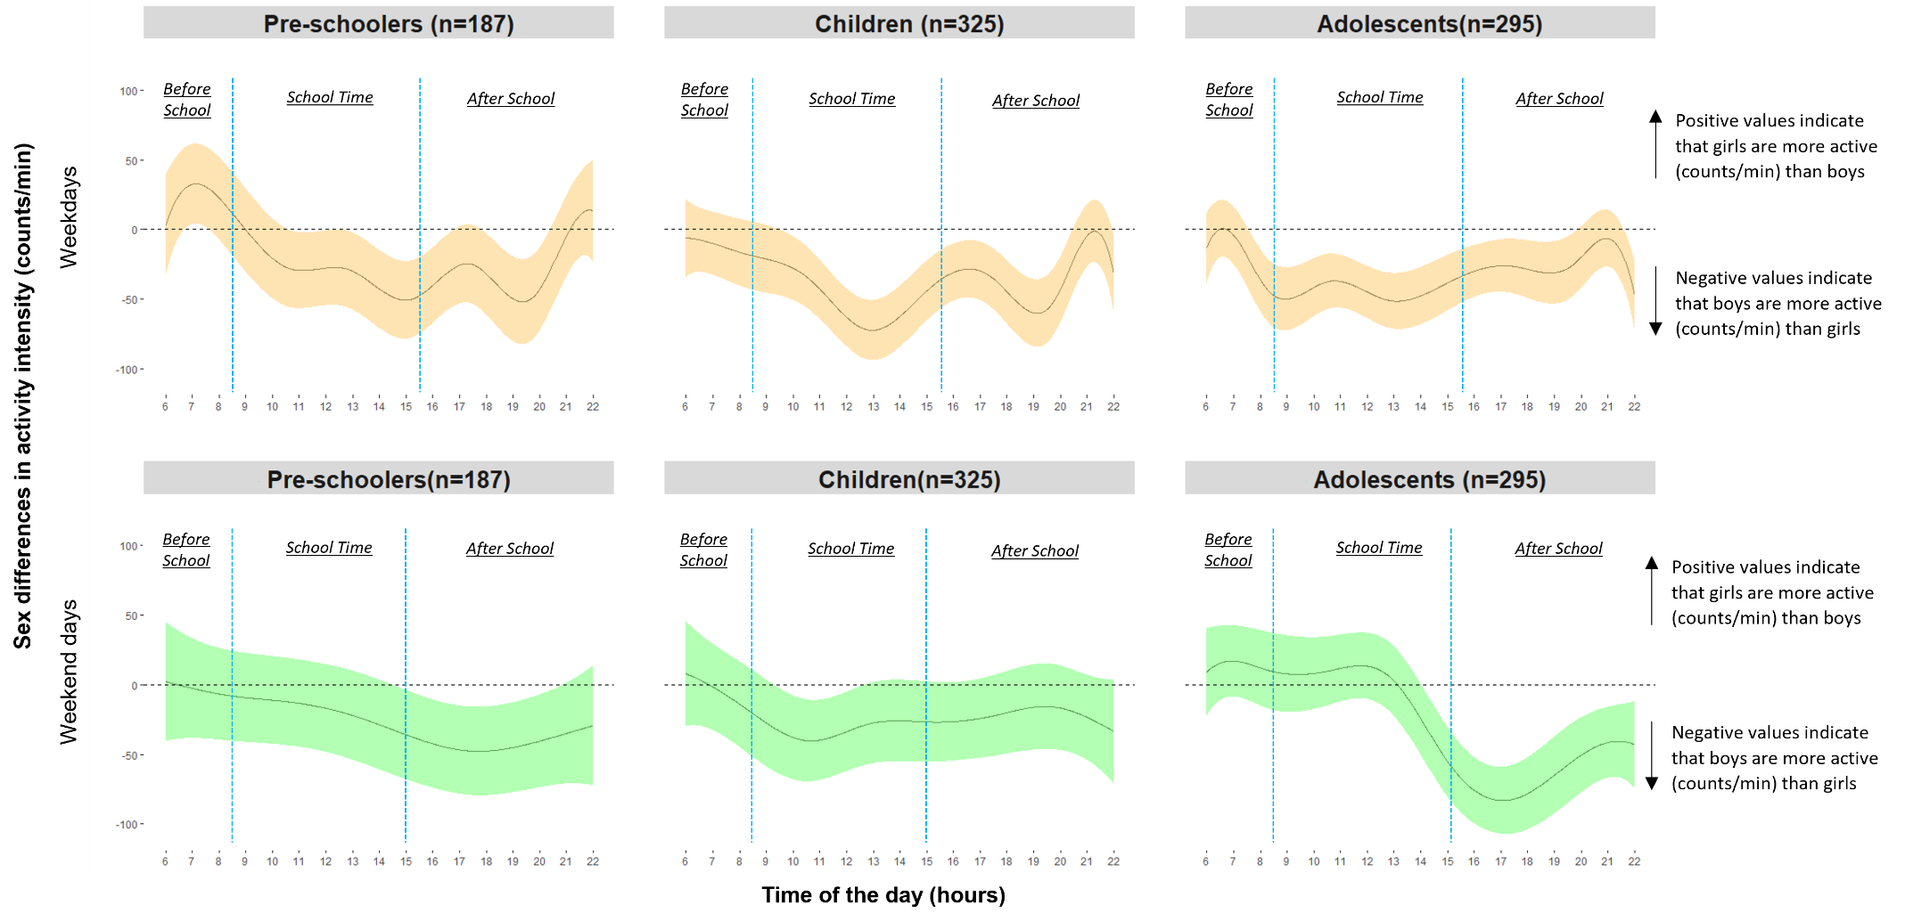
Blue lines were added to ease interpretation of the sex differences during the segments of day. On weekdays, before-school, school-time and after school was considered between 06h00 and 08h29, 08h30 and 15h29, 15h30 and 22h00, respectively. On weekend days, morning and afternoon-evening was considered between 06h00 and 11h59, 12h00 and 22h00, respectively.

Supplementary Figure S3. Sex differences in activity intensity (time of the day) on weekdays and weekend days in preschoolers by study.
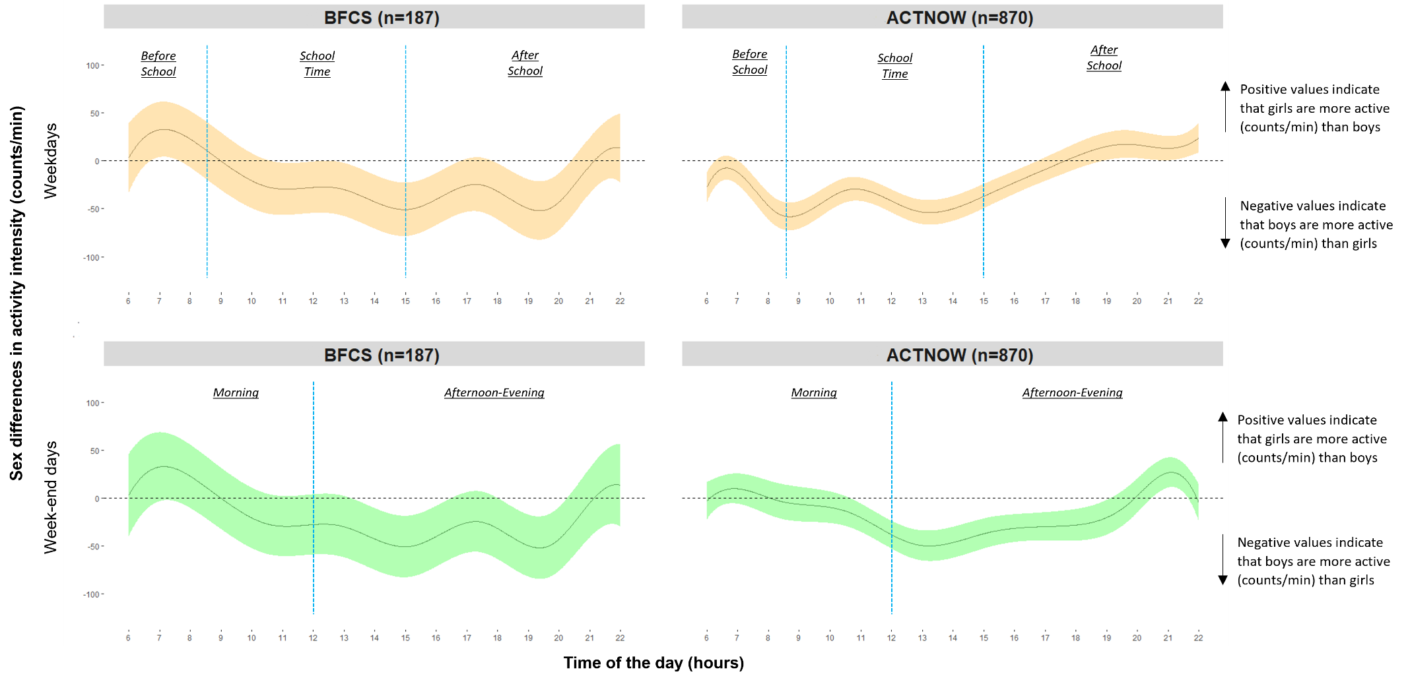
Blue lines were added to ease interpretation of the sex differences during the segments of day. On weekdays, before-school, school-time and after school was considered between 06h00 and 08h29, 08h30 and 15h29, 15:30 and 22h00, respectively. On weekend days, morning and afternoon-evening was considered between 06h00 and 11h59, 12h00 and 22h00, respectively.

Supplementary Figure S4. Sex differences in activity intensity (time of the day) on weekdays and weekend days in children by study.

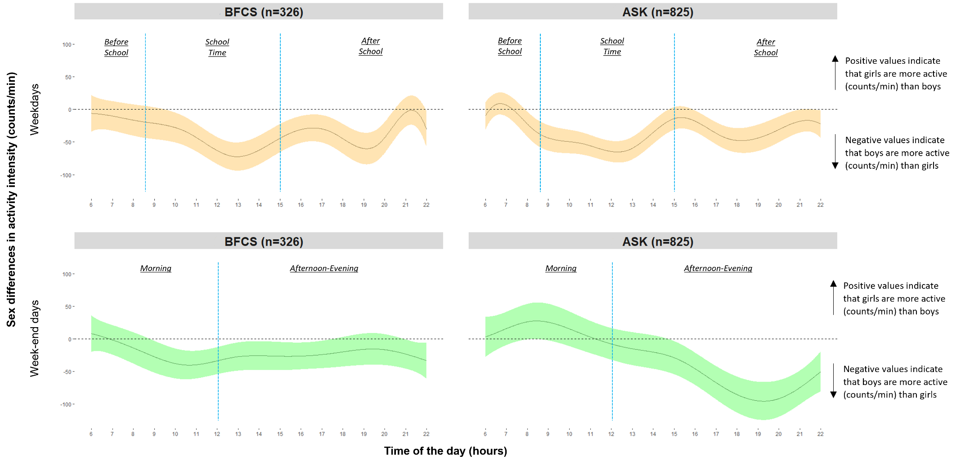
Blue lines were added to ease interpretation of the sex differences during the segments of day. On weekdays, before-school, school-time and after school was considered between 06h00 and 08h29, 08h30 and 15h29, 15:30 and 22h00, respectively. On weekend days, morning and afternoon-evening was considered between 06h00 and 11h59, 12h00 and 22h00, respectively.

References:
1 Crainiceanu, C., Goldsmith, J., Leroux, A. & Cui, E. Functional Data Analysis with R., 1-24 (2024).
2 Krivobokova, T. & Kauermann, G. A Note on Penalized Spline Smoothing With Correlated Errors. Journal of the American Statistical Association 102, 1328 - 1337 (2007).
3 Chen, M. et al. Individual Barriers to an Active Lifestyle at Older Ages Among Whitehall II Study Participants After 20 Years of Follow-up. JAMA Netw Open 5, e226379, doi:10.1001/jamanetworkopen.2022.6379 (2022).
Availability of data and materials'
Datasets used in the current study are subject to privacy protection regulations and may be shared by the respective coordinators of the cohorts on reasonable request. The codes and all documentations that supporting the conclusions of this article are available in the GitHub repository corresponding to the first author in: https://github.com/jaimelopez98/Sex-differences-in-youth-using-functional-data-analysis-FDA-.git

